Box

A smaller box is placed inside a larger box. On the inside of the top of the large box, is a layer of tin foil. Between the two boxes is a sponge. When someone touches the top of the box, it will start vibrating, due to the tin foil being used as a capacitive sensor. When pressing down the box, the sponge will be squeezed together, and the vibration becomes stronger. The amount of pressure is detected by two linear potentiometers located in each side between the two boxes. There are six vibrators in the box; three in the top, and three in the bottom. Somewhere outside the box, a potentiometer is located, to alter the behavior of the vibration. Changing this potentiometer, will in the one end make the top and bottom vibrate at the same time, and going towards the other end, generate a slower and slower rhythm between top and bottom vibrators.

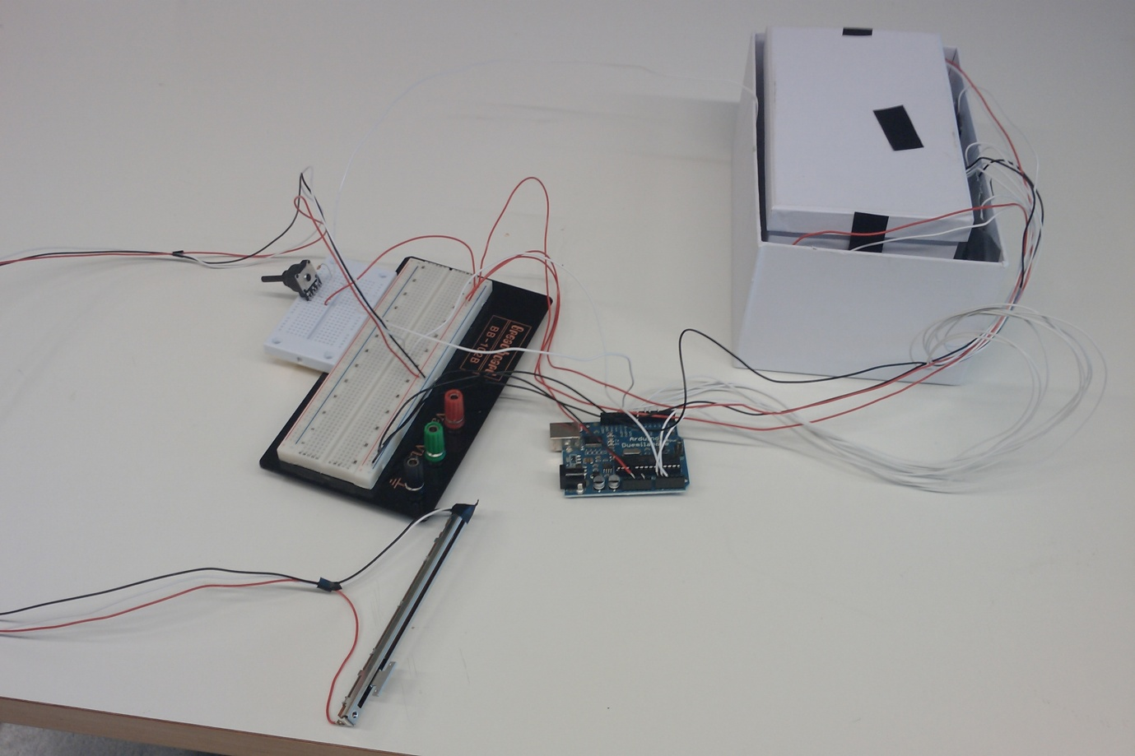

Overall view of the box with wires

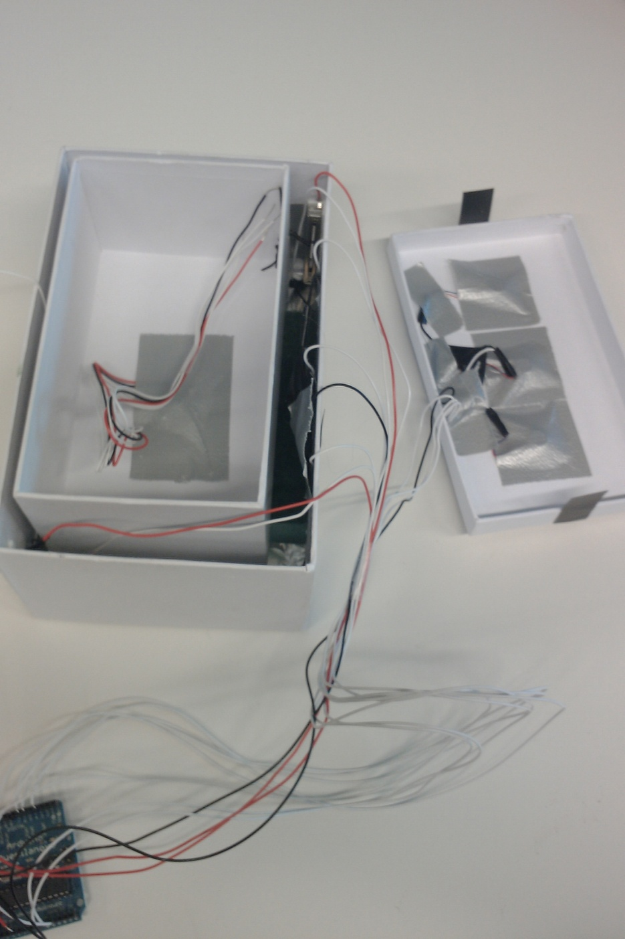

Inside view of the box

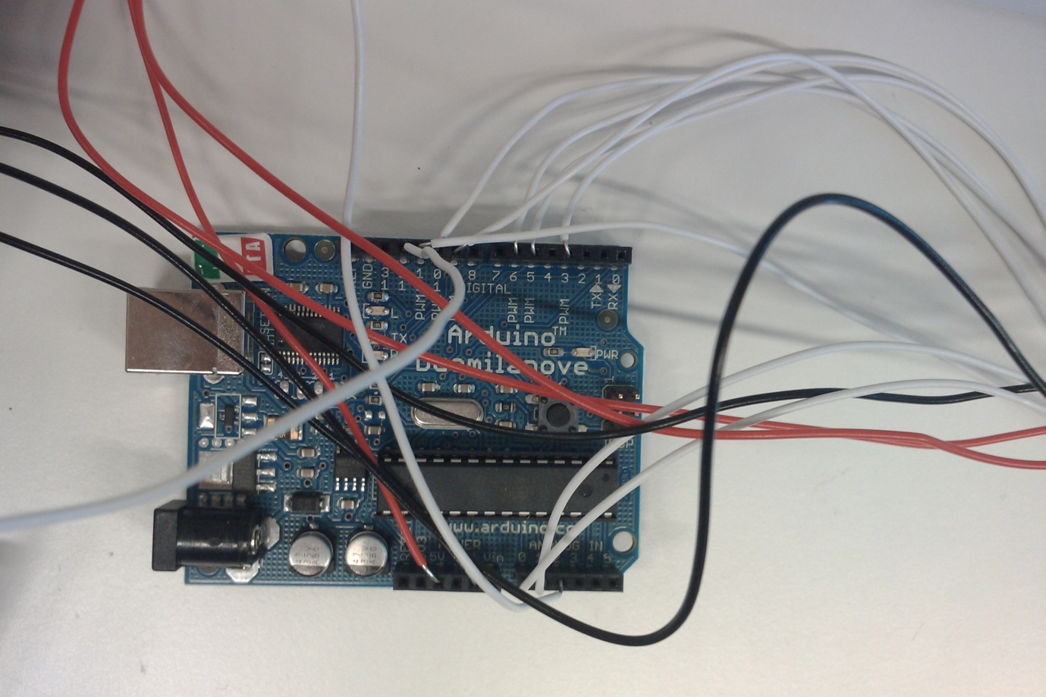

Arduino board wiring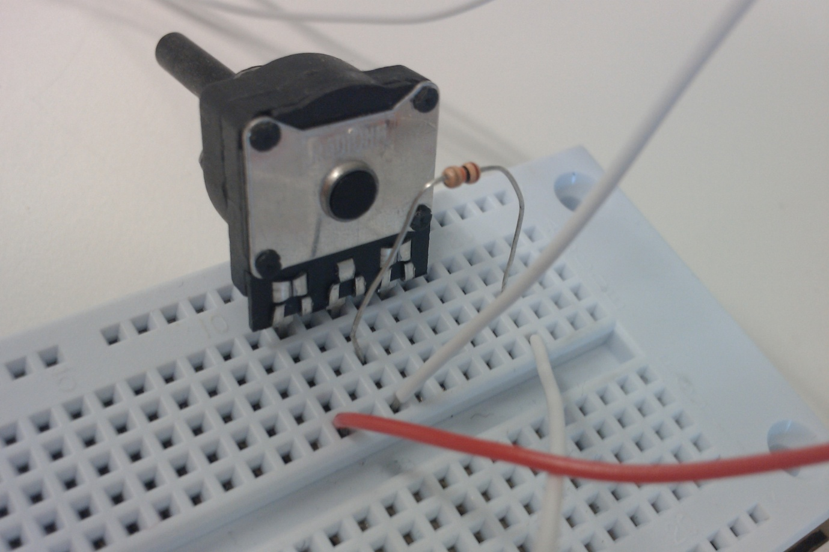

Capacitive sensor setup

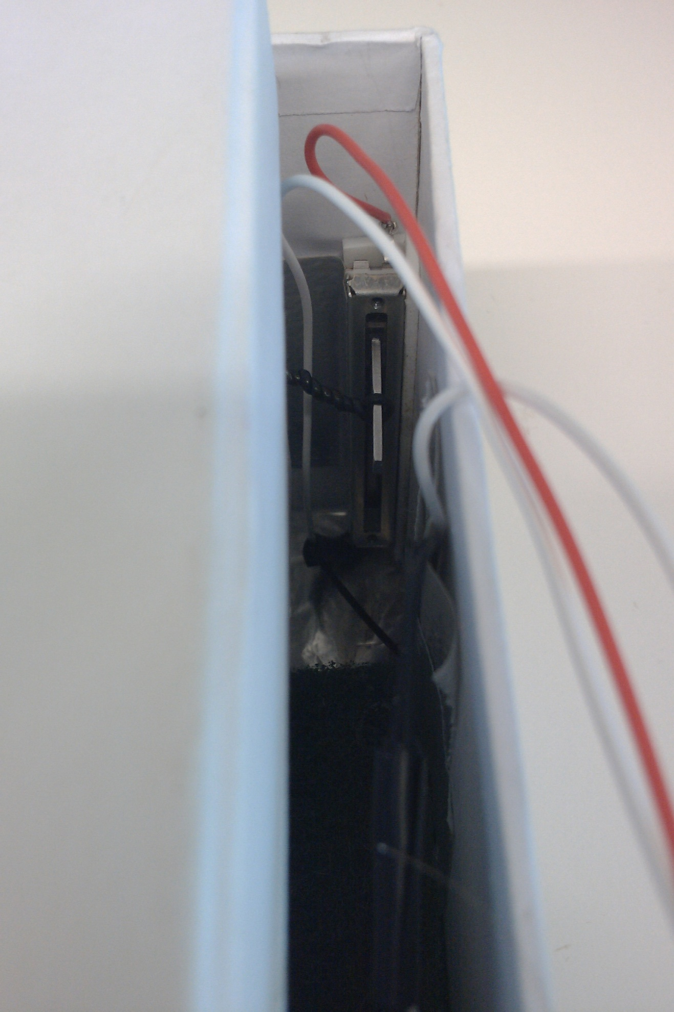

The potentiometer between the two boxes

