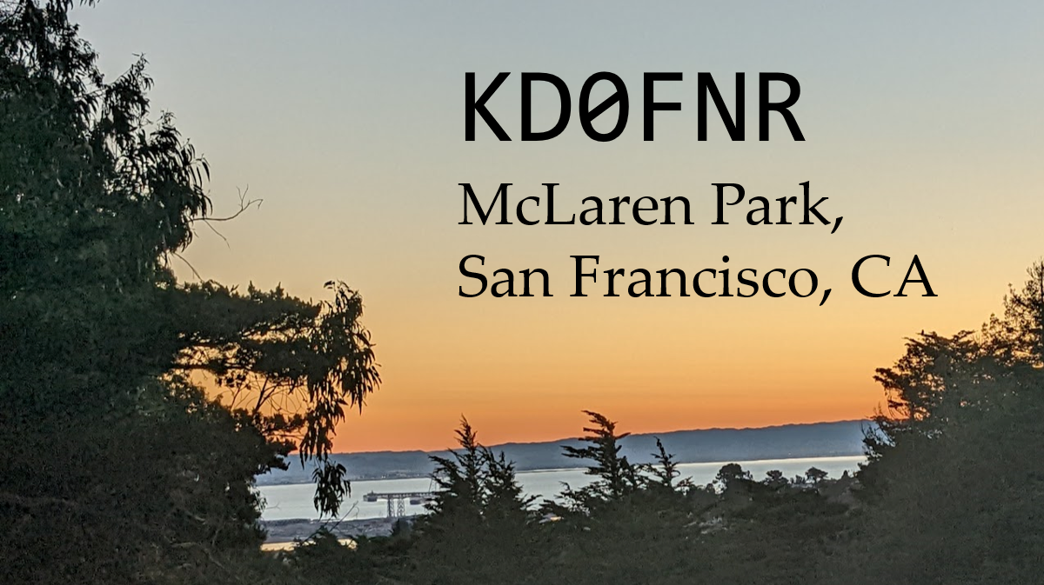

|  |  |
| --- | --- |
| Confirming QSO with AC2WU  **Date**: 12/4/22 **UTC**: 21:38  **MHz**: 14.058  **txRST**: 599 **rxRST** 419 **Mode**: CW **Rig**: Rockmite 20  **Antenna**: ½ λ dipole **PSE** QSL | Your return address SF, CA  Address of receiving station |



|  |  |
| --- | --- |
| Confirming QSO with  **Date**: **UTC**:  **MHz**:  **txRST**: **rxRST   Mode**: CW **Rig**: Rockmite 20  **Antenna**: ½ λ dipole **PSE** QSL | Your return address SF, CA  Address of receiving station |