good hearing 1
flatLoss 1
analyse accumulated data for this group & display average 3
save mean results as structures 3
print/ draw short vs long abs thresholds 4
save average profile and plot average profile 6
display results 6
results plots 6
hist 12
compare left and right ears 13

good hearing
figTitle=' good hearing'; conditional='~impaired'; conditionNo=1; subjectOffset=0; restrictParticipants=0;

flatLoss
IH14 1 1 2.0 4 20.0
IH14 1 2 2.0 3 15.1
IH14 1 3 2.0 16 26.1
IH14 1 4 2.0 14 36.6
IH14 1 5 2.0 25 54.7
IH14 1 6 2.0 10 32.2
IH15 2 1 2.0 NaN NaN
IH15 2 2 2.0 1 NaN
IH15 2 3 2.0 2 -5.9
IH15 2 4 2.0 -3 0.0
IH15 2 5 2.0 6 NaN
IH15 2 6 2.0 7 -6.8
IH17 3 1 2.0 NaN NaN
IH17 3 2 2.0 5 NaN
IH17 3 3 2.0 3 NaN
IH17 3 4 2.0 6 NaN
IH17 3 5 2.0 4 14.2
IH17 3 6 2.0 NaN NaN
IH18 4 1 2.0 -3 NaN
IH18 4 2 2.0 -1 NaN
IH18 4 3 2.0 1 4.2
IH18 4 4 2.0 -10 5.0
IH18 4 5 2.0 NaN NaN
IH18 4 6 2.0 NaN NaN
IH58 5 1 2.0 NaN 5.9
IH58 5 2 2.0 7 19.9
IH58 5 3 2.0 2 9.5
IH58 5 4 2.0 6 5.3
IH58 5 5 2.0 3 -14.2
IH58 5 6 2.0 6 14.8
IH75 6 1 2.0 2 19.4
IH75 6 2 2.0 -1 25.9
IH75 6 3 2.0 -4 15.5
IH75 6 4 2.0 6 28.2
IH75 6 5 2.0 3 14.0
IH75 6 6 2.0 NaN NaN

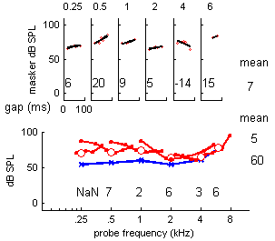

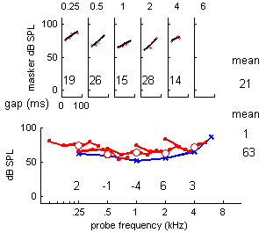

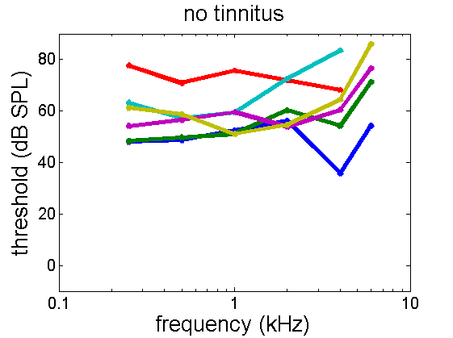

analyse accumulated data for this group & display average
6participants
ages =
56 42 58 71 69 64
mean age= 60 years. SD= 10.6019
mean THI= NaN, SD= NaN

save mean results as structures
statistics =
probeFrequencies: [250 500 1000 2000 4000 6000 8000]
absThrSampleSize: [6 6 6 6 6 4 3]
meanLongTones: [1x7 double]
meanShortTones: [1x7 double]
stdevLongTones: [11.1476 7.9628 9.4358 8.5190 15.7901 13.3069 13.7806]
stdevShortTones: [10.4649 8.2008 9.7551 9.3211 14.1747 9.0089 2.7577]
stErrLongTones: [4.5510 3.2508 3.8521 3.4779 6.4463 6.6535 7.9563]
stErrShortTones: [4.5510 3.2508 3.8521 3.4779 6.4463 6.6535 7.9563]
meanIFMCdepths: [0.9167 2.2750 3.5392 3.0408 8.1550 7.5500 NaN]
stdevIFMCs: [3.6626 3.1116 6.5917 8.4283 9.2669 2.0049 NaN]
IFMCsampleSize: [3 6 6 6 5 3 0]
stErrIFMC: [2.1146 1.2703 2.6911 3.4408 4.1443 1.1575 NaN]
meanTMCslopes: [15.0733 20.2694 9.8844 15.0355 17.1860 13.3794 NaN]
stdevTMCs: [7.9669 5.3875 11.9896 16.2673 28.3609 19.5302 NaN]
TMCsampleSize: [3 3 5 5 4 3 0]
stErrTMC: [4.5997 3.1105 5.3619 7.2749 14.1805 11.2757 NaN]

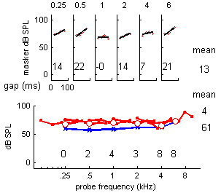

print/ draw short vs long abs thresholds
statistics across individuals
freq/ short/ long / difference abs thresholds
250 67 59 8
500 63 57 6
1000 63 58 4
2000 64 62 2
4000 65 61 4
6000 71 72 -1
8000 77 83 -5
frequency (kHz) mean
0.25 0.5 1 2 4 6
abs threshold (long)
59 57 58 62 61 72 61
sd= 11 8 9 9 16 13
N= 6 6 6 6 6 4
SE= 4.6 3.3 3.9 3.5 6.4 6.7
abs threshold (short)
67 63 63 64 65 71 65
sd= 10 8 10 9 14 9
N= 6 6 6 6 6 4
SE= 4.6 3.3 3.9 3.5 6.4 6.7
IFMC depth
1 2 4 3 8 8 4
sd= 4 3 7 8 9 2
N= 3 6 6 6 5 3
SE= 2.1 1.3 2.7 3.4 4.1 1.2
TMC slopes
15 20 10 15 17 13 15
sd= 8 5 12 16 28 20
N= 3 3 5 5 4 3
SE= 4.6 3.1 5.4 7.3 14.2 11.3

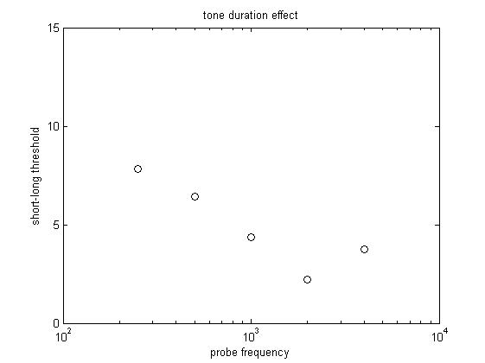

save average profile and plot average profile

display results

results plots
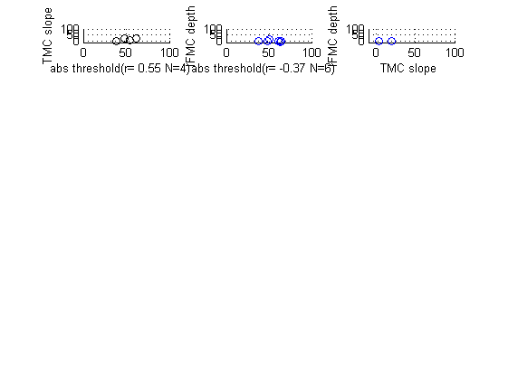

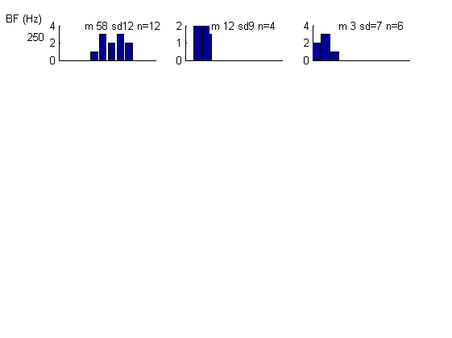

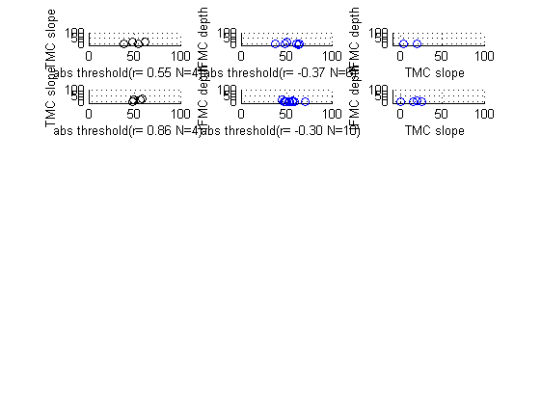

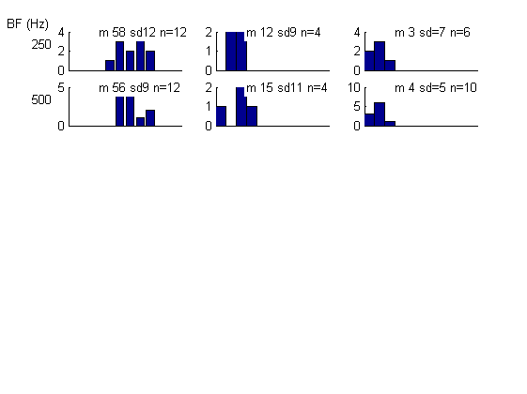

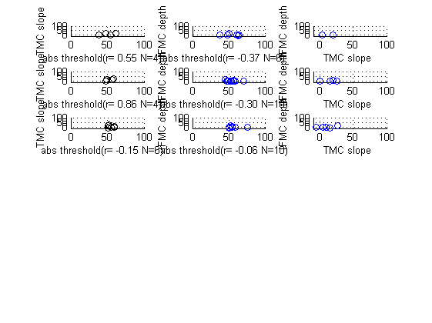

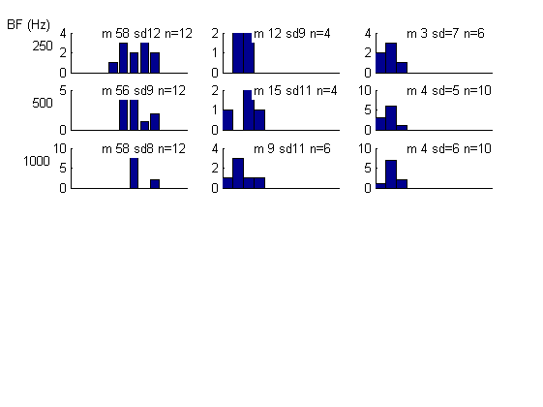

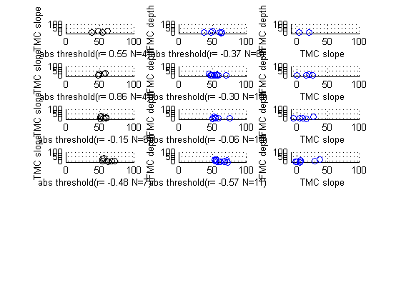

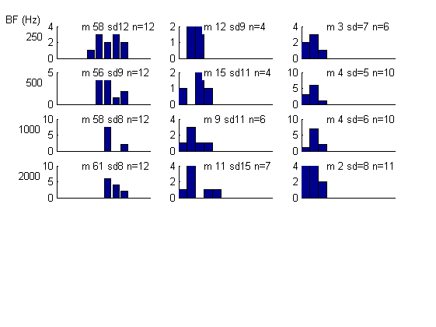

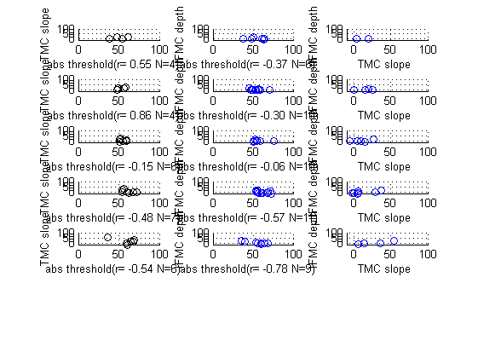

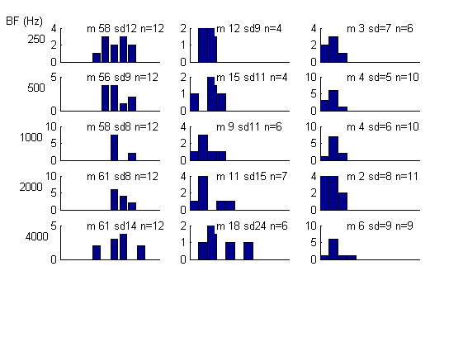

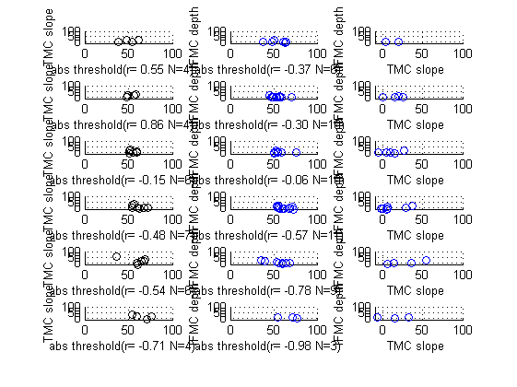

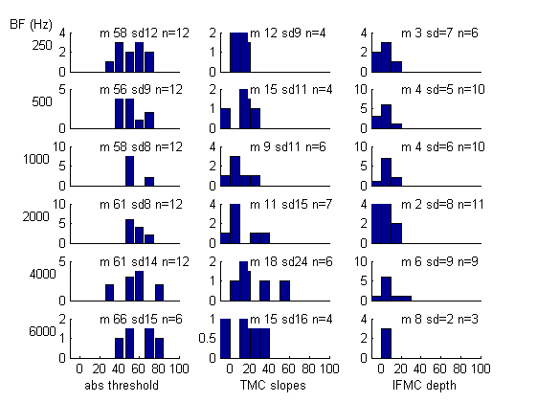

hist
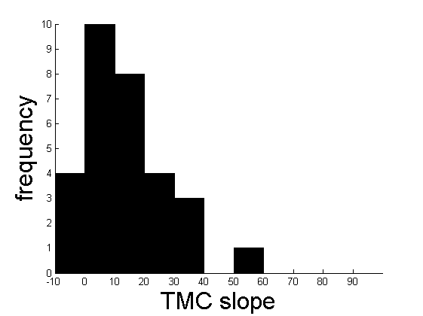

compare left and right ears
logical requirement= sum(listOfNumbers==participantNumber)

