good hearing 1
with low thresholds removed 1
non tinnitus 1
analyse accumulated data for this group & display average 4
save mean results as structures 5
print/ draw short vs long abs thresholds 6
save average profile and plot average profile 8
display results 8
results plots 8
hist 14
compare left and right ears 15

good hearing
figTitle=' good hearing'; conditional='~impaired'; conditionNo=1; subjectOffset=0; restrictParticipants=0;

with low thresholds removed
figTitle=' tinnitus (matched thresholds)';
conditionNo=1; subjectOffset=15;
allowedParticipants=...
{'AFR_L','DJE_L','DLE_R','JDO_R',...
'KBE_L','KBR_L','KSE_L','PBA_R','PBU_L' ...
'RWO_R','THO_L','SJO_L','JEV_L' ...
'PTO_R','SFO_R'
};

non tinnitus
BCR 1 1 2.0 NaN NaN
BCR 1 2 2.0 3 15.8
BCR 1 3 2.0 8 9.7
BCR 1 4 2.0 0 14.1
BCR 1 5 2.0 -2 12.5
BCR 1 6 2.0 NaN NaN
CWA 2 1 2.0 1 NaN
CWA 2 2 2.0 1 17.1
CWA 2 3 2.0 2 25.2
CWA 2 4 2.0 4 13.0
CWA 2 5 2.0 -1 20.1
CWA 2 6 2.0 9 11.1
KFR 3 1 2.0 NaN 19.3
KFR 3 2 2.0 12 12.2
KFR 3 3 2.0 2 10.6
KFR 3 4 2.0 3 3.1
KFR 3 5 2.0 9 19.2
KFR 3 6 2.0 5 0.7
DPE 4 1 2.0 -1 NaN
DPE 4 2 2.0 9 19.2
DPE 4 3 2.0 -2 -0.0
DPE 4 4 2.0 4 NaN
DPE 4 5 2.0 NaN NaN
DPE 4 6 2.0 NaN NaN
ECR 5 1 2.0 -1 2.2
ECR 5 2 2.0 2 0.5
ECR 5 3 2.0 1 -2.2
ECR 5 4 2.0 NaN NaN
ECR 5 5 2.0 NaN NaN
ECR 5 6 2.0 NaN NaN
JSA 6 1 2.0 7 NaN
JSA 6 2 2.0 11 -15.0
JSA 6 3 2.0 15 -12.9
JSA 6 4 2.0 31 112.2
JSA 6 5 2.0 29 139.7
JSA 6 6 2.0 9 NaN
LAD 7 1 2.0 3 NaN
LAD 7 2 2.0 1 14.0
LAD 7 3 2.0 -1 8.4
LAD 7 4 2.0 6 16.5
LAD 7 5 2.0 NaN NaN
LAD 7 6 2.0 NaN NaN
JPR 8 1 2.0 NaN NaN
JPR 8 2 2.0 15 17.1
JPR 8 3 2.0 22 4.2
JPR 8 4 2.0 20 25.7
JPR 8 5 2.0 -3 -0.2
JPR 8 6 2.0 14 -1.0
BHA 9 1 2.0 1 NaN
BHA 9 2 2.0 8 NaN
BHA 9 3 2.0 6 NaN
BHA 9 4 2.0 4 NaN
BHA 9 5 2.0 7 NaN
BHA 9 6 2.0 NaN NaN
BPR 10 1 2.0 2 3.8
BPR 10 2 2.0 3 -0.1
BPR 10 3 2.0 4 5.0
BPR 10 4 2.0 -3 -2.3
BPR 10 5 2.0 -7 5.6
BPR 10 6 2.0 NaN 21.0
LCR 11 1 2.0 1 6.3
LCR 11 2 2.0 -7 -2.3
LCR 11 3 2.0 -4 -4.4
LCR 11 4 2.0 2 -1.9
LCR 11 5 2.0 -4 -7.1
LCR 11 6 2.0 -2 -2.7
JAN 12 1 2.0 NaN NaN
JAN 12 2 2.0 17 33.8
JAN 12 3 2.0 13 28.5
JAN 12 4 2.0 37 19.4
JAN 12 5 2.0 -2 19.1
JAN 12 6 2.0 15 30.4
JWO 13 1 2.0 -1 26.2
JWO 13 2 2.0 0 21.8
JWO 13 3 2.0 10 20.8
JWO 13 4 2.0 -3 NaN
JWO 13 5 2.0 NaN NaN
JWO 13 6 2.0 NaN NaN
EEA 14 1 2.0 NaN NaN
EEA 14 2 2.0 2 3.6
EEA 14 3 2.0 8 17.1
EEA 14 4 2.0 -4 3.3
EEA 14 5 2.0 4 -0.9
EEA 14 6 2.0 17 3.6
NAB 15 1 2.0 2 19.4
NAB 15 2 2.0 -1 25.9
NAB 15 3 2.0 -4 15.5
NAB 15 4 2.0 6 28.2
NAB 15 5 2.0 3 14.0
NAB 15 6 2.0 NaN NaN

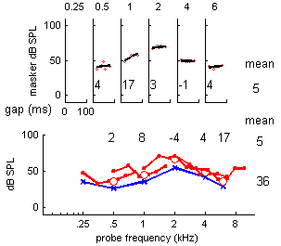

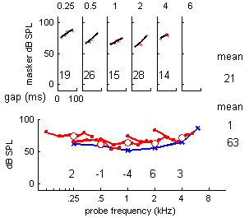

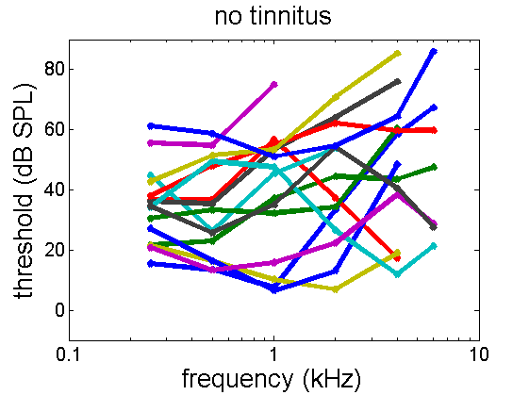

analyse accumulated data for this group & display average
15participants
ages =
Columns 1 through 13
71 66 50 64 75 63 71 69 67 69 55 33 74
Columns 14 through 15
63 64
mean age= 63.6 years. SD= 10.7557
mean THI= NaN, SD= NaN

save mean results as structures
statistics =
probeFrequencies: [250 500 1000 2000 4000 6000 8000]
absThrSampleSize: [15 15 15 14 13 7 8]
meanLongTones: [1x7 double]
meanShortTones: [1x7 double]
stdevLongTones: [1x7 double]
stdevShortTones: [1x7 double]
stErrLongTones: [3.3134 4.0869 5.3582 5.2556 6.2515 9.0570 6.9864]
stErrShortTones: [3.3134 4.0869 5.3582 5.2556 6.2515 9.0570 6.9864]
meanIFMCdepths: [1.5790 4.9817 5.3017 7.6711 3.0664 9.5371 8.1175]
stdevIFMCs: [2.3773 6.6682 7.5327 12.5862 9.8890 6.8036 12.6538]
IFMCsampleSize: [10 15 15 14 11 7 4]
stErrIFMC: [0.7518 1.7217 1.9449 3.3638 2.9817 2.5715 6.3269]
meanTMCslopes: [12.8664 11.6783 8.9469 21.0232 22.1836 9.0074 19.5550]
stdevTMCs: [1x7 double]
TMCsampleSize: [6 14 14 11 10 7 2]
stErrTMC: [4.0924 3.4517 3.1423 9.6390 13.4009 4.7349 24.6650]

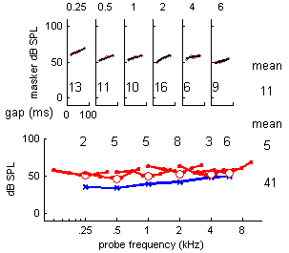

print/ draw short vs long abs thresholds
statistics across individuals
freq/ short/ long / difference abs thresholds
250 42 35 8
500 41 33 7
1000 44 39 5
2000 46 41 5
4000 52 48 4
6000 49 48 0
8000 61 57 4
frequency (kHz) mean
0.25 0.5 1 2 4 6
abs threshold (long)
35 33 39 41 48 48 41
sd= 13 16 21 20 23 24
N= 15 15 15 14 13 7
SE= 3.3 4.1 5.4 5.3 6.3 9.1
abs threshold (short)
42 41 44 46 52 49 46
sd= 12 13 19 19 22 19
N= 15 15 15 14 13 7
SE= 3.3 4.1 5.4 5.3 6.3 9.1
IFMC depth
2 5 5 8 3 10 5
sd= 2 7 8 13 10 7
N= 10 15 15 14 11 7
SE= 0.8 1.7 1.9 3.4 3.0 2.6
TMC slopes
13 12 9 21 22 9 14
sd= 10 13 12 32 42 13
N= 6 14 14 11 10 7
SE= 4.1 3.5 3.1 9.6 13.4 4.7

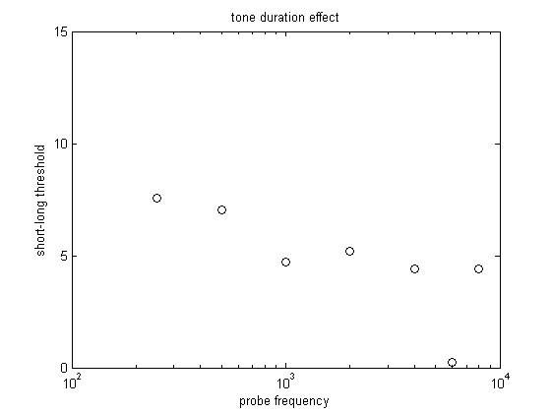

save average profile and plot average profile

display results

results plots
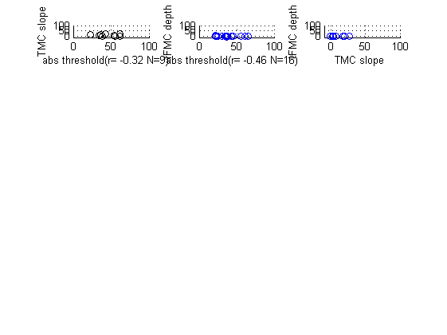

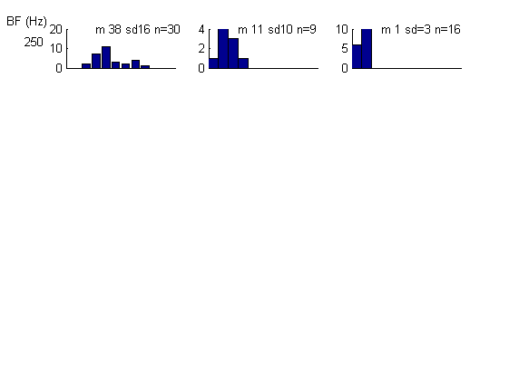

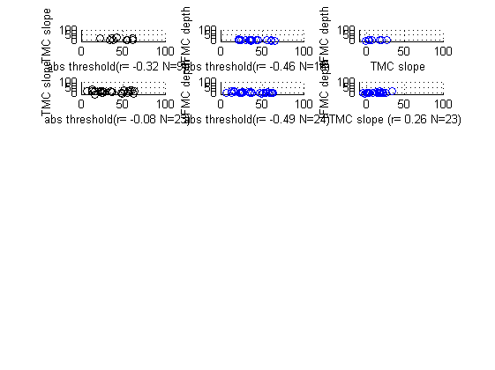

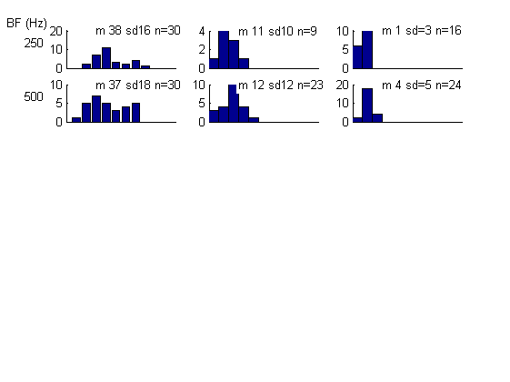

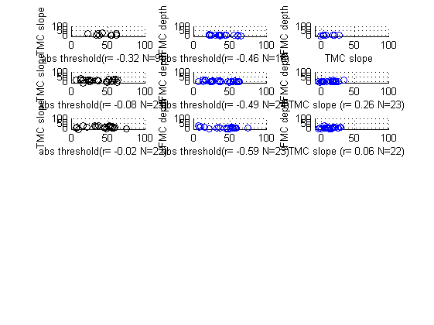

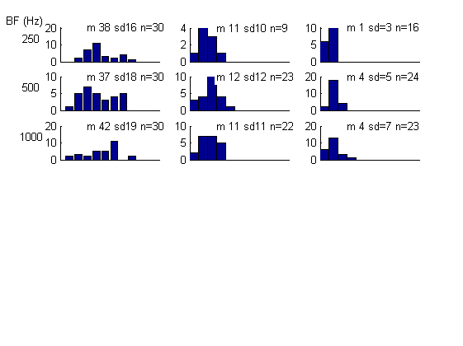

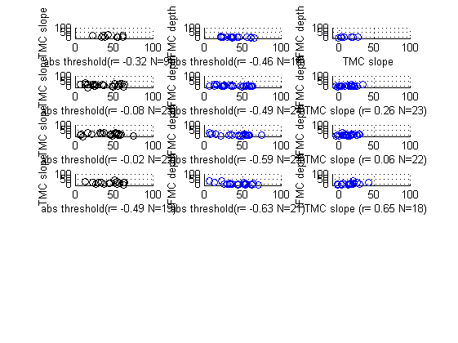

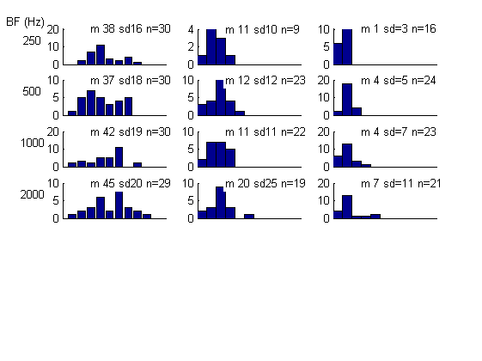

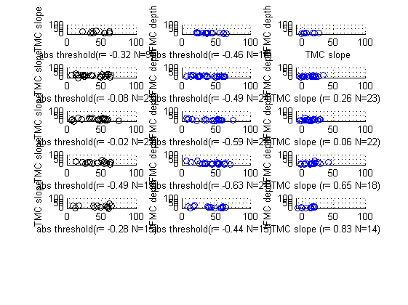

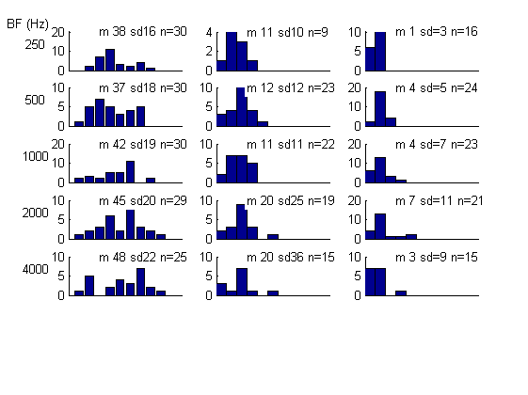

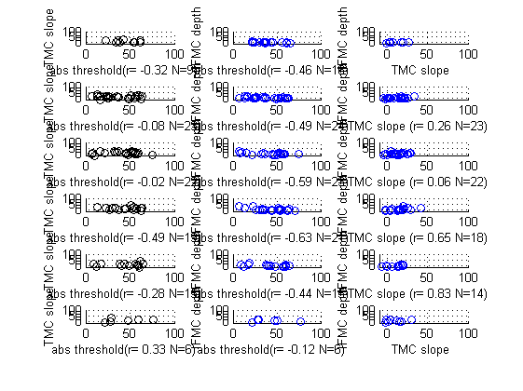

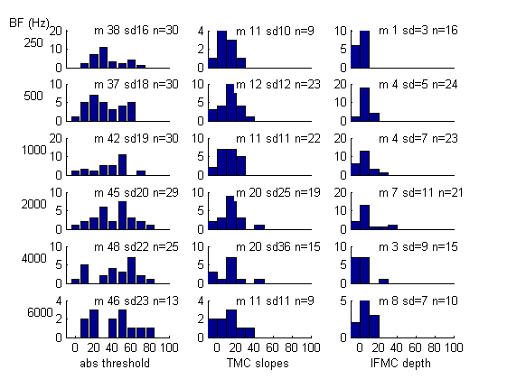

hist
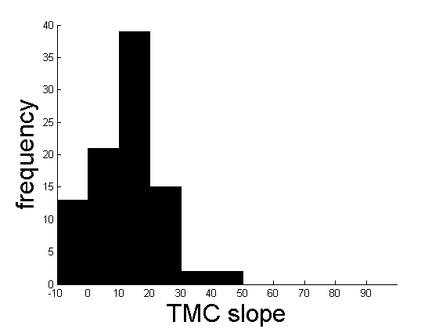

compare left and right ears
logical requirement= sum(strcmp(listOfInitials,initials))

