ESKF Batch Simulation Report
Generated at: 2026-04-23 20:54:34
Data folder: E:\eskf_bishe\bishe\ESKF-2.0\task_simulation_50000

task_simulation_random_01
Input data: E:\eskf_bishe\bishe\ESKF-2.0\task_simulation_50000\task_simulation_random_01.mat
Run status: OK
==================== RMSE summary ====================
Position RMSE [m] (N,E,D): 0.2311, 0.2415, 0.3042
Velocity RMSE [m/s] (N,E,D): 0.0924, 0.0951, 0.0675
Attitude RMSE [deg] (roll,pitch,yaw): 0.1267, 0.1431, 0.3264
Acc bias RMSE [m/s^2] (x,y,z): 0.018787, 0.011476, 0.012086
Gyro bias RMSE [deg/h] (x,y,z): 44.1159, 28.4335, 24.5053
======================================================
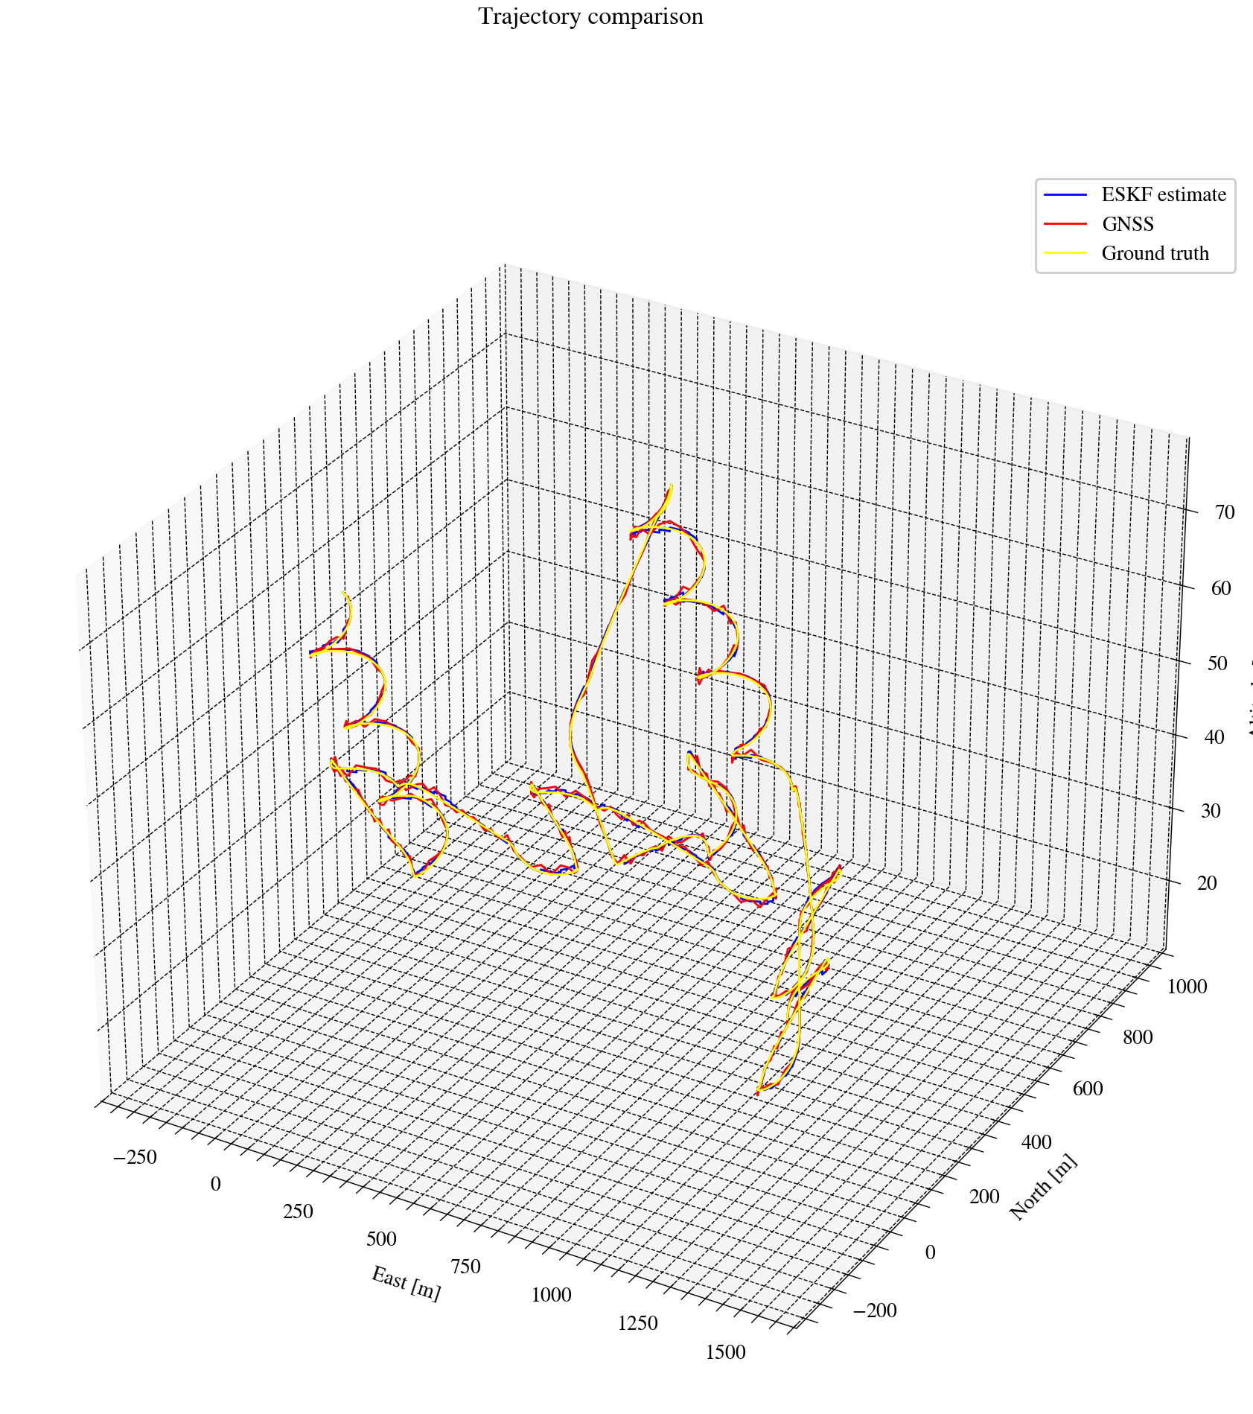
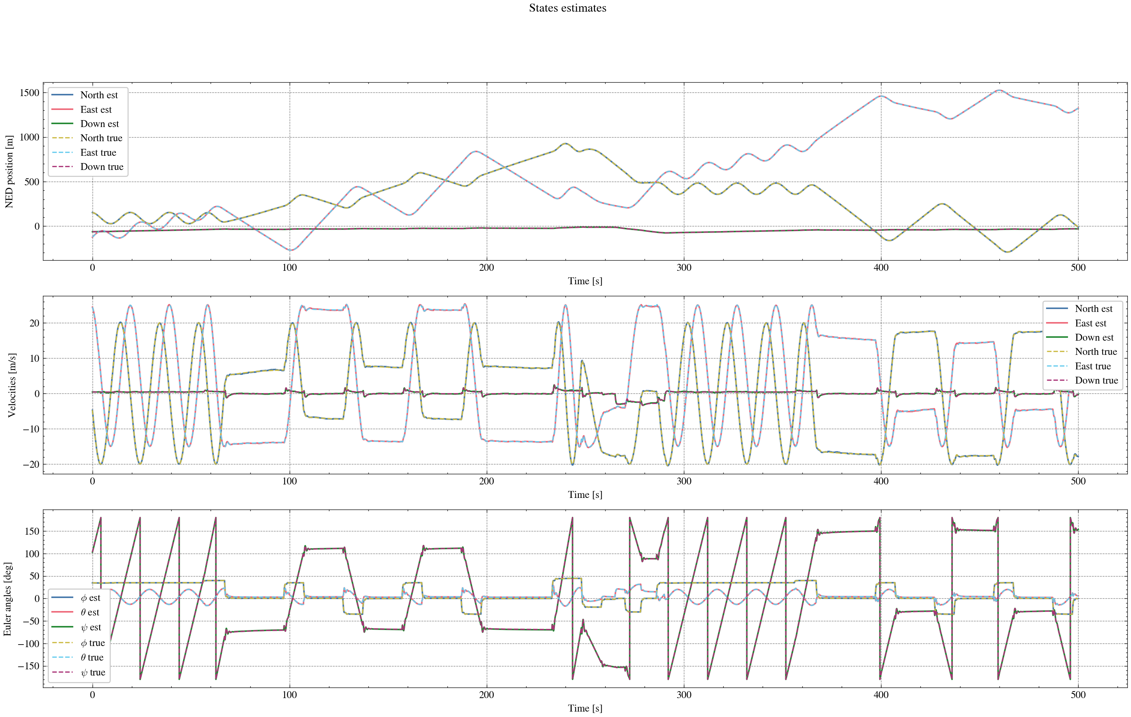
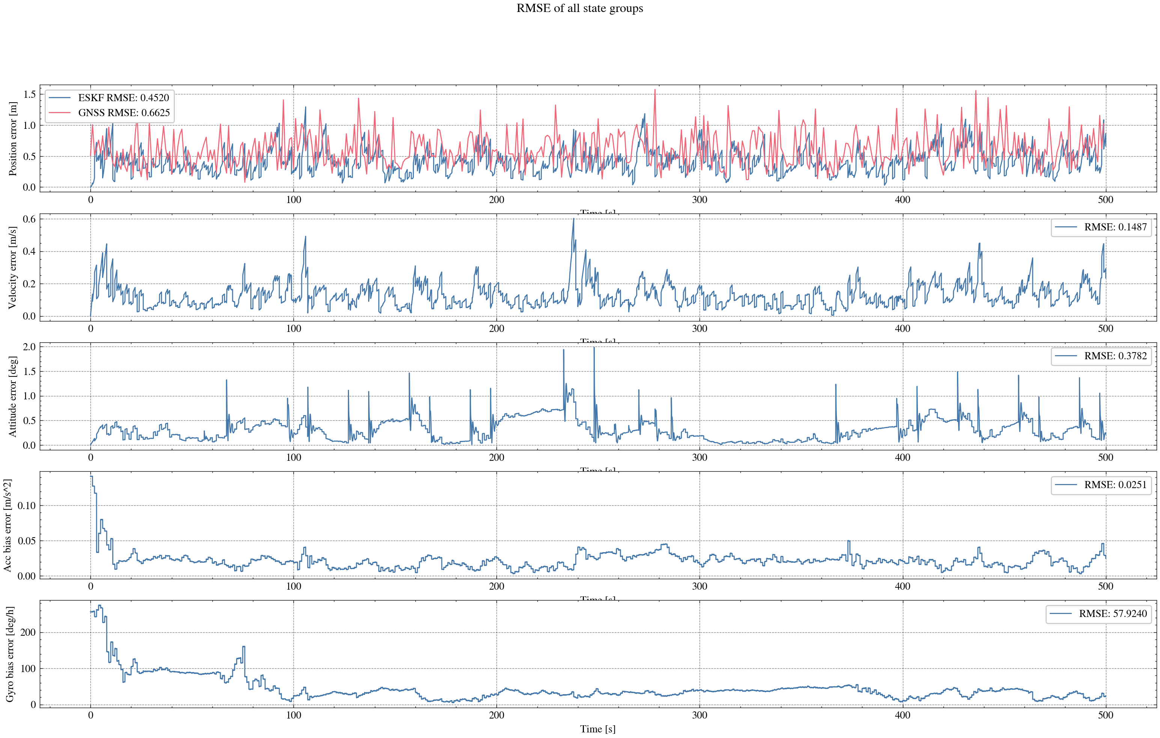
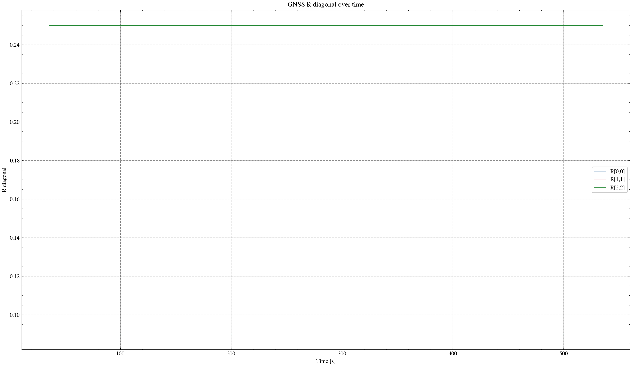

task_simulation_random_02
Input data: E:\eskf_bishe\bishe\ESKF-2.0\task_simulation_50000\task_simulation_random_02.mat
Run status: OK
==================== RMSE summary ====================
Position RMSE [m] (N,E,D): 0.2301, 0.2414, 0.3240
Velocity RMSE [m/s] (N,E,D): 0.0946, 0.0925, 0.0732
Attitude RMSE [deg] (roll,pitch,yaw): 0.1292, 0.1638, 0.3902
Acc bias RMSE [m/s^2] (x,y,z): 0.017528, 0.013410, 0.012923
Gyro bias RMSE [deg/h] (x,y,z): 34.2661, 22.5332, 29.1622
======================================================
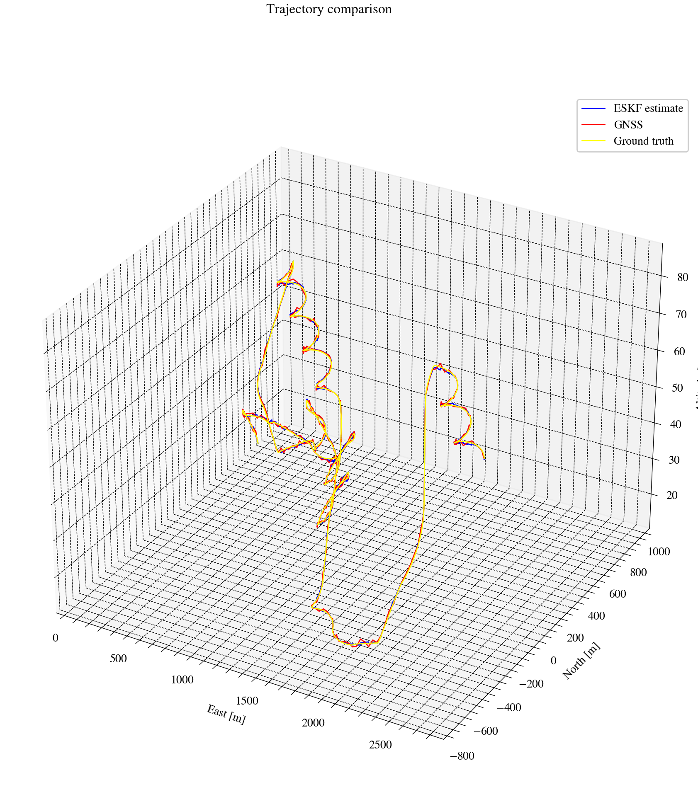
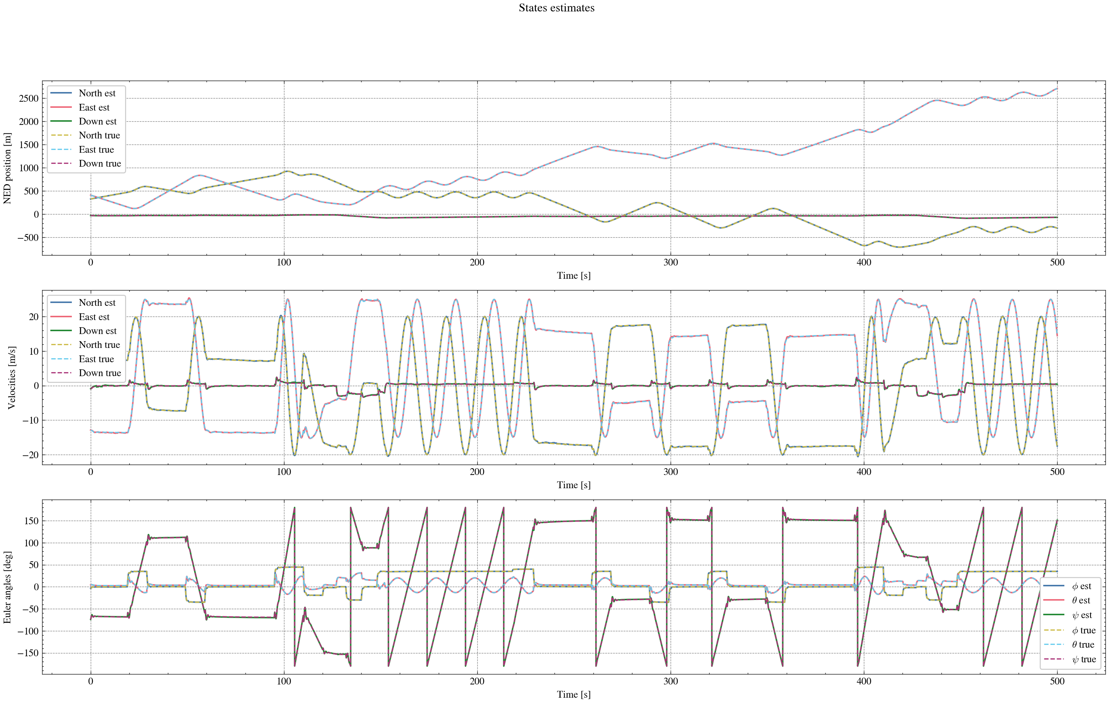
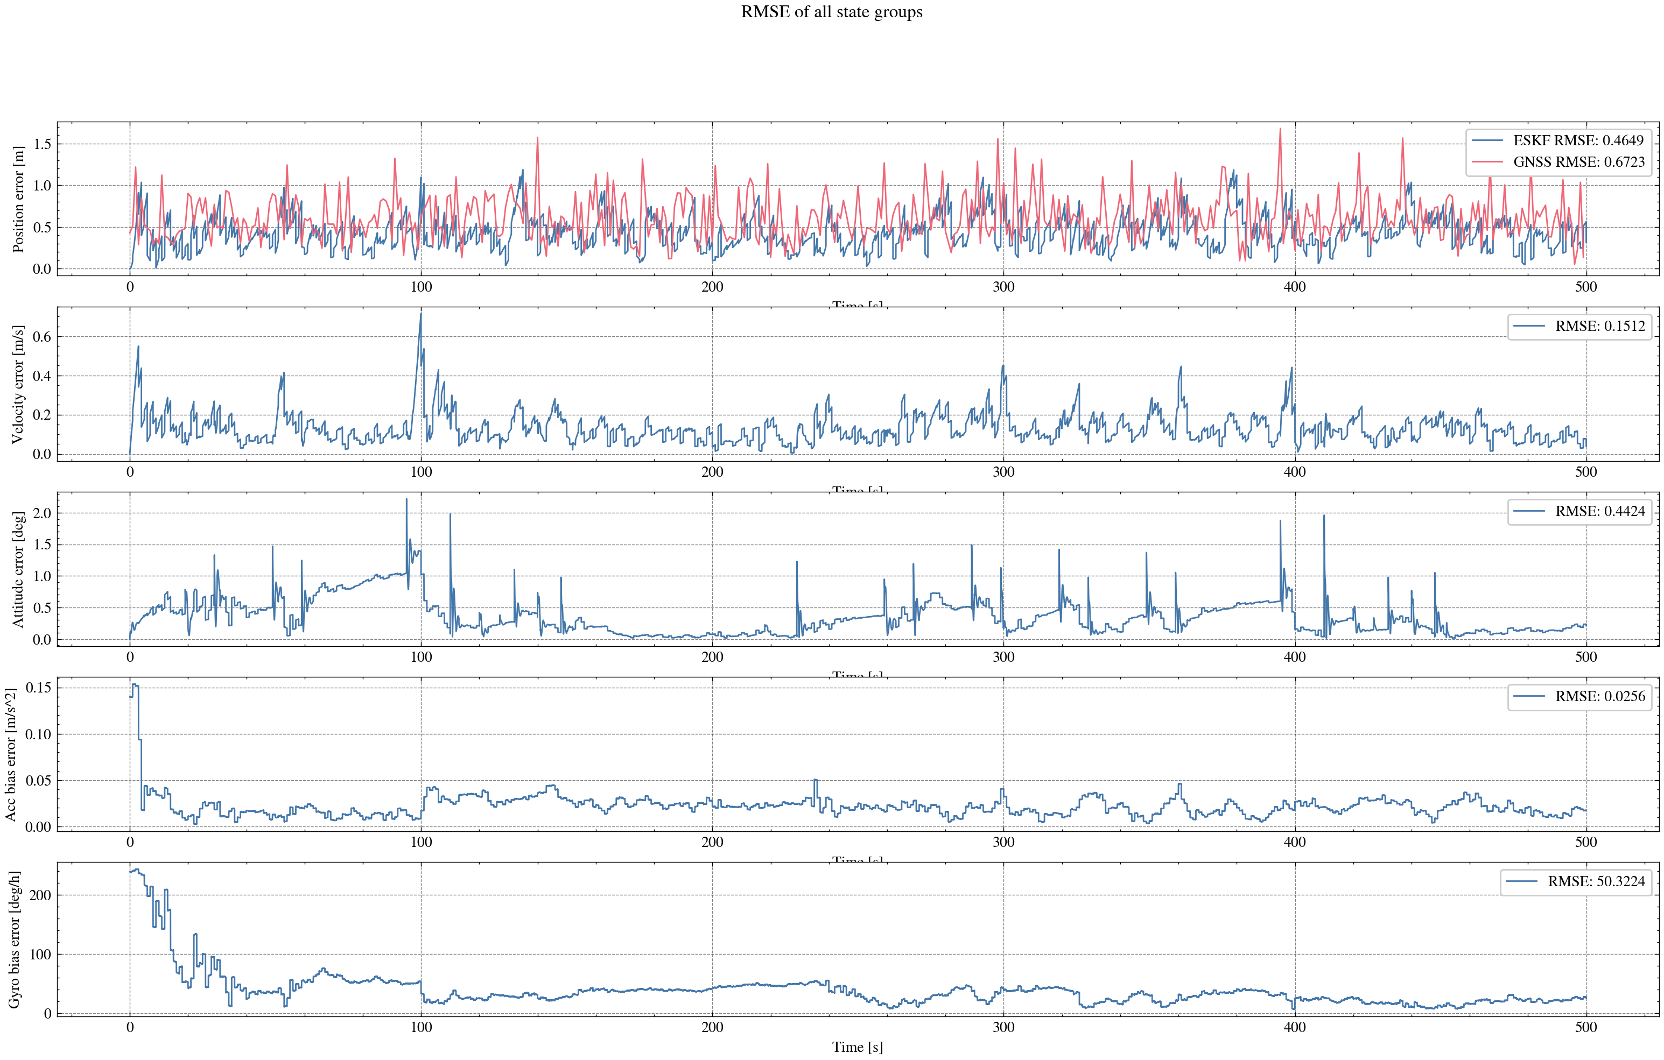
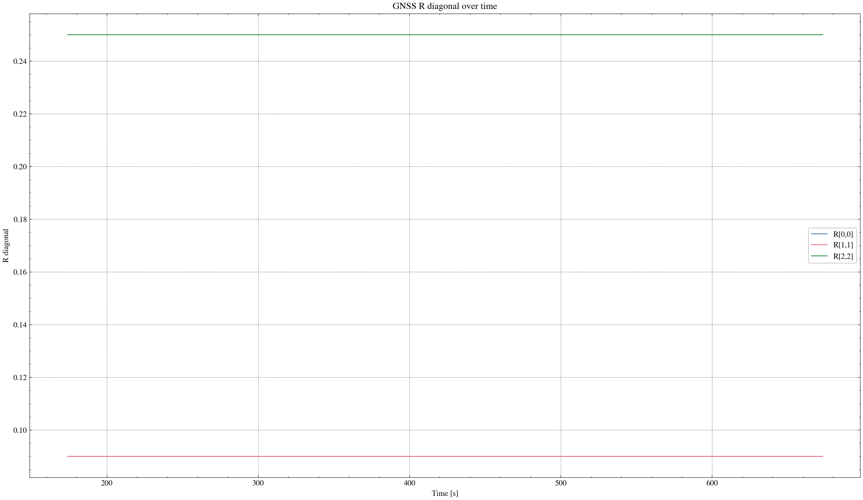

task_simulation_random_03
Input data: E:\eskf_bishe\bishe\ESKF-2.0\task_simulation_50000\task_simulation_random_03.mat
Run status: OK
==================== RMSE summary ====================
Position RMSE [m] (N,E,D): 0.2269, 0.2420, 0.3227
Velocity RMSE [m/s] (N,E,D): 0.0914, 0.0933, 0.0726
Attitude RMSE [deg] (roll,pitch,yaw): 0.1252, 0.1673, 0.3945
Acc bias RMSE [m/s^2] (x,y,z): 0.017459, 0.012250, 0.012634
Gyro bias RMSE [deg/h] (x,y,z): 33.1696, 24.3730, 32.7750
======================================================
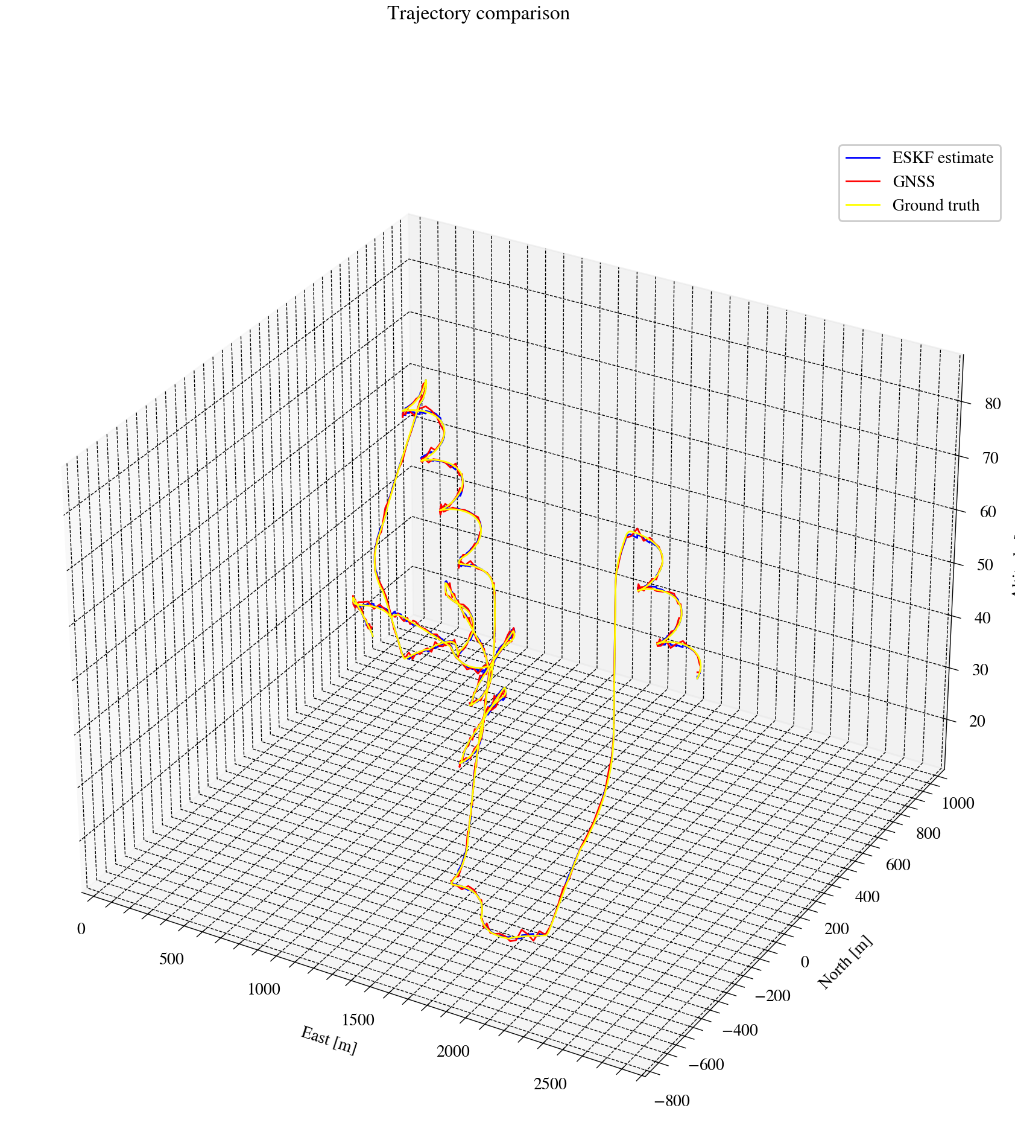
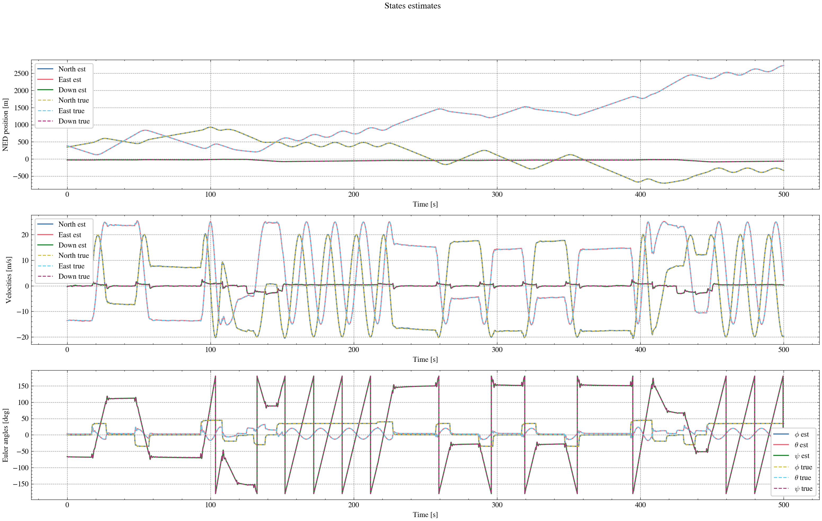
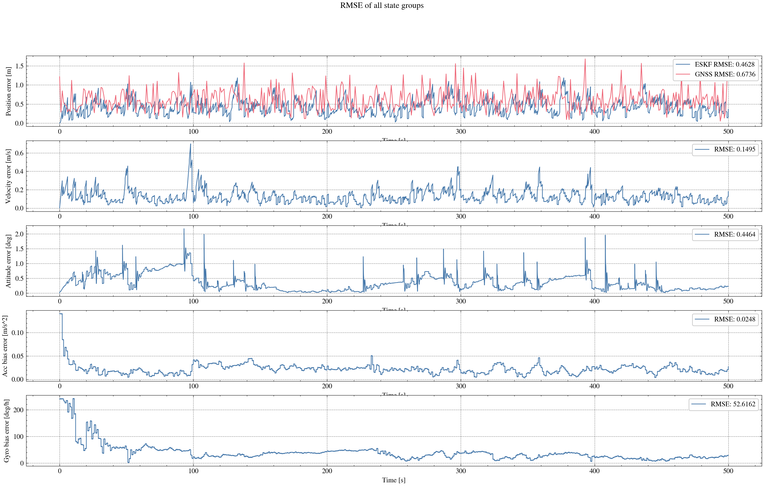
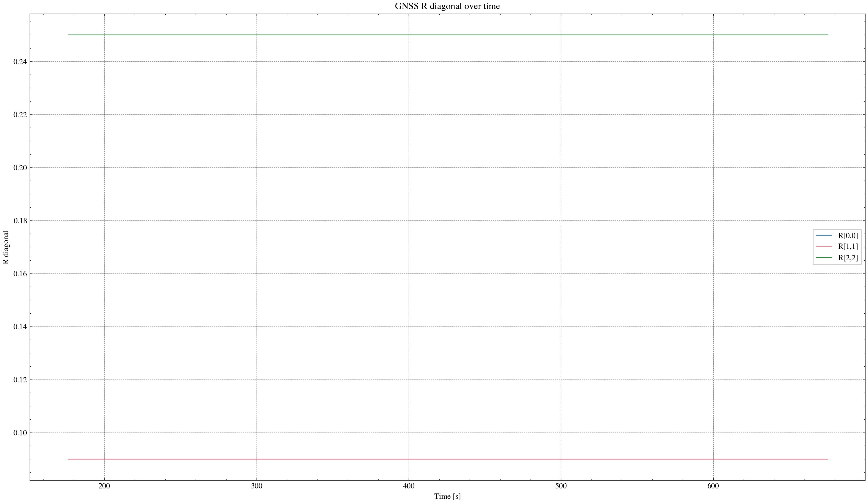

task_simulation_random_04
Input data: E:\eskf_bishe\bishe\ESKF-2.0\task_simulation_50000\task_simulation_random_04.mat
Run status: OK
==================== RMSE summary ====================
Position RMSE [m] (N,E,D): 0.2348, 0.2488, 0.3348
Velocity RMSE [m/s] (N,E,D): 0.0899, 0.0941, 0.0734
Attitude RMSE [deg] (roll,pitch,yaw): 0.1318, 0.1377, 0.3257
Acc bias RMSE [m/s^2] (x,y,z): 0.019489, 0.013263, 0.012958
Gyro bias RMSE [deg/h] (x,y,z): 38.4427, 23.6688, 24.8908
======================================================
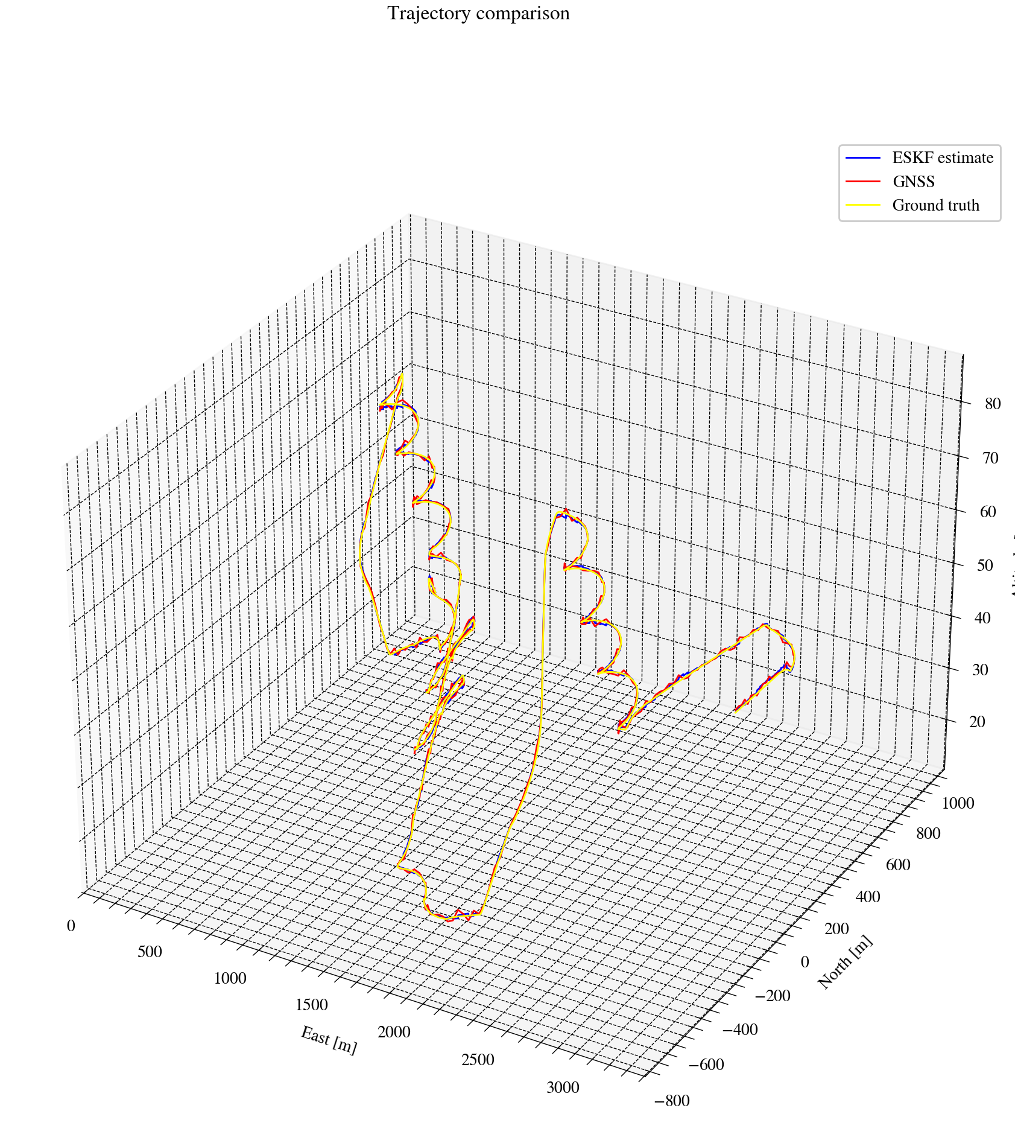
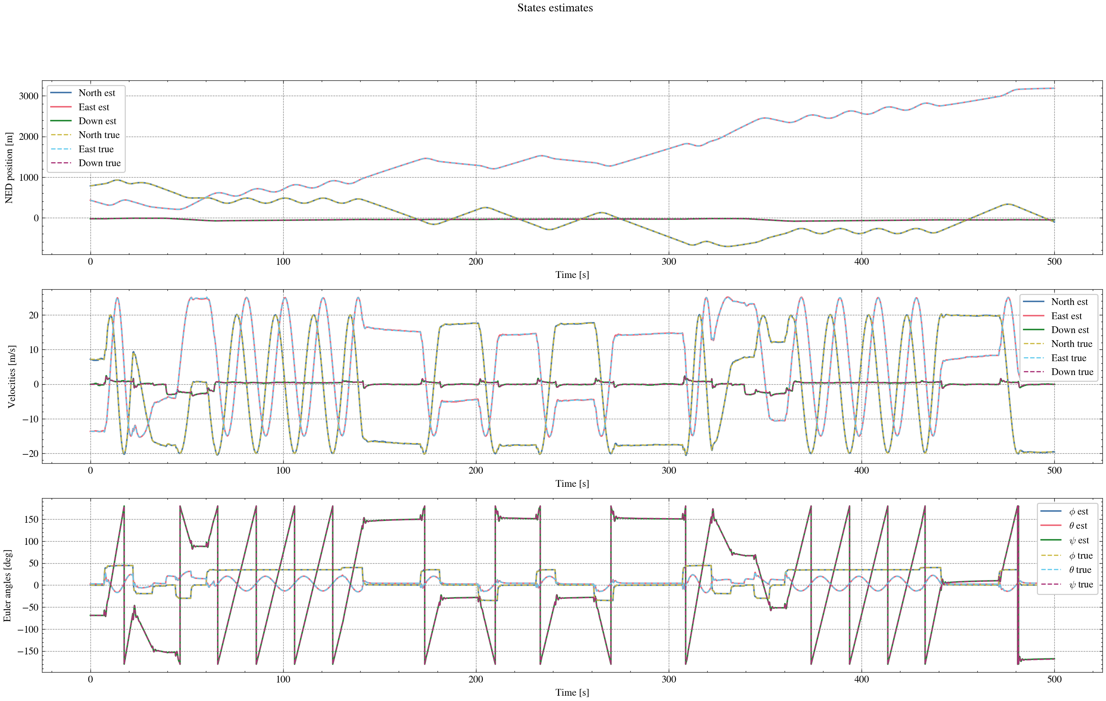
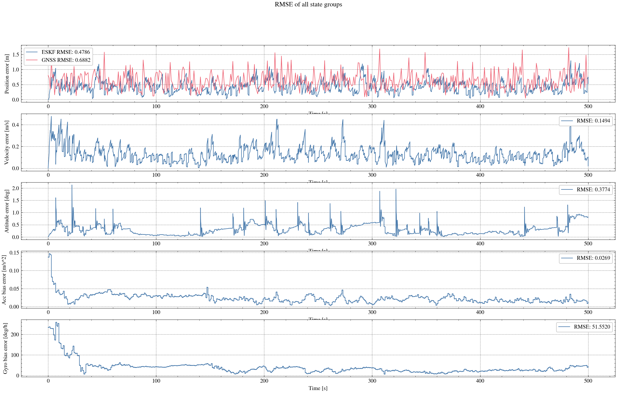
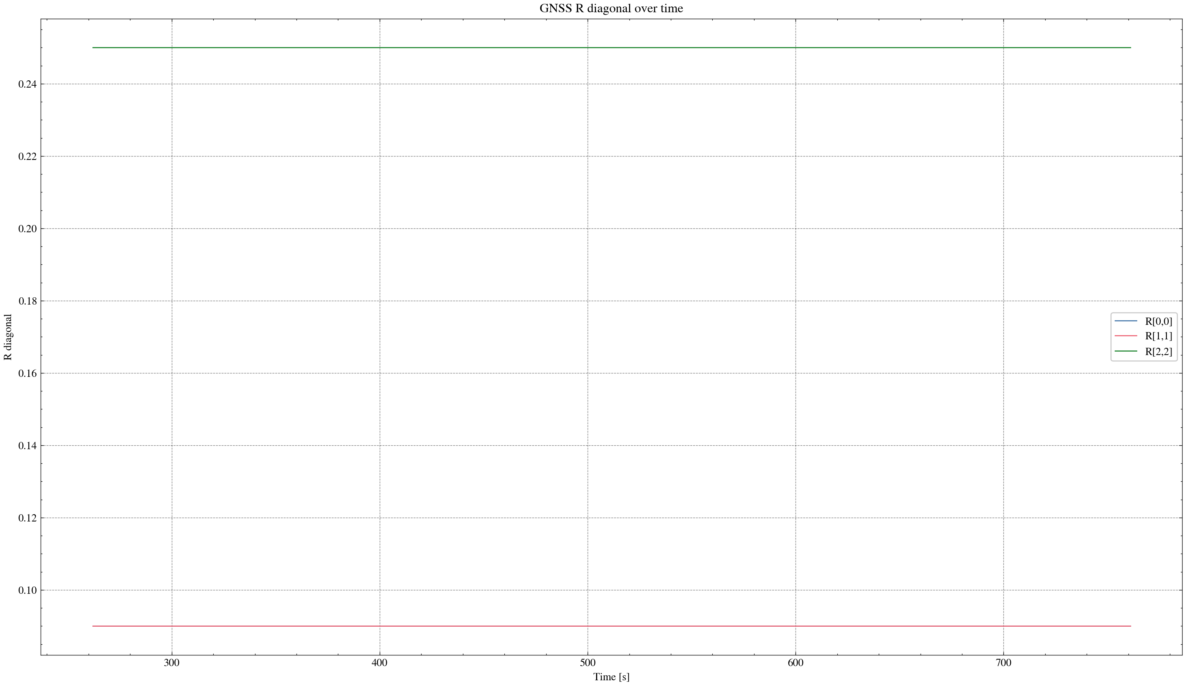

task_simulation_random_05
Input data: E:\eskf_bishe\bishe\ESKF-2.0\task_simulation_50000\task_simulation_random_05.mat
Run status: OK
==================== RMSE summary ====================
Position RMSE [m] (N,E,D): 0.2350, 0.2469, 0.3384
Velocity RMSE [m/s] (N,E,D): 0.0879, 0.0955, 0.0738
Attitude RMSE [deg] (roll,pitch,yaw): 0.1316, 0.1654, 0.3495
Acc bias RMSE [m/s^2] (x,y,z): 0.016310, 0.012111, 0.012084
Gyro bias RMSE [deg/h] (x,y,z): 35.3223, 33.2233, 33.5758
======================================================
