ESKF Batch Simulation Report
Generated at: 2026-04-23 21:04:40
Data folder: E:\eskf_bishe\bishe\ESKF-2.0\task_simulation_9000

task_simulation_part_01
Input data: E:\eskf_bishe\bishe\ESKF-2.0\task_simulation_9000\task_simulation_part_01.mat
Run status: OK
==================== RMSE summary ====================
Position RMSE [m] (N,E,D): 0.2606, 0.2784, 0.3761
Velocity RMSE [m/s] (N,E,D): 0.1001, 0.1381, 0.1114
Attitude RMSE [deg] (roll,pitch,yaw): 0.1637, 0.2250, 0.3179
Acc bias RMSE [m/s^2] (x,y,z): 0.022101, 0.024777, 0.022192
Gyro bias RMSE [deg/h] (x,y,z): 68.8332, 63.6148, 66.1277
======================================================
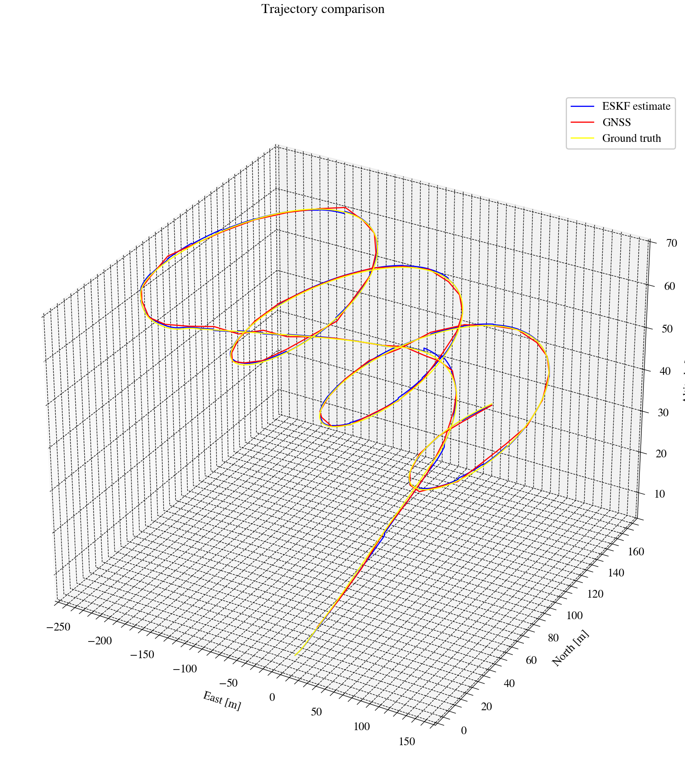
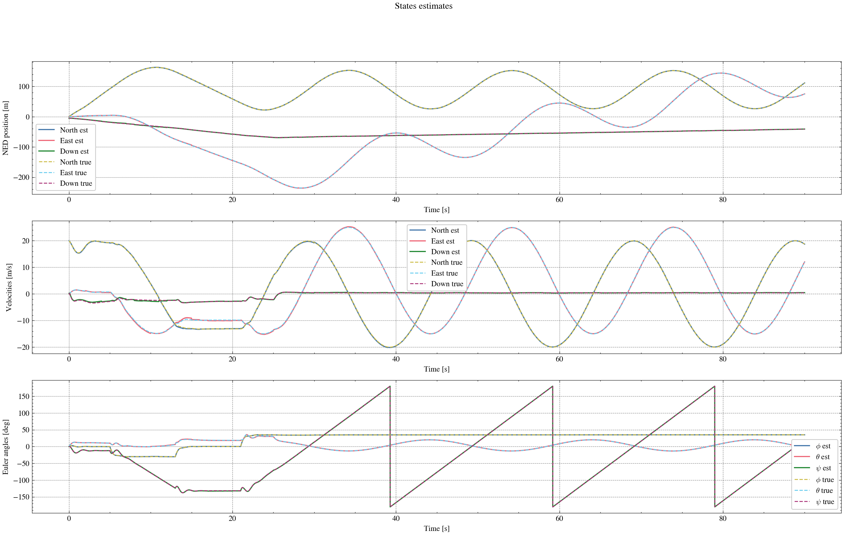
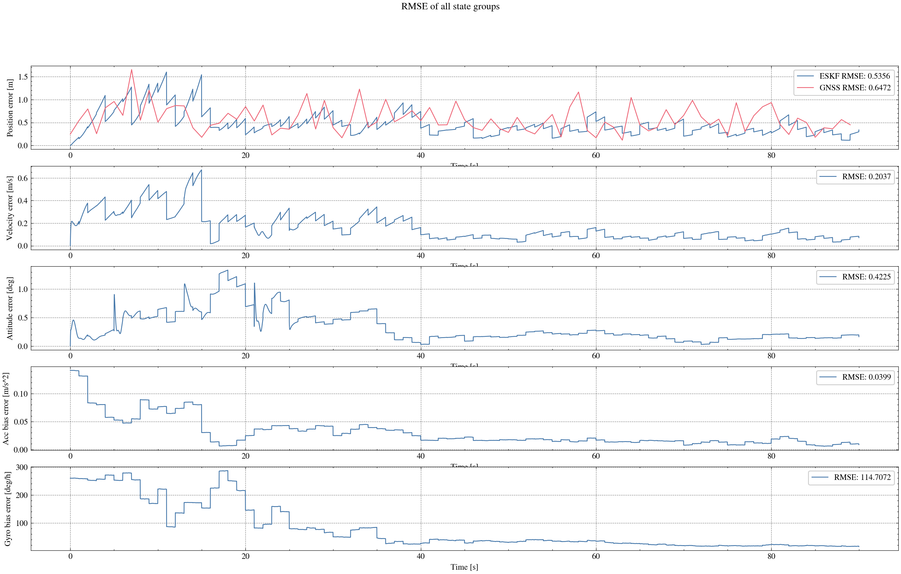
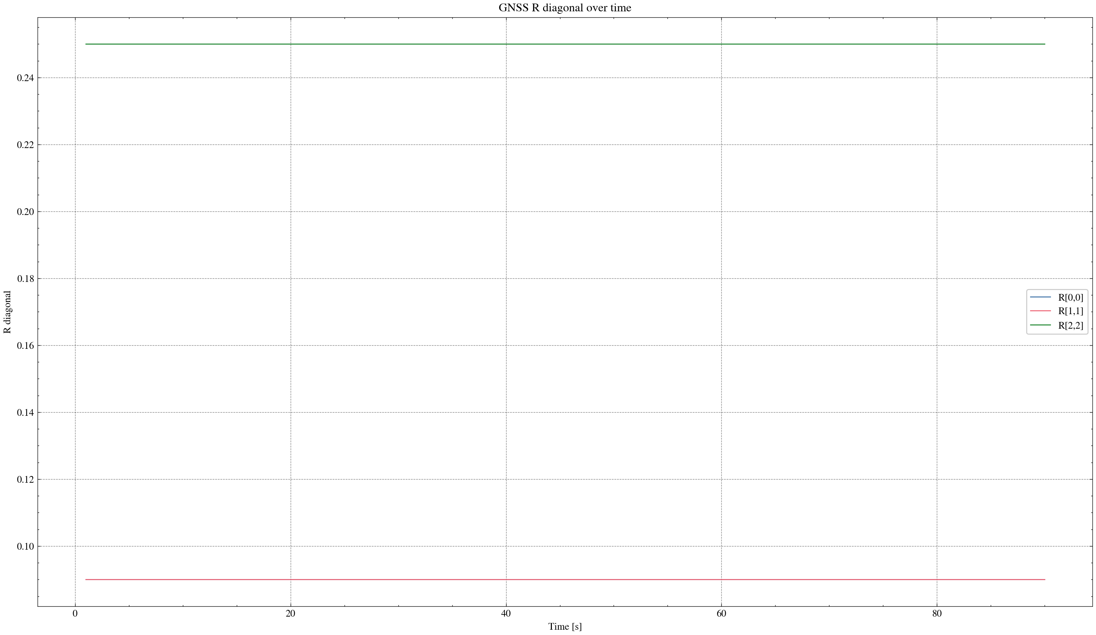

task_simulation_part_02
Input data: E:\eskf_bishe\bishe\ESKF-2.0\task_simulation_9000\task_simulation_part_02.mat
Run status: OK
==================== RMSE summary ====================
Position RMSE [m] (N,E,D): 0.2928, 0.2278, 0.3193
Velocity RMSE [m/s] (N,E,D): 0.1130, 0.1028, 0.0748
Attitude RMSE [deg] (roll,pitch,yaw): 0.1689, 0.1739, 0.3156
Acc bias RMSE [m/s^2] (x,y,z): 0.026858, 0.018551, 0.015732
Gyro bias RMSE [deg/h] (x,y,z): 70.9017, 60.2115, 35.2300
======================================================
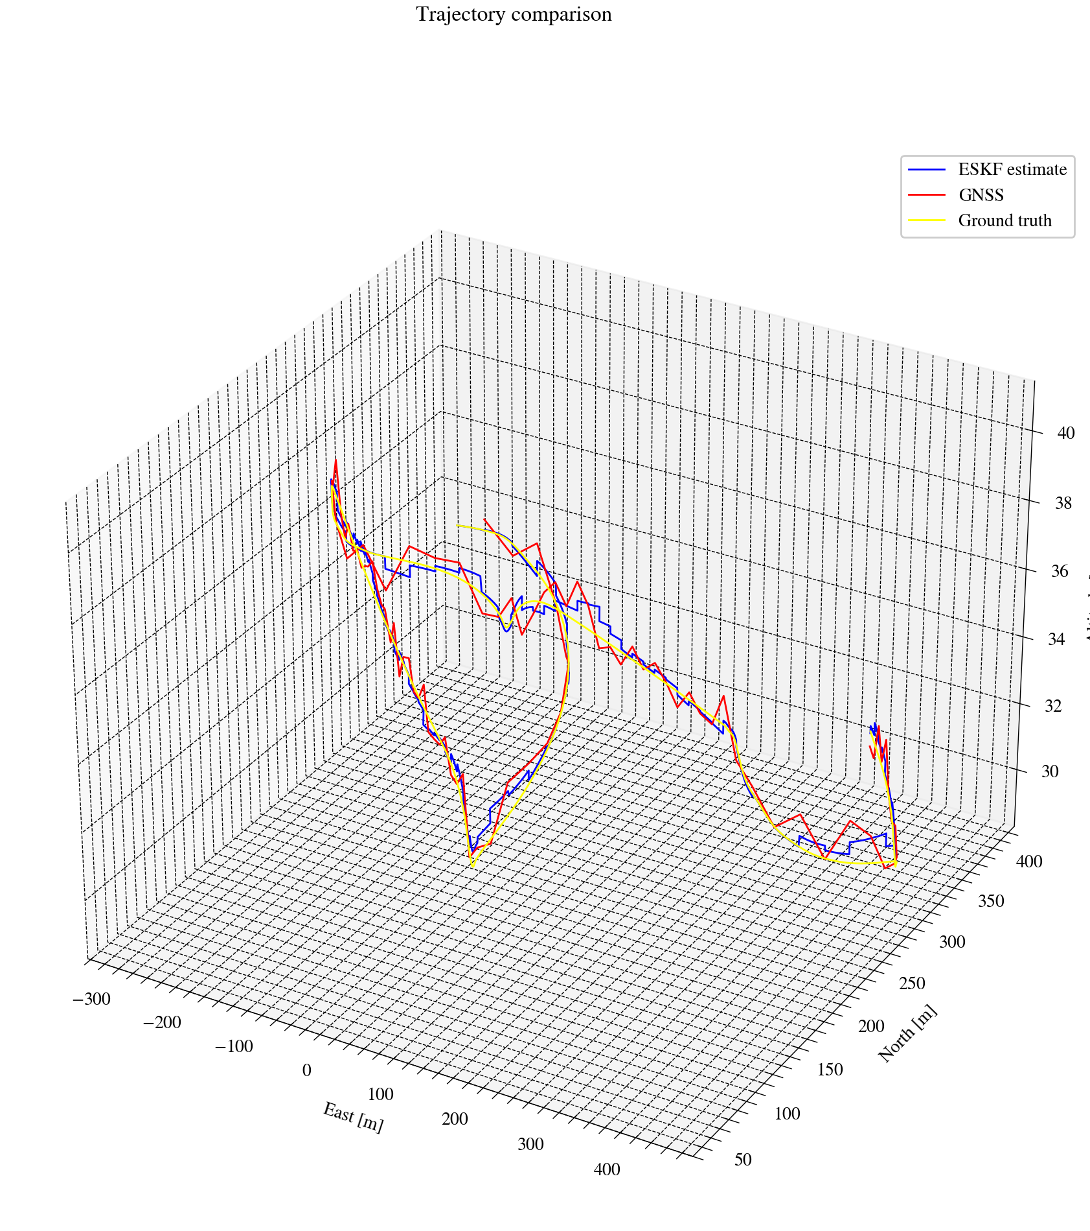
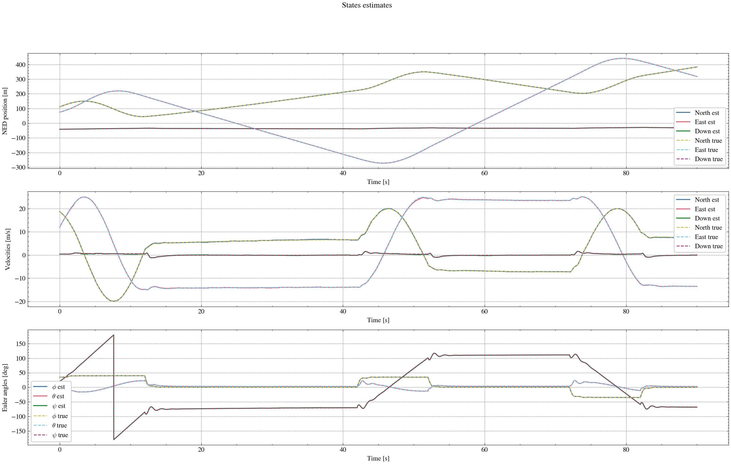
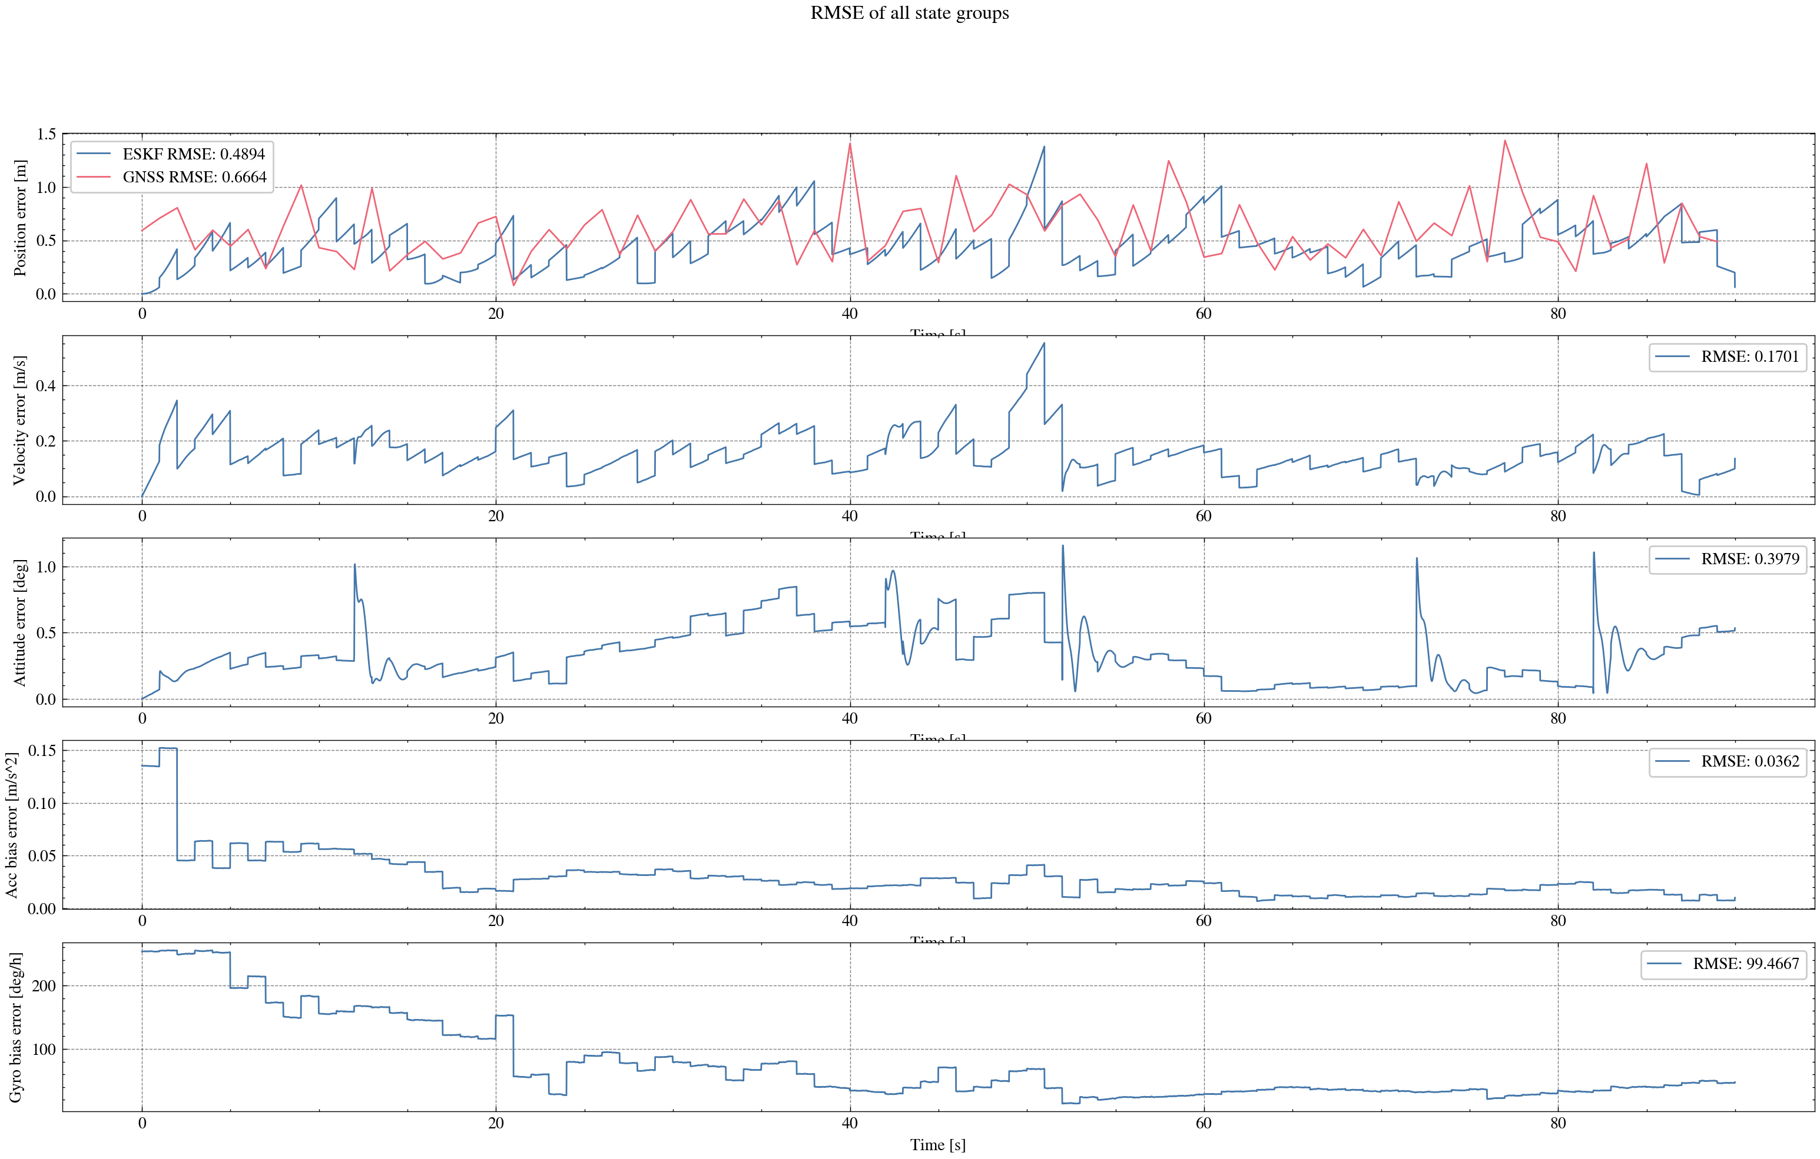
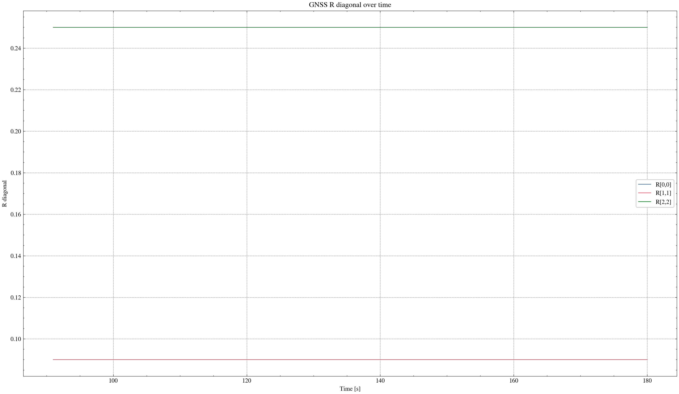

task_simulation_part_03
Input data: E:\eskf_bishe\bishe\ESKF-2.0\task_simulation_9000\task_simulation_part_03.mat
Run status: OK
==================== RMSE summary ====================
Position RMSE [m] (N,E,D): 0.2057, 0.2424, 0.3002
Velocity RMSE [m/s] (N,E,D): 0.0842, 0.1022, 0.0741
Attitude RMSE [deg] (roll,pitch,yaw): 0.1538, 0.2105, 0.7382
Acc bias RMSE [m/s^2] (x,y,z): 0.018543, 0.017301, 0.016533
Gyro bias RMSE [deg/h] (x,y,z): 56.6875, 52.9279, 75.1379
======================================================
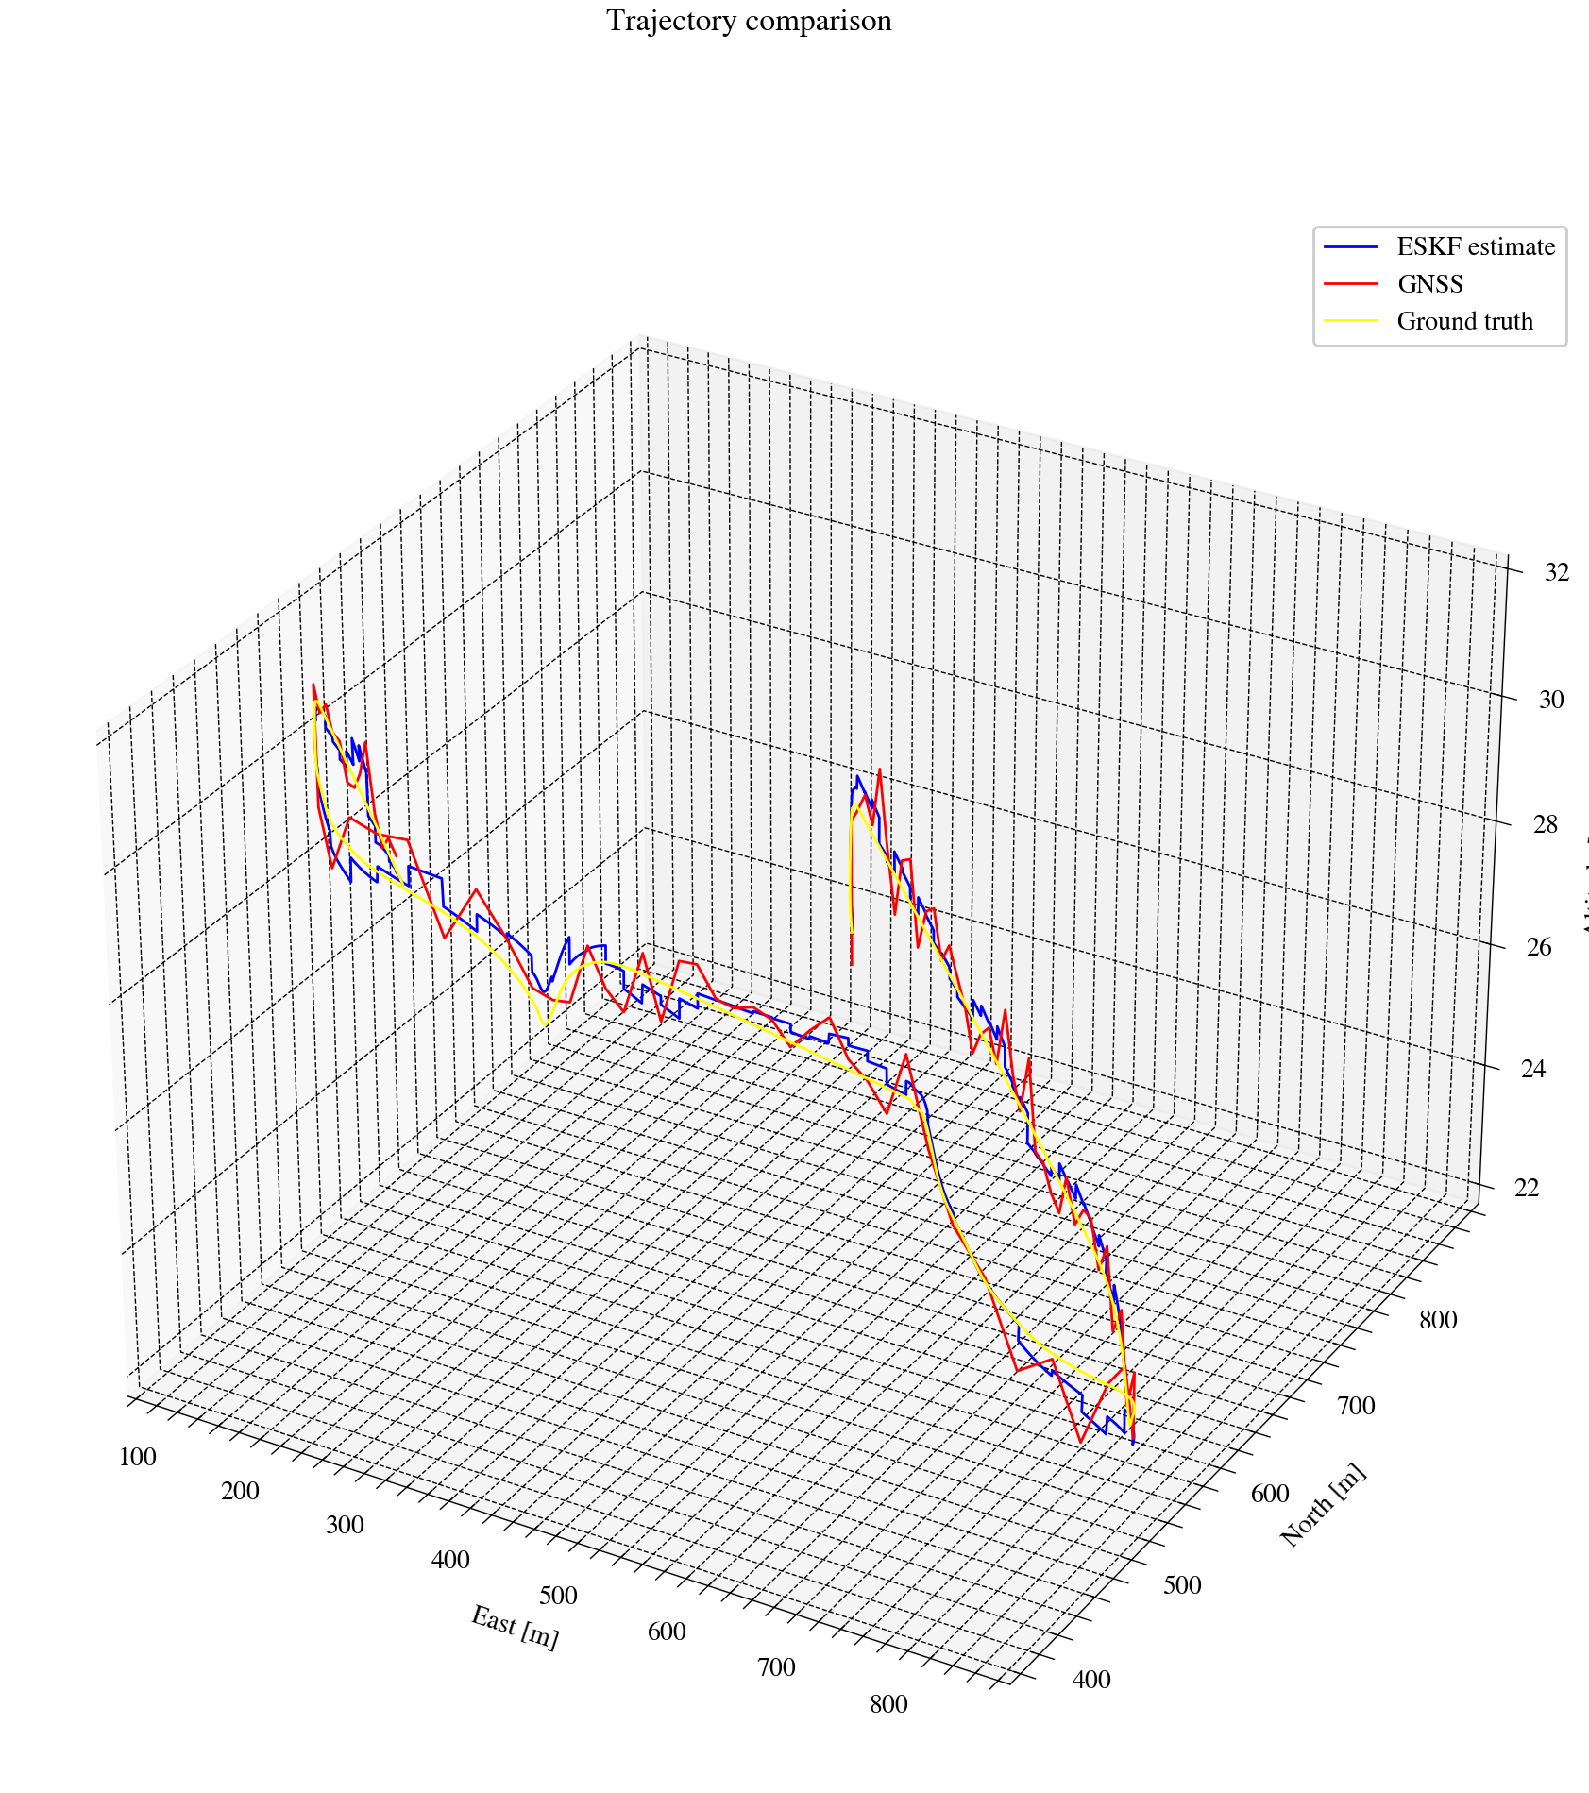
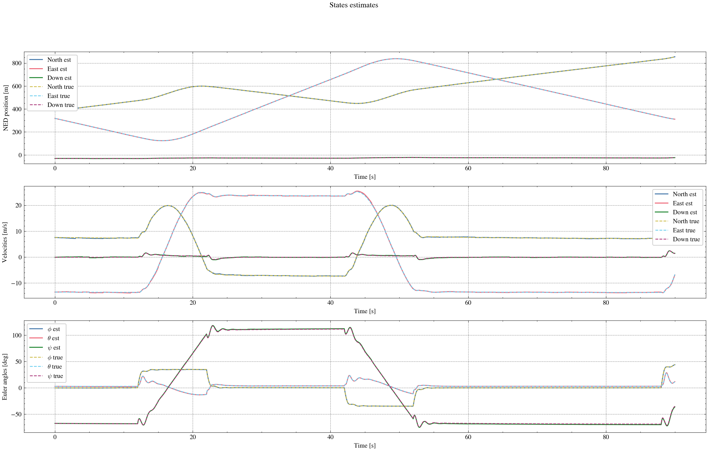
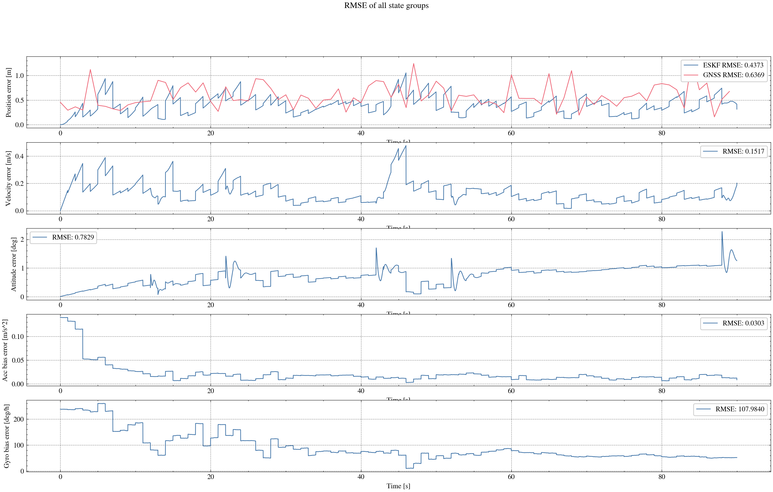
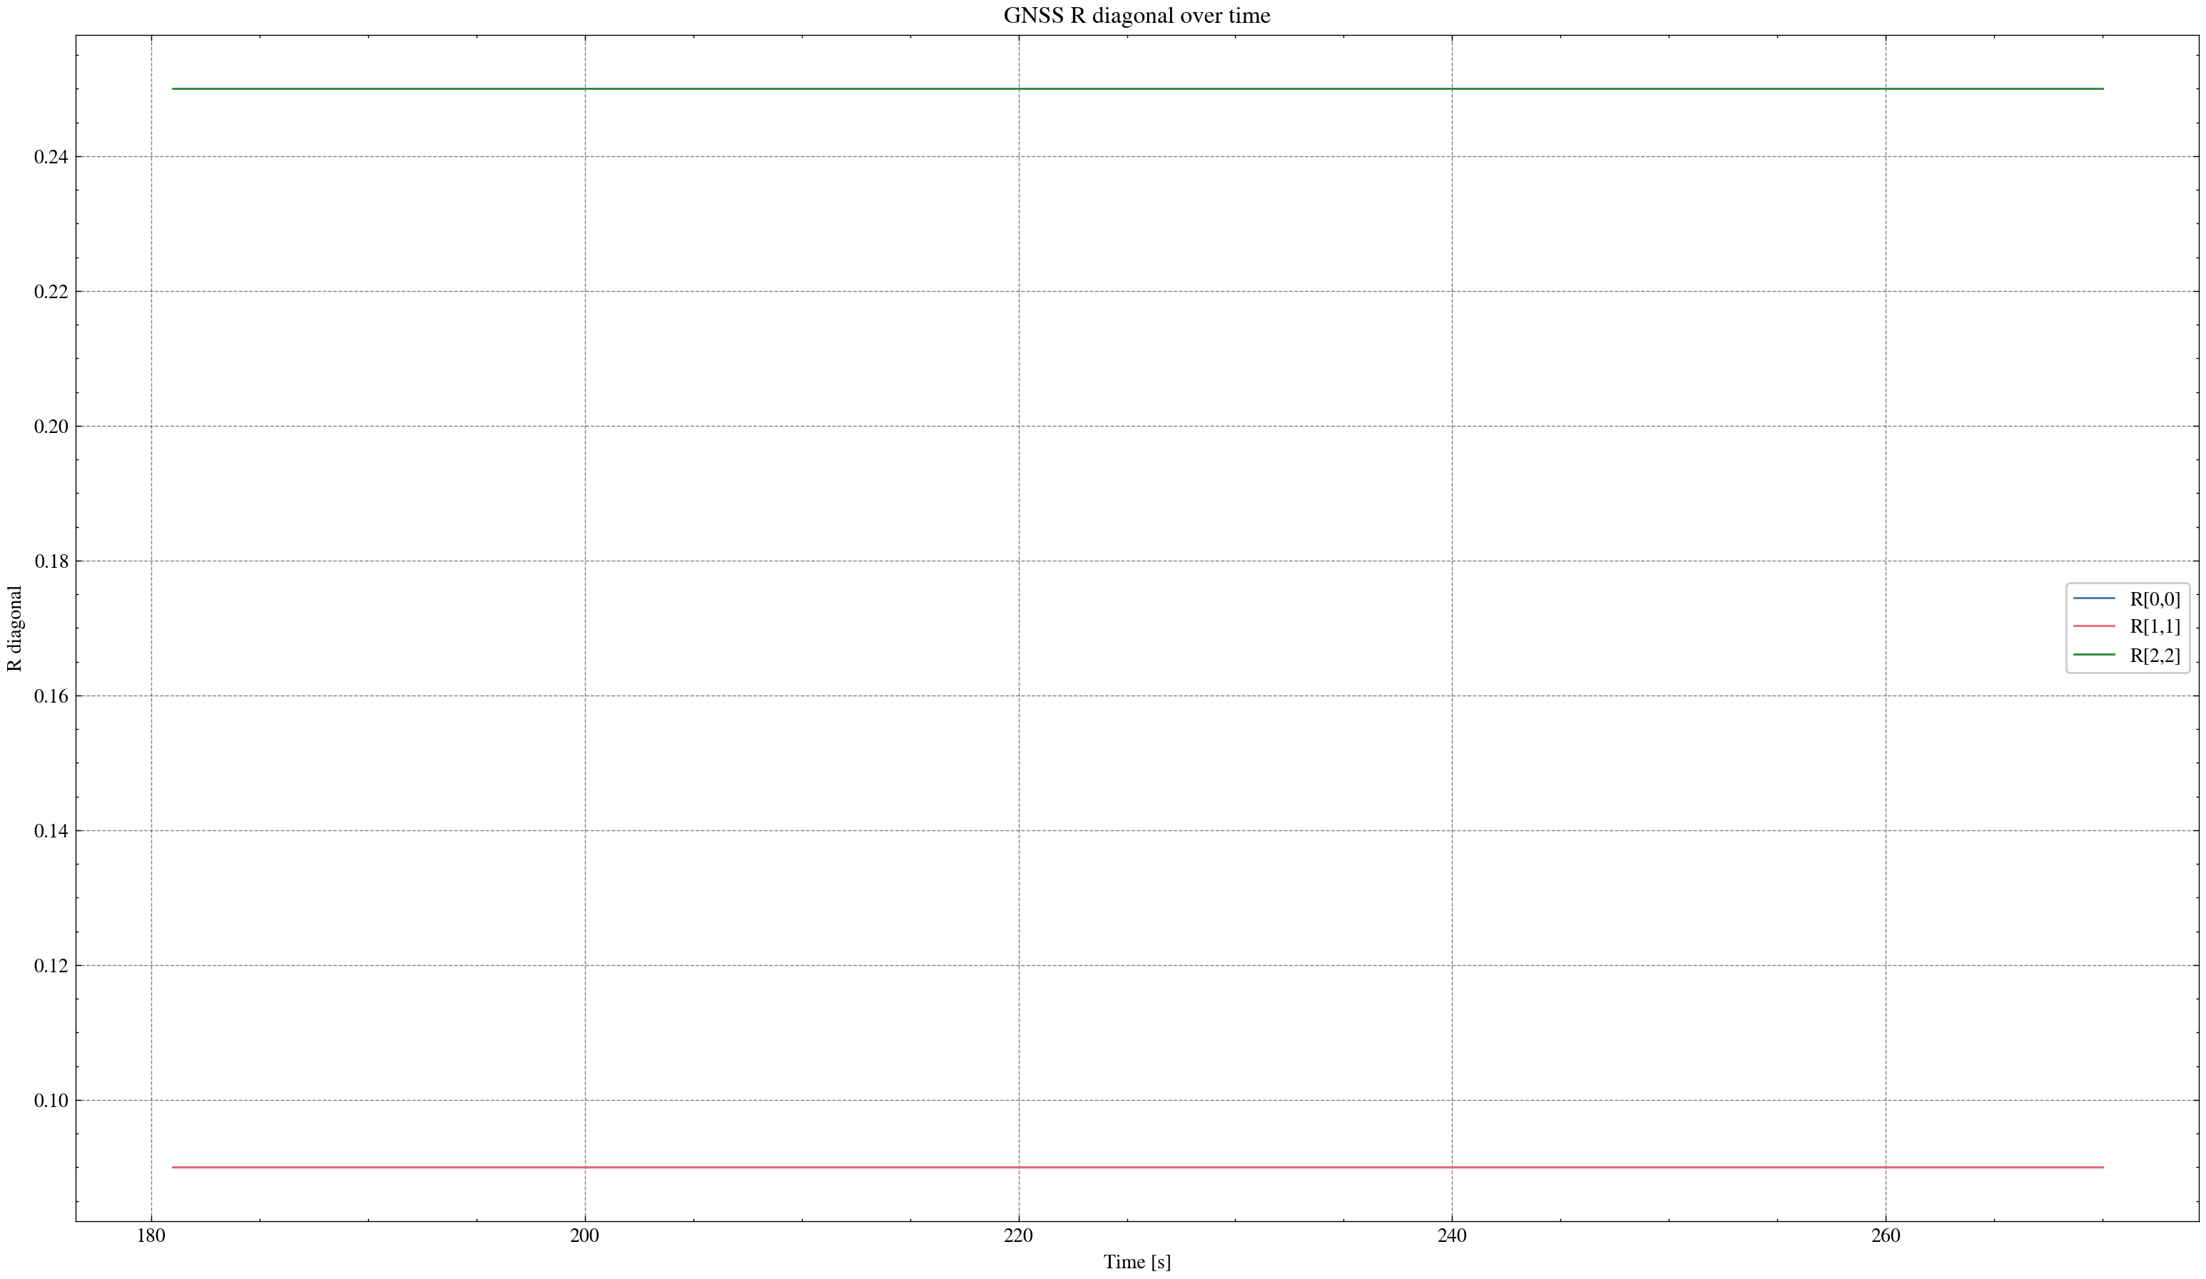

task_simulation_part_04
Input data: E:\eskf_bishe\bishe\ESKF-2.0\task_simulation_9000\task_simulation_part_04.mat
Run status: OK
==================== RMSE summary ====================
Position RMSE [m] (N,E,D): 0.2491, 0.2465, 0.3537
Velocity RMSE [m/s] (N,E,D): 0.0992, 0.1057, 0.0855
Attitude RMSE [deg] (roll,pitch,yaw): 0.1696, 0.2355, 0.2677
Acc bias RMSE [m/s^2] (x,y,z): 0.042998, 0.021610, 0.016455
Gyro bias RMSE [deg/h] (x,y,z): 85.4079, 68.7057, 30.1369
======================================================
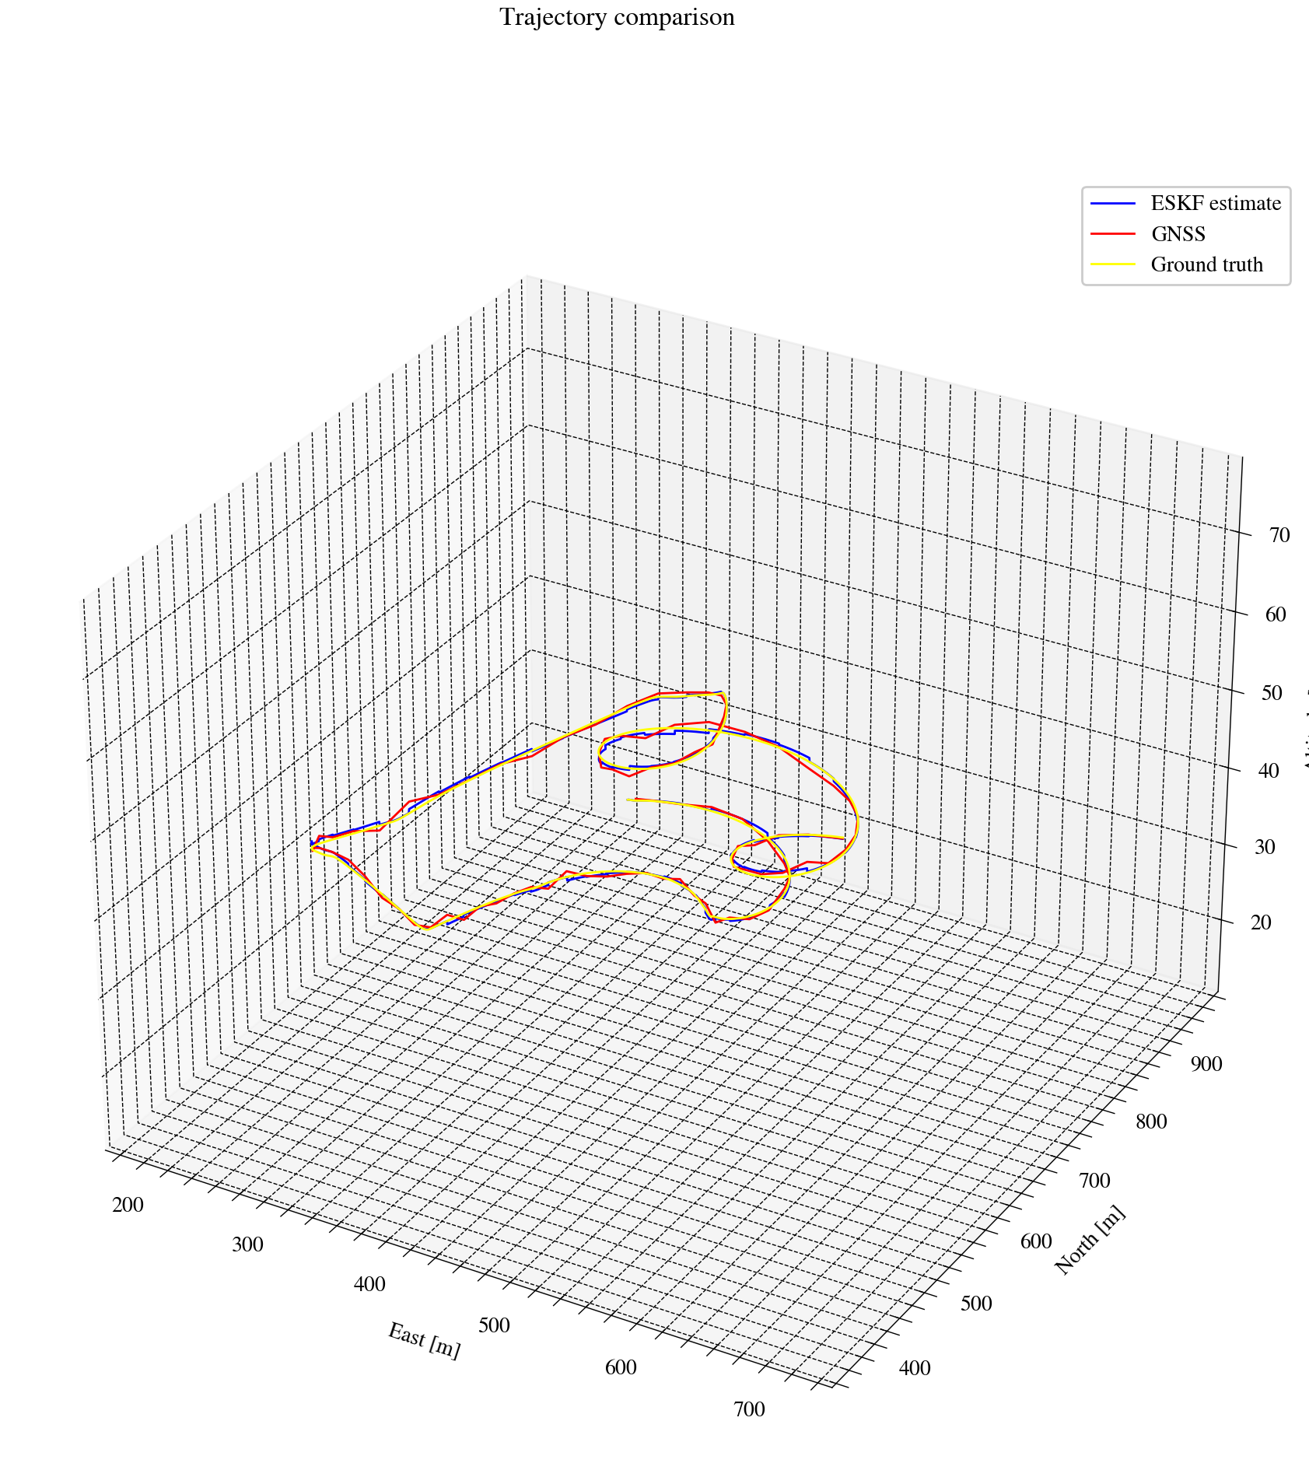
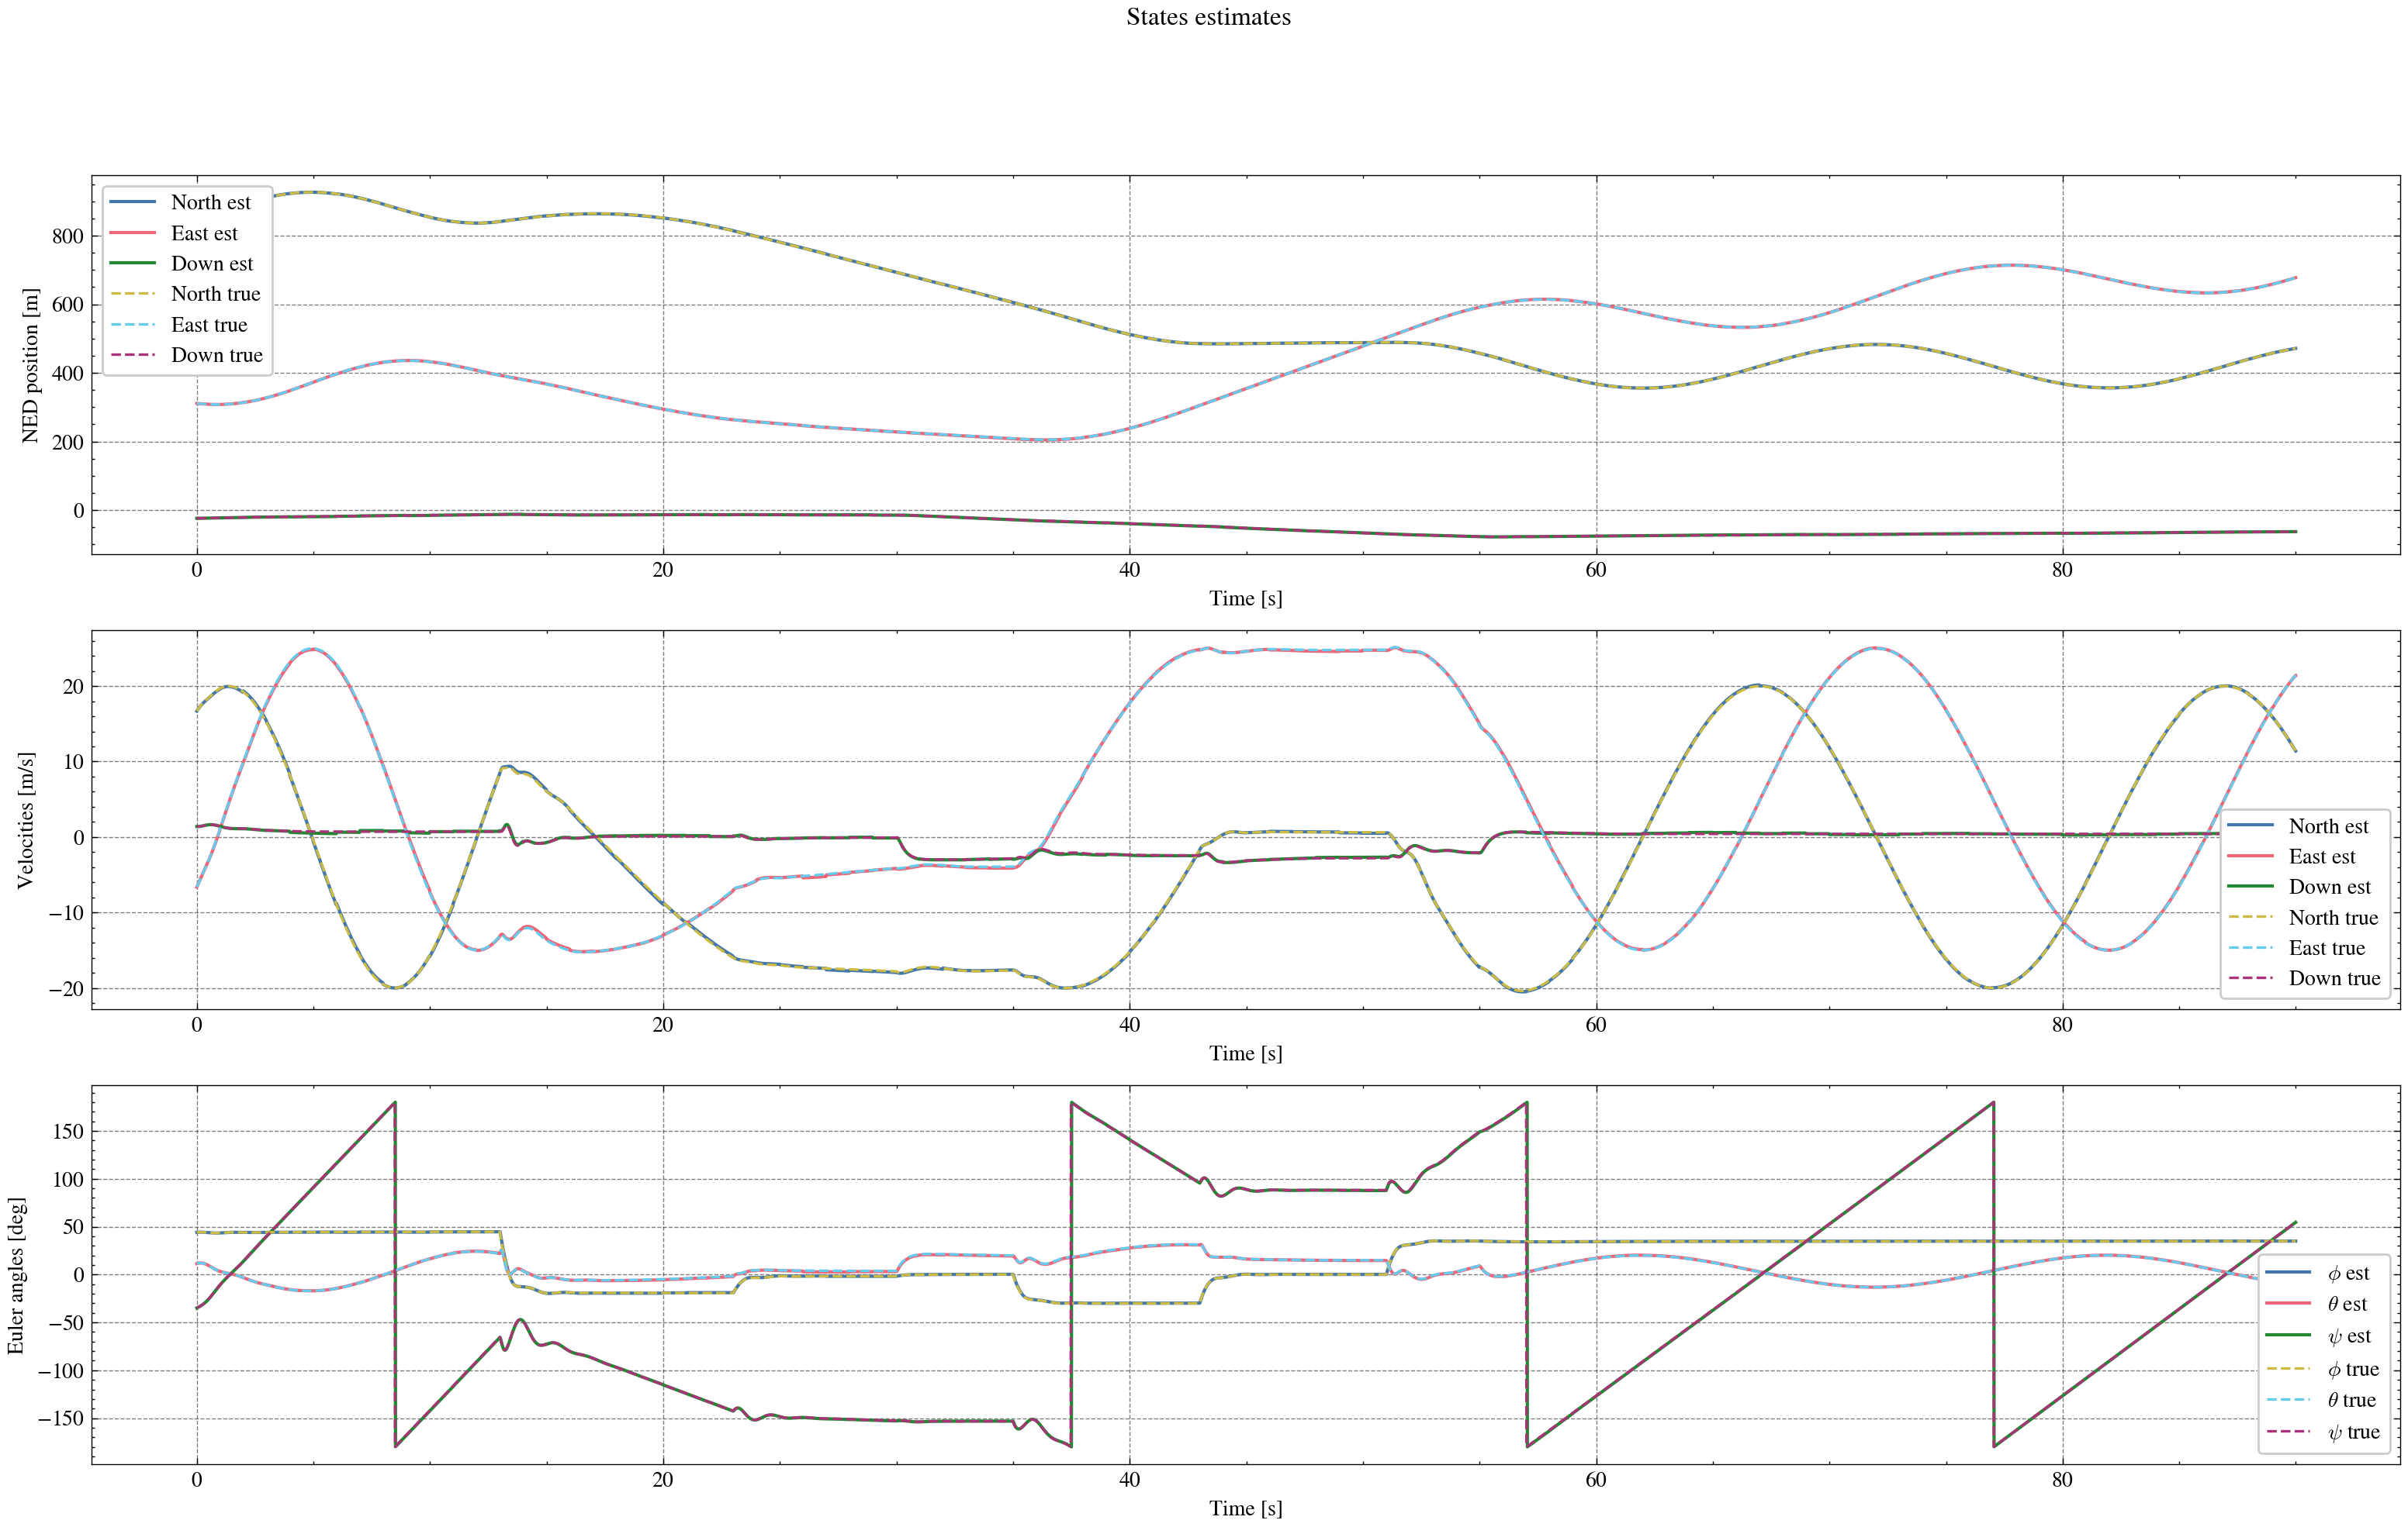
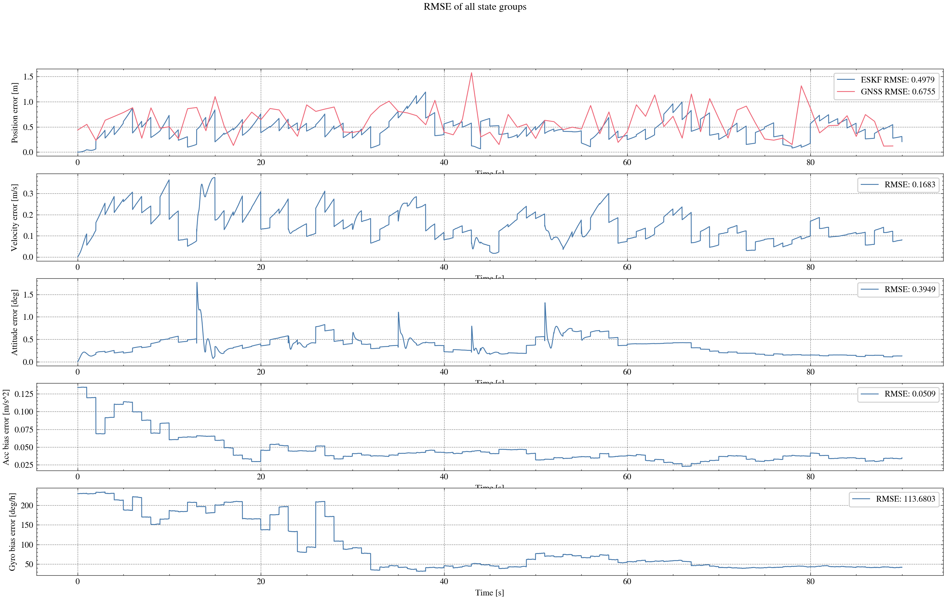
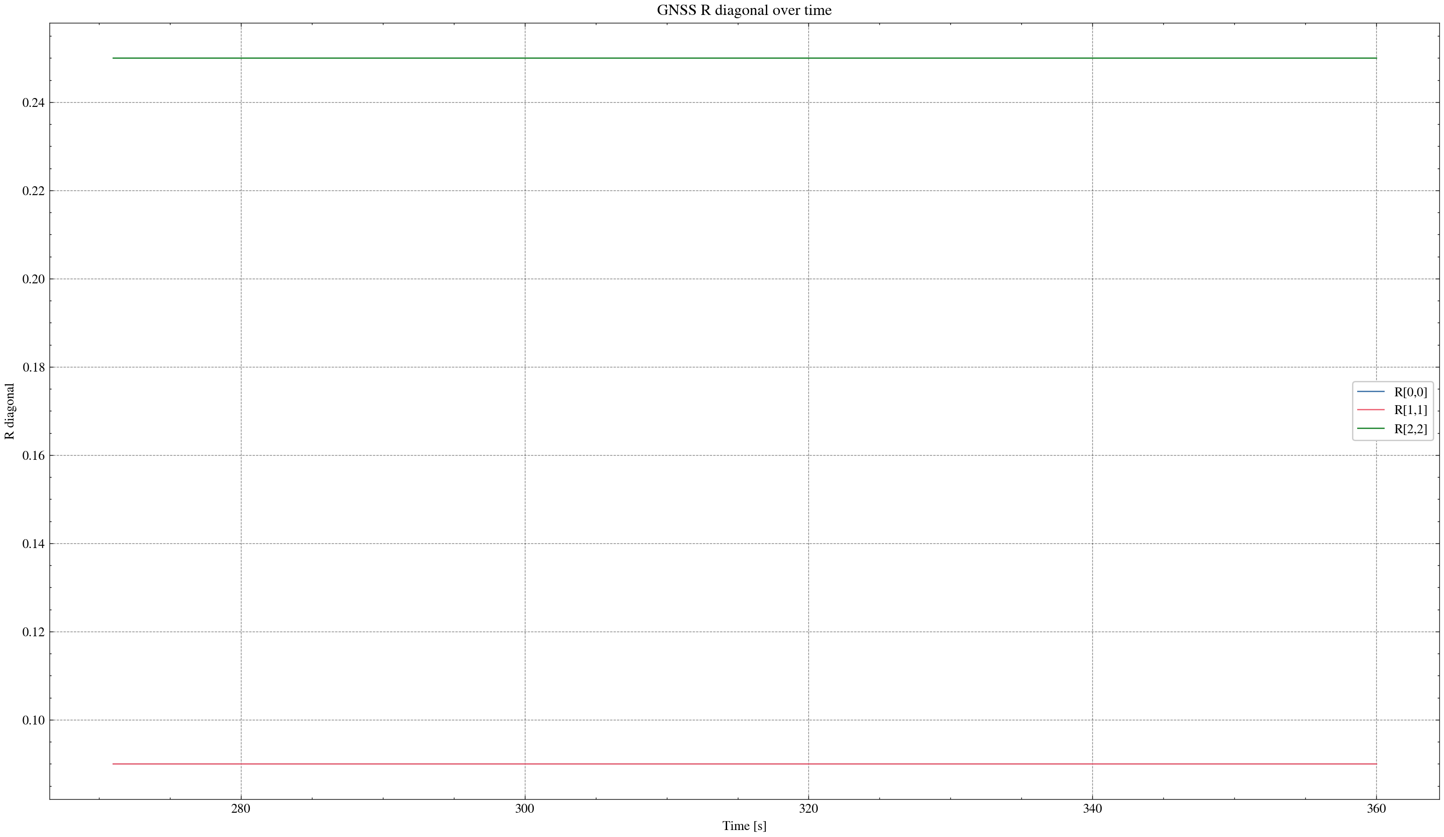

task_simulation_part_05
Input data: E:\eskf_bishe\bishe\ESKF-2.0\task_simulation_9000\task_simulation_part_05.mat
Run status: OK
==================== RMSE summary ====================
Position RMSE [m] (N,E,D): 0.2511, 0.2168, 0.2737
Velocity RMSE [m/s] (N,E,D): 0.1097, 0.0890, 0.0695
Attitude RMSE [deg] (roll,pitch,yaw): 0.1360, 0.1928, 0.2918
Acc bias RMSE [m/s^2] (x,y,z): 0.028936, 0.019426, 0.020150
Gyro bias RMSE [deg/h] (x,y,z): 81.3398, 61.8917, 31.6662
======================================================
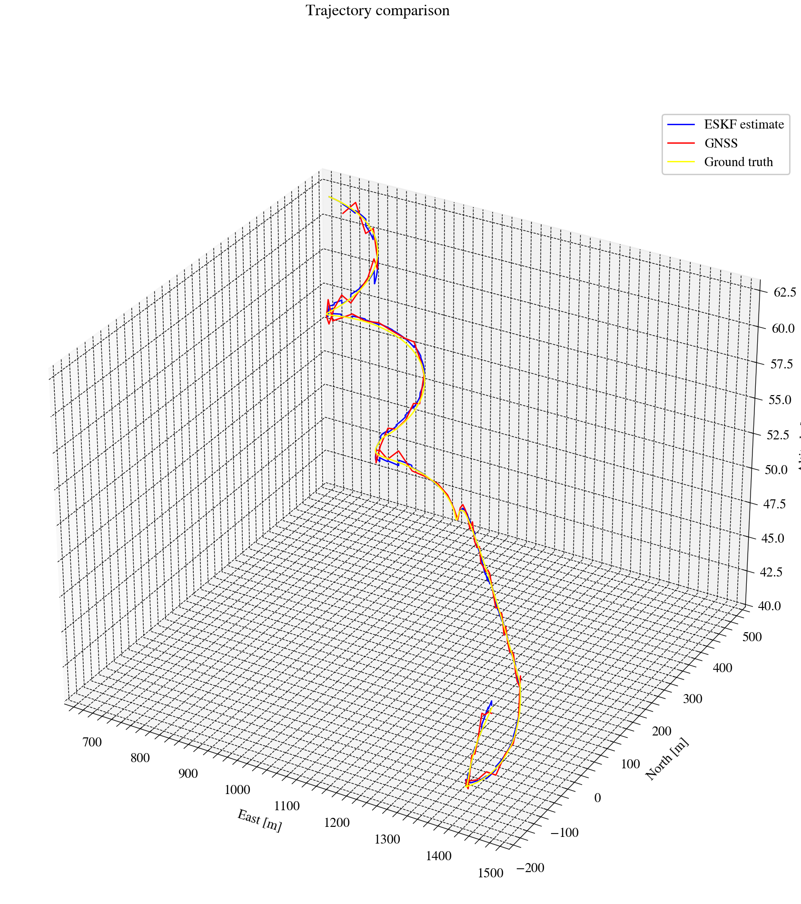
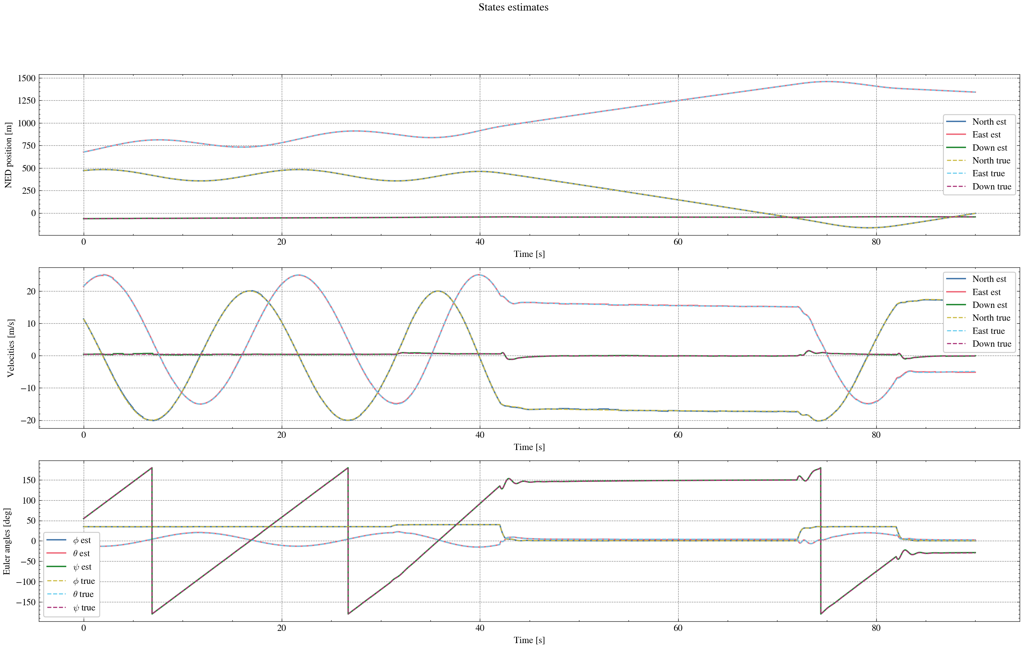
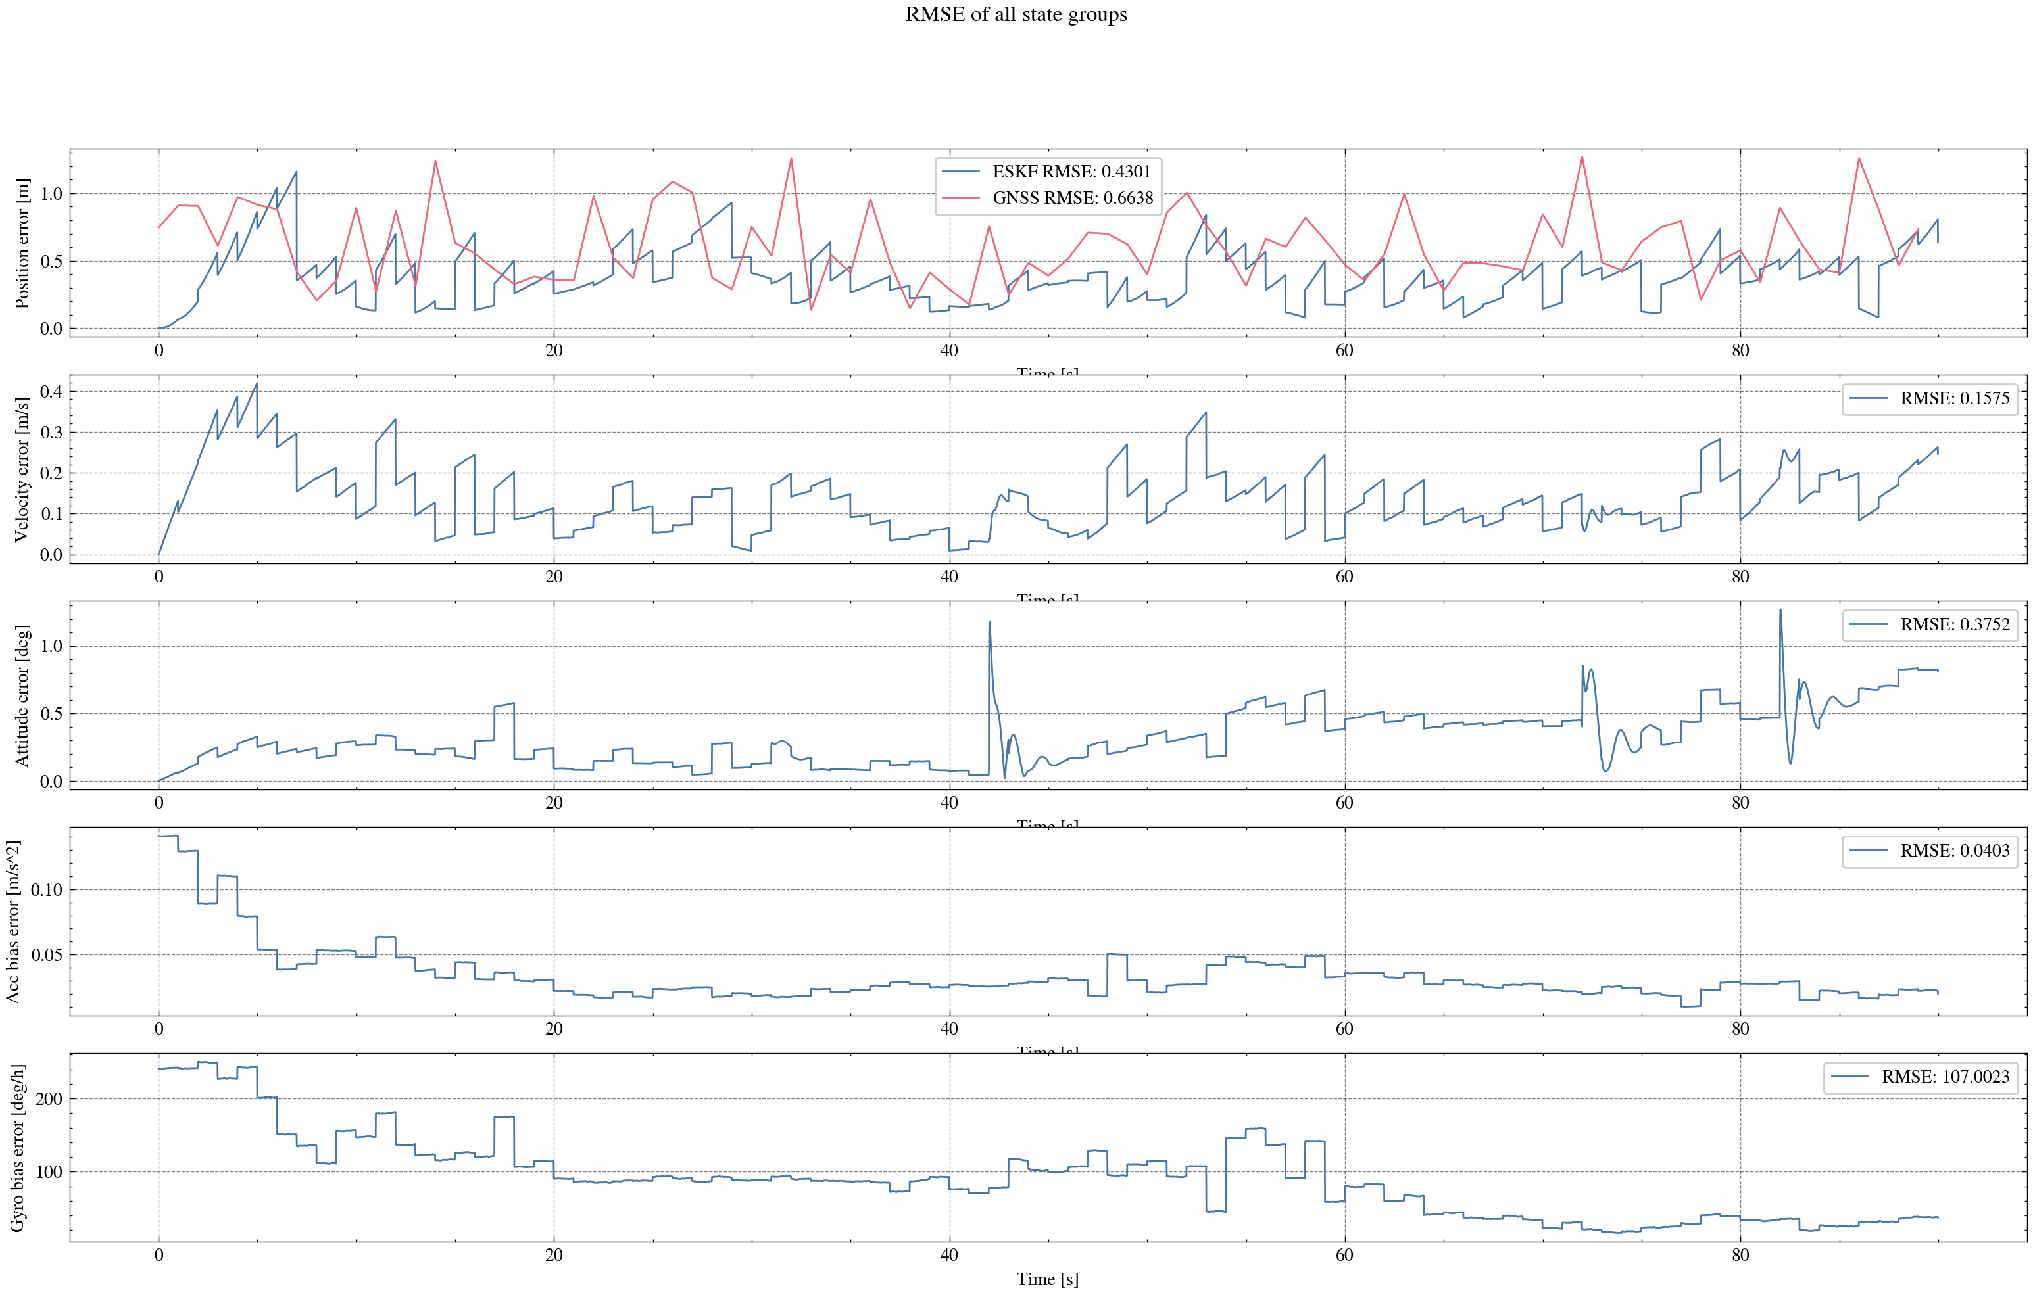
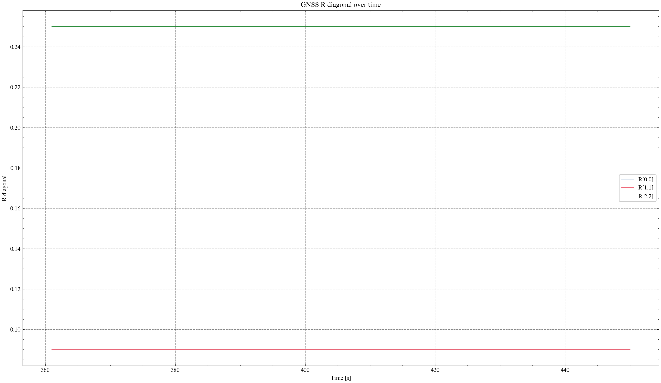

task_simulation_part_06
Input data: E:\eskf_bishe\bishe\ESKF-2.0\task_simulation_9000\task_simulation_part_06.mat
Run status: OK
==================== RMSE summary ====================
Position RMSE [m] (N,E,D): 0.2592, 0.3377, 0.3624
Velocity RMSE [m/s] (N,E,D): 0.1170, 0.1466, 0.0939
Attitude RMSE [deg] (roll,pitch,yaw): 0.1754, 0.2550, 0.6109
Acc bias RMSE [m/s^2] (x,y,z): 0.022880, 0.025714, 0.021302
Gyro bias RMSE [deg/h] (x,y,z): 69.3396, 47.9372, 67.7323
======================================================
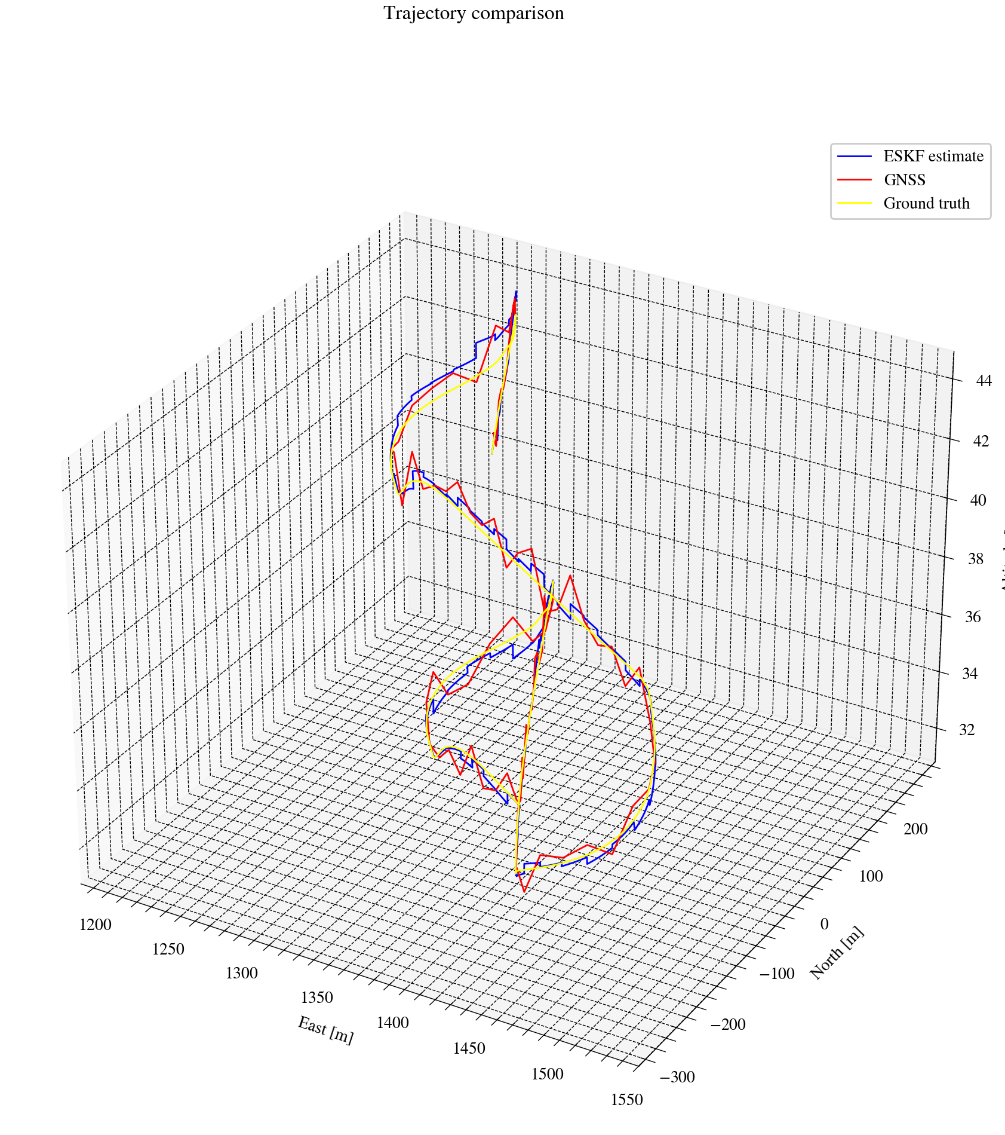
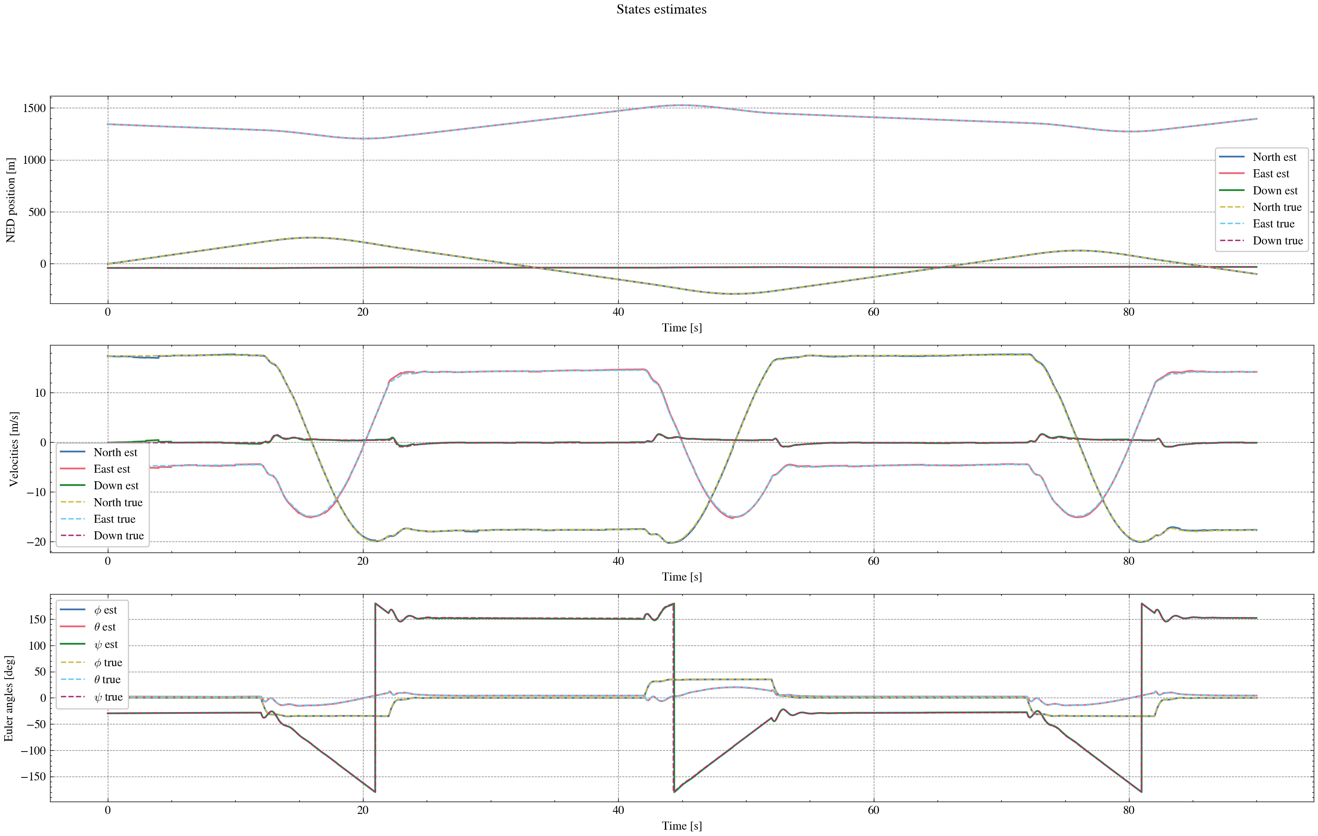
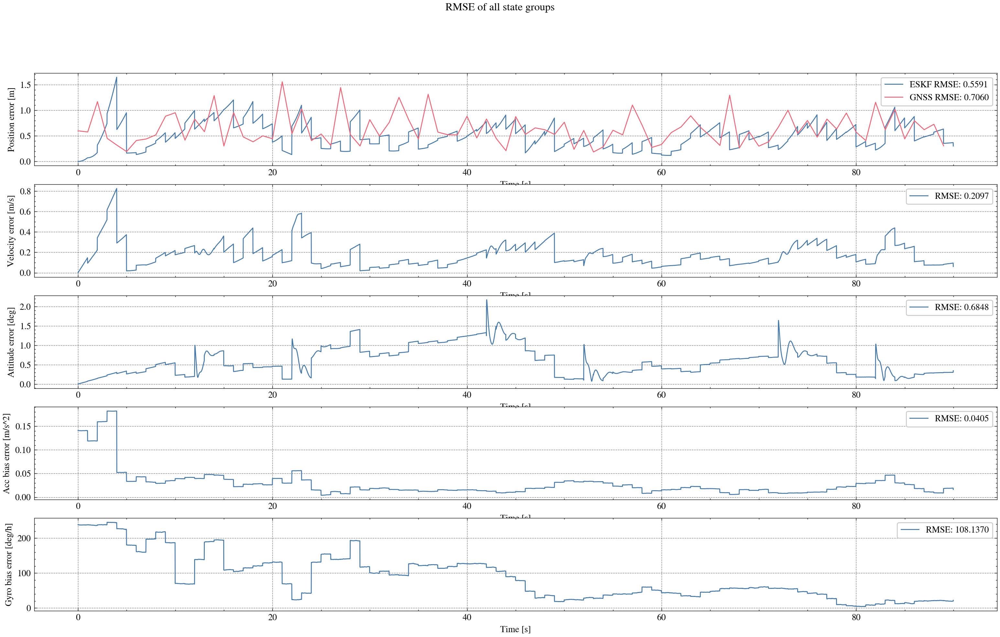
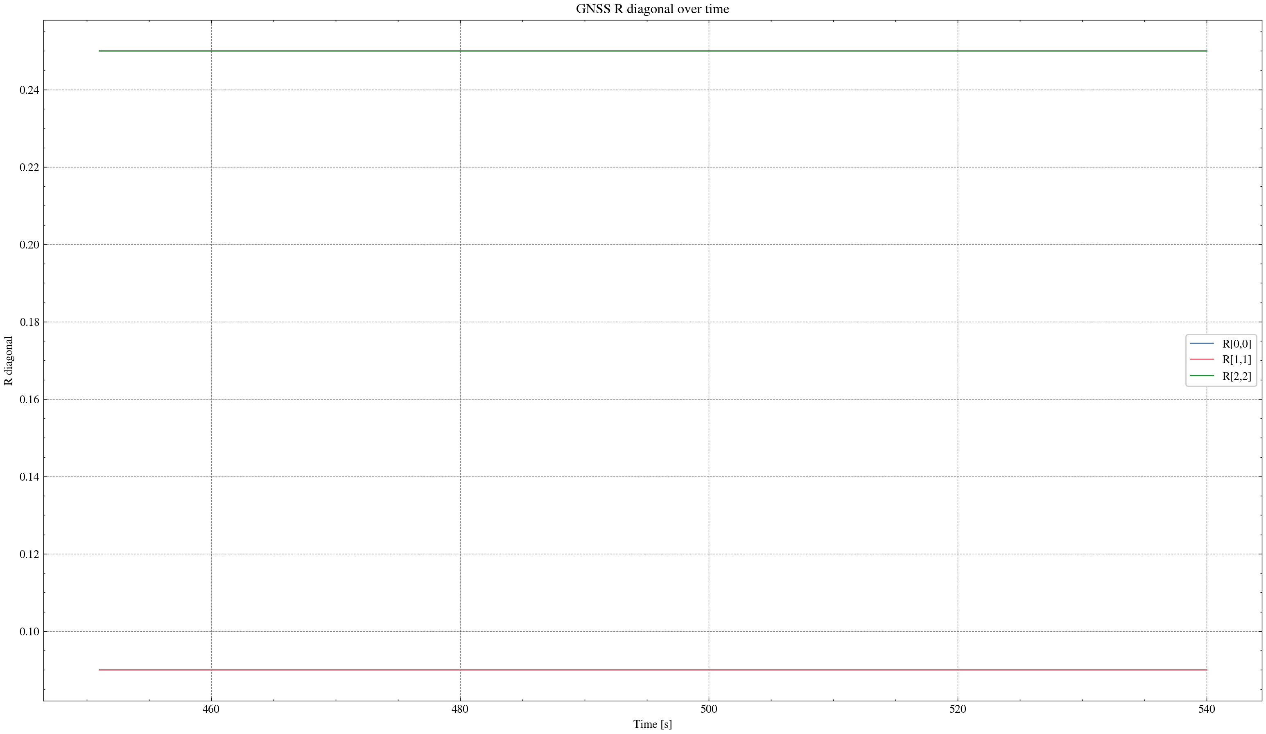

task_simulation_part_07
Input data: E:\eskf_bishe\bishe\ESKF-2.0\task_simulation_9000\task_simulation_part_07.mat
Run status: OK
==================== RMSE summary ====================
Position RMSE [m] (N,E,D): 0.2476, 0.2310, 0.4248
Velocity RMSE [m/s] (N,E,D): 0.0956, 0.1023, 0.1046
Attitude RMSE [deg] (roll,pitch,yaw): 0.1729, 0.2320, 0.3123
Acc bias RMSE [m/s^2] (x,y,z): 0.023424, 0.019747, 0.021635
Gyro bias RMSE [deg/h] (x,y,z): 59.4810, 54.0544, 49.5659
======================================================
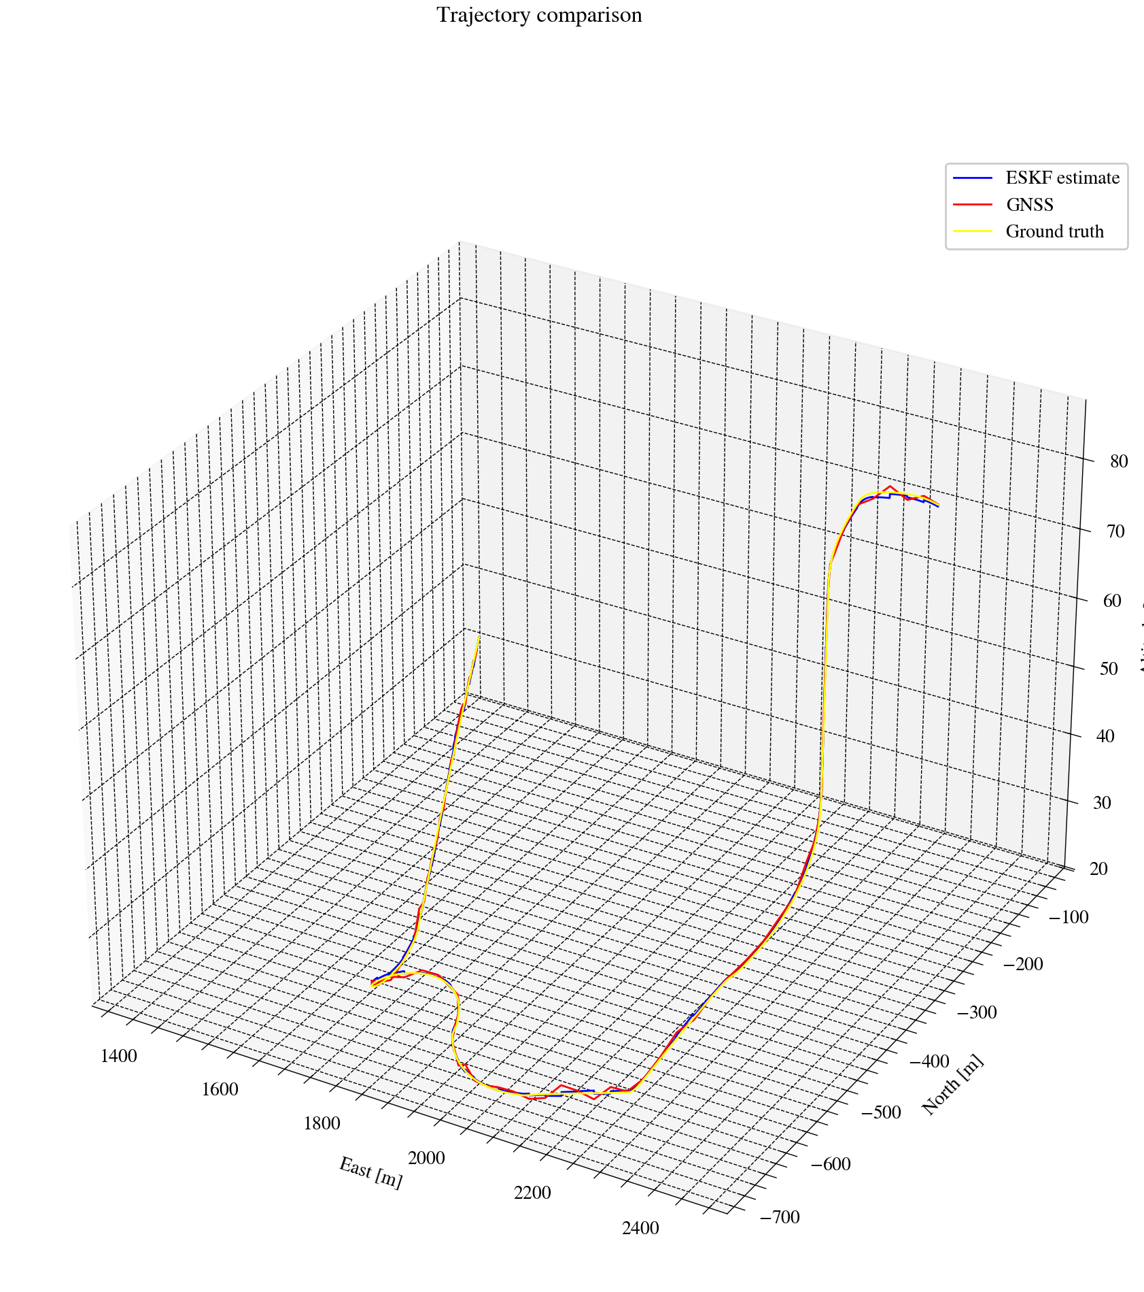
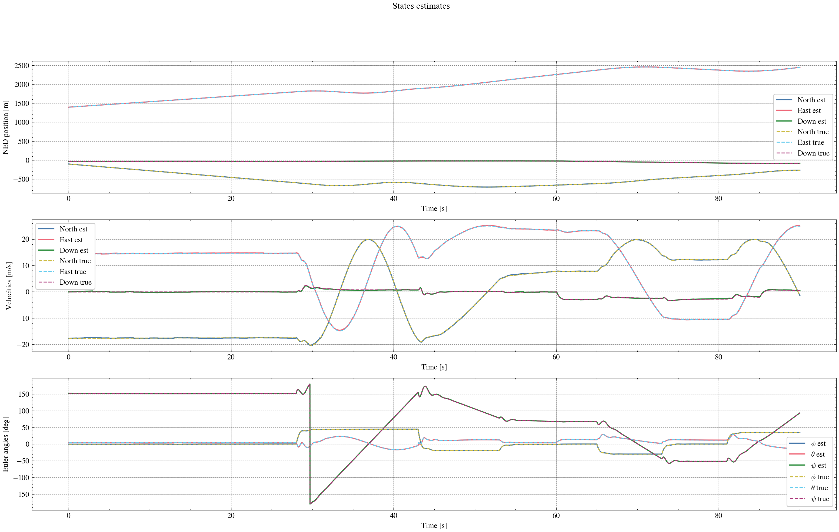
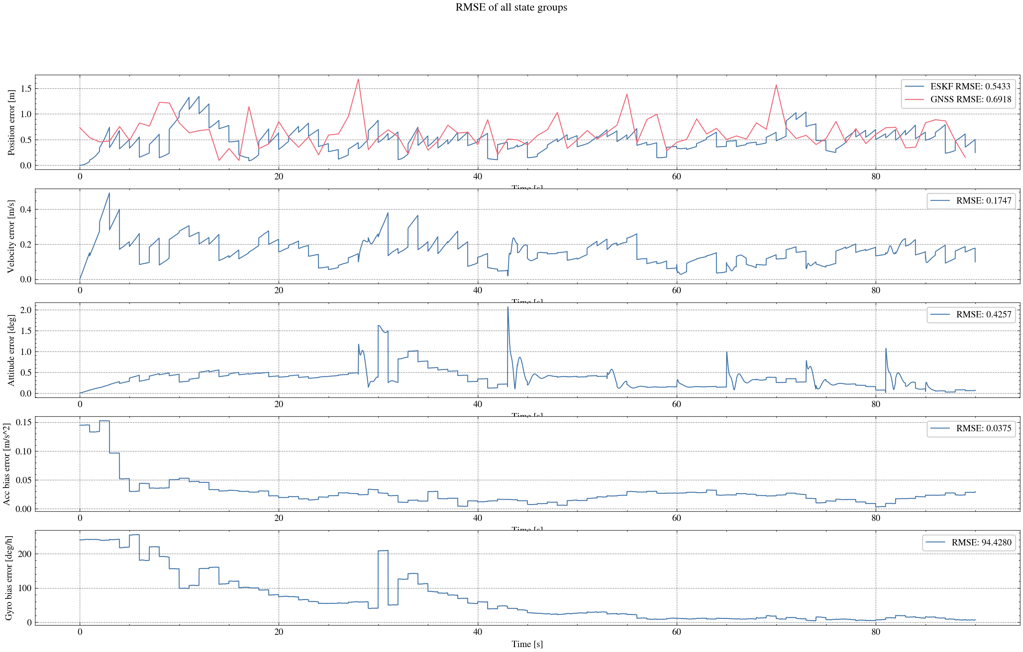
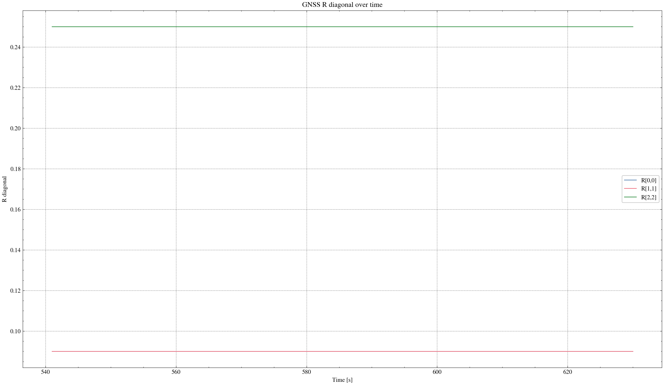

task_simulation_part_08
Input data: E:\eskf_bishe\bishe\ESKF-2.0\task_simulation_9000\task_simulation_part_08.mat
Run status: OK
==================== RMSE summary ====================
Position RMSE [m] (N,E,D): 0.2149, 0.2167, 0.3008
Velocity RMSE [m/s] (N,E,D): 0.0861, 0.0933, 0.0685
Attitude RMSE [deg] (roll,pitch,yaw): 0.1360, 0.1238, 0.2317
Acc bias RMSE [m/s^2] (x,y,z): 0.030325, 0.016782, 0.014973
Gyro bias RMSE [deg/h] (x,y,z): 90.9264, 69.0674, 42.1523
======================================================
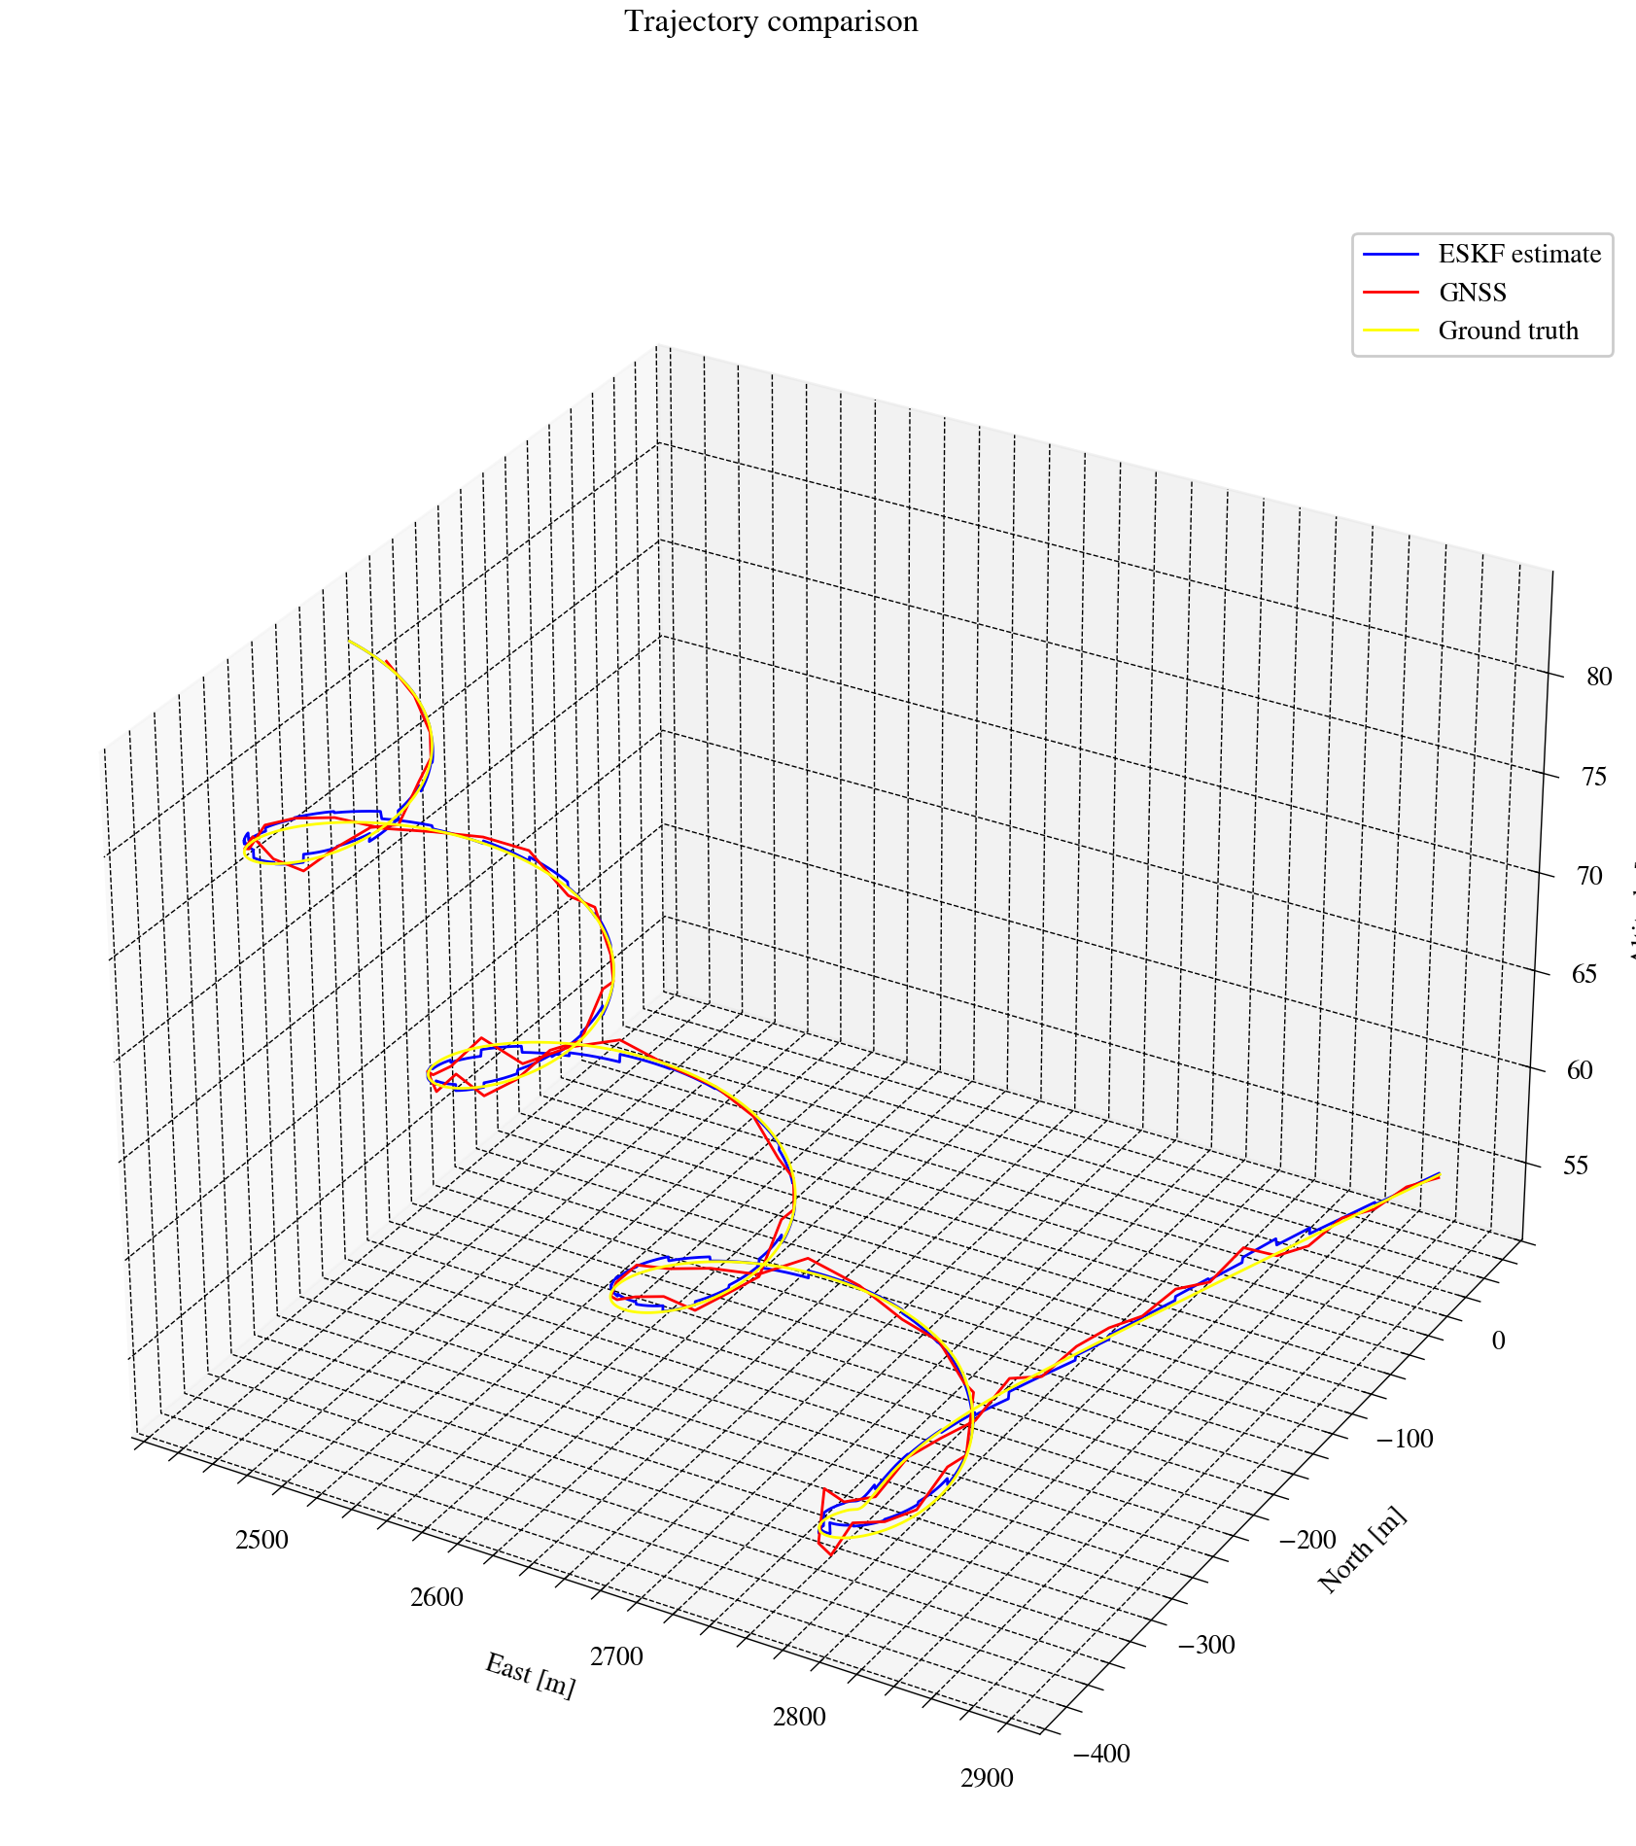
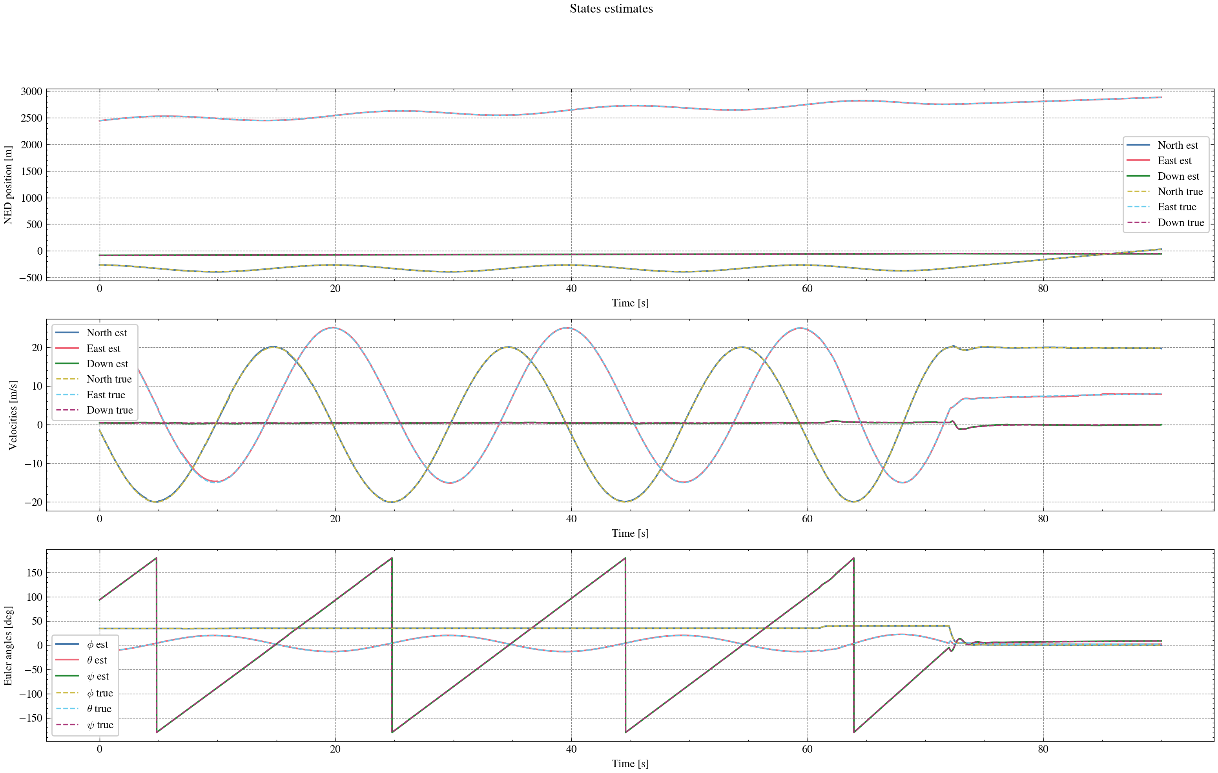
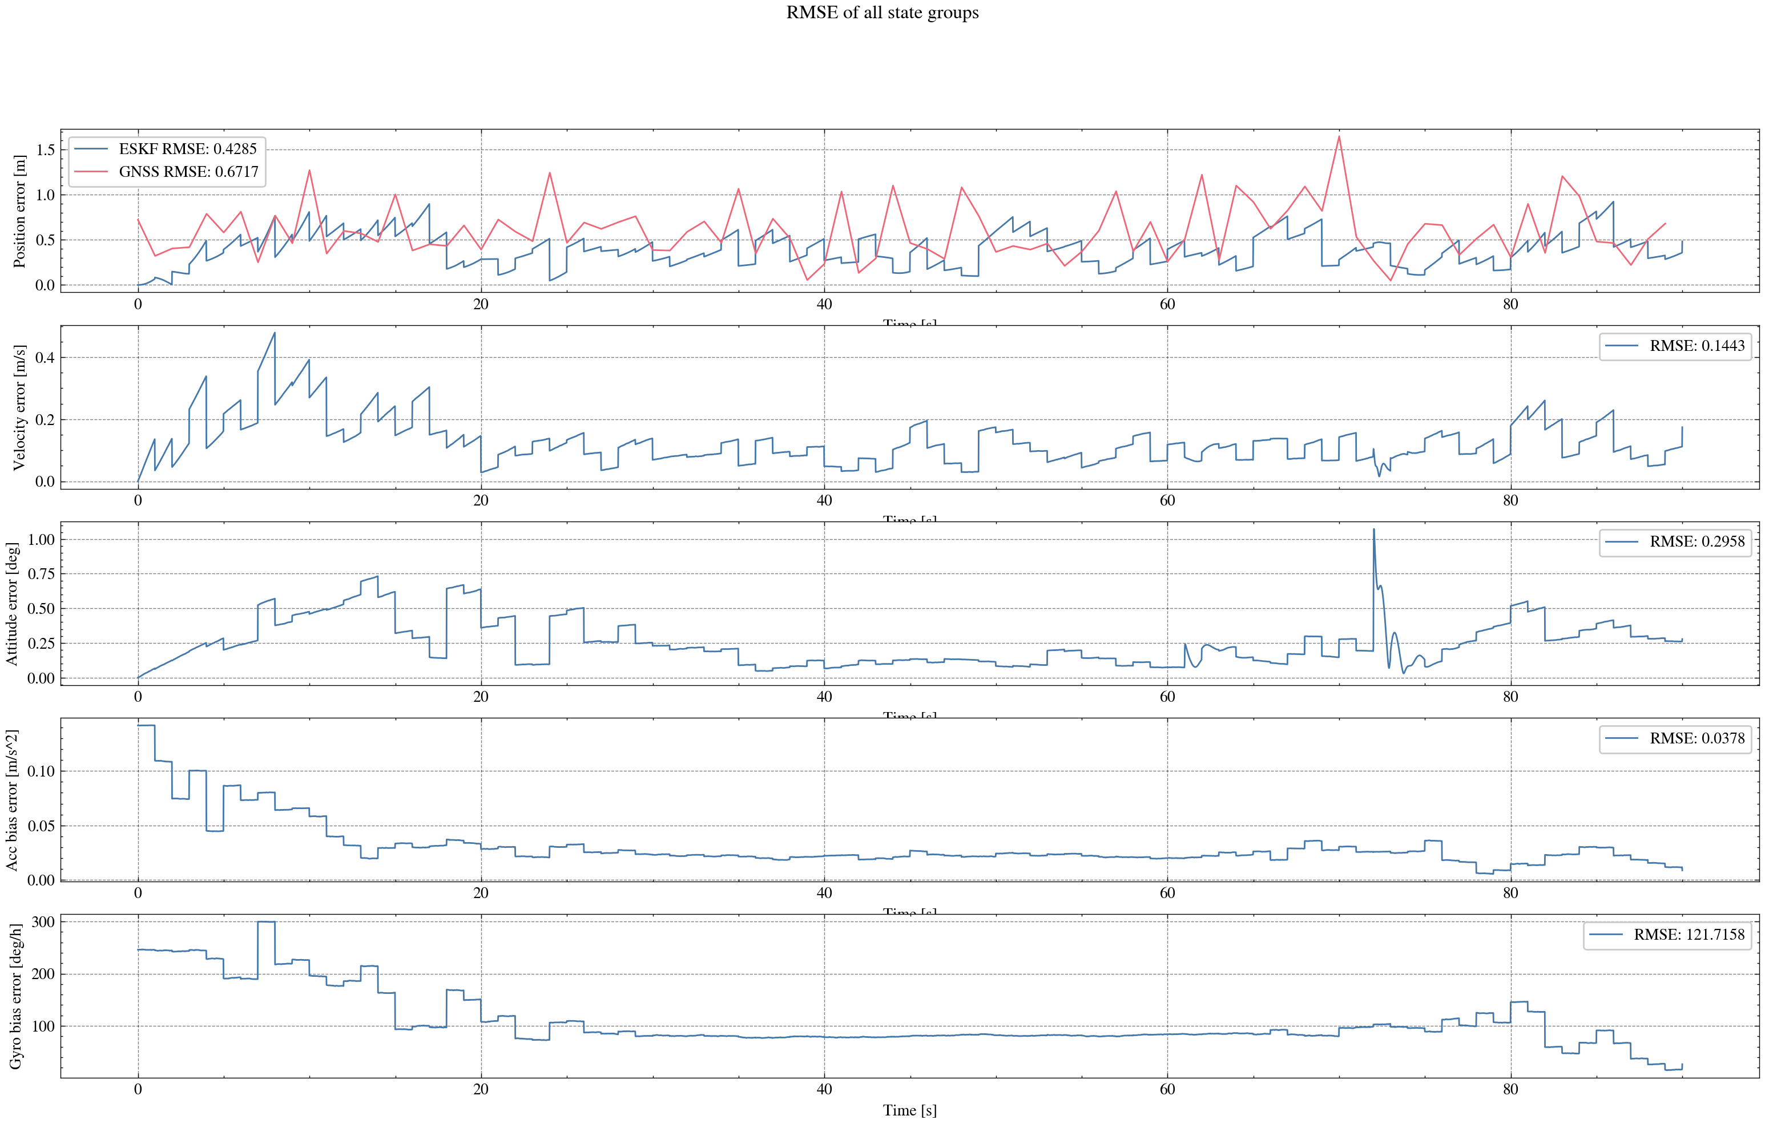
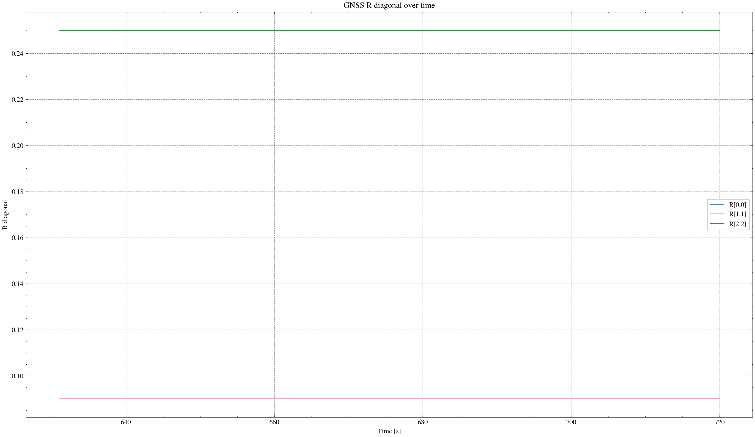

task_simulation_part_09
Input data: E:\eskf_bishe\bishe\ESKF-2.0\task_simulation_9000\task_simulation_part_09.mat
Run status: OK
==================== RMSE summary ====================
Position RMSE [m] (N,E,D): 0.2672, 0.3084, 0.3822
Velocity RMSE [m/s] (N,E,D): 0.1278, 0.1413, 0.0864
Attitude RMSE [deg] (roll,pitch,yaw): 0.2081, 0.2689, 0.8850
Acc bias RMSE [m/s^2] (x,y,z): 0.020630, 0.023069, 0.017746
Gyro bias RMSE [deg/h] (x,y,z): 67.4774, 48.5772, 107.9828
======================================================
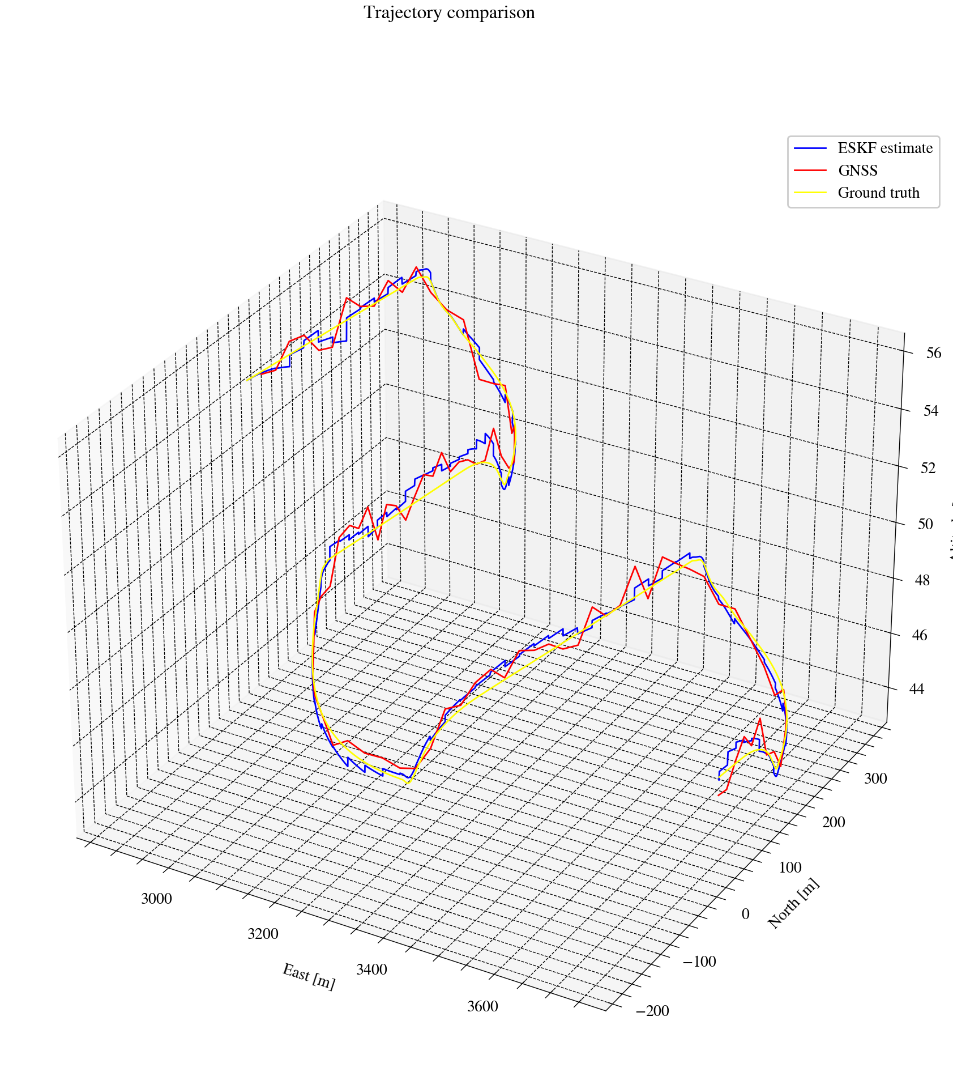
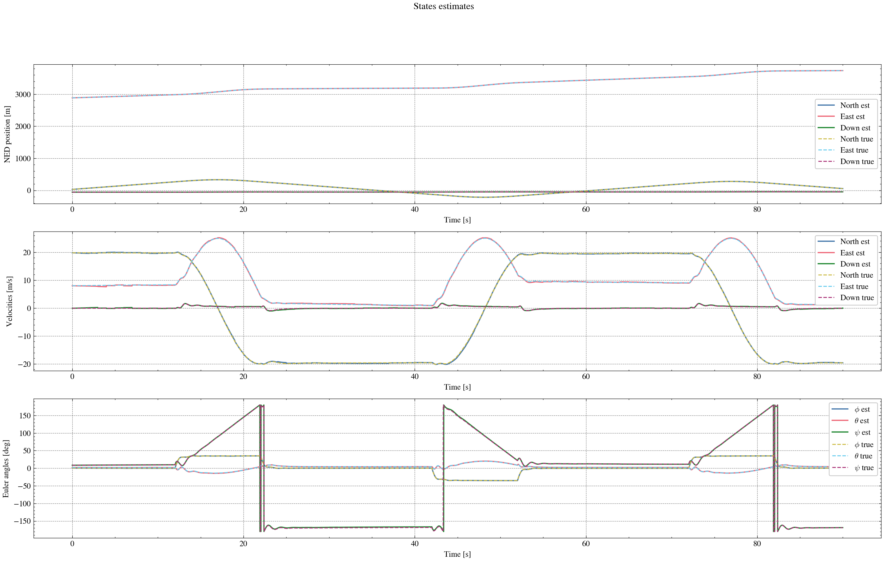
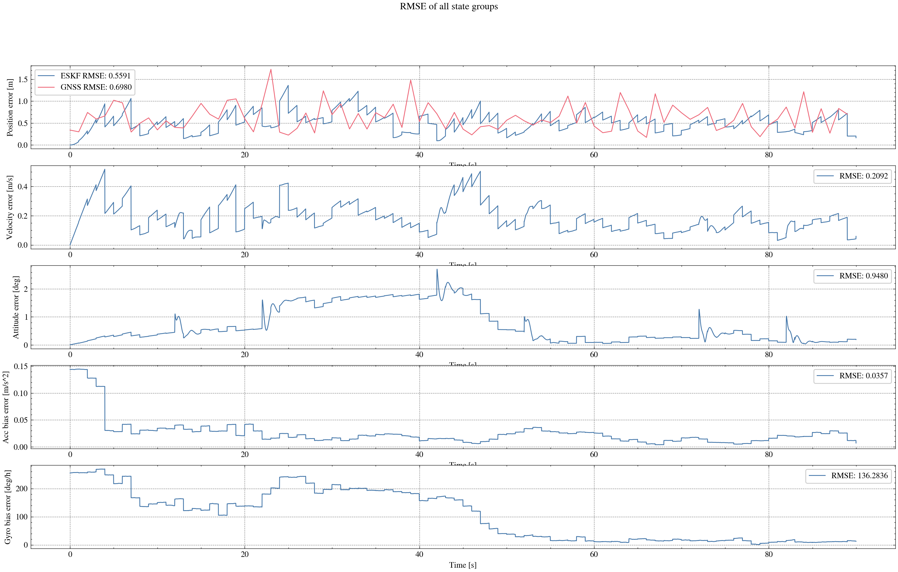
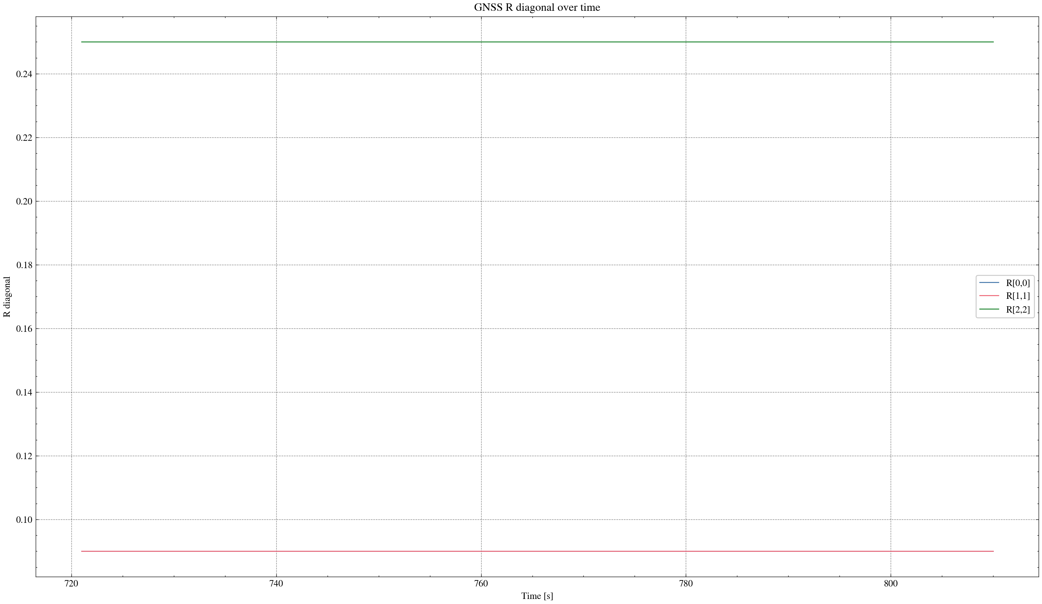

task_simulation_part_10
Input data: E:\eskf_bishe\bishe\ESKF-2.0\task_simulation_9000\task_simulation_part_10.mat
Run status: OK
==================== RMSE summary ====================
Position RMSE [m] (N,E,D): 0.2644, 0.2335, 0.2970
Velocity RMSE [m/s] (N,E,D): 0.1280, 0.1164, 0.0718
Attitude RMSE [deg] (roll,pitch,yaw): 0.1626, 0.2940, 0.7812
Acc bias RMSE [m/s^2] (x,y,z): 0.024660, 0.022167, 0.019093
Gyro bias RMSE [deg/h] (x,y,z): 71.2310, 64.3472, 83.2112
======================================================
