ESKF Batch Simulation Report
Generated at: 2026-04-23 20:51:33
Data folder: E:\eskf_bishe\bishe\ESKF-2.0\task_simulation_50000

task_simulation_random_01
Input data: E:\eskf_bishe\bishe\ESKF-2.0\task_simulation_50000\task_simulation_random_01.mat
Run status: OK
==================== RMSE summary ====================
Position RMSE [m] (N,E,D): 0.2257, 0.2331, 0.2828
Velocity RMSE [m/s] (N,E,D): 0.0859, 0.0845, 0.0551
Attitude RMSE [deg] (roll,pitch,yaw): 0.1233, 0.1204, 0.2663
Acc bias RMSE [m/s^2] (x,y,z): 0.015478, 0.010058, 0.011382
Gyro bias RMSE [deg/h] (x,y,z): 44.6715, 30.5370, 19.3135
======================================================
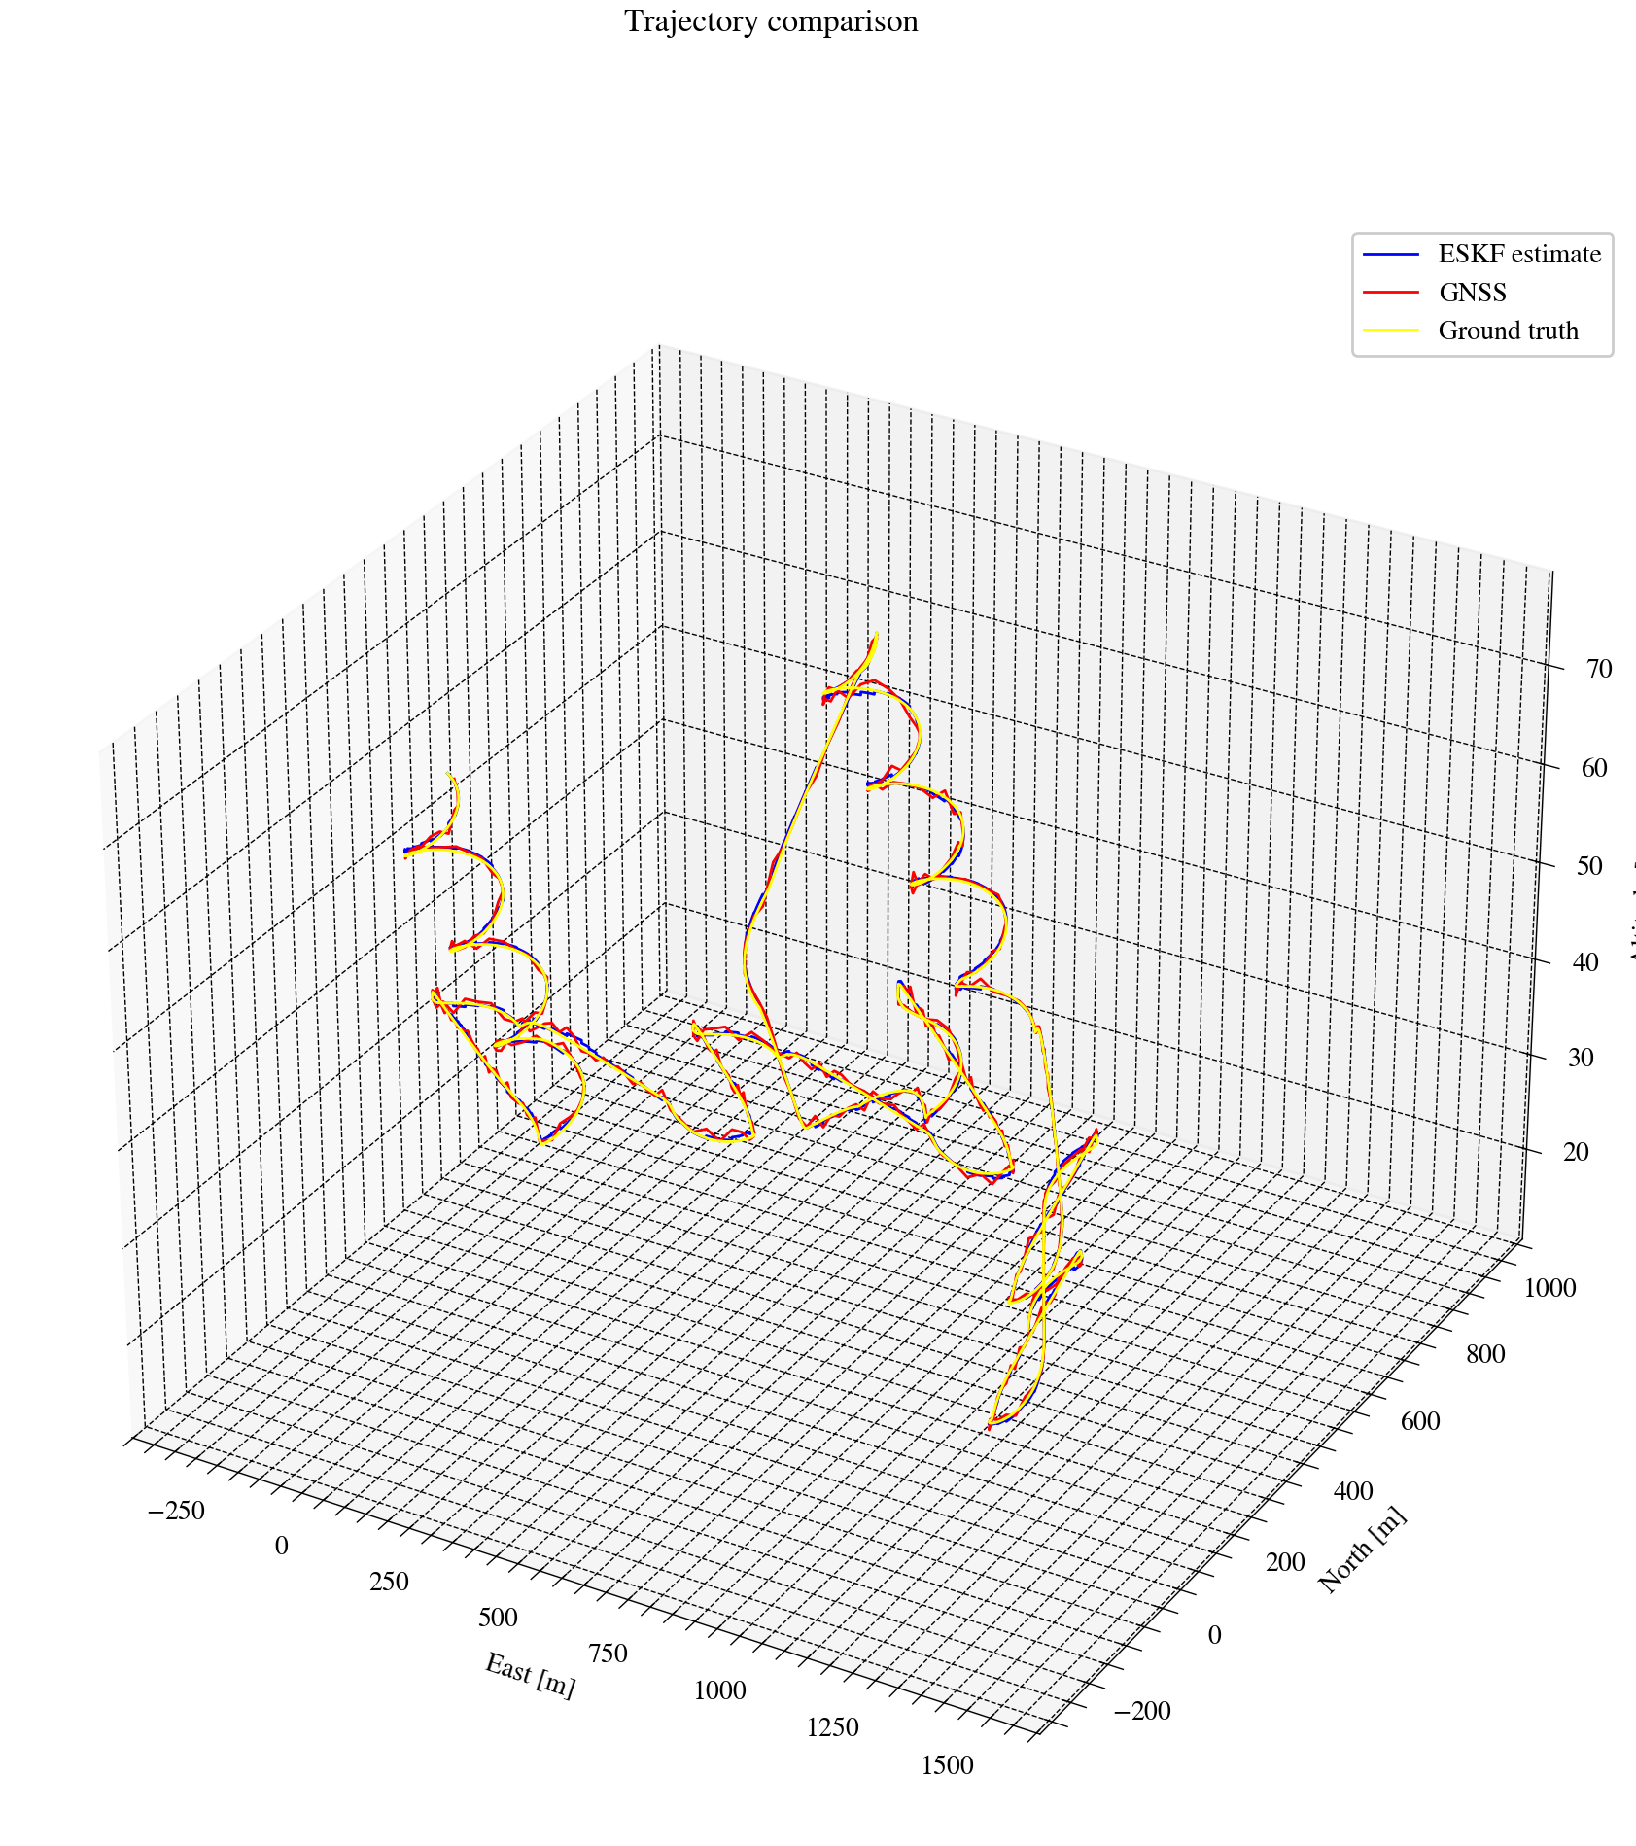
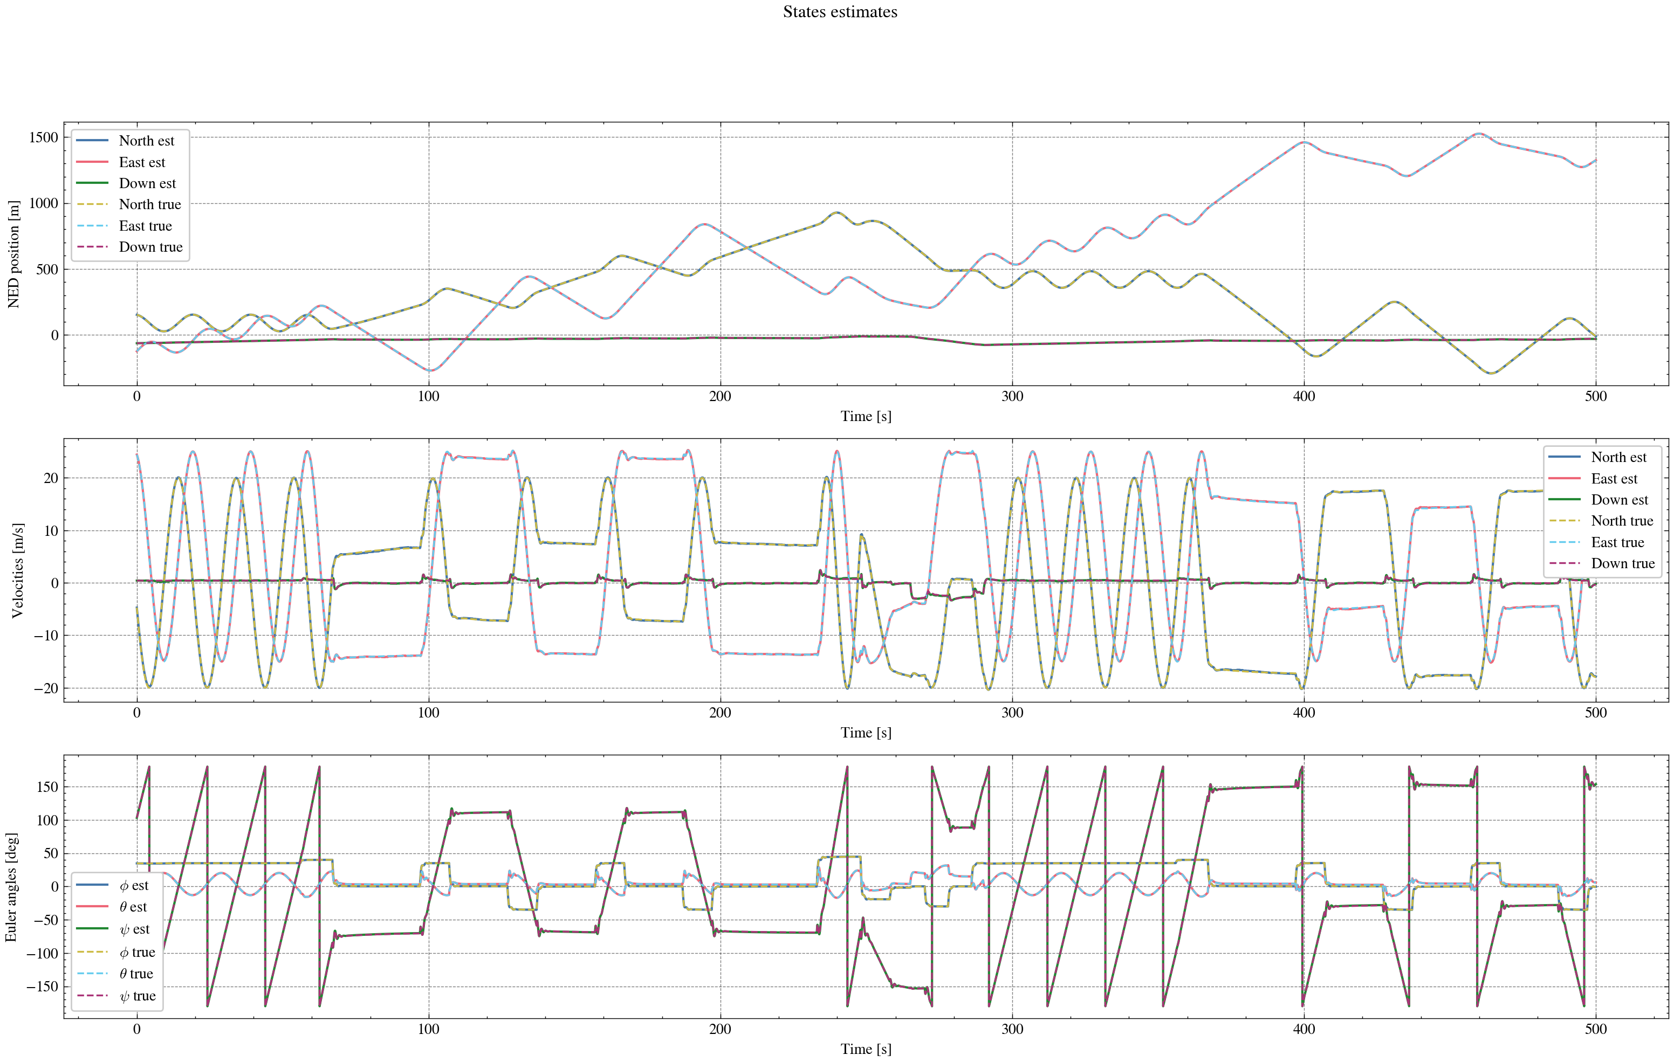
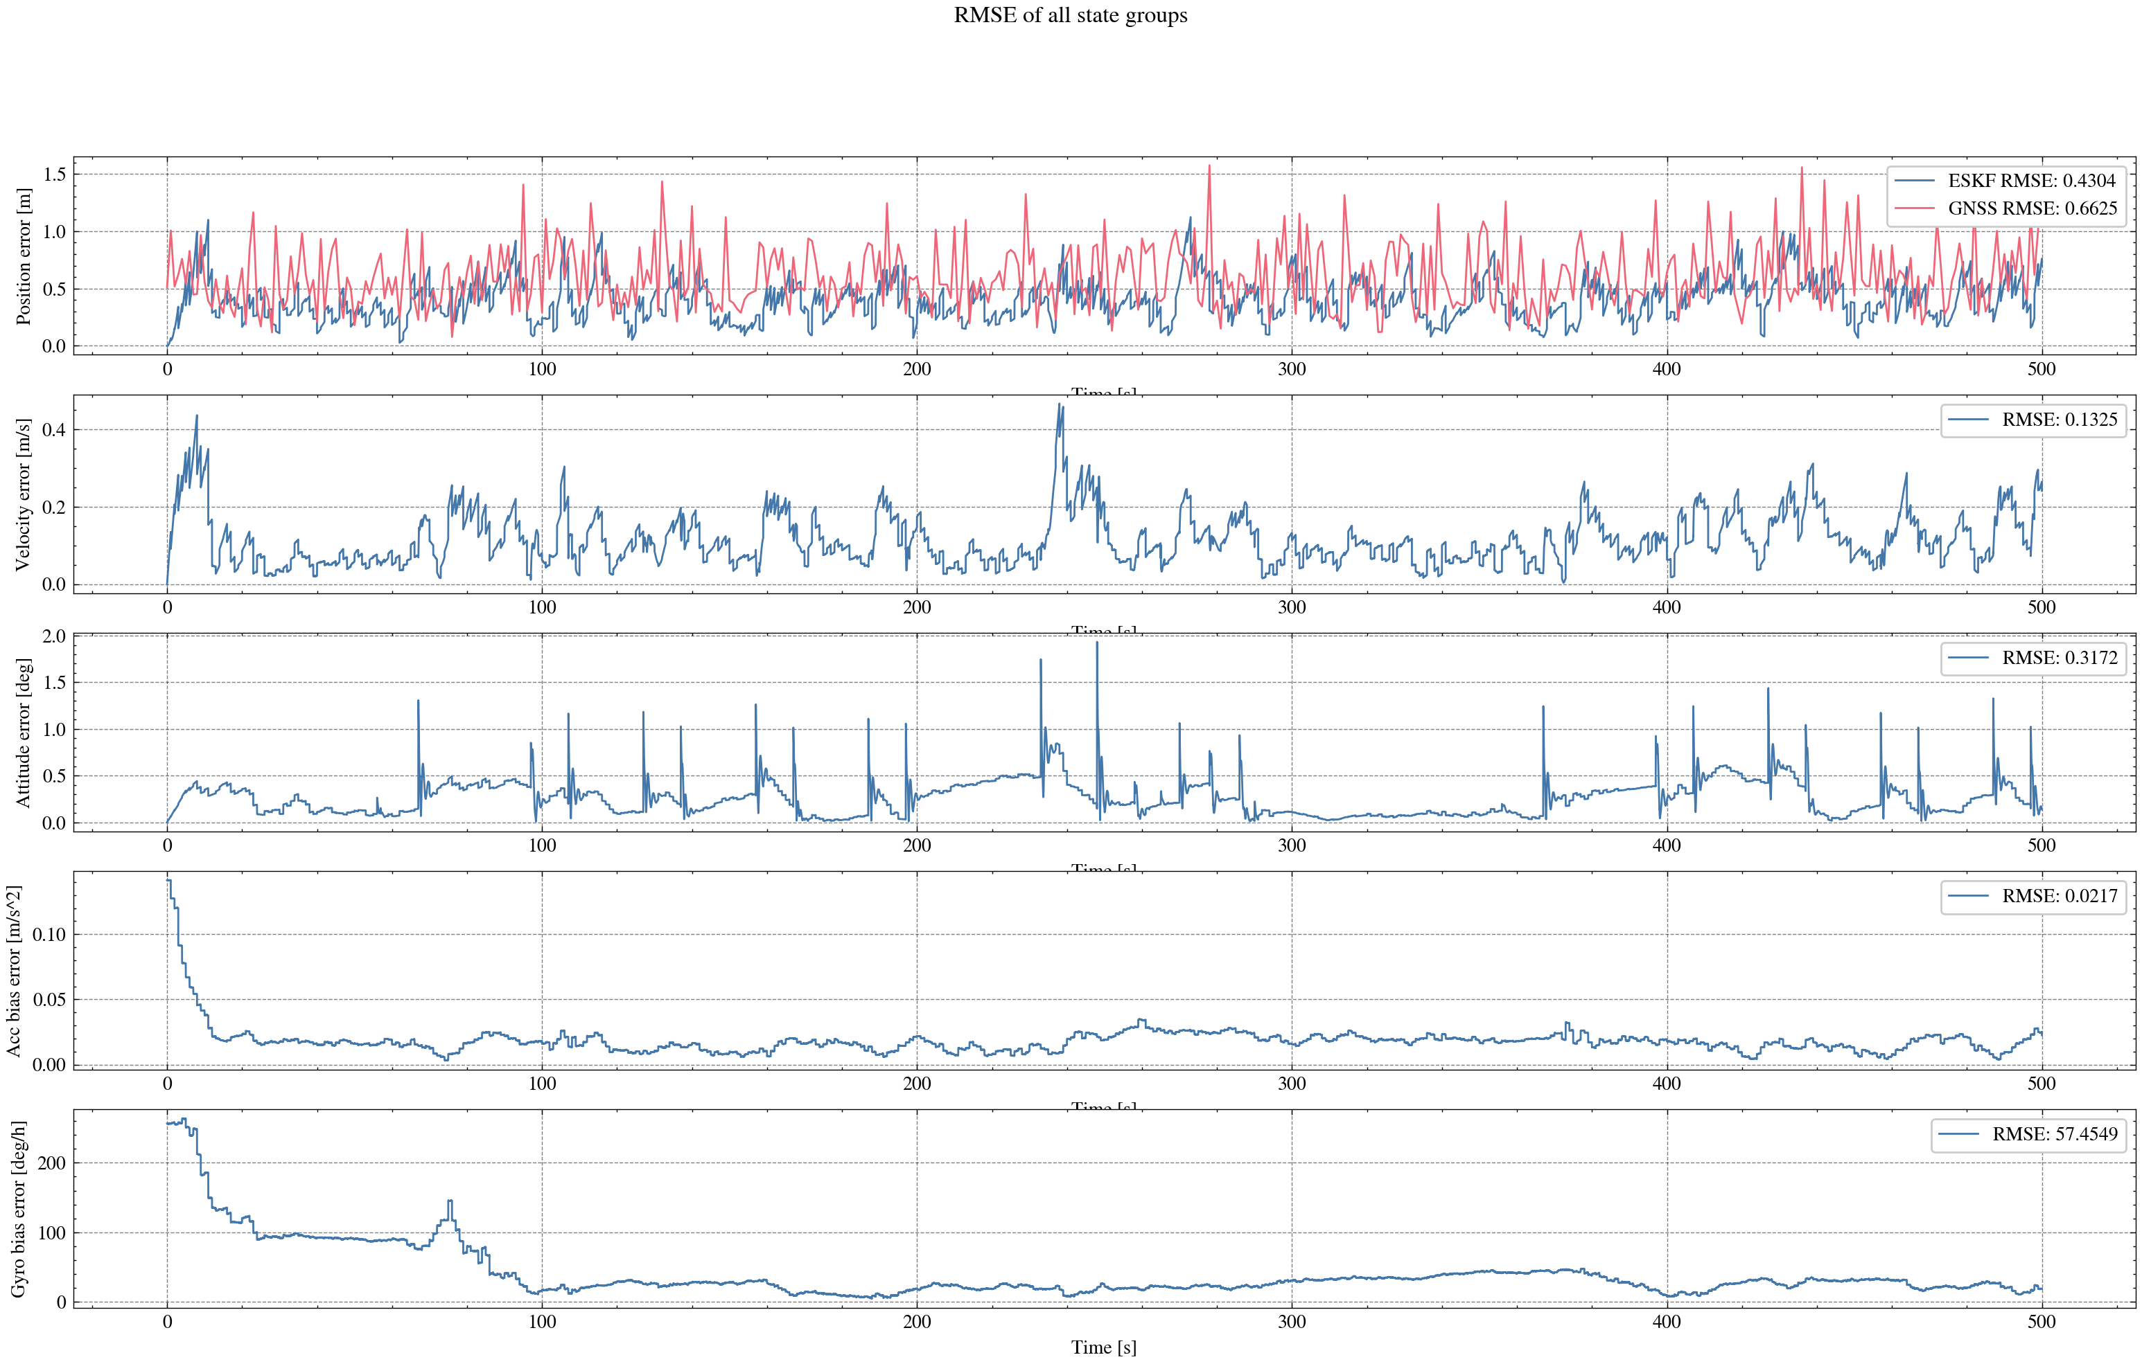
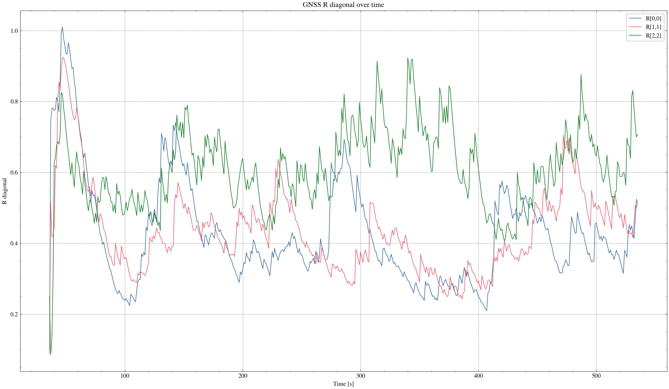

task_simulation_random_02
Input data: E:\eskf_bishe\bishe\ESKF-2.0\task_simulation_50000\task_simulation_random_02.mat
Run status: OK
==================== RMSE summary ====================
Position RMSE [m] (N,E,D): 0.2633, 0.2407, 0.3049
Velocity RMSE [m/s] (N,E,D): 0.0983, 0.0865, 0.0590
Attitude RMSE [deg] (roll,pitch,yaw): 0.1179, 0.1495, 0.3161
Acc bias RMSE [m/s^2] (x,y,z): 0.015839, 0.012081, 0.011871
Gyro bias RMSE [deg/h] (x,y,z): 30.2572, 25.7552, 23.4060
======================================================
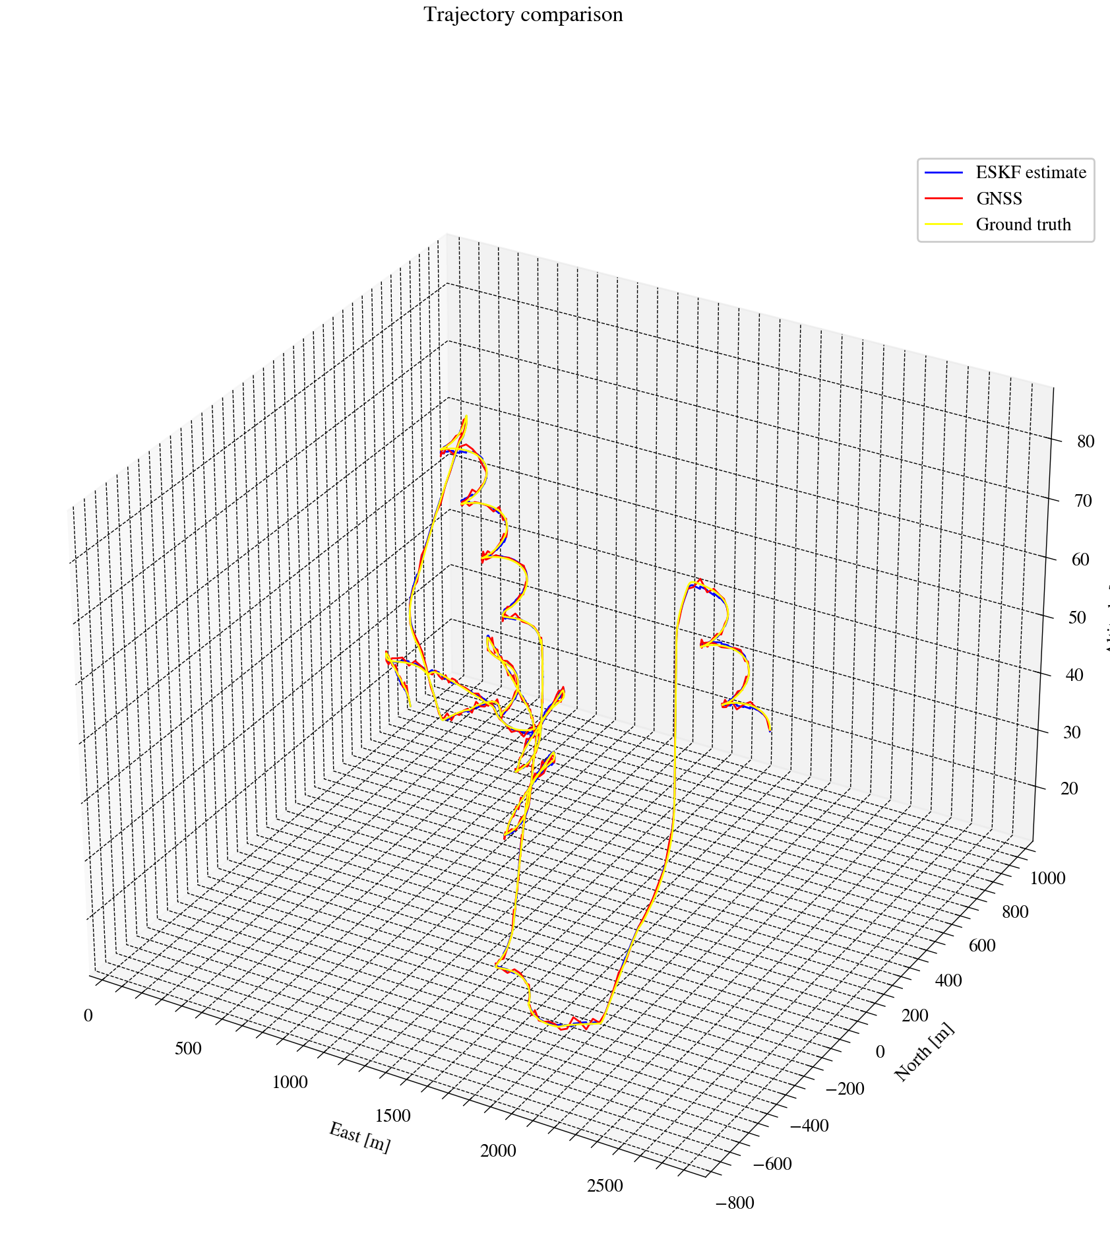
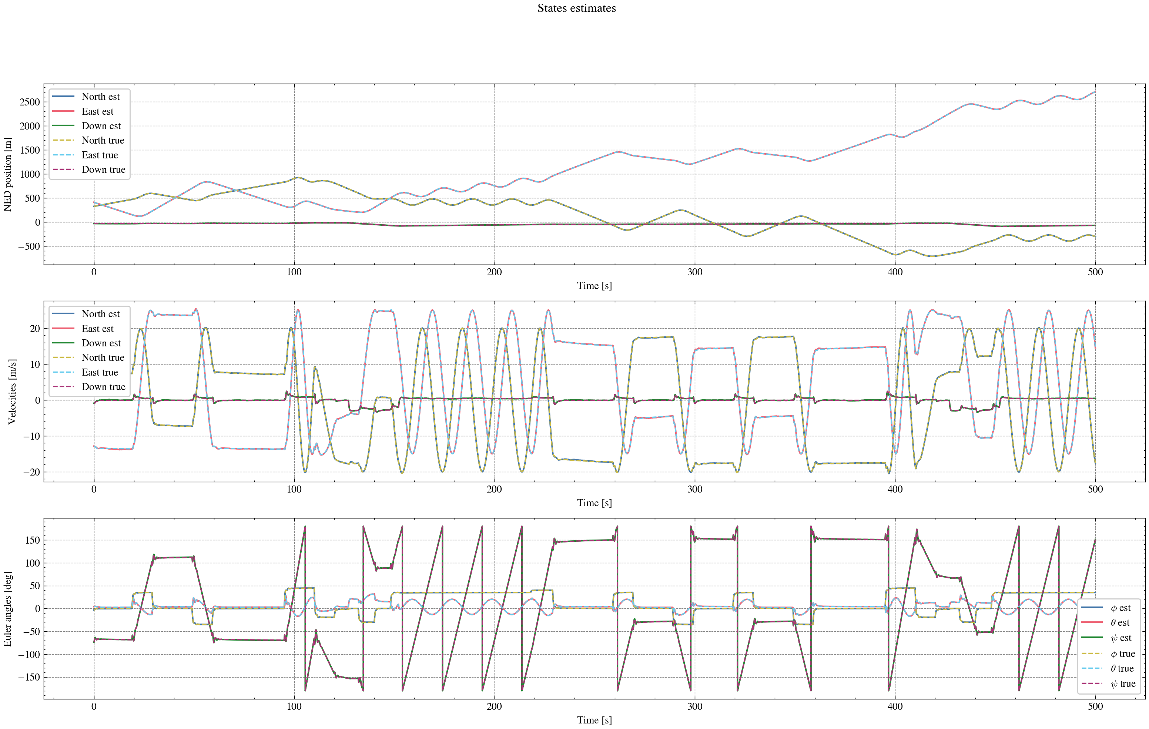
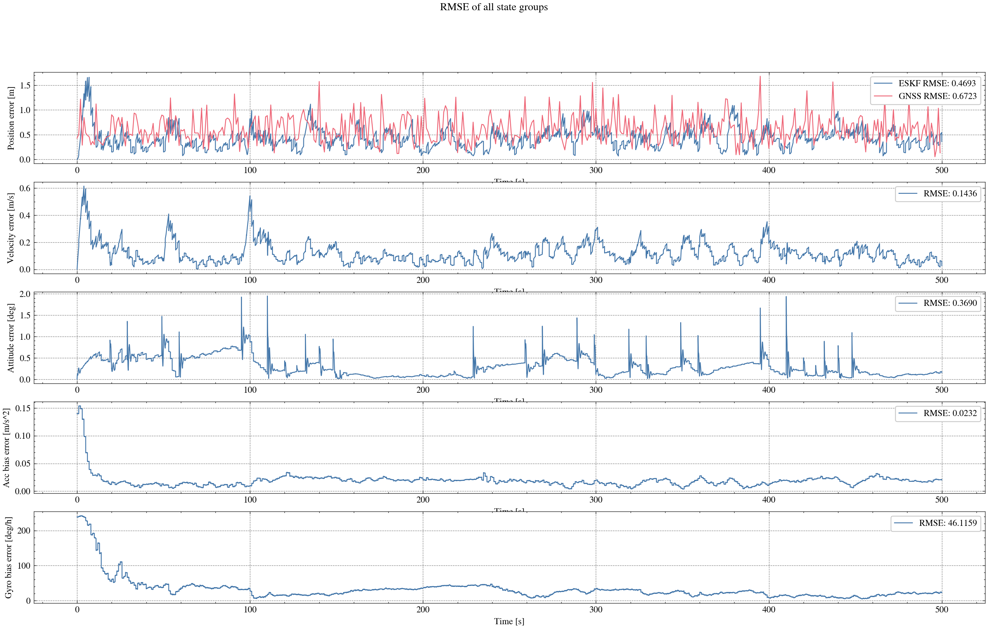
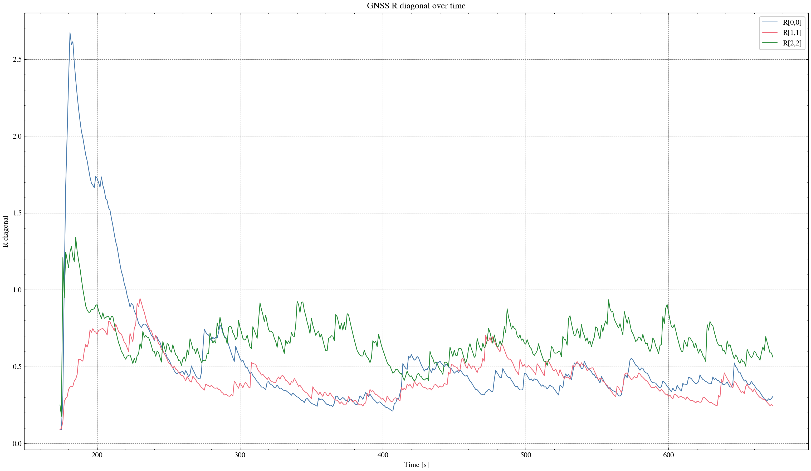

task_simulation_random_03
Input data: E:\eskf_bishe\bishe\ESKF-2.0\task_simulation_50000\task_simulation_random_03.mat
Run status: OK
==================== RMSE summary ====================
Position RMSE [m] (N,E,D): 0.2309, 0.2402, 0.3048
Velocity RMSE [m/s] (N,E,D): 0.0865, 0.0864, 0.0596
Attitude RMSE [deg] (roll,pitch,yaw): 0.1189, 0.1443, 0.3040
Acc bias RMSE [m/s^2] (x,y,z): 0.015499, 0.010567, 0.011846
Gyro bias RMSE [deg/h] (x,y,z): 31.2377, 25.1164, 24.0204
======================================================
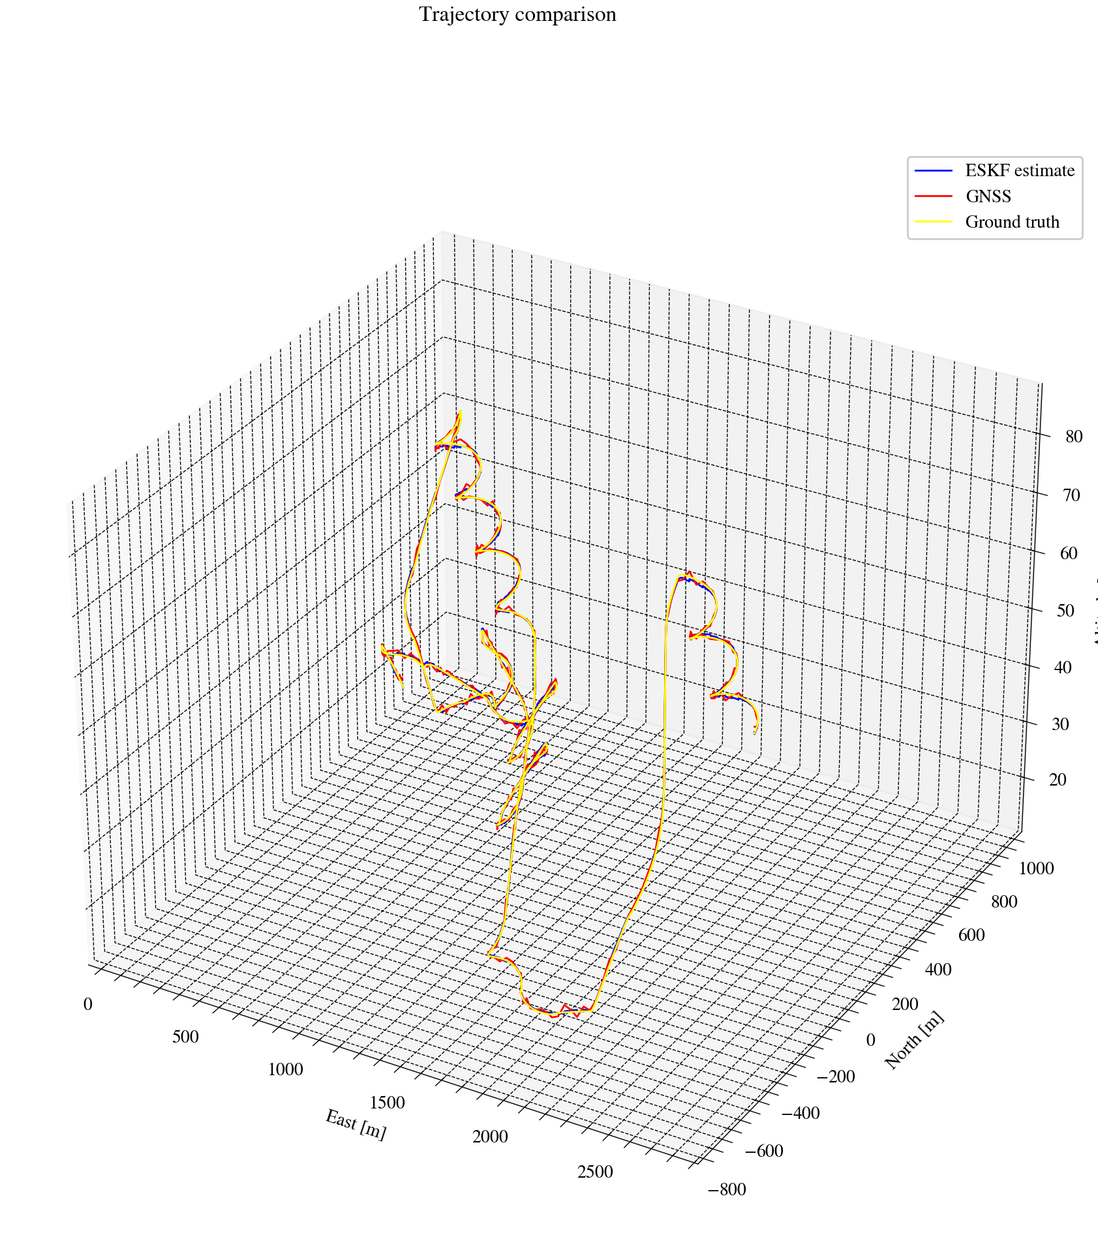
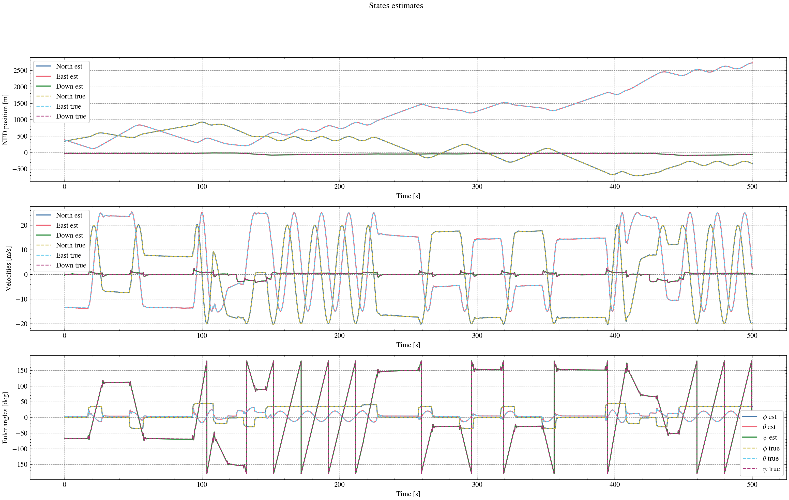
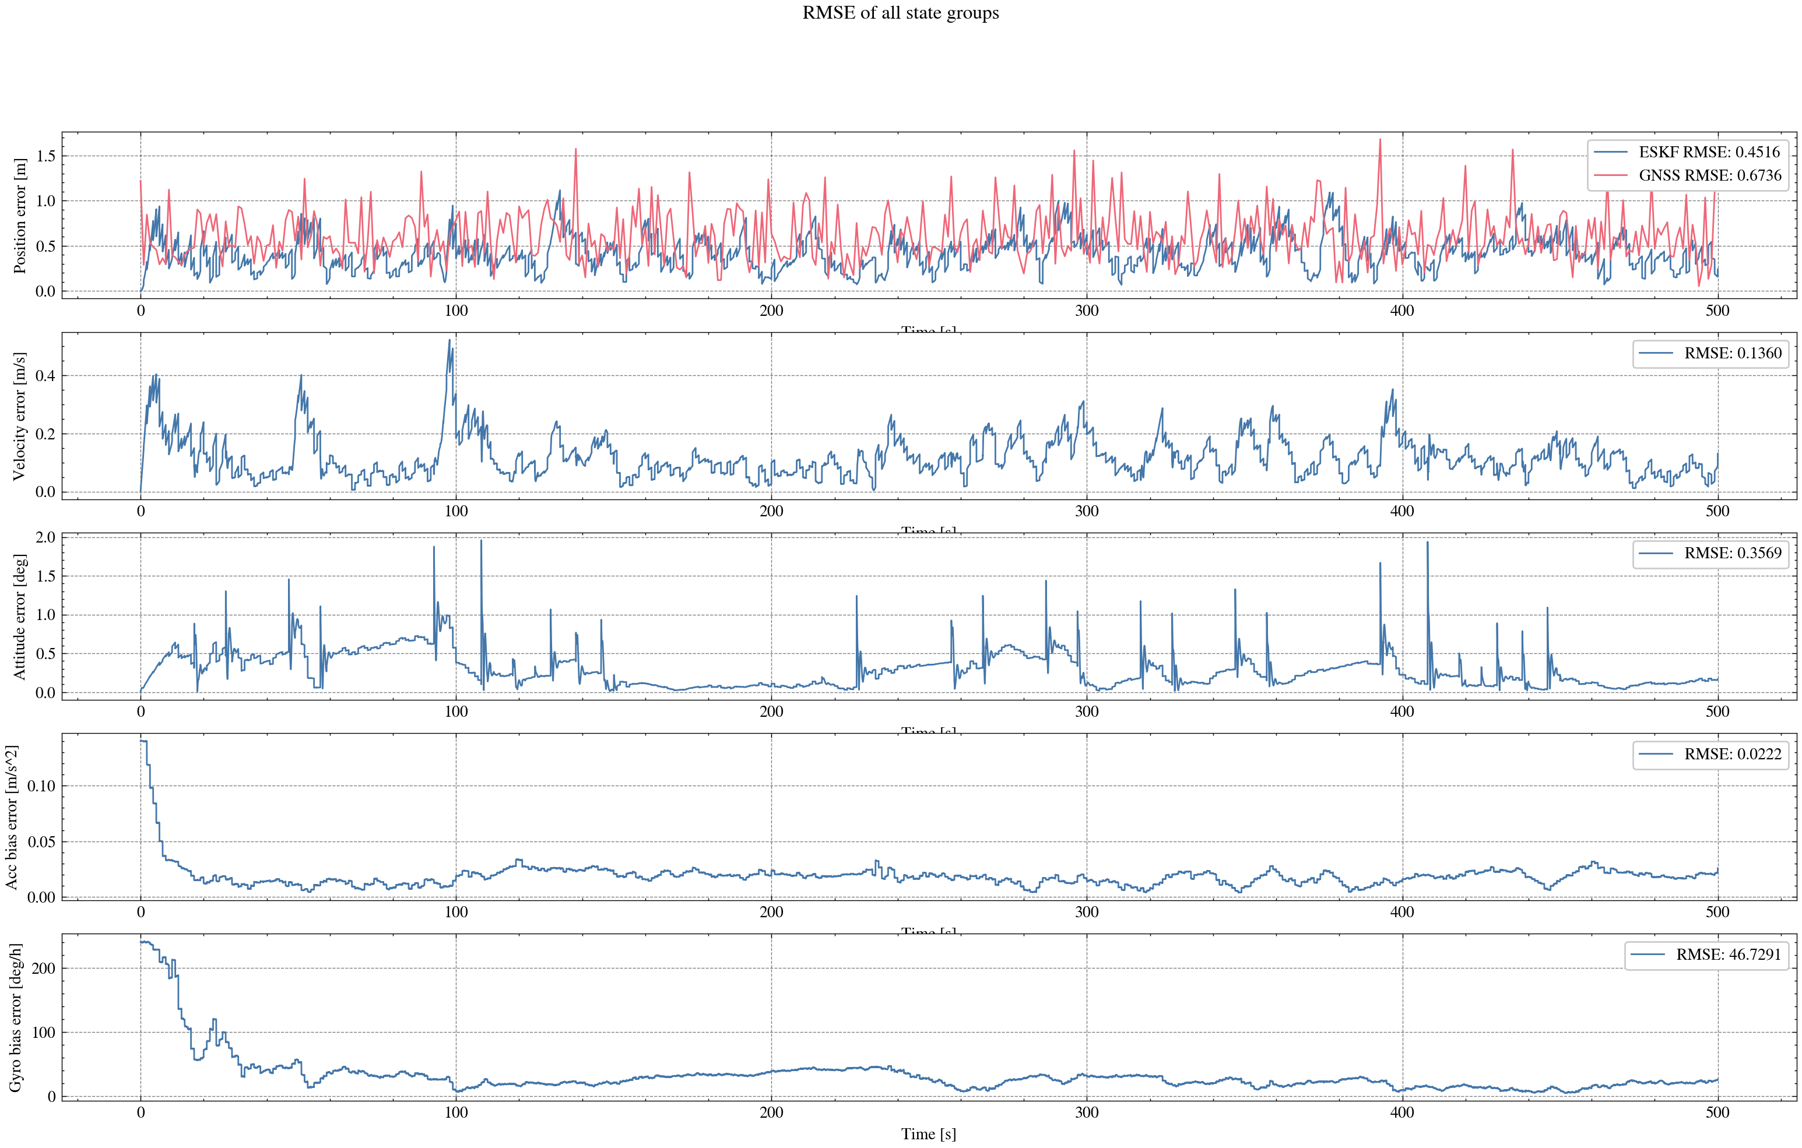
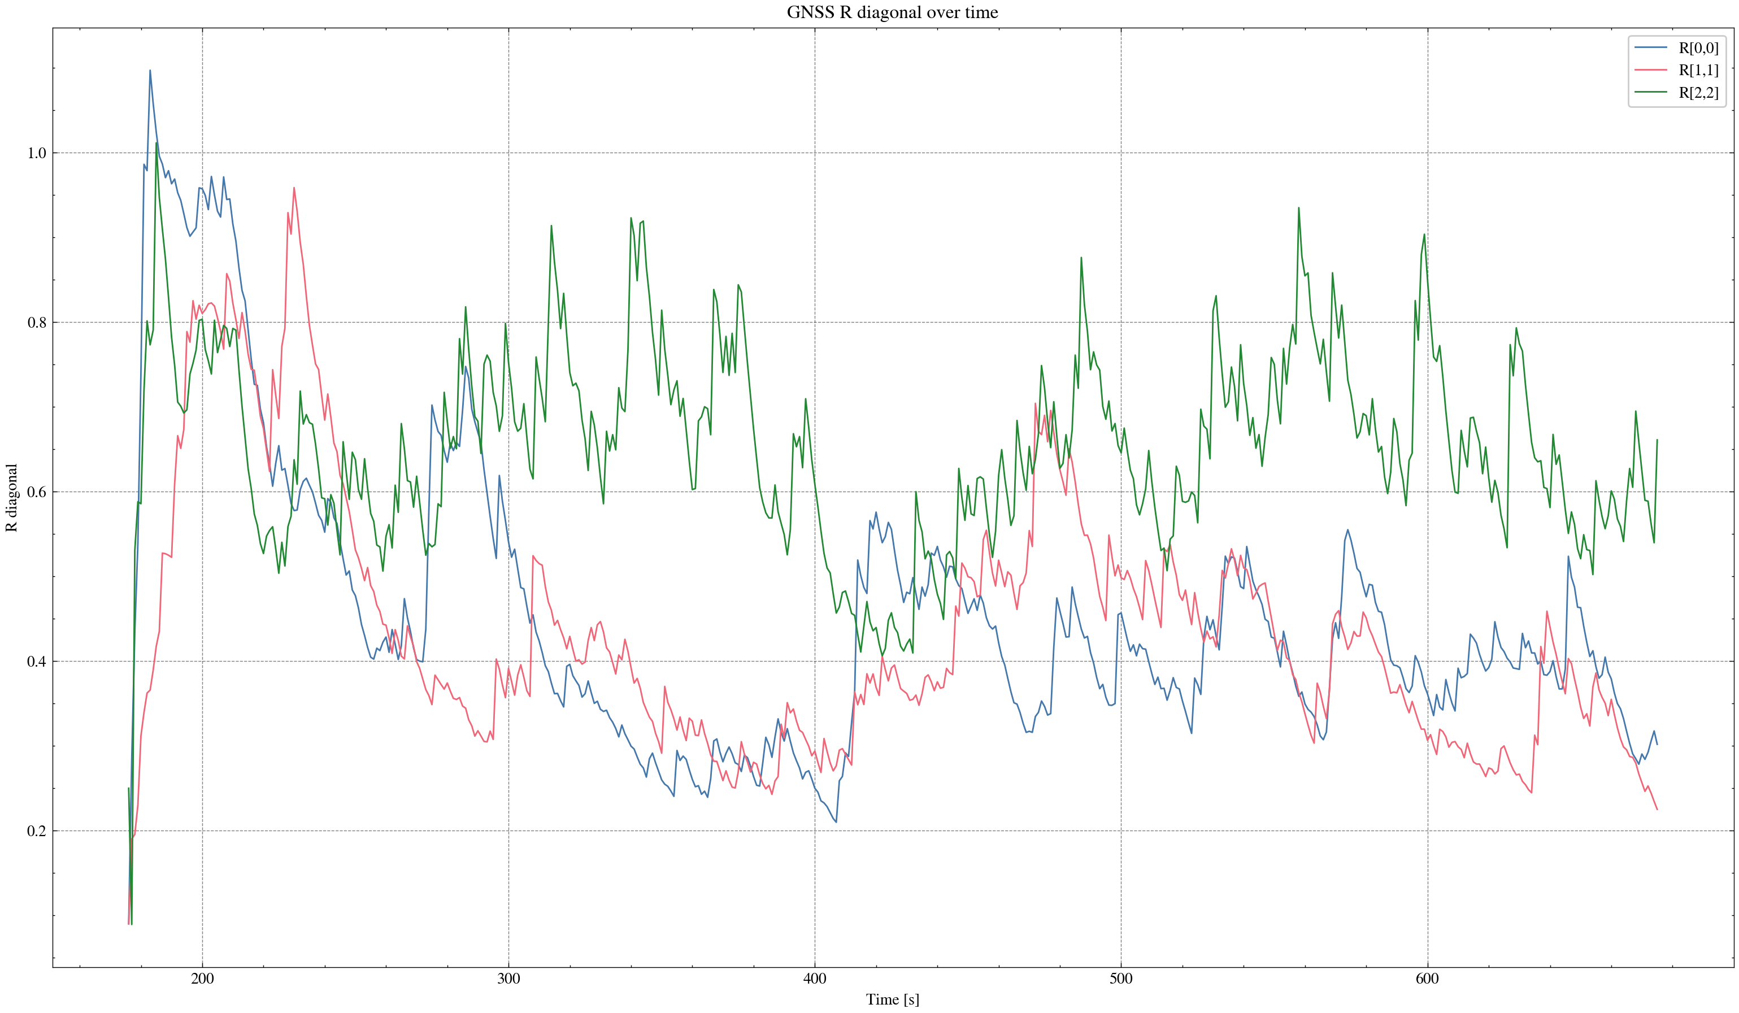

task_simulation_random_04
Input data: E:\eskf_bishe\bishe\ESKF-2.0\task_simulation_50000\task_simulation_random_04.mat
Run status: OK
==================== RMSE summary ====================
Position RMSE [m] (N,E,D): 0.2434, 0.2533, 0.3184
Velocity RMSE [m/s] (N,E,D): 0.0874, 0.0882, 0.0618
Attitude RMSE [deg] (roll,pitch,yaw): 0.1290, 0.1188, 0.2788
Acc bias RMSE [m/s^2] (x,y,z): 0.016988, 0.012137, 0.011645
Gyro bias RMSE [deg/h] (x,y,z): 34.7017, 27.2800, 19.7186
======================================================
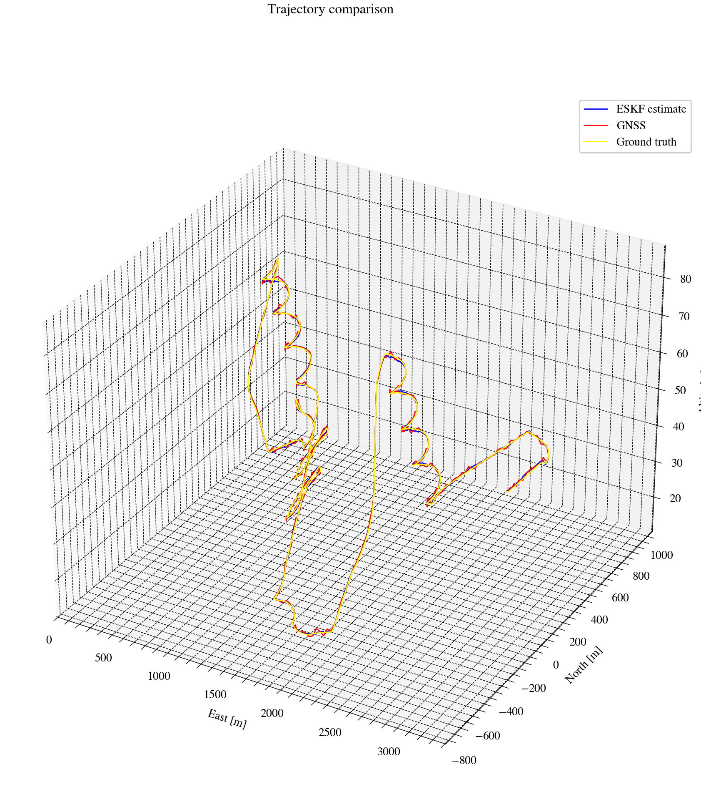
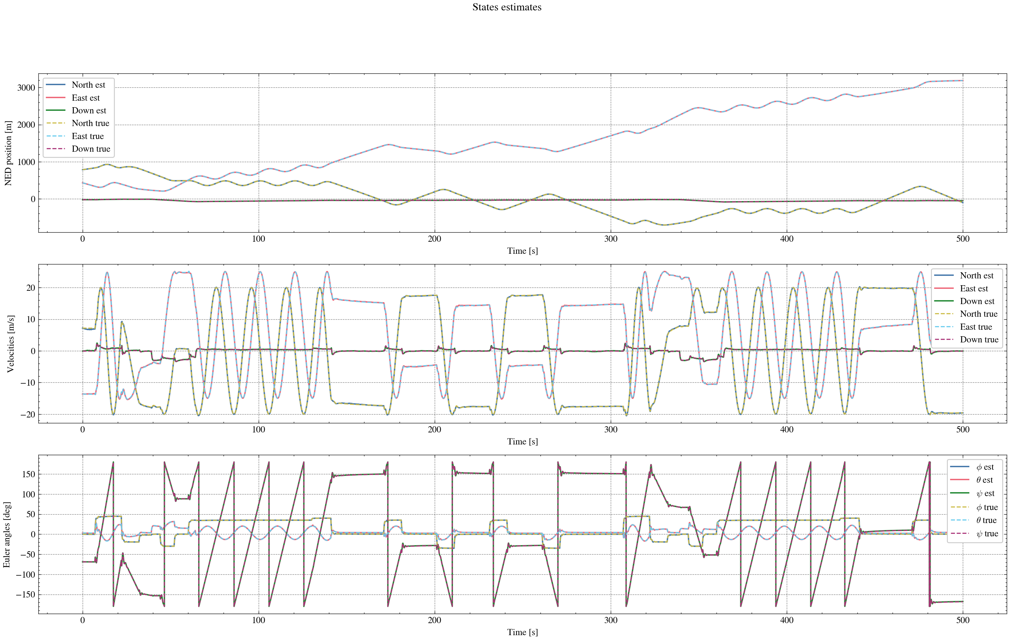
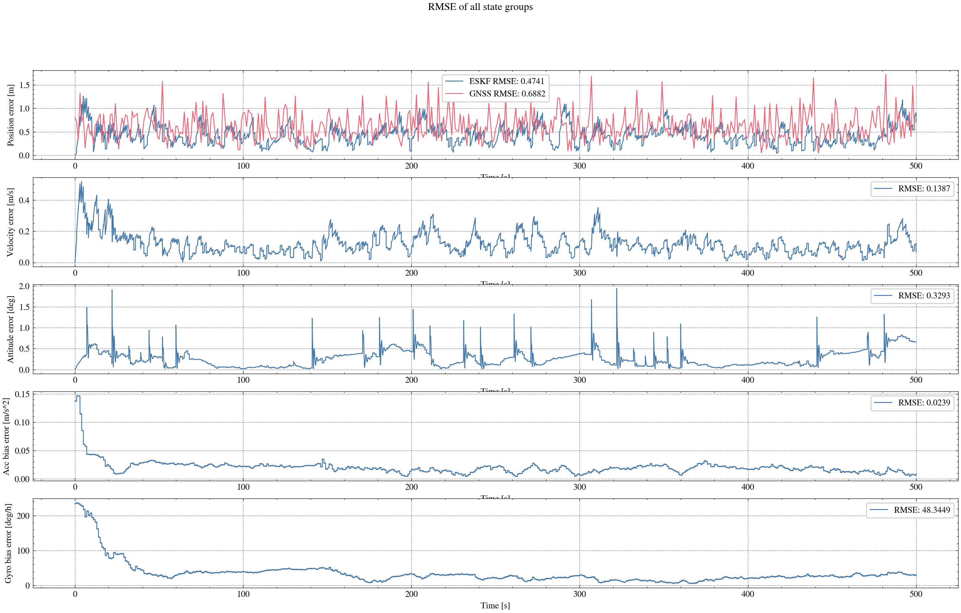
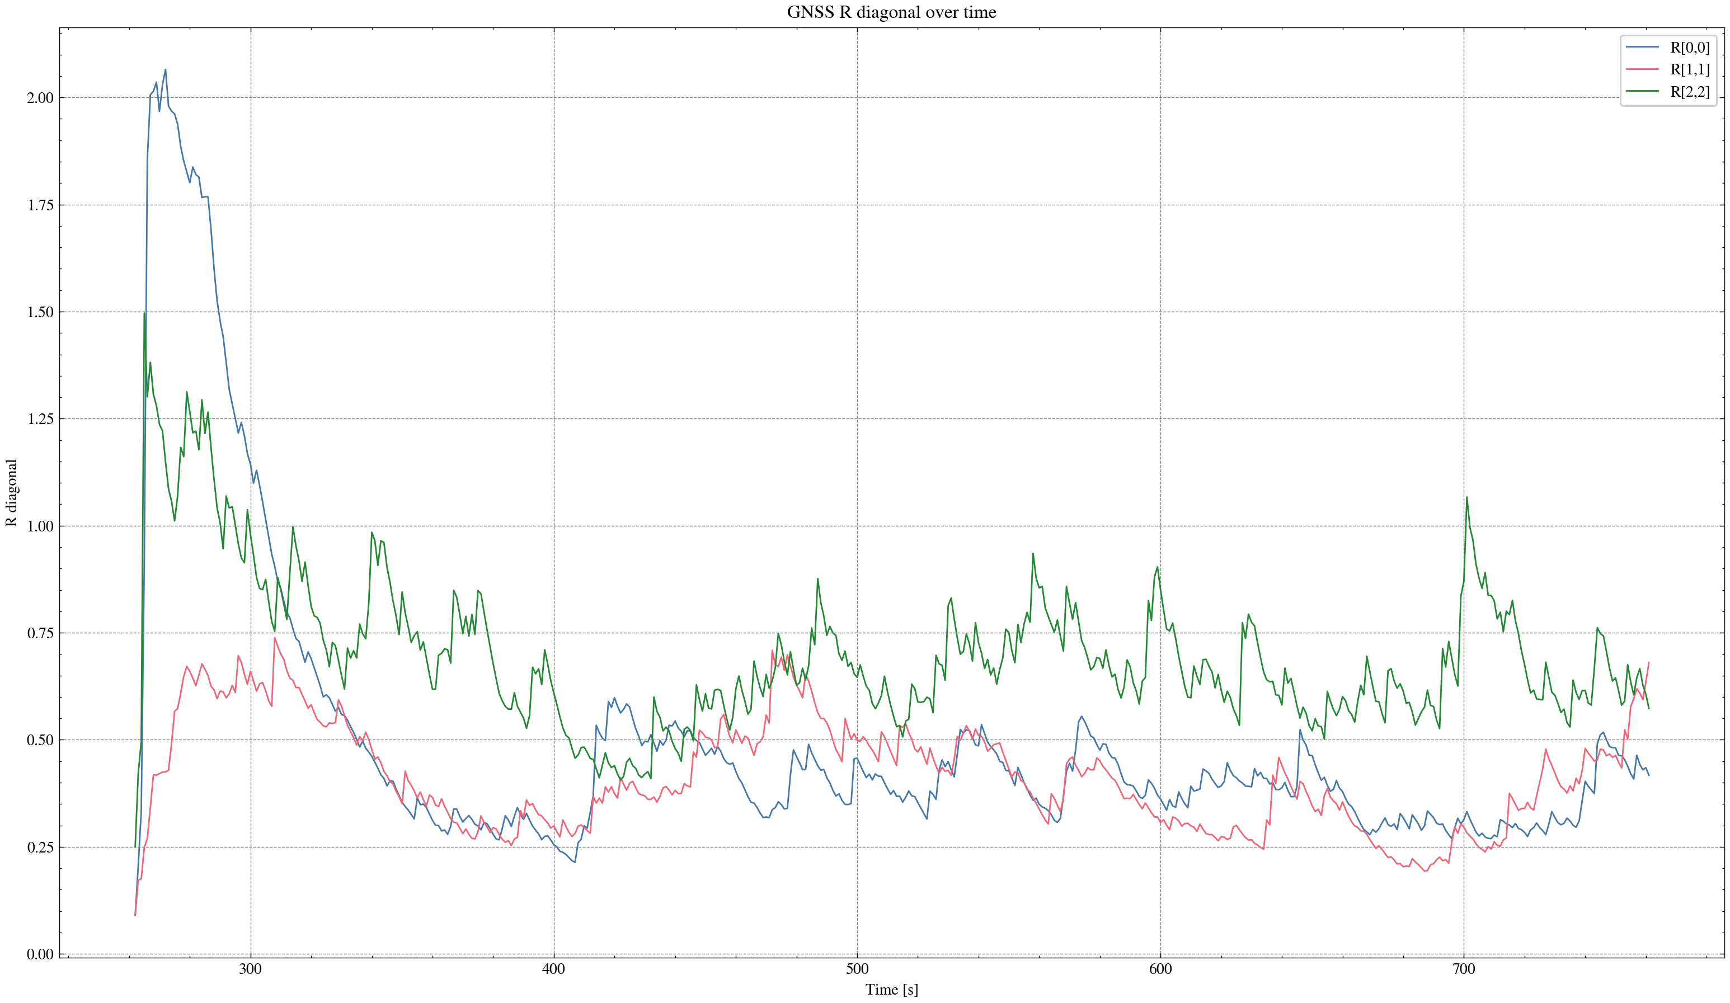

task_simulation_random_05
Input data: E:\eskf_bishe\bishe\ESKF-2.0\task_simulation_50000\task_simulation_random_05.mat
Run status: OK
==================== RMSE summary ====================
Position RMSE [m] (N,E,D): 0.2336, 0.2531, 0.3238
Velocity RMSE [m/s] (N,E,D): 0.0811, 0.0883, 0.0675
Attitude RMSE [deg] (roll,pitch,yaw): 0.1295, 0.1492, 0.3108
Acc bias RMSE [m/s^2] (x,y,z): 0.015267, 0.010976, 0.011702
Gyro bias RMSE [deg/h] (x,y,z): 36.1327, 32.1802, 29.9403
======================================================
