ESKF Batch Simulation Report
Generated at: 2026-04-23 20:57:26
Data folder: E:\eskf_bishe\bishe\ESKF-2.0\task_simulation_50000

task_simulation_random_01
Input data: E:\eskf_bishe\bishe\ESKF-2.0\task_simulation_50000\task_simulation_random_01.mat
Run status: OK
==================== RMSE summary ====================
Position RMSE [m] (N,E,D): 0.2154, 0.2258, 0.2864
Velocity RMSE [m/s] (N,E,D): 0.0807, 0.0833, 0.0564
Attitude RMSE [deg] (roll,pitch,yaw): 0.1229, 0.1191, 0.2545
Acc bias RMSE [m/s^2] (x,y,z): 0.016711, 0.008779, 0.011111
Gyro bias RMSE [deg/h] (x,y,z): 44.2454, 30.2372, 19.0790
======================================================
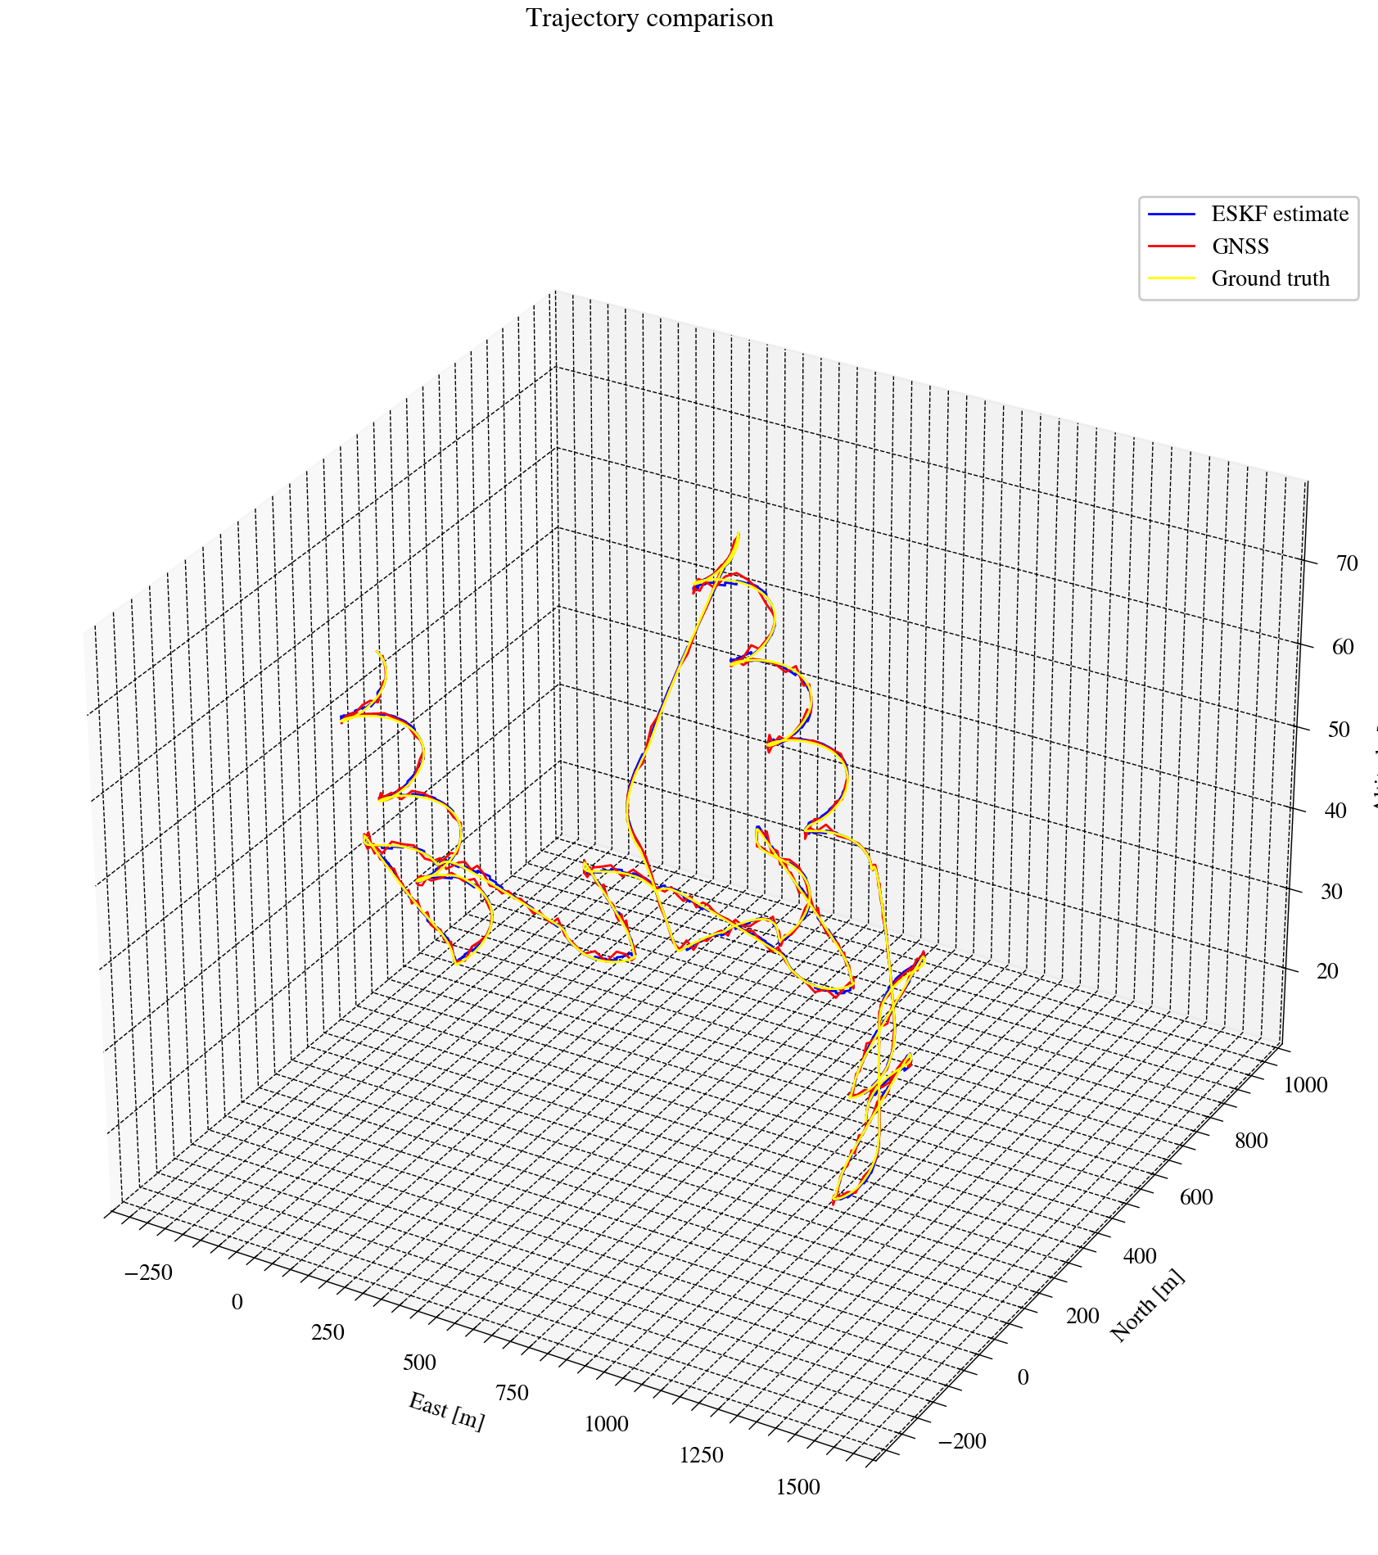
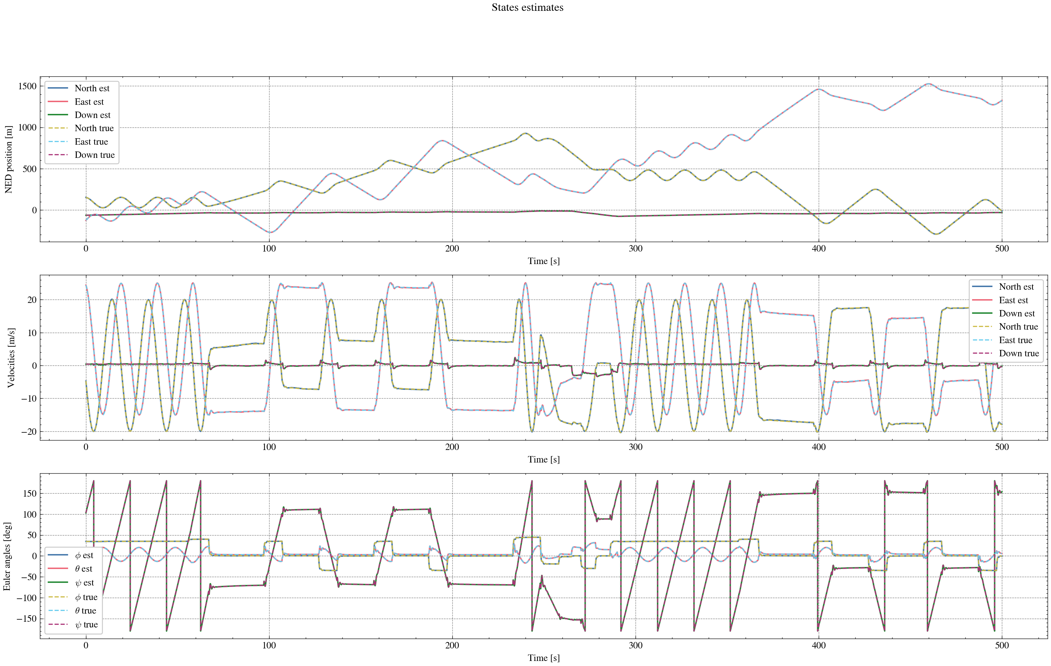
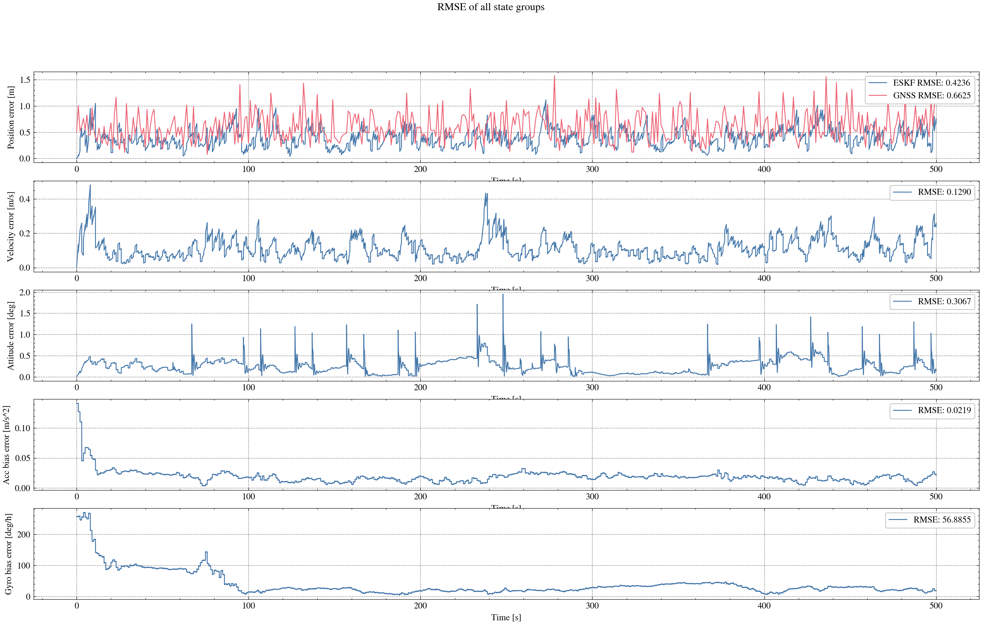
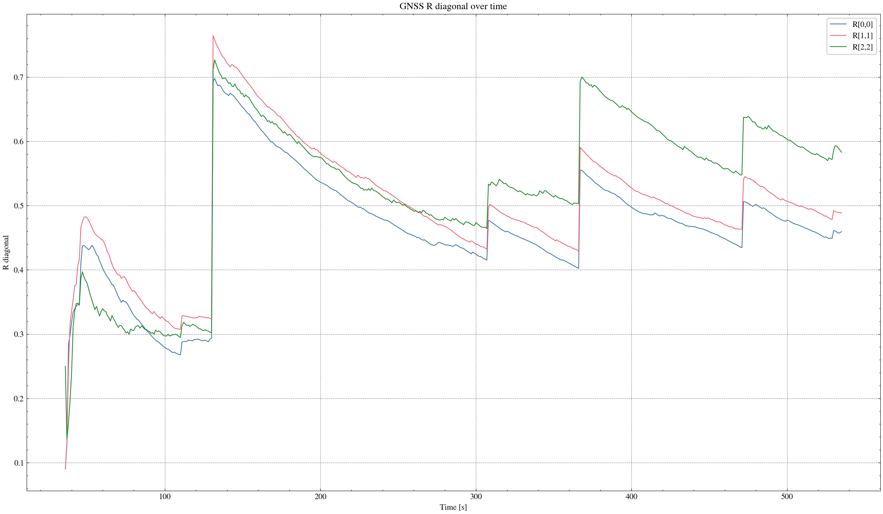

task_simulation_random_02
Input data: E:\eskf_bishe\bishe\ESKF-2.0\task_simulation_50000\task_simulation_random_02.mat
Run status: OK
==================== RMSE summary ====================
Position RMSE [m] (N,E,D): 0.2243, 0.2324, 0.3056
Velocity RMSE [m/s] (N,E,D): 0.0884, 0.0839, 0.0597
Attitude RMSE [deg] (roll,pitch,yaw): 0.1245, 0.1422, 0.3018
Acc bias RMSE [m/s^2] (x,y,z): 0.014829, 0.011529, 0.011755
Gyro bias RMSE [deg/h] (x,y,z): 32.0676, 24.3573, 21.4974
======================================================
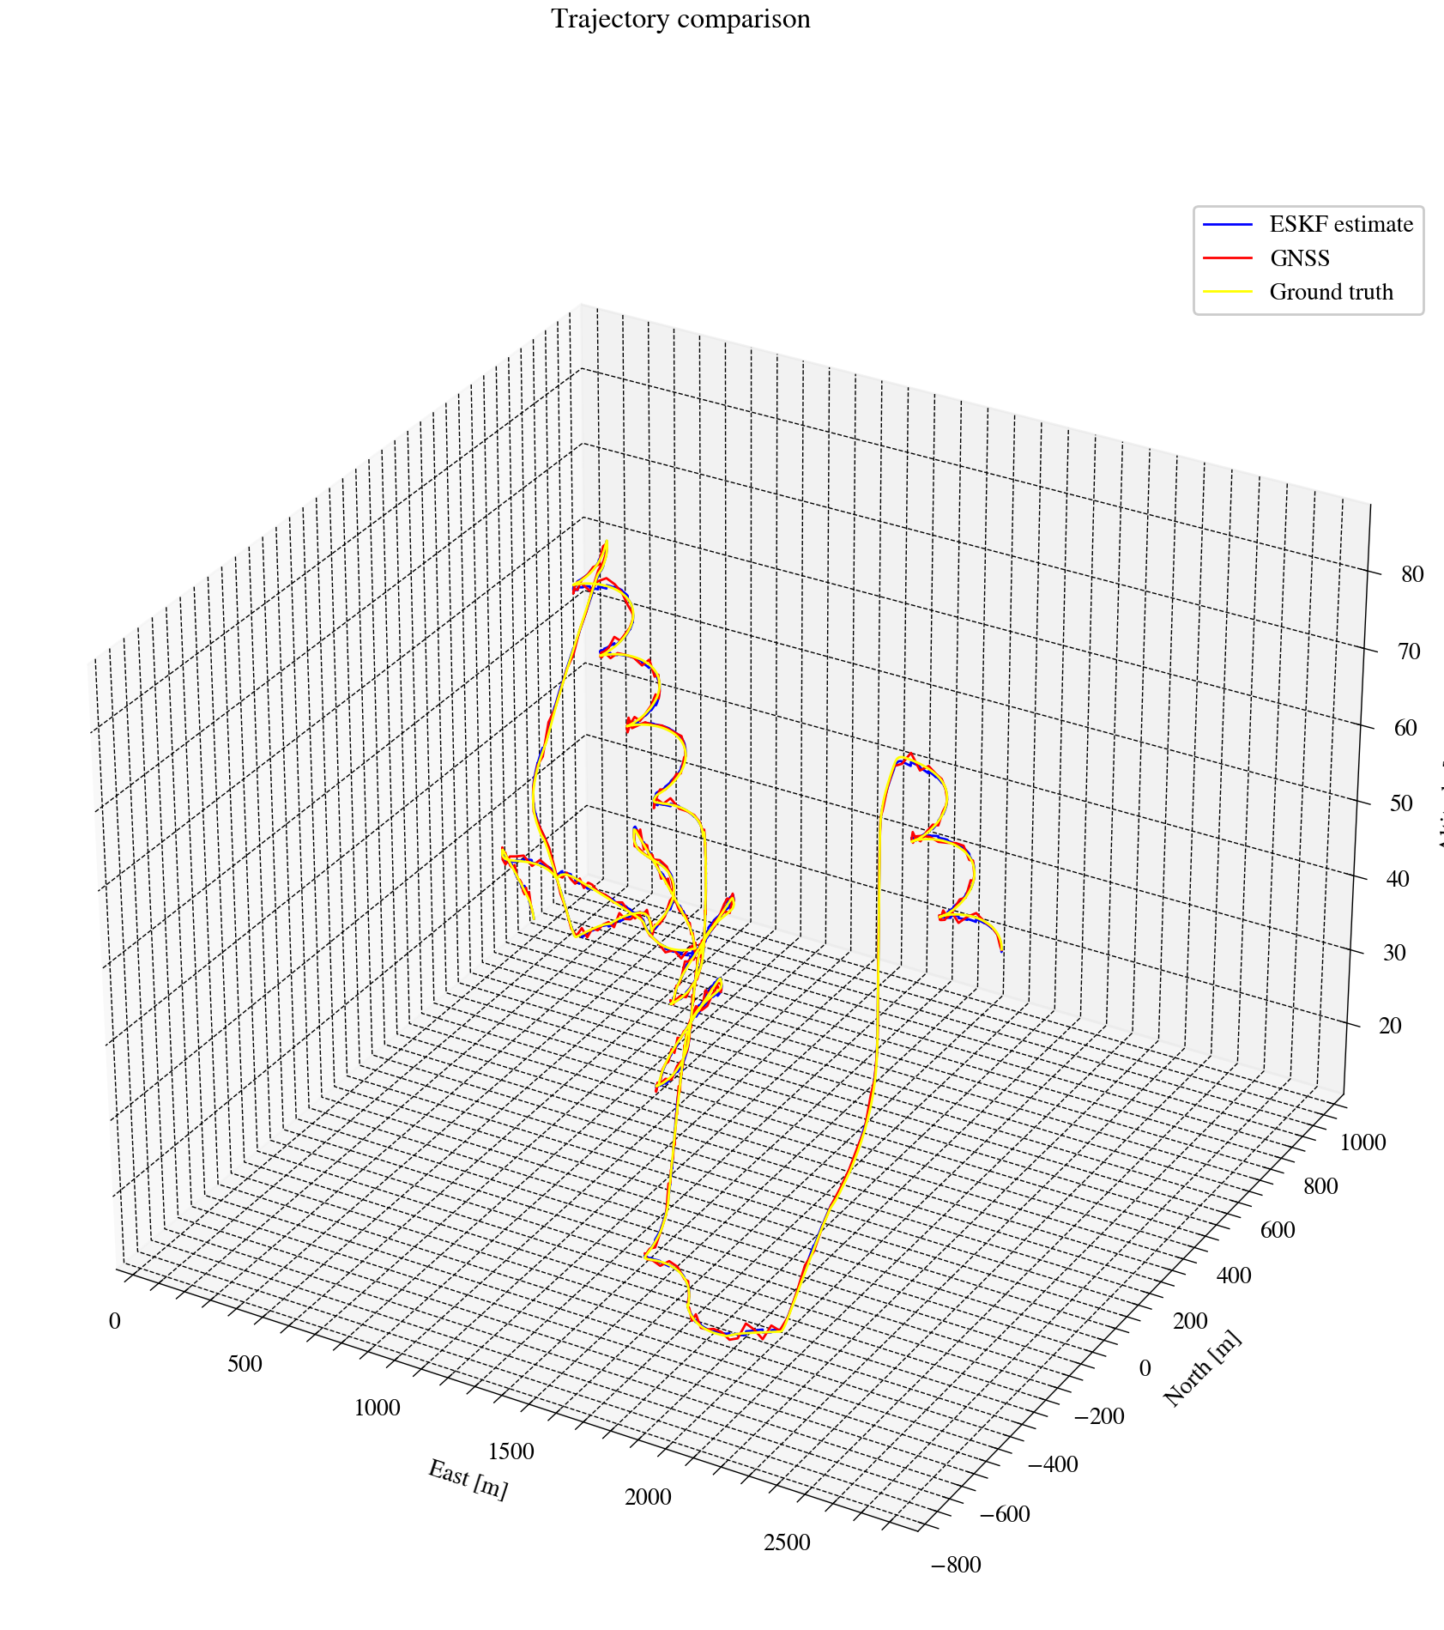
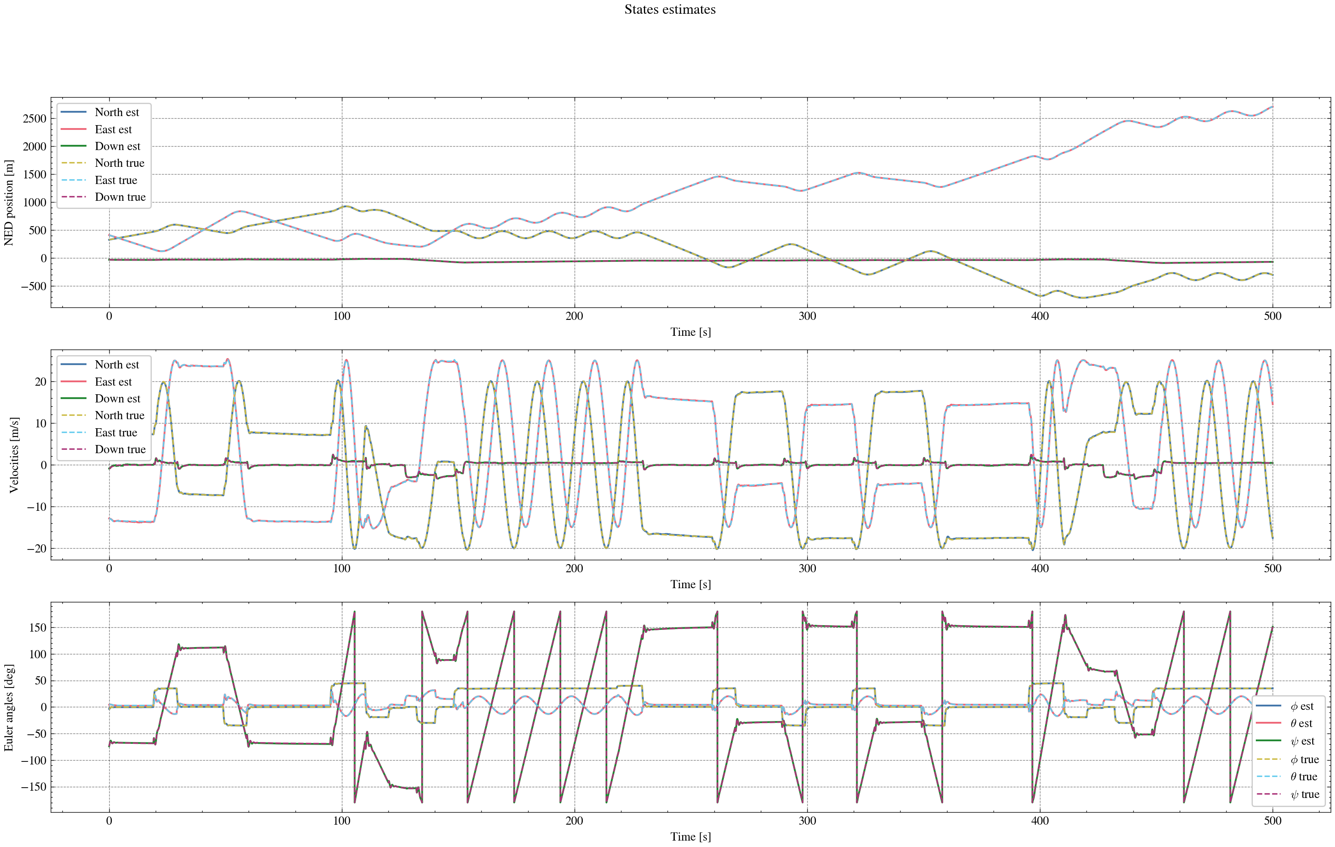
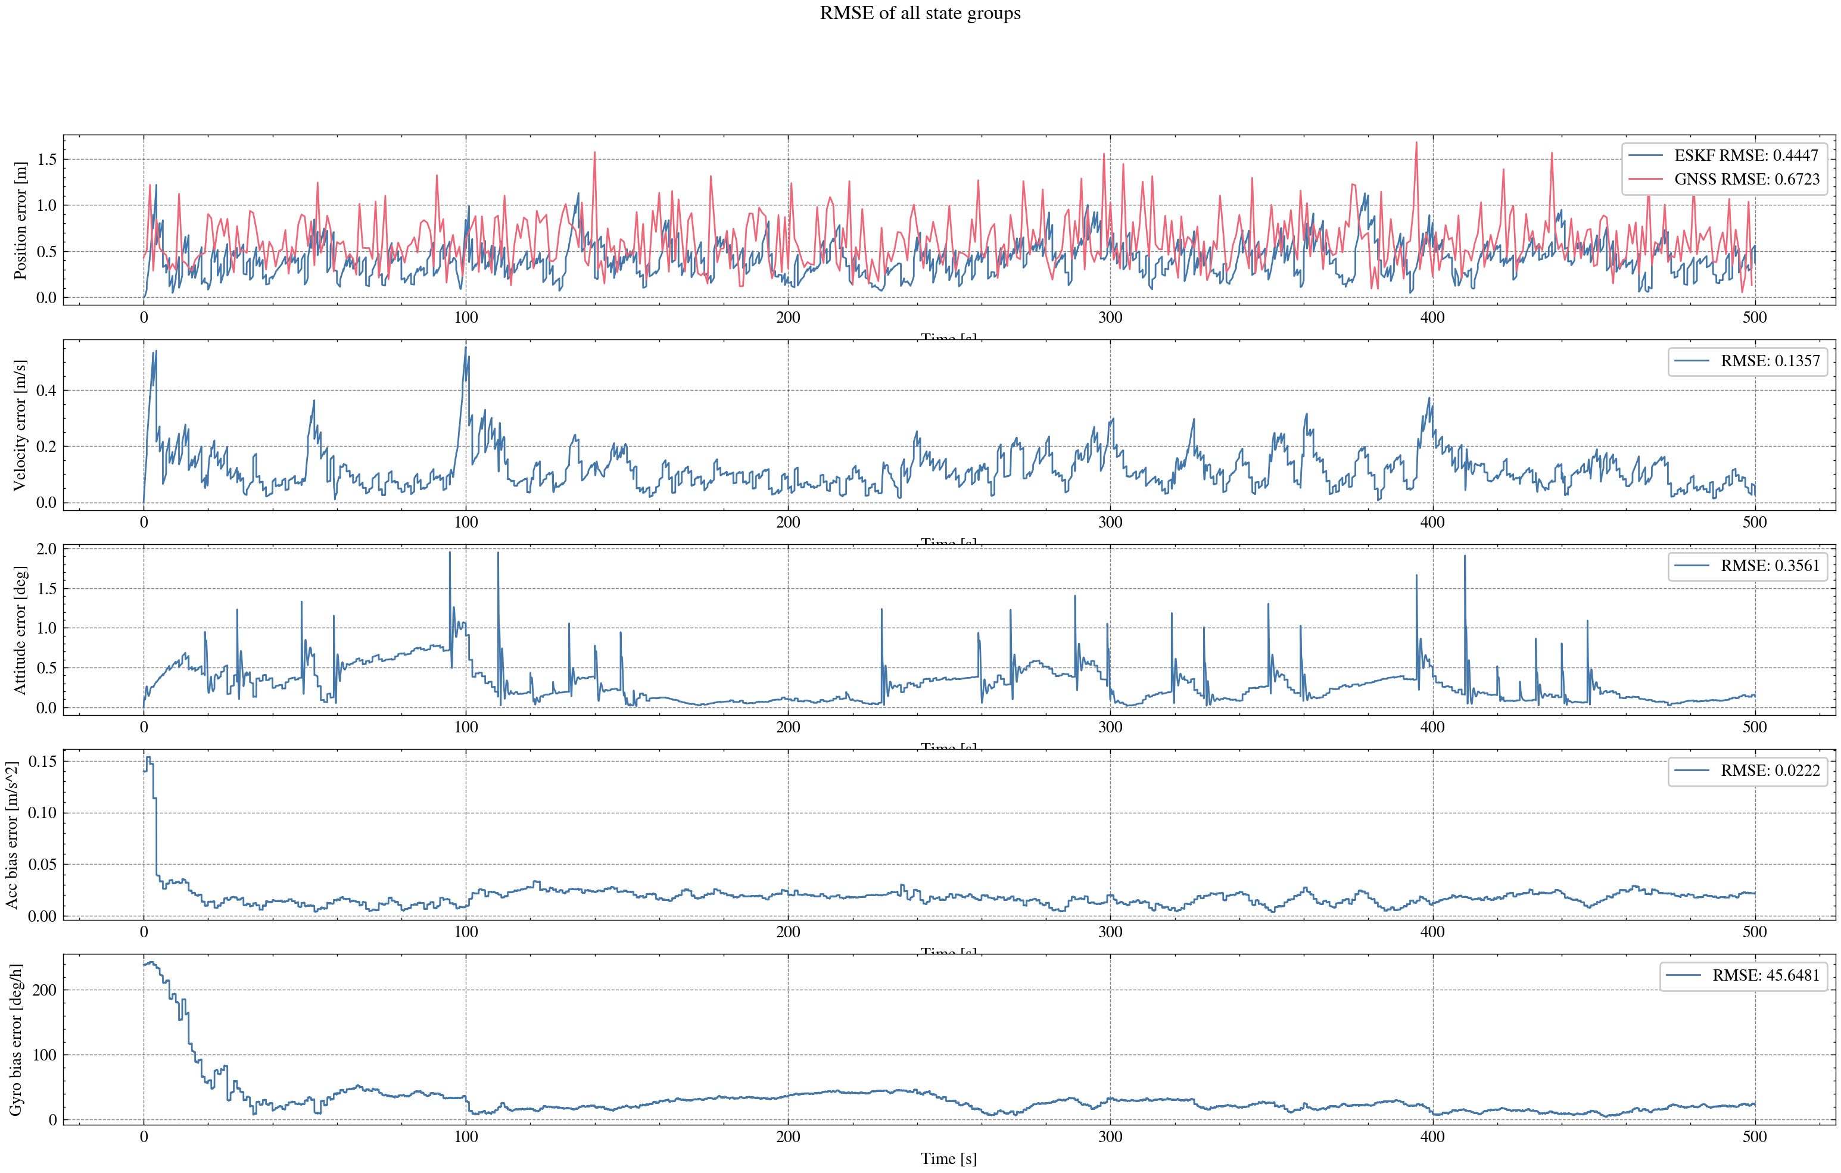
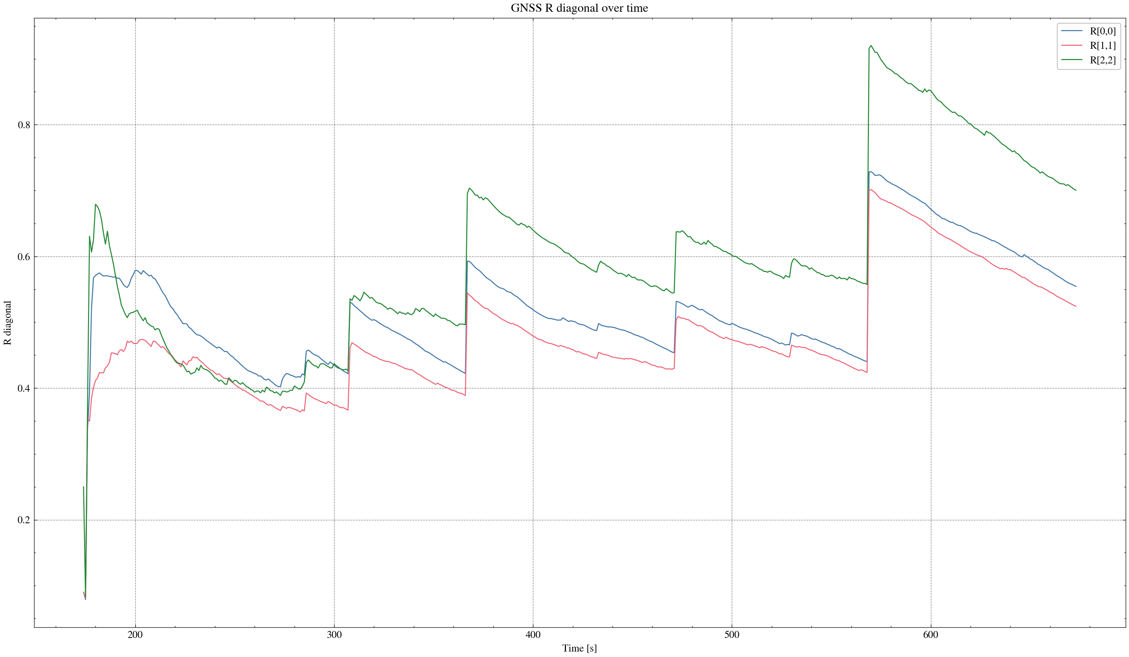

task_simulation_random_03
Input data: E:\eskf_bishe\bishe\ESKF-2.0\task_simulation_50000\task_simulation_random_03.mat
Run status: OK
==================== RMSE summary ====================
Position RMSE [m] (N,E,D): 0.2175, 0.2325, 0.3069
Velocity RMSE [m/s] (N,E,D): 0.0826, 0.0846, 0.0615
Attitude RMSE [deg] (roll,pitch,yaw): 0.1212, 0.1443, 0.3045
Acc bias RMSE [m/s^2] (x,y,z): 0.014710, 0.009641, 0.011868
Gyro bias RMSE [deg/h] (x,y,z): 31.6315, 24.5674, 25.2499
======================================================
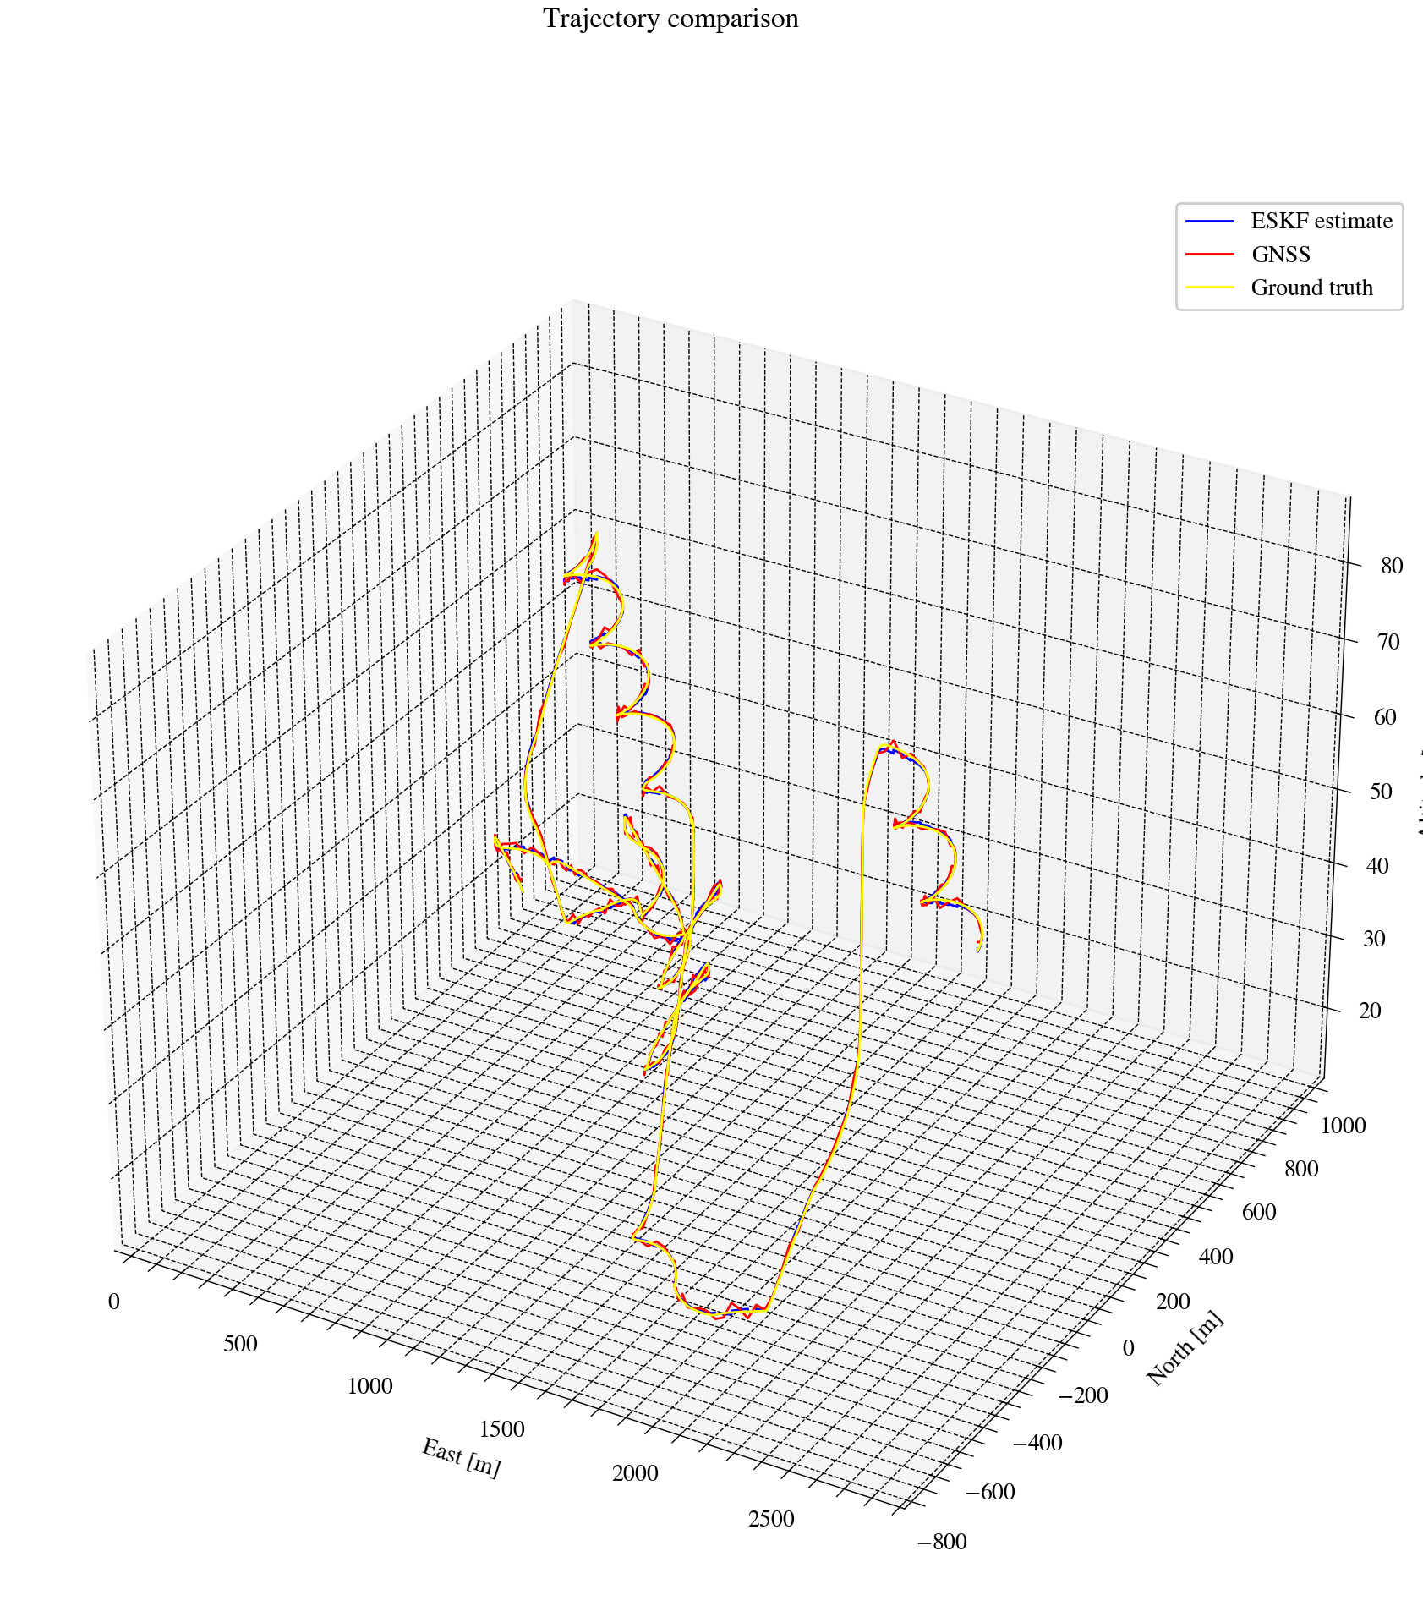
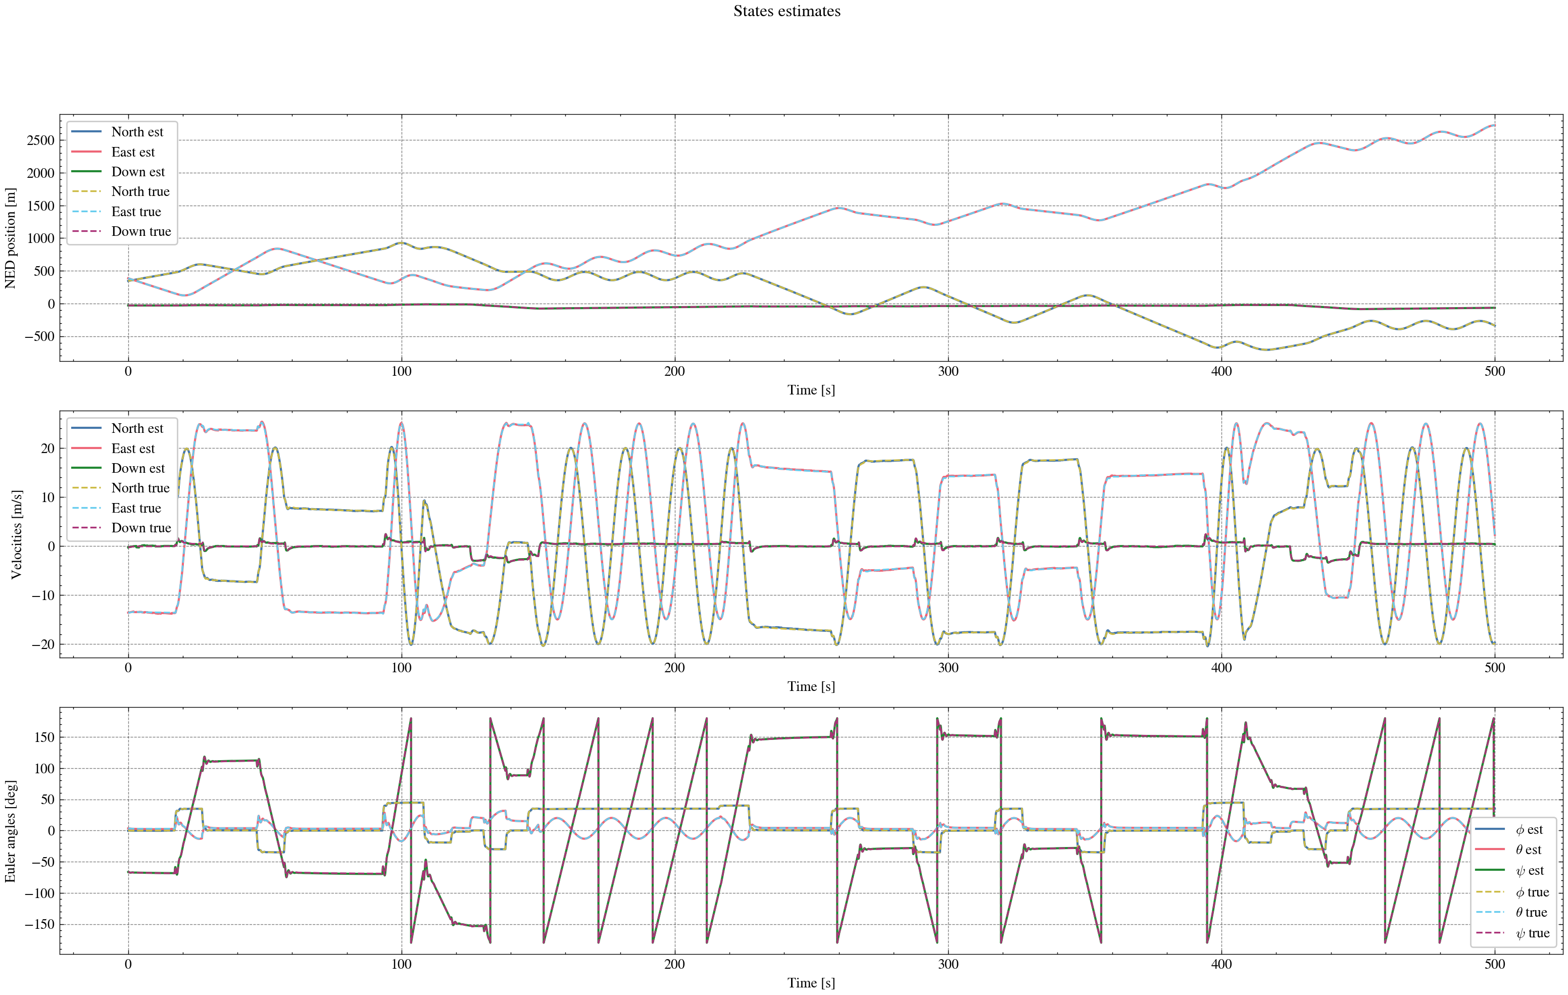
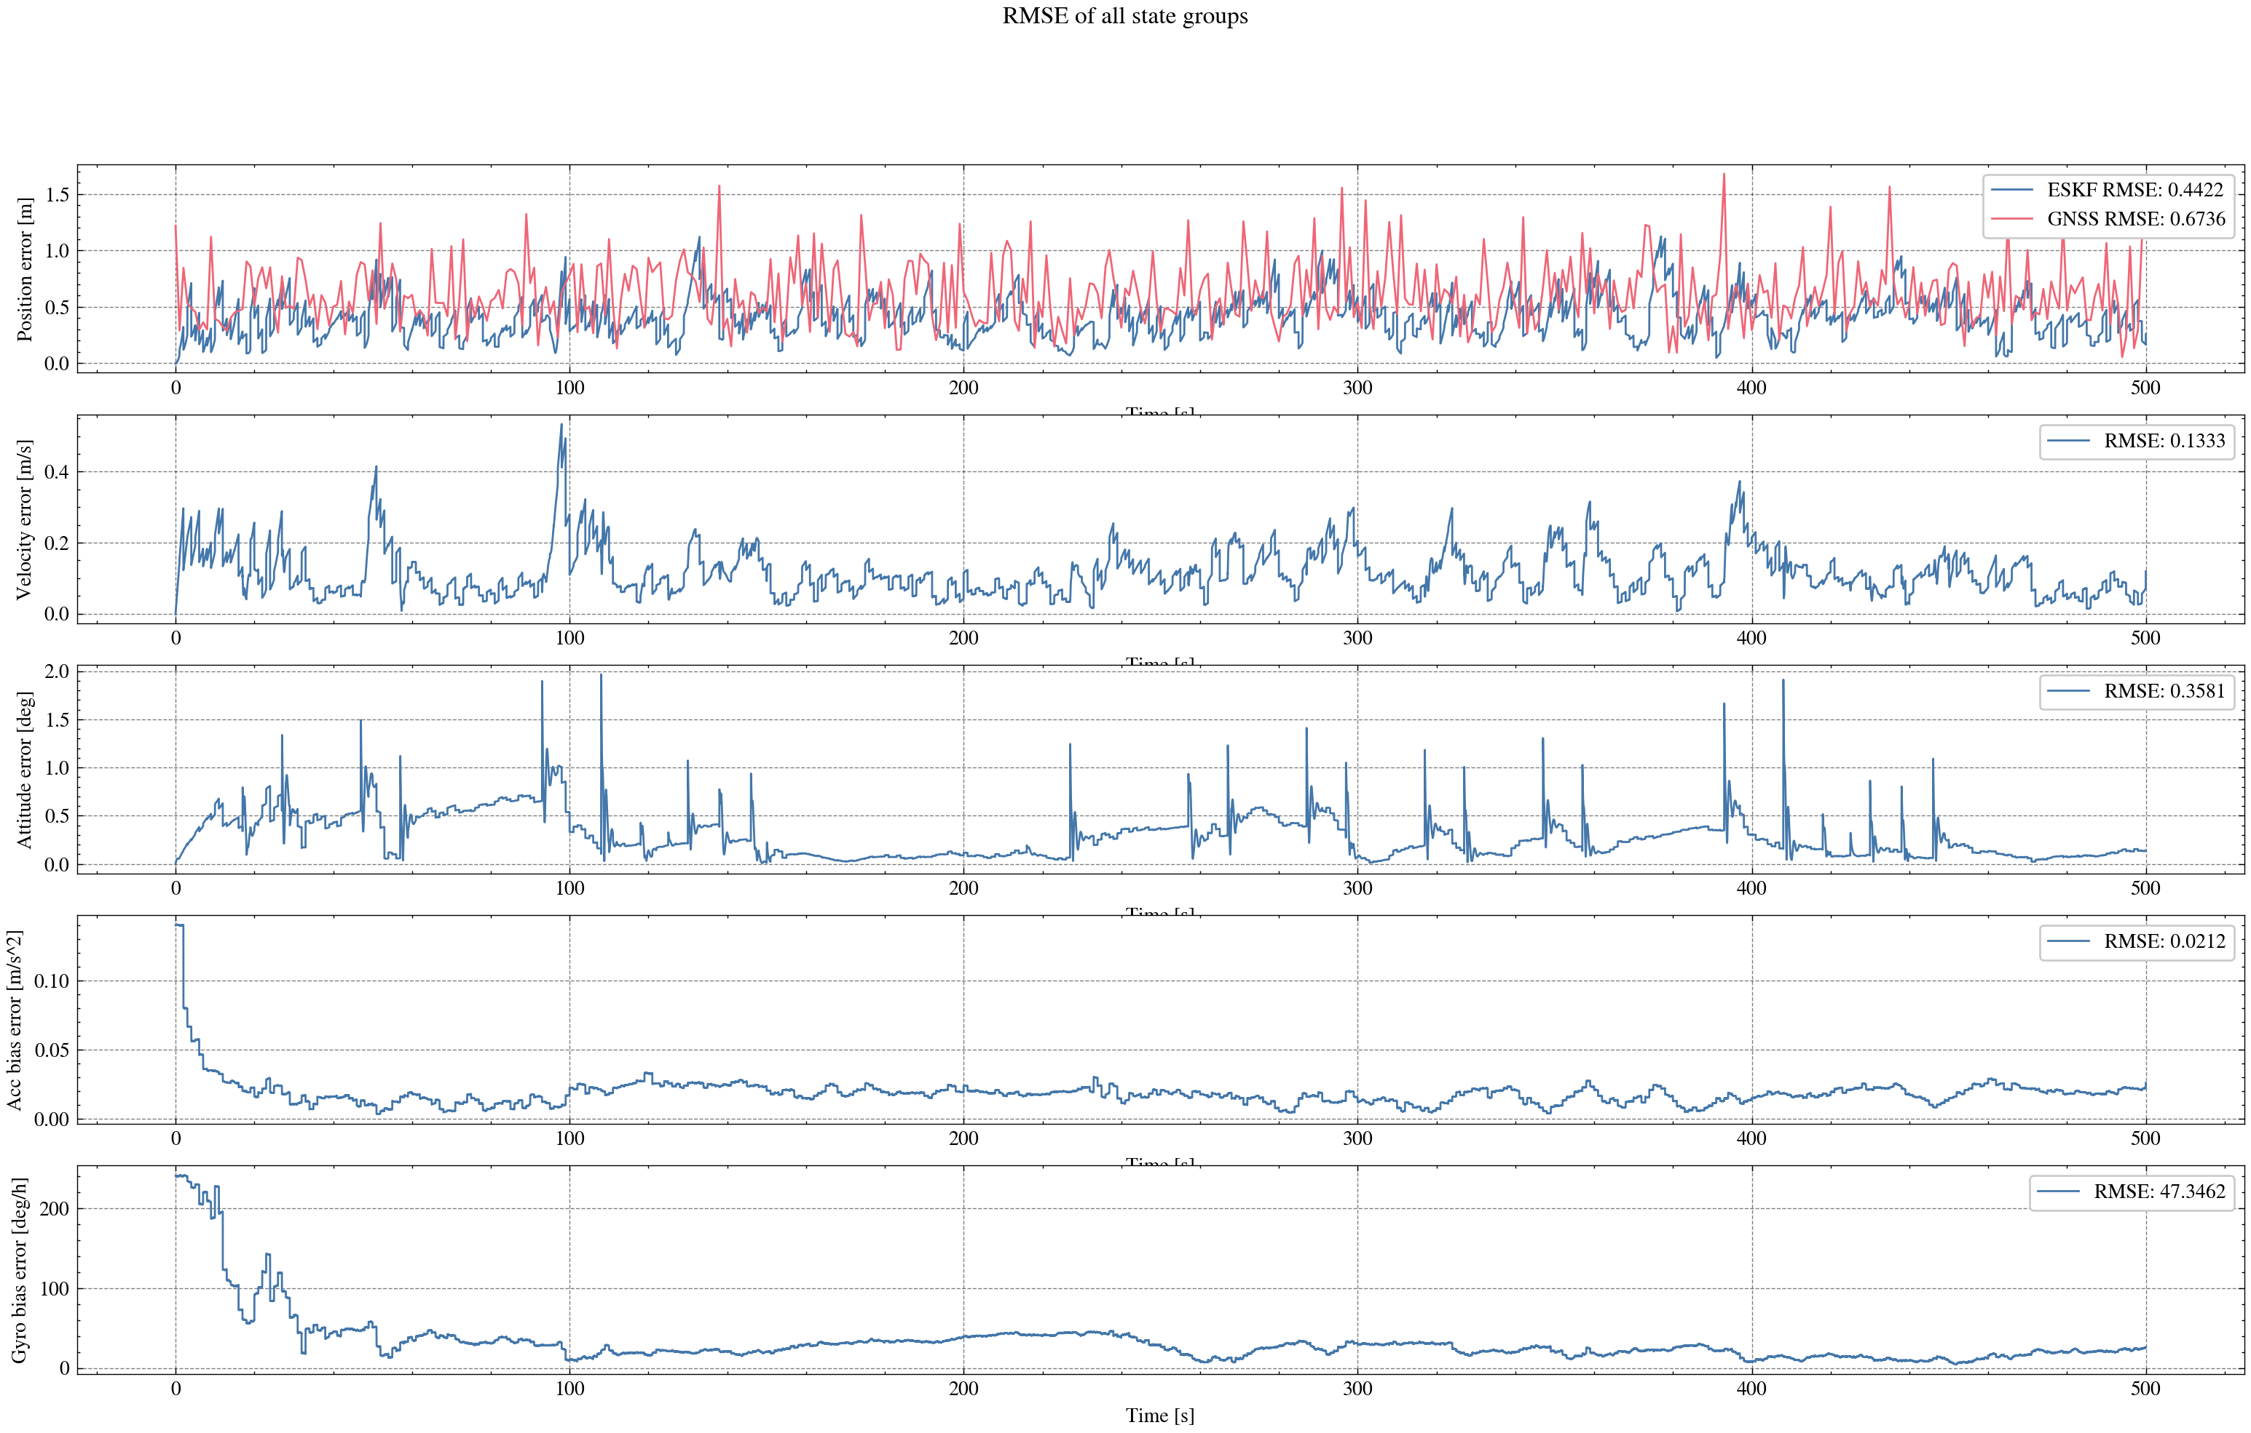
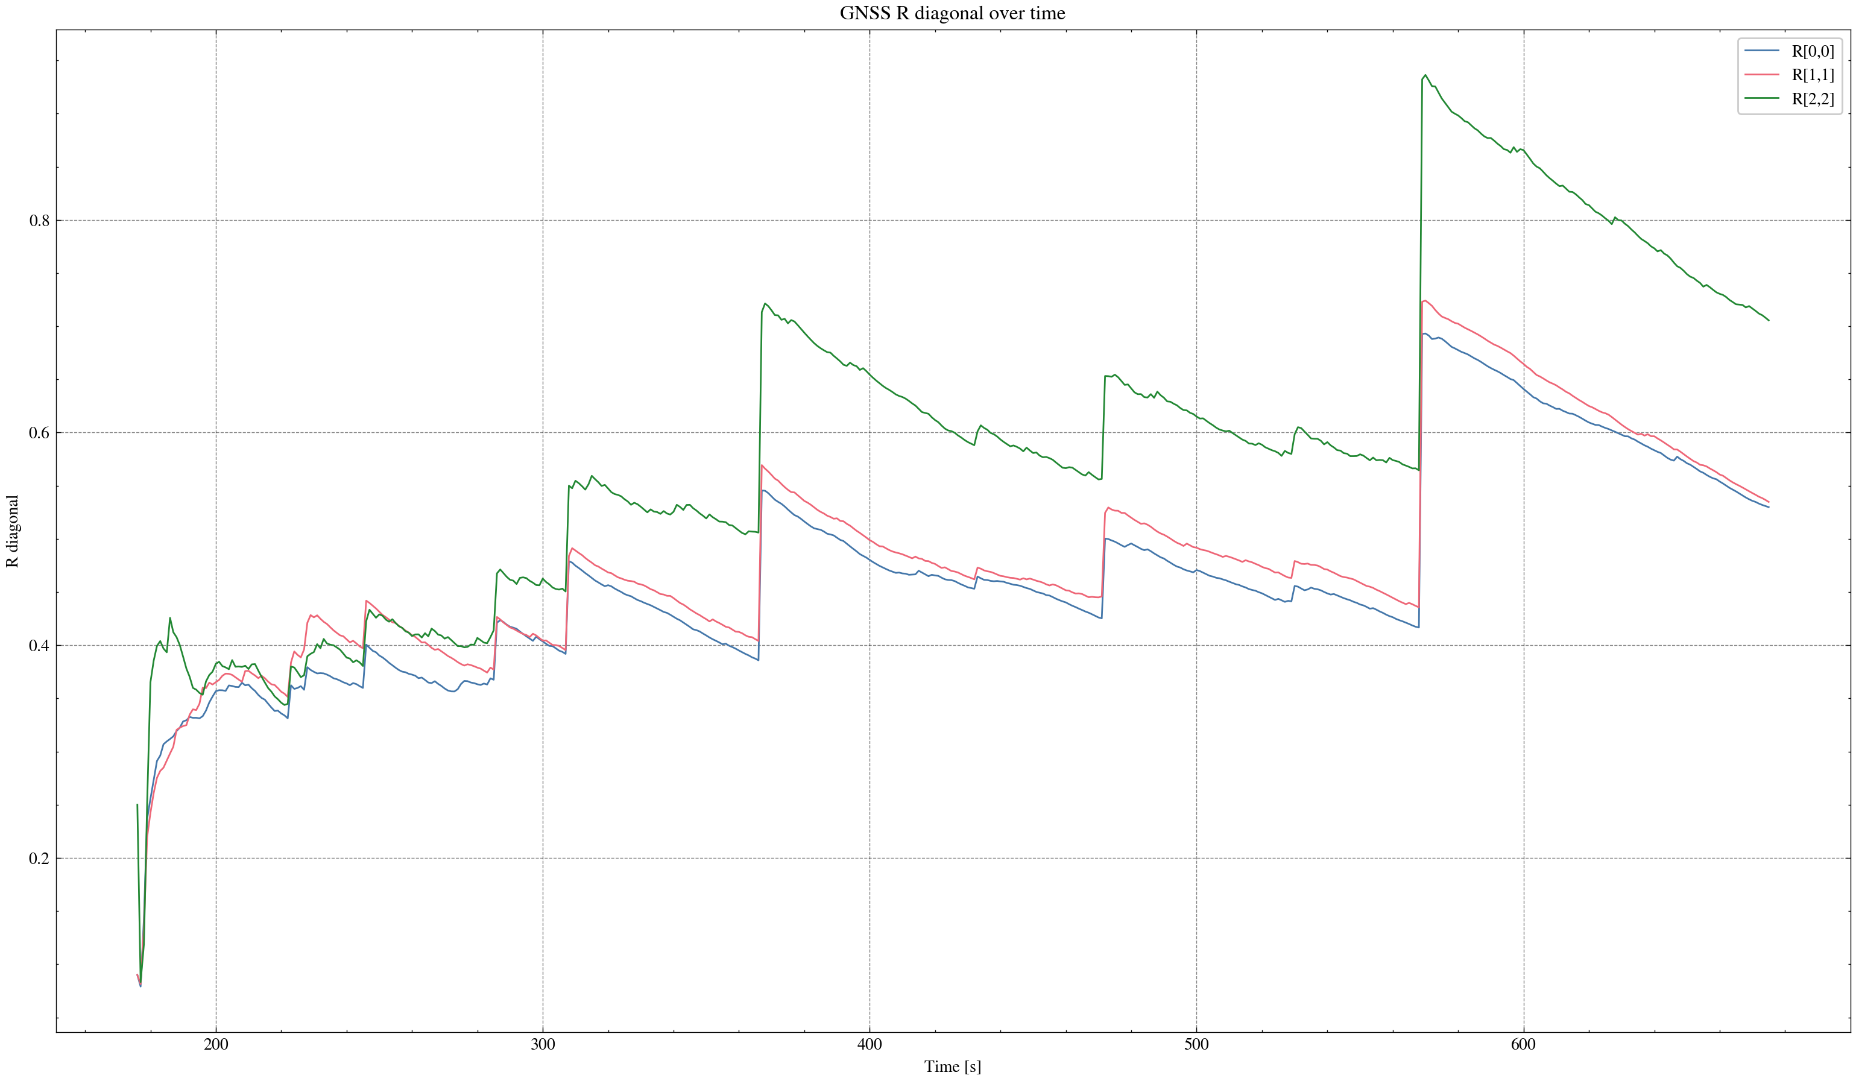

task_simulation_random_04
Input data: E:\eskf_bishe\bishe\ESKF-2.0\task_simulation_50000\task_simulation_random_04.mat
Run status: OK
==================== RMSE summary ====================
Position RMSE [m] (N,E,D): 0.2211, 0.2499, 0.3162
Velocity RMSE [m/s] (N,E,D): 0.0809, 0.0888, 0.0644
Attitude RMSE [deg] (roll,pitch,yaw): 0.1309, 0.1182, 0.2812
Acc bias RMSE [m/s^2] (x,y,z): 0.016838, 0.010518, 0.012749
Gyro bias RMSE [deg/h] (x,y,z): 35.7298, 26.4135, 21.3886
======================================================
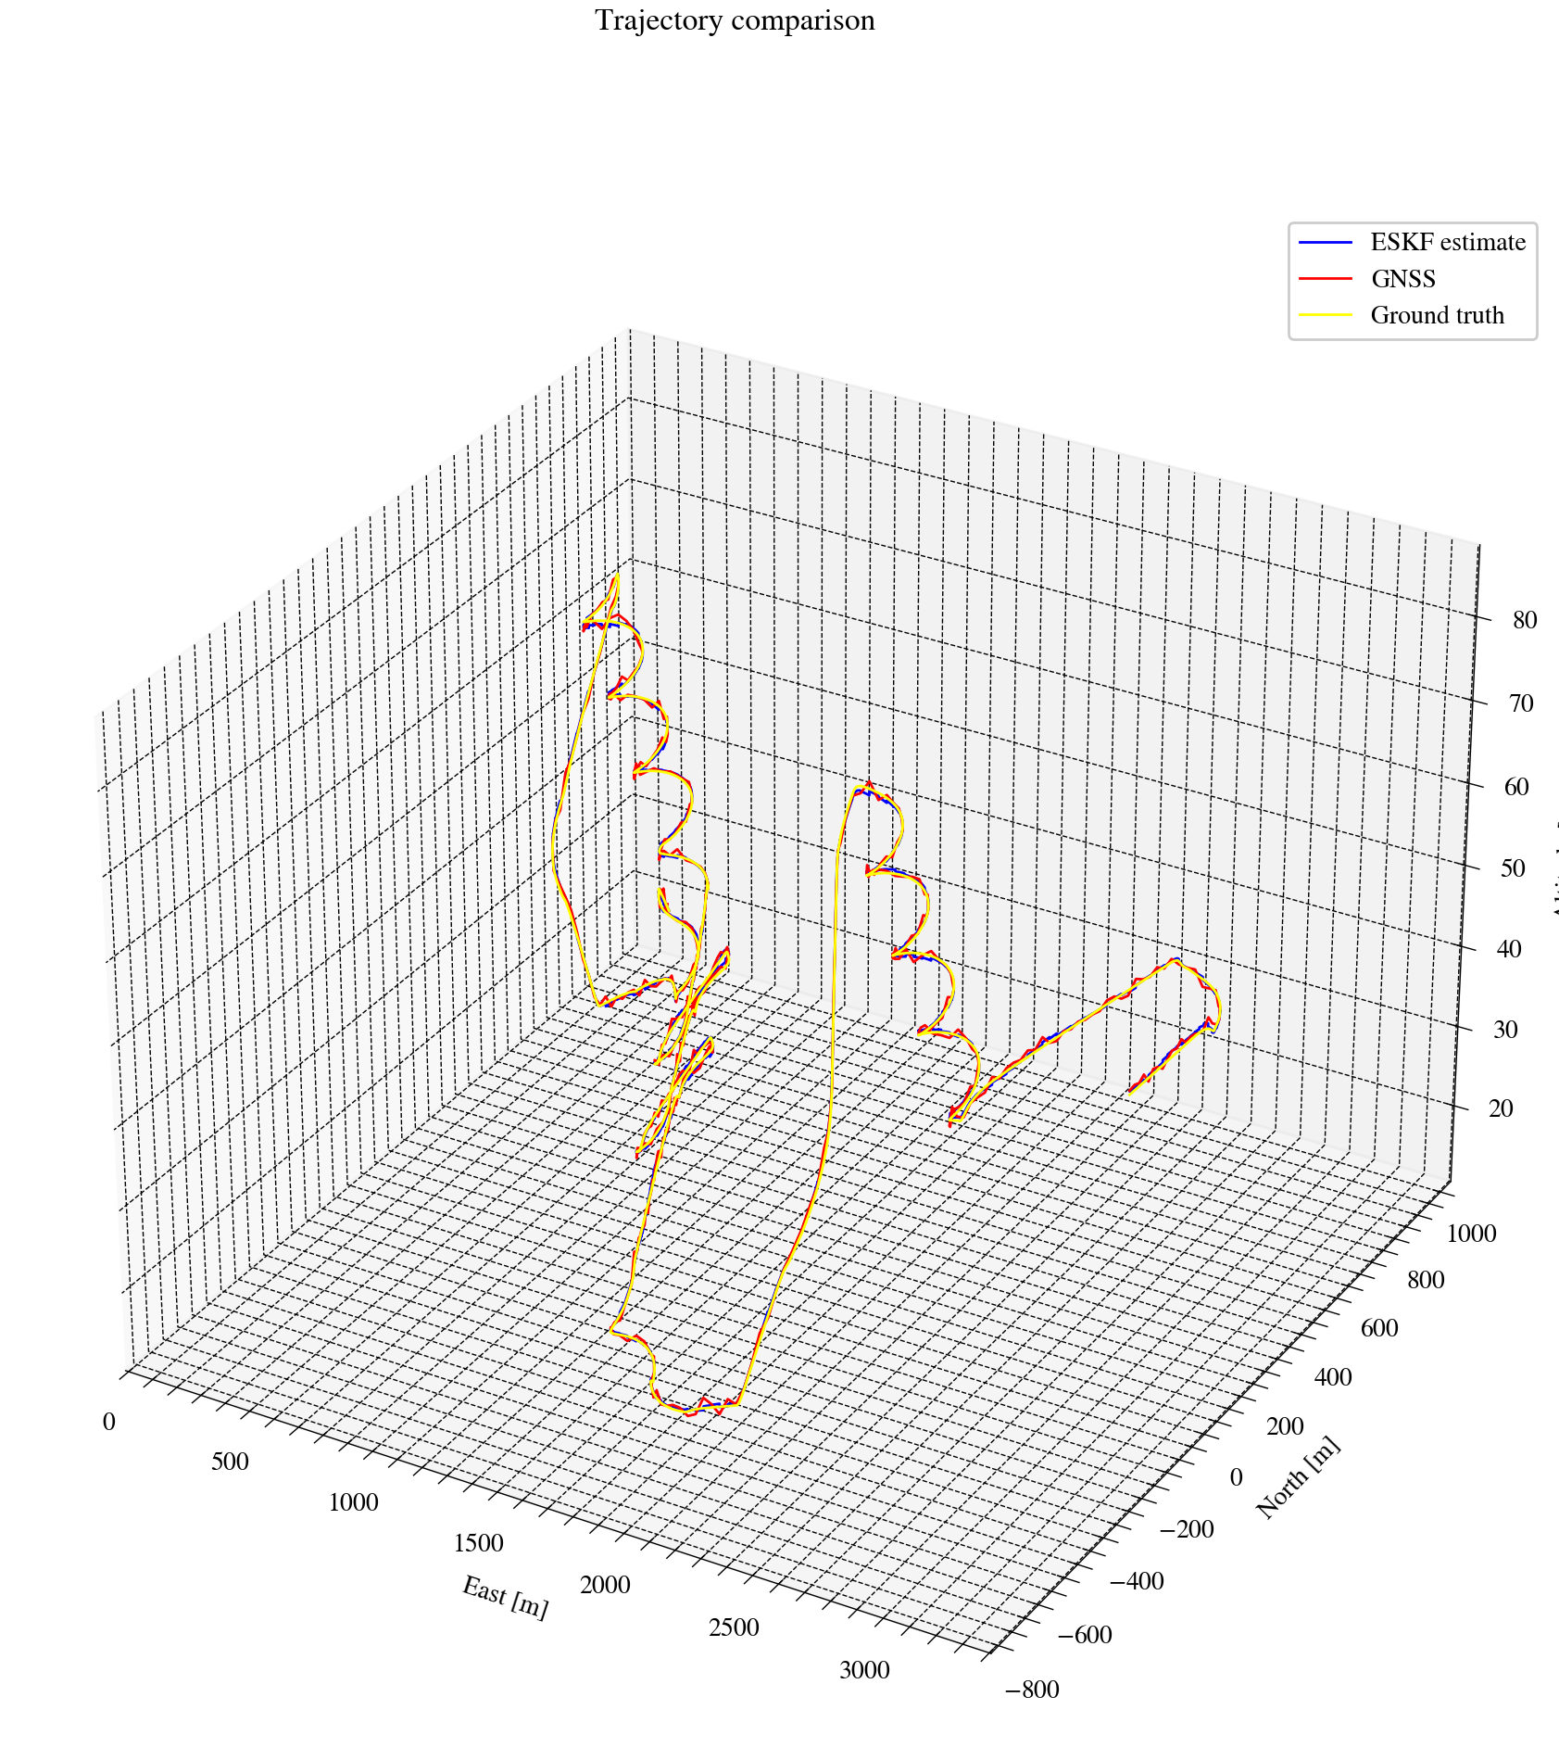
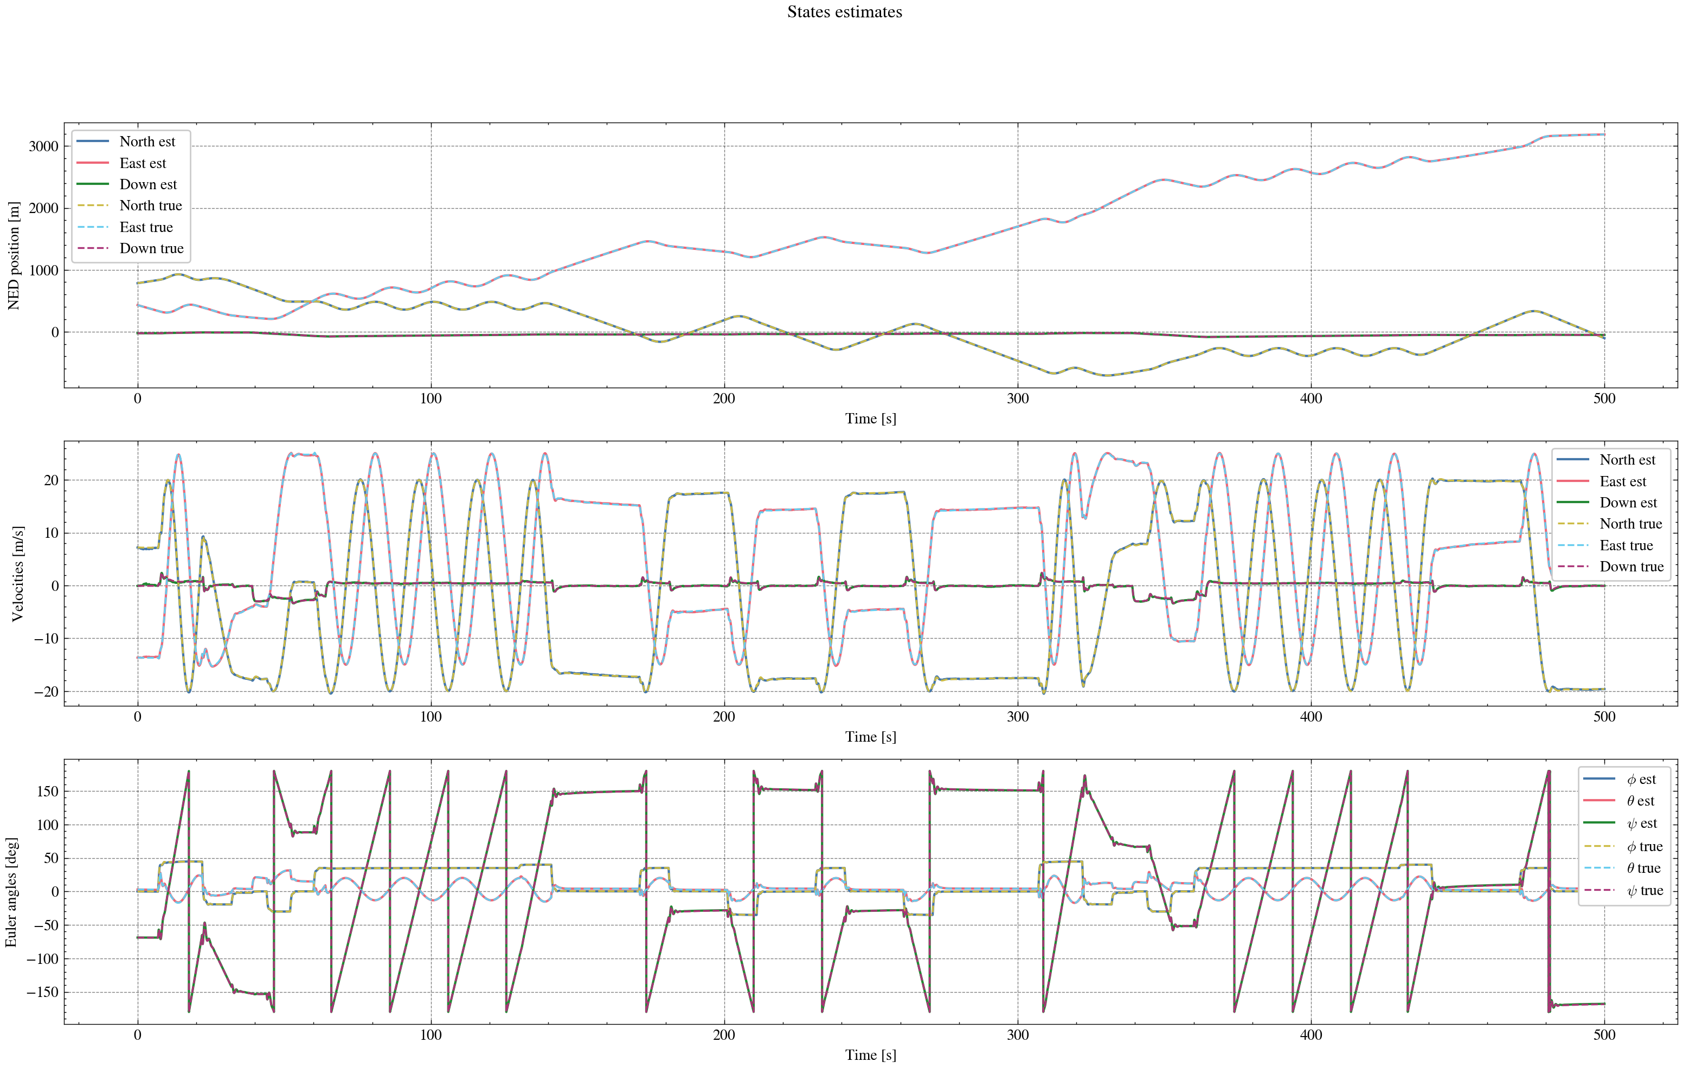
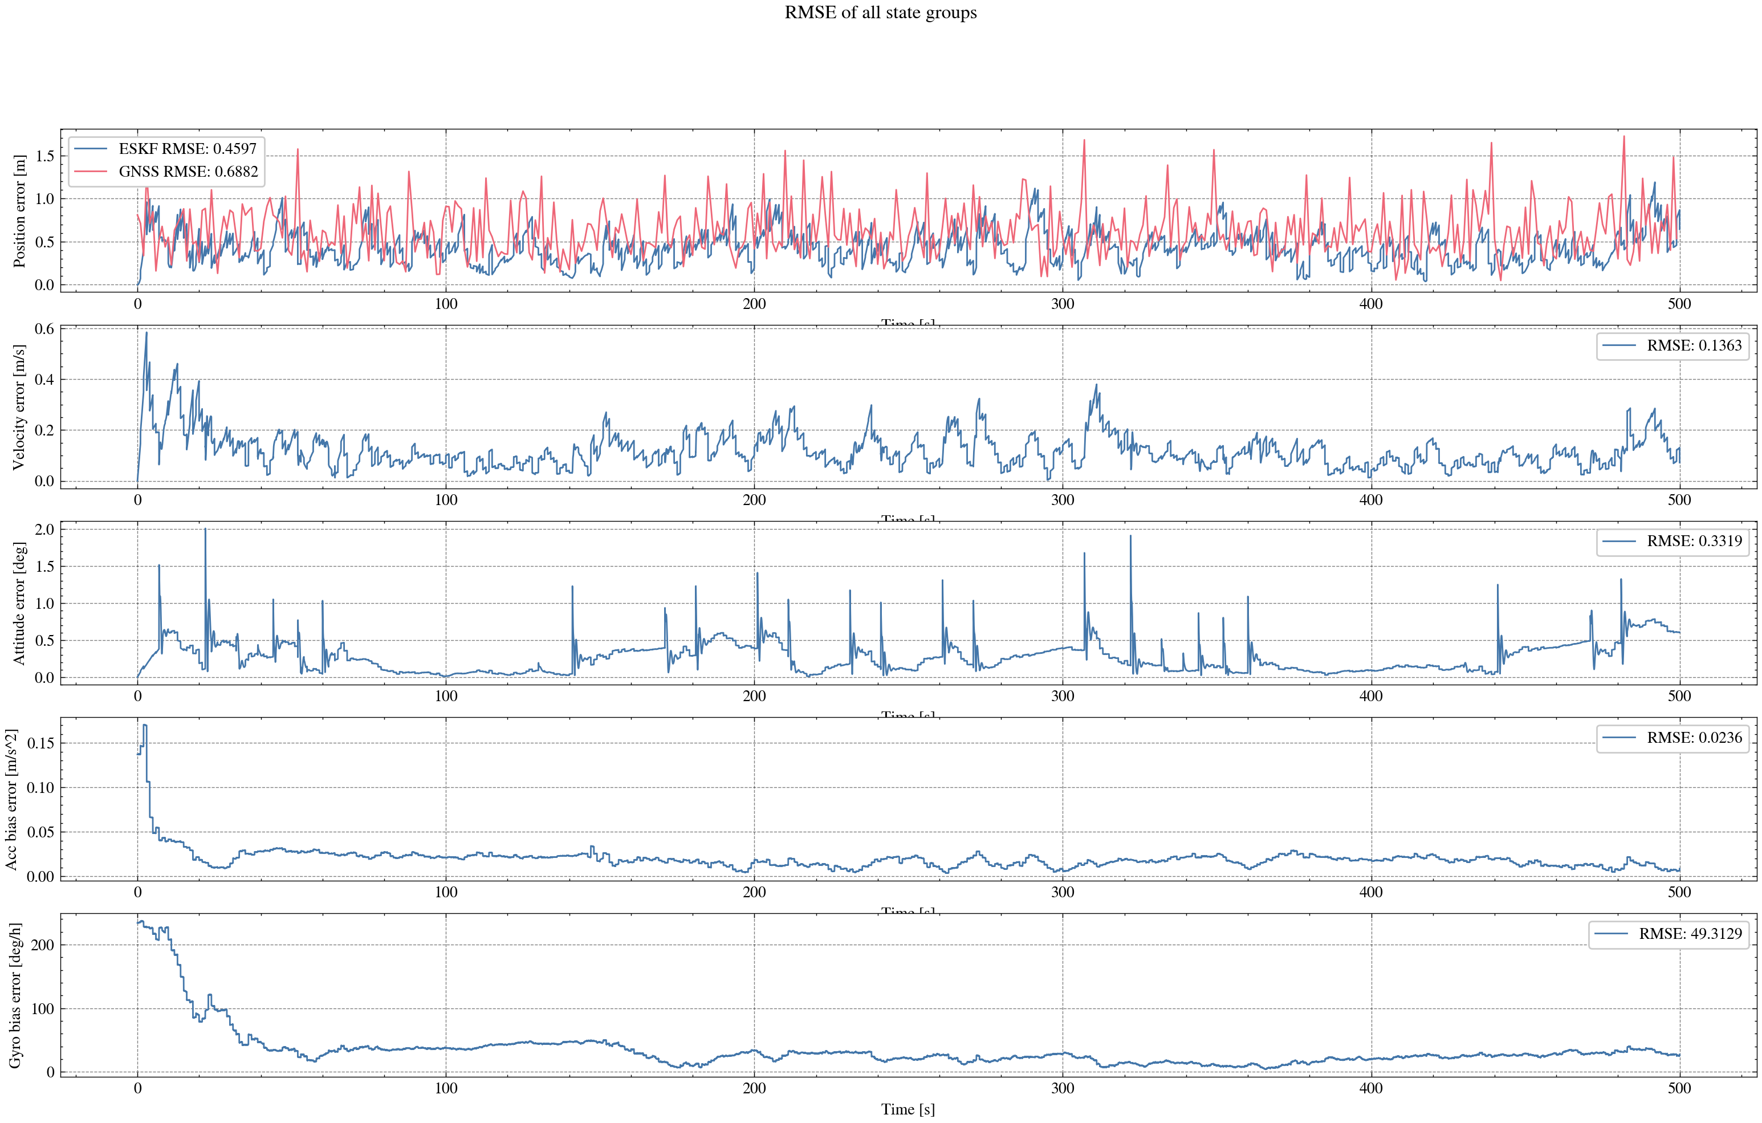
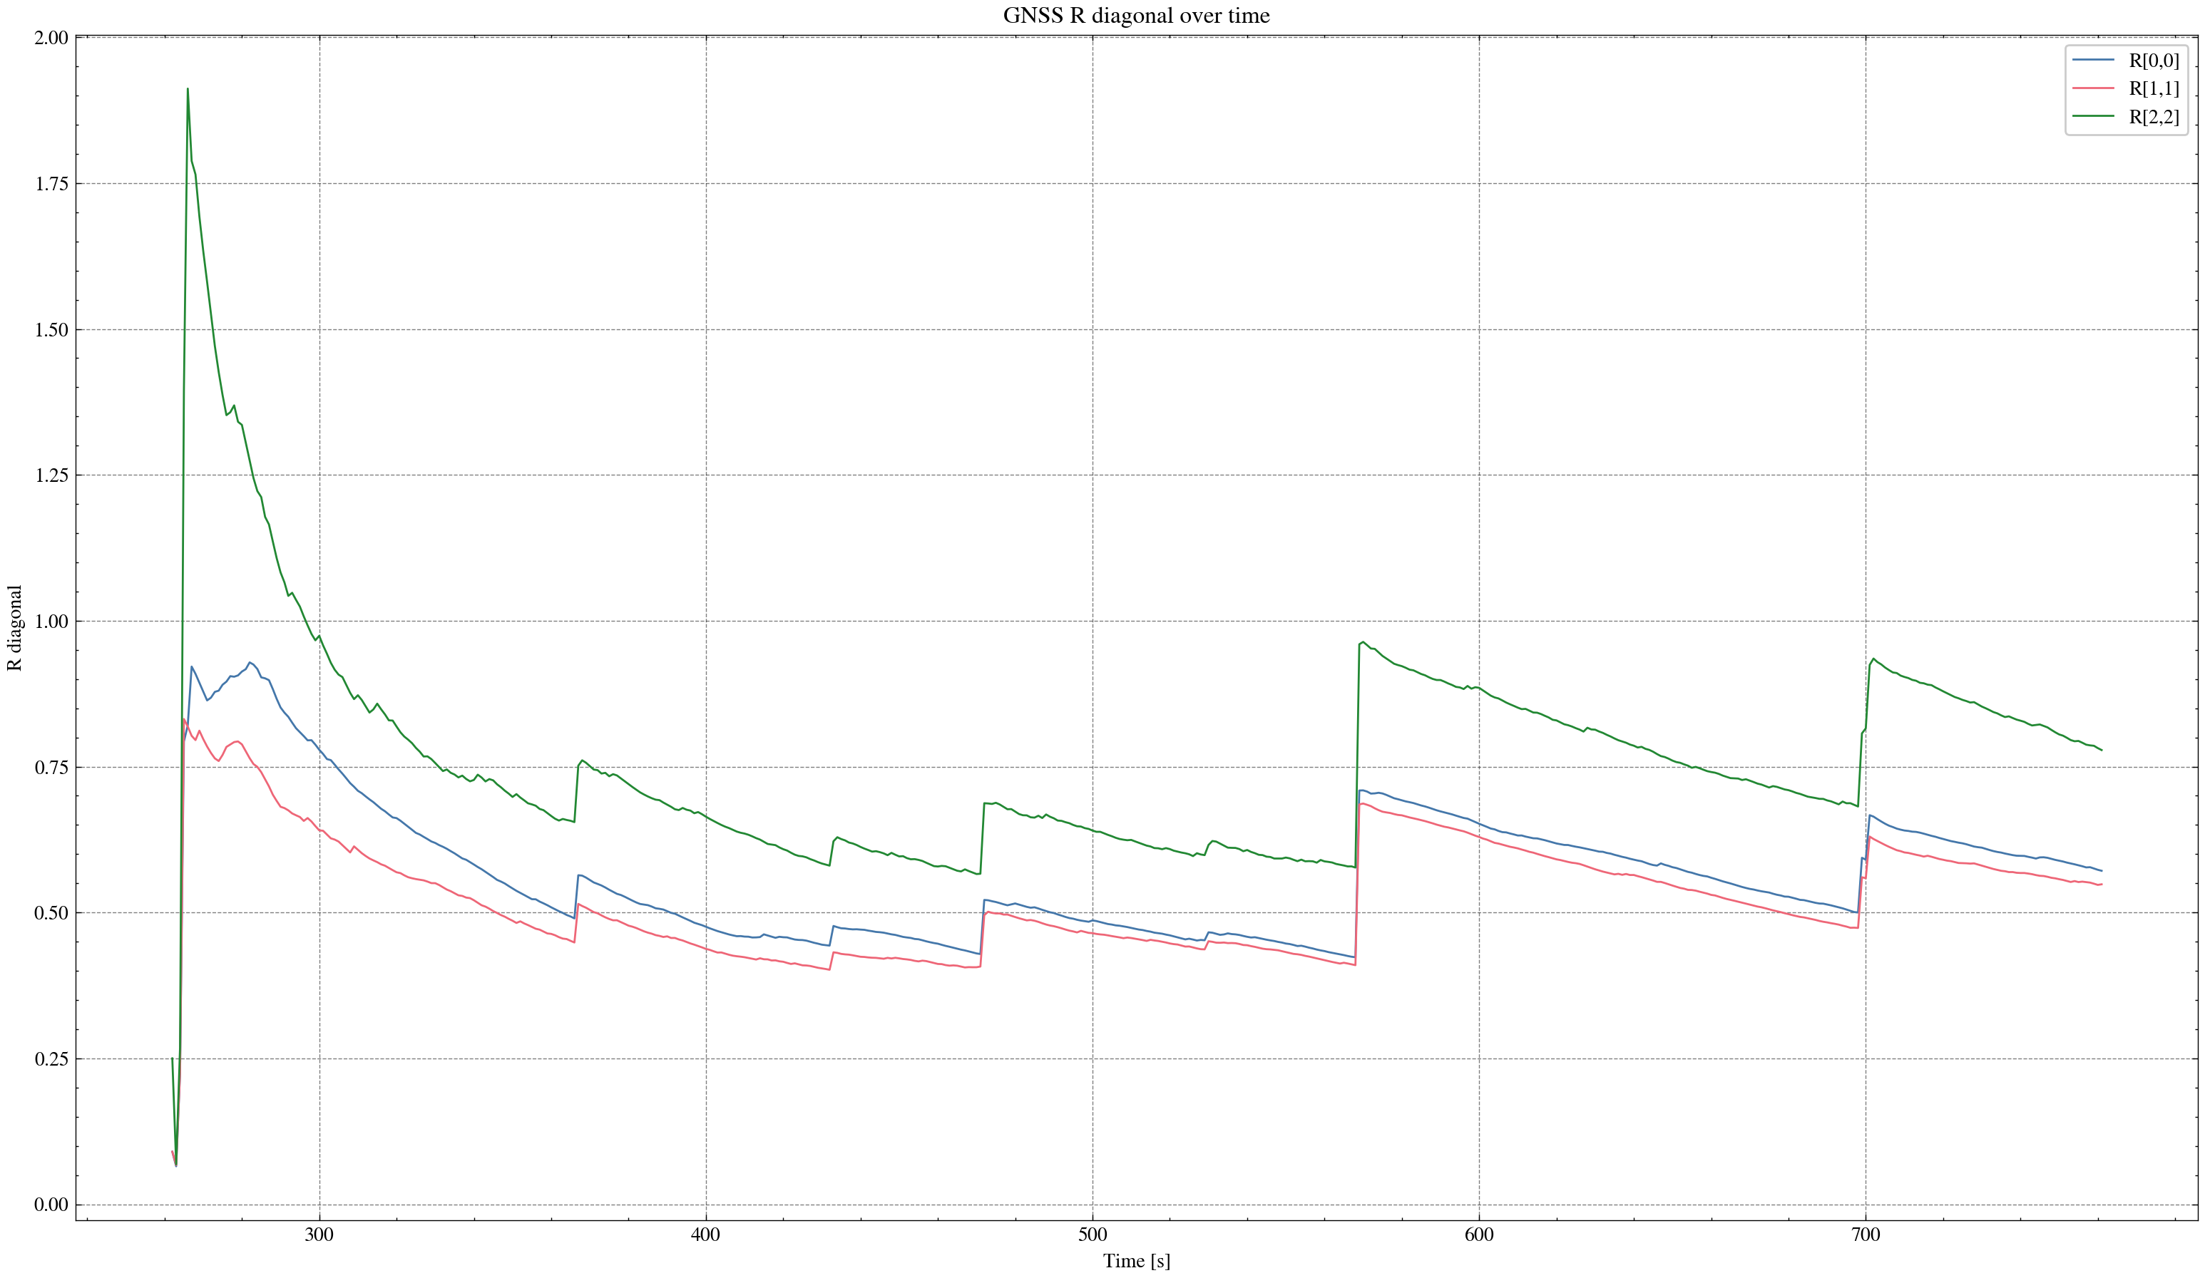

task_simulation_random_05
Input data: E:\eskf_bishe\bishe\ESKF-2.0\task_simulation_50000\task_simulation_random_05.mat
Run status: OK
==================== RMSE summary ====================
Position RMSE [m] (N,E,D): 0.2272, 0.2443, 0.3145
Velocity RMSE [m/s] (N,E,D): 0.0795, 0.0879, 0.0595
Attitude RMSE [deg] (roll,pitch,yaw): 0.1285, 0.1448, 0.3022
Acc bias RMSE [m/s^2] (x,y,z): 0.014675, 0.009626, 0.010849
Gyro bias RMSE [deg/h] (x,y,z): 35.0981, 31.1539, 29.6301
======================================================
