**Editor: Jie-Qi Huang**

**Python+openCV運行環境配置 :**

該系統由python編寫實現，運行在python2.7庫上，並需要PIL、wxPython、numpy、scipy的支援，同時運行環境中需有opencv，**建議使用python2.7，opencv2.3.0。**

http://python-xy.github.io/downloads.html

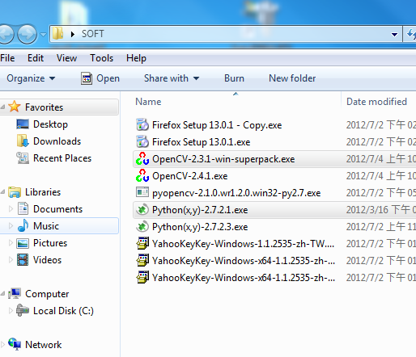

環境配置時:

Step1:

請將opencv安裝檔解壓到C:\，取出opencv2.3/build/python/2.7資料夾中的cv2.pyd複製到你的python安裝目錄...\Python\Lib\site-packages\下即可。至此，運行環境配置完成。

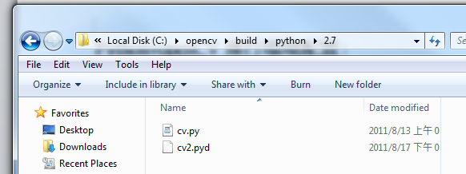

---相關軟體下載連結---

python： [HTTP://www.python.org/](http://www.microsofttranslator.com/bv.aspx?from=zh-CHS&to=zh-CHT&a=http%3A%2F%2Fwww.python.org%2F)

http://python-xy.github.io/downloads.html

opencv： [HTTP://sourceforge.net/projects/opencvlibrary/](http://www.microsofttranslator.com/bv.aspx?from=zh-CHS&to=zh-CHT&a=http%3A%2F%2Fsourceforge.net%2Fprojects%2Fopencvlibrary%2F)

numpy、scipy： [HTTP://numpy.scipy.org/](http://www.microsofttranslator.com/bv.aspx?from=zh-CHS&to=zh-CHT&a=http%3A%2F%2Fnumpy.scipy.org%2F)

PIL： [HTTP://www.pythonware.com/products/pil/](http://www.microsofttranslator.com/bv.aspx?from=zh-CHS&to=zh-CHT&a=http%3A%2F%2Fwww.pythonware.com%2Fproducts%2Fpil%2F)

wxPython： [HTTP://www.wxpython.org/](http://www.microsofttranslator.com/bv.aspx?from=zh-CHS&to=zh-CHT&a=http%3A%2F%2Fwww.wxpython.org%2F)

**#JK完成範例2012.07.04**

# Usage: python face_detect.py <image_file>

#功能: Python使用openCV作人臉偵測

#版本: openCV2.31 + python 2.7.2.3

#------------------------------------------

import sys, os

import cv2.cv as cv #必須要這樣引入cv LIB

import cv2

#import highgui

#from opencv.cv import *

#from opencv.highgui import *

from PIL import Image, ImageDraw

def detectObjects(image):

"""Converts an image to grayscale and prints the locations of any faces found"""

storage = cv.CreateMemStorage()

cascade = cv.Load('c:\opencv\data\haarcascades\haarcascade_frontalface_alt.xml')

faces = cv.HaarDetectObjects(image, cascade, storage)

result = []

for (x,y,w,h),n in faces: