Goals

To be able to:
- Create a code skeleton for building JUnit tests to validate an existing Java class.
- Implement a test fixture to allow the reuse of common test variables and test data.
- Use assertions to compare the actual output of variables with their expected values.
- Test for behavior that involves throwing Java exceptions.
- Run JUnit tests within Eclipse and understand the output of the failure trace.

Steps

- Launch Eclipse and Create a New Project
  - In Windows, Click Start → Programs → Developer Tools → Eclipse
  - From the Top Menu Bar, Click File → New → Project
  - Select 'Java Project' and Click 'Next'
  - For the Project Name, enter 'UnitTestDemo1'
  - In Contents, Select 'Create project from existing source'
  - For the directory, Click Browse and select the 'UnitTestDemo1' folder
Note: Your presenter will provide you with the path to the directory.
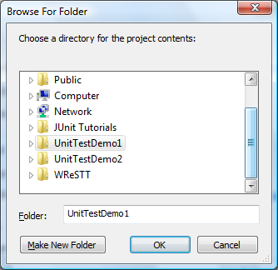
  - Click OK, and then Click Finish
Note: In the Package Explorer (left pane) you should now see the project.

- Create a New JUnit Test for the BankAccount Class
  - Right Click “BankAccount.java”, Select New → JUnit Test Case
2.
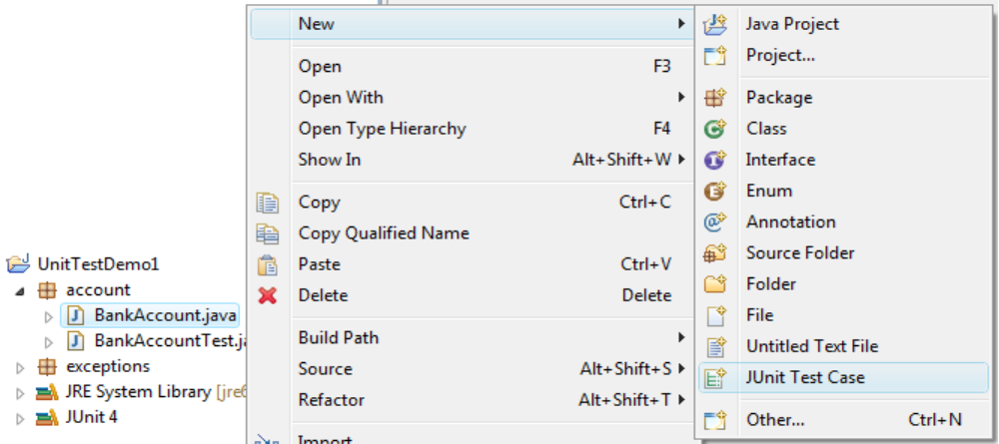
1.
3.

  - Select the radio button for ‘New JUnit4 Test’
  - In the name field type 'MyBankAccountTest'
  - Mark the checkboxes for generating setup() and teardown() method stubs, and click 'Next'.
  - Mark the checkbox for the BankAccount class

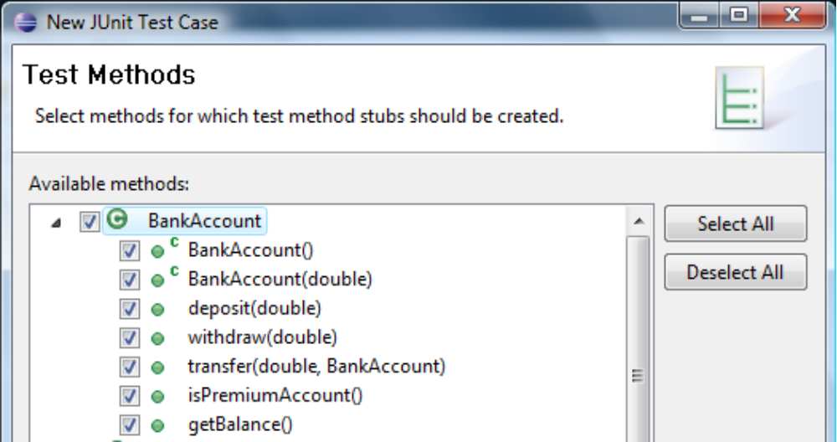
Note: All of the methods in the BankAccount class should be marked.
  - Click 'Finish'

- Declare Test Variables and Implement Test Fixture
  - Declare two bank account instance variables for the purposes of testing .
e.g., private BankAccount account1;
private BankAccount account2;
  - Initialize the test accounts within the setUp() method as follows:
    - account1 – use the default constructor,
e.g. account1 = new BankAccount();
    - account2 – use the user-defined constructor to create a new account with a balance of $600.00,
e.g., account2 = new BankAccount(600.0);
  - Deallocate the test variables within the tearDown() method.

- Write Tests using JUnit Assertions
  - Use the assertEquals(double expected,double actual) from the Assert API to write a test for the default constructor of BankAccount.java.
  - In the method body of testBankAccount insert the following statement: assertEquals(50.0, account1.getBalance());
  - Try writing some tests for:
    - the other constructor, testBankAccountDouble
    - the deposit, withdraw, and transfer methods
    - the premium status verification method, testIsPremiumAccount

- Write a Test that checks if an Exception has been Thrown
  - Create a new test method named testWithdraw2() that withdraws $0.01 from account1, and checks for an InsufficientFundsException.
    - Use the @Test annotation to create a new test method.
    - Insert the method signature, i.e., public void testWithdraw2()
    - Call the withdraw method, i.e., account1.withdraw(0.01)
    - Append the @Test annotation with the expected exception clause, i.e, @Test(expected=InsufficientFundsException.class)

- Run your JUnit Test and View the Results
  - Right Click “MyBankAccountTest.java”, Select Run As → JUnit Test
  - Use the JUnit tab (left pane) to view the test results and failure trace

