

FACULTY OF COMPUTING AND INFORMATICS

TGD2151 Computer Graphic Fundamental

TRIMESTER 2 2014/2015

PROJECT
Report

Lecture Section: TC01
Tutorial Section: TT01

For:
Dr. Wong Ya Ping

From:

Student ID | Name | Email Address | Phone No.
1131120642 | CHIA JIANFEI | Hyrex.chia@gmail.com | 0167634275
- | - | - | -

Introduction

This main object references for this project is “The Red Square” in Kremlin, Moscow, Russia. However, the main objects that are being rendered are the nine “tower” buildings. In term of futuristic, the element chosen is “The Dalek”, from Doctor Who. (Well, it’s space war machine)

The main goal is render the building as detail as possible, except the center tower that I choose to add the element into it.

Documents of Virtual Environment
The main reference is a building, and it should start from the ground. All nine sub-building are rendered separately, and for some building details that share similar properties were ripped into functions so it allow easy access and modification. The main flows of object building for one tower is separate the building into at least 3 parts which including: lower body, middle connectors bodies, upper body, and the head of the building. For each part, elements and detail are being added layer by layer.

Lastly, there is no animation done in this project.

Screen Shots
As the program execute, the only output of this project:

Acknowledgement

The only person in guiding this projects the tutor, Faris. There is no any other person that I collaborated with.

Limitation

Due to the time factor, main tower are being sacrificed to be the Dalek’s head. The original intention is build the all 11 domes and the original base, and attach it with other futuristic element.

Besides that, there is no any special input or behavior on the objects.

References

There are only picture used in this Project, all of the references picture are in the CGresources folder.
For the main coding tools, there are only the C++ MinGW, openGL, and the CGmain files from tutorials. Lastly, Paint is involved for ratio measuring.

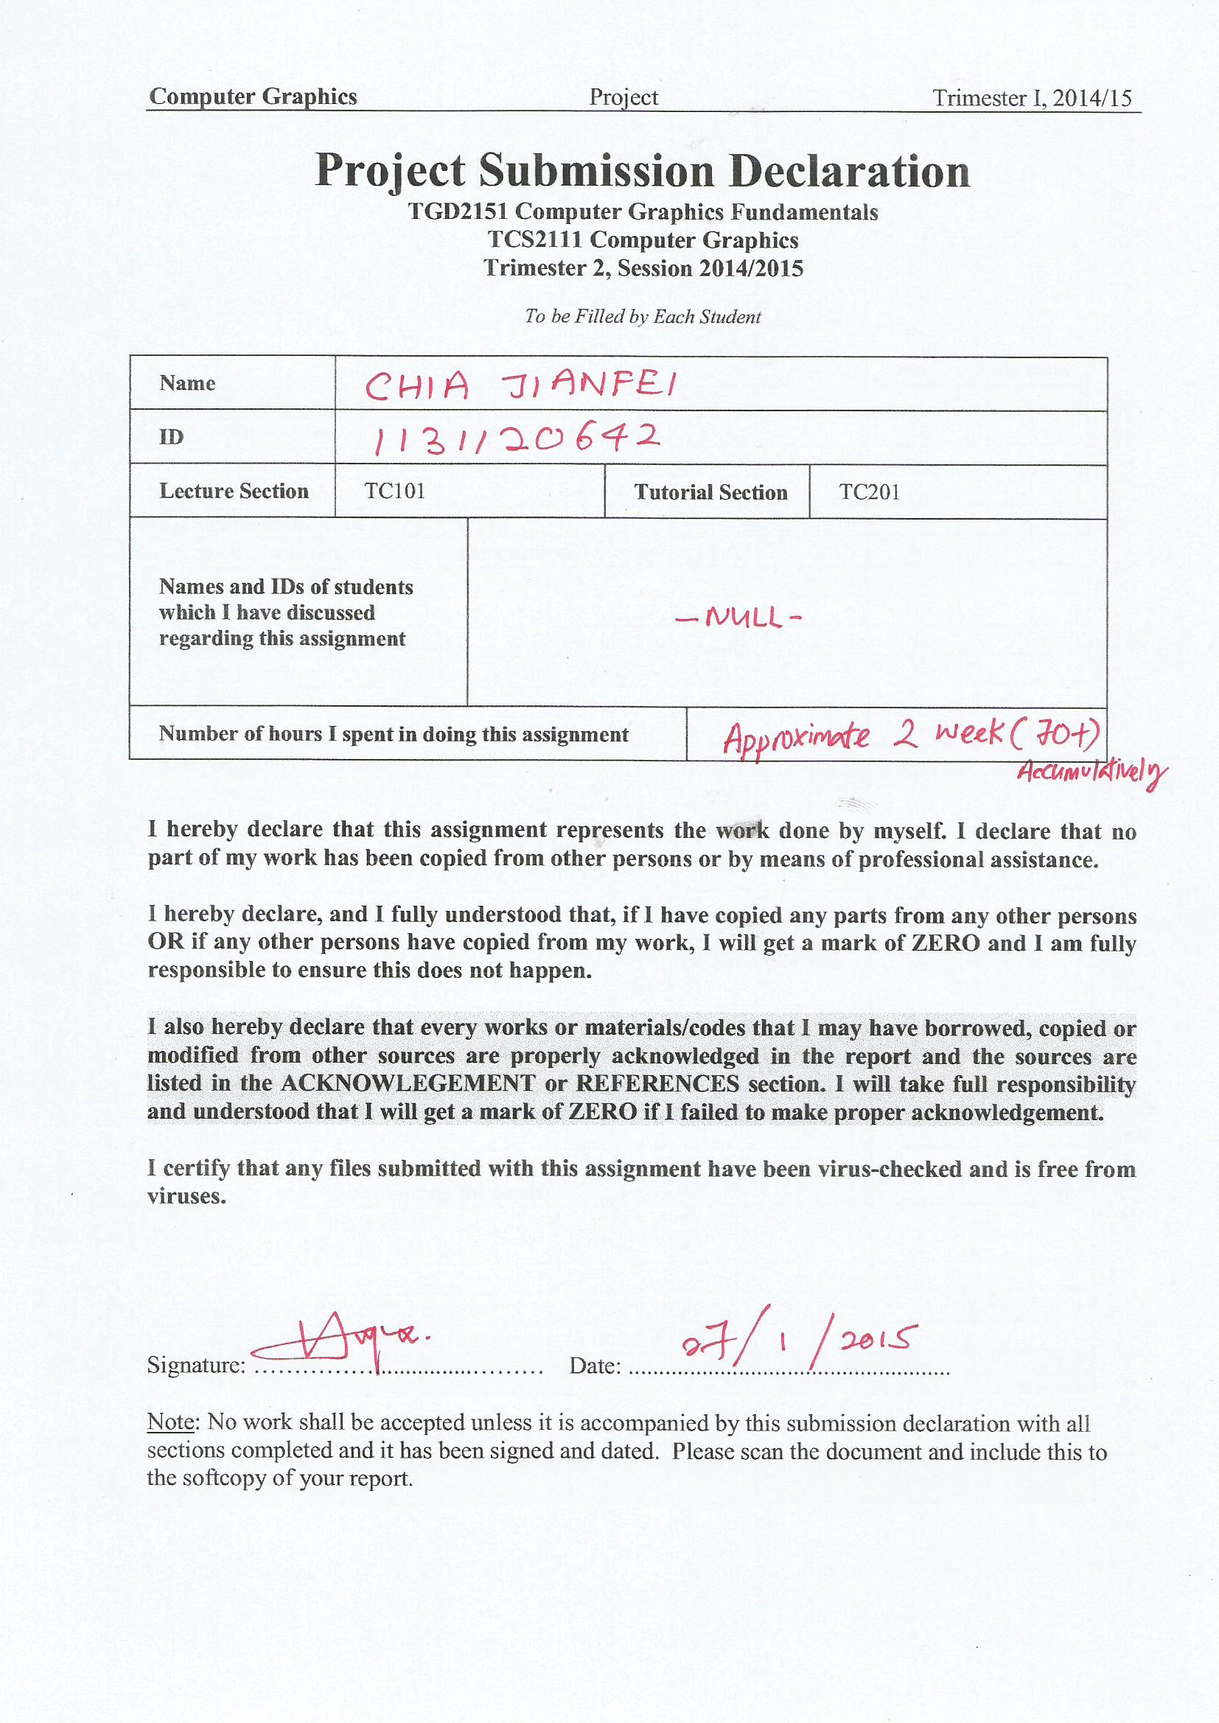Project Submission Declarations

