The Influence of Employment on the Asian American Income Gap

Addressing Wealth Disparity in America by Race

Harrison Cho

The University of North Carolina - Chapel Hill

**Introduction**

Income inequality is a substantive issue in American politics that plays a significant role in contemporary policy formation. Often, wealth disparity amongst differing groups is used to highlight the diminished wellbeing of poor citizens. It should come as no surprise that racial categorizations have provided an important basis to measure the gap between the wealthy and impoverished. Using a racial dichotomy, we as a society are better able to comprehend and visualize the environments different groups inhabit. For example, numerous evaluations of income inequality highlight the prominence of the wealth gap amongst Black Americans. For a long time, this wealth gap served as a prime example of income disparity in modern America. Although this reality is still of significant importance, a wider wealth gap has emerged in America within the Asian American community. Over the last 40 years, income inequality amongst Asians has surpassed that of Black Americans; wealth disparity amongst Asian Americans has become the most stark divide amongst all racial categorization in the United States. In 2018, studies claimed that income inequality amongst Asians has accumulated over time to develop into the fastest growing wealth gap in the United States[1]. The multiplicative effects of numerous factors, such as age and education, affect this disparity. Over time, though, a vast gap has resulted between those who have recently immigrated and those who are second-generation immigrants or beyond. Because recent immigrants have variable levels of employment, occupation has become an important factor in growing wealth inequality. Overall, this paper seeks to address the role of occupation in this developing inequality over time.

Wealth inequality specific to the Asian American community can have substantial effects on the economic development of America’s fastest growing minority group. It is no surprise this development presents numerous implications. First, due to shifting racial categorizations, we must consider disproportionate impacts amongst differing Asian ethnic groups. Addressing these changing factors can elucidate gaps in electoral representation and financial dependence amongst varying Asian populations. Wealth inequality also addresses overall social mobility amongst Asian Americans. Comparing disparate incomes with the ability to access housing, education, and employment are critical criteria that can address future economic success and overall wellbeing. Participation in America’s social order is a final important aspect to consider when addressing increasing wealth inequality. Critical race theorists argue that economic oppression, in a grand scheme of interlocking levels of racial and systemic inequality, can further disenfranchise people from participation in everyday life. This may have substantial impacts on access to voting, stunted representation in political interests, and limited access to wealth building instruments like credit. In general, it is important to understand the role of race, racism, and wealth in political schemas in order to ameliorate pressing issues amongst ethnic communities. As such, policy makers must grapple with growing income disparity amongst Asian Americans before substantial repercussions are realized in broader contemporary settings.

A study by Kochar and Cillufo (2018)[2] investigated the extent of income inequality amongst Asian Americans compared to other races in the United States. Their investigation addressed measures of inequality, potential circumstances that contribute to inequality, comparisons of wealth disparity amongst differing races, and the importance of circumstantial issues facing Asian Americans in the shadow of disparate incomes. Overall, this study concluded that the developing gap in income encapsulates shifting norms in the American status quo. Due to an influx of Asian immigrants, varying levels of education amongst Asian Americans, and declining standards of living amongst lower income Asian Americans, wealth is beginning to lag within lower income distributions of the Asian American community.

This paper will explore the circumstances that surround income inequality within the Asian American community by paying particular attention to the effects of occupation on income. Between the years 1995 and 2016, I utilized data taken from the Current Population Survey (CPS) to measure the overall effects on an occupation’s earnings coefficient. I examine this span of 21 years specifically in order to account for the an Asian immigration influx that occurred between the 1970s and 1980s. Applying two constant models over several distinct time periods, I hope to illustrate the significance of this income disparity that is of practical importance to policy makers.

**Economic Theory**

Theory concerning income inequality posits that increased economic stratification can have long term effects on divergent, isolated groups. Reduced accessibility to human capital found in education, housing, and occupation can have a sustained, negative effect on the disadvantaged. Citing Durlauf (1992)[3], income inequality leads to groups of similar incomes interacting with one another. Depending on which end of the income distribution one may fall, this can then lead to increased or decreased chances of wealth accumulation over time. Increased returns on human and social capital can improve one’s interactions within this economic framework. Although there are numerous indicators for inequality in America, wealth disparity helps serves as a universal metric across competing interests and racial groups. This paper uses two regressions to measure overall income inequality:

$$Earnings=educ\left(β_{1}\right)+age\left(β_{2}\right)+ {age}^{2}\left(β_{2}\right)+Executives\left(γ_{1}\right)+Services\left(γ_{2}\right)+Labor\left(γ_{3}\right)+asian\left(γ_{4}\right)+white(γ_{5})$$

$$Earnings=educ\left(β_{1}\right)+age\left(β_{2}\right)+ {age}^{2}\left(β_{2}\right)+whitecollar\left(γ_{1}\right)+asian\left(γ_{4}\right)+white(γ_{5})$$

I measure earnings as a function education, age, occupation, and race. Broken up into four distinct time periods, these models evaluate overall trends in income as an explanation for disparate socioeconomic realities. These models pay close attention to an occupation’s influence over income inequality trends over time. As identity groups, defined increasingly by race and occupation, compete over valuable socioeconomic resources, there will be winners and losers. As such, income inequality serves as a marker for the likelihood of success within this competition for resources. Because intersectional theory seeks to explain levels of societal exclusion through a series of interlocking, multifaceted issues, I chose income inequality as a broad qualifier. Through these models, I will estimate the extent that income has changed over this time period. I seek to test whether differing occupations amongst Asian Americans have helped spur an increasing wealth gap in the United States over 21 years. Utilizing these two models, I posit that occupations requiring significant skill or managerial experience have helped precipitate disparate incomes amongst Asian Americans.

**Data**

The data used in this paper comes from the CPS conducted by the US Census Bureau. Utilizing the software Stata, I was able to construct constant models for the years 1995, 2001, 2010, and 2016. These basic models estimate income as a function occupation, age, education and race. The CPS data sets have a plethora of distinct occupations; there are 14 occupations for the years 1995 and 2001 and 11 occupations for the years 2010 and 2016. In the years 2010 and 2016, the CPS regrouped three service occupations to serve as one.

I created occupation groups through several means. First, I redacted observations that served within the armed forces; the number of pertinent observations was not significant enough for this variable’s inclusion. Additionally, I set those not within the workforce as a reference category against all occupations. Second, in order to provide some clarity, I combined occupations that possessed similar characteristics in order to present a more cogent picture of the models. For model one, I combined occupations that had high skill or high professional learning curves as Executives, occupations that dealt primarily with the service industry as Services, and occupations that dealt with daily, intensive labor as Labor. The variable Executives is comprised of Executive, Administrative, Managerial, Professional, and Technician occupations. The variable Services is comprised of Sales, Administrative Support, Private Household, Protective Service, and Service occupations. The variable Labor is made up of Precision Production, Machine Operation, Transportation, Handling and Cleaning, and Agricultural Occupations. For model two, I created a variable based off traditional white-collar work. The variable Whitecollar is comprised of Executive, Administrative, Managerial, Professionals, Technicians, Sales, and Administrative Support Occupations. For both models, I sought to highlight the income gap between these occupation groups To do this, I estimated earnings as an indicator of wealth. Utilizing the coefficients from each variable, I was able to gauge change throughout the models. Over time, both models highlight the potential disparity between occupation groups.

Because Asian Americans purportedly have the fastest growing racial group and inequality gap in America, I created a set of racial variables. Race was dichotomized into three variables: Asian, White, and Other. Within both models, Asian and White were tested against the reference category, Other, to emphasize cumulative and individual effects of income disparity over time. Although White Americans do not sport the largest wealth inequality gap, they do hold significant power in the United States. Whether this be through governmental or occupational capacities, critical race theorists classify America as a country developed under a White status quo. It is important to contrast these shifting classes of economic power in order to provide a comprehensive analysis. Changing income gaps indicate shifting cultural paradigms, thus I sought to include race as a variable that holds significant importance to the formation of cultural contexts within our heterogenous state.

Age and education were included within both models as proxies of productivity within occupation. Given the influx of Asian immigrants during the 1970s and 1980s, I thought that it would be appropriate to highlight the importance of productivity over time. Given that there can be a generational lag in income accumulation due to immigration, the inclusion of these variables seeks to control for this factor of income attainment.

There are important limitations in the data that may have some pertinence to the overall efficiency of the model. The model only classifies Asian Americans as those that self-identify as fully Asian. With this being said, racial classifications are changing drastically over time; the number of multiracial categories containing Asians has grown substantially over the last decade. During the years 1995 and 2001, mixed race categories were not strictly accounted for when taking the survey. Additionally, those who fall within the broader categorizations of Asians, such as Pacific Islanders, were not included within these models. To make interpretation of regression results easier to understand, only one category of Asian Americans was included within the models. Given these constraints, the data can only possibly explain income discrepancies amongst self-identified full Asian Americans. Secondly, service occupations were combined in the years 2010 and 2016. Due to this combination, 14 occupations are in the years 1995 and 2001 while 11 occupations are in 2010 and 2016. Although the model is not strictly constant in the number of variables, for all intents and purposes occupations groups are similar given that they were created by combining like occupations. Finally, the model does not control for gender. Given that income attainment may be different between a mother of several children and a young professional, this model has limitations in explanatory power.

**Empirical Results**

Utilizing Table 2, I estimated effects on income through the use of a consistent model from the years 1995-2016. The dependent variable, income, was measured in dollars as a function of the independent variables education, age, occupation, and race. Using the racial dummy variable “Other” as a reference term, Asians were found to have higher earnings overall compared to Whites. Coefficients for both Asians and Whites were statistically significant and positive within all years. Racial coefficients for Asians increased by 321.03% over the span of 21 years; Whites increase by 168.29%. It should be noted that the greatest increases in race coefficients occurred between the years 1995 and 2001. According to Table 3, the race coefficient for Asian Americans increased by a total of 108.81% and the coefficients for Whites increased by 73.10% percent. It should be noted that the standard error for all the coefficients also increased significantly between the years 1995 and 2001. For race dummies, the standard error increased by 98.17% for Asians and 120.31% for whites.

Table 2 also provides an assessment of occupation groups, which all had statistically significant, positive results over the course of 21 years. Overall, the coefficients of the occupation dummies increased by 103.91% for executives occupations, 95.46% for service occupations, and 109.69% for labor occupations over the span of 21 years. According to Table 3, the greatest increase in the Executive income coefficient, 39.93%, occurred between the years 1995 and 2001. For the Service coefficient, the greatest increase, 28.18%, occurred between the years 2001 and 2010. For the Labor coefficient, the greatest increase, 32.49%, occurred between the years 2010 and 2016. Service occupations had the lowest coefficient amongst all occupation groups within Table 2. Additionally, standard error increased by several orders of magnitude between the years 1995 and 2001 amongst all occupation dummies. Referring to Table 3, standard errors increased by 101.74%, 106.81%, and 107.64%, for Executives, Services, and Labor occupations, respectively.

Age and age2 had negative, statistically significant effects over 21 years. It should be noted that age decreased by 25.84%, while age2 increased by 26.19% from 1995 to 2016. According to Table 3,the standard errors for these two variables also increased significantly between the years 1995 and 2001, by factors of 107.06% for age and 109.09% for age2. Finally, education increased drastically for the model. Statistically significant and positive, the coefficient for education increased by a factor of 165.47% between the years 1995 and 2016. Utilizing Table 3, the standard error increased drastically between the years 1995 and 2001, rising by almost 105.35%.

Controlling for the specific effects of race, Table 4 highlights the discrepancies in income coefficients. All occupation coefficients for Asians were statistically significant and positive. Asian occupation coefficients exhibited the greatest percentage increase between 1995 and 2016. Citing Table 5, Coefficients for Asian Executive, Service, and Labor occupations increased by 122.60%, 111.89% and 120.43%, respectively, during this time period. Utilizing Table 4, Asian American Executive and Service occupations boasted greater coefficients when compared to all races by 2016.

From Table 6, it should be noted that there is a sizable difference between occupation coefficients amongst Asians. Holding all other effects constant, we can break down these occupational differences by year. In 1995 and 2010, for example, Asian Executive occupations possessed income coefficient 151.63% and 182.13% times great than Asian Service occupations. Additionally, Asian Executive occupations had income coefficients 120.47% and 160.39% greater than Labor occupations in the years 1995 and 2010, respectively. Finally, those in service Labor occupations had coefficients 14.13% and 18.73% greater than those with Service occupations in 1995 and 2016, respectively. These statistics demonstrate that, over time, income disparities due to occupation have developed rapidly. It is also important to note that, compared to other races, Asian income coefficients have also increased throughout 1995 and 2016. Referencing Table 7, Asian Executive occupations made 39.60% more than Executive Occupations of other races. Those within Asian Service Occupations made 26.64% more than Service Occupation of other races in 2016. Compared to other race occupation groups, Asian occupation groups are showing greater disparity over time via their income coefficients. Income gaps, derivative of vastly varying coefficient values, continuously grow as a result of this disparity.

Addressing Table 4 again, an Asian’s education coefficient also had a value greater than all races by 2016. There is a discrepancy in the age variable amongst Asians; it should be noted that the age coefficient is only statistically significant at 5% in 1995, and insignificant in every year thereafter. The age2 coefficient is not statistically significant throughout the model. The inclusion of these variables may decrease the efficiency of the model amongst Asians. This case is specific to only Asians. For regressions controlling for Whites and other races, age is positive and significant while age2 is negative and significant. Although the age coefficient for the year 2001 was not statistically significant amongst other races, it should be noted that all other coefficients for age and age2 are significant at a 1% level.

Standard errors amongst all coefficients regressed in the Asian category significantly increased between 1995 and 2001. Referencing Table 5, the increase in standard error continues to gradually increase between 2010 and 2016. Given that the number of observations increases from 4,935 to 10,869 between the years 2001 and 2010, standard error decreases for all variables except for Service occupations. However, it should be noted that a slight decrease in Asian observations between 2010 and 2016, 10,869 to 10,709 observations respectively, leads to an increase of the standard error within all occupation dummies and the education variable.

Table 8 displays the second model used to address income disparity over time. Income was measured as a function of several independent variables: education, age, occupation, and race. In this model, white-collar occupations were grouped as a dummy variable. A dummy variable Other was used as a reference term for race in this model. Asians, on average, were found to have higher earnings than Whites by 2016. All coefficients for Asians and Whites were statistically significant and positive over the course of 21 years. Referring to Table 9, the Asian race coefficient increased by 457.57% over 21 years while the White racial coefficient increased by 171.58%. In addition, all standard errors for race dummies greatly increased from 1995-2001, decreased from 2001-2010, and increased from 2010-2016.

Table 8’s Whitecollar occupation had statistically significant, positive coefficients over the course of 21 years. Referencing Table 9, those within white-collar occupations saw an overall 144.93% increase in the value of their earnings coefficient between 1995 and 2016. The greatest increase in standard error , 97.35%, occurred between the years 1995 and 2001. Although the standard error actually decreased by 4.02% between the years 2001 and 2010, a significant increase of 42.08% took place between the years 2010 and 2016. Model two’s age variable had a positive, statistically significant effects from 1995 to 2016. Age2 had a negative, statistically significant effect over time. Standard errors for age and age2 increased from 1995 to 2016 gradually. The greatest percent increase for both variables occurred between the years 1999 and 2001. Finally, the statistically significant and positive education coefficient increased by 87.33% from 1995 to 2016. Standard error increased between the years 1995 and 2001, decreased during 2001 and 2010, and increased between 2010 and 2016.

Table 10 displays the results of model two when controlling for race. Overall, the coefficients for Whitecollar amongst Asians were statistically significant and positive. Amongst all races, the Asian Whitecollar coefficient exhibited the greatest growth over time. Citing Table 11, the Asian Whitecollar coefficient increased by 172.21% between 1995 and 2016. By 2016, Asians had the greatest Whitecollar coefficient amongst all races in the model. The greatest increase, 51.1%, in the Whitecollar coefficient occurred between the years 1995 and 2001. Additionally, the greatest increase in the standard error of the Whitecollar coefficient, 83.23%, occurred between 1995 and 2001. Over time, disparity between so-called white and blue-collar crimes has significantly increase amongst Asian Americans. This gap helps corroborate that occupation has exacerbated a wealth gap over time. Given the magnitude of change in the Whitecollar occupation coefficient over the last 21 years, we may posit that white-collar occupations have significantly influenced this wealth gap. Compared to the other race variable, Asian Whitecollar coefficients have exhibited great change. Under Table 12, the Asian Whitecollar occupations boast significant differences compared to other races. In 2010, the Whitecollar coefficient amongst Asians was 74.54% greater than that of the Whitecollar coefficient for other races. In 2016, the Asian Whitecollar coefficient was 76.73% greater than that of the Whitecollar coefficient of other races. Compared to the Whitecollar coefficient of other racial groups, the Asian Whitecollar coefficient shows greater disparity over. Again, the external and internal income gaps resultant of occupation are becoming more pronounced over time.

A final point that supports growing income disparity is increasing income variance amongst Asians. Across both models, it is important to recognize that variance in income increases when specifically controlling for Asians. As maintained by Table 13, variance in income has gradually increased between 1995 and 2016. The greatest increase in variance occurred between the years 1995 and 2001; during this period, variance increased by 208.41%. Increasing income variance is the most important metric to explain that, amongst Asians, a wealth gap has emerged. Overall, income variance has increased by several order of magnitude; between the years 1995 and 2016, variance in earnings increased by 908.88%. Given the rapidly increasing coefficients of occupation groups in both models, increasing income disparity can be partially explained via occupation within the model.

**Conclusion**

This paper’s results relay several important developments in wealth inequality. Utilizing economic models one and two, it is clear that wealth inequality amongst Asian occupations has grown larger over the last few decades. When analyzing the effects of race in both models, Asian Americans are developing outstanding differences in income that may lead to stratification. Given increasing Executive, Labor, Service, and Whitecollar coefficients, there is significance to the validity that occupation is driving wealth inequality. Overall, this trend is corroborated by an increase in income variance demonstrated within Table 13. Those with access to managerial or professional occupations, especially Asians, have experienced significant gains in income over the last two decades. As a result, the attainment of human capital amongst varying occupations has become increasing inequitable due to occupation. By keeping both models constant over a period of 21 years, income disparity through occupation and race have arisen.

Given that income disparity is drastically growing, policy makers should do their best to provide public goods and services to volatile Asian American communities. Because disproportionally affected pockets of immigrants and families seek to lose out from reduced access to resources, it would be prudent to institute social programs that promote greater social and human capital accumulation amongst those in lower paying occupations. Whether this be through accessible education, affordable housing, or health and wellness programs, a variety of initiatives can be undertaken to improve general quality of life amongst impoverished peoples. Income disparity should be addressed to promote social mobility amongst all races. Given that it is becoming a glaring problem amongst Asian Americans, there should be a greater sense of urgency to act amongst policy makers.

The results of the paper do not address several crucial factors that could help explain the model further. First, there are no variables that distinguish between recent immigrants and naturalized citizens. Having this distinction would help elucidate disparities, particularly within the Asian American community, given lags in income as a result of generational status. Second, the model does not account for geography. Given that access to resources is drastically variable across the country, it is important to recognize that geography could have a substantial impact on the overall interpretation of the regression. Those within a large metropolitan area may have increased access to education or employment compared to those within a rural area; thus, geography has an effect on potential earnings. Third, the model does not take gender into account. Given that Females, mothers, or those with children may make less money, future models that examine gender or family dynamics would be prudent to evaluate income inequality. Finally, these results do not take other assets besides income into account. Income is only one metric of wealth inequality. Continuously compounding wealth, built upon large assets like property or luxury goods, serves as a catalyst for income proliferation. Those within lower income distributions may not have access to these appreciating goods. As such, the effect of generational wealth can have an impact on income over a sustained period of time. Although age is included to help account for this effect to a very minor degree, it does not fully explain the extent or magnitude of multi-generational wealth and its effects on earnings.

As previously alluded to, income inequality amongst Asian American families should be explored at length. Measuring the impact of raising a family, tracking expenditures, and gauging economic stability would be important questions to consider in further models. Additional models could also take time to address interactions between Asian American interest groups, interest group funding, and policy legislated at state or federal levels. Researching the impact of income on policy could help elucidate interest group and racial taxonomies that have become entrenched within our bureaucracy. Capitol proliferation alongside political representation are hugely important to the momentum of this income gap developing among Asian Americans. Further research could also help explore the importance of wealth inequality amongst specific subgroups of Asian Americans. Given that this paper does not account for mixed Asian Americans or Pacific Islanders, incorporating these groups within a broader economic model could provide a greater understanding of the fractionality of race, income inequality within the Asian American community, and wealth discrepancies that result from disparate access to resources. Overall, these investigations would provide a comprehensive view of the status quo in a minority community that is growing exponentially in size and net worth. Income inequality amongst Asian Americans is a substantive issue in contemporary politics. As we reconsider the cultural and economic hegemonies perpetuated by race within modern America, we must scrutinize the impact of wealth in order to deduce a comprehensive framework of democratic sustainability.

# Works Cited

Durlauf, Steven N. 1996. "A Theory of Persistent Income Inequality." *Journal of Economics Growth* 75-93.

Kochhar, Rakesh, and Jessica Pumphrey. 2018 . *Income Inequality in the U.S. Is Rising Most Rapidly Amongst Asian Americans.* Washington, D.C. : Pew Research Center.

Table 1: Variable Explanations

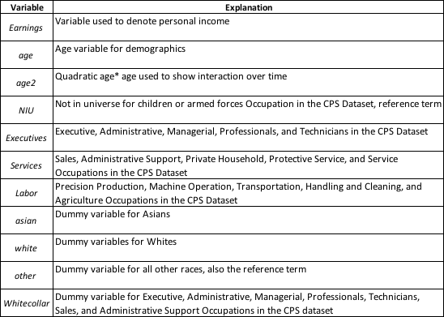

Table 2: The Effects of Occupation on Average Income Amongst Different Races and Occupations in the US (1995-2016)

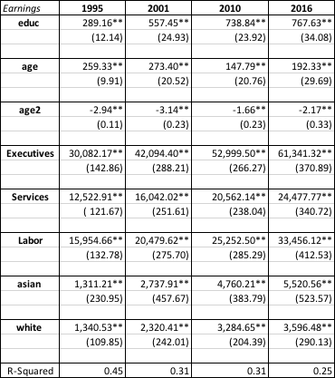

Table 3: Percentage Change per time period in Coefficients and Standard Errors Amongst Different Occupations and Races (1995-2016)

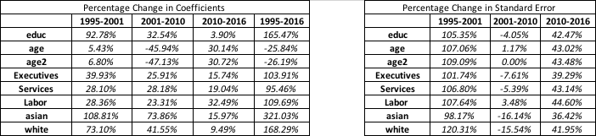

Table 4: Differential Effects of Race on Average Income Amongst Differing Occupation Groups in the US (1995-2016)

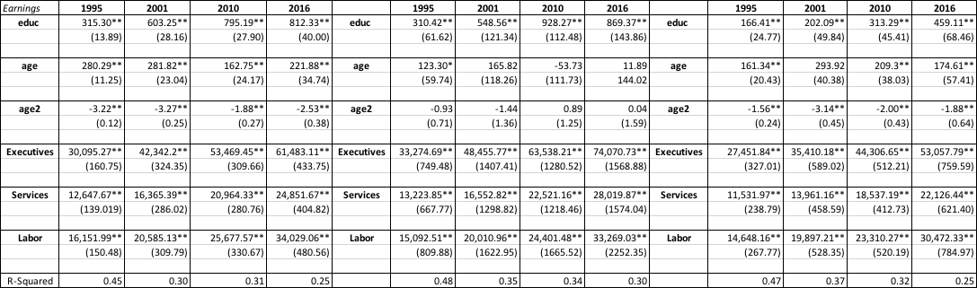

**Notes:** Standard errors are in parentheses. Significance levels: ** = 1%; * = 5%. Number of observations per year: 1995: 149, 642; 2001: 128,821; 2010: 209,802; 2016: 185,487.

Table 5: Percentage Change per time period in Coefficients and Standard Errors by Differing Racial Groups (1995-2016)

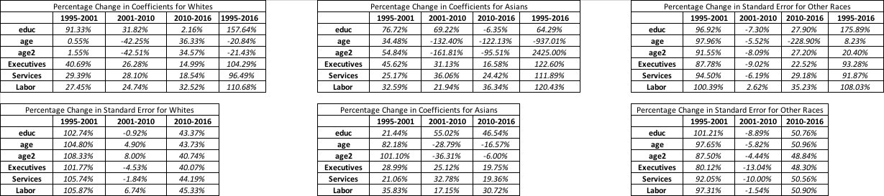

Table 6: Percentage Difference in Coefficient Values of Occupation Groups Amongst Asians (1995-2016)

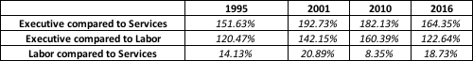

Table 7: Percentage Difference in Coefficient Values of Asian Occupation Groups Compared to Other Races (1995-2016)

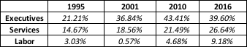

Table 8: The Effects of White-collar Occupations on Earnings for Racial Groups in the US (1995-2016)

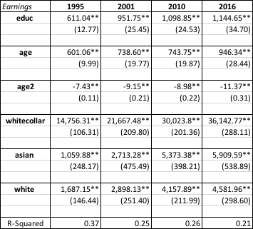

Table 9: Percentage Change per time period in Coefficients and Standard Errors Amongst White-collar Occupations and Race (1995-2016)

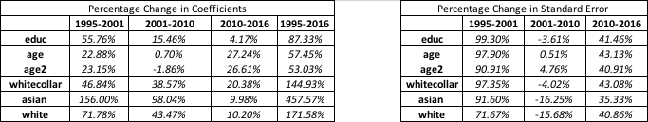

Table 10: Differential Effects of Race on Earnings for White-collar Occupations in the US (1995-2016)

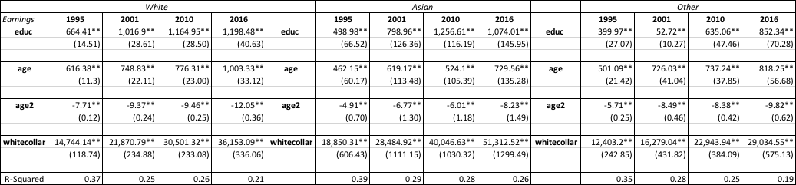

**Notes:** Standard errors are in parentheses. Significance levels: ** = 1%; * = 5%. Number of observations per year: 1995: 149, 642; 2001: 128,821; 2010: 209,802; 2016: 185,487.

Table 11: Percentage Change per time period in Coefficients and Standard Errors by Differing Racial Groups (1995-2016)

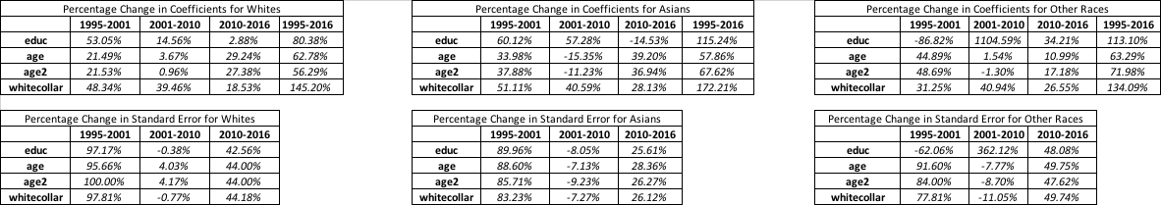

Table 12: Percentage Difference in Coefficient Values of Asian White-collar Occupations Compared to Other Races (1995-2016)



Table 13: Income Variance Over Time amongst Asians (1995-2016)

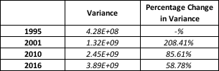

1. Kochhar, R., & Cilluffo, A. (2018, September 20). Income Inequality in the U.S. Is Rising Most Rapidly Among Asians. Retrieved from http://www.pewsocialtrends.org/2018/07/12/income-inequality-in-the-u-s-is-rising-most-rapidly-among-asians/
2. Kochhar, R., & Cilluffo, A. (2018, September 20). Income Inequality in the U.S. Is Rising Most Rapidly Among Asians. Retrieved from http://www.pewsocialtrends.org/2018/07/12/income-inequality-in-the-u-s-is-rising-most-rapidly-among-asians/
3. Durlauf, S. (1992). A Theory of Persistent Income Inequality. *Journal of Economics Growth,1*(1), 75-93.