**URL of the commit history:**

<https://github.com/hchqin/learning-about-version-control/commits/main>

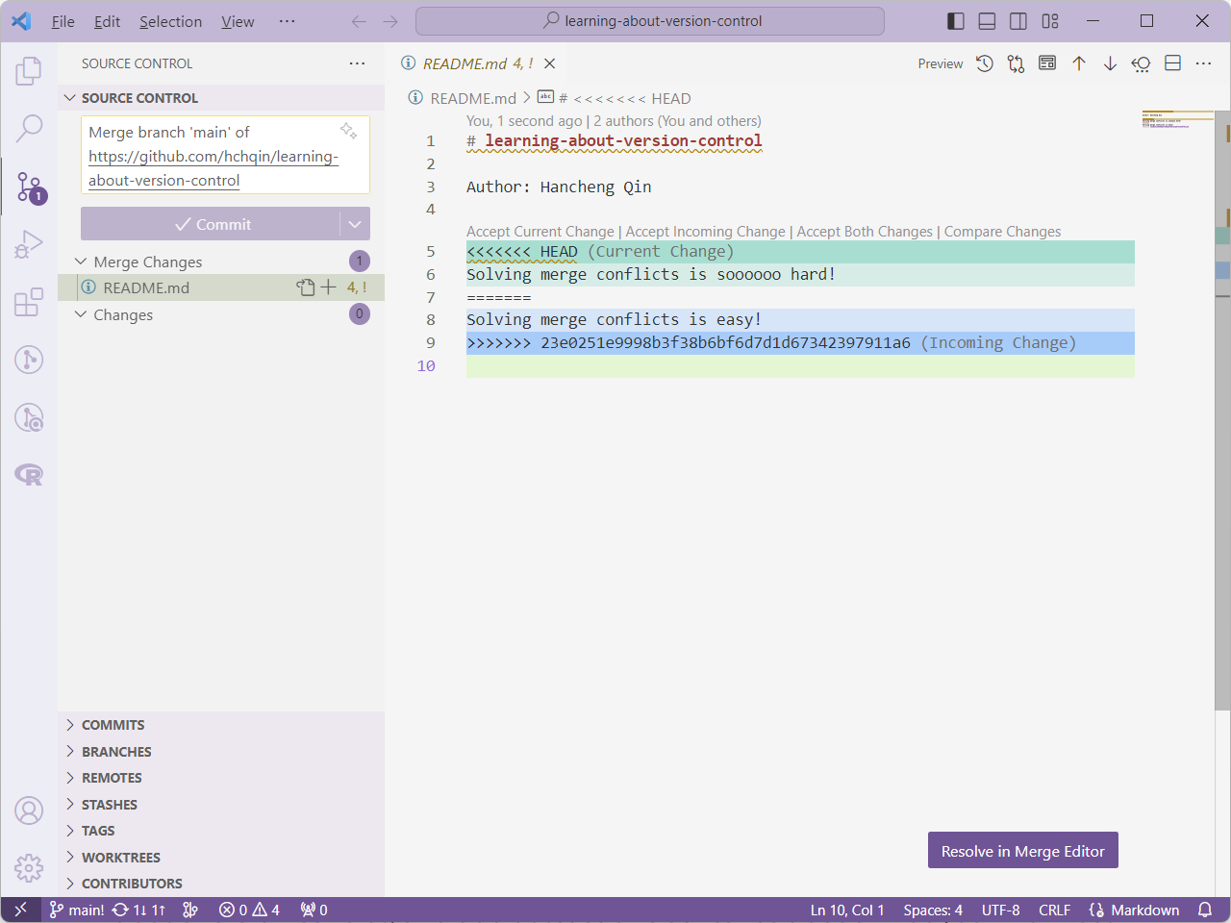

Working in a branch-pull-request workflow helps maintain the stability of the main branch, especially in a collaborative environment. The pull-request process facilitates code review and collaboration. It allows team members to discuss, suggest improvements, and refine code before it is merged,