Henry Chung
Game Survey Server

Abstract
Revolving around the idea of a game, I wanted to collect data from the players to run analysis on the users in a database. To do this, a simple client-server is needed to send the data between user and data accumulator. Afterwards, the accumulated data is stored in a database. This database is useful as the website would need this database to display the desired data using a HTML file.
The software, Python2 is used to build the simple game. Using pre-built libraries, pygame, was downloaded and was the pivot point of all the game code. In addition, there are libraries Python already contain: random, time, uuid, and getpass were useful in simplifying the code.
A simple client-server, is built out of python with a goal in mind of a simple way of collecting data from players to analyze. In the user side, a client is used to send information to a server with the desired information through the Web. The server in response, gathers the data and writes the data into a SQLite database using sql connector after placing them in a certain format.
This populated database is in turn used by a Django web application and displayed on a browser. The Django is a python tool used to be a communicator between the database and the html script. Meanwhile, the web page that displays high scores and other information is shown to incoming requests to the HTML script and haves various functions such as filters to view the data more efficiently.

Background
The main inspiration of becoming a computer scientist is the game coding possibilities in the field when understanding code. In the future, I hope to have a stable work position as a programmer while my spare time is used to create fun games of my own. The block dodge game was my first visual 2D game I created while following along a programing tutorial using python and pygame. The game tutorial was later used as a template to modify additional function to the existing program. Although the gaming aspect was fun, I felt that there was many ways to make this program more interesting as a person can see how well the game was made. As such, from my classes, I used my assignment from class and programs used to make a python client-server, html, database, and django. With this, a method of collecting and reviewing data idea was made after piecing the assignment together.

Introduction
To start off, a pygame library was used to create a simple game where one just has to move out of the way from the incoming blocks. This game has some features such as exiting, menus, and score counter as any normal, repetitive game would. Underneath the game is a method for collecting data and saving them in the home directory of the device used. That data, once a certain conditions is achieved a client will compile the data into a string to send to the server.

The server on the administrator/owner side would collect the data and format the string into a usable format to inject into the database using the sql connector. The database can be utilized by Django to project in a HTML page with certain functions can be added to quickly analyze the result.

Method
With more experience in python, I used python as the programming library for many other sections of the code. Having the idea for a game as the center of the design, I chosen pygame library to build a game. To make the game simple, I followed a simple 2D pygame tutorial taught electronically by Sentdex. From the tutorial and trying to understand the code, I modified and added other features to the game and added another idea of game developers needing to analyze players of their game and if there was many games, to find which game is less popular.

With any game developer, they would want to know if the game was satisfactory to the users, to get the information, the game needs a client to send information to a server, in this case, a simple python client-server would work. The client sends everything in a string to a simple server that would format the string into data and saved in a database using a sql connector.

The goal of data collection is to analyze the players/users. One idea is if a player, identified by the mac address moves frequently know by the different ip addresses in a database, two assumption can be made. One is the device is mobile and second is if the program is meant to access the server whenever possible, making sure the game does not need the INTERNET, then it may show that there are time where a player does not have access if the game becomes Internet dependent like most multi player games. Another idea for analysis is a list of times a user has played a game. This can be used to see what game is more popular and other games that may need improvement based on the newer game. The last idea is the high score function. If the developer had made a game where one expects a certain result and the data shows otherwise, an adjustment can be made.

Conveniently, the scripting language, Django, was also built mainly out of python and is a web development tool that works with HTML files and a database. This goes well with the pygame idea as I planned to collect gaming data and player information by placing them into a structured database. Django can connect the database to an HTML file which can display all desired information.

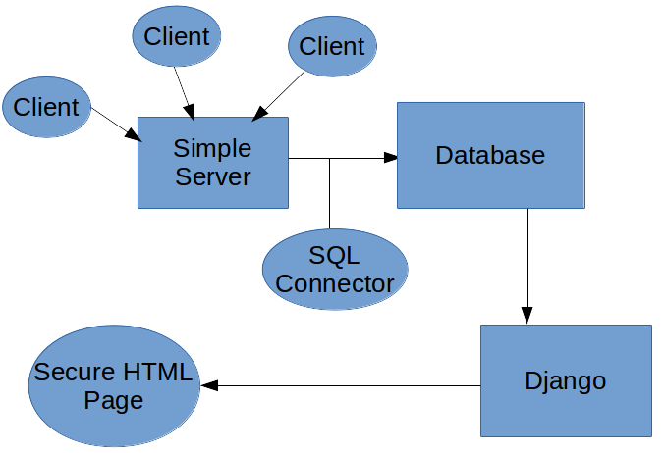
Image 1
Image 1: A simple diagram where a game client from the user connects with the server to send data into the database using an SQL connector. That database is accessed using the Django program coupled with a HTML server to show the data.

As for the game, after following the tutorial from Sentdex, I tried to improve the game, contained in one file using different menus and effects which made a shaky structure of code where at one point, I could not find the main error that caused multiple failures, basically a monolithic structure with a few functions. To solve the problem, a more distributed structure with many codes converted into functions where a broken code does not affect an entire file the code in the program was decided on. The direct benefit of the distributed structure was the code being easier to test and troubleshoot. I isolated all independent variables and sectioned functions into different python files to be imported. As the code grew, the downside to the distributed code was the file naming when having to head back into the previous code to test for errors. As I randomly named the files, it was hard to pinpoint files to modify and all the imports had imported all defined functions under the symbol *. In this case, there needed to be a massive reorganization to rename files to ensure all files names matches their function.
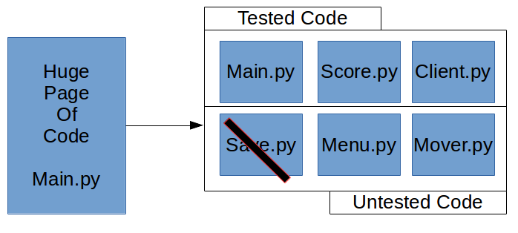
Image 2
Image 2: As errors in the block of code appeared and attempts to fix the error caused another, a solution that each code can be split into parts and tested individually to ensure that the program function in a desired way. In case of an error, the code can be ran separately and revised without accidentally modifying the other code and their function. The disadvantage to this was when I initially gave random names like two.py for menu.py. With similar circumstances to the rest and as the files expanded, managing the code became tedious. As such, I realized, for convenience, naming was important as the code expanded for this method.

After the game functioned in a desired way, the current game needed to write data out to a file that a client can send to the server. To hide the file from prying eyes, a python library, os, changed the directory and created a folder to move into. With this folder, the file can be hidden, but as I currently use a linux system. The file has a dot in front of the file to ensure the file is hidden in the directory, but does not do the same for Windows. Using the hidden directory, data can be saved in separate formats to ensure the data is safely stored in a correct format.

Conclusion
Ideally, if there is enough data, the game developer can find the data useful to analyze their game community. Starting from the average high score, if the developer expected a certain average in the difficulty bar for a game has a huge difference, this informations gives the developer knowledge of the problem and allows time to fix them. While if there were many games, there will be popularity ratings between different games, one may find that a game may be played more than others. If this is the case, a rough comparison can be made to improve both sides with many qualitative details of these games. In addition, if the game is a series with many versions, a simple idea of their current community is important such as if the game should be reliant on the Internet if many users have multiple ip addresses or should it just connect when having an available Internet source just for sending data.

Bibliography
Sentdex. n.d. Home - YouTube. Retrieved December 08, 2017. from
https://www.youtube.com/channel/UCfzlCWGWYyIQ0aLC5w48gBQ
Sentdex. n.d. PyGame Buttons, part 5, running functions on a button click. Retrieved December 08,
2017. from https://pythonprogramming.net/pygame-button-function-events/
Python Software Foundation. n.d. 15.1. os — Miscellaneous operating system interfaces. Retrieved November 3, 2017. from https://docs.python.org/2/library/os.html
Armin Ronacher. (2008, October 10). StackOverflow. Getting MAC Address. Retrieved November 7,
2017. from https://stackoverflow.com/questions/159137/getting-mac-address
Matsjoyce. (2015, March 15). StackOverflow. Python – Get mac address. Retrieved November 7, 2017
from https://stackoverflow.com/questions/28927958/python-get-mac-address
Vinko Vrsalovic (2008, October 3). StackOverflow. Finding local IP addresses using Python’s stdlib.
Retrieved November 7, 2017. from https://stackoverflow.com/questions/166506/finding-local-
ip-addresses-using-pythons-stdlib
Zags. (2008, March 31). StackOverflow. Finding local IP addresses using Python’s stdlib. Retrieved
November 8, 2017. from https://stackoverflow.com/questions/166506/finding-local-ip-
addresses-using-pythons-stdlib
Laria. Github. (2017, May 30). Tetris implementation in Python. Retrieved October 20, 2017 . from
https://gist.github.com/silvasur/565419

