Mikael Mahendra Buyung Wirasukma

5116100044

HCI A

Bad UI Design in Website or Appliances

1. **Matur Ibu**

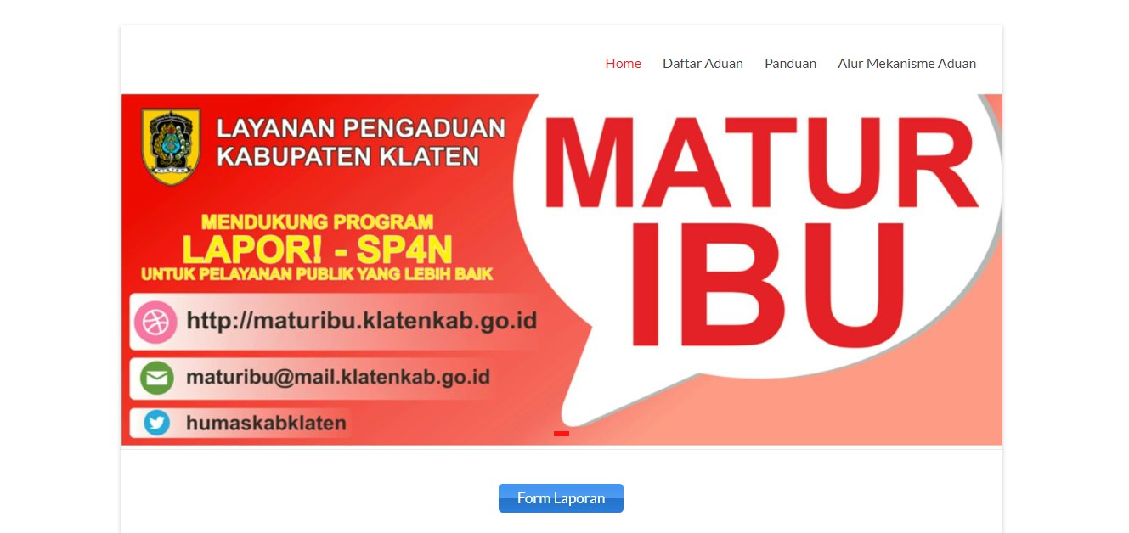Matur Ibu is one of the complaints systems carried out by the government of the Klaten district which has been digitalized and connected to the internet, so that the Klaten community can report their complaints with procedures that already exist on the web. Mom has a web page itself wherein there is information from the system and procedures for public complaints that can be posted on the webpage.

On the main page of the website there is absolutely no clear guidance or instructions regarding the web for what and how to do a good complaint. indicated by simply placing the "report form" button in the bottom center of the website section

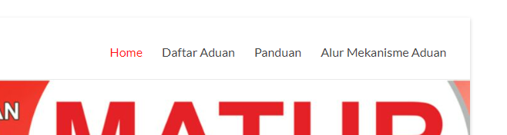

The tab position indicator being visited is not clear because it only changes the font color to red for some people it will be a little difficult to distinguish.

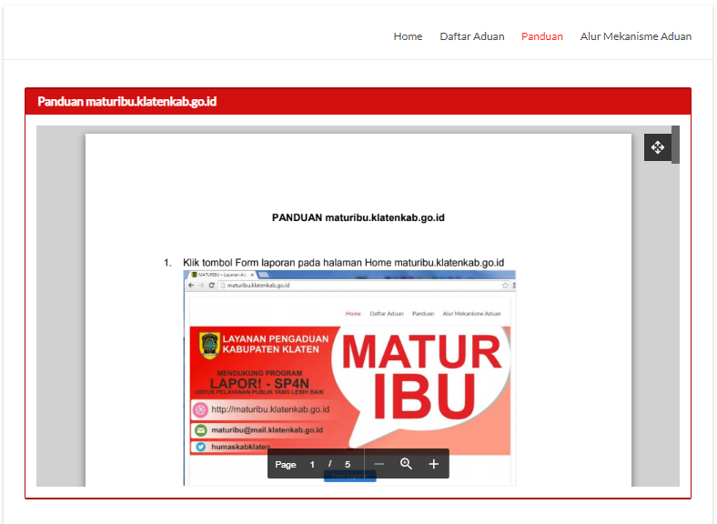

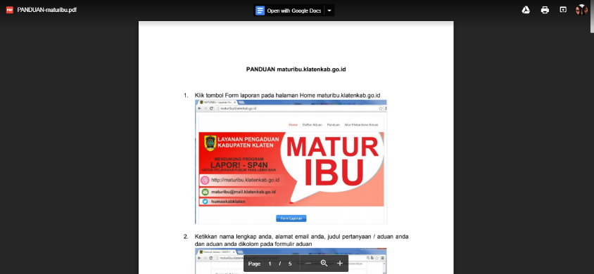

On the guide tab, the complaint guide is still shaped like a narrative that makes the reader indirectly get the point. the guide is also not in a full page, and if enlarged with the expand button, it will be directed to google docs and move to another Web tab.

**Solution:**

Overall, in my opinion, the UI / UX design of the maturity web should be made to further clarify the functions of the web. It would be better if the complaint guide was made on the start page. Thus, the user opens and uses the web will more quickly understand the purpose of the web function. On the other hand, complaint guides that might be less informative would be better made like infographics so that they are more interesting and if necessary illustrated the implementation of the complaint through the web. And the last one, for the tab section each menu will be better made hover or other effects that better show the movement.

1. **GoPro Hero 3+ Black Edition**

GoPro hero 3+ Black edition is an action camera that is small in shape so that it can be easily carried anywhere and under any conditions. This can happen because the camera has a waterproof and portable feature. Like other cameras, the function of the GoPro is almost the same as other cameras. To see battery information, other indicators, and the mode menu of the camera, the GoPro has a small screen and several buttons to operate it.

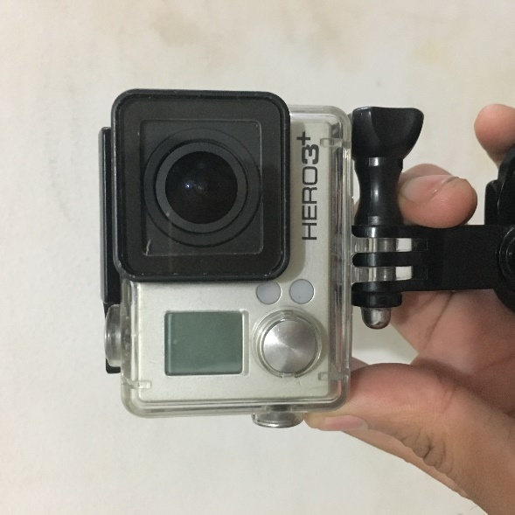

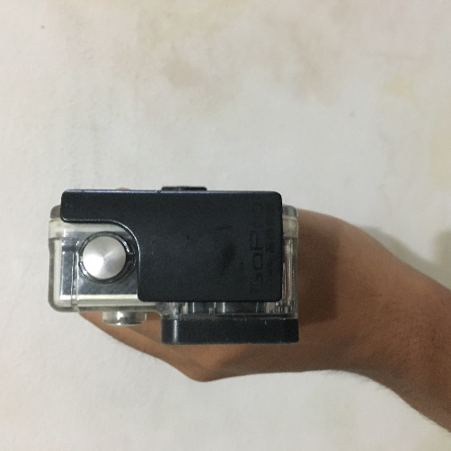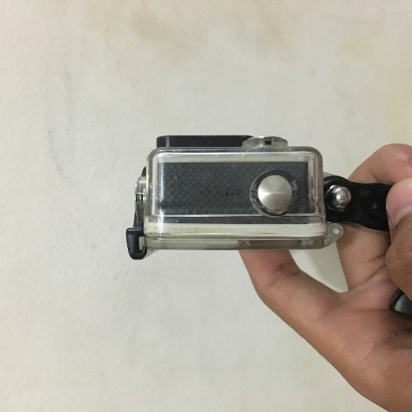In this camera, there is only 1 small screen that contains all the info about the camera. starting from the current mode, battery, camera memory and more. For some people will feel troubled for that. with a small size, it will be more difficult to see clearly at a certain distance. If you want to see it clearly, camera distance must be close to the user to see information on the screen.

There are only 3 camera operation buttons. the first is the mode button which is also for the power button the camera, wifi button, and shutter button to start taking pictures and videos. This can be a bit difficult for the user to understand the functions of the three buttons, because of the three buttons there is no sign or an indicator that shows the function of each button on the camera.

**Solution:**

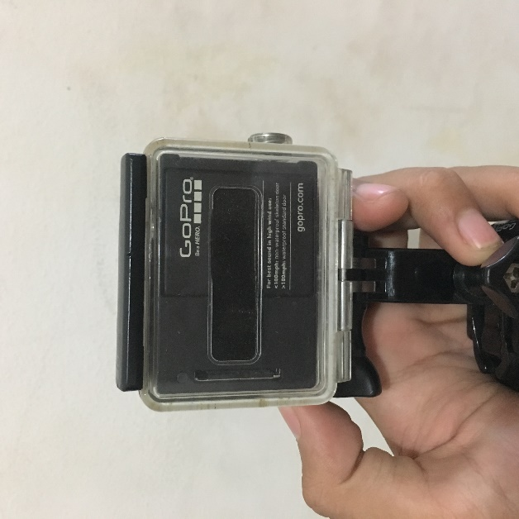

The first, the screen that is in front of the camera can be moved in the rear position of a wider camera. So that the information displayed on the screen can be more clearly seen without changing the shape of the camera and reducing the essence of portable features from the camera. but the position of the battery that was originally behind the camera, also must be moved if it will use the back of the camera for put the camera's information screen

the solution to the buttons on the gopro camera, the simplest is to add a sign or indicator about the function of each button that exists. if it's the power button, a power sign or icon is given. and the wifi button, given a sign or signal iconas in general. thus it will make it easier for users to operate the camera

1. **MyTuner Radio**

MyTuner Radio is an application in the Apple App Store that has features for streaming various radio channels in Indonesia. In addition, there are various options for listening to existing music and podcasts.

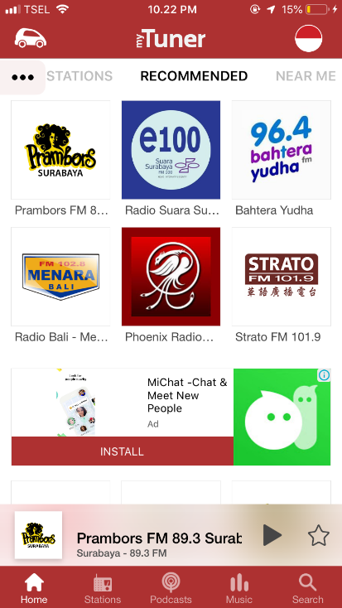

Bad design in this application, in my opinion there is a redundancy in the radio category menu selection at the top. The first slide menu, then there is a button with three dots. Both of them have the same function to replace or show the menu of the application.

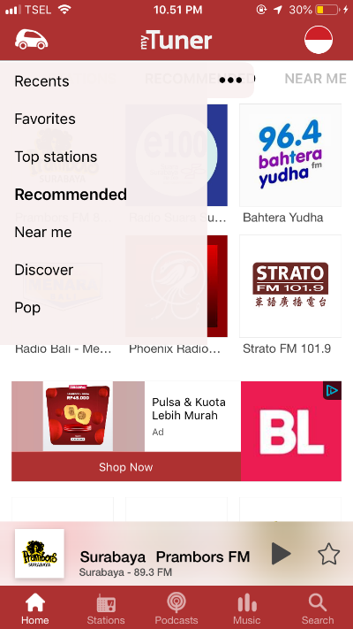

**Solution:**

in my opinion, it should be made just one way to display the menu, besides being a redundant thing, another thing that can happen is to make application users confused by the function of the buttons with those three points. If you choose the menu button, the slide menu can be removed or the other way can do.