Modifying GNomEx Billing Account to match your Institution’s Funding String

There are four approaches you could take to introduce your institution’s billing account format. I have described them in the order of least effort to most effort. In any case, I don’t think you will need to get into Flex Builder to make the UI changes. Instead, you can just change the .mxml files. and then rebuild using the ant script and it will produce a new gnomex.ear with the new .swf file. If you don’t care about having the funding string in separate fields, I think Approach 2 is the most straightforward.

Approach 1 – Use the ‘PO’ checkbox when creating Billing Accounts
- Click on Users and Groups link and go to the Groups tab. Select a group. Then click on the Billing accounts tab. When adding a billing account, click on the ‘PO’ checkbox. This will allow your full funding string to be entered into the account name. (See screen capture 1 below.)
- If you use this approach, you will have to parse the code in any interfaces that require separate fields

Approach 2 – Only use the account name and number fields. Modify the user interface to only require account name and account number. Enter the full funding string in account number.
- gnomex/flex/views/util/WorkAuthorizationForm.mxml - Change the window for submitting work authorization forms. (See screen capture 3a & 3b below.) Remove all of the fields accept for account number and account name. Change the code in the disable property of the ‘Save’ button so that only your billing account name, number, expiration date, and funding agency are required.
- gnomex/flex/view/user/GroupDetail.mxml – Modify the Billing Account tab to hide the columns not needed. Modify the validateAndSave() method to only require account name, number, expiration date, and funding agency fields.

Approach 3 – Change the user interface only to match your funding fields.
- gnomex/flex/views/util/WorkAuthorizationForm.mxml - Change the window for submitting work authorization forms. (See screen capture 3a & 3b below.) Change the header labels and text field max characters to match your format. For example, rename the label Hide or disable the fields you will not use. Change the code in the disable property of the ‘Save’ button so that only your billing account fields users are required.
- gnomex/flex/view/user/GroupDetail.mxml – Modify the Billing Account tab to rename column headers and hide the columns not needed. Modify the validateAndSave() method to only require targeted fields.
- gnomex/src.hci/gnomex/billing/BillingAccount.java – Modify the getAccountName() to format according to your institution’s funding string.

Approach 4 – Modify user interface and underlying data model
- Make all of the user interface changes in Approach 3 and also change the fields names to match your funding string. For example, rename ‘Bus’ field to ‘Fund’. Make sure you change the XML attribute names in the save() methods as well.
- gnomex/gnomex_db_ddb.sql – Change the BillingAccount table columns
- gnomex/src/hci/gnomex/billing/BillingAccount.java – Change the java member variables, getters and setters.
- gnomex/src/SchemaGNomExEx.hbm.xml – Change the hibernate mapping for BillingAccount.
- gnomex/scr/hci/gnomex/utility/BillingAccountParser.java – Change the attribute names and initialize the BillingAccount using the new member variable names
Screen capture 1 – Use the ‘PO’ checkbox on the Group’s billing account tab.
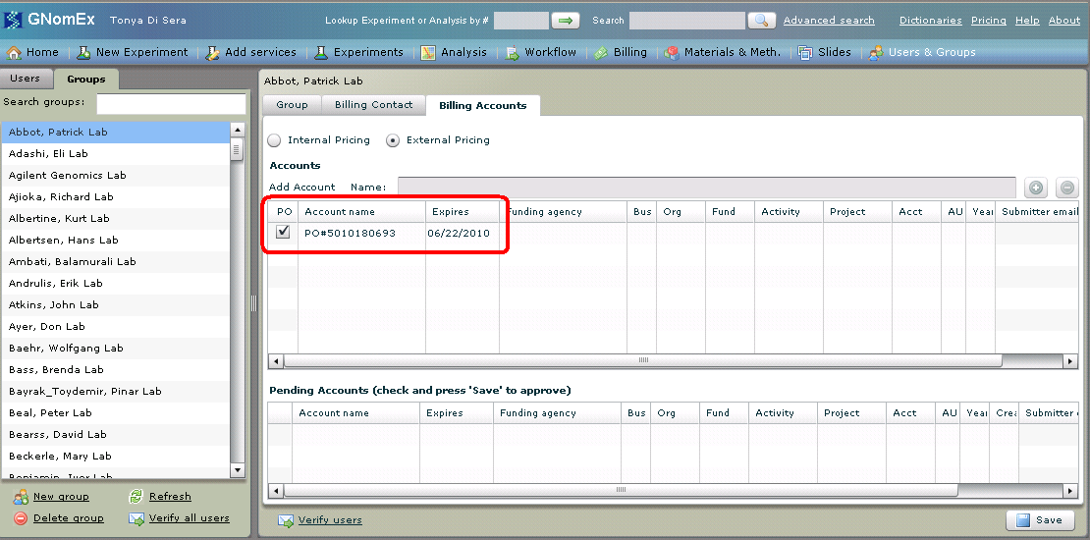

Screen capture 3a – Dashboard button to submit Work Authorization Form
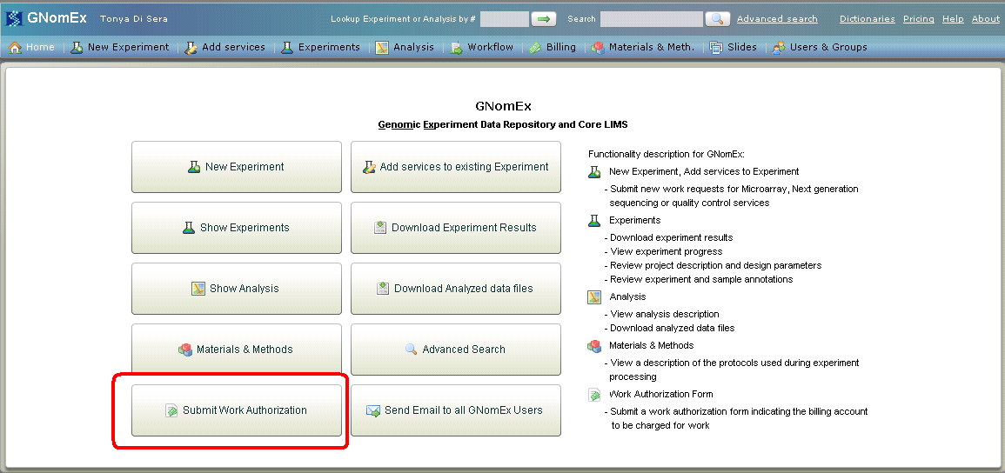

Screen capture 3b – Work authorization form
