Epson Moverio BT-200 USB Configuration Document
11/27/2013

This document is used for setting up Epson Moverio BT-200 for Android application development.

You must install the USB ADB driver by following the steps below. This document covers the following computing environments:
- Macintosh and Linux
- Windows XP, Windows 7 and Windows 8

- Setup Moverio USB Debugging mode
  - Launch “Settings” App.
  - Check mark “Settings > Developer options > USB Debugging”.
  - You may need to reboot Moverio BT-200.

(Example from Step B above as seen on the Moverio BT-200 screen)
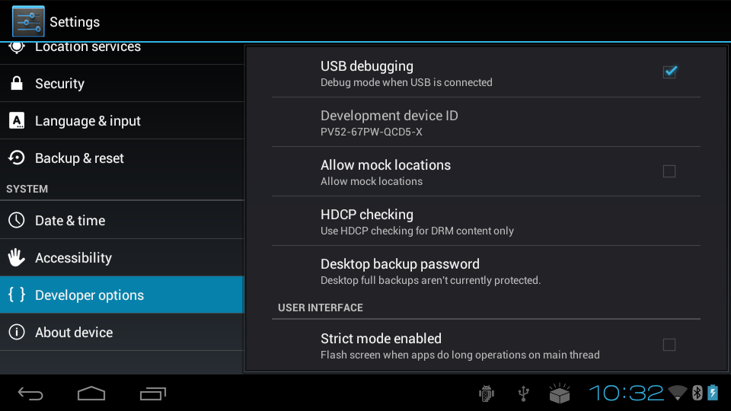

- Install Android SDK by following the instructions on developer.android.com and refer to http://developer.android.com/sdk/oem-usb.html#InstallingDriver

Macintosh or Linux:

- Setup Vendor ID in ADB
- Add vendor ID(0x04B8) in ~usr/.android/adb_usb.ini
# ANDROID 3RD PARTY USB VENDOR ID LIST -- DO NOT EDIT.
# USE 'android update adb' TO GENERATE.
# 1 USB VENDOR ID PER LINE.
0x04B8
- Save the above adb_usb.ini file.

- Testing BT-200 adb USB driver
- Bring up command prompt.
- Type “adb kill-server” then enter.
- Type “adb start-server” then enter.
- Type “adb devices” then enter.
- You should see BT-200 as one of the devices.

Windows XP, 7 & 8:

- Setup USB Driver
  - Install Google USB driver from Android SDK Manager
  - Add following bolded lines in [Google.NTx86] and [Google.NTamd64] sections in <android-sdks>\extras\google\usb_driver\android_winusb.inf
[Manufacturer]
%ProviderName% = Google, NTx86, NTamd64

[Google.NTx86]
WS2-MTP
%SingleAdbInterface% = USB_Install, USB\VID_04B8&PID_0C06
%CompositeAdbInterface% = USB_Install, USB\VID_04B8&PID_0C06&MI_01

;WS2-PTP
%SingleAdbInterface% = USB_Install, USB\VID_04B8&PID_0C07
%CompositeAdbInterface% = USB_Install, USB\VID_04B8&PID_0C07&MI_01

;Google Nexus One
%SingleAdbInterface% = USB_Install, USB\VID_18D1&PID_0D02
%CompositeAdbInterface% = USB_Install, USB\VID_18D1&PID_0D02&MI_01
%SingleAdbInterface% = USB_Install, USB\VID_18D1&PID_4E11
%CompositeAdbInterface% = USB_Install, USB\VID_18D1&PID_4E12&MI_01
……………………….
……………………….

[Google.NTamd64]
;WS2-MTP
%SingleAdbInterface% = USB_Install, USB\VID_04B8&PID_0C06
%CompositeAdbInterface% = USB_Install, USB\VID_04B8&PID_0C06&MI_01

;WS2-PTP
%SingleAdbInterface% = USB_Install, USB\VID_04B8&PID_0C07
%CompositeAdbInterface% = USB_Install, USB\VID_04B8&PID_0C07&MI_01

;Google Nexus One
%SingleAdbInterface% = USB_Install, USB\VID_18D1&PID_0D02
%CompositeAdbInterface% = USB_Install, USB\VID_18D1&PID_0D02&MI_01
%SingleAdbInterface% = USB_Install, USB\VID_18D1&PID_4E11
%CompositeAdbInterface% = USB_Install, USB\VID_18D1&PID_4E12&MI_01
……………………….
……………………….

  - Setup Vendor ID in ADB
- Execute <sdk>\tools\android.bat with argument “update adb” to create [C:\[username]\.android\adb_usb.ini].
- Add vendor ID
# ANDROID 3RD PARTY USB VENDOR ID LIST -- DO NOT EDIT.
# USE 'android update adb' TO GENERATE.
# 1 USB VENDOR ID PER LINE.
0x04B8

- Save above adb_usb.ini file and reboot Windows

Windows 7 & 8:

- Install USB Driver
- Connect USB cable to BT-200.
- Confirm EPSON BT-200 from the Device Manager, it shows as embt2 under Other devices.
- Double click on embt2.
- Click Update Driver.

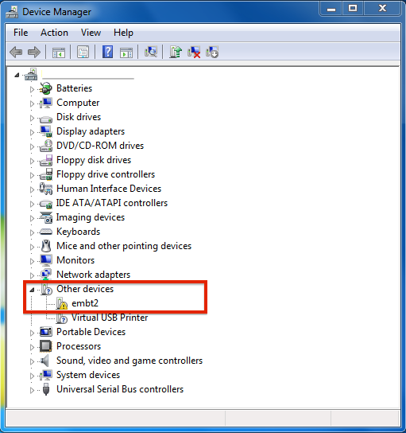

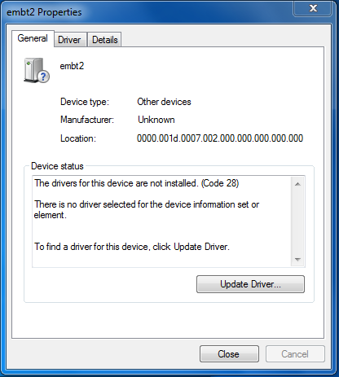

- Select Browse my computer for driver software ~ Locate and install driver software manually.
- Select Browse …, and select android-sdks\extras\google\usb_driver folder.

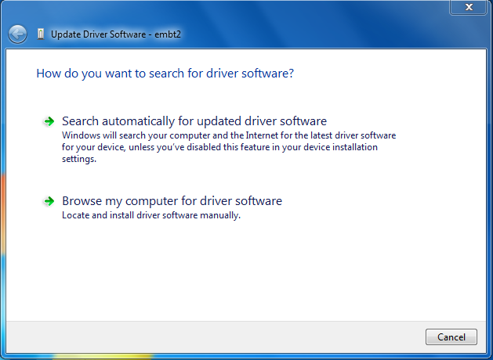

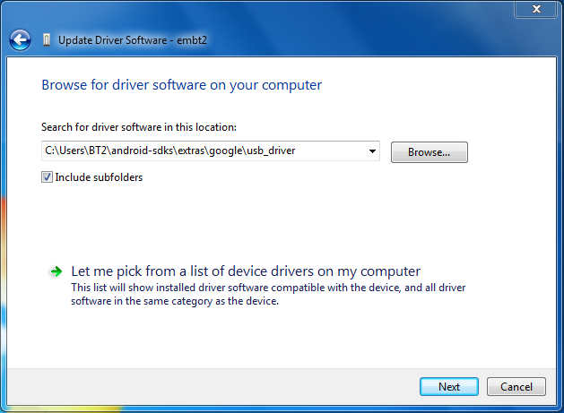

- When Windows Security prompt appears, select Install this driver software anyway.

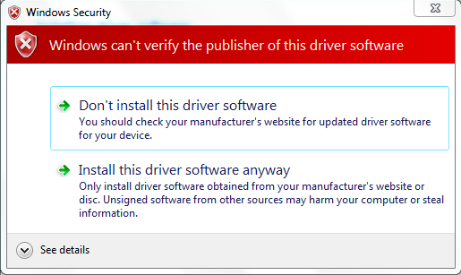

(You may have to change Windows 8 startup settings to disable Driver signing enforcement).

- You have completed the driver installation. BT-200 should be under Portable Devices as shown below.

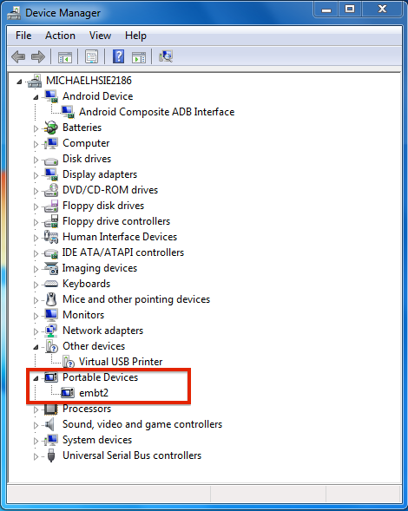

- From Devices and Printers, BT-200 shows as MTP, and double click on it. It will show as follows.

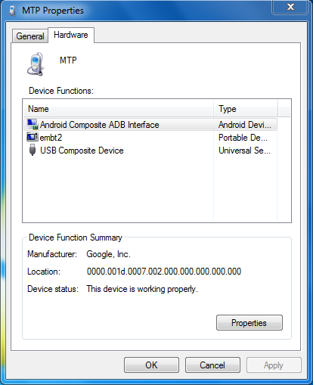

- Testing BT-200 adb USB driver
- Bring up command prompt.
- Type “adb kill-server” then enter.
- Type “adb start-server” then enter
- Type “adb devices” then enter.
- You should see BT-200 as one of the devices.

Windows XP:

- Install USB Driver
- Power on and connect BT-200 to your PC through the USB port. Windows will detect the device and launch the Hardware Update Wizard.
- Select Install from a list or specific location and click Next.
- Select Search for the best driver in these locations; un-check Search removable media; and check Include this location in the search.
- Click Browse and locate the USB driver folder. <sdk>\extras\google\usb_driver\
- Click Next to install the driver.

- Testing BT-200 adb USB driver
- Bring up command prompt.
- Type “adb kill-server” then enter.
- Type “adb start-server” then enter
- Type “adb devices” then enter.
- You should see BT-200 as one of the devices.

FOV2GO 3D:

- Import Mxr_Unity_Package
- add script s3dCameraSBS.js and s3dGyroCamSBS.js to MainCamera.
- Handle configuration as following:
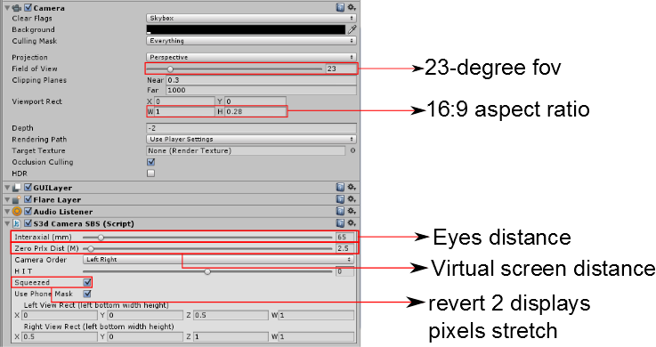

Important notice:

- Unity should set the player setting to support Android SDK version 4.0.

