4. Methodology
This section covers the technical design of AIPM, discussing the development environment , data warehouse design, AI agent system architecture and user interface design. Together, all these components ensure that the platform is scalable, transparent, and can provide explainable trading insights in real time.
4.1 Platform Setup
AIPM is developed in a Python-based environment using Pandas and NumPy for high-performance data manipulation, TA-Lib and QuantLib for advanced financial computations, and a hybrid AI architecture combining Gemini 3.0 Pro and Llama 3.2. Gemini 3.0 Pro is chosen for the Supervisor and Synthesis layers because of its superior reasoning capabilities and large context window, ideal for complex agentic orchestration and report consolidation. Conversely, Llama 3.2 drives the five local core agent skills, chosen for its strong performance on focused, domain-specific tasks and favorable trade-off between local execution speed and accuracy. Qdrant is used as the primary database because of its specialized, high-speed vector storage optimized for semantic retrieval (RAG), providing significant advantages over traditional relational or general-purpose NoSQL databases. Moreover, the platform leverages the use of components like Apache Airflow for scheduled data orchestration, Streamlit for real-time interactive visualization, and PostgreSQL for robust metadata management. PostgreSQL provides scalable, ACID-compliant structured storage critical for audit trails. Docker orchestrates the entire infrastructure through containerized microservices, ensuring reproducible deployments, isolated environments for each component (Airflow, Qdrant, PostgreSQL), and simplified dependency management across development and production environments. Specifically, Qdrant is preferred over Pinecone for its local deployment flexibility, and Airflow over Prefect for its mature ecosystem in managing complex dependency graphs.
4.2 Data Warehouse Architecture Design
The system architecture of AIPM is designed to support incremental daily data ingestion, semantic enrichment, and agentic analysis. The following Figure 1 outlines the key components and data flow of the system.
Figure 1
System Architecture diagram of AIPM.
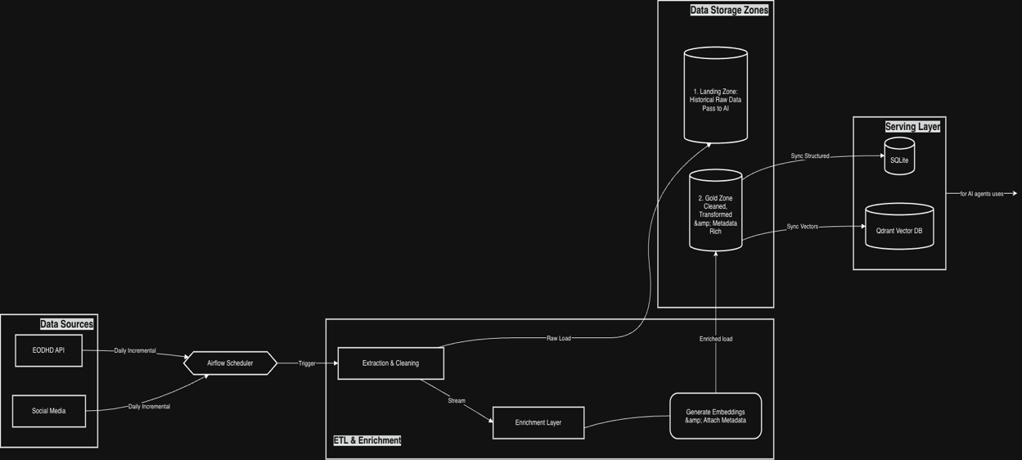
As shown in Figure 1, the system fetches financial data such as EODHD API stock prices and Social Media sentiment. Data flows through an orchestration layer managed by Airflow, which triggers daily incremental loads rather than real-time streams. The pipeline follows a Medallion Architecture: data is first extracted and cleaned into a Landing Zone (historical raw data), then passed to an Enrichment Layer where embeddings are generated and metadata is attached. The final, processed data resides in the Gold Zone. From there, it is synchronized to the Serving Layer, composed of SQLite for structured financial metrics and Qdrant for vector-based semantic retrieval. On the inference side, the underlying Agentic RAG system, powered by a hybrid of Gemini 3.0 Pro (Supervisor) and Llama 3.2 (Local Skills), utilizes this enriched data to yield grounded investment insights. Subsequently, user interactions and citation usage are captured by a feedback loop, further refining the retrieval weights and agent decision-making. The architecture is optimized for accuracy and traceability rather than ultra-low latency, ensuring every output is verified against the Gold Zone data. Qdrant's indexing speed and SQLite's relational integrity are critical performance factors, with specific optimizations for vector search efficiency addressed in the self-improvement module.

4.3 Data Warehouse Architecture Design
The AI architecture of AIPM is designed to support multi-agent orchestration, parallel skill execution, and self-improving retrieval. The following Figure 2 outlines the key components and workflow of the agentic system.
Figure 2
Agentic Architecture diagram of AIPM.
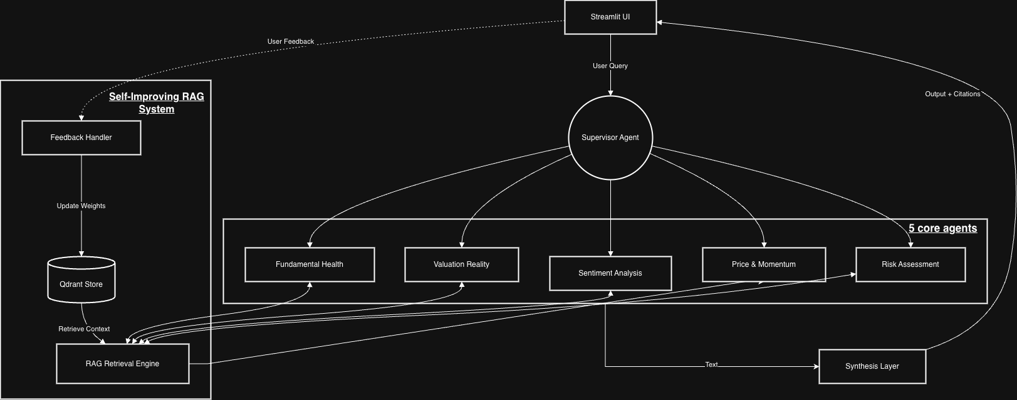
As shown in Figure 2, the workflow begins at the Streamlit UI, where user queries are submitted. These requests are routed to the Supervisor Agent, powered by Gemini 3.0 Pro, which parses intent and delegates tasks to five parallel Local Core Skills running on Llama 3.2. These skills—ranging from Fundamental Health to Sentiment Analysis—independently query the Self-Improving RAG System. This RAG engine retrieves semantic context from the Qdrant Vector Store, ensuring that agent analysis is grounded in verified data. The outputs from all skills are then aggregated by the Synthesis Layer, also powered by Gemini 3.0 Pro, which consolidates the findings into a coherent, cited report. Crucially, a Feedback Handler captures user interactions and citation accuracy, feeding this data back into the VectorDB to update retrieval weights. This closed-loop feedback mechanism allows the system to continuously refine its accuracy and relevance over time, evolving from a static tool into a learning partner. The architecture prioritizes explainability, with the final output explicitly tracing the logic and sources used by each agent skill.

4.4 User Interface Design
To ensure transparency and accessibility for financial analysts, the UI is designed to demystify the AI’s reasoning process rather than presenting it as a "black box." The interface is organized into two primary functional workflows: interactive reasoning and comprehensive reporting.
Figure 3
Tab 1: Chat Analysis Interface. This view features the interactive query input (left) and the real-time Chain of Thought sidebar (right), which visualizes the Plan-Execute-Synthesize reasoning loop.
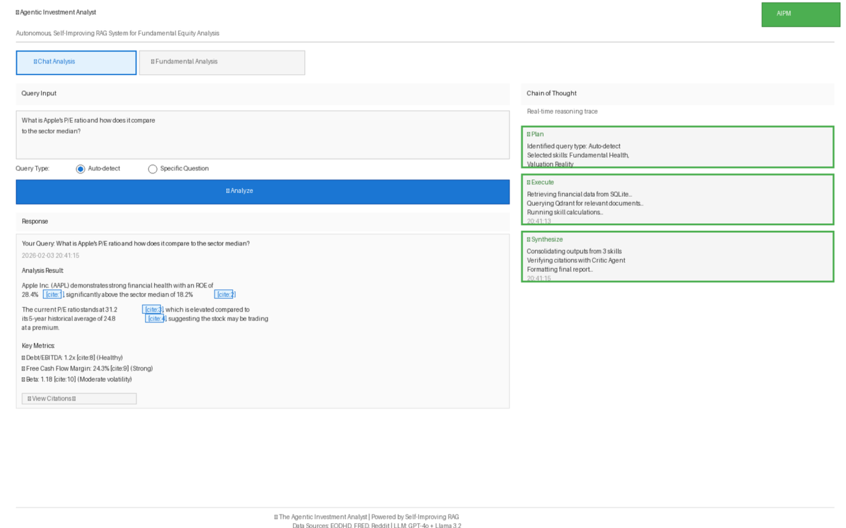
The Chat Analysis interface (Figure 3) is designed for iterative inquiry. Users input queries through a text field and can manually select a query type (e.g., Specific Question vs. Comparison) or allow the agent to auto-detect intent. A distinct "Chain of Thought" sidebar on the right visualizes the agent’s logic in real-time, displaying the Plan, Execute, and Synthesize stages. This "Glass Box" approach allows users to audit the system's decision-making process as it happens. The response area utilizes granular inline citations (e.g., [cite:1]) for every factual claim, enabling users to verify data sources immediately against the original documents.
Figure 4
Tab 2: Fundamental Analysis Interface. This view displays the structured 5-section report generated for a specific ticker, including financial health cards, valuation metrics, and risk assessment.
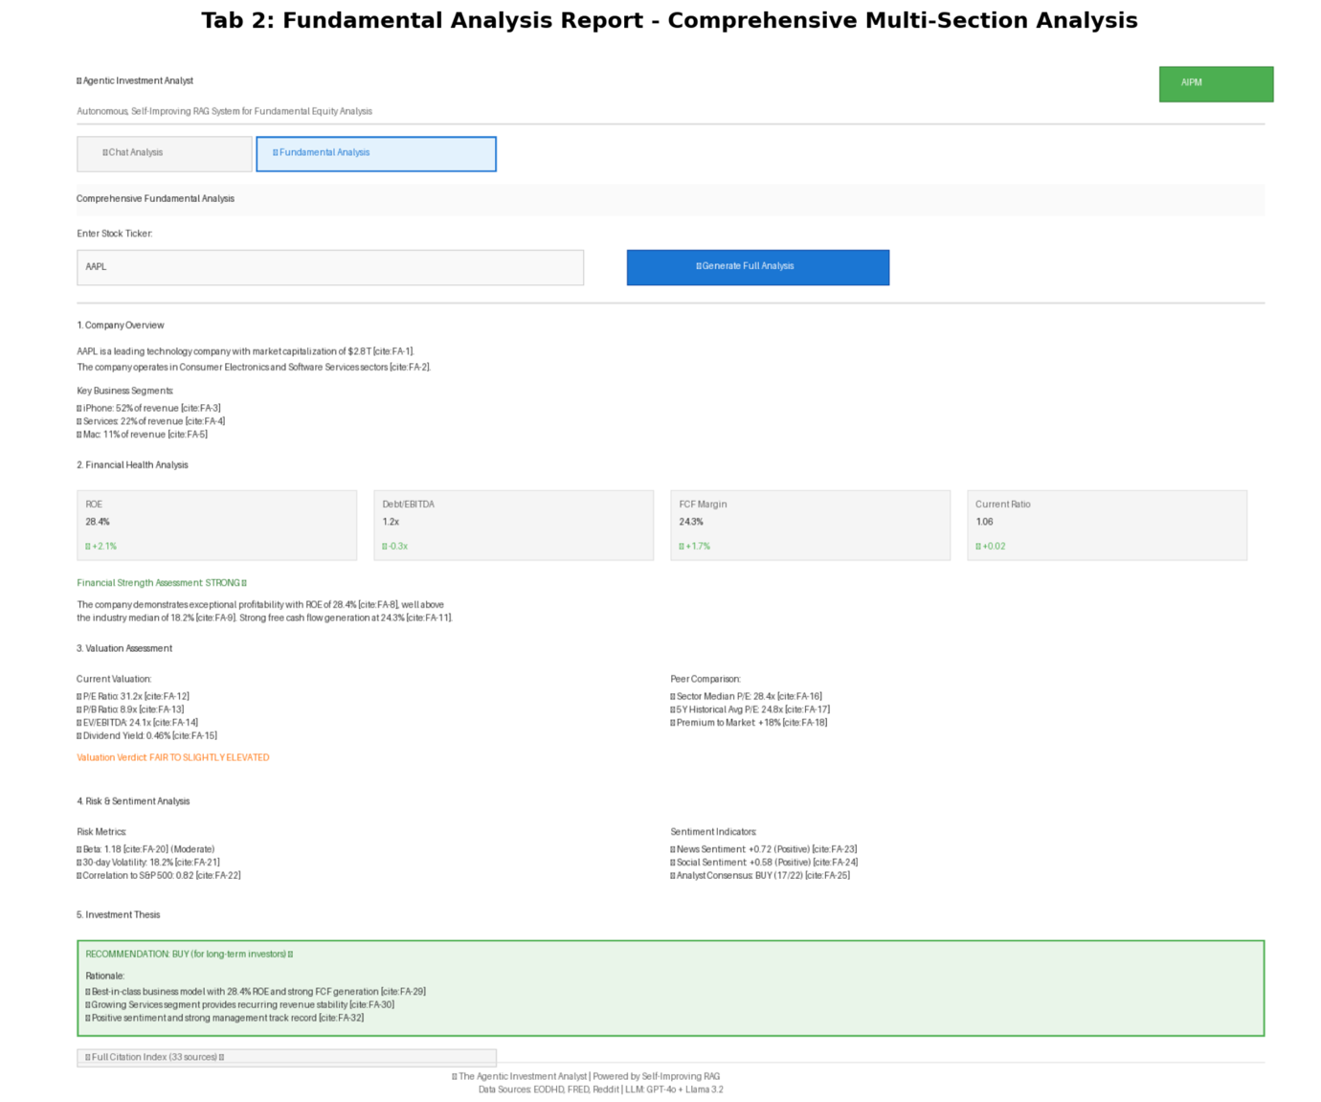
The Fundamental Analysis interface (Figure 4) serves as a production-grade reporting tool. Upon entering a stock ticker, the agent synthesizes a structured 5-section report that mirrors professional equity research. This includes visualized Financial Health metrics (such as ROE and Debt/EBITDA) presented as cards with trend indicators, peer valuation comparisons, and a consolidated investment thesis. The design prioritizes information density and clarity, using a split-column layout to present quantitative risk metrics alongside qualitative sentiment indicators.

5. Project Schedule and Milestones
The development of the Agentic Investment Analyst (AIPM) is structured as an intensive, eleven-week engineering sprint commencing on February 1st, 2026, and concluding on April 20th, 2026. The project lifecycle follows an iterative implementation strategy, moving from foundational infrastructure to complex agentic orchestration and finally to rigorous system evaluation. This schedule is designed to ensure that the data pipelines are robust enough to support the AI components before the higher-level reasoning agents are deployed. We estimate a total cumulative effort of approximately 400-500 learning and development hours to bring the system to production readiness.
5.1 Tentative Schedule
The project execution is divided into four distinct phases. Phase 1: Infrastructure & Data Pipeline (Feb 1 – Feb 21) focuses on establishing the core "nervous system" of the platform. during this period, the team will containerize the environment using Docker, deploying the microservices architecture that hosts Apache Airflow, PostgreSQL, and Qdrant. The primary objective is to finalize the Airflow DAGs for ingesting equity, macroeconomic, and risk data, populating the SQLite database with high-quality structured financial records.
Phase 2: Core Agent Skills & Local LLM Integration (Feb 22 – Mar 14) shifts the focus to the "limbs" of the agent—the executable tools it uses to perceive the market. This phase involves implementing the five deterministic skills (Fundamental Health, Valuation, Risk, etc.) driven by the local Llama 3.2 model. By mid-March, the system will possess the ability to perform specific financial calculations and semantic searches via the Qdrant vector database, though it will lack a central planner.
Phase 3: Supervisor Agent & Orchestration (Mar 15 – Apr 4) introduces the "brain" of the operation. This critical phase centers on integrating Gemini 3.0 Pro as the Supervisor Agent. The team will build the LangGraph orchestration layer, enabling the system to plan complex workflows, route queries to the appropriate skills, and synthesize multi-modal outputs into coherent investment reports.
Finally, Phase 4: Evaluation, UI & Refinement (Apr 5 – Apr 20) is dedicated to validation and delivery. The focus here is on deploying the Streamlit user interface to visualize the "Chain of Thought" reasoning process and conducting the comprehensive evaluation framework to measure citation accuracy and hallucination rates before the final submission.
5.2 Division of Labor
To maximize efficiency, the workload is distributed based on specialized domains while maintaining collaboration on core AI components. Brian assumes the role of Data & Infrastructure Lead, taking primary responsibility for the "pipes and plumbing" of the system. His focus is split between data engineering and AI implementation. Specifically, Brian will architect the Dockerized environment, build the Airflow ETL pipelines, and manage the API integrations for EODHD and Reddit. He is also responsible for the frontend development using Streamlit, ensuring the complex backend logic is accessible to users. In the AI domain, Brian contributes to the coding of the deterministic financial skills, translating quantitative finance concepts into Python logic.
Ivan serves as the AI & Evaluation Lead, focusing heavily on the system's cognitive architecture and quality assurance. His primary responsibility is the design of the Supervisor Agent using Gemini 3.0 Pro and the optimization of the RAG retrieval system. Ivan will lead the prompt engineering efforts for the synthesis layer, ensuring reports are coherent and professionally formatted. Crucially, Ivan owns the evaluation framework; he will design the testing protocols to measure the system's factuality, manage the self-improvement feedback loops, and implement the "Critic Agent" logic to verify citations. While Brian ensures data arrives correctly, Ivan ensures the AI reasons about that data accurately.

