超高性能Web服务器(htmlserver)

厉华

版本修订
文档版本号 | 修订日期 | 修订人 | 修订内容
v1.0.0 | 2016-08-08 | 厉华 | 创建
v1.0.1 | 2016-08-17 | 厉华 | 新增章节 压测

目录索引
1 概述 4
2 编译安装 5
1.1 编译 5
1.1 安装 5
1.2 用缺省配置第一次启动 5
3 配置文件 6
1.3 配置项说明 6
1.4 调整正式配置 10
4 服务器管理 11
1.5 用自带脚本管理 11
1.6 直接用命令管理 12
5 压测 13
1.7 压测环境 13
1.8 压测方案 13
1.9 压测过程 14
1.10 压测结果 21

概述
htmlserver(HS)是一款我原创研发的超高性能Web服务器，使用高性能HTTP解析器fasterhttp作为解析核心，在开启Keep-Alive和gip压缩时性能秒杀nginx。如此高性能得益于轻巧的架构设计和采用Inotify文件变化主动通知缓存机制，把大量静态文件尽可能缓存在内存直接读取，比传统的轮询式检查文件机制避免了大量存储IO操作。
htmlserver的目标理念是快速、稳定和小巧。没有完全采用apache或nginx纯模块化架构，因为大多数人使用webserver一般都会把所有模块都打上，除了动态内容模块（如mod_php），很少见到有人特意去组装模块，那还不如直接全部编译在一起算了，使用简单，避免了管理员或运维人员面对过多选择带来的学习成本。当你需要本地定制化时，直接改代码吧，因为它就是开源的嘛。htmlserver只有在动态内容上才设计了模块接口，以适应各种各样的语言架构和开发者。
htmlserver目前只支持GET和HEAD方法，将来很快会支持POST动态网页。

htmlserver进程结构：
·管理进程，监管工作进程
·工作进程（工作线程+定时器线程）

htmlserver功能：
·支持HTTP/1.0、HTTP/1.1
·支持多侦听端口
·支持自定义错误页面
·支持自定义缺省index文件
·支持多虚拟主机（基于域名）
·支持自适应Keep-Alive
·支持自适应gzip、deflate压缩
·支持通讯超时控制
·支持工作进程绑定CPU
·支持工作进程异常后，管理进程自动重启工作进程
·支持优雅重启/重载配置，重启期间完全不中断对外服务

编译安装

编译
从http://git.oschina.net/calvinwilliams/htmlserver或https://github.com/calvinwilliams/htmlserver上git clone或直接下载zip包到本地解开，进入src目录，执行编译命令
$ make
没有报错的话就能编译出可执行文件htmlserver。

安装
（以下为安装到系统用户中，如果要安装到其它目录，请自行调整命令）手工复制htmlserver到可执行文件目录$HOME/bin/。
手工复制安装包中的conf/htmlserver.conf到你的配置文件目录，如$HOME/etc/，作为缺省配置。
手工复制安装包中的www/*到你的网站根目录，如$HOME/www/，error_pages目录放着缺省的报错页面，index.html是示例首页文件。
手工复制安装包中的shbin/hs.do到$HOME/shbin/，这个脚本用于htmlserver启停管理。
这样就安装好了!

用缺省配置第一次启动
执行以下命令以缺省配置启动
$ htmlserver ~/etc/htmlserver.conf
如果没有产生输出、没有产生~/log/error.log以及该日志中没有出现ERROR行的话表示启动成功。注意：缺省配置文件中的侦听端口为9527。
可以看到进程，htmlserver进程结构由一个管理进程+n个工作进程组成
$ ps -ef | grep htmlserver | grep -v grep
calvin 14122 1 0 23:17 ? 00:00:00 htmlserver /home/calvin/etc/htmlserver.conf
calvin 14123 14122 0 23:17 ? 00:00:00 htmlserver /home/calvin/etc/htmlserver.conf
以及侦听端口
$ netstat -an | grep 9527
tcp 0 0 0.0.0.0:9527 0.0.0.0:* LISTEN
自测一下
$ curl http://127.0.0.1:9527/index.html
<!DOCTYPE html PUBLIC "-//W3C//DTD XHTML 1.0 Transitional//EN" "http://www.w3.org/TR/xhtml1/DTD/xhtml1-transitional.dtd">
<html xmlns="http://www.w3.org/1999/xhtml">
<head>
<meta http-equiv="Content-Type" content="text/html; charset=gb18030" />
<title>Welcome</title>
</head>
<body>
Hello htmlserver
</body>
</html>
恭喜您，启动成功！
直接发送TERM信号到父进程可停止htmlserver
$ kill 14122

配置文件

配置项说明
安装时复制的配置文件为缺省配置
$ cat ~/etc/htmlserver.conf
{
"worker_processes" : 1 ,
"cpu_affinity" : 1 ,
"accept_mutex" : 1 ,

"error_log" : "$HOME$/log/error.log" ,
"log_level" : ERROR ,

"limits" :
{
"max_http_session_count" : 100000
} ,

"listen" :
{
"ip" : "" ,
"port" : "9527"
} ,

"server" :
{
"domain" : "192.168.6.17:9527" ,
"wwwroot" : "$HOME$/www" ,
"index" : "/index.html,/index.htm" ,
"access_log" : "$HOME$/log/access.log"
} ,
"tcp_options" :
{
"nodelay" : 1 ,
"nolinger" : -1
} ,

"http_options" :
{
"compress_on" : 1 ,
"connection_timeout" : 10 ,
"timeout" : 60
} ,

"error_pages" :
{
"error_page_400" : "$HOME$/www/error_pages/error_page_400.html" ,
"error_page_401" : "$HOME$/www/error_pages/error_page_401.html" ,
"error_page_403" : "$HOME$/www/error_pages/error_page_403.html" ,
"error_page_404" : "$HOME$/www/error_pages/error_page_404.html" ,
"error_page_408" : "$HOME$/www/error_pages/error_page_408.html" ,
"error_page_500" : "$HOME$/www/error_pages/error_page_500.html" ,
"error_page_503" : "$HOME$/www/error_pages/error_page_503.html" ,
"error_page_505" : "$HOME$/www/error_pages/error_page_505.html"
} ,

"mime_types" :
{
"mime_type" : { "type":"html htm shtml" , "mime":"text/html" } ,
"mime_type" : { "type":"css" , "mime":"text/css" } ,
"mime_type" : { "type":"xml" , "mime":"text/xml" } ,
"mime_type" : { "type":"txt" , "mime":"text/plain" } ,
"mime_type" : { "type":"gif" , "mime":"image/gif" } ,
"mime_type" : { "type":"jpeg jpg" , "mime":"image/jpeg" } ,
"mime_type" : { "type":"png" , "mime":"image/png" } ,
"mime_type" : { "type":"tif tiff" , "mime":"image/tiff" } ,
"mime_type" : { "type":"ico" , "mime":"image/x-ico" } ,
"mime_type" : { "type":"jng" , "mime":"image/x-jng" } ,
"mime_type" : { "type":"bmp" , "mime":"image/x-ms-bmp" } ,
"mime_type" : { "type":"svg svgz" , "mime":"image/svg+xml" } ,
"mime_type" : { "type":"jar war ear" , "mime":"application/java-archive" } ,
"mime_type" : { "type":"json" , "mime":"application/json" } ,
"mime_type" : { "type":"doc" , "mime":"application/msword" } ,
"mime_type" : { "type":"pdf" , "mime":"application/pdf" } ,
"mime_type" : { "type":"rtf" , "mime":"application/rtf" } ,
"mime_type" : { "type":"xls" , "mime":"application/vnd.ms-excel" } ,
"mime_type" : { "type":"ppt" , "mime":"application/vnd.ms-powerpoint" } ,
"mime_type" : { "type":"7z" , "mime":"application/x-7z-compressed" } ,
"mime_type" : { "type":"rar" , "mime":"application/x-rar-compressed" } ,
"mime_type" : { "type":"swf" , "mime":"application/x-shockwave-flash" } ,
"mime_type" : { "type":"xhtml" , "mime":"application/xhtml+xml" } ,
"mime_type" : { "type":"bin exe dll iso img msi msp msm" , "mime":"application/octet-stream" } ,
"mime_type" : { "type":"zip" , "mime":"application/zip" } ,
"mime_type" : { "type":"docx" , "mime":"application/vnd.openxmlformats-officedocument.wordprocessingml.document" } ,
"mime_type" : { "type":"xlsx" , "mime":"application/vnd.openxmlformats-officedocument.spreadsheetml.sheet" } ,
"mime_type" : { "type":"pptx" , "mime":"application/vnd.openxmlformats-officedocument.presentationml.presentation" } ,
"mime_type" : { "type":"mid midi kar" , "mime":"audio/midi" } ,
"mime_type" : { "type":"mp3" , "mime":"audio/mpeg" } ,
"mime_type" : { "type":"ogg" , "mime":"audio/ogg" } ,
"mime_type" : { "type":"m4a" , "mime":"audio/x-m4a" } ,
"mime_type" : { "type":"ra" , "mime":"audio/x-realaudio" } ,
"mime_type" : { "type":"3gpp 3gp" , "mime":"video/3gpp" } ,
"mime_type" : { "type":"ts" , "mime":"video/mp2t" } ,
"mime_type" : { "type":"mp4" , "mime":"video/mp4" } ,
"mime_type" : { "type":"mpeg mpg" , "mime":"video/mpeg" } ,
"mime_type" : { "type":"mov" , "mime":"video/quicktime" } ,
"mime_type" : { "type":"webm" , "mime":"video/webm" } ,
"mime_type" : { "type":"flv" , "mime":"video/x-flv" } ,
"mime_type" : { "type":"m4v" , "mime":"video/x-m4v" } ,
"mime_type" : { "type":"mng" , "mime":"video/x-mng" } ,
"mime_type" : { "type":"asx asf" , "mime":"video/x-ms-asf" } ,
"mime_type" : { "type":"wmv" , "mime":"video/x-ms-wmv" } ,
"mime_type" : { "type":"avi" , "mime":"video/x-msvideo" }
}
}
htmlserver配置文件格式为json。各配置项说明如下：
worker_processes 子进程数量。因为内部采用了多路复用，一般情况下一个子进程足矣。如果设置成-1，则创建与CPU核数量相等的子进程。
cpu_affinity 如果为1，则子进程绑定在CPU上，如果为0，不绑定。
accept_mutex 如果为1，开启accept锁，防止多子进程因epoll惊群而引起的CPU稍稍高耗。
error_log 详细日志文件名。支持$...$环境变量展开。以下所有目录文件配置项都可以内嵌环境变量。
log_level 详细日志文件内的日志等级
limits 限制配置
max_http_session_count 最大HTTP通讯会话数量
listen 侦听配置
ip 本地侦听端口，不填则为0.0.0.0
port 本地侦听端口，如果有多个端口，则格式为"port1,port2,..."。注意：前后有双引号。
server 主站点配置
domain HTTP头选项Host里的内容，用于区分虚拟主机。
wwwroot 网站根目录。
index 当浏览器请求的是目录，尝试的入口文件，格式为"/index.html"，如果有多个，则格式为"/index.html,/index.htm,..."。注意：入口文件名前有"/"。
access_log 事件日志文件名
servers 虚拟主机站点设置
server 主站点配置
domain HTTP头选项Host的值，用于区分虚拟主机。
wwwroot 网站根目录。
index 当浏览器请求的是目录，尝试的入口文件，格式为"/index.html"，如果有多个，则格式为"/index.html,/index.htm,..."。注意：入口文件名前有"/"。
access_log 事件日志文件名
tcp_options TCP选项
nodelay 当为1时，启用TCP选项TCP_NODELAY，有助于提高响应速度；当为0时，关闭之。
nolinger 当大于等于0时，启用TCP选项SO_LINGER并设置成其值；当为-1时，不设置之。
http_options HTTP选项
compress_on 启用服务端压缩，有助于大幅减少通讯数量量。
timeout HTTP超时时间
error_pages 出错页面配置
error_page_??? HTTP响应???时返回的页面文件。目前支持的有400、401、403、404、408、500、503、505。
mime_types 流类型配置集合
mime_type 流类型配置
type 文件扩展名
mime HTTP响应头Content-Type值

调整正式配置
一般只需要修改server.domain或servers.server[].domain为你的网站访问域名或IP即可，即在浏览器输入的"http://"与"/"之间部分，如：
http://www.google.com/ domain改为"www.google.com"
http://192.168.1.110:8080/ domain改为"192.168.1.110:8080"
其实就是浏览器上送的HTTP头选项里的Host的值。

服务器管理

用自带脚本管理
启动htmlserver
$ hs.do start
htmlserver start ok
calvin 14703 1 0 00:05 ? 00:00:00 htmlserver /home/calvin/etc/htmlserver.conf
calvin 14704 14703 0 00:05 ? 00:00:00 htmlserver /home/calvin/etc/htmlserver.conf
查询htmlserver进程
$ hs.do status
calvin 14703 1 0 00:05 ? 00:00:00 htmlserver /home/calvin/etc/htmlserver.conf
calvin 14704 14703 0 00:05 ? 00:00:00 htmlserver /home/calvin/etc/htmlserver.conf
重启htmlserver
$ hs.do restart
calvin 14703 1 0 00:05 ? 00:00:00 htmlserver /home/calvin/etc/htmlserver.conf
calvin 14704 14703 0 00:05 ? 00:00:00 htmlserver /home/calvin/etc/htmlserver.conf
htmlserver end ok
htmlserver start ok
calvin 14761 1 0 00:06 ? 00:00:00 htmlserver /home/calvin/etc/htmlserver.conf
calvin 14762 14761 0 00:06 ? 00:00:00 htmlserver /home/calvin/etc/htmlserver.conf
优雅的重启htmlserver，或者重载配置文件
$ hs.do restart_graceful
calvin 14761 1 0 00:06 ? 00:00:00 htmlserver /home/calvin/etc/htmlserver.conf
calvin 14762 14761 0 00:06 ? 00:00:00 htmlserver /home/calvin/etc/htmlserver.conf
new htmlserver pid[14796] start ok
old htmlserver pid[14761] end ok
calvin 14796 1 0 00:06 ? 00:00:00 htmlserver /home/calvin/etc/htmlserver.conf
calvin 14797 14796 0 00:06 ? 00:00:00 htmlserver /home/calvin/etc/htmlserver.conf
向htmlserver发送重新打开日志文件信号
$ hs.do relog
calvin 14796 1 0 00:06 ? 00:00:00 htmlserver /home/calvin/etc/htmlserver.conf
calvin 14797 14796 0 00:06 ? 00:00:00 htmlserver /home/calvin/etc/htmlserver.conf
send signal to htmlserver for reopenning log
停止htmlserver
$ hs.do stop
calvin 14796 1 0 00:06 ? 00:00:00 htmlserver /home/calvin/etc/htmlserver.conf
calvin 14797 14796 0 00:06 ? 00:00:00 htmlserver /home/calvin/etc/htmlserver.conf
htmlserver end ok

直接用命令管理
启动htmlserver
$ htmlserver ~/etc/htmlserver.conf
查询htmlserver进程
$ ps -ef | grep htmlserver | grep -v grep
calvin 14876 1 0 00:10 ? 00:00:00 htmlserver /home/calvin/etc/htmlserver.conf
calvin 14877 14876 0 00:10 ? 00:00:00 htmlserver /home/calvin/etc/htmlserver.conf
优雅的重启htmlserver，或者重载配置文件
$ ps -ef | grep htmlserver | grep -v grep
calvin 14876 1 0 00:10 ? 00:00:00 htmlserver /home/calvin/etc/htmlserver.conf
calvin 14877 14876 0 00:10 ? 00:00:00 htmlserver /home/calvin/etc/htmlserver.conf
$ kill -USR2 14876
$ ps -ef | grep htmlserver | grep -v grep
calvin 14876 1 0 00:10 ? 00:00:00 htmlserver /home/calvin/etc/htmlserver.conf
calvin 14877 14876 0 00:10 ? 00:00:00 htmlserver /home/calvin/etc/htmlserver.conf
calvin 14889 1 0 00:12 ? 00:00:00 htmlserver /home/calvin/etc/htmlserver.conf
calvin 14890 14889 0 00:12 ? 00:00:00 htmlserver /home/calvin/etc/htmlserver.conf
$ kill 14876
$ ps -ef | grep htmlserver | grep -v grep
calvin 14889 1 0 00:12 ? 00:00:00 htmlserver /home/calvin/etc/htmlserver.conf
calvin 14890 14889 0 00:12 ? 00:00:00 htmlserver /home/calvin/etc/htmlserver.conf
向htmlserver发送重新打开日志文件信号
$ kill -USR1 14889
停止htmlserver
$ kill 14889

压测

压测环境
拿两款现在最流行的Web服务器软件做横向压测，采用版本如下：
nginx/1.9.13
Apache/2.2.3
htmlserver版本为
htmlserver/1.0.0

压测客户端采用Apache自带工具ab
压测发起端为笔记本电脑，配置如下：
CPU : Intel Core i5-3320 2.60GHz 2.60GHz
内存 : 1GB
RedHat Enterprise Linux Server release 5.4 ( 32BITS )
压测网络为百兆有线
压测服务端为台式PC，配置如下：
CPU : Intel Core i3-3240 3.40GHz 3.40GHz
内存 : 512MB
RedHat Enterprise Linux Server release 5.4 ( 32BITS )

压测方案
方案A
考察较大量HTTP短连接、小网页文件处理性能
并发1000，共发起HTTP请求10万次，目标网页文件大小2B
命令：ab -c 1000 -n 100000 http://192.168.6.17:9527/press2.html
方案B
考察较大量HTTP长连接Keep-Alive、中型网页、gzip压缩处理性能
并发1000，共发起HTTP请求20万次，目标网页文件大小约4.3KB
命令：ab -kc 1000 -n 200000 -H "Accept-Encoding: gzip" http://192.168.6.17:9527/press.html

压测过程
先方案A，先交替的各压一次热热身（可以预览一下性能）
$ ab -c 1000 -n 100000 http://192.168.6.17:9527/press2.html
This is ApacheBench, Version 2.3 <$Revision: 655654 $>
Copyright 1996 Adam Twiss, Zeus Technology Ltd, http://www.zeustech.net/
Licensed to The Apache Software Foundation, http://www.apache.org/

Benchmarking 192.168.6.17 (be patient)
Completed 10000 requests
Completed 20000 requests
Completed 30000 requests
Completed 40000 requests
Completed 50000 requests
Completed 60000 requests
Completed 70000 requests
Completed 80000 requests
Completed 90000 requests
Completed 100000 requests
Finished 100000 requests

Server Software: htmlserver/1.0.0
Server Hostname: 192.168.6.17
Server Port: 9527

Document Path: /press2.html
Document Length: 2 bytes

Concurrency Level: 1000
Time taken for tests: 18.324 seconds
Complete requests: 100000
Failed requests: 0
Write errors: 0
Total transferred: 9100273 bytes
HTML transferred: 200006 bytes
Requests per second: 5457.36 [#/sec] (mean)
Time per request: 183.239 [ms] (mean)
Time per request: 0.183 [ms] (mean, across all concurrent requests)
Transfer rate: 484.99 [Kbytes/sec] received

Connection Times (ms)
min mean[+/-sd] median max
Connect: 0 56 473.9 4 9018
Processing: 1 93 657.6 17 9043
Waiting: 0 91 657.5 15 9043
Total: 5 149 859.2 21 9099

Percentage of the requests served within a certain time (ms)
50% 21
66% 23
75% 24
80% 25
90% 29
95% 42
98% 3037
99% 3064
100% 9099 (longest request)

$ ab -c 1000 -n 100000 http://192.168.6.17:9528/press2.html
This is ApacheBench, Version 2.3 <$Revision: 655654 $>
Copyright 1996 Adam Twiss, Zeus Technology Ltd, http://www.zeustech.net/
Licensed to The Apache Software Foundation, http://www.apache.org/

Benchmarking 192.168.6.17 (be patient)
Completed 10000 requests
Completed 20000 requests
Completed 30000 requests
Completed 40000 requests
Completed 50000 requests
Completed 60000 requests
Completed 70000 requests
Completed 80000 requests
Completed 90000 requests
Completed 100000 requests
Finished 100000 requests

Server Software: nginx/1.9.13
Server Hostname: 192.168.6.17
Server Port: 9528

Document Path: /press2.html
Document Length: 2 bytes

Concurrency Level: 1000
Time taken for tests: 21.201 seconds
Complete requests: 100000
Failed requests: 0
Write errors: 0
Total transferred: 23106466 bytes
HTML transferred: 200054 bytes
Requests per second: 4716.70 [#/sec] (mean)
Time per request: 212.013 [ms] (mean)
Time per request: 0.212 [ms] (mean, across all concurrent requests)
Transfer rate: 1064.32 [Kbytes/sec] received

Connection Times (ms)
min mean[+/-sd] median max
Connect: 0 68 846.2 4 21035
Processing: 1 104 844.4 16 21117
Waiting: 1 103 844.0 15 21105
Total: 6 172 1297.6 20 21170

Percentage of the requests served within a certain time (ms)
50% 20
66% 23
75% 25
80% 26
90% 31
95% 39
98% 3019
99% 9006
100% 21170 (longest request)

$ ab -c 1000 -n 100000 http://192.168.6.17:9529/press2.html
This is ApacheBench, Version 2.3 <$Revision: 655654 $>
Copyright 1996 Adam Twiss, Zeus Technology Ltd, http://www.zeustech.net/
Licensed to The Apache Software Foundation, http://www.apache.org/

Benchmarking 192.168.6.17 (be patient)
Completed 10000 requests
Completed 20000 requests
Completed 30000 requests
Completed 40000 requests
Completed 50000 requests
Completed 60000 requests
Completed 70000 requests
Completed 80000 requests
Completed 90000 requests
Completed 100000 requests
Finished 100000 requests

Server Software: Apache/2.2.3
Server Hostname: 192.168.6.17
Server Port: 9529

Document Path: /press2.html
Document Length: 2 bytes

Concurrency Level: 1000
Time taken for tests: 45.163 seconds
Complete requests: 100000
Failed requests: 0
Write errors: 0
Total transferred: 26200262 bytes
HTML transferred: 200002 bytes
Requests per second: 2214.20 [#/sec] (mean)
Time per request: 451.631 [ms] (mean)
Time per request: 0.452 [ms] (mean, across all concurrent requests)
Transfer rate: 566.53 [Kbytes/sec] received

Connection Times (ms)
min mean[+/-sd] median max
Connect: 0 48 612.5 1 21024
Processing: 1 255 2494.2 26 45074
Waiting: 1 255 2494.2 25 45074
Total: 16 303 2602.5 27 45158

Percentage of the requests served within a certain time (ms)
50% 27
66% 30
75% 32
80% 33
90% 42
95% 54
98% 3026
99% 9022
100% 45158 (longest request)
然后交替压8次，取“Requests per second”的值
再方案B，先交替的各压一次热热身（可以预览一下性能）
$ ab -kc 1000 -n 200000 -H "Accept-Encoding: gzip" http://192.168.6.17:9527/press.html
This is ApacheBench, Version 2.3 <$Revision: 655654 $>
Copyright 1996 Adam Twiss, Zeus Technology Ltd, http://www.zeustech.net/
Licensed to The Apache Software Foundation, http://www.apache.org/

Benchmarking 192.168.6.17 (be patient)
Completed 20000 requests
Completed 40000 requests
Completed 60000 requests
Completed 80000 requests
Completed 100000 requests
Completed 120000 requests
Completed 140000 requests
Completed 160000 requests
Completed 180000 requests
Completed 200000 requests
Finished 200000 requests

Server Software: htmlserver/1.0.0
Server Hostname: 192.168.6.17
Server Port: 9527

Document Path: /press.html
Document Length: 283 bytes

Concurrency Level: 1000
Time taken for tests: 10.543 seconds
Complete requests: 200000
Failed requests: 0
Write errors: 0
Keep-Alive requests: 200000
Total transferred: 84402532 bytes
HTML transferred: 56601698 bytes
Requests per second: 18969.70 [#/sec] (mean)
Time per request: 52.716 [ms] (mean)
Time per request: 0.053 [ms] (mean, across all concurrent requests)
Transfer rate: 7817.82 [Kbytes/sec] received

Connection Times (ms)
min mean[+/-sd] median max
Connect: 0 5 115.9 0 3007
Processing: 9 48 161.5 49 9066
Waiting: 9 48 161.5 49 9066
Total: 9 52 216.9 49 9124

Percentage of the requests served within a certain time (ms)
50% 49
66% 51
75% 52
80% 54
90% 58
95% 75
98% 81
99% 84
100% 9124 (longest request)

$ ab -kc 1000 -n 200000 -H "Accept-Encoding: gzip" http://192.168.6.17:9528/press.html
This is ApacheBench, Version 2.3 <$Revision: 655654 $>
Copyright 1996 Adam Twiss, Zeus Technology Ltd, http://www.zeustech.net/
Licensed to The Apache Software Foundation, http://www.apache.org/

Benchmarking 192.168.6.17 (be patient)
Completed 20000 requests
Completed 40000 requests
Completed 60000 requests
Completed 80000 requests
Completed 100000 requests
Completed 120000 requests
Completed 140000 requests
Completed 160000 requests
Completed 180000 requests
Completed 200000 requests
Finished 200000 requests

Server Software: nginx/1.9.13
Server Hostname: 192.168.6.17
Server Port: 9528

Document Path: /press.html
Document Length: 308 bytes

Concurrency Level: 1000
Time taken for tests: 42.928 seconds
Complete requests: 200000
Failed requests: 0
Write errors: 0
Keep-Alive requests: 0
Total transferred: 105000525 bytes
HTML transferred: 61600308 bytes
Requests per second: 4659.01 [#/sec] (mean)
Time per request: 214.638 [ms] (mean)
Time per request: 0.215 [ms] (mean, across all concurrent requests)
Transfer rate: 2388.66 [Kbytes/sec] received

Connection Times (ms)
min mean[+/-sd] median max
Connect: 0 62 711.5 2 21025
Processing: 1 110 861.9 23 21038
Waiting: 1 109 861.9 22 21038
Total: 5 172 1225.1 25 21109

Percentage of the requests served within a certain time (ms)
50% 25
66% 26
75% 27
80% 27
90% 30
95% 38
98% 3026
99% 3051
100% 21109 (longest request)

$ ab -kc 1000 -n 200000 -H "Accept-Encoding: gzip" http://192.168.6.17:9529/press.html
This is ApacheBench, Version 2.3 <$Revision: 655654 $>
Copyright 1996 Adam Twiss, Zeus Technology Ltd, http://www.zeustech.net/
Licensed to The Apache Software Foundation, http://www.apache.org/

Benchmarking 192.168.6.17 (be patient)
Completed 20000 requests
Completed 40000 requests
Completed 60000 requests
Completed 80000 requests
Completed 100000 requests
Completed 120000 requests
Completed 140000 requests
Completed 160000 requests
Completed 180000 requests
Completed 200000 requests
Finished 200000 requests

Server Software: Apache/2.2.3
Server Hostname: 192.168.6.17
Server Port: 9529

Document Path: /press.html
Document Length: 4301 bytes

Concurrency Level: 1000
Time taken for tests: 84.140 seconds
Complete requests: 200000
Failed requests: 0
Write errors: 0
Keep-Alive requests: 0
Total transferred: 913448180 bytes
HTML transferred: 860242062 bytes
Requests per second: 2376.98 [#/sec] (mean)
Time per request: 420.702 [ms] (mean)
Time per request: 0.421 [ms] (mean, across all concurrent requests)
Transfer rate: 10601.79 [Kbytes/sec] received

Connection Times (ms)
min mean[+/-sd] median max
Connect: 0 128 778.9 13 55204
Processing: 2 262 1513.2 71 66072
Waiting: 1 232 1454.4 58 54037
Total: 30 390 1745.0 84 66119

Percentage of the requests served within a certain time (ms)
50% 84
66% 86
75% 88
80% 89
90% 130
95% 3082
98% 3092
99% 9038
100% 66119 (longest request)
然后交替压8次，取“Requests per second”的值

压测结果
方案A：
ROUND | htmlserver/1.0.0 | nginx/1.9.13 | Apache/2.2.3
1 | 5477.76 | 4732.07 | 2216.27
2 | 5459.26 | 4722.11 | 2209.36
3 | 5388.35 | 4715.31 | 2371.89
4 | 5421.64 | 4746.15 | 2160.36
5 | 5423.54 | 4743.78 | 2075.2
6 | 5347.08 | 4729.63 | 2204.47
7 | 5469.55 | 4695.48 | 2215.76
8 | 5405.51 | 4716.23 | 2076.46
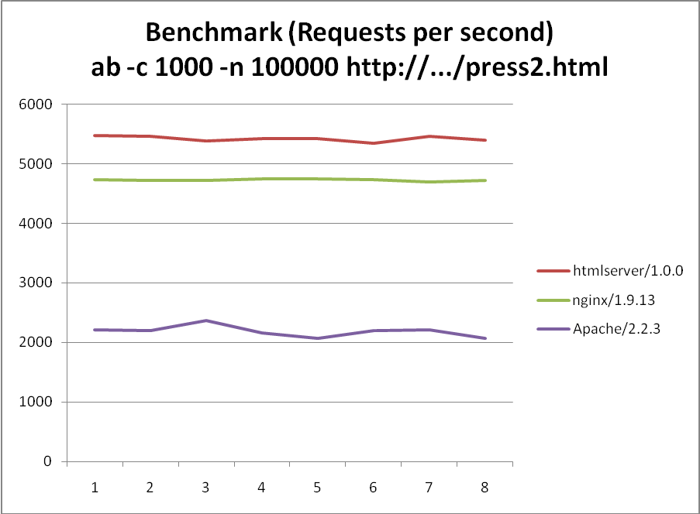
方案B：
ROUND | htmlserver/1.0.0 | nginx/1.9.13 | Apache/2.2.3
1 | 23678.5 | 4689.11 | 2337.84
2 | 23840.37 | 4733.28 | 2327.54
3 | 20989.13 | 4649.61 | 2328.36
4 | 21585.88 | 4434.38 | 2327.78
5 | 22030.33 | 4710.11 | 2357.61
6 | 23646.51 | 4601.01 | 2350.02
7 | 23414.56 | 4435.19 | 2332.41
8 | 22274.86 | 4436.41 | 2323.57
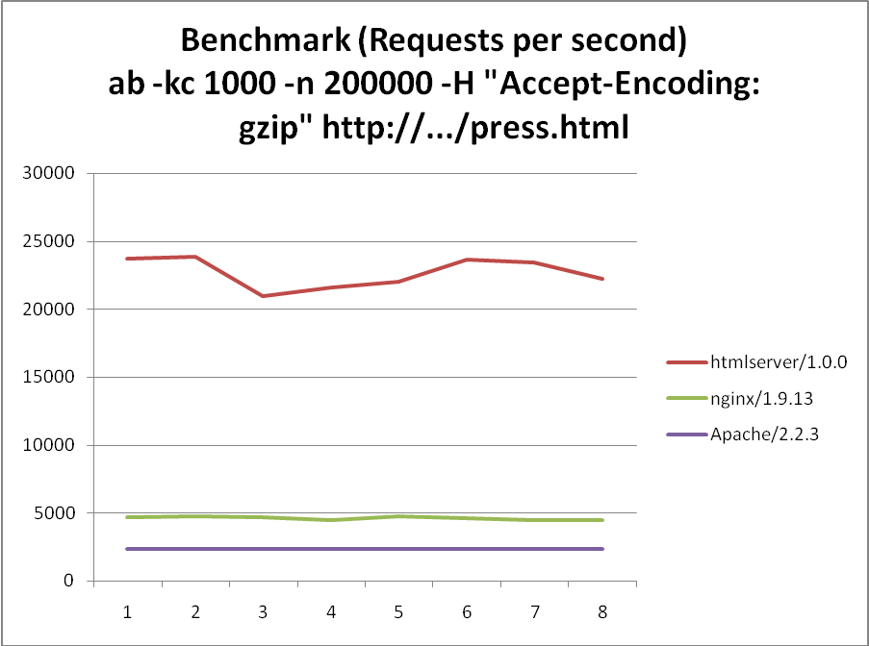
结论：
在未启用Keep-Alive、小文件的场景下，htmlserver比nginx大约快了15%；
在开启Keep-Alive、中型文件（约4.3KB）、开启gzip压缩的场景下，htmlserver比nginx足足快了5倍，秒杀目前世界上号称最快的nginx！^_^
（现代浏览器一般都开启Keep-Alive，4.3KB也算是普遍的网页大小）

