VULNERABILITY ASSESSMENT &
PENETRATION TESTING REPORT

Session S07 | Target: Metasploitable 2 | Toolchain: Kali Linux, Nmap, Metasploit Framework, Greenbone GVM/OpenVAS

Prepared By | Zahid Ullah (Cohort 02-Weekend-ISB)
Role | Junior Penetration Tester
Target Host | Metasploitable 2 Enterprise Testbed (10.50.20.30/24)
Assessing Host | Kali Linux Rolling (10.50.20.10/24)
Engagement Window | 6–7 November 2026 (Session S07)
Engagement Type | Grey-Box Internal Security Assessment
Lead Instructor | Waseem Abbas Khan:Senior Cybersecurity Specialist, CEI Master Trainer
Program | Atomcamp & Pakistan Software Export Board (PSEB)
Legal Authorization | Host-only, air-gapped virtual lab network; written course authorization. PECA 2016 compliant.
Classification | RESTRICTED / HIGH CONFIDENTIALITY :Student Deliverable
Repository | github.com/hckr-zahid/pseb-deploy-bootcamp :/s07-VAPT

LEGAL & ETHICAL NOTICE All activity described in this report was carried out solely against an isolated, host-only laboratory network built for this course, under explicit written authorization from the instructor and program. No production system, third-party asset, or system outside the authorized scope was accessed or tested. Testing a system without prior, explicit authorization is a criminal offence under the Prevention of Electronic Crimes Act (PECA) 2016 and comparable international legislation.

Table of Contents
Table of Contents 2
1. Summary 3
Key Metrics 3
Primary Business Impact 4
Scope and Limitations 4
2. Methodology 4
3. Host Discovery and Network Isolation Verification 4
4. Active Service Enumeration & Attack Surface Mapping 5
5. Automated Vulnerability Management (Greenbone GVM / OpenVAS) 10
5.1 Installation and Verification 10
5.2 Feed Synchronization and Scan Readiness 12
5.3 Automated Scan Execution and Results 14
5.4 GVM vs. Manual Penetration Testing :Comparative Analysis (20% Requirement) 17
6. Detailed Findings & Controlled Exploitation Proofs 20
Finding 01: Backdoor Command Execution in vsftpd 2.3.4 (CVE-2011-2523) 20
Finding 02: Weak Default Credentials Leading to Unrestricted Sudo Root Takeover 21
Finding 03: Unauthenticated Direct Root Shell Listener on Port 1524 23
Finding 04: Samba 3.0.20 usermap_script Remote Command Execution (CVE-2007-2447) 24
7. Metasploit Exploitation Walkthrough (Command-by-Command) 25
7.1 vsftpd 2.3.4 Backdoor Exploitation (Finding 01) 25
7.2 Samba usermap_script Exploitation (Finding 04) 27
8. Post-Exploitation Demonstration & Operational Discipline 28
8.1 Sensitive Data Exposure (Confidentiality Impact) 28
8.2 Persistence Staging (Demonstrating Maintained Access) 28
8.3 Clean-Up Discipline 28
9. Prioritized Remediation Roadmap 30
10. Engagement Status & Next Steps 31
10.1 Work Completed 31
10.2 Outstanding / Scheduled Next Steps 31
10.3 Repository & Evidence 31

1. Summary
Between 6–7 November 2026, the assessor conducted an authorized grey-box Vulnerability Assessment and Penetration Testing (VA/PT) engagement against a single target host, 10.50.20.30, within an isolated host-only laboratory network. The objective was:
- Enumerate the exposed attack surface and correlate it against known vulnerability signatures using Greenbone Vulnerability Management (GVM/OpenVAS).
- Independently validate exploitability through manual, controlled proof-of-concept exploitation using the Metasploit Framework and native Linux tooling.
- Translation of both result sets into a prioritized, actionable remediation roadmap.
The engagement confirmed that the target exposes a critical, multi-vector attack surface consistent with a deliberately vulnerable training image. Four findings were fully weaponized and proven with root-level proof of concept, three of them rated Critical (CVSS v3.1 9.8) and one High (CVSS v3.1 8.1). Exploitation chains required no prior credentials, no user interaction, and no evasion of any defensive control indicating the host, as configured, provides essentially unrestricted compromise to any network adjacent-attacker.
The automated phase has since been completed and corroborates these results. After feed synchronization finished, a GVM/OpenVAS scan of 10.50.20.30 ran to completion on 7 November 2026 and returned 63 high-confidence findings (11 Critical, 7 High, 39 Medium, 6 Low) with a composite severity of 10.0 (Critical). Section 5.4 shows where automated and manual results agree (the vsftpd backdoor and the port 1524 bindshell), where they diverge (the Samba flaw and default credential chain were under-rated by the scanner), and which additional Critical exposures GVM reported that were not weaponized.

Key Metrics
Metric | Result | Significance
Findings fully validated with PoC | 4 | Covers four independent attack vectors
Critical-severity findings (CVSS ≥ 9.0) | 3 of 4 | Unauthenticated RCE achievable on each
High-severity findings | 1 of 4 | Credentialed, trivially escalates to root
Root shells obtained | 4 independent paths | vsftpd backdoor, Samba RCE, raw bindshell, SSH+sudo
Sensitive data exposure confirmed | /etc/shadow hash dump | Full offline credential-cracking exposure
Automated GVM scan (QoD ≥ 70%) | 63 findings: 11 Critical, 7 High, 39 Medium, 6 Low | Composite severity 10.0 (Critical) across 15 ports; 529 raw results before filtering
GVM rating vs. manual proof | 2 of 4 findings agree | Samba and default credentials under-rated by GVM
Critical exposure found by GVM only | TWiki, dRuby, distccd, rexec | Carried into roadmap (Section 9)

Primary Business Impact
An unauthenticated, network-adjacent attacker can obtain immediate, unrestricted root command execution on the target through at least three independent vectors, extract every password hash on the host, demonstrate durable persistence, and pivot toward the exposed database and messaging services all without defeating any access control, encountering any logging countermeasure, or requiring advance reconnaissance beyond a standard port scan.

Scope and Limitations
This assessment was limited to the single host 10.50.20.30 on an isolated host-only network segment, over a fixed two-day engagement window. Testing was grey-box: the assessor was given target scope and general environment context but no pre-shared credentials. The automated GVM/OpenVAS scan was executed once vulnerability-feed synchronization had completed; it is reported in Section 5.3 and compared against the manual results in Section 5.4. Known limitations are:
(1) A single scan run is reported and reviewed at the default 70% QoD threshold, so the 466 lower-confidence results (of 529) are excluded from the severity counts.
(2) Only four findings were carried to full proof-of-concept exploitation, so the additional Critical results reported by GVM were not manually validated.
(3) GVM severities are taken from its vulnerability feed and may differ from the CVSS v3.1 scores assigned to the manually validated findings.

2. Methodology
The engagement followed a standard four-phase penetration testing methodology aligned with PTES (Penetration Testing Execution Standard) and OWASP testing guidance, adapted for a single-host lab scope:
- Reconnaissance & Network Isolation Verification
Confirm host reachability and confirm the test network has no route to production or external networks before any intrusive activity begins.
- Active Enumeration:
Full TCP port, service, and OS fingerprinting with Nmap to establish the attack surface.
- Vulnerability Analysis:
Automated correlation of service banners/versions against known-vulnerability signatures using Greenbone GVM/OpenVAS, cross-checked against manual research (NVD/CVE, Exploit-DB, Metasploit module database).
- Exploitation & Post-Exploitation: Controlled, in-scope proof-of-concept exploitation of confirmed vulnerabilities using the Metasploit Framework and native OS tooling, followed by a bounded demonstration of impact (data access, persistence, cleanup) consistent with a professional, non-destructive testing standard.
Severity throughout this report is scored with CVSS v3.1 base metrics, and weaknesses are classified against MITRE CWE identifiers. All commands, tool output, and figures in this report were captured live during the engagement window stated on the cover page.

3. Host Discovery and Network Isolation Verification
Before any intrusive testing, the lab network was confirmed to be a closed, host-only segment with no route to production networks or the internet a standard safety control for any offensive-security exercise. The assessing host (10.50.20.10) was confirmed to reach the target (10.50.20.30) over the local segment, while an outbound probe to a public resolver (8.8.8.8) was confirmed to fail completely, evidencing zero external egress.
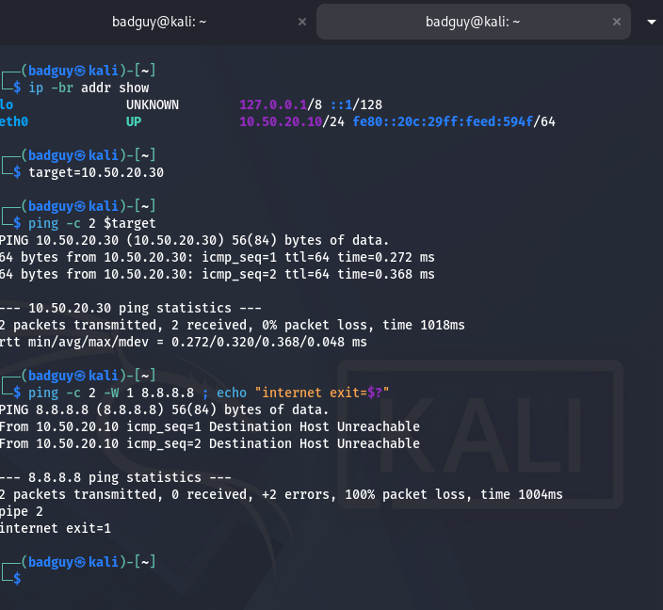
Figure 3.1 Kali Linux interface configuration, successful target reachability check, and confirmed host-only isolation (100% loss / exit 1 to an external address).

Interpretation
This step is a prerequisite control, not a finding: it establishes that every subsequent exploitation step in this report occurred entirely within an authorized, air-gapped laboratory boundary, and that no traffic could have reached a system outside the defined scope.

4. Active Service Enumeration & Attack Surface Mapping
A full TCP connect/SYN scan with service/version detection, default NSE scripts, and OS fingerprinting was executed against the target:
sudo nmap -sV -sC -O -T4 10.50.20.30 -oN nmap_services.txt
The scan returned 20 open TCP ports, several of which are individually sufficient to compromise the host outright. The table below summarizes the attack-surface-relevant results;
Full raw output is captured in Figures 4.1–4.3.
Port | Service | Version / Banner | Notable Risk Indicator
21/tcp | ftp | vsftpd 2.3.4 | Anonymous login allowed; known backdoored build (Finding 1)
22/tcp | ssh | OpenSSH 4.7p1 Debian | Legacy version; weak/default credentials (Finding 2)
23/tcp | telnet | Linux telnetd | Cleartext authentication protocol
25/tcp | smtp | Postfix smtpd | Open relay risk / user enumeration via VRFY
139,445/tcp | netbios-ssn | Samba smbd 3.0.20-Debian | Vulnerable usermap_script RCE (Finding 4)
512,513,514/tcp | exec/login/shell | Netkit rsh/rexec | Cleartext r-services, trivially abused
1524/tcp | bindshell | Metasploitable root shell | Unauthenticated raw root shell (Finding 3)
3306/tcp | mysql | MySQL 5.0.51a-3ubuntu5 | Legacy, multiple known CVEs
5432/tcp | postgresql | PostgreSQL 8.3 | Legacy, default postgres account risk
5900/tcp | vnc | VNC protocol 3.3 | Weak authentication scheme
6667/tcp | irc | UnrealIRCd 3.2.8.1 | Historically backdoored IRCd build
8180/tcp | http | Apache Tomcat/Coyote 1.1 | Default/weak manager credentials risk
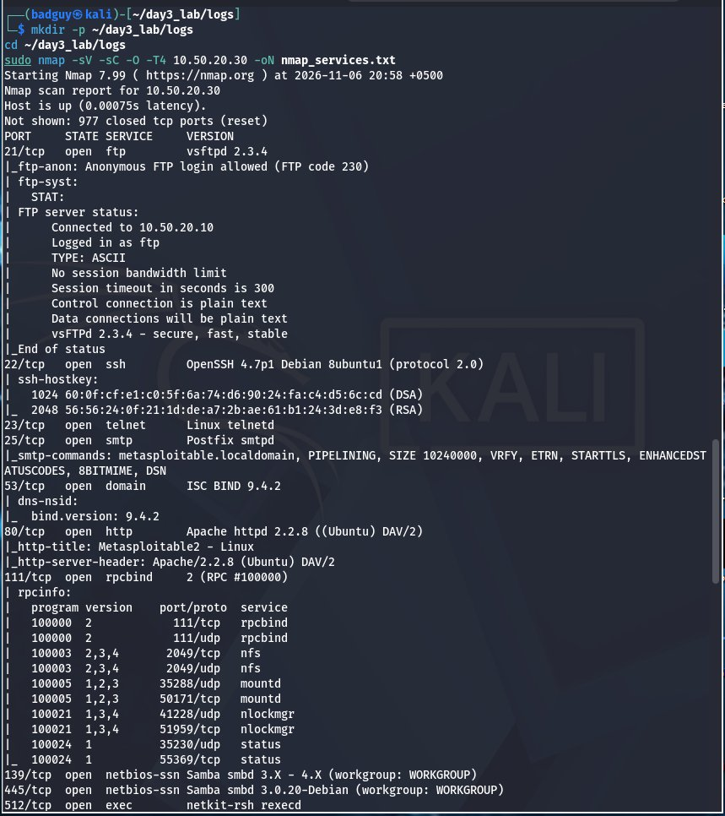
Figure 4.1 Nmap scan output (part 1) ports 21 (vsftpd 2.3.4, anonymous FTP enabled), 22 (OpenSSH 4.7p1), 23, 25, 53, 80, 111, 139/445.
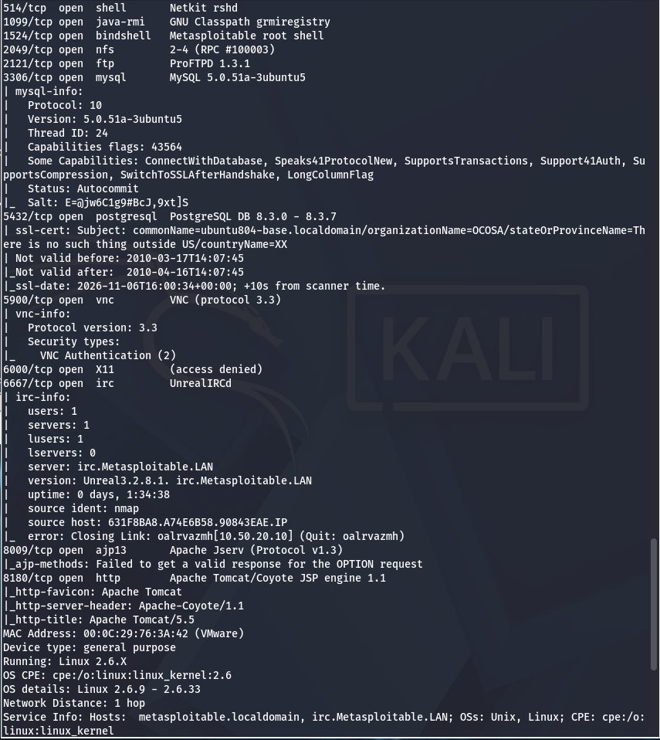
Figure 4.2 Nmap scan output (part 2) ports 512–524, 1099, 1524 (bindshell, flagged by Nmap itself as "Metasploitable root shell"), 2049, 2121, 3306, 5432, 5900, 6000, 6667, 8009, 8180.
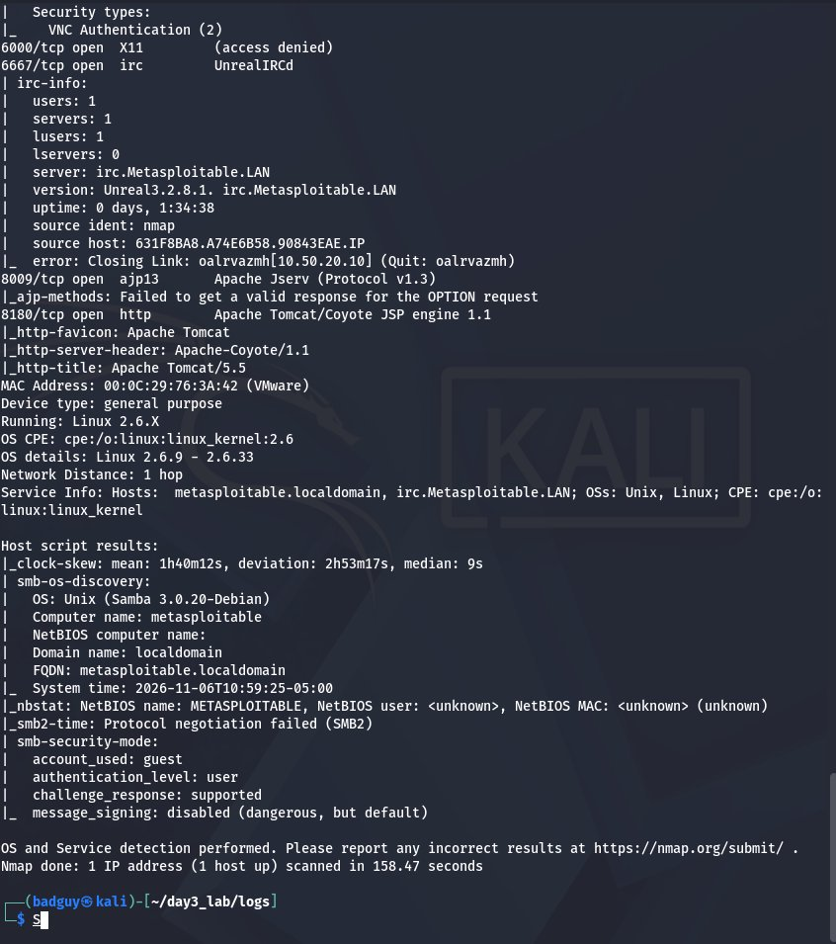
Figure 4.3 Nmap OS detection, service summary, and SMB host-script results confirming hostname metasploitable, Samba 3.0.20-Debian, SMB signing disabled, and Linux kernel 2.6.9–2.6.33.

Interpretation
Three results independently stand out as critical-severity indicators even before exploitation: Nmap's own service-fingerprint database labels port 1524 as "Metasploitable root shell"; the vsftpd banner on port 21 corresponds to a publicly documented, intentionally backdoored release; and SMB message signing is reported as disabled, which both weakens integrity guarantees on the protocol and is consistent with the legacy Samba configuration exploited in Finding 4. This breadth of exposure; 20 open services, several unauthenticated and several carrying known-CVE software defines an attack surface more consistent with a deliberately vulnerable training image than a production host, and framed the prioritization of the manual testing phase that followed.

5. Automated Vulnerability Management (Greenbone GVM / OpenVAS)
Greenbone Vulnerability Management (GVM / OpenVAS, scanner v28.3.0 as reported by the web UI) was deployed on the Kali assessment host to provide independent, automated vulnerability correlation against the enumerated attack surface.

5.1 Installation and Verification
Initial setup surfaced a PostgreSQL collation-version mismatch on the template1 database, which blocks gvmd database initialization. This was remediated by refreshing the database's collation version metadata, after which the gvmd database was created and the administrative account provisioned. All nine automated checks performed by gvm-check-setup subsequently passed, confirming a healthy scanner, manager, certificate chain, and an indexed Network Vulnerability Test (NVT) library of 95,107 signatures.
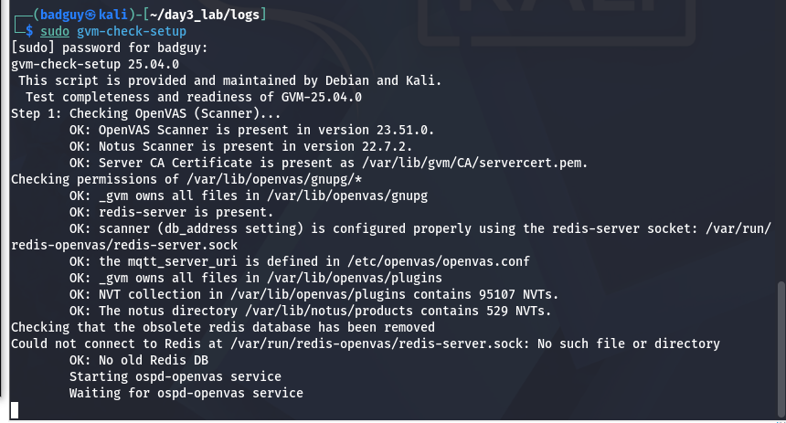
Figure 5.1 Initial gvm-check-setup run identifying the PostgreSQL collation-version dependency that required remediation before setup could complete.
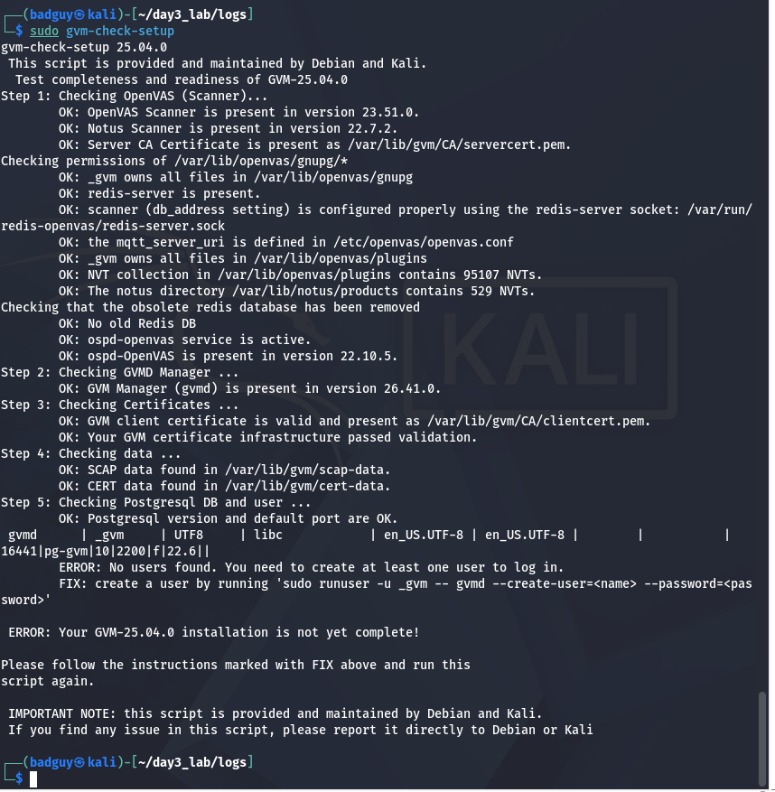
Figure 5.2 gvm-check-setup re-run confirming all nine validation steps passed: scanner present, GVM Manager (gvmd) present, certificate chain valid, SCAP/CERT data present, and PostgreSQL/user configuration OK.
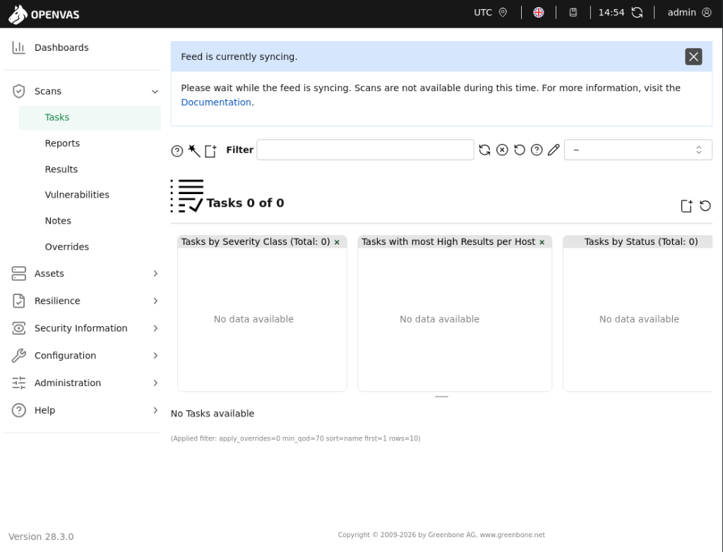
Figure 5.3 Greenbone Security Assistant web console reachable at https://127.0.0.1:9392, authenticated as the admin account provisioned above.
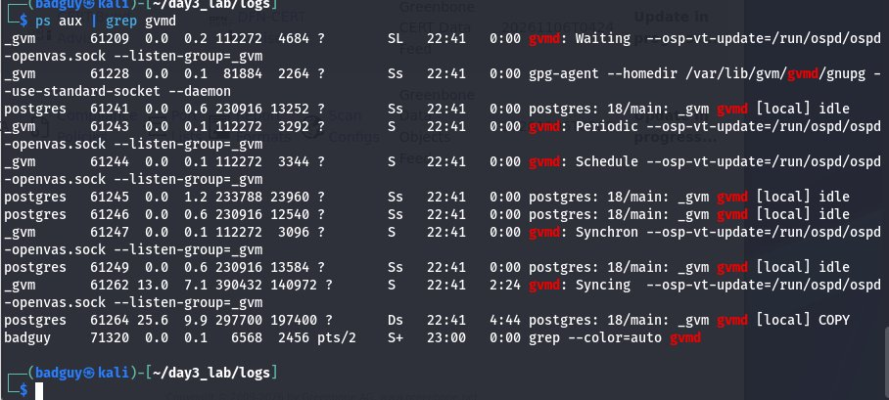
Figure 5.4 Backend process monitoring confirming active gvmd synchronization and PostgreSQL COPY operations while vulnerability-definition data is ingested.

5.2 Feed Synchronization and Scan Readiness
At the point the manual exploitation phase concluded, the GVM feed dashboard (Figure 5.5) showed the core NVT (Network Vulnerability Test) feed as Current, while the supplementary SCAP (CVE/CPE) and CERT advisory feeds were still synchronizing and no scan task had yet been created. The scan was deliberately deferred until synchronization completed so that results would be enriched with full CVE and advisory data. Synchronization subsequently finished: as shown in Figure 5.6, all four feed classes; NVT, SCAP, CERT and GVMD_DATA report a status of Current (feed versions dated 6 November 2026), and the scan engine was cleared to run a full task against the in-scope target.
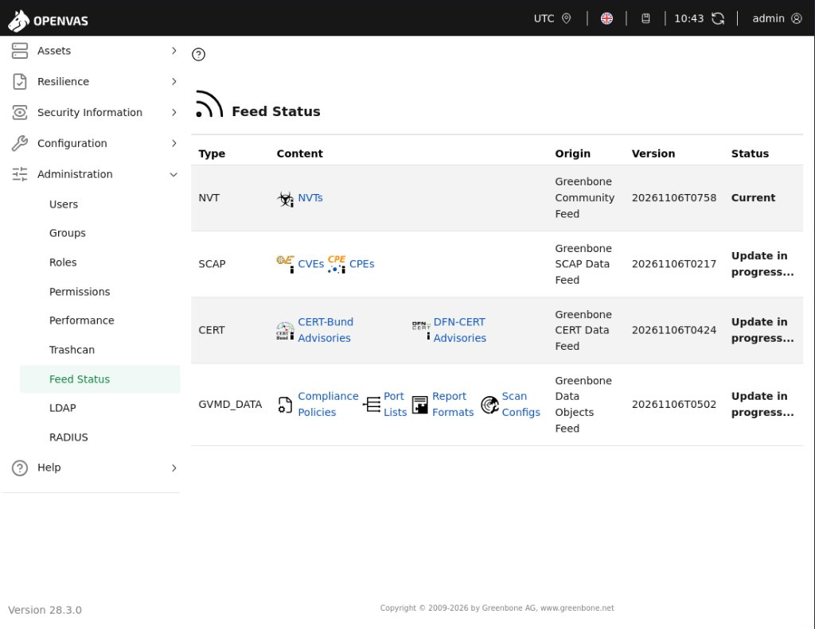
Figure 5.5 GVM Feed Status console (earlier capture): NVT feed Current (95,000+ tests available to the scan engine); SCAP and CERT advisory feeds still synchronizing.
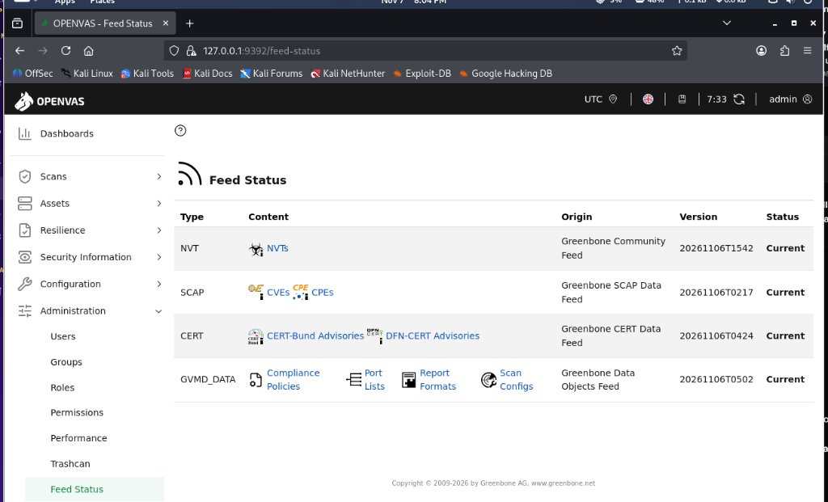
Figure 5.6 GVM Feed Status console after synchronization: NVT, SCAP, CERT and GVMD_DATA feeds all report Current.

5.3 Automated Scan Execution and Results
With all feeds current, an immediate scan task named “Immediate scan of IP 10.50.20.30” was created and executed against the single in-scope host. The task reached the Done status and produced one report (Figure 5.7). According to the report metadata, the scan ran from 3:16 PM to 4:05 PM UTC on 7 November 2026 (approximately 49 minutes) and returned a composite severity of 10.0 (Critical).
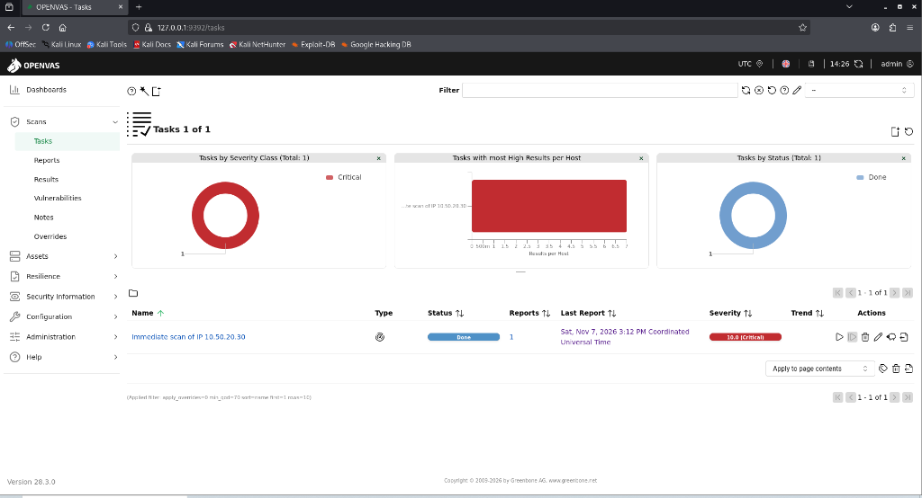
Figure 5.7 GVM Tasks view: scan task against 10.50.20.30 completed (Status: Done) with a Critical (10.0) severity rating.
The table below summarizes the scan outcome.
Metric | Result
Target | 10.50.20.30 (single in-scope host)
Task status | Done (one report generated)
Scan window | 7 November 2026, 3:16 PM – 4:05 PM UTC (≈ 49 minutes)
Raw results | 529
Results at QoD ≥ 70% | 63
Severity distribution (QoD ≥ 70%) | 11 Critical · 7 High · 39 Medium · 6 Low · 0 Log · 0 False Positive
Ports with findings | 15 of 23 detected ports
Applications / operating systems detected | 18 applications · 1 operating system
Composite severity | 10.0 (Critical)

The Results view (Figure 5.8) lists the 63 high-confidence findings. The five highest-ranked results are all rated Critical (10.0): TWiki < 4.2.4 multiple XSS / command execution vulnerabilities (80/tcp), Distributed Ruby (dRuby/DRb) multiple RCE vulnerabilities (8787/tcp), Operating System End-of-Life detection, Possible Backdoor: Ingreslock (1524/tcp) and the rexec service (512/tcp). The Hosts view (Figure 5.9) breaks the 63 results down by severity class.
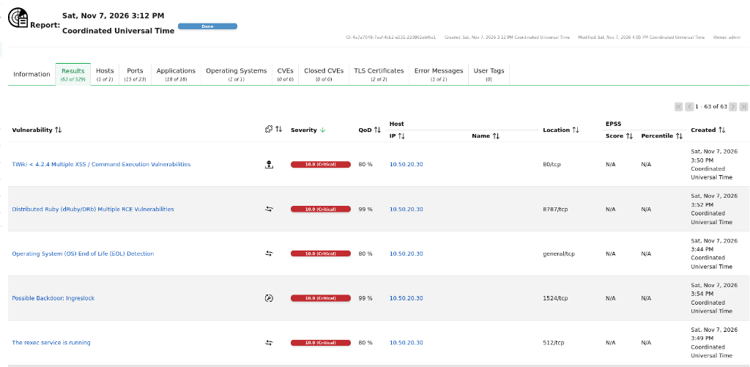
Figure 5.8 GVM Results view: 63 of 529 results at QoD ≥ 70%, sorted by severity; the top-ranked results are all Critical (10.0).
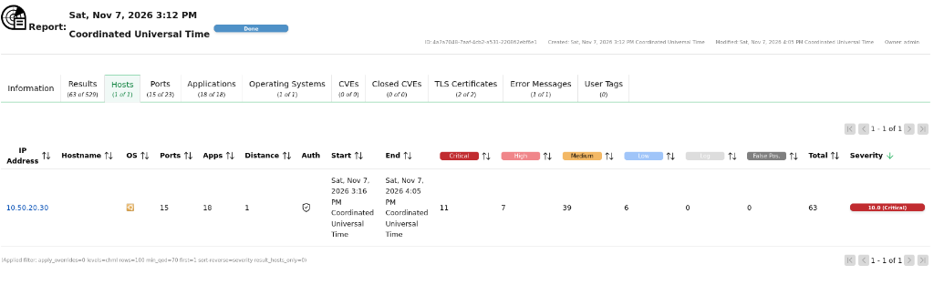
Figure 5.9 GVM Hosts view for 10.50.20.30: 11 Critical, 7 High, 39 Medium and 6 Low results (63 total) across 15 ports and 18 applications; overall severity 10.0.
Port-level severity (Figure 5.10) is the most useful bridge to the manual testing, because it shows the worst result GVM attributed to each service. The table below cross-references those ratings with the manually validated findings.
Port | Service | GVM Severity | Related Manual Finding
22/tcp | SSH | 5.3 (Medium) | Finding 02 (default credentials / sudo root)
25/tcp | SMTP | 6.0 (Medium) | Not weaponized
445/tcp | SMB (Samba) | 6.0 (Medium) | Finding 04 (usermap_script RCE)
2121/tcp | FTP (alternate port) | 7.5 (High) | Not weaponized
6697/tcp | IRC over TLS | 8.1 (High) | Not weaponized
5432/tcp | PostgreSQL | 9.0 (Critical) | Not weaponized
5900/tcp | VNC | 9.0 (Critical) | Not weaponized
3632/tcp | distccd | 9.3 (Critical) | Not weaponized
21/tcp | FTP (vsftpd 2.3.4) | 9.8 (Critical) | Finding 01 (vsftpd backdoor)
6200/tcp | vsftpd backdoor listener | 9.8 (Critical) | Finding 01 (backdoor shell port)
8009/tcp | Apache JServ (AJP) | 9.8 (Critical) | Not weaponized
80/tcp | HTTP (Apache / TWiki) | 10.0 (Critical) | Not weaponized
512/tcp | rexec | 10.0 (Critical) | Not weaponized (cleartext r-service, Section 4)
1524/tcp | Ingreslock bindshell | 10.0 (Critical) | Finding 03 (root bindshell)
8787/tcp | dRuby / DRb | 10.0 (Critical) | Not weaponized
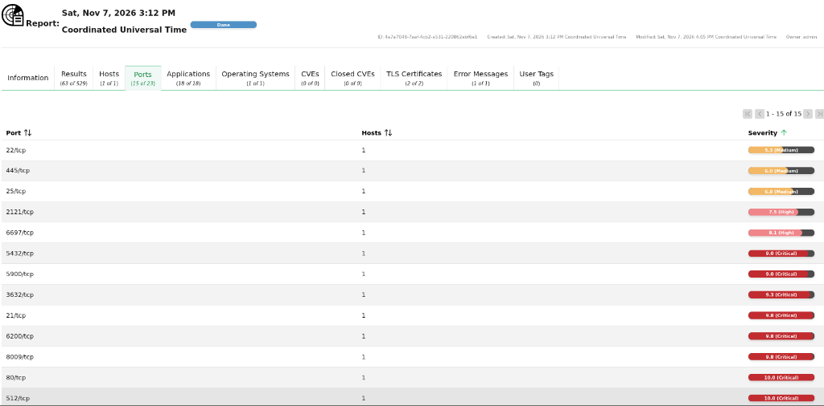
Figure 5.10 GVM Ports view: per-port severity for 10.50.20.30, from 5.3 (Medium) on 22/tcp up to 10.0 (Critical) on 80/tcp and 512/tcp (list cropped).

Interpretation
The automated scan independently confirms the overall posture established manually: a composite 10.0 (Critical) rating, with Critical-rated results on ports that correspond directly to Findings 01 and 03. Two further observations matter for prioritization. First, QoD filtering is essential only 63 of 529 raw results (about 12%) cleared the 70% threshold, which illustrates how unfiltered scanner output inflates the apparent workload. Second, GVM surfaced several Critical exposures (TWiki, dRuby, distccd, rexec, VNC and an end-of-life operating system) that fell outside the four-finding proof-of-concept scope; these are carried into the remediation roadmap in Section 9 rather than discarded.

5.4 A Comparative Analysis GVM vs. Manual Penetration Testing
The table below compares, for each confirmed finding, what the completed GVM scan actually reported (Section 5.3) against what manual exploitation proved, and explains the root cause of any agreement or divergence. This is the core deliverable for the assignment’s comparative-analysis requirement.
Finding | GVM / Automated Result | Manual Penetration Test | Agreement / Divergence & Root Cause
vsftpd 2.3.4 backdoor (CVE-2011-2523) | Detected. 21/tcp and the backdoor listener on 6200/tcp are both rated 9.8 (Critical). | Weaponized with Metasploit; interactive root Meterpreter session obtained and verified (getuid, sysinfo). | Agree on presence and severity. GVM’s check is safe and non-intrusive; only manual testing proves that live, interactive root code execution actually results.
Samba usermap_script RCE (CVE-2007-2447) | Under-rated. 445/tcp carries a maximum rating of 6.0 (Medium); no Critical result is attributed to the Samba service. | Exploited via exploit/multi/samba/usermap_script; interactive root command shell obtained over port 445. | Major divergence (severity). A 6.0 rating is consistent with the legacy CVSS v2 score historically published for CVE-2007-2447, which understates a flaw that gives unauthenticated root execution (9.8 under CVSS v3.1). Triage on scanner severity alone would have deprioritized the easiest-to-weaponize SMB flaw; the exported report should confirm which result produced the 6.0 rating.
Default credentials msfadmin:msfadmin + unrestricted sudo | Not reflected. 22/tcp carries a maximum rating of 5.3 (Medium); the credential-and-sudo escalation chain does not appear in the port-level severity. | Authenticated via SSH with the default credential pair; sudo -l confirmed (ALL) ALL; sudo su yielded immediate root. | Major divergence. Scanners intentionally do not guess credentials by default (lockout/DoS risk) and cannot evaluate post-authentication sudoers policy, so a full root takeover registers only as a Medium-rated SSH exposure.
Port 1524 raw root bindshell | Detected. “Possible Backdoor: Ingreslock” is rated 10.0 (Critical) at 99% QoD on 1524/tcp. | Connected directly with netcat; dropped immediately into an interactive root shell with zero authentication. | Agree on presence and severity. A service-signature match gives a high-confidence detection, but the “Possible” qualifier is resolved only by direct interaction, which proved a live, unauthenticated root shell.
Apache 2.2.8 / Tomcat 5.5 cumulative CVEs | High alert volume: 529 raw results, of which only 63 met the 70% QoD threshold; web-tier ports 80/tcp (10.0) and 8009/tcp (9.8) are rated Critical. | Triaged manually; the specific vulnerable code paths were not reachable or not enabled in this configuration. | Partial divergence (noise). Version-based NVTs over-report because a version string alone does not confirm a vulnerable module is present or exposed; the 466 results below the QoD threshold are the main source of alert fatigue. Manual triage is required to avoid wasting remediation effort on non-issues.
GVM-only findings (TWiki, dRuby, distccd, rexec, VNC, end-of-life OS) | Reported Critical (9.0–10.0) on ports 80, 8787, 3632, 512 and 5900, plus OS end-of-life detection. | Not weaponized in this engagement (outside the four-finding proof-of-concept scope). | Complementary coverage. Automated breadth surfaced exposures the manual phase did not prioritize; they are carried into the remediation roadmap (Section 9) and flagged for follow-up validation.

5.5 Conclusion of the Comparison
Across the six rows, the completed scan is consistent with the known strengths and blind spots of signature-based automated scanning. GVM reliably detected and correctly rated the two most obvious backdoors (vsftpd and the port 1524 bindshell), at low operational risk and without valid credentials, and its breadth surfaced further Critical exposures that the manual phase did not pursue. However, it materially under-rated two of the four manually validated compromise paths the Samba usermap_script flaw (6.0 Medium against a proven 9.8 root RCE) and the default-credential/sudo chain (5.3 Medium against a proven root takeover) because it is structurally unable to prove exploitability or to evaluate post-authentication privilege configuration. It also produced high alert volume (529 raw results, 63 high-confidence) that requires QoD filtering and manual triage. Manual penetration testing is therefore the only method that converts a signature match into a proven, business-relevant risk statement, while automated scanning provides the breadth that manual testing cannot economically cover which is why both disciplines are required together rather than either in isolation.

6. Detailed Findings & Controlled Exploitation Proofs
This section documents all four findings carried to full proof-of-concept exploitation, in the standard format of asset, severity, weakness classification, description, impact, and evidence. Finding severity is independently scored using CVSS v3.1 base metrics.

Finding 01: Backdoor Command Execution in vsftpd 2.3.4 (CVE-2011-2523)
SEVERITY CRITICAL CVSS v3.1 9.8 CVSS:3.1/AV:N/AC:L/PR:N/UI:N/S:U/C:H/I:H/A:H
Affected Asset | 10.50.20.30 port 21/tcp (vsftpd 2.3.4)
Weakness Class | CWE-78 Improper Neutralization of Special Elements used in an OS Command (OS Command Injection)
Metasploit Module | exploit/unix/ftp/vsftpd_234_backdoor
Authentication Required | None

Description
In July 2011 the official source distribution of vsftpd 2.3.4 was compromised and republished with a backdoor by an unauthorized third party. A client that supplies a username containing the sequence ":)" during the FTP login exchange triggers the planted backdoor code, which opens an unauthenticated listening shell on TCP port 6200 of the target. The affected archive remained available for a window of time before the compromise was detected, and the backdoored binary is still present by design in the Metasploitable 2 training image used in this lab.

Proof of Concept & Impact
The corresponding Metasploit module was configured against the target and a listener on the assessment host, then executed. The module's automatic vulnerability check first confirmed the vulnerable banner, then triggered the backdoor; a Meterpreter session opened immediately. Session identity was independently verified with getuid, id, whoami, and sysinfo, all confirming full root (uid=0) access with no authentication step of any kind.
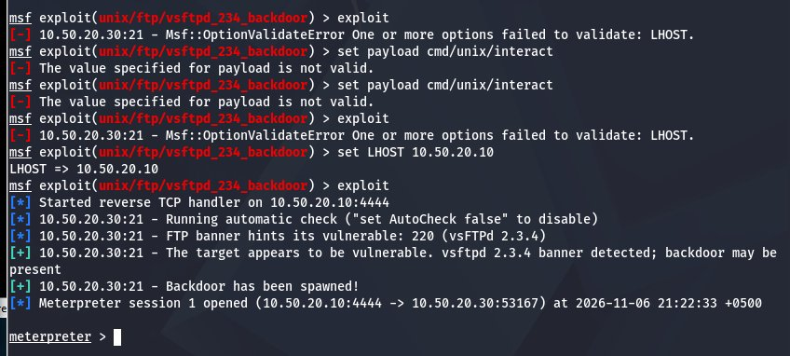
Figure 6.1 Metasploit vsftpd_234_backdoor module execution: automatic vulnerability confirmation ("backdoor may be present") followed by successful trigger and establishment of Meterpreter Session 1.
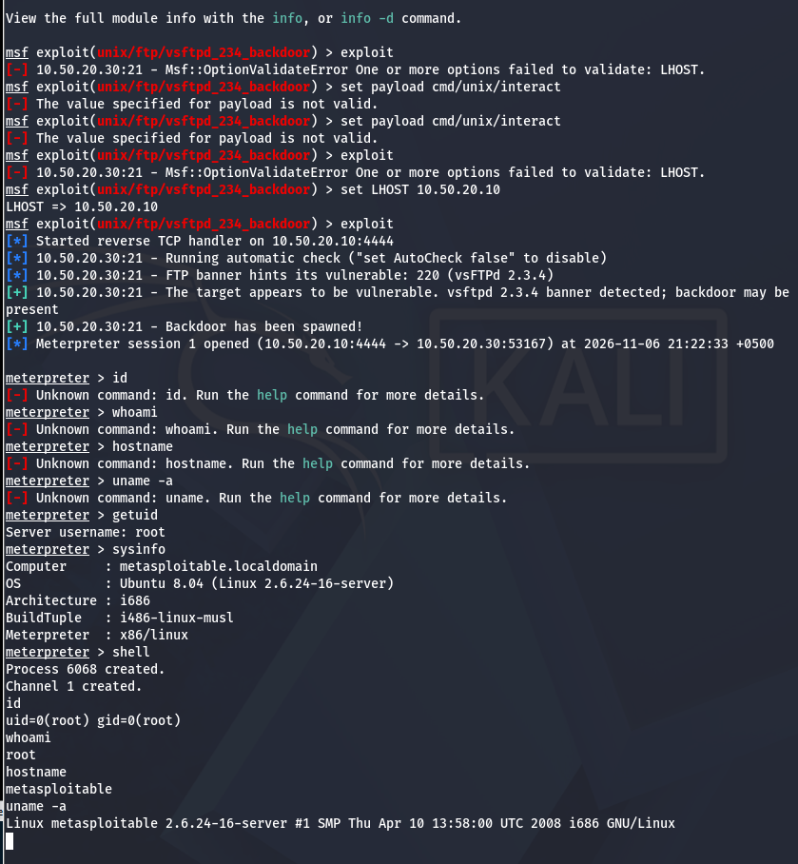
Figure 6.2 Post-session verification inside Meterpreter: getuid returns "Server username: root"; a dropped interactive shell confirms uid=0(root) gid=0(root) via id, root via whoami, and kernel/OS details via uname -a.

Business Impact
This vector grants complete, unauthenticated compromise of the host in a single step, requiring only network reachability to port 21. Any attacker capable of reaching the FTP service with no credentials, no reconnaissance beyond a port scan, and no social engineering obtains root.

Finding 02: Weak Default Credentials Leading to Unrestricted Sudo Root Takeover
SEVERITY HIGH CVSS v3.1 8.1 CVSS:3.1/AV:N/AC:H/PR:N/UI:N/S:U/C:H/I:H/A:H
Affected Services | 22/tcp (SSH), 21/tcp (FTP), 3306/tcp (MySQL) share the same default credential pair
Weakness Class | CWE-1392 Use of Default Credentials; CWE-250 Execution with Unnecessary Privileges
Credentials Used | msfadmin : msfadmin (documented default account on the Metasploitable 2 image)
Authentication Required | Valid (but default/guessable) credentials

Description
The account msfadmin authenticates successfully over SSH using its well-documented default password. Inspecting the account's sudo policy with sudo -l revealed an unrestricted entry (ALL) ALL meaning the account may run any command as any user, including root, without a dedicated exploit or privilege-escalation technique of any kind.

Proof of Concept & Impact
An SSH session was established using the default credential pair. Once authenticated, sudo -l enumerated the account's privileges and confirmed the unrestricted (ALL) ALL grant. Re-authenticating with the account's own password via sudo su transitioned the session directly to root, confirmed by id returning uid=0(root) gid=0(root) groups=0(root). 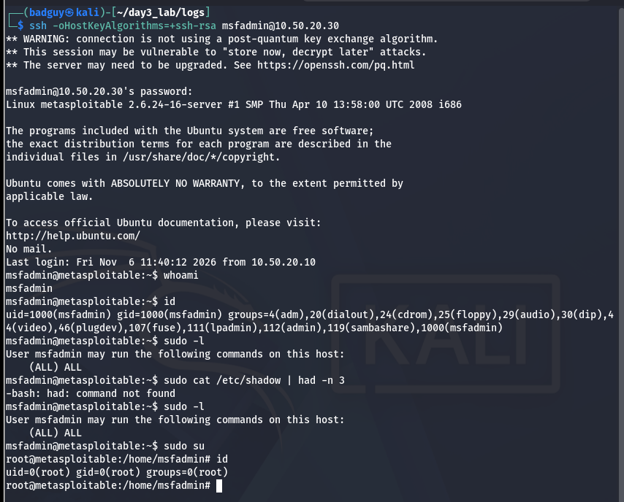
Figure 6.3 SSH authentication as msfadmin using the default credential pair, followed by whoami, id, sudo -l (showing the unrestricted (ALL) ALL grant), and sudo su escalating the session to uid=0(root).

Business Impact
This finding demonstrates that credential hygiene and privilege-policy review are just as critical as patch management: no software vulnerability was exploited here at all only a documented default password and an overly permissive sudoers entry, both configuration failures rather than code defects, and both fully preventable without any software update.

Finding 03: Unauthenticated Direct Root Shell Listener on Port 1524
SEVERITY CRITICAL CVSS v3.1 9.8 CVSS:3.1/AV:N/AC:L/PR:N/UI:N/S:U/C:H/I:H/A:H
Affected Service | 10.50.20.30 port 1524/tcp (identified by Nmap's own fingerprint DB as "Metasploitable root shell")
Weakness Class | CWE-287 Improper Authentication; CWE-1188 Initialization of a Resource with an Insecure Default
Tooling Used | netcat (nc)
Authentication Required | None

Description
Port 1524 hosts a raw, unauthenticated shell directly attached to /bin/sh running as root a leftover debugging/backdoor listener present by design in the training image, with no login prompt, credential check, or protocol handshake of any kind in front of it.

Proof of Concept & Impact
A raw TCP connection to port 1524 was opened with netcat. The connection dropped directly into an interactive shell; id and whoami both confirmed the shell was already running as root, with no authentication step having occurred at any point.
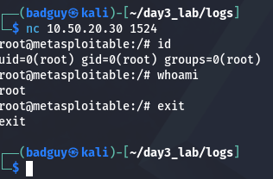
Figure 6.4 Raw netcat connection to 10.50.20.30:1524 landing immediately in an interactive shell; id and whoami confirm uid=0(root) with zero authentication.

Business Impact
This is the most severe and simplest finding in the engagement: no exploit framework, no payload crafting, and no vulnerability research were required only a standard TCP client. Any port scan that enumerates 1524 as open effectively discloses full root compromise.

Finding 04: Samba 3.0.20 usermap_script Remote Command Execution (CVE-2007-2447)
SEVERITY CRITICAL CVSS v3.1 9.8 CVSS:3.1/AV:N/AC:L/PR:N/UI:N/S:U/C:H/I:H/A:H
Affected Service | 10.50.20.30 ports 139, 445/tcp (Samba smbd 3.0.20-Debian)
Weakness Class | CWE-78 OS Command Injection
Metasploit Module | exploit/multi/samba/usermap_script
Authentication Required | None

Description
Samba versions in the 3.0.20–3.0.25rc3 range support a username map script configuration directive that passes an MS-RPC-supplied username directly to a shell without sanitizing shell metacharacters. By embedding shell metacharacters in the username field of an authentication request, an unauthenticated remote attacker can execute arbitrary commands with the privileges of the Samba daemon root, by default on this image.

Proof of Concept & Impact
The Metasploit usermap_script module was configured against the target with its default reverse command-shell payload and executed. A command-shell session opened immediately; id and whoami confirmed root-level command execution with no authentication performed.
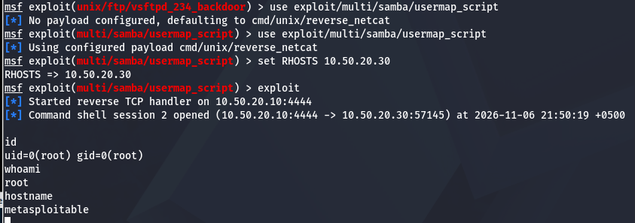
Figure 6.5 Metasploit exploit/multi/samba/usermap_script execution establishing command-shell Session 2 over port 445, with id/whoami confirming uid=0(root).

Business Impact
A second, fully independent unauthenticated root-level RCE path confirms that the host's compromise is not attributable to a single misconfigured service: at minimum two unrelated listening daemons (vsftpd and smbd) each independently grant full root takeover.

7. Metasploit Exploitation Walkthrough (Command-by-Command)
This section provides a step-by-step walkthrough of the Metasploit console session used to exploit Finding 1 (vsftpd 2.3.4 backdoor), with every command explained in turn, so the exploitation process is fully reproducible and auditable within the authorized lab scope. The same session is also where Finding 4 (Samba usermap_script) was exploited as a second module load; that portion is covered in Section 7.2.

7.1 vsftpd 2.3.4 Backdoor Exploitation (Finding 01)
Command | What It Does / Why It Was Run
use exploit/unix/ftp/vsftpd_234_backdoor | Loads the target Metasploit exploit module into the active console context. Every subsequent set/show/exploit command in the session now applies specifically to this module until a different module is loaded.
set payload cmd/unix/interact | An initial attempt to set an interactive command payload. Metasploit rejected this value ("payload is not valid") because this exploit module's payload compatibility is restricted to its own handler-driven payloads rather than a generic cmd/unix/interact stager a useful reminder that not every payload type is compatible with every module, and show payloads should be consulted when in doubt.
exploit | A first run was attempted before the required LHOST option was set, and Metasploit's own option validator correctly refused to proceed ("OptionValidateError... failed to validate: LHOST"), preventing a misconfigured exploit attempt rather than failing silently.
set LHOST 10.50.20.10 | Sets the local (assessor) host IP that the reverse handler will bind to, so the backdoor's spawned shell has an address to call back to. This is the Kali assessment host's interface address on the isolated lab segment.
exploit | Launches the module. Metasploit performs its automatic vulnerability check first ("Running automatic check"), confirms the vulnerable vsftpd 2.3.4 banner, reports the backdoor is likely present, triggers it, and a Meterpreter session opens all visible in Figure 6.1.
getuid | Once inside the Meterpreter session, queries the identity the payload is executing as at the server. Returned "Server username: root", the first direct confirmation of full root-level compromise.
sysinfo | Requests host fingerprint information from the compromised target via the Meterpreter session itself (not a shell command) hostname, OS, architecture, and the Meterpreter build in use. Confirms the target as metasploitable.localdomain running Ubuntu 8.04 on Linux 2.6.24.
shell | Upgrades the session to a native, interactive /bin/sh shell on the target, dropping out of the Meterpreter API and into ordinary Unix shell semantics for the remaining verification commands.
id | Standard Unix identity command, run inside the native shell obtained above. Returned uid=0(root) gid=0(root) an independent, OS-level confirmation (distinct from Meterpreter's own getuid) that the session holds full root privileges.
whoami / hostname / uname -a | Further standard verification commands confirming the effective user (root), the target's hostname (metasploitable), and full kernel/build string (Linux metasploitable 2.6.24-16-server, i686) establishing an unambiguous, OS-corroborated record of the compromised host's identity alongside the privilege level obtained.
Corresponding evidence for this walkthrough is Figures 6.1 and 6.2 above (the module execution/session establishment, and the subsequent identity-verification commands), reproduced together with Figure 7.1 below to keep the full console transcript in one place for grading convenience.
Figure 7.1 Full console transcript for the walkthrough above: module load attempts, payload/LHOST validation errors (and their correction), successful exploitation, and the getuid / shell / id / whoami / hostname / uname -a identity-verification sequence.

7.2 Samba usermap_script Exploitation (Finding 04)
Command | What It Does / Why It Was Run
use exploit/multi/samba/usermap_script | Switches the active module to the Samba username-map command-injection exploit. Metasploit automatically defaults the payload to cmd/unix/reverse_netcat, a lightweight payload well suited to this module's command-injection delivery mechanism.
set RHOSTS 10.50.20.30 | Sets the remote target address for this module (RHOSTS, plural form in current Metasploit releases, supports single hosts or ranges).
exploit | Launches the module. A reverse TCP handler starts on the assessment host, the crafted SMB authentication request with the injected command is sent, and a command-shell session (Session 2) opens over port 445.
id / whoami / hostname | The same identity-verification pattern as Section 7.1, run inside the new command-shell session: id confirms uid=0(root) gid=0(root), whoami returns root, and hostname confirms the target is metasploitable establishing this as a second, independent root compromise path.
Figure 7.2 Console transcript for the Samba usermap_script walkthrough: module selection, RHOSTS configuration, successful exploitation, and root-level identity confirmation.

8. Post-Exploitation Demonstration & Operational Discipline
Obtaining a shell is the start of a penetration test, not its conclusion. To demonstrate real business impact rather than a theoretical finding, impact was demonstrated across three controlled, reversible phases, each kept to the minimum necessary to prove impact and each followed immediately by cleanup consistent with a professional, non-destructive testing standard.

8.1 Sensitive Data Exposure (Confidentiality Impact)
With root access already established, the protected system credential store was read to demonstrate that an attacker at this privilege level can exfiltrate every password hash on the host, exposing all local accounts to offline dictionary and brute-force attacks regardless of individual password strength.

8.2 Persistence Staging (Demonstrating Maintained Access)
A simulated scheduled-task entry was staged to demonstrate how root-level access could be converted into durable, reconnect-capable persistence via a cron-based callback a standard technique for maintaining access after an initial exploitation vector is patched or a session is lost. The entry was staged only, never installed into the live crontab, and was removed immediately after being demonstrated.

8.3 Clean-Up Discipline
All staged test artifacts were removed immediately after demonstration, restoring the target to its pre-engagement state. No persistent backdoor, scheduled task, or planted file was left on the target at the conclusion of testing consistent with the professional and ethical obligation to leave an assessed system in the condition it was found.
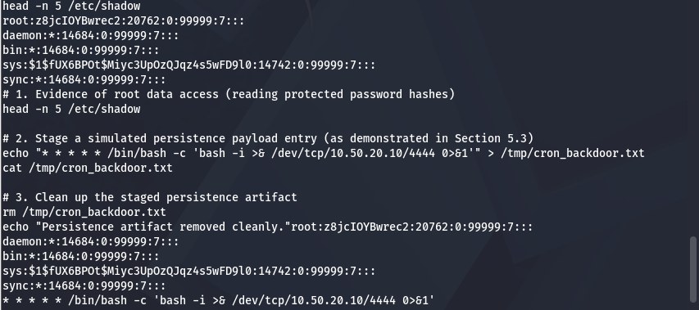
Figure 8.1 Post-exploitation sequence: (1) reading the protected /etc/shadow credential store to prove data-exfiltration impact, (2) staging a simulated cron-based persistence entry, and (3) immediately removing the staged artifact, confirmed by a clean verification message.

Interpretation
This three-step sequence converts the four technical findings in Section 6 into a concrete business-risk statement: an attacker reaching this host does not merely gain "a shell" they gain the ability to harvest every credential on the system, establish access that survives a reboot or a partial remediation, and do so without leaving any obvious trace once standard logging is not actively monitored.

9. Prioritized Remediation Roadmap
Remediation actions are grouped by priority tier, mapped to the findings above and to the Critical results reported by the completed GVM scan, and sequenced so that the highest-impact, lowest-effort fixes (disabling two outright backdoors and forcing a credential reset) are completed first.
Priority | Remediation Action | Target Component | Risk Mitigated
P1: Immediate (24h) | Disable/decommission the port 1524 bindshell service and remove or upgrade the backdoored vsftpd 2.3.4 build. | Ports 21, 1524 | Closes both unauthenticated direct-to-root RCE vectors (Findings 1 and 3).
P1: Immediate (24h) | Force a password reset for all local and service accounts; retire any shared/default credential pairs. | All system accounts | Neutralizes default-credential login and the resulting sudo escalation (Finding 2).
P2: Short-Term (7 days) | Upgrade Samba to a maintained release line; remove or disable the username map script directive entirely. | Ports 139, 445 | Closes the Samba command-injection RCE path (Finding 4).
P2: Short-Term (7 days) | Harden /etc/sudoers to remove blanket (ALL) ALL grants; apply least-privilege, command-scoped sudo rules instead. | Linux privilege model | Prevents any compromised non-root account from trivially escalating to root.
P2: Short-Term (7 days) | Remove or upgrade the TWiki application (< 4.2.4) on port 80; disable the unauthenticated dRuby/DRb (8787) and distccd (3632) remote-execution services, or bind them to localhost. | Ports 80, 8787, 3632 | Closes additional Critical RCE vectors reported by GVM (Section 5.3).
P2: Short-Term (7 days) | Disable rexec (512/tcp) and the AJP connector (8009/tcp) if not required; remove VNC (5900) or restrict it to trusted hosts; limit PostgreSQL (5432) to authorized clients with strong authentication. | Ports 512, 8009, 5900, 5432 | Reduces the 9.0–10.0 rated exposure reported by GVM.
P3: Medium-Term (30 days) | Decommission or replace remaining legacy cleartext services (Telnet, r-services, plaintext FTP control channel). | Ports 23, 513, 514 | Eliminates cleartext credential interception on the local segment.
P3: Medium-Term (30 days) | Patch or decommission remaining legacy software with known CVEs (MySQL 5.0, PostgreSQL 8.3, UnrealIRCd, Tomcat/Coyote 1.1). | Ports 3306, 5432, 6667, 8180 | Reduces residual attack surface not directly weaponized in this engagement but confirmed exposed in Section 4.
P3: Medium-Term (30 days) | Replace the end-of-life operating system (Ubuntu 8.04) with a currently supported release and enable automatic security updates. | Operating system | Removes the unpatchable root cause flagged by GVM’s End-of-Life detection.

10. Engagement Status & Next Steps

10.1 Work Completed
- Network isolation verified and host-only lab boundary confirmed before any intrusive activity.
- Full TCP service/version/OS enumeration completed against the target (20 open ports mapped).
- GVM/OpenVAS installed, configured and verified operational (all 9 setup checks passed, 95,107 NVTs indexed); feeds fully synchronized.
- Four findings independently validated with full root-level proof of concept (vsftpd backdoor, default-credential sudo escalation, raw bindshell, Samba usermap_script RCE).
- Post-exploitation impact demonstrated (credential exposure, persistence staging) and fully cleaned up.
- Full task-based GVM scan of 10.50.20.30 completed on 7 November 2026 (63 high-confidence findings; composite severity 10.0 Critical), and the GVM-vs-manual comparison completed against the actual scan results.
- This report drafted, reviewed, and finalized.

10.2 Repository & Evidence
All raw command output, full-resolution figures, and the Nmap scan file referenced throughout this report are preserved in the course repository: https://github.com/hckr-zahid/pseb-deploy-bootcamp/tree/main/s07-report

