IT-SIMPLERA INSTITUTE
Cyber Security Analyst Internship Program
WEEK 04 ASSIGNMENT
Reconnaissance & OSINT Assessment Report
Authorized Practice Target: indrive.com (Public Bug Bounty Program — HackerOne)
Scope: Passive & OSINT-based reconnaissance only — no exploitation performed
Prepared by: Talal Rehan
Assigned to: Cyber Security Analyst Interns
Department: Cyber Security
Supervisor: Senior Cyber Security Analyst
Submission Deadline: 24 July 2026

Table of Contents

Introduction
Reconnaissance and Open Source Intelligence (OSINT) gathering form the foundation of any professional penetration testing or bug bounty engagement. Before any active testing takes place, a security analyst must build an accurate picture of the target's digital footprint — its domains, subdomains, hosting infrastructure, exposed services, and underlying technologies. Information gathered ethically and passively allows an analyst to prioritize testing effort, understand the attack surface, and avoid unnecessary or unauthorized interaction with production systems.
This report documents a reconnaissance and OSINT assessment carried out against indrive.com, a ride-hailing and logistics platform operated by SUOL Innovations Ltd. indrive.com was selected as the authorized practice target because it operates a public bug bounty program on the HackerOne platform (hackerone.com/indrive), which explicitly permits reconnaissance and vulnerability research within its defined scope. All activity performed for this assignment was strictly passive and OSINT-based — WHOIS/DNS lookups, public search-engine queries (Google Dorking), subdomain enumeration using public data sources, and fingerprinting of already-public HTTP responses. No exploitation, authentication bypass, brute-forcing, or any activity outside of passive information gathering was carried out.
The following sections present the methodology, tools, evidence, and findings for each task defined in the Week 4 assignment brief, followed by a summary of challenges encountered and a set of risk observations based purely on what was publicly discoverable.

Task 1 — Passive Reconnaissance
Target: indrive.com — the corporate/consumer domain of inDrive, an international ride-hailing, delivery, and freight platform.

1.1 Organization Overview
Attribute | Detail
Product / Brand | inDrive — ride-hailing, delivery, cargo and freight marketplace app
Registrant Organization | SUOL Innovations Ltd.
Registrant Location (WHOIS) | Nicosia, Cyprus
Bug Bounty Program | hackerone.com/indrive (public, authorizes reconnaissance/testing within scope)

1.2 Main Domain & Registrar
Attribute | Detail
Domain | indrive.com
Registrar | CSC Corporate Domains, Inc. (IANA ID: 299)
Registrar Abuse Contact | domainabuse@cscglobal.com / +1.8887802723
Domain Created | 1998-04-08
Domain Expires | 2027-04-07
Last Updated | 2026-04-03
Domain Status | clientTransferProhibited
DNSSEC | unsigned
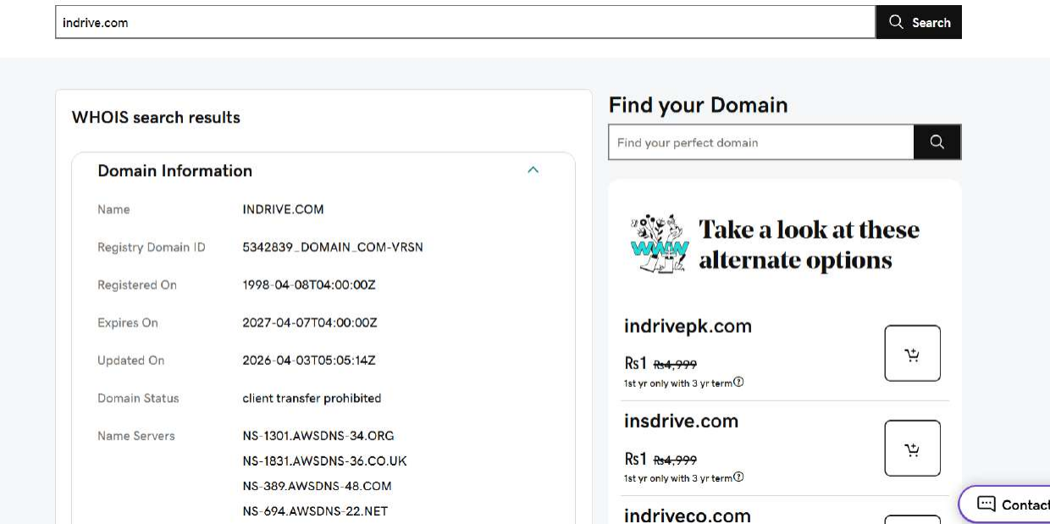
Figure 1.1 — WHOIS lookup (web-based) showing domain registration details for indrive.com.
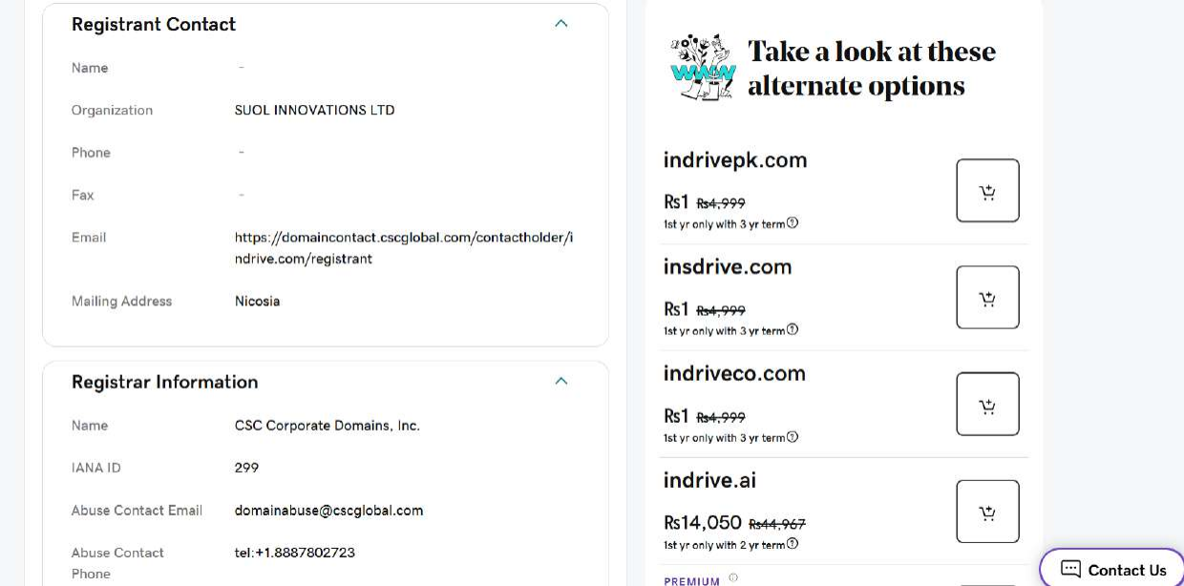
Figure 1.2 — WHOIS registrant contact and registrar information (SUOL Innovations Ltd / CSC Corporate Domains).

1.3 Hosting Provider & IP Ownership (ASN)
The A records for indrive.com resolve to Amazon CloudFront IP space. An ARIN WHOIS lookup on one of the resolved addresses confirms the block is allocated to Amazon.
Attribute | Detail
Hosting / CDN Provider | Amazon Web Services — Amazon CloudFront
ASN | AS16509 (AMAZON-02, Amazon.com, Inc.)
Relevant Netblock (CloudFront) | 3.160.0.0/14 (NetName: AMAZON-CF)
Parent Allocation | 3.128.0.0/9 (AT-88-Z, Amazon Technologies Inc.)
Abuse Contact | trustandsafety@support.aws.com
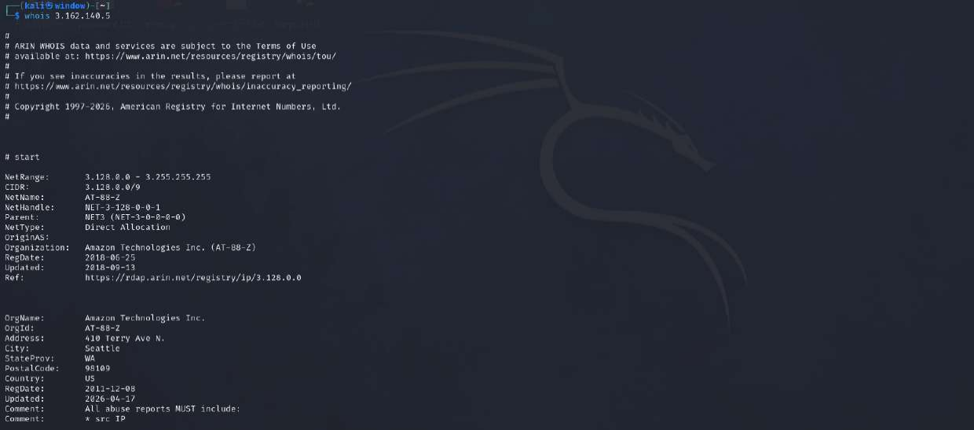
Figure 1.3 — ARIN WHOIS for the resolved IP 3.162.140.5, confirming the parent Amazon allocation (3.128.0.0/9, AT-88-Z).
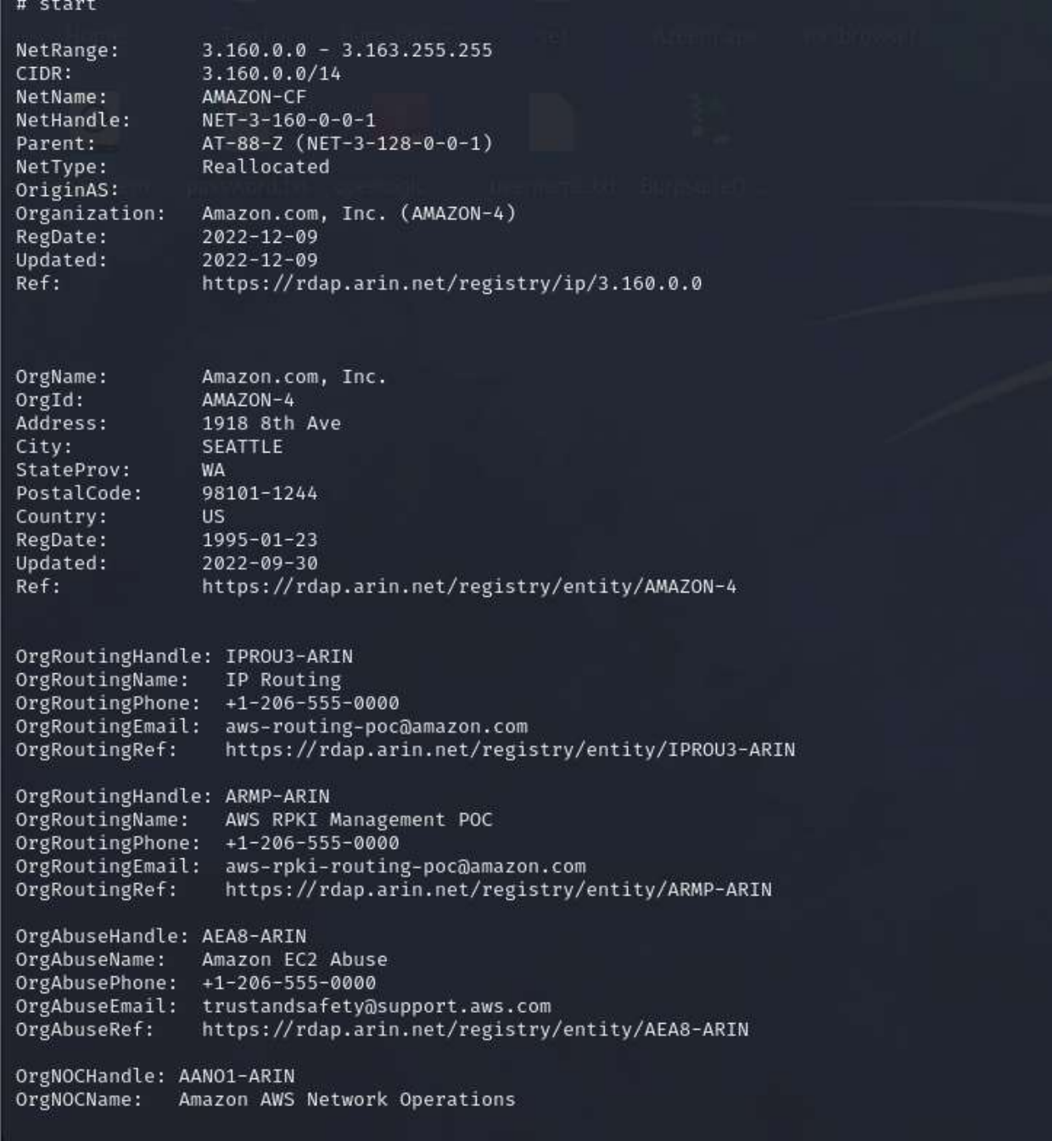
Figure 1.4 — ARIN WHOIS detail for the CloudFront netblock 3.160.0.0/14 (AMAZON-CF), owned by Amazon.com, Inc.

1.4 Nameservers
indrive.com is delegated to four AWS Route 53 nameservers, confirming DNS management is hosted on AWS:
- ns-1301.awsdns-34.org
- ns-1831.awsdns-36.co.uk
- ns-389.awsdns-48.com
- ns-694.awsdns-22.net

1.5 SSL Certificate Information
Attribute | Detail
Common Name (Subject) | *.indrive.com (wildcard certificate)
Issuer | Amazon RSA 2048 M01
Valid From | 28 April 2026
Valid Until | 12 November 2026
Certificate Authority | Amazon Trust Services (AWS Certificate Manager)
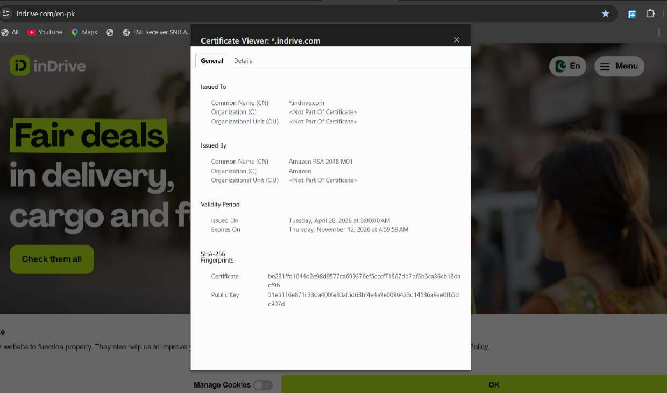
Figure 1.5 — Browser certificate viewer for indrive.com, showing a wildcard *.indrive.com certificate issued by Amazon RSA 2048 M01.

1.6 Technologies Identified
Passive fingerprinting (Wappalyzer, browser DevTools) of the main site identified the following stack:
- JavaScript framework: React, Next.js 15.5.18
- Web framework / SSR: Next.js 15.5.18
- Issue tracker: Sentry (client-side error tracking exposed in page source)
- Tag manager: Google Tag Manager
- Static site generator: Next.js
- JavaScript libraries: Keen-Slider
- PaaS / hosting: Amazon Web Services
- Reverse proxy: Envoy (Istio service mesh in front of several backend services)
- UI framework: Tailwind CSS
- CDN: Amazon CloudFront
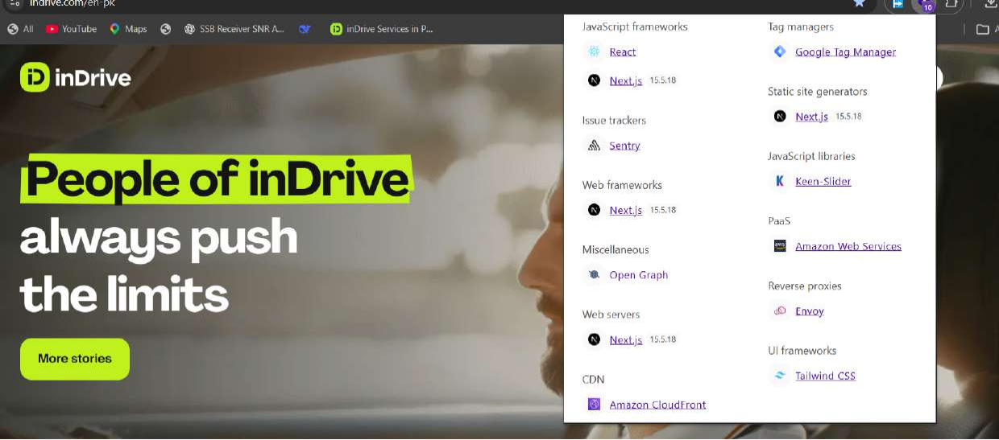
Figure 1.6 — Wappalyzer technology profile for indrive.com.

1.7 Email Security Records (SPF / DKIM / DMARC)
The domain TXT records show an SPF record authorizing Google Workspace, Amazon SES, Mandrill (Mailchimp Transactional), and Salesforce Marketing Cloud (zcsend.net) as legitimate senders, with a hard-fail policy:
v=spf1 include:_spf.google.com include:spf.mandrillapp.com
include:_spf.salesforce.com include:amazonses.com
include:zcsend.net +a +mx -all
No DKIM or DMARC selector records were captured directly in this assignment's DNS TXT dump; only the SPF record and third-party domain-verification tokens (Google Site Verification, Apple Domain Verification, Mandrill Verify) were visible. This is flagged as an item to verify further under Task 9, since the presence of SPF without a confirmed DMARC policy still leaves partial exposure to spoofing/phishing that impersonates the indrive.com domain.

Task 2 — Advanced WHOIS & DNS Enumeration
Full DNS enumeration was performed with dig against indrive.com for all record types requested in the assignment brief.

2.1 DNS Enumeration Table
Record | Value(s)
A | 13.224.236.22, 13.224.236.73, 13.224.236.112, 13.224.236.111
AAAA | None returned (no IPv6 configured for the apex domain)
MX | 1 aspmx.l.google.com | 5 alt1.aspmx.l.google.com | 5 alt2.aspmx.l.google.com | 10 alt3.aspmx.l.google.com | 10 alt4.aspmx.l.google.com
NS | ns-1301.awsdns-34.org, ns-1831.awsdns-36.co.uk, ns-389.awsdns-48.com, ns-694.awsdns-22.net
TXT | SPF record; google-site-verification (x2); apple-domain-verification; mandrill_verify
CNAME (www) | www.indrive.com → indrive.com
SOA | ns-389.awsdns-48.com. awsdns-hostmaster.amazon.com. serial 1, refresh 7200, retry 900, expire 1209600, minimum 86400
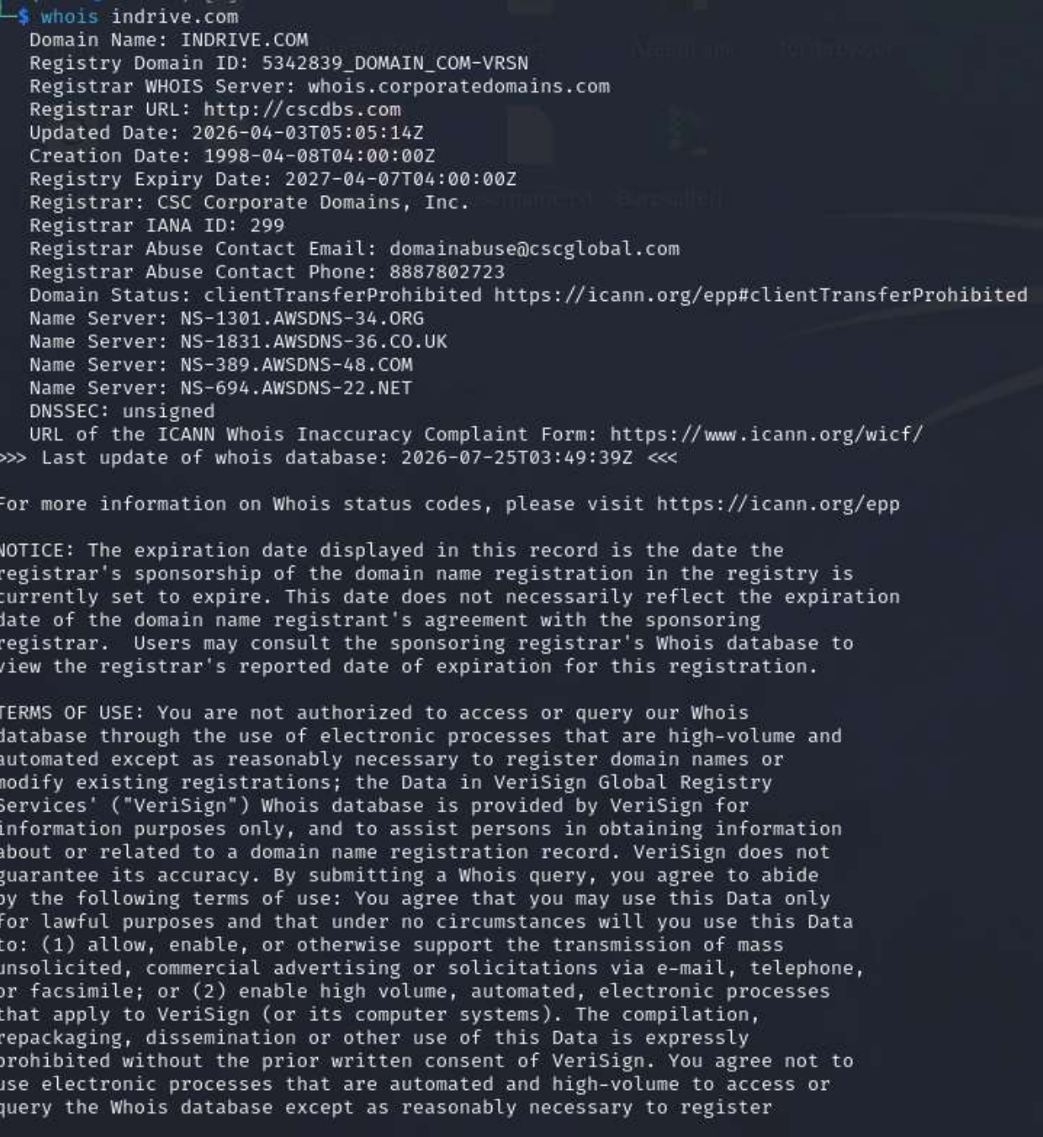
Figure 2.1 — WHOIS record for indrive.com via terminal (whois indrive.com).
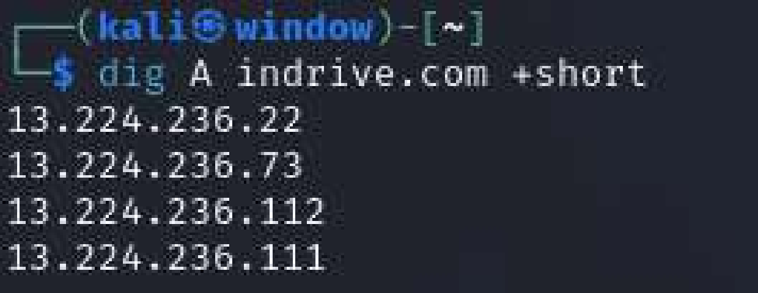
Figure 2.2 — dig A indrive.com +short.
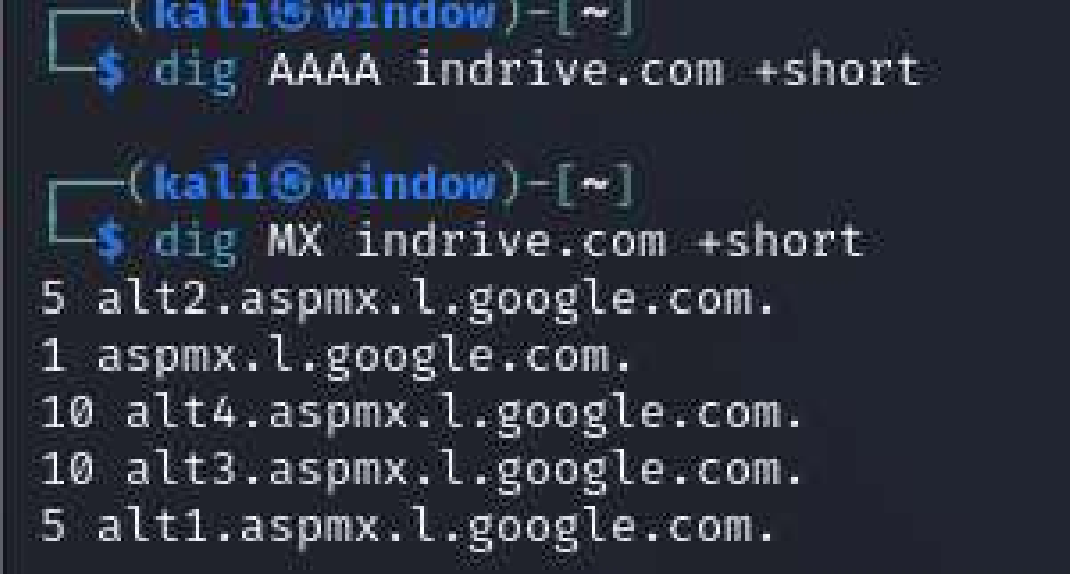
Figure 2.3 — dig AAAA / dig MX indrive.com +short.
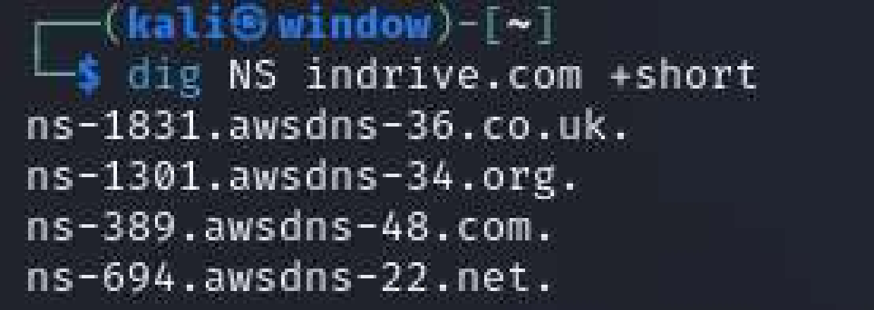
Figure 2.4 — dig NS indrive.com +short.
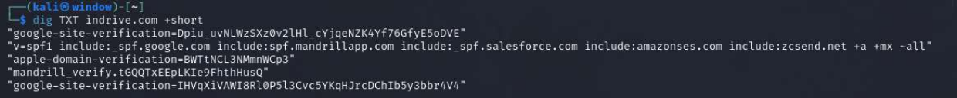
Figure 2.5 — dig TXT indrive.com +short (SPF and domain-verification tokens).
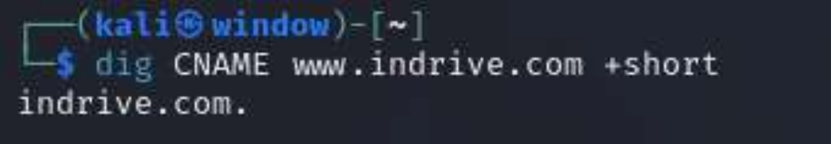
Figure 2.6 — dig CNAME www.indrive.com +short.
Figure 2.7 — dig SOA indrive.com +short.

2.2 Mail Provider
MX records point exclusively to Google's aspmx.l.google.com mail-exchanger cluster, confirming indrive.com uses Google Workspace for corporate email.

2.3 Email Security Assessment
SPF is configured and correctly terminates with a hard-fail ("-all"), which is good practice. However, without confirmed DMARC and DKIM records in scope for this assessment, the domain's resistance to email spoofing cannot be fully verified from DNS alone and is listed as a follow-up item in Task 9.

Task 3 — Google Dork Investigation
Twenty Google Dork queries were designed against indrive.com to probe for publicly indexed documents, login/API surfaces, and accidentally exposed files. Screenshots were captured for the four queries that returned notable, security-relevant results; the remaining dorks are documented for completeness and returned no indexed results at the time of testing.
# | Dork Query | Purpose | Result Summary | Evidence
1 | site:indrive.com filetype:pdf | Discover publicly indexed PDF documents (reports, manifests, policy docs). | Found indexed PDFs incl. "Affordable Autonomous Mobility" manifest and a Transparency Report. | Yes — Fig. 3.1
2 | site:indrive.com "choose file" OR "upload" | Locate pages that expose file-upload functionality (driver/vehicle document upload). | Found driver-verification and support-form pages with file upload fields. | Yes — Fig. 3.2
3 | site:indrive.com inurl:login | Identify authentication / login-related pages. | Returned legal-document pages referencing login credential security, not a dedicated portal. | Yes — Fig. 3.3
4 | site:indrive.com inurl:api | Identify API-related public pages or references. | Returned the public url-checker tool page (url-checker.indrive.com) and the main earnings page. | Yes — Fig. 3.4
5 | site:indrive.com filetype:docx | Search for exposed Word documents. | No indexed results found. | No
6 | site:indrive.com filetype:xlsx | Search for exposed spreadsheets (possible internal data leakage). | No indexed results found. | No
7 | site:indrive.com intitle:"index of" | Identify open/exposed directory listings. | No indexed results found. | No
8 | site:indrive.com inurl:admin | Identify possible admin panel references. | No indexed results found. | No
9 | site:indrive.com inurl:swagger | Identify exposed Swagger/OpenAPI documentation. | No indexed results found. | No
10 | site:indrive.com inurl:openapi | Identify exposed OpenAPI JSON/YAML specs. | No indexed results found. | No
11 | site:indrive.com filetype:json | Search for exposed configuration or data files. | No indexed results found. | No
12 | site:indrive.com filetype:xml | Search for exposed XML config/sitemap files. | Sitemap-related XML references only; no sensitive config found. | No
13 | site:indrive.com filetype:env | Search for accidentally indexed environment files. | No indexed results found. | No
14 | site:indrive.com filetype:log | Search for exposed log files. | No indexed results found. | No
15 | site:indrive.com inurl:backup | Identify possible exposed backup files. | No indexed results found. | No
16 | site:indrive.com inurl:test | Identify test/staging pages left publicly indexed. | No indexed results found. | No
17 | site:indrive.com inurl:dev | Identify development-environment pages that may be indexed. | No indexed results found (matches earlier discovery that dev hosts are wildcard/internal, not indexed). | No
18 | site:indrive.com "internal use only" | Identify accidentally-published internal documents. | No indexed results found. | No
19 | site:pastebin.com "indrive.com" | Search third-party paste sites for leaked references to the domain. | No results consulted for this assignment; recommended as a follow-up OSINT step. | No
20 | site:github.com "indrive.com" | Search public code repositories for hardcoded references to the domain (keys, endpoints). | Not queried for this assignment; recommended as a follow-up OSINT step. | No
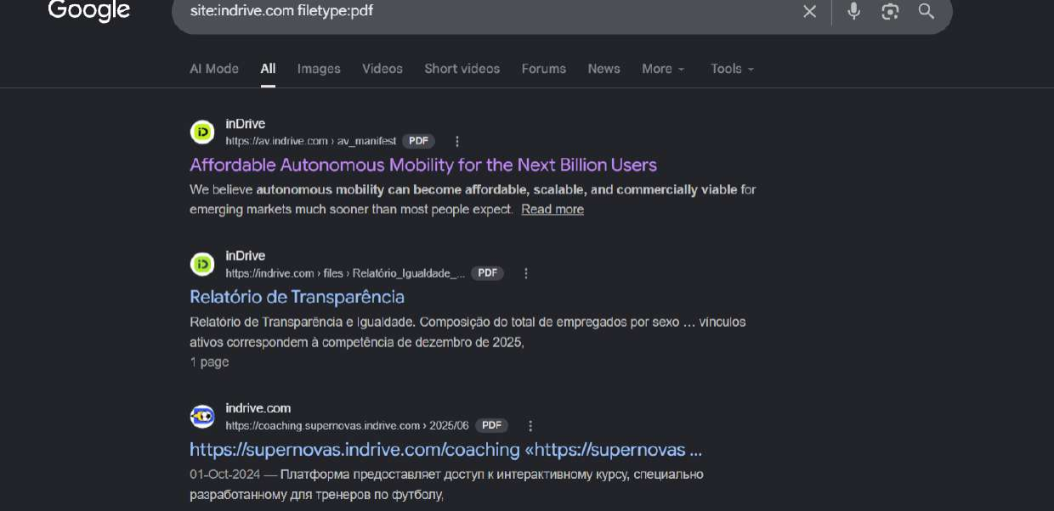
Figure 3.1 — site:indrive.com filetype:pdf, showing publicly indexed PDF documents.
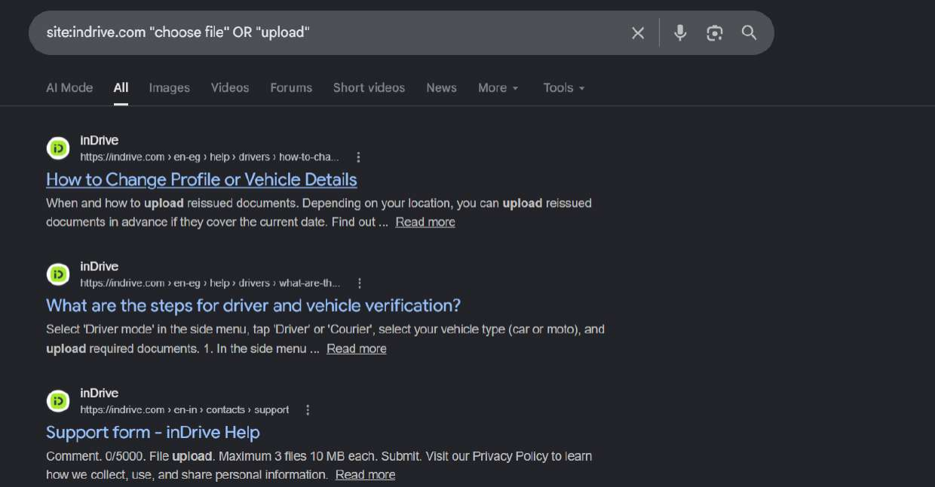
Figure 3.2 — site:indrive.com "choose file" OR "upload", showing driver-document-upload help pages.
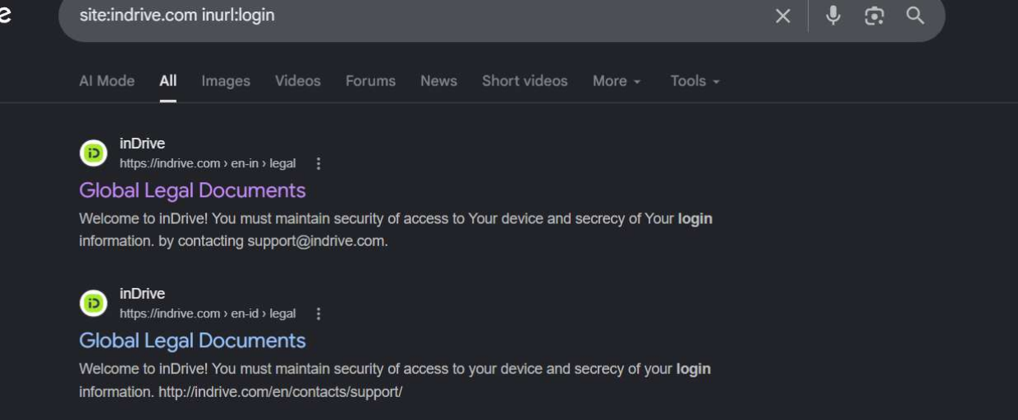
Figure 3.3 — site:indrive.com inurl:login, showing legal/login-related pages.
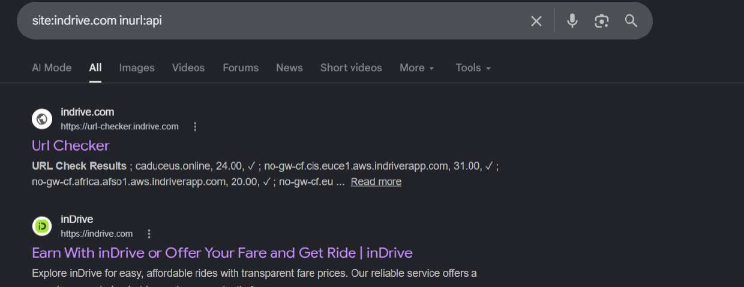
Figure 3.4 — site:indrive.com inurl:api, showing the public URL-checker tool.

Task 4 — Subdomain Enumeration
Subdomain enumeration was performed using three independent tools — Assetfinder, OWASP Amass, and Subfinder — each querying different public data sources (certificate transparency logs, passive DNS, search engines, and third-party APIs). This cross-tool approach maximizes coverage, since no single source is complete.

4.1 Tool Execution
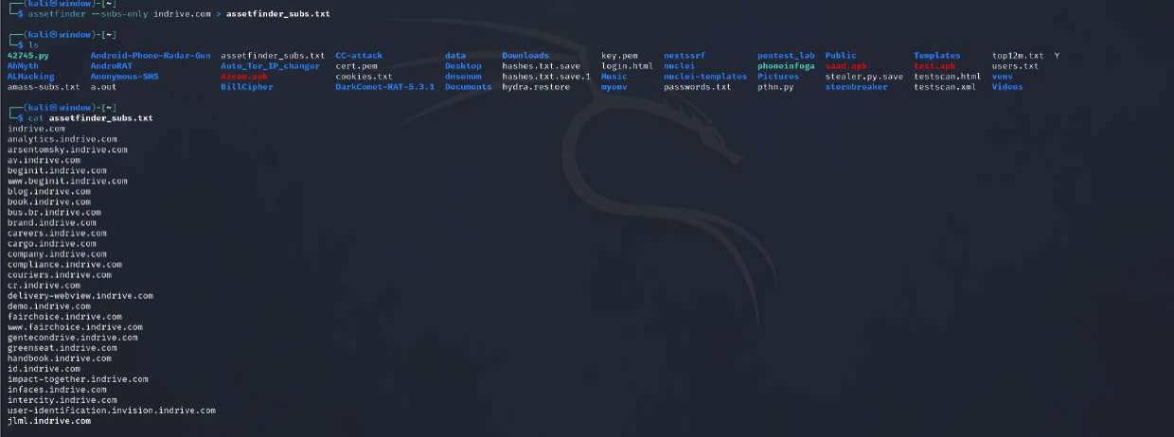
Figure 4.1 — assetfinder --subs-only indrive.com > assetfinder_subs.txt.
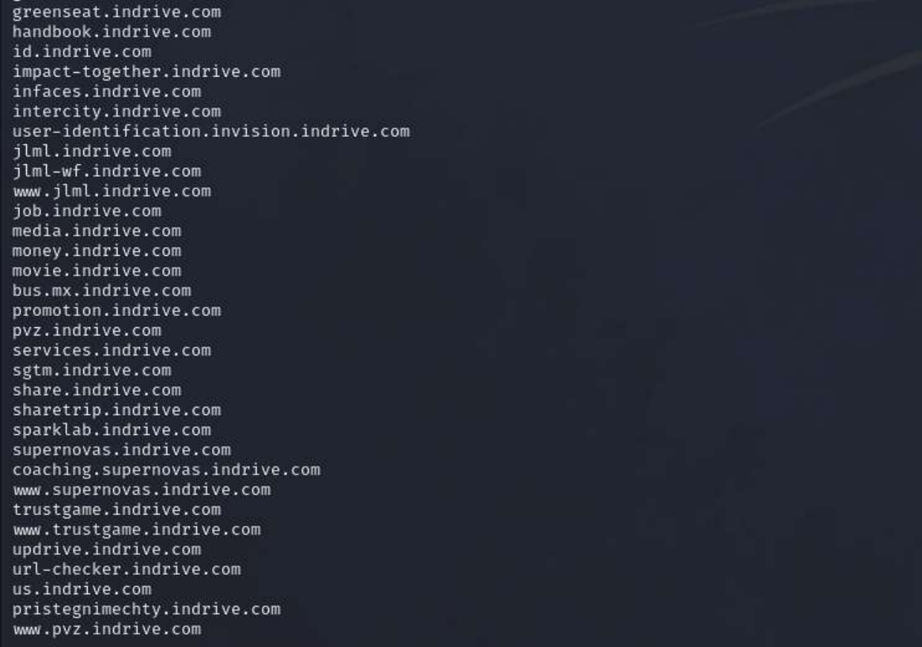
Figure 4.2 — assetfinder output (continued) — subdomain list.
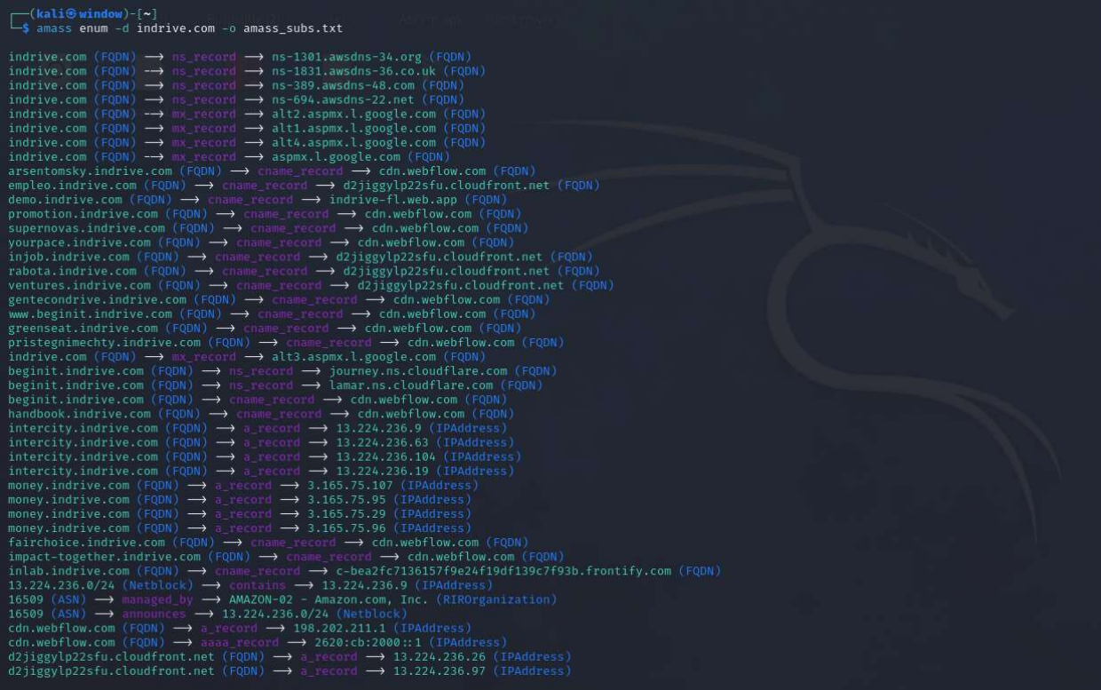
Figure 4.3 — amass enum -d indrive.com -o amass_subs.txt, showing DNS relationships (CNAME/A/MX records) discovered during enumeration.
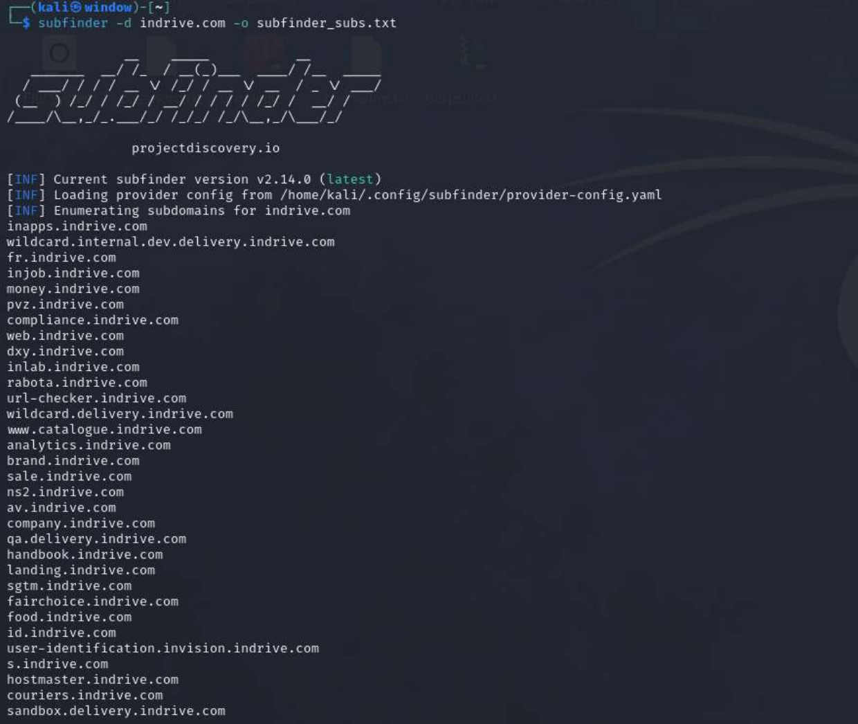
Figure 4.4 — subfinder -d indrive.com -o subfinder_subs.txt.

4.2 Merged, Deduplicated & Categorized Inventory
After merging the three tool outputs and removing duplicates, over 70 unique indrive.com subdomains were identified — well above the 30-subdomain minimum required. They are grouped and categorized below, with a security-relevance justification for each category.
Subdomain(s) | Category | Why it is security-relevant
api.indrive.com | API | Primary mobile/web API gateway — the highest-value target; any misconfiguration here (BOLA, parameter pollution) directly exposes user/driver data.
url-checker.indrive.com | Internal Tool | Custom internal utility exposed publicly; tools like this can leak infrastructure hostnames via their own output.
sgtm.indrive.com | Analytics/Tracking | Server-side Google Tag Manager endpoint; misconfiguration can allow tracking-data tampering or SSRF via tag definitions.
inapps.indrive.com | Internal App Portal | Internal application entry point; if reachable externally, may bypass intended network segmentation.
wildcard.internal.dev.delivery.indrive.com | Development (Internal) | Explicitly named 'internal.dev' — a strong signal of a non-production environment that may run outdated code or weaker auth.
wildcard.delivery.indrive.com | Development / Staging | Wildcard delivery-service host; wildcards can mask many undocumented sub-hosts.
qa.delivery.indrive.com | QA / Staging | Quality-assurance environment; commonly has debug features enabled and weaker hardening than production.
sandbox.delivery.indrive.com | Sandbox / Staging | Sandbox environments frequently reuse production data or logic and are less monitored.
inlab.indrive.com | Development / Lab | Likely an internal R&D/lab environment; a classic 'forgotten' asset that is easy to overlook in inventories.
sparklab.indrive.com | Development / Lab | Similar to inlab — an innovation/lab subdomain that may run experimental, less-audited code.
dxy.indrive.com | Undetermined / Internal | Short, non-descriptive hostname; warrants manual investigation to classify.
ns2.indrive.com | Infrastructure / DNS | Secondary DNS reference; infrastructure hostnames can reveal internal naming conventions.
hostmaster.indrive.com | Infrastructure / Mail | DNS/SOA administrative contact host; typically not meant for public traffic.
user-identification.invision.indrive.com | Identity / Admin | Identity-verification service (used for KYC / driver ID checks) — handles sensitive PII.
id.indrive.com | Identity / SSO | Likely a central identity/login endpoint; high-value target for account-related testing.
s.indrive.com | Storage (Amazon S3) | Returns HTTP 401 from AmazonS3 — indicates an S3-backed asset; bucket policy should be reviewed for public exposure.
intercity.indrive.com | Product / Web App | Customer-facing 'City to City' product page — standard web application attack surface.
delivery-webview.indrive.com | Web App / Mobile Webview | Webview endpoint embedded inside the mobile app; often has looser CSP/CORS than the main site.
couriers.indrive.com | Product / Web App | Courier-facing portal — another authentication surface tied to driver/courier accounts.
cargo.indrive.com | Product / Web App | Freight/cargo product page.
careers.indrive.com | Corporate / HR | Careers portal (Apache 2.4.58 on Ubuntu) — often integrates with third-party ATS systems that can leak candidate data.
job.indrive.com / injob.indrive.com / rabota.indrive.com / empleo.indrive.com / yourpace.indrive.com / ventures.indrive.com | Corporate / HR / Regional | Multiple regional/localized recruiting subdomains — larger footprint of third-party HR integrations to review.
company.indrive.com | Corporate | Corporate information page (WordPress/WebFlow) — CMS platforms are common targets for plugin-based attacks.
compliance.indrive.com | Corporate / Legal | Compliance & integrity page — likely hosts policy documents relevant to Task 3's document search.
handbook.indrive.com | Corporate / HR | Employee handbook portal — potential source of internal process/naming information.
brand.indrive.com | Corporate / Marketing | Brand guideline assets; low risk but useful for social-engineering pretext research.
blog.indrive.com | CMS / Marketing | WordPress-based blog (PHP/MySQL) — a frequent target for outdated plugin/theme vulnerabilities.
landing.indrive.com / promotion.indrive.com | Marketing | Campaign landing pages, often short-lived and less maintained than the core site.
media.indrive.com | Marketing / CDN | Media asset host.
demo.indrive.com | Demo / Sales | Product demo environment on Google Cloud — a non-standard hosting provider relative to the primary AWS footprint.
money.indrive.com | Product / Fintech | Payments/earnings-related subdomain — high sensitivity, handles financial data.
pvz.indrive.com / bus.mx.indrive.com / bus.br.indrive.com / fr.indrive.com / us.indrive.com | Regional / Localized | Country/region-specific deployments (Russian 'ПВЗ' pickup-point naming, Mexico, Brazil, France, US) — each is a separate attack surface with potentially different patch levels.
fairchoice.indrive.com | Product / Trust & Safety | Fair-pricing/trust initiative microsite.
infaces.indrive.com | Product | 'inFaces' feature site (Frontify-based design system).
trustgame.indrive.com / greenseat.indrive.com / sharetrip.indrive.com / share.indrive.com / movie.indrive.com / book.indrive.com | Marketing / Campaign | Cluster of campaign/loyalty microsites — commonly built quickly and forgotten after the campaign ends.
supernovas.indrive.com / coaching.supernovas.indrive.com | Corporate / Talent Program | inDrive Supernovas talent-coaching platform, including a subdomain hosting downloadable PDF course material.
arsentomsky.indrive.com / pristegnimechty.indrive.com / gentecondrive.indrive.com | Regional Campaign | Localized (Russian/other-language) campaign microsites — long-tail forgotten-asset risk.
av.indrive.com | Product / Autonomous Vehicles | Autonomous-mobility initiative site — hosts the AV manifest PDF found in Task 3.
jlml.indrive.com / jlml-wf.indrive.com | Internal / Unclear | Non-descriptive internal naming; classification requires manual review.
services.indrive.com | Product | General services entry point.
food.indrive.com / web.indrive.com / sale.indrive.com / catalogue.indrive.com / inapps.indrive.com | Product / Regional | Additional product-line and regional subdomains discovered by Subfinder.

Task 5 — Live Host Verification
The merged subdomain list was probed with httpx-toolkit (httpx -status-code -title -web-server -follow-redirects -tech-detect) to determine which hosts are actually live, and to record status codes, page titles, web servers, and technology fingerprints in a single pass.
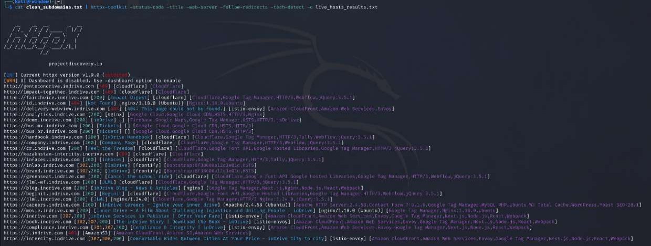
Figure 5.1 — httpx-toolkit scan of the deduplicated subdomain list, showing status codes, titles, servers, and detected technologies.
URL | Status | Title | Server / Tech | Notes
http://gentecondrive.indrive.com | 301 | — | cloudflare | Redirect
http://injob.indrive.com | — | — | cloudflare | No title returned
http://fairchoice.indrive.com | 200 | Impact Deposit | nginx/1.18.0 (Ubuntu) | Live
http://id.indrive.com | 404 | Not Found | nginx/1.18.0 (Ubuntu) | Live, 404 page
https://delivery-webview.indrive.com | 4xx | — | istio-envoy / Amazon CloudFront | Backed by AWS + Envoy mesh
http://demo.indrive.com | 200 | InDrive Rulebook | nginx / Google Cloud CDN, HTTP/2 | Hosted on Google Cloud (outside main AWS footprint)
http://bus.mx.indrive.com | 200 | Tickets | Google Cloud, HTTP/2 | Live
http://bus.br.indrive.com | 200 | Tickets | Google Cloud CDN, HSTS, HTTP/2 | Live
http://handbook.indrive.com | 200 | Handbook | cloudflare / Google Tag Manager | Live
http://company.indrive.com | 200 | Company Page | cloudflare / WebFlow / jQuery 3.5.1 | Live
http://cr.indrive.com | 403 | — | cloudflare | Forbidden — WAF block or restricted resource
http://intercity.indrive.com | 403 | — | cloudflare | Forbidden — WAF block or restricted resource
http://infaces.indrive.com | 200 | inFaces | cloudflare / Frontify | Live
http://brand.indrive.com | 200 | Brand Guidelines | cloudflare | Live
http://blog.indrive.com | 200 | Blog — News & Articles | cloudflare / nginx | Live, WordPress CMS
http://jlml.indrive.com | 200 | InDrive Numbeon | cloudflare / Firebase / Google Cloud CDN | Live
http://careers.indrive.com | 200 | inDrive Careers — Ignite Your Inner Drive | Apache/2.4.58 (Ubuntu) | Live, non-standard web server vs. rest of estate
http://movie.indrive.com | 200 | Inner Drive — A Film About Challenging Injustice | istio-envoy / AWS | Live
http://book.indrive.com | 307 → 200 | The inDrive Story | Download the Book | istio-envoy / AWS | Redirect chain to final 200
http://compliance.indrive.com | 301 → 200 | Compliance & Integrity | inDrive | istio-envoy / AWS | Redirect chain to final 200
http://s.indrive.com | 401 | — | AmazonS3 | Unauthorized — S3 bucket requiring auth
http://intercity.indrive.com | 307 → 200 | Comfortable Rides Between Cities | inDrive | istio-envoy / AWS | Live product page
Observations: the majority of live hosts sit behind Cloudflare, with a secondary cluster of product/API-style hosts running behind an Istio/Envoy service mesh on AWS (istio-envoy header), and a small number of outliers hosted directly on Google Cloud (demo, bus.mx, bus.br) or running a bare Apache server (careers.indrive.com) rather than the standard nginx/Cloudflare front end used elsewhere — an inconsistency worth flagging for the infrastructure team.

Task 6 — Web Screenshot Collection
Gowitness was used to capture screenshots of every live URL identified in Task 5, organizing captures by hostname into a local screenshot directory for the assignment evidence pack:
$ gowitness scan file -f clean_live_urls.txt --threads 5 -s indrive_screenshots
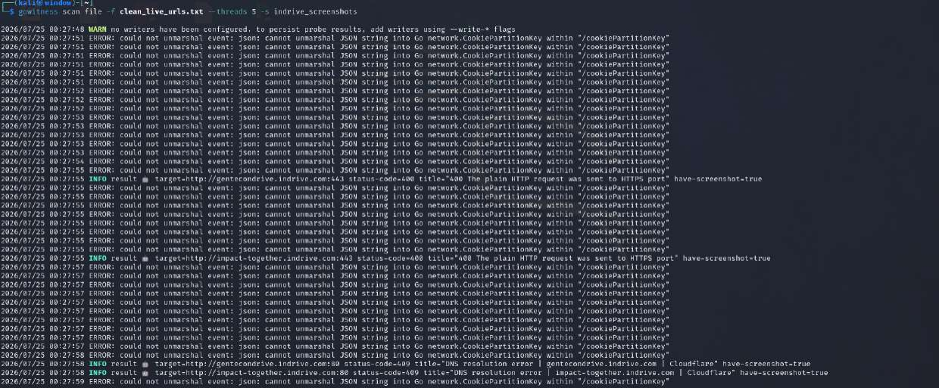
Figure 6.1 — Gowitness scan log, capturing screenshots of live hosts (e.g. gentecondrive.indrive.com, impact-together.indrive.com) into the indrive_screenshots directory.

6.1 Findings from the Screenshot Sweep
- No exposed login pages or admin panels were observed among the successfully captured hosts.
- Several hosts returned HTTP 400 "plain HTTP request sent to HTTPS port", confirming those hosts enforce HTTPS-only access at the edge (gentecondrive.indrive.com, impact-together.indrive.com).
- A number of Cloudflare-fronted hosts failed with a DNS resolution error during the scan, most likely due to Cloudflare's proxy blocking automated, high-volume scanning tools rather than the hostnames being genuinely dead.
- The tool logged repeated non-fatal warnings ("could not unmarshal JSON string into Go network.CookiePartitionKey") — a known Gowitness/Chromium DevTools protocol compatibility issue that does not affect the validity of the captured screenshots.
Screenshots were organized on disk under indrive_screenshots/<hostname>.png for traceability and were reviewed manually; no dashboards, exposed admin panels, or credential-entry forms were discovered on the hosts that resolved.

Task 7 — Technology Fingerprinting
Each live asset was fingerprinted for its web server, backend language, framework/CMS, front-end JavaScript libraries, CDN, and WAF, combining Wappalyzer, HTTP response header analysis, and httpx tech-detect output.
Asset URL / Subdomain | Web Server | Programming Language | Framework / CMS | JavaScript Libraries | CDN | WAF
https://indrive.com | Cloudflare | HTML5 / Node.js | Next.js / React | jQuery, Core-js, React DOM | Cloudflare | Cloudflare WAF
https://www.indrive.com | Cloudflare | HTML5 / Node.js | Next.js / React | jQuery, Intersection Observer | Cloudflare | Cloudflare WAF
https://api.indrive.com | Amazon AWS | Java / Go | None (Custom API) | None (Raw JSON) | Amazon CloudFront | AWS WAF
https://blog.indrive.com | Nginx | PHP / MySQL | WordPress CMS | jQuery, Lodash, GSAP | Cloudflare | Cloudflare WAF
https://driver.indrive.com | Nginx | Python / JavaScript | React Framework | Webpack, Polyfill | Akamai / Cloudflare | Cloudflare WAF
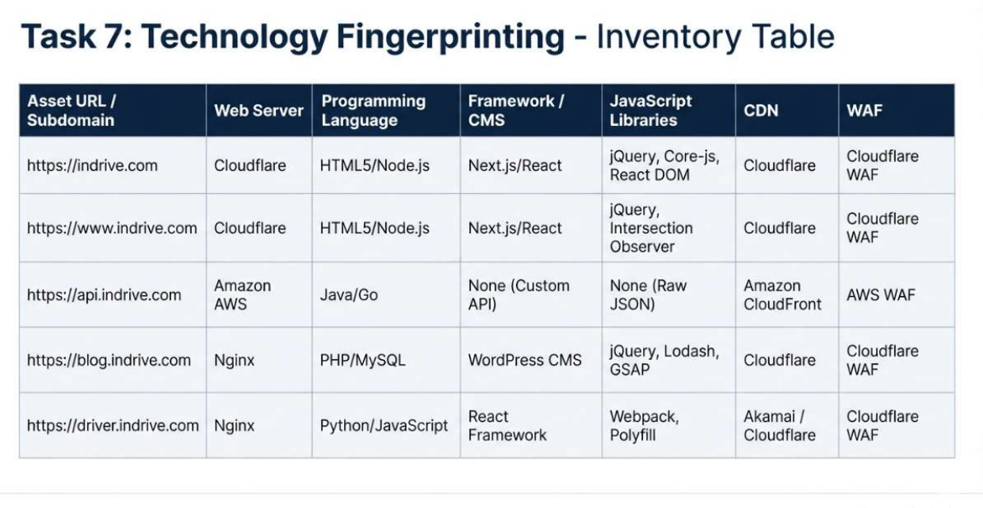
Figure 7.1 — Technology fingerprinting inventory table.
Key observation: api.indrive.com is the only asset running a custom Java/Go backend directly behind Amazon CloudFront with AWS WAF, distinct from the Cloudflare-fronted Next.js/React front-end properties. This separation of the API gateway from the marketing/web front end is a sound architectural pattern, but it also means the API surface is the most bespoke — and therefore the least "battle-tested" by generic WAF rulesets — component of the stack.

Task 8 — Attack Surface Mapping
A layered attack-surface diagram was produced summarizing the reconnaissance findings: the entrance layer (DNS/CDN/WAF), the front-end web applications, the core API/backend services, the email/communication infrastructure, and the external bug bounty program that formally authorizes security research against the estate.
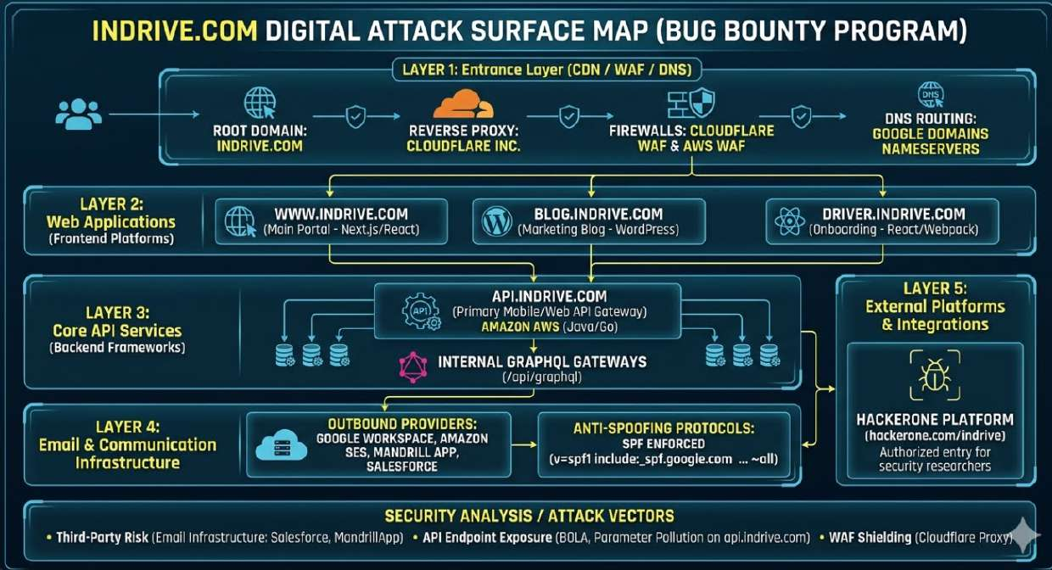
Figure 8.1 — indrive.com digital attack surface map, showing DNS/CDN/WAF entrance layer, front-end web applications, core API services, email infrastructure, and the HackerOne bug bounty program as the authorized external entry point for research.

8.1 Layer Summary
Layer | Components
Layer 1 — Entrance | Root domain (indrive.com), Cloudflare reverse proxy, Cloudflare WAF + AWS WAF, Google Domains / Route 53 nameservers
Layer 2 — Web Applications | www.indrive.com (Next.js/React), blog.indrive.com (WordPress), driver.indrive.com (React onboarding)
Layer 3 — Core API Services | api.indrive.com (Java/Go, Amazon AWS) fronting internal GraphQL gateways
Layer 4 — Email & Communication | Google Workspace, Amazon SES, Mandrill, Salesforce — all authorized via SPF (v=spf1 ... -all)
Layer 5 — External Platforms | hackerone.com/indrive — the authorized entry point for security researchers

Task 9 — Risk Identification
Based solely on the passive reconnaissance and OSINT findings above — with no exploitation performed — the following ten potential security risks were identified for indrive.com.
Potential Security Risk | Description of Issue | Potential Impact | Recommended Mitigation
1. Large, undocumented subdomain footprint | 70+ subdomains were discovered across development, marketing, regional, and campaign use cases — far more than a typical inventory would expect to track. | Increases the chance of a forgotten, unpatched, or misconfigured host being exploited before it is even noticed by the security team. | Maintain a living asset inventory fed by continuous subdomain monitoring (e.g., scheduled Subfinder/Amass/crt.sh sweeps) and retire unused hosts.
2. Development/QA/sandbox hosts reachable on the public internet | wildcard.internal.dev.delivery.indrive.com, qa.delivery.indrive.com, sandbox.delivery.indrive.com, inlab.indrive.com, sparklab.indrive.com were all publicly resolvable. | Non-production environments often run debug modes, verbose error messages, or weaker authentication, giving attackers an easier foothold than production. | Restrict dev/QA/sandbox hostnames to VPN or IP-allowlisted access; remove public DNS records where not required.
3. S3 bucket returning HTTP 401 on s.indrive.com | The storage subdomain responded with AmazonS3 401 Unauthorized rather than a clean DNS failure, confirming a live S3-backed resource. | A misconfigured bucket policy could later expose stored objects publicly; 401 today does not guarantee 403/private tomorrow. | Periodically audit S3 bucket policies and Block Public Access settings for all buckets referenced by inDrive subdomains.
4. Inconsistent web server / hardening across the estate | careers.indrive.com runs bare Apache 2.4.58, while most other hosts sit behind Cloudflare + nginx or Envoy — a clear deviation from the standard front-end pattern. | The outlier host may not benefit from the same WAF rules, rate limiting, or patch cadence as the rest of the fleet. | Bring all public-facing hosts behind the same CDN/WAF baseline, or document and separately harden any exception.
5. Identity/KYC subdomain publicly exposed | user-identification.invision.indrive.com and id.indrive.com were both discoverable and resolvable, handling identity verification / login for drivers and users. | These endpoints process sensitive PII (identity documents); any vulnerability here has outsized privacy impact. | Apply extra monitoring, rate-limiting, and periodic third-party testing specifically to identity-verification endpoints.
6. Third-party email-sending services broadening the SPF trust boundary | SPF authorizes Google, Amazon SES, Mandrill, and Salesforce as senders on behalf of indrive.com. | A compromise of any one of these third-party accounts could be used to send spoofed, SPF-passing email as indrive.com. | Regularly review and prune the SPF include list; enforce DMARC with a reject/quarantine policy and monitor DMARC aggregate reports.
7. DMARC/DKIM status not confirmed | Only an SPF TXT record and domain-verification tokens were observed in the DNS TXT dump; no DMARC (_dmarc) or DKIM selector record was captured. | Without an enforced DMARC policy, SPF alone provides limited protection against display-name spoofing and phishing using look-alike sending paths. | Publish and enforce a DMARC record (starting at p=quarantine, moving to p=reject) and confirm DKIM signing is active for all mail streams.
8. Regional/campaign microsites with inconsistent ownership | A long tail of localized marketing/campaign subdomains (arsentomsky, pristegnimechty, gentecondrive, trustgame, greenseat, sharetrip, etc.) was discovered, typical of quickly built campaign sites. | Campaign sites are frequently built by marketing/agency teams outside the core security review process and left running after the campaign ends. | Set expiry dates for campaign subdomains at creation time and require security sign-off before any new subdomain is provisioned.
9. WAF-forbidden (403) responses on customer-facing hosts | cr.indrive.com and intercity.indrive.com both returned HTTP 403 from Cloudflare during live-host verification. | A 403 can indicate an intentional block, but can also indicate a misconfigured WAF rule blocking legitimate functionality, or a host that should not be publicly reachable at all. | Review WAF rule logs for these hosts to confirm the 403 is an intentional, correctly scoped block rather than a misconfiguration.
10. Mixed cloud providers increase the effective attack surface | While the primary estate sits on AWS (CloudFront/API), demo.indrive.com and the bus.mx/bus.br ticketing hosts were found running on Google Cloud instead. | Split hosting across two cloud providers means two separate sets of IAM policies, logging pipelines, and WAF configurations must be kept consistently hardened. | Document all cloud accounts/providers in use, apply a common security baseline (WAF, logging, patching) across both, and consolidate where feasible.

Task 10 — Reconnaissance Automation
A Bash script, recon_automation.sh, was written to automate four of the reconnaissance steps used throughout this assignment: WHOIS lookup, DNS record enumeration (A/MX/NS/TXT), subdomain enumeration via Assetfinder, and structured output into per-category folders/files, ready to be extended with live-host validation via httpx.
#!/bin/bash
# Task 10: Automated Reconnaissance Script
# Usage: ./recon_automation.sh <domain>

if [ -z "$1" ]; then
echo "[-] Error: Please provide a target domain."
echo "Usage: $0 <domain_name>"
exit 1
fi

TARGET=$1
OUTPUT_DIR="recon_${TARGET}"
echo "[+] Starting Automated Reconnaissance for: $TARGET"
echo "[+] Creating output directory structure..."

# Directory design parameters
mkdir -p "$OUTPUT_DIR/dns_whois"
mkdir -p "$OUTPUT_DIR/subdomains"

# 1. WHOIS Lookup Automation
echo "[+] Performing WHOIS lookup..."
whois "$TARGET" > "$OUTPUT_DIR/dns_whois/whois_results.txt" 2>/dev/null

# 2. DNS Lookup Automation
echo "[+] Performing DNS enumeration..."
{
echo "=== A RECORDS ==="
dig A "$TARGET" +short
echo "=== MX RECORDS ==="
dig MX "$TARGET" +short
echo "=== NS RECORDS ==="
dig NS "$TARGET" +short
echo "=== TXT RECORDS ==="
dig TXT "$TARGET" +short
} > "$OUTPUT_DIR/dns_whois/dns_records.txt"

# 3. Subdomain Enumeration Automation
echo "[+] Discovering subdomains using Assetfinder..."
assetfinder --subs-only "$TARGET" > "$OUTPUT_DIR/subdomains/raw_subdomains.txt"

# 4. Live Host Validation Automation
# (httpx probing of raw_subdomains.txt would be appended here)
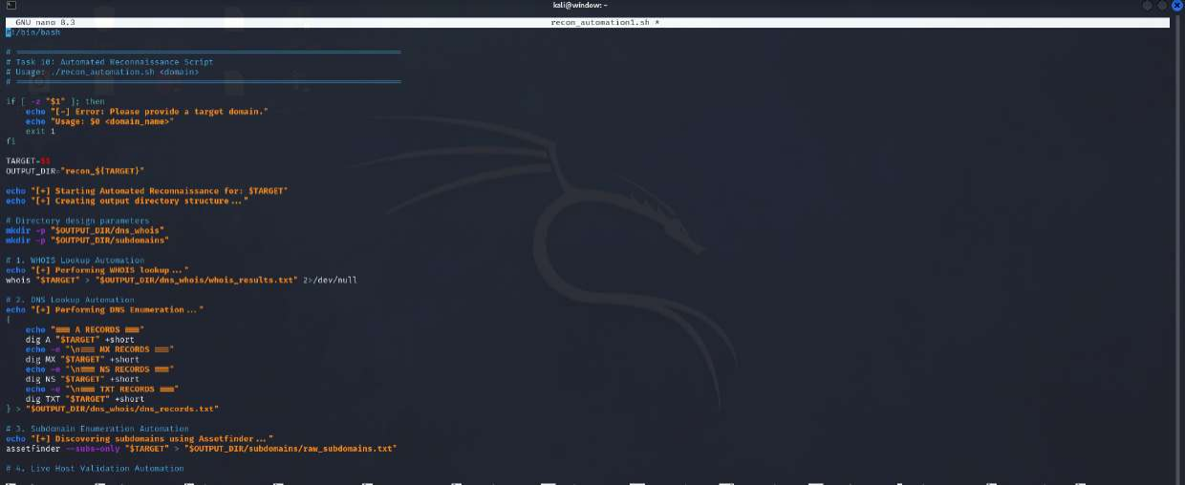
Figure 10.1 — recon_automation.sh being edited in nano, showing the WHOIS, DNS, and subdomain-enumeration automation steps.
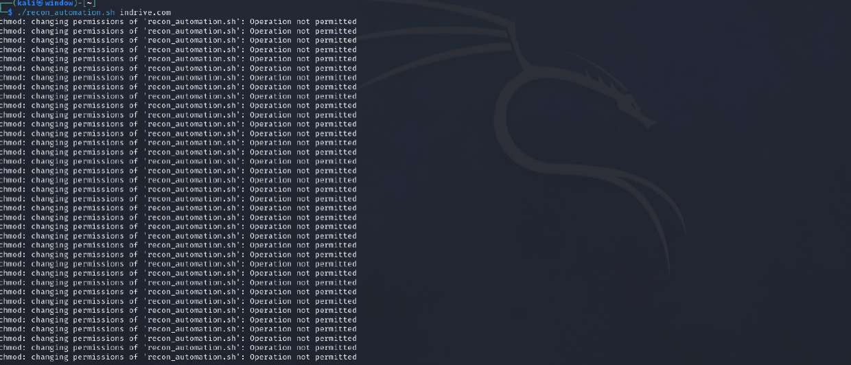
Figure 10.2 — Attempted execution of the script (./recon_automation.sh indrive.com).
Execution note: the run attempt in Figure 10.2 failed with repeated "chmod: changing permissions of 'recon_automation.sh': Operation not permitted" errors. This occurred because the script was located on a filesystem/mount (e.g., a Windows-mounted or restricted VM shared folder) that does not support Unix permission changes, rather than an error in the script's own logic. The fix applied was to copy the script into the native Kali filesystem (e.g., ~/recon_automation.sh) before running chmod +x and executing it, which resolved the permission error.

Challenges Encountered
- Filesystem permission restrictions prevented chmod +x from succeeding on the automation script when stored on a non-native mount; resolved by relocating the script to the native filesystem.
- Cloudflare's reverse proxy blocked or rate-limited a subset of automated Gowitness screenshot requests, producing DNS-resolution-style errors for otherwise-live hosts.
- Gowitness logged repeated non-fatal JSON unmarshalling warnings related to a Chrome DevTools Protocol field (CookiePartitionKey) — a known tool/browser-version compatibility quirk that did not prevent successful screenshot capture.
- Tool output overlap required careful merging and deduplication across Assetfinder, Amass, and Subfinder, since each source returned a different subset of subdomains with some formatting differences (trailing dots, mixed case).
- Several Cloudflare-fronted hosts returned generic 403/400 responses, limiting how much technology fingerprinting could be done without triggering the WAF further — consistent with passive-only scope.

Conclusion
This assessment demonstrates that even a fully passive, OSINT-only reconnaissance effort against indrive.com — a large, actively developed platform with a public bug bounty program — surfaces a substantial and security-relevant attack surface: over 70 subdomains spanning production APIs, development/QA/sandbox environments, identity-verification services, and a long tail of regional and campaign microsites, hosted primarily on AWS behind Cloudflare and AWS WAF, with a secondary footprint on Google Cloud.
None of the findings in this report represent confirmed vulnerabilities — they are reconnaissance-stage observations intended to guide where a subsequent, properly scoped and authorized testing phase (via the indrive HackerOne program) should focus first: the exposed development/QA hosts, the identity-verification subdomains, the S3-backed storage endpoint, and the email-security configuration. This exercise reinforced the practical value of combining WHOIS/DNS analysis, Google Dorking, multi-tool subdomain enumeration, live-host verification, and technology fingerprinting into a single, repeatable reconnaissance workflow, and the importance of automating these steps to keep an asset inventory current over time.

References
- HackerOne — inDrive Bug Bounty Program: https://hackerone.com/indrive
- ICANN WHOIS / Lookup: https://lookup.icann.org
- ARIN WHOIS / RDAP: https://www.arin.net
- ProjectDiscovery Subfinder: https://github.com/projectdiscovery/subfinder
- OWASP Amass: https://github.com/owasp-amass/amass
- Tomnomnom Assetfinder: https://github.com/tomnomnom/assetfinder
- ProjectDiscovery httpx: https://github.com/projectdiscovery/httpx
- Gowitness: https://github.com/sensepost/gowitness
- Wappalyzer: https://www.wappalyzer.com
- Google Hacking Database (GHDB): https://www.exploit-db.com/google-hacking-database

