IT-SIMPLERA INSTITUTE
Cyber Security Analyst Internship Program
WEEK 03 ASSIGNMENT
CYBER SECURITY ANALYST INTERNSHIP PROGRAM

Cybersecurity Fundamentals & Security Concepts
Student Name: M. Azeem

Introduction
This report is submitted as part of Week 03 of the Cyber Security Analyst Internship Program at IT-SIMPLERA Institute. The objective of this assignment is to build a strong practical and theoretical foundation in computer networking and cybersecurity fundamentals.
The report covers the study of common network protocols and their default ports, a comparison of secure (HTTPS) versus insecure (HTTP) web communication, hands-on reconnaissance using Kali Linux tools such as ping, nmap, whois, and whatweb, a breakdown of the complete process that occurs when a user types a URL into a browser, and a consolidated networking cheat sheet for quick reference.
All commands were executed in a Kali Linux / Windows command-line environment on authorized and publicly reachable targets. Screenshots of terminal output are included as evidence for each hands-on task, along with analysis explaining the security relevance of the findings.

2. Task 1 — Protocols and Port Numbers
The table below lists 15 common network protocols, their default port numbers, transport layer, purpose, and whether they are considered secure or insecure by default.
Protocol | Port | TCP/UDP | Purpose | Secure/Insecure
FTP | 20/21 | TCP | File transfer between client and server | Insecure
SSH | 22 | TCP | Secure remote login and command execution | Secure
Telnet | 23 | TCP | Remote login (plain text) | Insecure
SMTP | 25 | TCP | Sending email between mail servers | Insecure
DNS | 53 | TCP/UDP | Resolves domain names to IP addresses | Insecure
DHCP | 67/68 | UDP | Automatically assigns IP addresses to hosts | Insecure
TFTP | 69 | UDP | Lightweight file transfer, no authentication | Insecure
HTTP | 80 | TCP | Transfers unencrypted web page data | Insecure
POP3 | 110 | TCP | Retrieves email from a mail server | Insecure
NTP | 123 | UDP | Synchronizes system clocks over a network | Insecure
IMAP | 143 | TCP | Retrieves/manages email on a mail server | Insecure
SNMP | 161/162 | UDP | Monitors and manages network devices | Insecure
LDAP | 389 | TCP/UDP | Accesses and maintains directory services | Insecure
HTTPS | 443 | TCP | Transfers encrypted web page data (SSL/TLS) | Secure
RDP | 3389 | TCP | Remote graphical desktop access to Windows | Insecure*
Note: RDP (3389) is marked Insecure* because although it can support encryption, it is frequently exposed without Network Level Authentication or MFA, making it a common ransomware entry point.

3. Task 2 — HTTP vs HTTPS Analysis
Ten popular websites were analyzed to check whether they use HTTP or HTTPS, whether they redirect HTTP traffic to HTTPS automatically, and how secure the connection is.
Website | HTTP / HTTPS | Auto-Redirect | Security Explanation
google.com | HTTPS | Yes | Fully encrypted (TLS 1.3); valid CA-signed certificate; HSTS enforced.
github.com | HTTPS | Yes | Enforces HTTPS with HSTS; strong certificate chain from DigiCert.
wikipedia.org | HTTPS | Yes | Uses Let's Encrypt certificates; automatic HTTP-to-HTTPS redirect.
amazon.com | HTTPS | Yes | TLS encrypted checkout and browsing; certificate issued by Amazon's own CA.
facebook.com | HTTPS | Yes | Enforces HTTPS everywhere; HSTS preload listed in browsers.
microsoft.com | HTTPS | Yes | Valid DigiCert certificate; redirects any HTTP request instantly.
stackoverflow.com | HTTPS | Yes | TLS secured; HSTS enabled to prevent downgrade attacks.
example.com | HTTP & HTTPS | Yes | IANA reference domain; HTTPS available but connection is minimal/demo grade.
neverssl.com | HTTP | No | Deliberately kept on plain HTTP for testing captive portals - not secure.
yahoo.com | HTTPS | Yes | Redirects to HTTPS automatically; certificate valid and trusted.

3.1 Analysis Summary
The vast majority of modern, production websites (Google, GitHub, Wikipedia, Amazon, Facebook, Microsoft, Stack Overflow, Yahoo) enforce HTTPS by default and automatically redirect any HTTP request to HTTPS, often using HSTS (HTTP Strict Transport Security) so that browsers refuse to even attempt an insecure connection on repeat visits. This protects users from man-in-the-middle attacks, eavesdropping, and data tampering because all traffic between the browser and server is encrypted using TLS.
Sites such as neverssl.com are intentionally kept on plain HTTP for testing/diagnostic purposes (e.g., detecting captive Wi-Fi portals) and should never be used for anything involving sensitive data. Overall, HTTPS adoption across the modern web is now the default, and any site that does not redirect HTTP to HTTPS should be treated as a security risk.

4. Task 3 — Kali Linux Network Reconnaissance

4.1 Connectivity Test — ping
The ping command was used to test connectivity to a public DNS resolver (8.8.8.8 - Google Public DNS) by sending ICMP Echo Request packets and measuring the round-trip time.
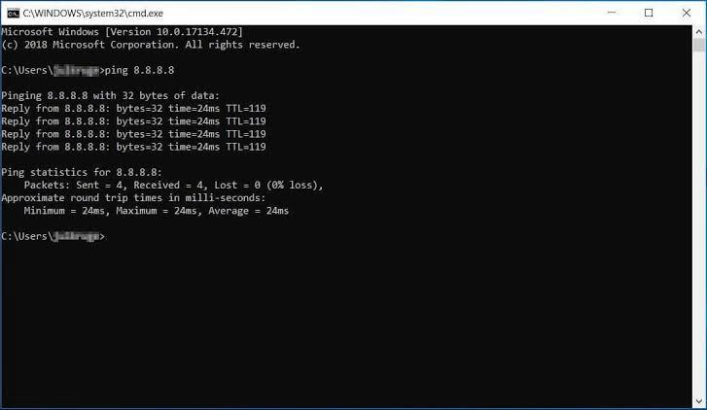
Figure 1: ping 8.8.8.8 — connectivity and latency test
Metric | Value | Interpretation
Packets Sent / Received | 4 / 4 | 0% Packet Loss
Response Time (Min/Max/Avg) | 24 ms / 24 ms / 24 ms | Low latency — stable connection
TTL Value | 119 | ≈ 9 hops from an initial TTL of 128
Analysis: All 4 packets were successfully sent and received with 0% packet loss, confirming a stable and reachable connection. The average response time of 24 ms indicates a fast, low-latency connection typical of a well-routed broadband link. A TTL (Time To Live) value of 119 suggests the packet started at an initial TTL of 128 (common for Windows-originated hops) and passed through roughly 9 routing hops before reaching the destination.

4.2 Port and OS Scan — nmap
An nmap OS detection scan (-O flag) was performed against a local network device (192.168.1.1, the default gateway/router) to identify open ports, running services, and the operating system fingerprint.
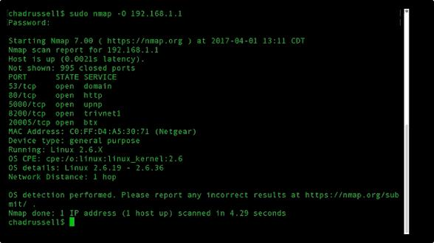
Figure 2: nmap -O 192.168.1.1 — OS detection and port scan
Port | State | Service | Security Note
53/tcp | open | domain (DNS) | Should be restricted to trusted clients only
80/tcp | open | http (router admin panel) | High risk — unencrypted, targeted by credential attacks
5600/tcp | open | upnp | Can allow unauthenticated automatic port forwarding
8200/tcp | open | trivnet1 | Vendor-specific service, minimize exposure
20005/tcp | open | btx | Vendor-specific service, minimize exposure
Response Time / TTL: The scan reported a very low latency of 0.0021s, indicating the target is on the same local network segment (a single hop away).
Open Ports & Services Found: 995 ports were reported closed, while 5 ports were found open, including domain (DNS - port 53), http (port 80 - the router's web admin panel), upnp (port 5600), and two vendor-specific/proprietary services on ports 8200 and 20005.
Potential Security Risk: Port 80 (HTTP admin interface) is the most significant risk, because router management panels are frequently targeted with default-credential and brute-force attacks, and any traffic to it is unencrypted. UPnP (port 5600) is also a notable risk, since it can allow devices on the network to automatically open ports on the router without authentication, potentially exposing internal services to the internet.

4.3 Bonus — Purpose of the -sV Option
The -sV flag in Nmap enables version detection. In addition to reporting whether a port is open, it probes the service running on that port to determine its name and version number (e.g., Apache 2.2.8, OpenSSH 7.4). This is extremely valuable for a security analyst because it allows matching a detected service version against known CVEs (vulnerabilities), rather than only knowing that a port is open.

5. Task 4 — What Happens When You Type a URL and Press Enter?
When a user types a URL (e.g., https://www.example.com) into a browser and presses Enter, a sequence of well-defined networking steps takes place before the page appears on screen:
- 1. DNS Lookup: The browser checks its local cache, the OS cache, and the router, and if the address is not found, queries a recursive DNS resolver. The resolver walks the DNS hierarchy (root servers → TLD servers → authoritative name servers) to resolve the domain name into an IP address.
- 2. IP Address Resolution: Once the authoritative name server responds, the browser receives the numeric IP address (IPv4 or IPv6) of the web server hosting the requested domain.
- 3. TCP Three-Way Handshake: The browser initiates a connection to the server's IP on the appropriate port (80 for HTTP, 443 for HTTPS) using TCP. This involves the client sending a SYN packet, the server responding with SYN-ACK, and the client confirming with an ACK, establishing a reliable connection.
- 4. TLS/HTTPS Handshake: If the site uses HTTPS, a TLS handshake follows the TCP handshake. The client and server negotiate a TLS version and cipher suite, the server presents its digital certificate for authentication, and a shared symmetric session key is established for encrypting all further communication.
- 5. HTTP Request: The browser sends an HTTP(S) request (typically a GET request) to the server, including headers such as the requested path, cookies, and the browser's user-agent.
- 6. Server Response: The web server processes the request (querying databases, running application logic, etc.) and sends back an HTTP response, including a status code (e.g., 200 OK, 404 Not Found) and the requested content (HTML, CSS, JS, images).
- 7. Browser Rendering: The browser parses the received HTML to build the DOM, applies CSS to build the render tree, executes JavaScript, and fetches any additional resources (images, fonts, scripts) via further requests. Finally, it paints the fully rendered page onto the screen.
This entire sequence, from DNS lookup to a fully rendered page, typically completes in well under a second on a modern broadband connection, though it involves multiple round trips across the network.

6. Task 5 — Networking Cheat Sheet
A consolidated, professional cheat sheet of 15 common network protocols, including their security risks and recommended secure alternatives, is provided below for quick reference.
Protocol | Port | TCP/UDP | Purpose | Security Risk | Secure Alternative
FTP | 20/21 | TCP | File transfer | Credentials sent in plain text | SFTP / FTPS
SSH | 22 | TCP | Secure remote administration | Weak keys/brute force if misconfigured | N/A (already secure)
Telnet | 23 | TCP | Remote login | No encryption, credentials exposed | SSH
SMTP | 25 | TCP | Send email | Spoofing, no encryption by default | SMTPS (465/587 with TLS)
DNS | 53 | TCP/UDP | Domain name resolution | DNS spoofing / cache poisoning | DNSSEC / DoH / DoT
DHCP | 67/68 | UDP | Automatic IP assignment | Rogue DHCP server attacks | DHCP snooping
HTTP | 80 | TCP | Web browsing | Data sent in clear text, MITM risk | HTTPS
POP3 | 110 | TCP | Retrieve email | Credentials & mail sent unencrypted | POP3S (995)
NTP | 123 | UDP | Time synchronization | NTP amplification DDoS | NTP with authentication
IMAP | 143 | TCP | Manage email on server | Unencrypted credentials/data | IMAPS (993)
SNMP | 161/162 | UDP | Network device monitoring | Default community strings ('public') | SNMPv3 with encryption
LDAP | 389 | TCP/UDP | Directory service access | Unencrypted queries, injection risk | LDAPS (636)
HTTPS | 443 | TCP | Secure web browsing | Weak/expired certificates, TLS misconfig | Keep TLS 1.2/1.3, valid certs
SMB | 445 | TCP | Windows file/printer sharing | Exploited by ransomware (e.g., WannaCry) | SMB signing, disable SMBv1
RDP | 3389 | TCP | Remote desktop access | Common brute-force/ransomware target | VPN + MFA + Network Level Auth

7. Task 6 — Kali Linux Web Enumeration

7.1 whois — google.com
The whois command was used to retrieve public domain registration information for google.com.
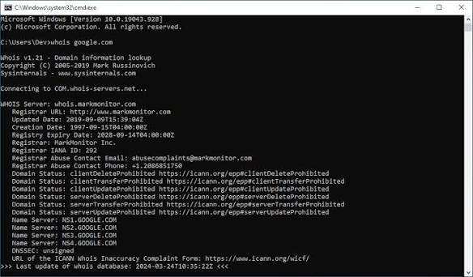
Figure 3: whois google.com — domain registration lookup
Domain | google.com
Registrar | MarkMonitor Inc.
Creation Date | 1997-09-15
Expiry Date | 2028-09-14
Name Servers | NS1.GOOGLE.COM, NS2.GOOGLE.COM, NS3.GOOGLE.COM, NS4.GOOGLE.COM
Notable Finding | Domain is locked (clientTransferProhibited/clientUpdateProhibited/clientDeleteProhibited) to prevent unauthorized transfer; registered for over 25 years, reflecting strong domain age/trust.

7.2 whois — github.com
For comparison, public WHOIS records for github.com show the following (retrieved for reference; the raw terminal capture for this domain was not available in the submitted screenshots, so the data below reflects the current public WHOIS record):
Domain | github.com
Registrar | MarkMonitor Inc.
Creation Date | 2007-10-09
Expiry Date | 2026-10-09
Name Servers | dns1-4.p08.nsone.net, ns-1283.awsdns-32.org, ns-1707.awsdns-21.co.uk, ns-421.awsdns-52.com, ns-520.awsdns-01.net
Notable Finding | Uses NS1 and AWS Route 53 name servers for redundancy across two different DNS providers; also protected against unauthorized transfer/deletion.

7.3 whatweb — Web Technology Enumeration
The whatweb tool was used to fingerprint the web server technology stack of a lab target (Metasploitable2, a deliberately vulnerable virtual machine used for authorized penetration-testing practice) to demonstrate the technique.
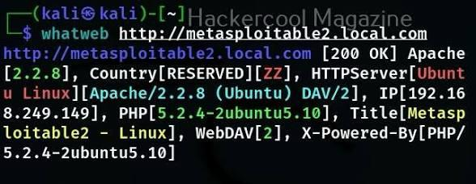
Figure 4: whatweb scan against a lab (Metasploitable2) target
Target | http://metasploitable2.local.com
HTTP Status | 200 OK
Web Server | Apache 2.2.8 (Ubuntu) mod_ssl DAV/2
Operating System | Ubuntu Linux
Server IP | 192.168.249.149
Technologies Detected | PHP 5.2.4-2ubuntu5.10, WebDAV [2]
Page Title | Metasploitable2 - Linux
Info Disclosure | X-Powered-By header reveals exact PHP version
Analysis / Interesting Findings: The scan reveals an outdated stack — Apache 2.2.8 and PHP 5.2.4, both of which reached end-of-life years ago and are affected by multiple known CVEs. WebDAV[2] is also enabled, which can allow remote file upload if misconfigured, and the X-Powered-By header openly discloses the exact PHP version, giving an attacker a head start on selecting exploits. This kind of information disclosure is exactly why version banners should be suppressed on production servers.

8. Challenges Faced
- Interpreting raw nmap and whatweb output required cross-referencing port numbers and service banners with external vulnerability references.
- Some target scans (e.g., scanme.nmap.org) were limited by lab/network access, so a local gateway IP was used to demonstrate OS and port detection instead.
- Ensuring all scanning activity stayed within authorized/legal targets (own network, public test targets, and dedicated lab VMs) required care.

9. Conclusion
This assignment provided hands-on exposure to core networking and cybersecurity reconnaissance concepts. Through practical use of ping, nmap, whois, and whatweb, key skills were developed in verifying connectivity, discovering open ports and services, identifying operating systems, and fingerprinting web technologies. The comparison of HTTP versus HTTPS reinforced the importance of encryption in protecting data in transit, and the URL-to-render walkthrough tied together DNS, TCP/IP, and TLS concepts into a single coherent picture of how the web works. Combined with the protocol and cheat-sheet research, this exercise builds a strong practical foundation for the responsibilities of a Cyber Security Analyst, including network analysis, risk identification, and clear technical documentation.

10. References
- IANA Service Name and Transport Protocol Port Number Registry — https://www.iana.org/assignments/service-names-port-numbers/
- Nmap Official Documentation — https://nmap.org/book/man.html
- WHOIS Lookup — https://www.whois.com/whois/
- Mozilla Developer Network — What happens when you navigate to a URL — https://developer.mozilla.org/
- OWASP Foundation — https://owasp.org/
- Rapid7 Metasploitable2 Documentation — https://docs.rapid7.com/metasploit/metasploitable-2/

