IT-SIMPLERA INSTITUTE
Cyber Security Analyst Internship Program
WEEK 02 ASSIGNMENT
CYBER SECURITY ANALYST INTERNSHIP PROGRAM

Cybersecurity Fundamentals & Network Configuration
Student Name: M. Azeem

1. Introduction
This report is submitted as part of the Week 02 Assignment for the Cyber Security Analyst Internship Program at IT-SIMPLERA Institute. The assignment focuses on Computer Networking Fundamentals and Network Configuration. It is designed to build a strong foundation in identifying network configuration details, using essential command-line networking tools, understanding the differences between core networking devices such as routers and switches, comparing IPv4 and IPv6 addressing, and studying the seven layers of the OSI Model.
All practical tasks in this report were carried out on a Windows-based machine (Host Name: Azeem) connected via a Wi-Fi network. Screenshots of actual command outputs are included as evidence for each task, along with explanations, comparison tables, and supporting diagrams.
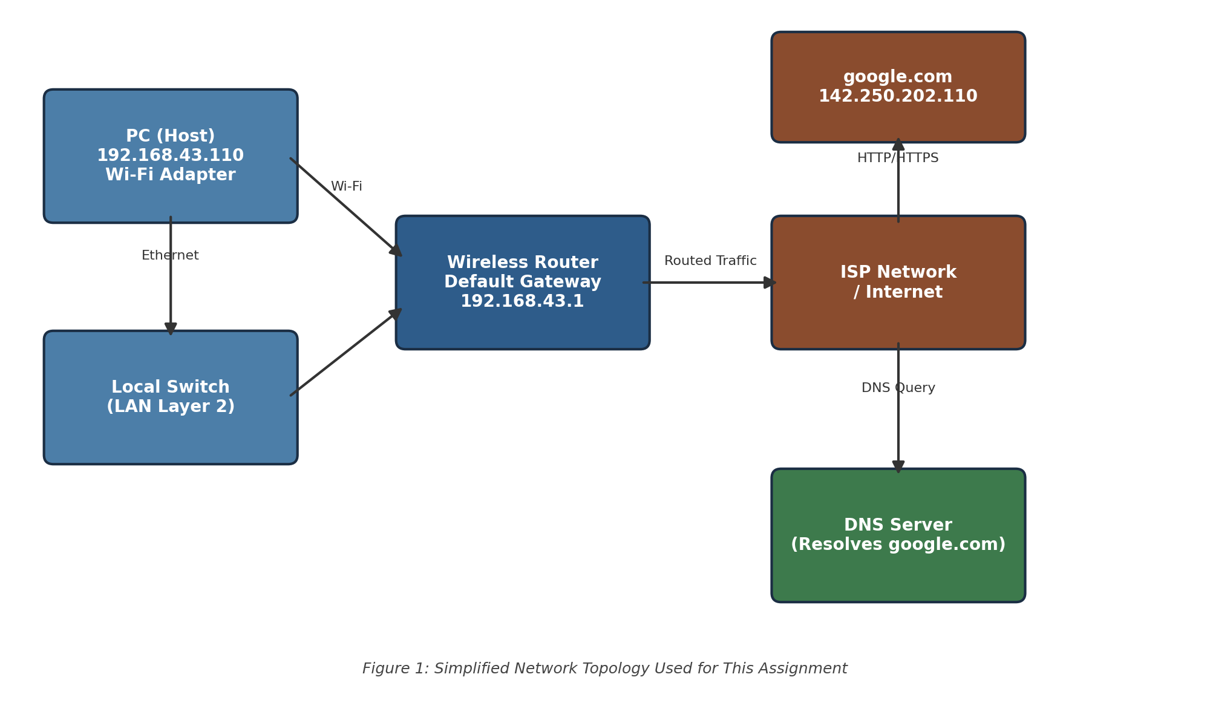
Figure 1: Simplified network topology used for this assignment.

2. Task 1 — Network Information (ipconfig /all)
Q1. Using the ipconfig /all command, identify your computer's IPv4 Address, MAC Address, and Default Gateway. Explain the purpose of each and attach screenshots of your results.
The ipconfig /all command was executed in Command Prompt to display the full network configuration of the machine, including all active and virtual network adapters.
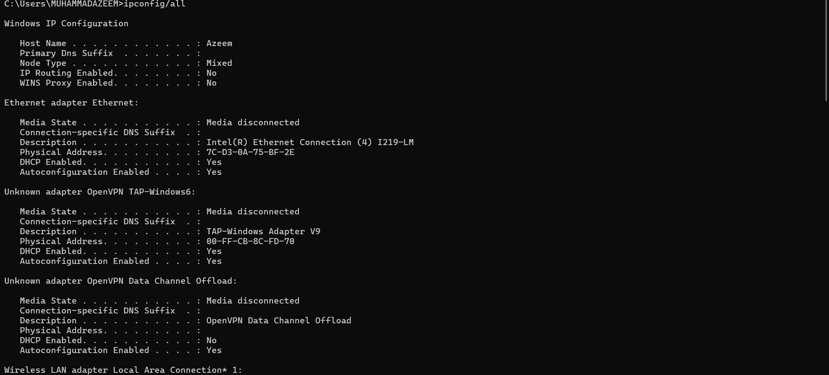
Figure 2: ipconfig /all output — Host name and Ethernet adapter details.
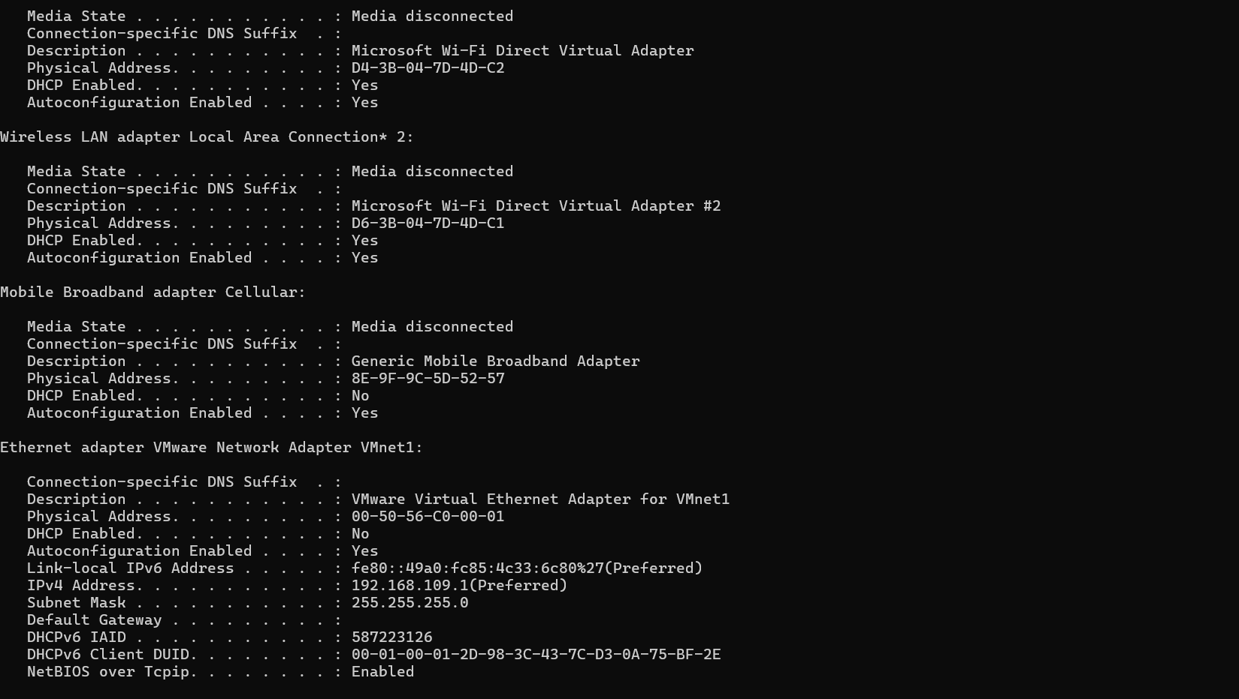
Figure 3: ipconfig /all output — Wireless LAN and VMware virtual adapters (VMnet1).
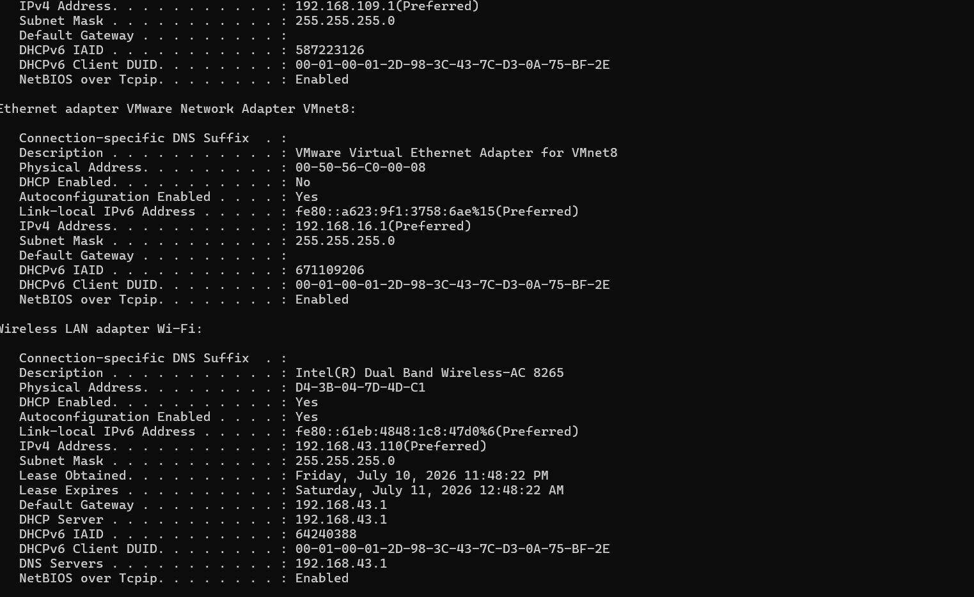
Figure 4: ipconfig /all output — VMnet8 adapter and active Wi-Fi adapter with IPv4 address.

Key values identified (Wi-Fi adapter):
Parameter | Value | Purpose
IPv4 Address | 192.168.43.110 | The logical address assigned to this device on the local network, used to identify and locate the host for communication.
MAC Address (Physical Address) | D4-3B-04-7D-4D-C1 | A unique hardware identifier burned into the network interface card, used for communication at the Data Link layer (Layer 2).
Default Gateway | 192.168.43.1 | The router's IP address that the device uses to send traffic destined for networks outside the local subnet, such as the Internet.
Subnet Mask | 255.255.255.0 | Defines which portion of the IP address represents the network and which portion represents the host.
DHCP Server | 192.168.43.1 | The device that automatically assigns IP configuration (IP address, gateway, DNS) to hosts on the network.
DNS Servers | 192.168.43.1 | Resolves human-readable domain names (e.g., google.com) into IP addresses.

3. Task 2 — Basic Networking Commands
Q2. Execute the following networking commands on your computer. Attach screenshots of the output and write 1–2 lines explaining the purpose of each command: ipconfig /all, ping google.com, tracert google.com, nslookup google.com, arp -a.

2.1 ping google.com
The ping command sends ICMP Echo Request packets to a target host to test connectivity and measure round-trip time. It confirms whether a remote host is reachable and how responsive the connection is.
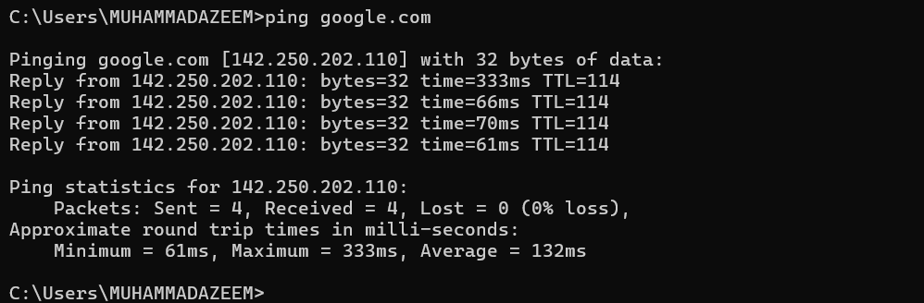
Figure 5: ping google.com — all 4 packets received, 0% loss, average round-trip time 132ms.

2.2 tracert google.com
The tracert (traceroute) command traces the path packets take from the local machine to the destination host, listing each intermediate router (hop) along with the response time. It is useful for diagnosing routing issues and locating where delays occur.
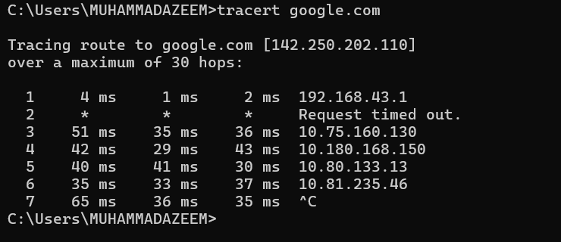
Figure 6: tracert google.com — showing the default gateway (192.168.43.1) and subsequent ISP hops.

2.3 nslookup google.com
The nslookup command queries the Domain Name System (DNS) to resolve a domain name into its corresponding IP address(es). It is commonly used to verify DNS resolution and troubleshoot DNS-related issues.
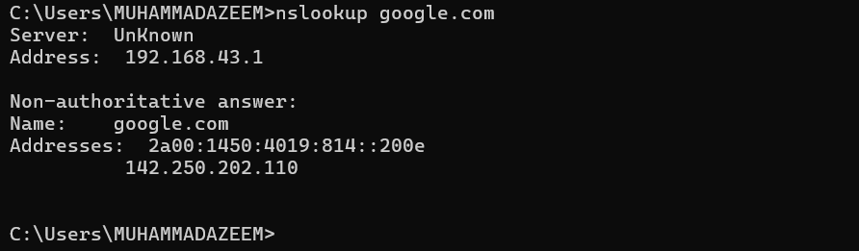
Figure 7: nslookup google.com — resolved to IPv6 (2a00:1450:4019:814::200e) and IPv4 (142.250.202.110).

2.4 arp -a
The arp -a command displays the current ARP (Address Resolution Protocol) cache, which maps known IPv4 addresses on the local network to their corresponding MAC addresses. It helps verify which devices the host has recently communicated with on the local subnet.
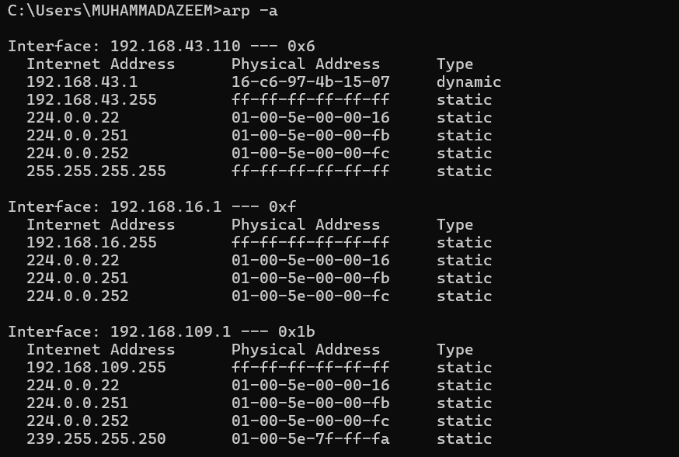
Figure 8: arp -a output — ARP tables for the Wi-Fi, VMnet1, and VMnet8 interfaces.

4. Task 3 — Router vs. Switch
Q3. Compare a Router and a Switch by creating a table with at least six comparison points, including their functions, OSI layer, addressing, and common use cases.
Comparison Point | Router | Switch
Primary Function | Connects multiple different networks together and forwards data (packets) between them. | Connects multiple devices within the same local network (LAN) and forwards data (frames) between them.
OSI Layer | Operates mainly at Layer 3 (Network Layer). | Operates mainly at Layer 2 (Data Link Layer); Layer 3 switches also exist.
Addressing Used | Uses IP addresses to determine the best path for forwarding data. | Uses MAC addresses to forward frames to the correct device.
Broadcast Domain | Separates broadcast domains between networks. | By default, all connected devices share a single broadcast domain (unless VLANs are configured).
Data Unit | Packet | Frame
Common Use Case | Connecting a home/office LAN to the Internet; connecting multiple networks/subnets. | Connecting computers, printers, and other devices within a single office or building.
Intelligence | Makes routing decisions using routing tables and protocols (e.g., OSPF, BGP). | Learns device MAC addresses automatically and builds a MAC address table.

5. Task 4 — IPv4 vs. IPv6
Q4. Compare IPv4 and IPv6 by listing at least six key differences in a table. Include one valid example of an IPv4 address and one valid example of an IPv6 address.
Feature | IPv4 | IPv6
Address Length | 32-bit | 128-bit
Address Format | Dotted decimal (e.g., 142.250.202.110) | Hexadecimal, colon-separated (e.g., 2a00:1450:4019:0814:0000:0000:0000:200e)
Total Address Space | ~4.3 billion addresses | ~340 undecillion addresses
Address Configuration | Manual or DHCP | Supports auto-configuration (SLAAC) in addition to DHCPv6
Header Complexity | More complex header with checksum field | Simplified, more efficient header; no checksum field
Security | IPSec is optional | IPSec support is built-in
NAT Requirement | Commonly requires NAT due to limited address space | Designed to eliminate the need for NAT thanks to the vast address space
Example IPv4 address: 142.250.202.110
Example IPv6 address: 2a00:1450:4019:0814::200e

6. Task 5 — The OSI Model
Q5. List all seven layers of the OSI Model in the correct order. For each layer, write: its primary function, one commonly used protocol, and one networking device associated with that layer.
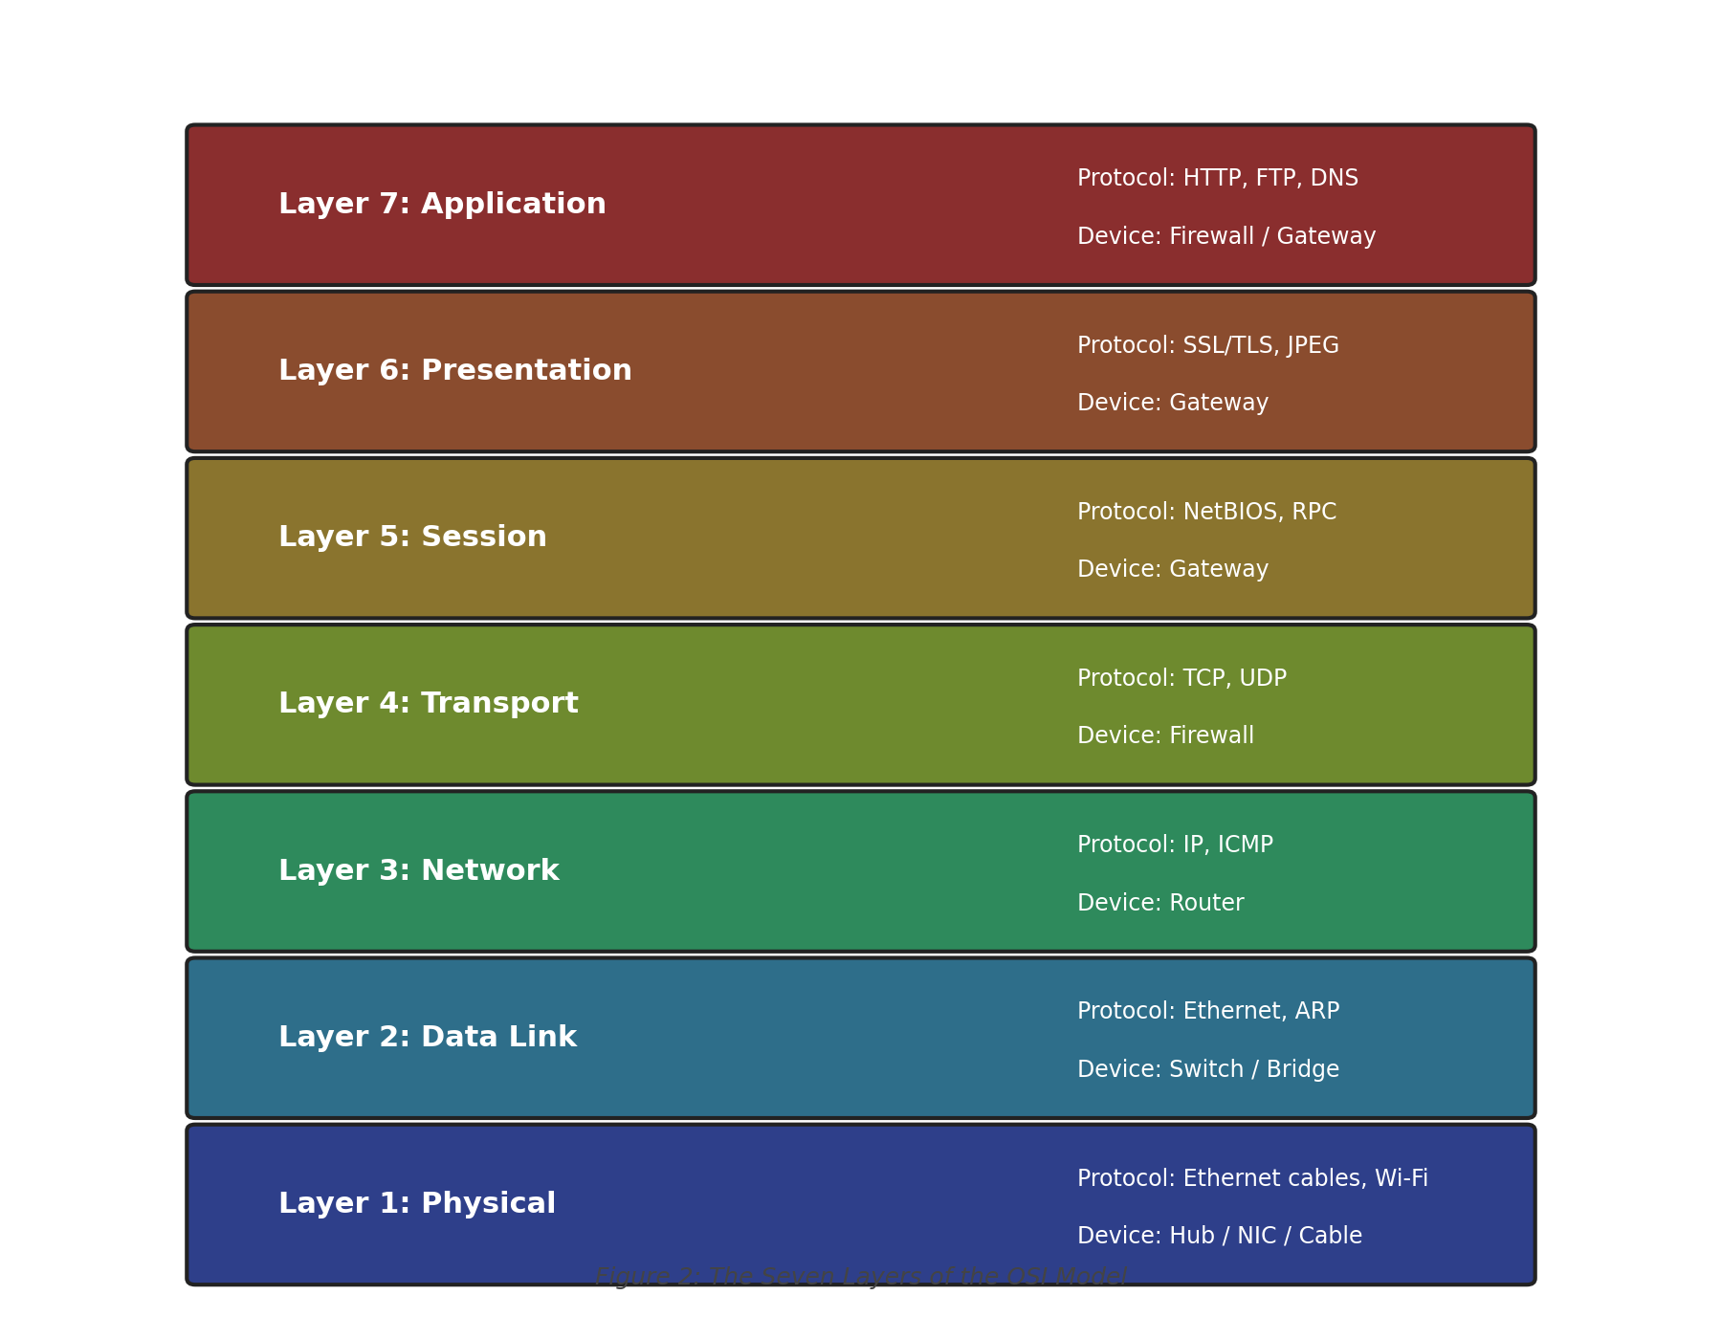
Figure 9: The seven layers of the OSI Model, from Application (Layer 7) down to Physical (Layer 1).
Layer | Primary Function | Protocol Example | Associated Device
7. Application | Provides network services directly to end-user applications (e.g., browsing, email). | HTTP / DNS | Firewall / Gateway
6. Presentation | Translates, encrypts, and compresses data between the application and the network. | SSL/TLS | Gateway
5. Session | Establishes, manages, and terminates sessions between two communicating devices. | NetBIOS / RPC | Gateway
4. Transport | Ensures reliable, end-to-end delivery of data with error checking and flow control. | TCP / UDP | Firewall
3. Network | Handles logical addressing and routing of packets between different networks. | IP / ICMP | Router
2. Data Link | Handles physical addressing (MAC) and reliable transfer of frames across a single link. | Ethernet / ARP | Switch / Bridge
1. Physical | Transmits raw bit streams over a physical medium (cables, radio signals). | Ethernet / Wi-Fi | Hub / NIC / Cable

7. Challenges
- Interpreting the large amount of output produced by ipconfig /all was initially difficult due to the number of virtual adapters (VMware VMnet1, VMnet8, TAP-Windows) alongside the physical Wi-Fi and Ethernet adapters.
- The tracert command occasionally timed out at intermediate hops, which required understanding that this is normal ISP router behavior (hops that block ICMP) rather than a fault.
- Distinguishing between IPv4 and IPv6 DNS resolution results in the nslookup output required additional research, since Google returned both an IPv6 and an IPv4 address.

8. Conclusion
This assignment provided practical, hands-on exposure to fundamental networking concepts and command-line diagnostic tools that are essential for a Cyber Security Analyst. Using ipconfig /all, ping, tracert, nslookup, and arp -a, the local network configuration was identified and basic connectivity to an external host (google.com) was verified and traced. The comparison of routers and switches, along with IPv4 and IPv6 addressing, reinforced theoretical understanding of how devices communicate at different layers of a network. Finally, mapping these tools and devices onto the seven layers of the OSI Model tied together the practical and theoretical aspects of the assignment, building a solid foundation for further study in network security and administration.

