IT SIMPLERA INSTITUTE
CYBER SECURITY ANALYST INTERNSHIP PROGRAM

WEEK 01 ASSIGNMENT
Cybersecurity Fundamentals & Security Concepts
Student Name: M. Azeem

OBJECTIVES
This project was designed to build a practical foundation in core cybersecurity concepts. The primary objectives were to:
- Develop cybersecurity fundamentals
- Learn the CIA Triad (Confidentiality, Integrity, Availability)
- Research real-world cyberattacks and analyze their impact
- Learn to use common cybersecurity tools
- Design a secure home network
- Improve technical documentation skills

Task 1: Five Real-World Cyberattacks
The five incidents below were selected to represent a range of attack types — from unpatched vulnerabilities and worm-based ransomware to supply chain compromise and long-term unauthorized access — and span roughly a decade of major breaches.

1. Equifax Data Breach (2017)
Organization: Equifax
Attack type: Web application exploit (unpatched Apache Struts vulnerability, CVE-2017-5638)
Description: Attackers exploited a known, unpatched vulnerability in the Apache Struts framework used on Equifax's online dispute portal. The flaw allowed remote code execution, giving attackers a foothold that let them move through the network undetected for months.
Impact: Personal data of approximately 147 million people was exposed, including Social Security numbers, birth dates, addresses, and some driver's license and credit card numbers. Equifax's stock dropped sharply, the CEO and other executives departed, and the company paid a large settlement.

2. WannaCry Ransomware Attack (2017)
Organization: Global (NHS in the UK, and organizations in 150+ countries)
Attack type: Ransomware / worm exploiting an unpatched Windows SMB vulnerability (Eternal Blue)
Description: WannaCry was a self-propagating ransomware worm that exploited a Windows Server Message Block (SMB) vulnerability to spread automatically between unpatched machines, encrypting files and demanding Bitcoin ransom payments.
Impact: Over 200,000 computers across roughly 150 countries were infected. The UK's National Health Service was hit especially hard, with hospitals cancelling appointments and diverting ambulances. Estimated global damages ranged into the billions of dollars.

3. SolarWinds / SUNBURST Supply Chain Attack (2020)
Organization: SolarWinds and roughly 18,000 downstream customers, including multiple U.S. federal agencies
Attack type: Software supply chain compromise
Description: A suspected Russian state-sponsored group inserted malicious code (SUNBURST) into legitimate software updates for SolarWinds' Orion network monitoring platform. Customers who installed the trojanized update unknowingly gave the attackers a backdoor into their networks.
Impact: Thousands of organizations downloaded the compromised update, including several U.S. federal agencies (Treasury, Commerce, Homeland Security). Recovery and forensic costs across affected organizations totaled tens of millions of dollars, and the incident significantly damaged trust in software supply chains.

4. Colonial Pipeline Ransomware Attack (2021)
Organization: Colonial Pipeline Company
Attack type: Ransomware (Dark Side group)
Description: Attackers gained access through a compromised password on an inactive VPN account that did not have multi-factor authentication enabled. They deployed ransomware against Colonial Pipeline's IT systems, prompting the company to proactively shut down pipeline operations to contain the threat.
Impact: The pipeline, which carries roughly 45% of the East Coast's fuel supply, was shut down for several days, causing fuel shortages, panic buying, and price spikes. Colonial Pipeline paid a ransom of 75 bitcoin (about $4.4 million); U.S. authorities later recovered a portion of it.

5. Marriott / Starwood Guest Reservation Breach (2018 (discovered; intrusion began 2014))
Organization: Marriott International (Starwood guest reservation database)
Attack type: Unauthorized network access / long-term data exfiltration
Description: Attackers had unauthorized access to the Starwood reservation system for roughly four years before discovery, quietly extracting guest data during that period.
Impact: Approximately 500 million guest records were exposed, including names, contact information, passport numbers, and encrypted payment card details for some guests. Marriott faced regulatory fines and significant reputational damage.

Task 2: CIA Triad Analysis
The CIA Triad — Confidentiality, Integrity, and Availability — is the foundational model used to evaluate the security impact of an incident.
The table below maps each attack from Task 1 to the CIA component(s) it primarily violated.
Attack | CIA Component(s) Violated | Explanation
Equifax Data Breach (2017) | Confidentiality | Attackers accessed and exfiltrated sensitive personal data (SSNs, birth dates, addresses) that should have remained private. This is a textbook confidentiality violation — unauthorized parties gained access to protected information.
WannaCry Ransomware (2017) | Availability (with a secondary Integrity impact) | By encrypting files and locking users out of their own systems, WannaCry directly attacked availability — legitimate users could no longer access their data or systems. The encryption process also altered files, touching on integrity.
SolarWinds / SUNBURST (2020) | Confidentiality and Integrity | The attackers modified trusted software (an integrity violation of the update itself) in order to gain covert access and exfiltrate sensitive government and corporate data (a confidentiality violation).
Colonial Pipeline (2021) | Availability | The ransomware attack forced the company to shut down pipeline operations entirely, denying legitimate access to a critical service. The primary harm was the inability to deliver fuel, not data theft.
Marriott / Starwood Breach (2018) | Confidentiality | The core failure was unauthorized, long-term access to guest personal and payment data. Sensitive information was exposed to parties who should never have had access to it.

Task 3: Cybersecurity Tools
Three widely used cybersecurity tools were explored hands-on: Wireshark (network traffic analysis), Nmap (network scanning and reconnaissance), and Burp Suite (web application security testing).
Screenshots from each tool are included below along with an explanation of their purpose, function, and a practical use case.

Wireshark
Purpose: A free, open-source network protocol analyzer used to capture and inspect traffic moving across a network in real time.
How it functions: Wireshark captures packets at the network interface and decodes them layer by layer (Ethernet, IP, TCP/UDP, and application-layer protocols like HTTP and DNS), letting an analyst see exactly what data is being sent, where it is going, and whether it is encrypted.
Use case: In the screenshot below, Wireshark is being used to inspect a DNS response for a Netflix CDN hostname (cdn-0.nflximg.com), showing the query, the resolved CNAME records, and surrounding TCP/HTTP traffic. Analysts use this kind of packet-level visibility to troubleshoot connectivity issues, detect suspicious traffic patterns, and investigate incidents such as data exfiltration or command-and-control communication.
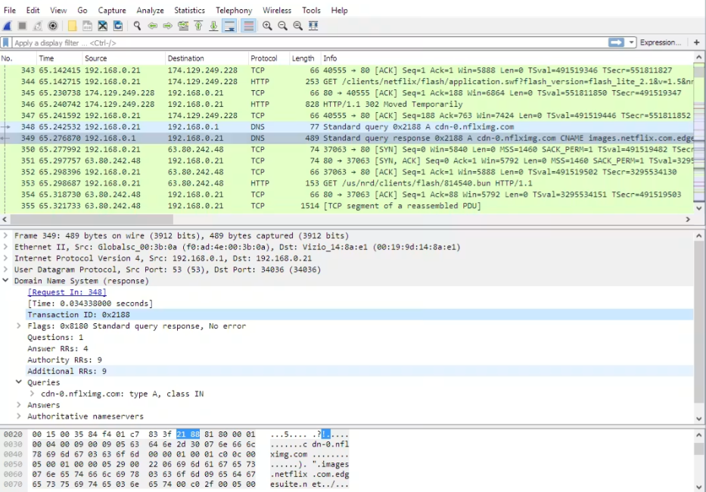
Figure 1: Wireshark capturing and decoding DNS and HTTP traffic between a host and a CDN.

Nmap (Network Mapper)
Purpose: A free, open-source tool used to discover hosts and services on a network, commonly used for network mapping and security auditing.
How it functions: Nmap sends specially crafted packets to target hosts and analyzes the responses to determine which ports are open, what services are running on them, and often the operating system of the target device (OS fingerprinting).
Use case: The screenshot below shows an Nmap OS detection scan ("nmap -O") against a local router (192.168.1.1). The output identifies open ports (53, 80, 5000, 8200, 20005), the associated services, the device's MAC address vendor (Netgear), and an estimate of the Linux kernel version running on the device. Security analysts use this kind of scan to build an inventory of devices and exposed services on a network and to identify unnecessary open ports that could be attack surfaces.
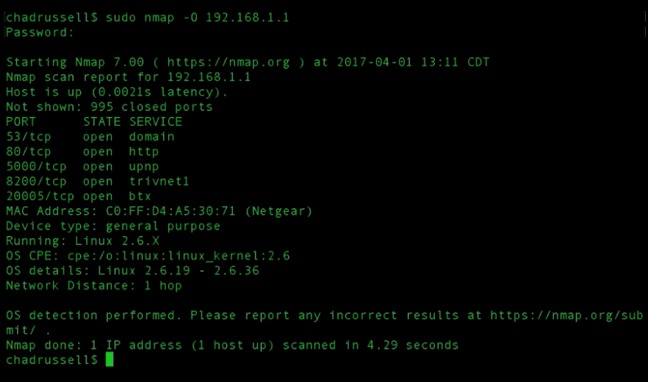
Figure 2: Nmap performing an OS detection scan against a home router. [Placeholder for Image]

BurpSuite
Purpose: A widely used web application security testing platform, primarily used for finding and exploiting vulnerabilities in web applications.
How it functions: Burp Suite acts as an intercepting proxy between a browser and a web server, letting an analyst capture, inspect, and modify HTTP/HTTPS requests and responses. Its Proxy "HTTP history" tab logs every request the browser made, along with the full request and response, so testers can analyze application behavior in detail.
Use case: The screenshot below shows Burp Suite's HTTP history for a website, listing each GET request, its status code, response length, and MIME type, with the raw request and response payloads shown for a selected item. Analysts use this to manually test for vulnerabilities such as injection flaws, broken authentication, or insecure data exposure during a penetration test.
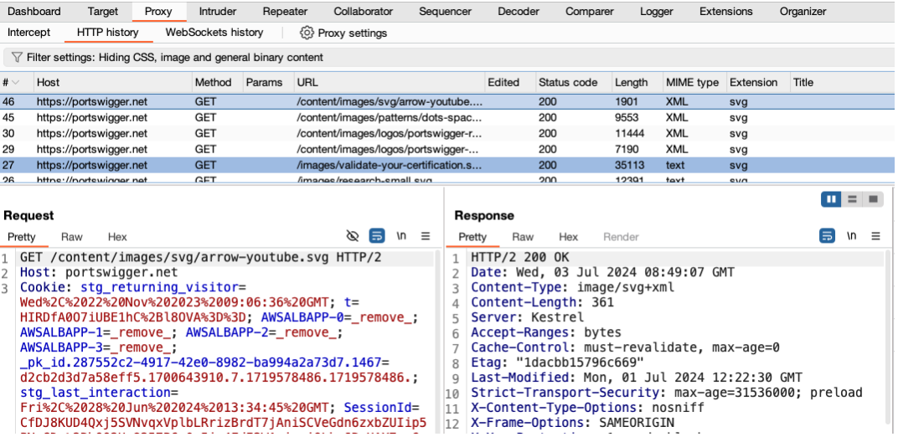
Figure 3: Burp Suite's Proxy HTTP history showing intercepted web requests and responses.

Task 4: Secure Home Network Diagram
The diagram below illustrates a secure home network architecture. Traffic flows from the internet through the ISP modem into a router/firewall, which performs Network Address Translation (NAT), enforces firewall rules, and broadcasts a WPA3-secured Wi-Fi network.
Devices are logically separated: trusted personal devices sit on the main network, IoT devices are isolated on their own VLAN/SSID to limit lateral movement if compromised, and guest devices connect through a fully isolated guest network with no access to the internal LAN.
An optional VPN can be layered on the router to encrypt outbound traffic.
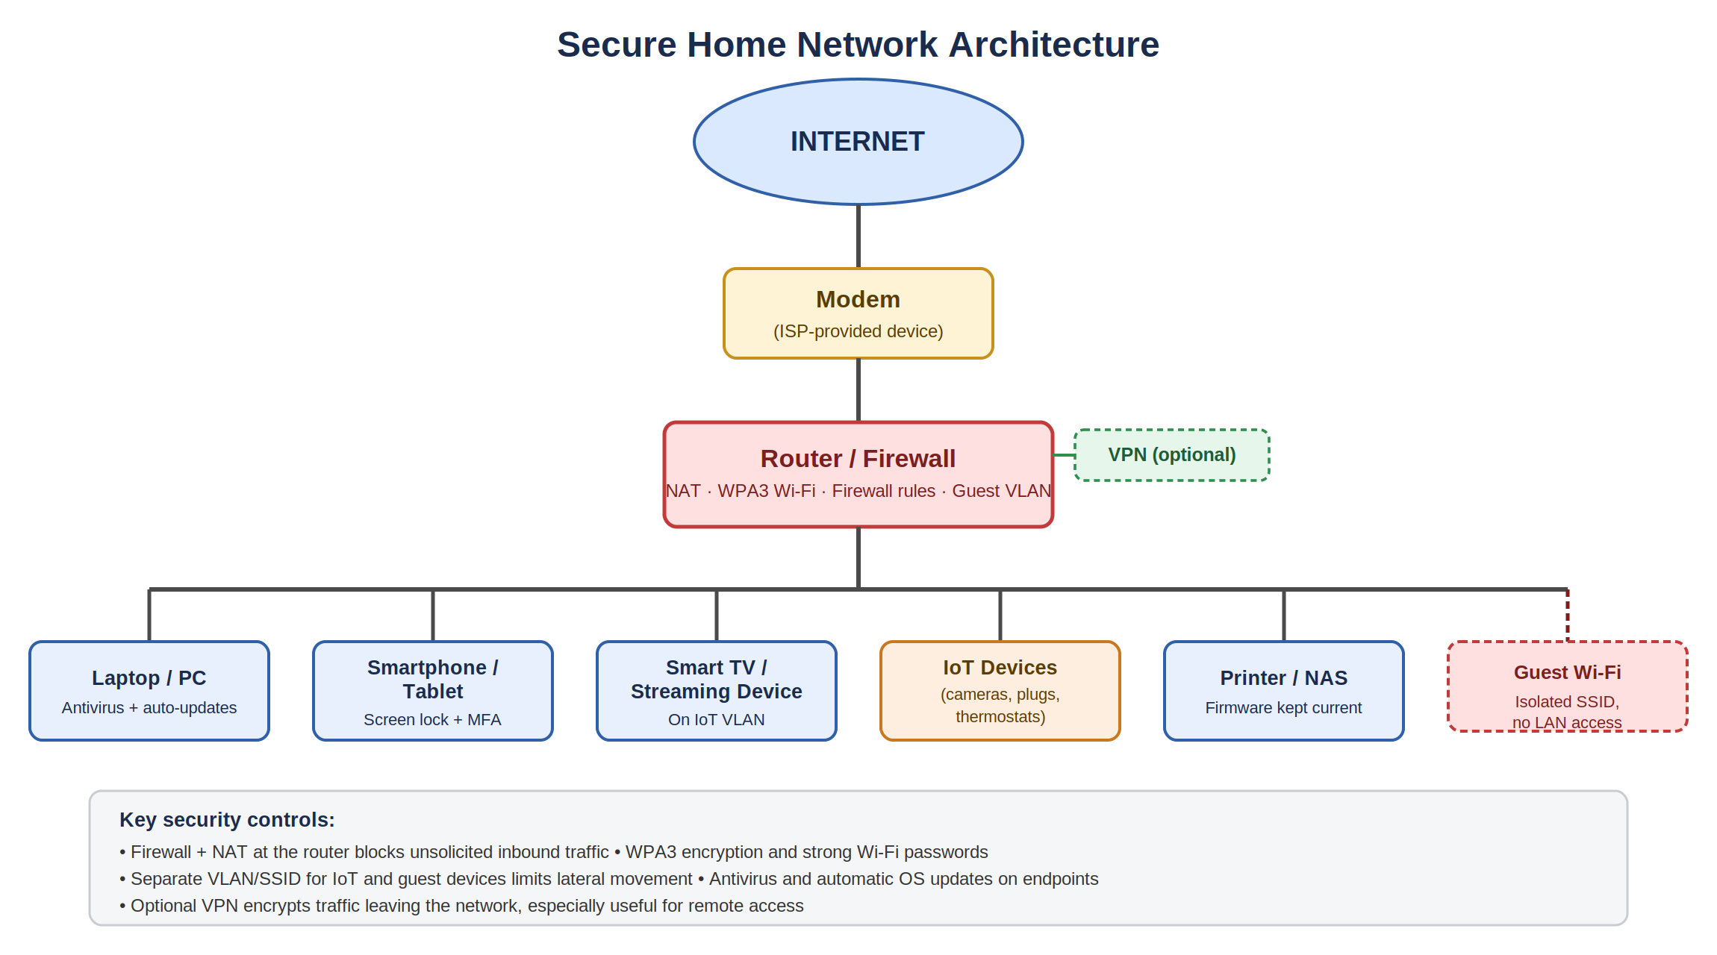
Figure 4: Secure home network architecture with segmented IoT and guest networks.

Key design principles applied:
- Network segmentation — IoT devices and guests are isolated from personal devices and each other, so a compromised smart device or guest laptop cannot directly reach a personal PC or NAS.
- Strong perimeter defense — the router/firewall performs NAT and blocks unsolicited inbound connections from the internet.
- Encrypted Wi-Fi — WPA3 with a strong, unique passphrase protects the wireless network from unauthorized access.
- Endpoint protection — antivirus software and automatic OS/firmware updates are applied to all capable devices.
- Optional VPN — encrypts traffic leaving the network, which is especially useful when connecting to the home network remotely.

Task 5: What Does a Cybersecurity Analyst Do Every Day?
A cybersecurity analyst's day typically begins with reviewing overnight alerts generated by monitoring tools such as SIEM (Security Information and Event Management) platforms, intrusion detection systems, and endpoint protection software.
The analyst triages these alerts, separating false positives from events that warrant deeper investigation, and prioritizes them based on potential severity and business impact.
Throughout the day, much of the work involves investigation: examining logs, network traffic, and system behavior to understand whether an alert represents a genuine threat.
Tools like Wireshark may be used to inspect suspicious network traffic, while Nmap or vulnerability scanners help maintain an accurate picture of what devices and services exist on the network and where weaknesses may be.
When testing the security of internally developed or third-party web applications, an analyst might use a tool like Burp Suite to probe for vulnerabilities before attackers can exploit them.
Analysts also spend time on proactive work: applying and verifying security patches, reviewing firewall and access control rules, participating in vulnerability management cycles, and updating documentation such as incident response playbooks and network diagrams.
Many organizations require regular reporting, so analysts summarize findings for technical teams and, at times, for non-technical stakeholders or management.
Communication and collaboration are a constant thread — coordinating with IT teams to remediate vulnerabilities, working with other analysts during active incidents, and staying current on emerging threats through threat intelligence feeds and security research.
When a genuine incident occurs, the analyst's day shifts to incident response: containing the threat, gathering evidence, coordinating remediation, and later helping produce a post-incident report so the organization can learn from what happened.
In short, a cybersecurity analyst's daily work blends routine monitoring and maintenance with investigative problem-solving, and requires constant learning, since new threats, tools, and defensive techniques emerge continuously.

