 | 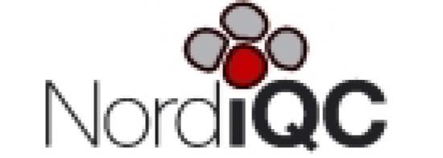
03022, Kyiv, str. Vasylkivska, 45  Phone: 0 800 33 00 75, 044 333 71 75  www.csdlab.ua, e-mail: csd@csd.com.ua | The laboratory is a member of the European quality control system
Pathohistological study

Patient data | Data about the doctor | Research data
Patient's name: Zherlitsyna Anastasiia  Stanislavivna | Doctor's name: Oksana Mykolaivna  Latsinnikova | Research no.: 23CN007785
Date of birth: 25.04.1976 | Institution: Private doctor (Kyiv region) | Collection date: 04.05.2023
Sex: female | Department: | Received date: 04.05.2023
 |  | Date of reply: 10.05.2023

Clinical data
Date and time of operation |  | Operation type | Tru-cut biopsy of the lesion of the liver.
Clinical diagnosis | Uterine sarcoma, metastases to the liver.

Pathomorphological conclusion
Diagnosis | Metastasis of gastrointestinal stromal tumor to liver tissue (ICD-O code 8936/3).

Microscopic description
The material contains fragments of a tumor consisting of elongated tumor cells forming short bundles intersecting in different directions. The cells of the tumor with indistinct borders, cytoplasm is eosinophilic, ovoid or slightly elongated nuclei, some have vacuoles. There are mitotic figures in the tumor.
There is not enough material for immunohistochemical examination in the provided paraffin block, so the immunohistochemical examination was performed on fragments of histological material on the provided slide 48278/22. In the immunohistochemical study, tumor cells are positive for CD117, DOG-1. Therefore, the histological picture and immunophenotype of the tumor cells correspond to a metastasis of a gastrointestinal stromal tumor.

Immunohistochemical studies
Slide 48278/22:
CD117 (c-kit) (DAKO, polyclonal ones) – a positive reaction in tumor cells;
DOG-1 (Diagnostic Biosystems, clone DOG1.1) - a positive reaction in tumor cells.

Comments
The material on histological slide 48278/22 is divided into 2 parts: one left with hematoxylin-eosin staining (a new slide label was assigned); an immunohistochemical study was performed on another half of it.

O.O. Koshyk | 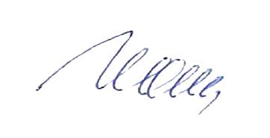 | 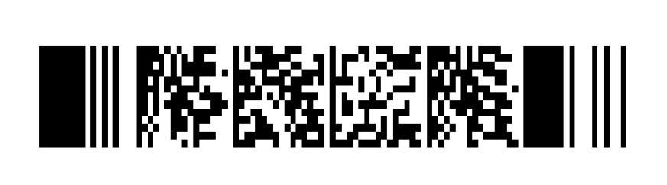
23CN007785 | Zherlitsyna Anastasiia Stanislavivna | 1/1
License of the Ministry of Health of Ukraine АВ526963 dated 25.02.2010. ISO 9001:2015 certificate, registration number 12 100 62151 TMS - valid: 06/21/2021 to 06/20/2024. DSTU ISO 9001:2015 registration number 10021060 TMS - valid:
06/10/2021 to 06/09/2024

