Patient's name: | Anastasia Stanislavivna Zherlitsyna |  | 
Sex: | Female | Date of birth: 25.04.1976

The date of the analysis:  Doctor: | 01.04.2024 11:21 | Registration number: | 3000093103241516592747
Research results
Name of the study |  | Result | Measurement  units | Reference values
 | Folic acid (vitamin B9) | 5.85 | ng/ml | 3.2 - 19.6
 | Ferritin | 48.2 | ng/ml | 5.0 - 148.0
 | Vitamin B12 (cyanocobalamin) | 442.30 | pg/ml | 180.0 - 916.0
Package No. 01.06 "Thyroid" (TSH, T3, T4)
 | Free triiodothyronine (free T3) | 3.04 | pg/ml | Adults: 1.8 - 4.2  Children:  4-30 days: 1.9 - 5.0  2-12 months: 1.4 - 6.1  2-6 years: 1.9 - 5.7  7-11 years: 2.6 - 5.0  12-19 years: 2.2 - 4.8
 | Free thyroxine (free T4) | 1.28 | ng/dL | Adults: 0.8 - 1.9  Pregnant women:  1st trimester: 0.86 - 1.87  2-3rd trimester: 0.64 - 1.92  Children:  1-12 years: 0.65 - 2.3

Head of the laboratory: Samosyuk N.O. |  | Date of readiness: | 01.04.2024 18:39
The results of laboratory tests are not a diagnosis, they require a doctor's consultation and interpretation
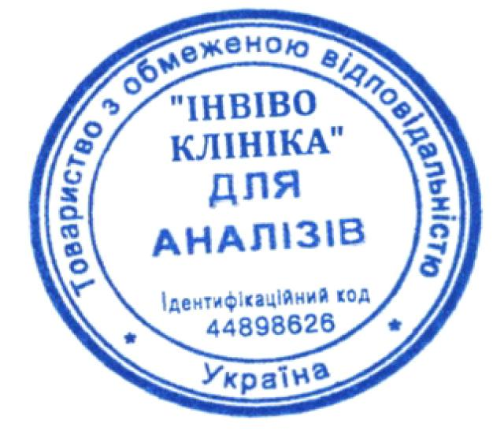
Patient's name: | Anastasia Stanislavivna Zherlitsyna
Sex: | Female | Date of birth: 25.04.1976

The date of the analysis:  Doctor: | 01.04.2024 11:21 | Registration number: | 3000093103241516592747
Research results
Name of the study |  | Result | Measurement  units | Reference values
 | Thyroid-stimulating hormone (TSH) | 0.92 | μIU/ml | Adults: 0.35 - 5.1  Pregnant women:  1st trimester: 0.05 - 4.73  2nd trimester: 0.30 - 4.79  3rd trimester: 0.50 - 6.02  Children:  0-12 months: 1.66 - 10.73  1-6 years: 1.04 - 7.93  7-12 years: 0.34 - 5.24
Package note: |  | Package No. 01.06.
Package No. 16.29 "Total iron-binding capacity of serum" (TIBC, Iron, % transferrin saturation with iron)
 | Total iron-binding capacity of serum (TIBC, Iron, % transferrin saturation with iron)
 | Iron | 22.26 | μmol/l | 9.0 - 30.4
 | Total iron-binding capacity of serum (TIBC) | 63.80 | μmol/l | 44.8 - 76.1
 | Unsaturated iron-binding capacity (UIBC) | 41.54 | μmol/l | 32.0 - 46.0
 | The percentage of saturation of transferrin with iron | 35 | % | 15 - 50
Package note: |  | Package No. 16.29.

Head of the laboratory: Samosyuk N.O. |  | Date of readiness: | 01.04.2024 18:39
The results of laboratory tests are not a diagnosis, they require a doctor's consultation and interpretation

