GUV-CFD Simulation Report
Illuminate room design file: C:\Users\hukcl\Documents\1work\222\Collaboration projects\South Africa\TB project\simulation files\patient ward 4B1 v4.guv
CFD Project file: C:\Users\hukcl\Documents\1work\222\Collaboration projects\South Africa\TB project\simulation files\patientwardV6.guvcfd
OpenFoam directory: //wsl.localhost/Ubuntu/tmp/decay_ach6_z7_uv
Simulation date | 2026-07-23 18:34
Total elapsed time | 14h 48m 45s
CPU | 12th Gen Intel(R) Core(TM) i7-1255U
RAM | 15.7 GB
GPU | Intel(R) Iris(R) Xe Graphics (not used - this simulation's OpenFOAM solve is CPU-only)

Room Setup
Room dimensions | 3.2 x 4.8 x 2.57 meters
Lamps | 4
Ventilation ACH | 6 /hr
UV inactivation constant Z | 7 cm²/mJ
Inlet | xMax, y=1.2m z=2.4m, size=0.6x0.3m
Outlet | xMax, y=1.2m z=1.3m, size=0.6x0.3m
Inlet 2 | xMax, y=3.6m z=2.4m, size=0.6x0.3m
Outlet 2 | xMax, y=3.6m z=1.3m, size=0.6x0.3m
Injection point | (0.4, 1.2, 1.3) m
Monitoring point: Patient | (0.45, 3.6, 1.2) m, box=2 cells/side
Monitoring point: exhaust | (3.2, 1.2, 1.4) m, box=3 cells/side

Case Setup
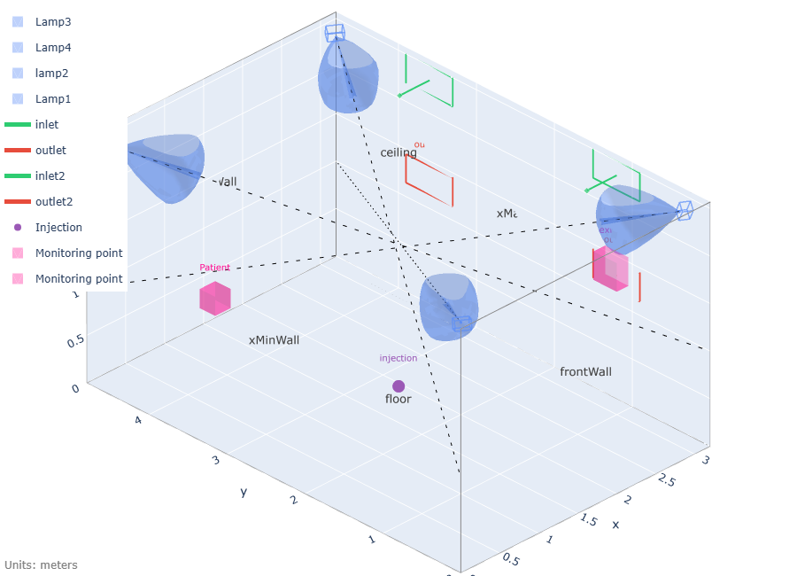

Convergence & Trust
Flow field | Not available (older run, or flow convergence was skipped)
Ventilation delivery | 5.93/hr measured vs 6/hr nominal (99%) - OK

Results
Note: T is the OpenFOAM field name for the transported scalar this whole simulation tracks - the substance being reduced, per unit volume. In a GUV disinfection context this is typically a pathogen concentration, e.g. CFU/m³ (colony-forming units per cubic meter) or an equivalent airborne-contaminant unit; the CFD itself is unit-agnostic and just tracks relative concentration.

Room Settings
Average fluence rate | 2.869 µW/cm²
Susceptibility constant Z (cm² / mJ) | 7.0
Set well-mixed steady-state T (entire volume) | 1
Calculated eACH | 72.31 /hr

Results from Decay mode analysis
ACH (air) measured | 5.932 /hr
Effective ACH_{eff} CFD measured | 4.197 /hr
ACH efficiency | 70.7%
eACH_{eff} CFD measured | 34.7 /hr
Total Room ACH_{eff}+eACH_{eff} | 38.9 /hr

Analysis of simulations
Total average Pathogen reduction in room per hour | 89.2%
Room pathogen removal efficacy | 49.7%
Total ACH in room (ACH+eACH_uv) | 78.31 /hr

UV Germicidal Effectiveness
True UVGI Effectiveness | 89.2%

Monitoring Results
Patient pathogen reduction | 89.2%
Exhaust pathogen reduction | 89.1%
Note: the room is NOT well mixed - 'Patient' is 86% below the room average (Phase 1); 'exhaust' is 102% above the room average (Phase 1); 'Patient' is 100% below the room average (Phase 2); 'exhaust' is 20% above the room average (Phase 2). Room-average volAverage(T) should not be read as representative of concentration at any specific location; use the monitoring-location values for occupant-specific exposure estimates instead.

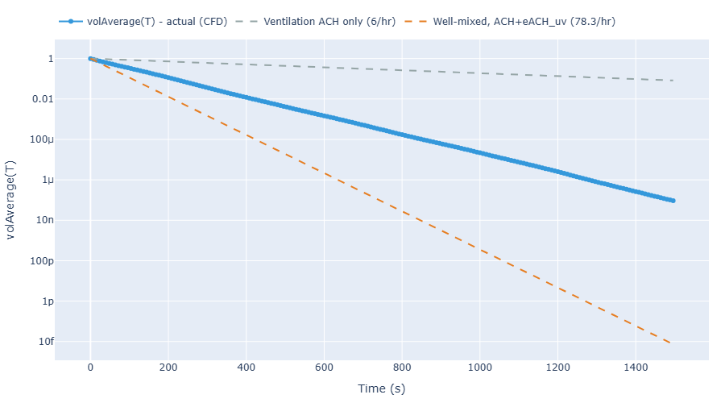
Note: the effective/measured ventilation ACH above is not the airflow rate delivered by the inlet - that's fixed at the nominal design ACH by the boundary condition. It's the well-mixed-equivalent rate implied by Phase 1's room-average steady-state concentration, and reads lower than nominal when the room mixes imperfectly (e.g. inlet/outlet short-circuiting on the same wall).

Assuming well mixed condition eACH = Z*Eavg
Mass balance -air in vs. air out – is an indication of how good the model settled
This measures the actual T removal by air, in not well mixed conditions will be different to (lower) that nominal ACH.
Gives an indication how well the air is mixed
The actual eACH value from the CFD run
Based on steady state calculation taking eACH_{eff} and ACH_{eff} into account
= (ACH_{eff} + eACH_{eff} ) / ( ACH + eACH) – shows the real efficiency of the setup (CFD) vs. nominal values of ACH and eACH
This is a value showing the effectiveness of UV over mechanical ventilation alone. See “Miller, Shelly L. / MacHer, Janet M.; Evaluation of a Methodology for Quantifying the Effect of Room Air Ultraviolet Germicidal Irradiation on Airborne Bacteria; 2000-09; Aerosol Science and Technology , Vol. 33, No. 3 Taylor & Francis; p. 283” ; E= 1- (T_{SS2}/T_{SS1}-T_{SS2}) or E= 1-(eACH/(ACH_{eff}+eACH)
Based on steady state calculation

