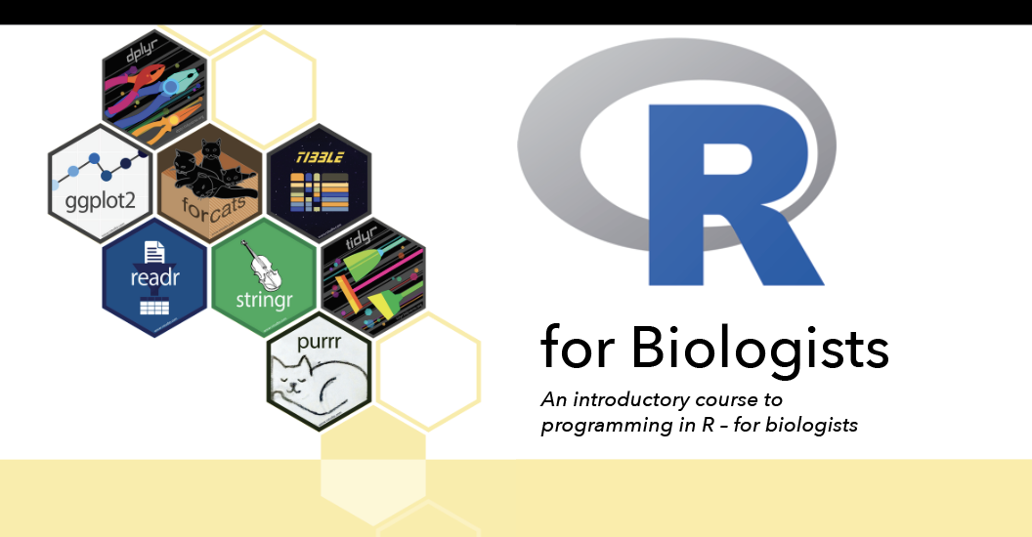

Day 1 (25th January 2024, 9am-12pm)

* Introduction to the R programming language
* Scripting with R markdown

Day 2 (26th January 2024, 9am-12pm)

* Data-wrangling with the tidyverse
* Data visualization with ggplot2

Day 3 (27th January 2024, 9am-12pm)

* Basic statistics in R
* Bring your own data!

*Course description*

This course is aimed at biologists who wish to learn how to use R for data analysis. Participants are expected to have little to know experience using R, but are familiar with different types of biological data and basic statistics. This course will introduce participants to the R programming language provide a crash-course on how to use this tool for data wrangling, visualization and basic statistical testing. Participants who have specific interests/needs (such as those working with phylogenetic, GIS, sound recordings or other types of biological data) are encouraged to bring datasets with them.

Participants are required to bring their own laptop with at least 4Gb of RAM and a processor with at least 2 cores (e.g. minimum Intel Core i3 or similar). An internet connection is required. Prior to the course, participants should have installed both R and RStudio (2 programs), following the instructions here: <https://posit.co/download/rstudio-desktop/>. These are free software and are be available for Windows, Mac, and Linux.

*Course Organizers:*

John Lyakurwa, Simon Loader, Christoph Liedtke