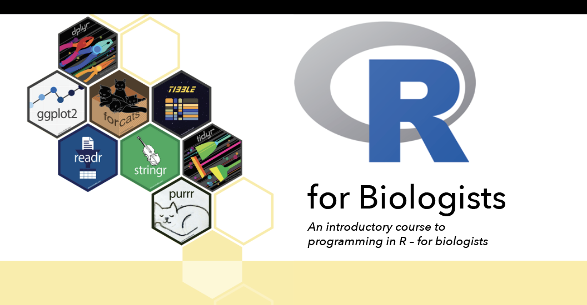

**Day 1** (24th January 2024, 9am-12pm)

* Introduction to the R programming language
* Scripting with R markdown

**Day 2** (25th January 2024, 9am-12pm)

* Data-wrangling with the tidyverse
* Data visualization with ggplot2

**Day 3** (26th January 2024, 9am-12pm)

* Basic statistics in R
* Bring your own data!

*Course description*

This course is aimed at biologists who wish to learn how to use R for data analysis. Participants are expected to have little to no experience using R, but are familiar with different types of biological data and basic statistics. This course will introduce participants to the R programming language provide a crash-course on how to use this tool for data wrangling, visualization and basic statistical testing. Participants who have specific interests/needs (such as those working with phylogenetic, GIS, sound recordings or other types of biological data) are encouraged to bring datasets with them.

Participants are required to bring their own laptop with at least 4Gb of RAM and a processor with at least 2 cores (e.g. minimum Intel Core i3 or similar) and a working internet connection.

**This course is free, but places are limited.** Please fill in [this form](https://forms.gle/iJsfv1B3Vfxr9EJ26) before the **31/12/2023** to request your attendance. Selected candidates will be informed by the 07/01/2024.

*Course locations:*

Department of Zoology and Wildlife Conservation, University of Dar es Salaam

*Course Organizers:*

John Lyakurwa – UDSM

Christoph Liedtke – Biological Station of Doñana, Spain

Simon Loader – Natural History Museum, United Kingdom