Conductor Agent Platform
Infrastructure Setup, Access Requests and Runbook

AWS - EKS - ECR - RDS PostgreSQL - Bedrock - CI/CD - Observability
From a blank account to a running, monitored agent: what to decide, what to request, what to fill in, and which steps to apply.

Field | Value
Document owner
Version / date | Draft 0.1 - 11 Oct 2026
Environments covered | dev, stage, prod
Primary runtime | EKS (AgentCore as an optional second runtime)
Status | Draft - to be completed as access is granted

How to read the markers
[U] = not verified by the author against a real account or current vendor docs. Check it before relying on it.
Yellow cells are for you to fill in. Dashed frames are for real screenshots that you capture as you complete each step.
Diagrams in this document are drawn illustrations, not AWS console screenshots. Real screenshots cannot be taken until an account exists, so each frame names the console page to capture.

Contents

1. What you are building
The agent runs as short, resumable jobs on a private Kubernetes cluster. All durable state lives in PostgreSQL, so a pod or node can die at any time without losing finished work. Models are called through Amazon Bedrock over a private endpoint. Nothing is exposed to the internet.
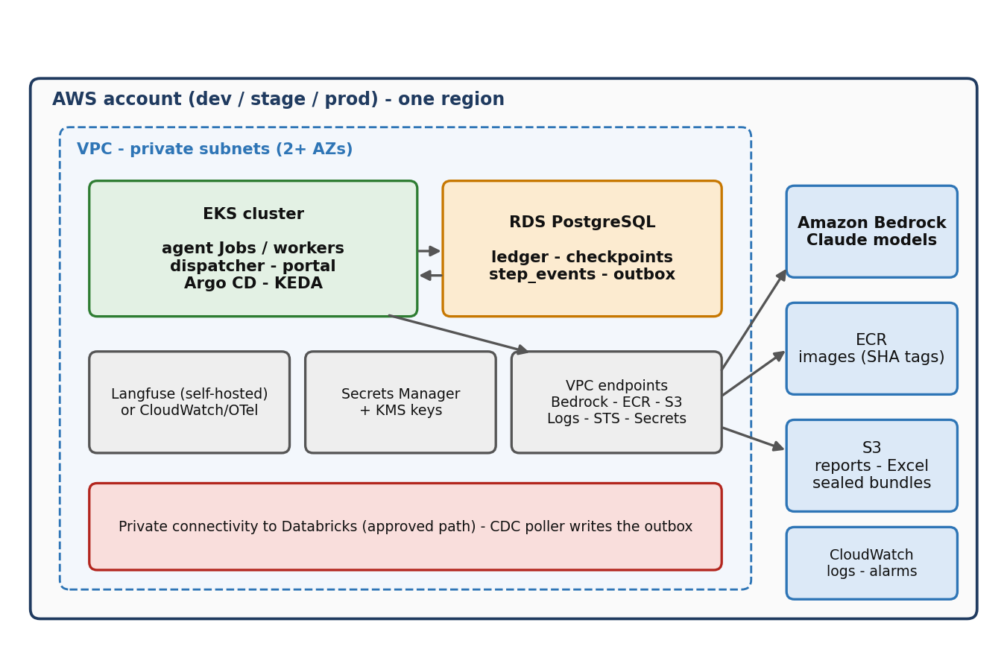
Figure 1. Target architecture inside one AWS account (repeat for dev, stage, prod)

1.1 Components and owners
Component | Purpose | Usually owned by
AWS account + SSO roles | Isolation per environment, human and CI access | Cloud platform
VPC, subnets, endpoints | Private network; no public internet path | Network team
EKS cluster + nodes | Runs the agent Jobs, dispatcher, portal | Platform team (you consume)
ECR | Stores container images (tag = git SHA) | Platform team / you
RDS PostgreSQL | Ledger, checkpoints, step events, outbox | Platform team + you (schema)
S3 + KMS | Reports, Excel files, sealed bundles | Platform team
Secrets Manager | Database credentials, service principals | Platform + security
Bedrock | Claude model calls, with quotas | Cloud platform
Databricks link | Source of changed case data | Data platform + network
CI/CD + Argo CD | Build, scan, deploy, roll back | DevOps / you
Observability | Logs, metrics, alerts, traces | Platform + you

1.2 How a case flows at runtime
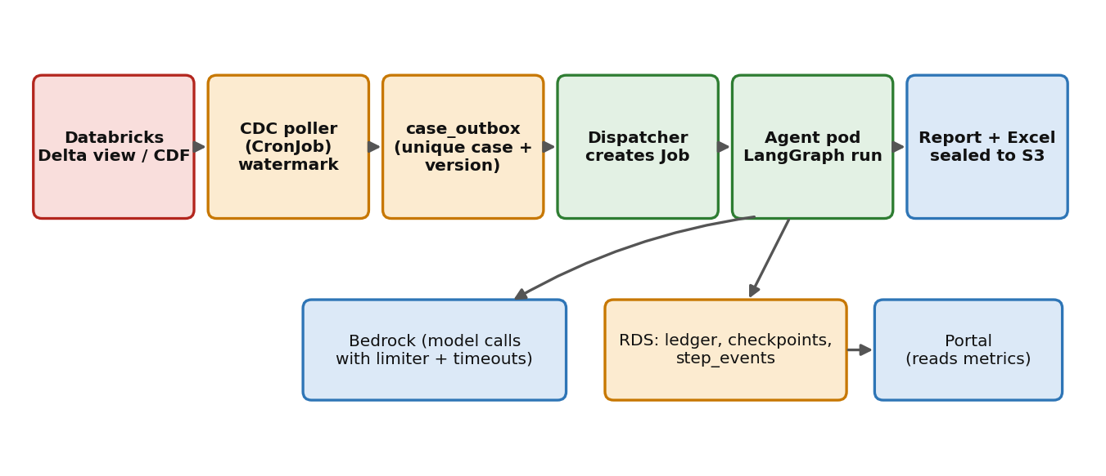
Figure 2. Runtime data flow: from a Databricks change to a sealed report

2. Plan on a page
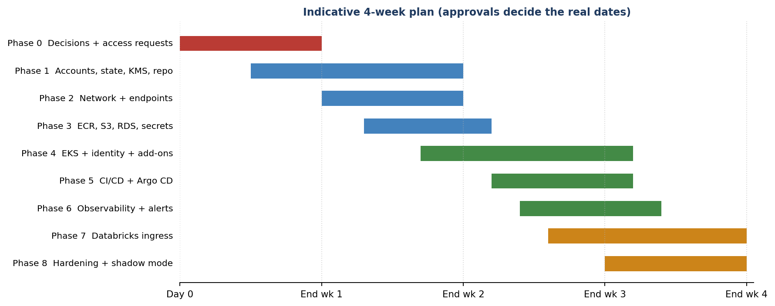
Figure 3. Indicative four-week plan. Approvals, not engineering, set the real dates.
Critical path
The items that usually take longest are not technical: account creation, Bedrock model access and quotas, network endpoints, private connectivity to Databricks, security review, and model risk approval.
Send those requests on day 1 and track them in Section 5.

2.1 Order of work
Phase | Goal | Week | Depends on
0 | Decisions made, access requests sent | 1 | -
1 | Accounts, Terraform state, KMS keys, repo layout | 1-2 | Phase 0 approvals
2 | Network: VPC, subnets, endpoints, Databricks path | 2 | Network team
3 | ECR, S3, RDS, Secrets Manager, schema | 2 | Phase 1, 2
4 | EKS, pod identity, add-ons, policies | 2-3 | Phase 2, 3
5 | CI/CD pipeline and Argo CD | 3 | Phase 3, 4
6 | Observability, alerts, budgets | 3 | Phase 4
7 | Databricks ingress (poller, outbox, dispatcher) | 3-4 | Phase 2, 3, 4
8 | Hardening, drills, shadow mode | 4 | All

3. Step A - Decision sheet (fill in first)
Make and record these decisions before provisioning anything. The recommended default is what the rest of this document assumes.
# | Decision | Options | Recommended default | Your decision | By / date
D1 | Environments | dev only / dev+prod / dev+stage+prod | dev, stage, prod (separate accounts if allowed)
D2 | AWS region | Any with Bedrock models you need | One primary region; check model availability first
D3 | Primary runtime | EKS / AgentCore / both | EKS first; AgentCore optional after the Case B test
D4 | Database | RDS PostgreSQL / Aurora PostgreSQL | RDS PostgreSQL, Multi-AZ in stage and prod
D5 | Trace store | Langfuse self-hosted / CloudWatch + OTel | Decide after the PII rule (D9)
D6 | IaC tool | Terraform / CDK / platform standard | Whatever the platform team mandates
D7 | CI system | GitHub Enterprise Actions / other | Bank standard CI
D8 | Node architecture | arm64 (Graviton) / x86 | Match the image build; check what the platform offers
D9 | What traces and logs may contain | Full prompts / masked / IDs only | Masked; no raw PII in logs
D10 | Data retention | Ledger, outputs, traces: how long | Per bank retention policy
D11 | Release approach | Big-bang / shadow then limited live | Shadow mode first, then one data type live
D12 | Human review path | Queue + portal / ticket system | Queue in the portal with audit log

4. Step B - Information intake sheet (collect and fill in)
These are the values the setup steps need. Collect them from the teams named, write them in the yellow cells, and keep this sheet with the project. Never write secrets here: record where a secret is stored, not the secret.

4.1 Cloud and identity
Item | Where to get it | Example format | Your value
AWS account ID - dev | Cloud platform team | 12-digit number
AWS account ID - stage | Cloud platform team | 12-digit number
AWS account ID - prod | Cloud platform team | 12-digit number
Region | Decision D2 | e.g. us-east-1
SSO start URL | Cloud platform team | https://<org>.awsapps.com/start
SSO role names | Cloud platform team | e.g. DevPowerUser, ReadOnly
CI role ARN | Cloud platform / DevOps | arn:aws:iam::<acct>:role/<name>
Cost center / tag values | Finance / platform | env, app, owner, cost-center

4.2 Network
Item | Where to get it | Example format | Your value
VPC ID and CIDR | Network team | vpc-0abc... / 10.x.0.0/16
Private subnet IDs - app (A, B) | Network team | subnet-0abc...
Private subnet IDs - data (A, B) | Network team | subnet-0abc...
Private subnet IDs - endpoints (A, B) | Network team | subnet-0abc...
Route table ID(s) | Network team | rtb-0abc...
Existing VPC endpoints | Network team | list of service names
Private path to Databricks | Network + data platform | PrivateLink / peering / TGW
Internal DNS / domain for the portal | Network team | conductor.<env>.<internal domain>

4.3 Models, data and source control
Item | Where to get it | Example format | Your value
Bedrock model IDs enabled | Cloud platform | model / inference profile IDs
Bedrock quotas (requests/min, tokens/min) | Service Quotas console | numbers per model
Databricks workspace URL | Data platform team | https://<workspace>.cloud.databricks.com
Source table/view and catalog path | Data platform team | catalog.schema.view
Databricks service principal name | Data platform team | sp-conductor-<env>
GitHub Enterprise org/repo - infra | DevOps | <org>/conductor-infra
GitHub Enterprise org/repo - agent | DevOps | <org>/conductor-agent
ECR repo names | Platform / you | conductor-agent, -dispatcher, -portal
On-call channel / alert email | Operations | channel or distribution list
Data classification label | Security / privacy | e.g. Confidential - PII

5. Step C - Access and approval requests
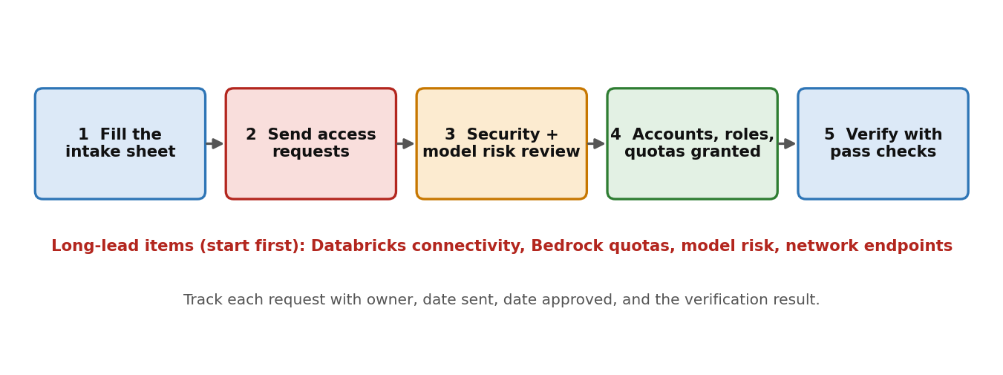
Figure 4. Request workflow
Send each request below. Copy the text from Section 5.2, fill in the bracketed parts, and record the date sent. The status column is for you.

5.1 Request tracker
ID | Request | To | Why it matters | Sent | Approved | Verified
R1 | AWS dev (and later stage/prod) accounts + SSO roles | Cloud platform | Nothing can be built without it
R2 | Bedrock model access + quota increase | Cloud platform | No model calls; limits cap throughput
R3 | VPC, subnets, VPC endpoints | Network team | Private-only design depends on it
R4 | Private path to Databricks + service principal | Network + data platform | Longest lead item for ingress
R5 | ECR repos + CI push role | Platform / DevOps | Images cannot ship
R6 | EKS namespace or cluster + pod identity | Platform team | Where the agent runs
R7 | RDS PostgreSQL + KMS keys + Secrets Manager | Platform + security | State and secrets
R8 | Security architecture review | AppSec | Gate before go-live
R9 | Model risk / AI governance review | Model risk, compliance | Gate for AI that influences decisions
R10 | Change-control path to production | Change management | No release without it
R11 | Data handling and retention ruling | Privacy / records | Sets logging and retention

5.2 Copy-and-paste request texts

R1 AWS accounts and SSO roles
Subject: Request - AWS dev account and roles for the Conductor agent platform
We need an AWS account for [dev], with later accounts for [stage] and [prod], in region [region].
Access needed: developer SSO role (read/write in dev; read-only in stage/prod), a CI role that can
push images to ECR and run Terraform, and break-glass access per standard.
Tags: env, app=conductor, owner=[name], cost-center=[code], data-class=[label].
Needed by: [date]. Business owner: [name]. Technical owner: [name].

R2 Bedrock access and quotas
Subject: Request - Amazon Bedrock model access and quota increase
Account: [account id], region: [region].
Enable models: [Claude model names / IDs]. Use: automated analysis jobs, synthetic data in dev.
Expected load: [N] concurrent cases, about [N] model calls per case, peak [N] requests/min and
[N] tokens/min. Please confirm current quotas and raise them to these values.
Network: calls will go through a private VPC endpoint (bedrock-runtime).

R3 Network
Subject: Request - VPC, subnets and private endpoints for a Kubernetes workload
Need: 2 AZs with private subnets for app, data and endpoints (sizes: [/24 each or per standard]).
Interface endpoints: bedrock-runtime, ecr.api, ecr.dkr, logs, sts, secretsmanager, kms.
Gateway endpoint: S3. Private DNS enabled. No public ingress. NAT only if you require it for [reason].
Security groups: nodes to RDS 5432; nodes to endpoints 443. Please share VPC and subnet IDs.

R4 Databricks connectivity
Subject: Request - private access to Databricks and a service principal (read-only)
Need: private network path from VPC [id] to workspace [url] (PrivateLink / peering / TGW per standard).
Service principal: [name], read-only on [catalog.schema.view]. Change data feed enabled on that view.
We poll for changes on a schedule and store a watermark. Please confirm the polling rate limit.

R5 ECR and CI
Subject: Request - ECR repositories and CI push role
Repos: conductor-agent, conductor-dispatcher, conductor-portal; immutable tags; scan on push.
Push only from role [CI role]. Pull from the EKS node/pod roles in [env].
Question: is pushing from CI only, and is a vulnerability-scan gate required before deploy?

R6 EKS
Subject: Request - EKS namespace (or cluster) with pod identity
Namespaces: conductor-[env]. Need Jobs, Deployments, CronJobs, internal LB for one web app.
Add-ons: metrics-server, KEDA, Argo CD (or access to the shared one), Karpenter or node group.
Node architecture: [arm64/x86]. Pod identity: roles per service account (agent, dispatcher, portal).
Policies: default-deny network policy, restricted pod security. Please share the kubeconfig process.

R7 RDS, KMS, Secrets
Subject: Request - PostgreSQL database, KMS keys and secrets
RDS PostgreSQL [version], [instance class], encrypted (KMS), automated backups [days], Multi-AZ in stage/prod.
Private subnets only; TLS required. DB roles: app_rw, portal_ro, migrator.
Secrets Manager entries with rotation for DB credentials and the Databricks service principal.

R8-R9 Security and model risk reviews
Subject: Request - architecture review slot for an AI agent platform
Summary: LangGraph agents on EKS call Bedrock models; state in PostgreSQL; outputs sealed (SHA-256) with
an audit ledger; human review for low-confidence cases. Dev uses synthetic data only.
Attached: architecture diagram (Figure 1), data flow (Figure 2), identity map (Figure 5), control list.
Please advise: required documents, review dates, and what evidence you need from a shadow-mode run.

6. Identity and permissions map
One role per service, least privilege, no shared keys. Ask the platform team to create these roles, or create them in Terraform with their review.
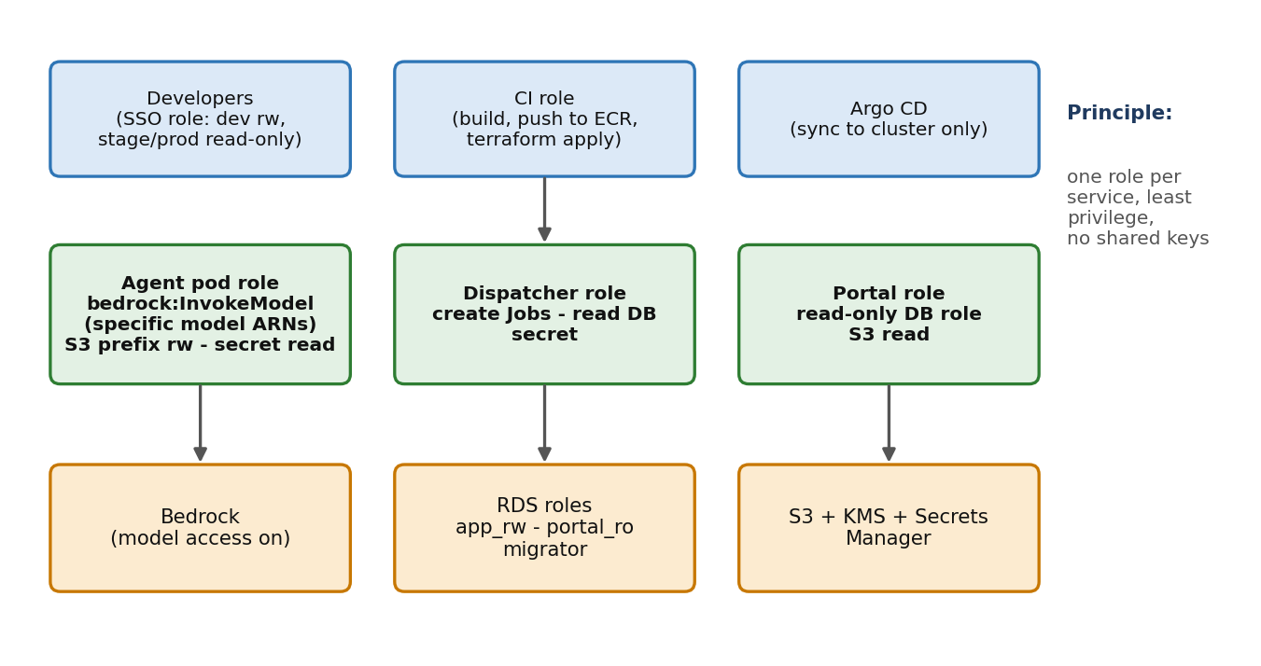
Figure 5. Who can do what
Role | Assumed by | Allowed | Not allowed
developer-dev | Engineers (SSO) | Read/write in dev; deploy via pull request | Write access to stage/prod
ci-deploy | CI pipeline | Push to ECR, run Terraform plan/apply for its environment | Read secrets values; act in other environments
agent-role | Agent pod (service account) | bedrock:InvokeModel on named model ARNs; S3 read/write on its prefix; read its secret; write logs | Other S3 prefixes; other models; IAM changes
dispatcher-role | Dispatcher pod | Create Jobs in its namespace; read DB secret | Invoke Bedrock; read S3 outputs
portal-role | Portal pod | Read-only DB role; read S3 outputs | Write to the ledger
argocd | Argo CD | Sync manifests in the cluster | Access AWS resources directly

7. Step D - Setup steps, phase by phase
Each phase lists the goal, the steps, the commands, and a pass check. Do not start the next phase until the check passes. Replace every <placeholder> with a value from Section 4. Command syntax marked [U] needs checking against current documentation.

Phase 1 - Foundations
Goal: A working login in every account, remote Terraform state, encryption keys and a repo layout.
Owner: Cloud platform + you

Steps
- Configure SSO on your machine and sign in to the dev account.
- Confirm the Terraform remote state bucket and lock table exist (or ask the platform team for their standard).
- Create the infra repository with the layout below.
- Create KMS keys per environment for RDS, S3, secrets and EBS (aliases below).
- Apply the tag policy (env, app, owner, cost-center, data-class) in Terraform defaults.

Commands
aws configure sso --profile conductor-dev
aws sso login --profile conductor-dev
aws sts get-caller-identity --profile conductor-dev

infra/
modules/ network eks rds s3 ecr iam observability
envs/ dev stage prod
k8s/ base overlays/dev overlays/stage overlays/prod

# KMS aliases (names are a suggestion)
alias/conductor-dev-rds alias/conductor-dev-s3
alias/conductor-dev-secrets alias/conductor-dev-ebs

Pass check
get-caller-identity prints the dev account ID; terraform init succeeds from CI; the four KMS aliases exist.

Common problem
SSO profile names differ between teams. If login loops, check the SSO start URL and region in your AWS config.
[ PASTE YOUR SCREENSHOT HERE ]
Signed-in account and role
Console path: AWS access portal -> your account -> role
Capture: The account ID and role name shown after login (hide anything sensitive).

Phase 2 - Network
Goal: A private network where nodes can reach RDS, Bedrock, ECR and S3 without the public internet.
Owner: Network team (you verify)

Steps
- Receive VPC and subnet IDs (R3) and record them in Section 4.2.
- Confirm there are private subnets in at least two AZs for app, data and endpoints.
- Confirm interface endpoints exist for: bedrock-runtime, ecr.api, ecr.dkr, logs, sts, secretsmanager, kms; and an S3 gateway endpoint.
- Confirm private DNS is enabled on the interface endpoints.
- Confirm security groups: nodes to RDS on 5432; nodes to endpoints on 443; no inbound from the internet.
- Confirm the approved private path to Databricks (R4).

Commands
# Verify from inside the cluster once it exists (Phase 4)
kubectl run nettest --rm -it --image=busybox:1.36 --restart=Never -n conductor-dev -- \
nslookup bedrock-runtime.<region>.amazonaws.com
# Expect a private IP address inside your VPC CIDR [U: depends on endpoint private DNS]

Pass check
The Bedrock runtime name resolves to a private IP from a pod, and a test call to a model works.

Common problem
Endpoint security group does not allow 443 from the node security group; or private DNS is off so the name resolves to a public address.
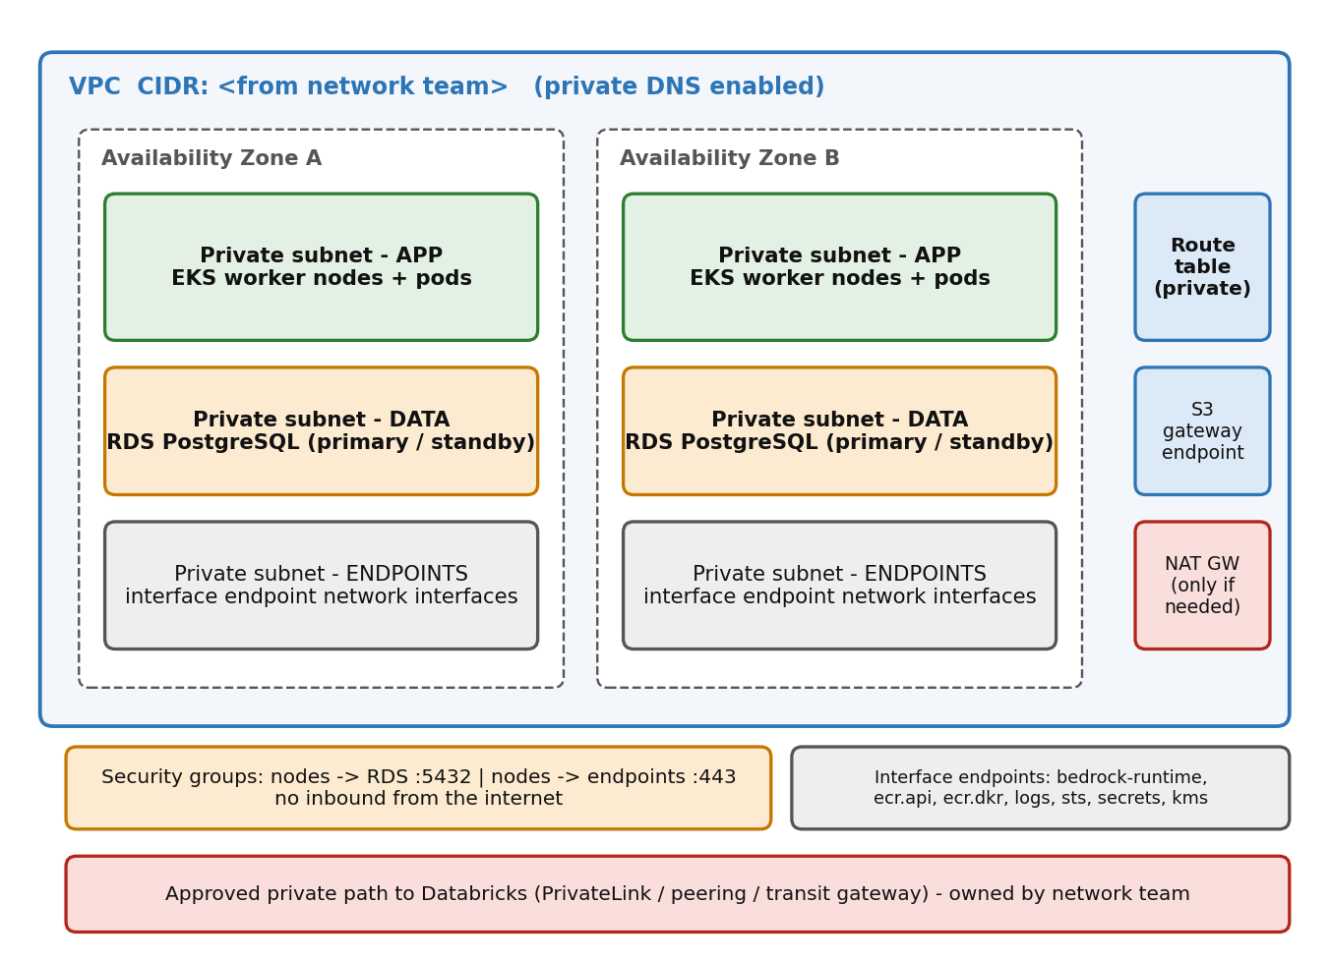
Figure 6. VPC layout: subnets, endpoints, security groups and the Databricks path
[ PASTE YOUR SCREENSHOT HERE ]
VPC and subnets
Console path: VPC console -> Your VPCs, then Subnets
Capture: VPC ID, CIDR, and the subnet list showing AZ and CIDR per subnet.

[ PASTE YOUR SCREENSHOT HERE ]
VPC endpoints
Console path: VPC console -> Endpoints
Capture: The endpoint list with service names, type (Interface/Gateway), and status 'Available'.

[ PASTE YOUR SCREENSHOT HERE ]
Security groups
Console path: VPC console -> Security groups
Capture: Inbound rules for the RDS and endpoint security groups.

Phase 3 - Registry, storage, database, secrets
Goal: Places to put images, outputs, state and secrets, all encrypted and private.
Owner: Platform team + you

Steps
- Create ECR repositories (immutable tags, scan on push) and restrict push to the CI role.
- Create the S3 outputs bucket: versioning on, SSE-KMS, block public access, lifecycle rule per retention (D10).
- Create RDS PostgreSQL in the data subnets: encrypted, TLS required, backups on, Multi-AZ in stage/prod.
- Create DB roles app_rw, portal_ro, migrator. Store credentials in Secrets Manager with rotation.
- Run the schema migration as a Job from CI (tables: ledger, step_events, source_cases, case_outbox, cdc_watermark).
- Do one test restore from an RDS snapshot into a scratch instance and delete it.

Commands
aws ecr create-repository --repository-name conductor-agent --region <region> \
--image-scanning-configuration scanOnPush=true --image-tag-mutability IMMUTABLE

-- Core ledger table (idempotent writes)
CREATE TABLE ledger (
case_id text NOT NULL, step text NOT NULL, payload jsonb NOT NULL,
created_at timestamptz NOT NULL DEFAULT now(), PRIMARY KEY (case_id, step));
-- INSERT ... ON CONFLICT (case_id, step) DO NOTHING => a replayed step is skipped

Pass check
A pod connects to RDS over TLS with app_rw; portal_ro cannot write; ECR push works only from CI; the restore test succeeded.

Common problem
RDS in the wrong subnets or security group (connection timeouts), or the password stored with the wrong key so the pod cannot read it.
[ PASTE YOUR SCREENSHOT HERE ]
RDS instance
Console path: RDS console -> Databases -> your instance
Capture: Status 'Available', encryption on, Multi-AZ setting, VPC and subnet group.

[ PASTE YOUR SCREENSHOT HERE ]
ECR repositories
Console path: ECR console -> Private repositories
Capture: Repo names, tag immutability, scan on push.

Phase 4 - EKS cluster, identity, add-ons, pods
Goal: A private cluster where each service has its own identity, and the standard add-ons are installed.
Owner: Platform team (you consume and configure namespaces)

Steps
- Obtain the cluster (R6) and update your kubeconfig. Always check the current context before any change.
- Create the namespace conductor-<env> with a ResourceQuota, LimitRange and a default-deny NetworkPolicy.
- Create service accounts agent-sa, dispatcher-sa, portal-sa and link each to its IAM role with Pod Identity or IRSA.
- Install add-ons with pinned versions: metrics-server, KEDA, Argo CD (or use the shared one), Karpenter or node group scaling.
- Deploy a test Job that calls Bedrock using agent-sa; confirm that a pod without the role cannot.
- Set pod security: non-root, read-only root filesystem, no privilege escalation.

Commands
aws eks update-kubeconfig --name conductor-<env> --region <region> --profile conductor-dev
kubectl config current-context # must show the EKS cluster, not minikube
kubectl create namespace conductor-<env>
kubectl get nodes
kubectl get pods -A

helm repo add metrics-server https://kubernetes-sigs.github.io/metrics-server/
helm repo add kedacore https://kedacore.github.io/charts
helm repo add argo https://argoproj.github.io/argo-helm
helm repo update
helm install keda kedacore/keda -n keda --create-namespace
helm install argocd argo/argo-cd -n argocd --create-namespace
# Karpenter and pod identity: follow current AWS docs [U]

Pass check
Nodes are Ready; pods in the test namespace can call Bedrock and cannot reach the internet; kubectl top nodes works.

Common problem
Wrong kube context (changes applied to the wrong cluster), a missing role association (AccessDenied on Bedrock), or a default-deny policy blocking DNS (allow kube-dns).
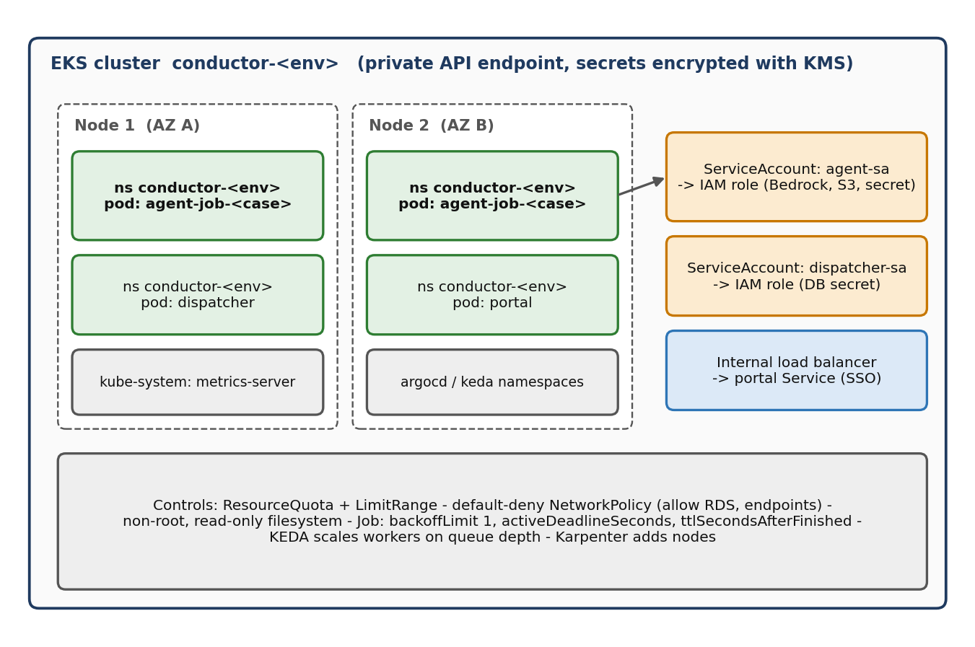
Figure 7. Cluster layout: nodes, namespaces, pods, service accounts, controls
[ PASTE YOUR SCREENSHOT HERE ]
EKS cluster overview
Console path: EKS console -> Clusters -> your cluster
Capture: Status Active, Kubernetes version, API endpoint access (private), logging enabled.

[ PASTE YOUR SCREENSHOT HERE ]
Nodes and workloads
Console path: EKS console -> your cluster -> Resources, or terminal: kubectl get nodes
Capture: Node list Ready; pods listed by namespace.

What healthy output looks like (illustrative)
$ kubectl get nodes
NAME STATUS ROLES AGE VERSION
ip-10-0-1-21.<region>.compute Ready <none> 2d v1.xx
ip-10-0-2-37.<region>.compute Ready <none> 2d v1.xx

$ kubectl get pods -n conductor-dev
NAME READY STATUS RESTARTS AGE
dispatcher-6c9d7b5f4-abcde 1/1 Running 0 3h
portal-7f8b9c6d5-fghij 1/1 Running 0 3h
case-t1-v1-xk2lm 0/1 Completed 0 10m

This output is an example of the expected shape. Your names, versions and ages will differ.

Phase 5 - CI/CD and Argo CD
Goal: Every change goes from pull request to a running dev pod without manual steps, and can be rolled back by a revert.
Owner: DevOps + you

Steps
- Pull request pipeline: lint, unit tests, graph tests with the stub runner, and the evaluation harness.
- Merge pipeline: build the image, scan it, tag with the git SHA, push to ECR.
- Open an automated commit that sets the new tag in k8s/overlays/dev.
- Create one Argo CD Application per environment pointing at its overlay. Dev syncs automatically; stage and prod require approval.
- Promote the same image tag dev -> stage -> prod; never rebuild for production.
- Terraform: plan on pull request, apply on merge, separate roles per environment.
- Rehearse a rollback by reverting the tag commit.

Commands
# Argo CD application (conceptual) - repoURL: <infra repo>, path: k8s/overlays/dev,
# destination: namespace conductor-dev, syncPolicy: automated (dev only)
argocd login <argocd-host> --sso # [U] depends on your Argo CD setup
argocd app list

Pass check
A one-line change reaches a running dev pod automatically; reverting the commit restores the previous version.

Common problem
Image tag mismatch between CI and manifests, or Argo CD lacking permission to the target namespace.
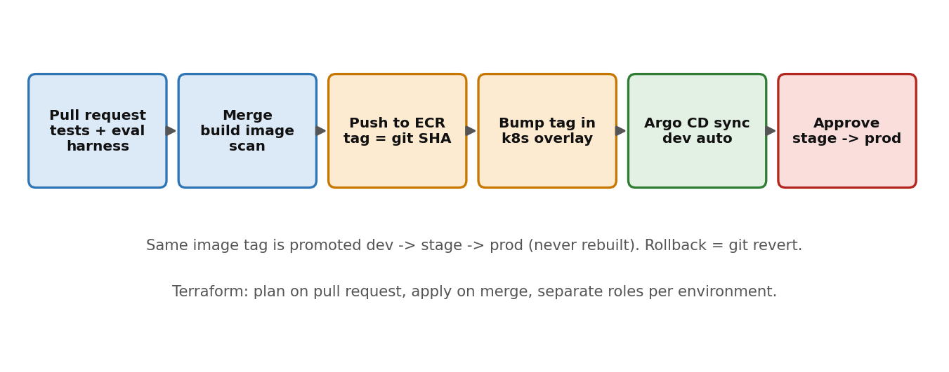
Figure 8. Delivery pipeline
[ PASTE YOUR SCREENSHOT HERE ]
Argo CD application
Console path: Argo CD UI -> Applications
Capture: Application tile showing Healthy and Synced, with the resource tree.

Phase 6 - Observability, alerts, budgets
Goal: You find out about a stuck case, a failure or a cost spike before the business does.
Owner: Platform + you

Steps
- Emit structured JSON logs with case_id and run_id; mask PII per decision D9; set log retention.
- Write step_events (per node: start, end, duration, attempts, model, tokens, status) and point the portal at them.
- Create the alarms in the table below and route them to the on-call channel.
- Set AWS Budgets per environment and a per-case token cap in code.
- Deploy Langfuse (if chosen) with its own database, SSO and retention.
Pass check
A forced failure and a forced stall each produce an alert within the stated time; the portal shows the stalled case.

Common problem
Alert noise from short retries. Alert on the condition lasting a few minutes, not on a single event.
Alert | Condition | Severity | Notify
Stalled case | No heartbeat from a running case for N minutes | High | On-call
Failed Job | Job failed after retries | High | On-call
Queue age | Oldest waiting case older than N minutes | Medium | Team channel
Bedrock throttling | Throttle rate above threshold for 5 minutes | Medium | Team channel
RDS health | CPU, storage or connections near limit | High | On-call
Daily spend | Model spend over the daily cap | High | On-call + owner
Secret or certificate expiry | Expires within 14 days | Medium | Team channel

[ PASTE YOUR SCREENSHOT HERE ]
CloudWatch alarms
Console path: CloudWatch console -> Alarms
Capture: The list of alarms with state OK, and one test alarm in ALARM.

Phase 7 - Databricks ingress
Goal: A changed case in Databricks produces exactly one agent run.
Owner: Data platform + you

Steps
- Confirm change data feed on the source view and record the starting version.
- Deploy a CronJob poller that reads changes since the stored watermark and writes outbox rows (unique on case and data version).
- Store the watermark in Postgres so a restart never skips or repeats changes.
- Deploy the dispatcher: it turns new outbox rows into Kubernetes Jobs and records done/failed.
- Test: change one row, expect one Job; repeat the same change, expect none; change again, expect one new run.

Commands
-- Watermark table
CREATE TABLE cdc_watermark (source text PRIMARY KEY, last_version bigint NOT NULL,
updated_at timestamptz NOT NULL DEFAULT now());

-- Delta Change Data Feed read (confirm exact table and options with the data team) [U]
SELECT * FROM table_changes('<catalog.schema.table>', <last_version> + 1);

Pass check
Exactly one Job per data version, and a restart of the poller does not duplicate runs.

Common problem
The source is polled, not pushed, so there is a delay of one polling interval. State this clearly when demonstrating.
[ PASTE YOUR SCREENSHOT HERE ]
Pods running a case
Console path: Terminal: kubectl get pods -n conductor-<env> -w
Capture: A case Job pod going Pending -> Running -> Completed after a data change.

Phase 8 - Hardening and shadow mode
Goal: Evidence that the platform survives failure and matches the existing process before real use.
Owner: You + security + model risk

Steps
- Run the failure drills in Section 8 and record results.
- Run the 10-case suite plus a burst to test quotas and the shared limiter.
- Security checks: image scan clean, IAM review, no public endpoints, security-group review, secrets scan.
- Walk the runbooks with the on-call person.
- Run shadow mode in stage: the new system processes the same cases as the current process and humans compare outcomes.
- Hold the go/no-go review with security, model risk and change control.
Pass check
All drills pass, the shadow comparison is documented, and the approvers sign off.

8. Verification and failure drills

8.1 Verification checklist
Check | Expected result | Done | Result / note
Login to each account | Correct account ID and role
Terraform plan from CI | No errors; no unexpected changes
Pod resolves Bedrock endpoint | Private IP inside the VPC
Pod calls a Bedrock model | Valid response; metered
Pod without role calls Bedrock | AccessDenied
Pod reads RDS over TLS (app_rw) | Connects; writes succeed
portal_ro attempts a write | Permission denied
ECR push from CI | Image appears with SHA tag
ECR push from a laptop | Denied (if CI-only)
Argo CD sync | Healthy and Synced
Data change in source | Exactly one run
Duplicate change | No second run
RDS restore test | Data restored in a scratch instance

8.2 Failure drills
Drill | How | Expected behaviour
Pod killed mid-run | kubectl delete pod <case pod> | Job restarts; finished steps are skipped; case completes
Node drain | kubectl drain <node> --ignore-daemonsets | Pods reschedule; checkpoints preserved; no repeated work
Bedrock unavailable | Block the endpoint or use a bad model ID in dev | Retries with backoff, then the case goes to review with a reason
Stalled step | Insert a step that never returns | Watchdog flags it; retried once; then human review
Database failover | RDS reboot with failover (stage) | Short pause; workers reconnect; no lost steps
Secret expired or rotated | Rotate the DB secret | Pods pick up the new secret without a code change
Queue burst | Insert many changes at once | Limiter holds; no Bedrock throttling storm; scale-out works

9. Risks, open items and appendix

9.1 Risks
Risk | Impact | Mitigation
Approvals take longer than the build | Timeline slips | Send all requests on day 1; track in Section 5; ask for a named contact per request
Databricks private path not ready | No automatic ingestion | Use manual or batch load in dev; build the poller against a copy
Bedrock quotas too low | Slow or throttled runs | File the increase early; shared limiter; per-case token cap
PII in logs and traces | Compliance finding | Decide D9 first; mask at source; limit retention
Model risk review not complete | No production use | Start early; use shadow-mode evidence
Sessions limited if AgentCore is used | Long cases cut off | Use EKS as primary, or chain sessions; test limits in a dedicated test

9.2 Items not verified by the author
- Exact Karpenter and Pod Identity commands for your EKS version.
- Whether private DNS on interface endpoints is enabled by default in your network setup.
- The Delta change data feed query form and options for your table.
- Argo CD login and application syntax for your installation.
- AgentCore session and Instances limits if you choose to use AgentCore (see the master reference).

9.3 Command cheat sheet
aws sts get-caller-identity # who am I, which account
kubectl config current-context # which cluster am I pointed at
kubectl get nodes / pods -A # health
kubectl logs job/<name> -n conductor-<env> # a case's output
kubectl describe pod <pod> -n conductor-<env> # why a pod is stuck
kubectl top nodes / pods -n conductor-<env> # resource use
aws ecr describe-images --repository-name <repo> # images and tags
aws ecr describe-image-scan-findings ... # scan results

9.4 Glossary
Term | Meaning
VPC | Your private network in AWS
Subnet | A slice of the VPC in one availability zone
VPC endpoint | A private doorway to an AWS service so traffic never uses the internet
EKS | AWS managed Kubernetes
Pod / Job | A running container group / a pod that runs to completion
Namespace | A named area in the cluster to separate workloads
Service account + pod identity | The way a pod gets its own AWS permissions
ECR | AWS container image registry
Ledger | Append-only table of finished steps; lets a restart skip finished work
Outbox | Table of pending runs created when source data changes
Argo CD | Tool that keeps the cluster in sync with a git repository
Shadow mode | New system runs on real cases in parallel with the existing process, without publishing

