Known problems with VS2013 projects
id | 001
type | linker error
date | 10-06-2015
reported by | Andreas Seiderer
system | Microsoft Windows [Version 6.3.9600]
description | test project with vc120 as target doesn't find lib because it searches in vc100 directory
solution | remove reference to plugin

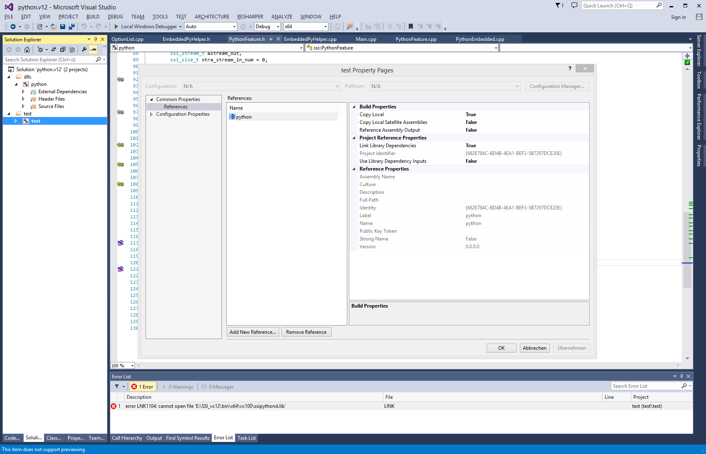
id | 002
type | crash during runtime
date | 10-06-2015
reported by | Andreas Seiderer
system | Microsoft Windows [Version 6.3.9600]
description | project always crashes with error in "ssievent.dll!ssi::Window::WindowProc(struct HWND__ *,unsigned int,unsigned __int64,__int64)"
solution | switch off "Randomized Base Address"

