The sample is to illustrate the merging of fields as defined in the CM_Notifyfields table

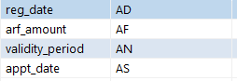

Your application to register the model was received on {regdate}. For this registration to be completed, please make payment of {arfamount} at our counter service, within the validity period of {validityperiod} days from the receipt of this notice.

Due to SMM, you may make a appointment with us starting {apptdate}.

{image}