Final_prj_exploration

Hannah Coles

3/25/2021

knitr::opts_chunk$set(echo = TRUE)  
rm(list=ls())  
library(ggplot2)  
bulltrout=read.csv("BLT_2018_timespent.csv",header=TRUE)  
View(bulltrout)  
names(bulltrout)

## [1] "ï..FishID" "Arm.1"   
## [3] "Arm.2" "Total.Time.in.Both.Arms"  
## [5] "Trm1" "Trm2"

length(bulltrout$ï..FishID)

## [1] 227

class(bulltrout$ï..FishID)

## [1] "character"

class(bulltrout$Arm.1)

## [1] "numeric"

class(bulltrout$Arm.2)

## [1] "numeric"

class(bulltrout$Total.Time.in.Both.Arms)

## [1] "numeric"

class(bulltrout$Trm1)

## [1] "character"

class(bulltrout$Trm2)

## [1] "character"

hist(bulltrout$Arm.1)

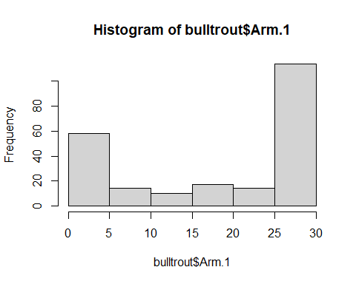

hist(bulltrout$Arm.2)

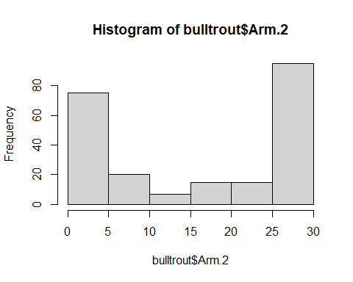

hist(bulltrout$Total.Time.in.Both.Arms)

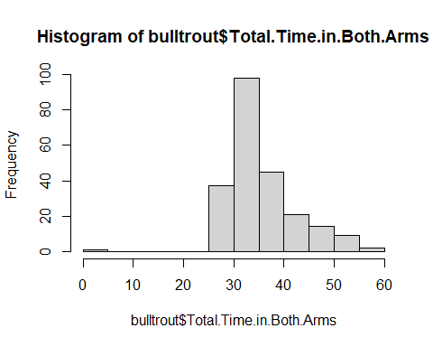

ggplot(bulltrout,aes(x=Arm.1))+geom_histogram(binwidth=5)+theme_classic()

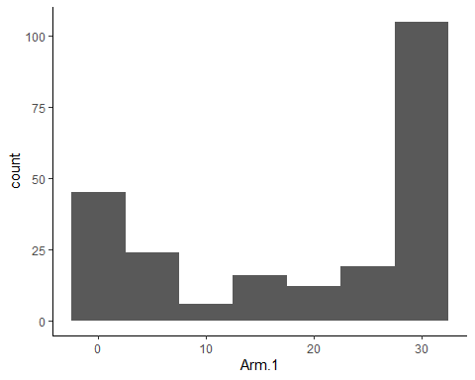

ggplot(bulltrout,aes(x=Arm.2))+geom_histogram(binwidth=5)+theme_classic()

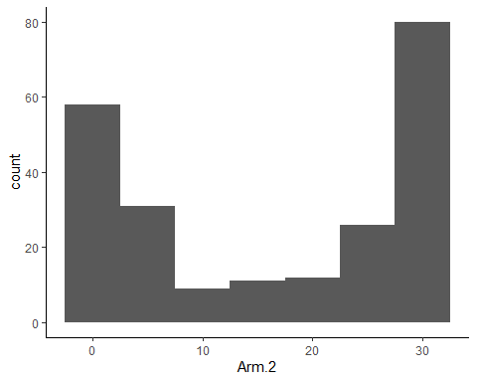

ggplot(bulltrout,aes(x=Total.Time.in.Both.Arms))+geom_histogram(binwidth=5)+theme_classic()

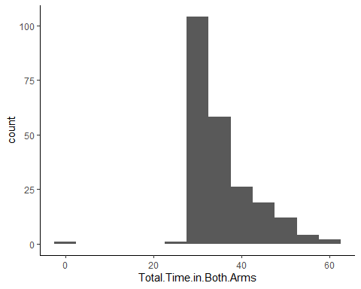

boxplot(Arm.1~Trm1,data=bulltrout)

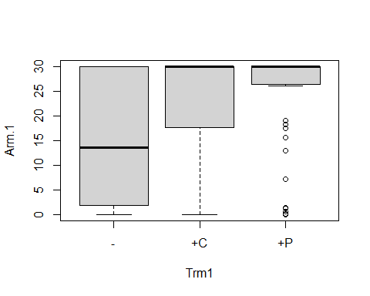

boxplot(Arm.2~Trm2,data=bulltrout)

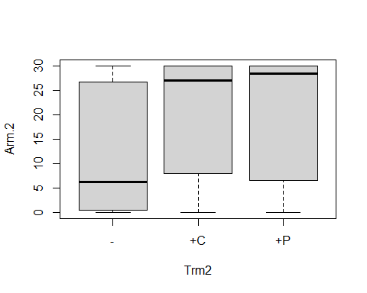

boxplot(Total.Time.in.Both.Arms~Trm1,data=bulltrout)

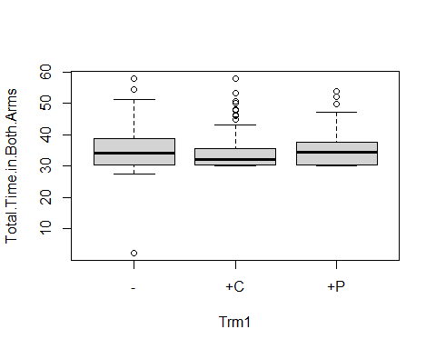

boxplot(Total.Time.in.Both.Arms~Trm2,data=bulltrout)

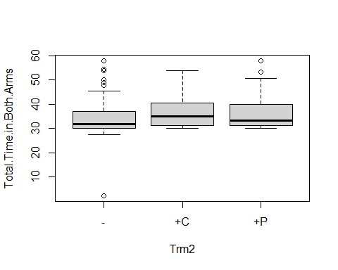

boxplot(Arm.1~Trm1+Trm2,data=bulltrout)

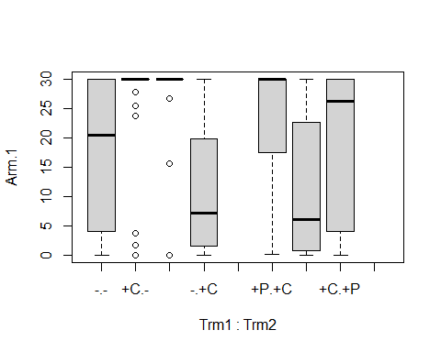

boxplot(Total.Time.in.Both.Arms~Trm1+Trm2,data=bulltrout)

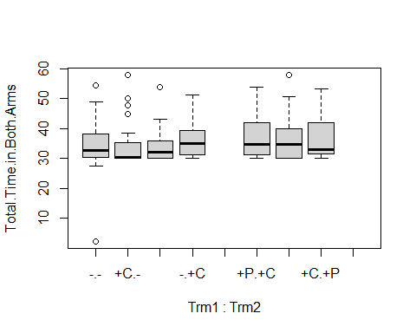

dotchart(bulltrout$Total.Time.in.Both.Arms)

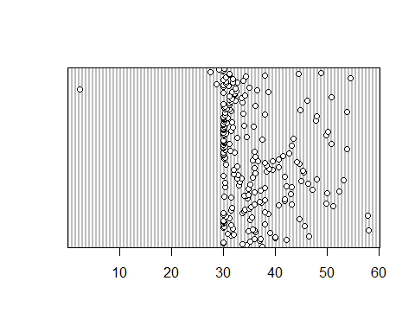

qqnorm(bulltrout$Arm.1)  
qqline(bulltrout$Arm.1)

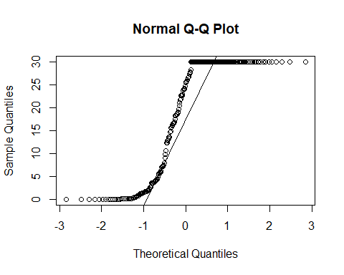

qqnorm(bulltrout$Arm.2)  
qqline(bulltrout$Arm.2)

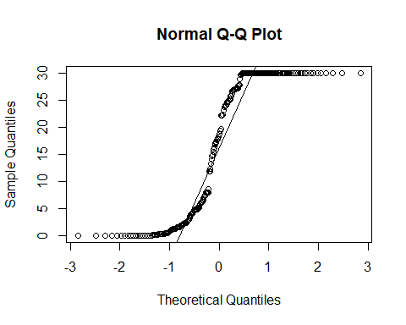

qqnorm(bulltrout$Total.Time.in.Both.Arms)  
qqline(bulltrout$Total.Time.in.Both.Arms)

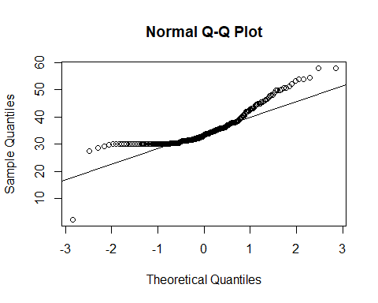

ggplot(bulltrout)+geom_qq(aes(sample=Arm.1))+theme_classic()+geom_qq_line(aes(sample=Arm.1))

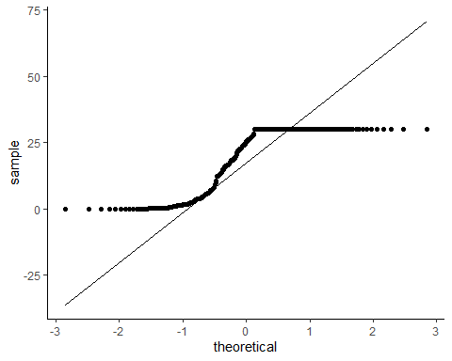

ggplot(bulltrout)+geom_qq(aes(sample=Arm.2))+theme_classic()+geom_qq_line(aes(sample=Arm.2))

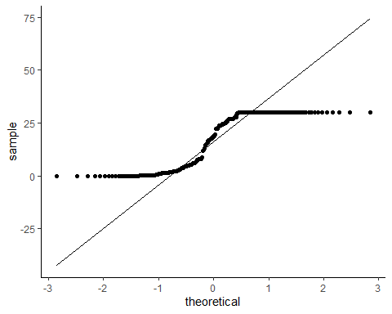

ggplot(bulltrout)+geom_qq(aes(sample=Total.Time.in.Both.Arms))+theme_classic()+geom_qq_line(aes(sample=Total.Time.in.Both.Arms))

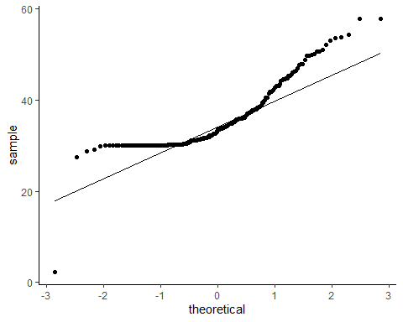

pairs(bulltrout[,2:4])

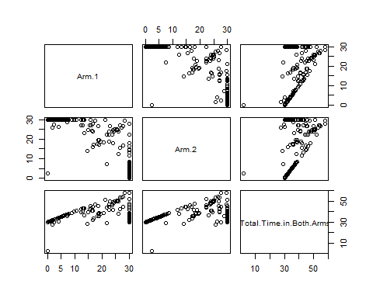

library(GGally)

## Registered S3 method overwritten by 'GGally':  
## method from   
## +.gg ggplot2

ggpairs(bulltrout[,2:4])

