Module2-Rmarkdown Document 1

Heather Copley

2/19/2021

# This is a level 1 header

## R Markdown

### This is a level 3 header

This is an R Markdown document. Markdown is a simple formatting syntax for authoring HTML, PDF, and MS Word documents. For more details on using R Markdown see <http://rmarkdown.rstudio.com>.

here is a link to [Google](http://google.com)

here is a word in **bold** and another word in **bold**

here is a word in *italics* and another word in *italics*

when we compile our document, we are using the rmarkdown package.

here are some example R commands:

2+2  
mean(c(1,2,3,4,5))

Here is an example of a non-numbered list:

* Breakfast
  + food
    - eggs
    - toast
    - bacon
  + drink
    - apple juice
* Lunch
  + taco
* Dinner
  + baked chicken
  + broccoli
  + rice

Here is an example of a block quote. This paragraph has two lines.

1. This is a list inside a block quote
2. Second item.

This text is nested

Here is an example of code in a blockquote using 5 spaces:

2+2  
mean(c(1,2,3,4,5))

When you click the **Knit** button a document will be generated that includes both content as well as the output of any embedded R code chunks within the document. You can embed an R code chunk like this:

summary(cars)

## speed dist   
## Min. : 4.0 Min. : 2.00   
## 1st Qu.:12.0 1st Qu.: 26.00   
## Median :15.0 Median : 36.00   
## Mean :15.4 Mean : 42.98   
## 3rd Qu.:19.0 3rd Qu.: 56.00   
## Max. :25.0 Max. :120.00

## Including Plots

You can also embed plots, for example:



Note that the echo = FALSE parameter was added to the code chunk to prevent printing of the R code that generated the plot.

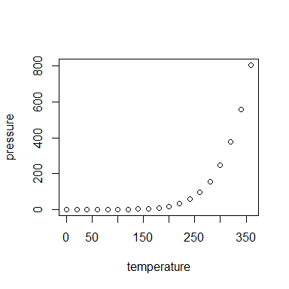

## Insert Tables

knitr::kable(head(cars))

|  |  |
| --- | --- |
| speed | dist |
| 4 | 2 |
| 4 | 10 |
| 7 | 4 |
| 7 | 22 |
| 8 | 16 |
| 9 | 10 |