
Honors Option Contract Final Report

Please complete this form and return it as soon as possible to:

Ms. Traci LM Dula
Associate Director
Honors College
Anne Arundel Hall
tdula@umd.edu

Student Name: ___Chris Eurle___________________ UID#____ 112453886_____________

Sponsoring Faculty member: _Hector Corrada Bravo_______________________________________

A. Indicate the course to which Honors credit may apply: ________CMSC 423_____________________

B. Indicate final course grade (submitted in the normal manner to Records & Registration) __A+_______

C. Please indicate how the conditions of the Honors Contract were or were not met.
All conditions of Honors Contract were met. Chris worked on a DNA methylation analysis, using data that was not used in class, and extending methodology used in class. He performed a literature review on cancer methylation. We met twice outside class and discussed progress regularly after class as well. He fulfilled everything described in the contract.

D. Do you recommend that an Honors notation be posted for this course to the student transcript?

YES____X_ NO______
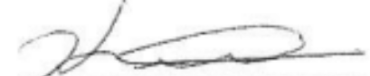

E. Professor's signature___________________________________ Date____12/22/14_________

