Henry Cort

3/30

CYB530

Prof. Long

import os

os.chdir('/Users/henry/ALL CODING PROJECT/Part2Mod1')

cwd = os.getcwd()

print("Current working directory: {0}".format(cwd))

print("os.getcwd() returns an object of type: {0}".format(type(cwd)))

Output: Current working directory: /Users/henry/ALL CODING PROJECT/Part2Mod1 os.getcwd() returns an object of type: <class 'str'>

import pandas

sample = pandas.read_csv("vulns.csv", index_col=0, parse_dates=True)

sample

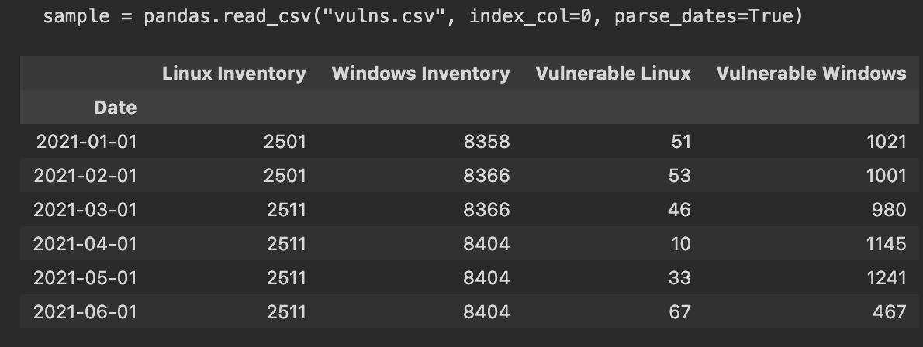

import matplotlib.pyplot as plt

plt.plot(sample['Linux Inventory'])

plt.plot(sample['Vulnerable Linux'])

plt.title("Linux OS Security Vulnerabilities")

plt.xlabel("Date")

plt.ylabel("Servers")

plt.show()

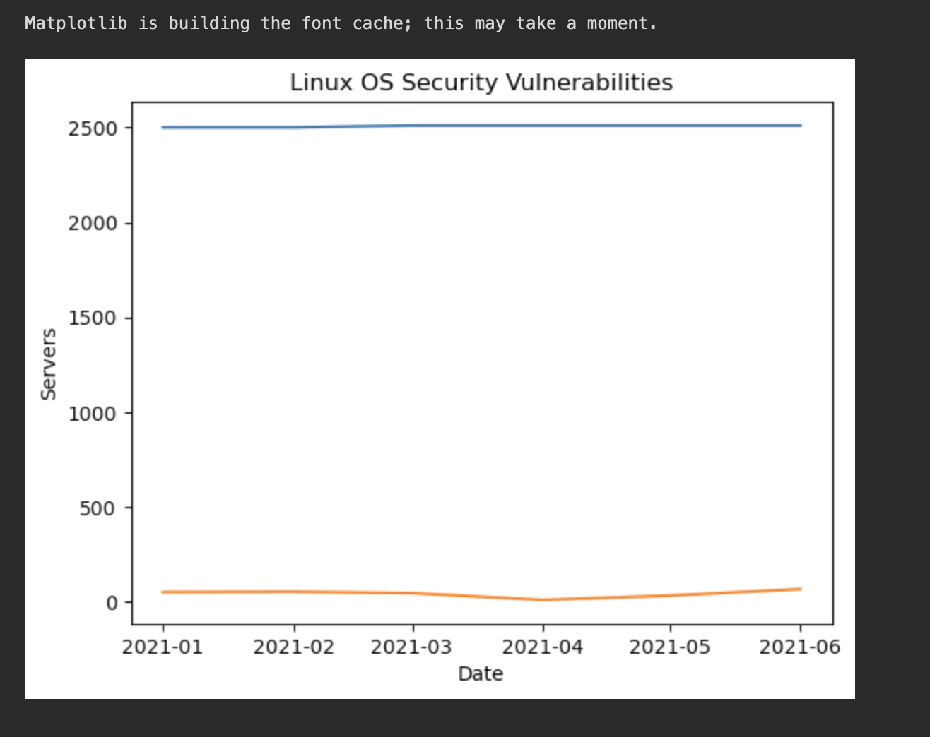

plt.plot(sample['Windows Inventory'])

plt.plot(sample['Vulnerable Windows'])

plt.title("Windows OS Security Vulnerabilities")

plt.xlabel("Date")

plt.ylabel("Servers")

plt.show()

