DAD Week 3 **Credit** Submission Tasks

Student ID: 6835937

Student Name: Harrison Parker

## Credit Task 1.

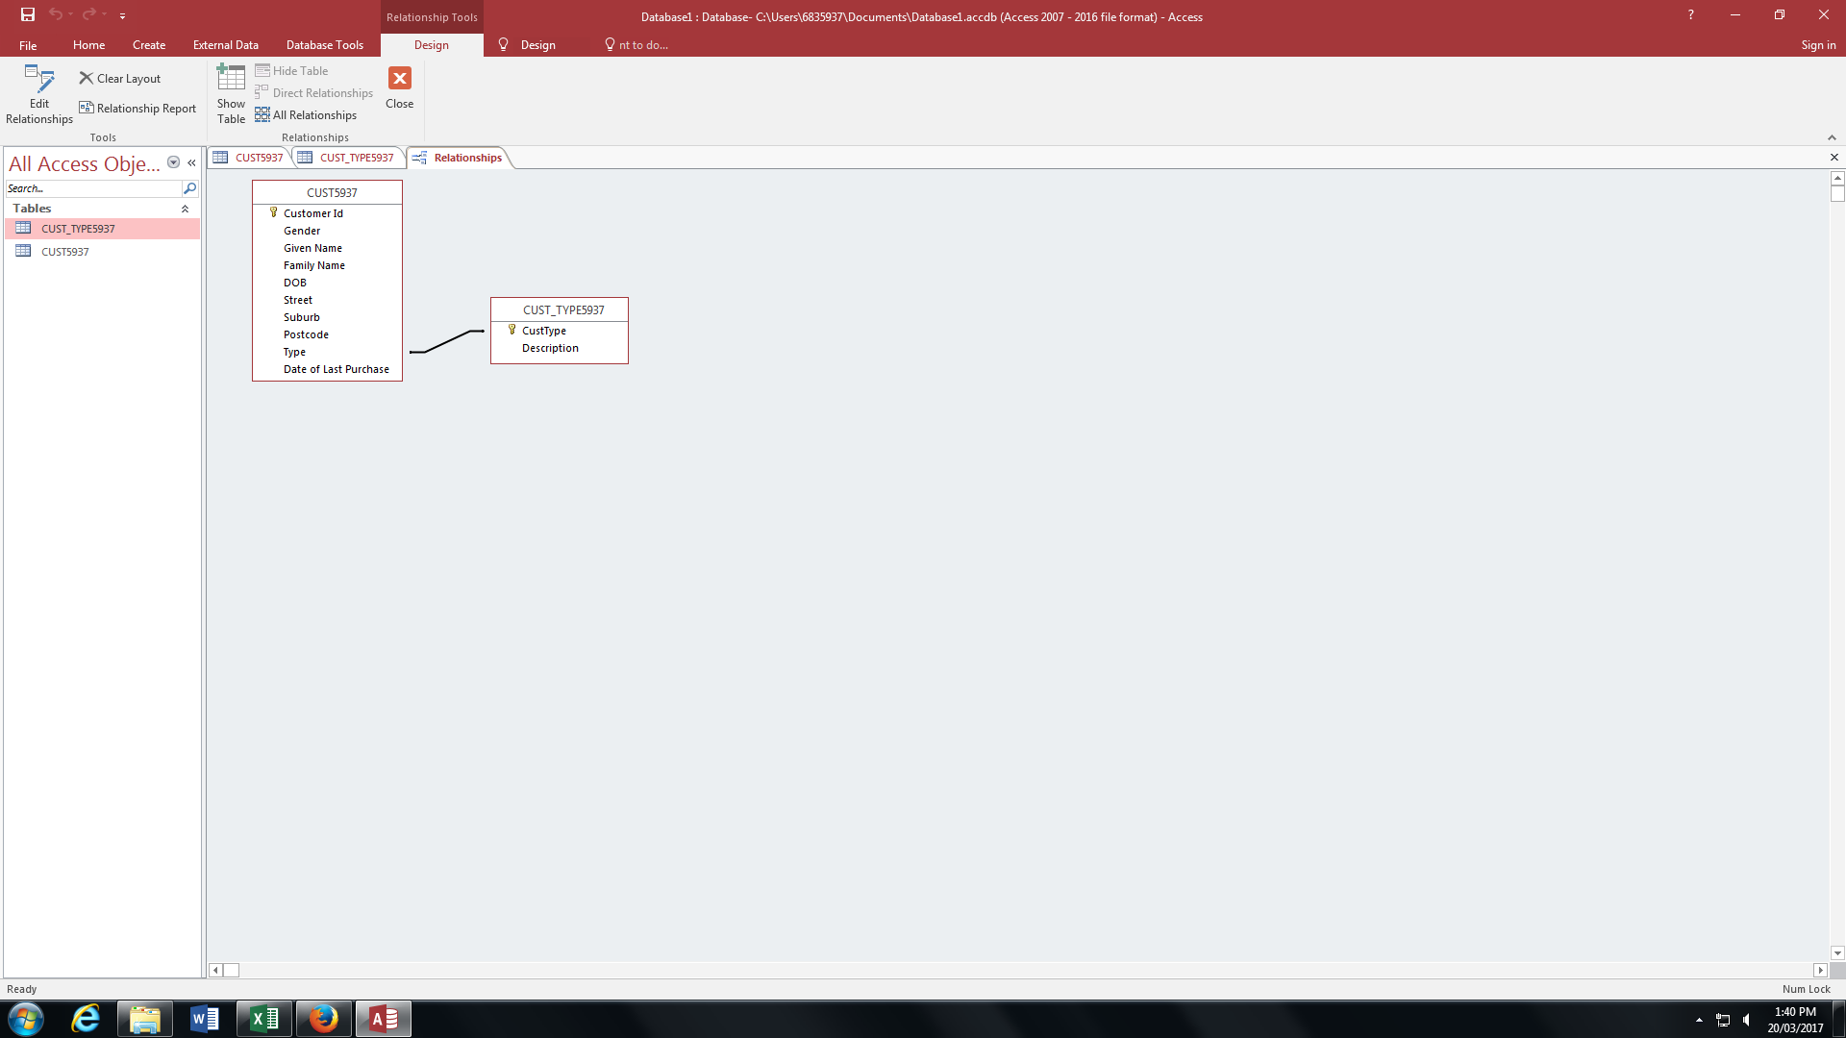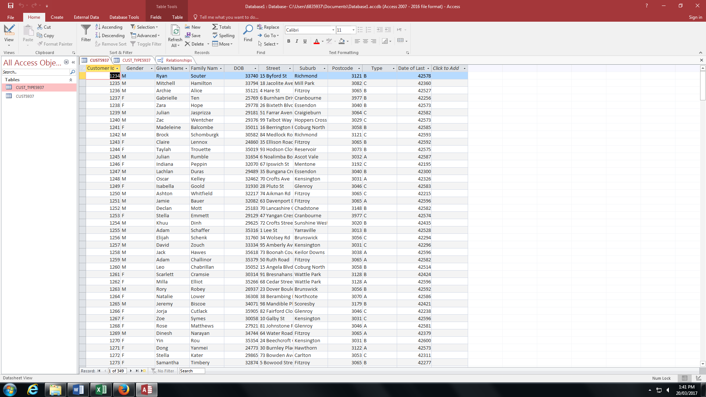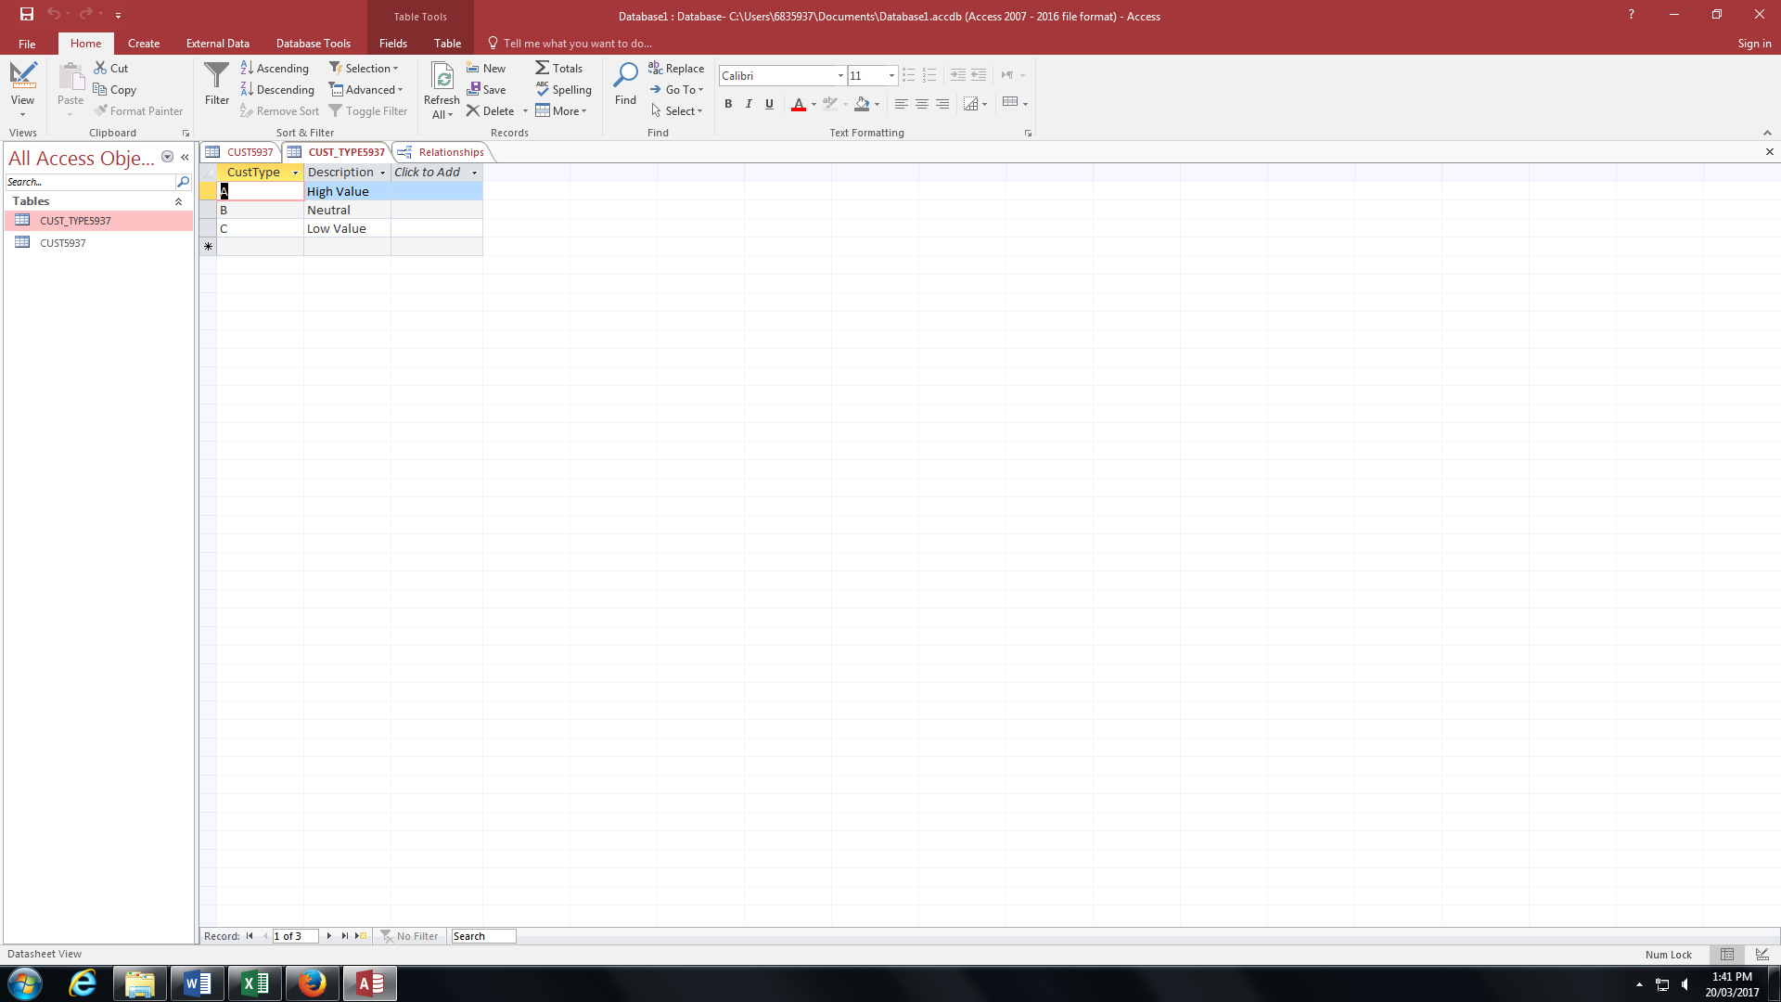========================================================

## Credit Task 2.

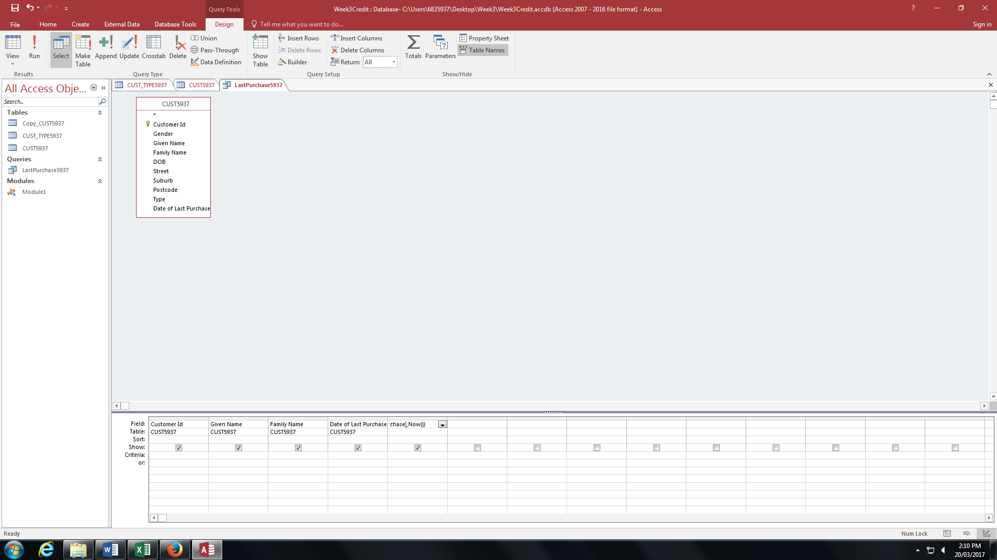

Days from last purchase: DateDiff('d',[Date of Last Purchase],Now())

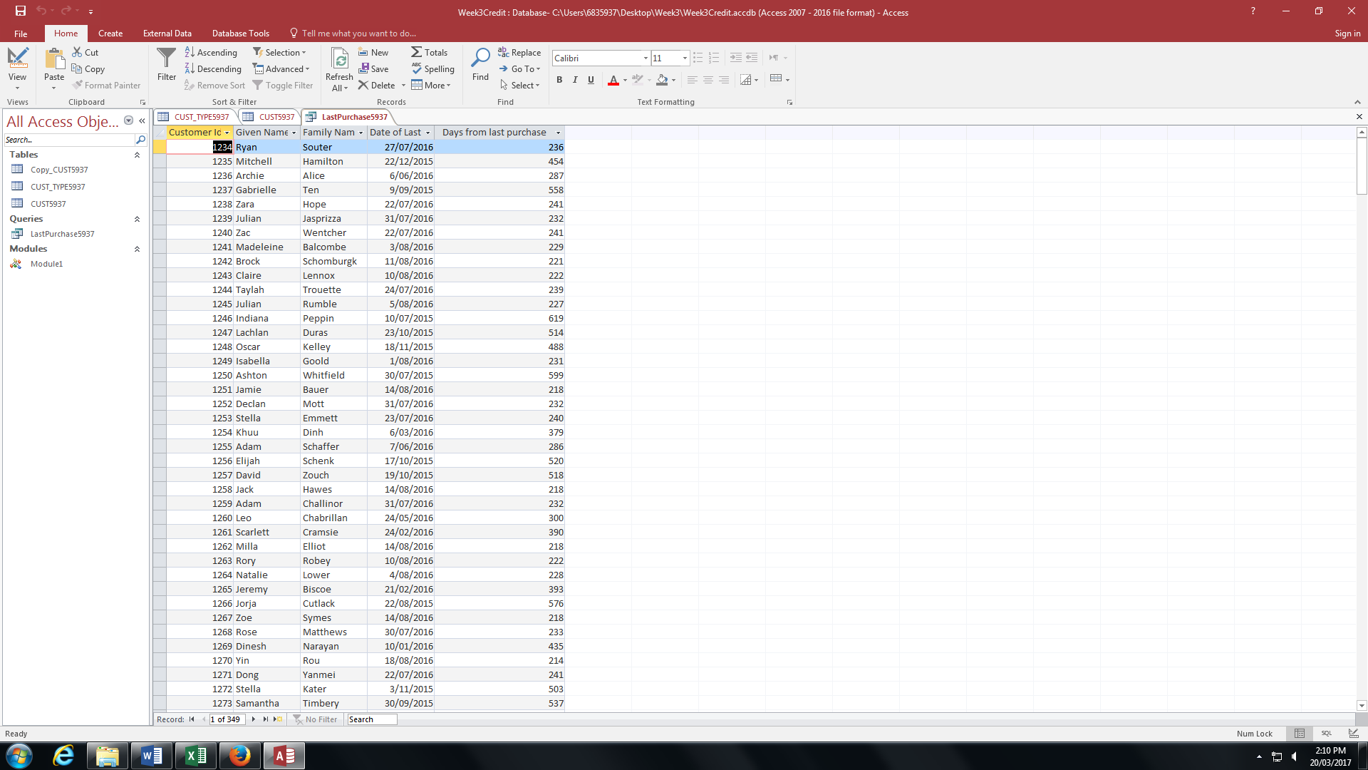

========================================================

## Credit Task 3.

Paste the appropriate screen captures here.

========================================================

## Credit Task 4.

Paste the appropriate screen captures here.

========================================================

## Credit Task 5.

Paste the appropriate screen captures here.

========================================================

Add more sections here if required…