DAD Week 6 **Pass** Submission Tasks

Student ID: 6835937

Student Name: Harrison Parker

## Pass Task 1.

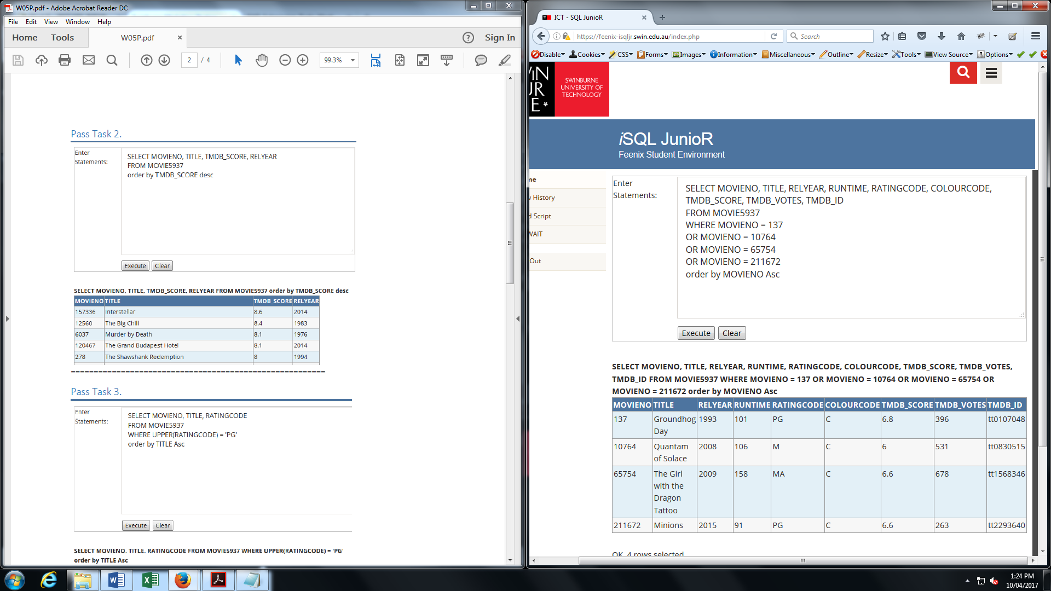========================================================

## Pass Task 2.

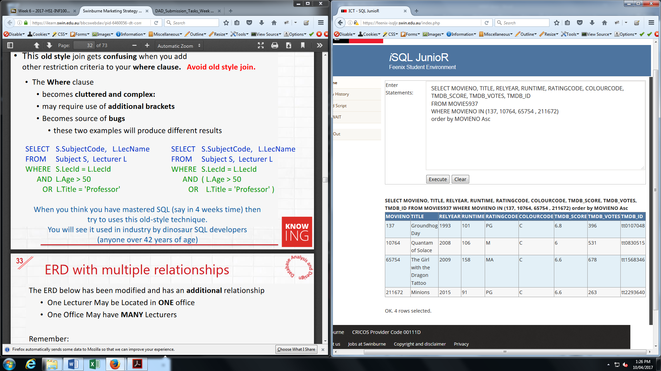========================================================

## Pass Task 3.

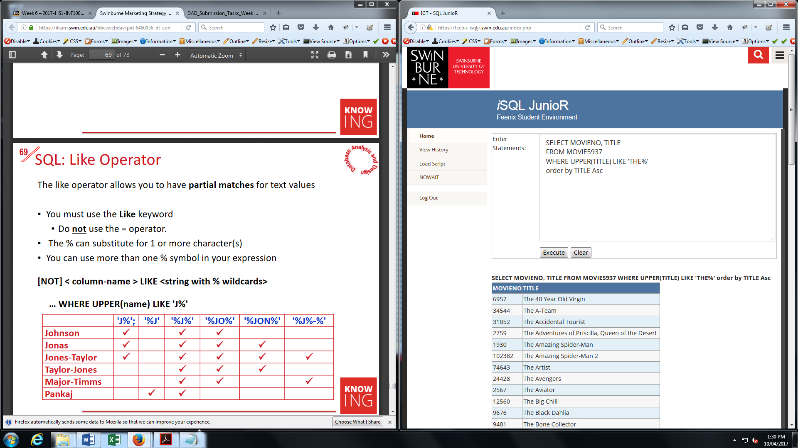========================================================

## Pass Task 4.

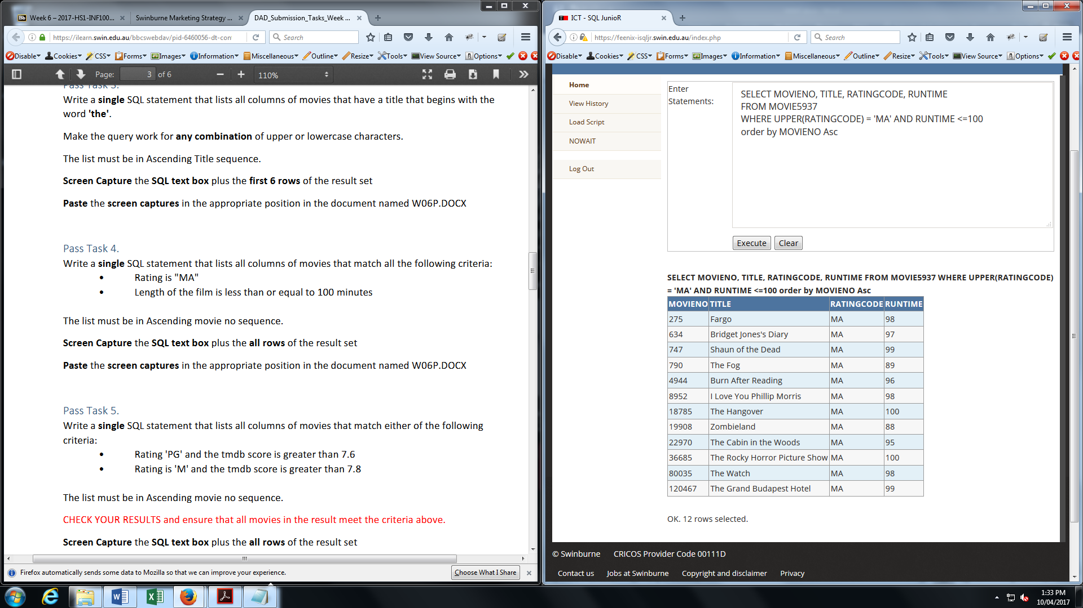========================================================

## Pass Task 5.

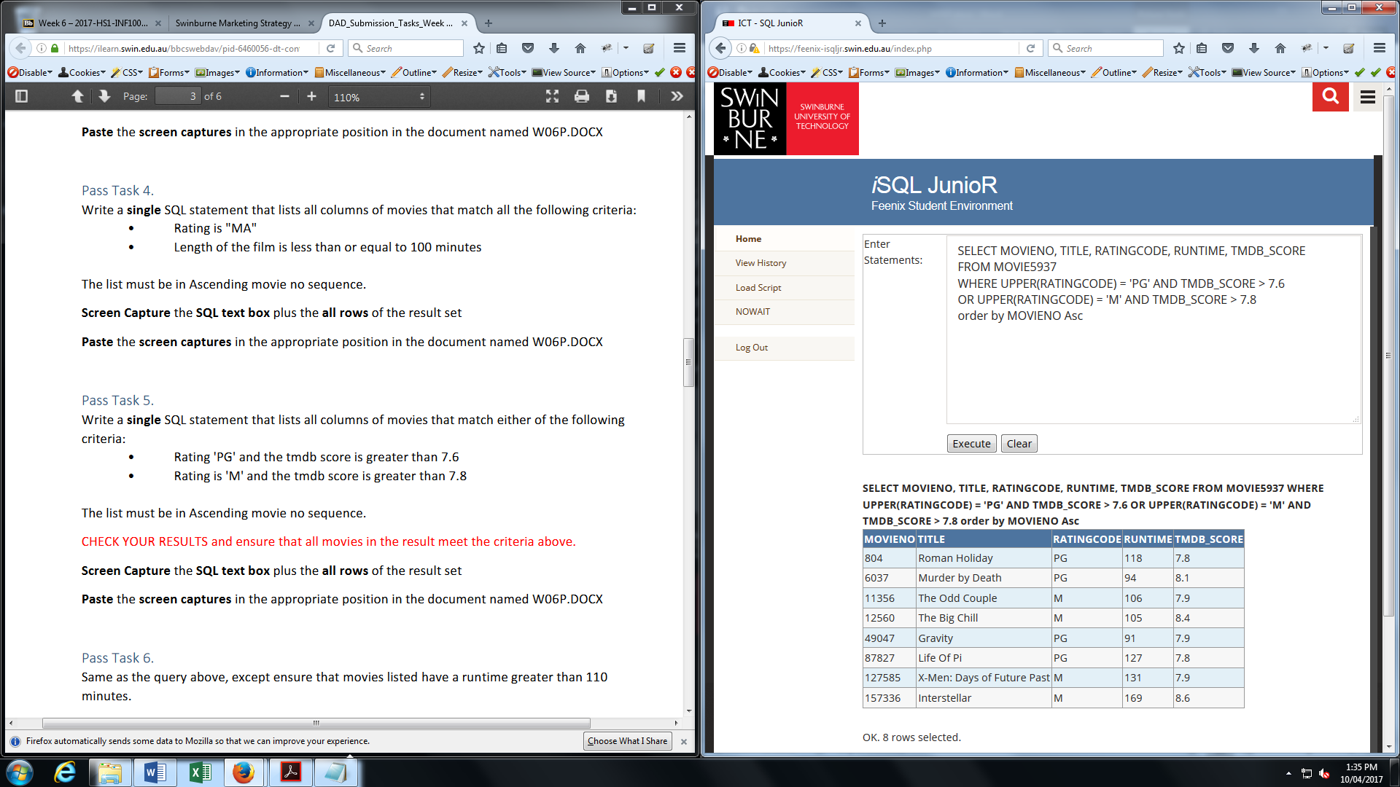========================================================

## Pass Task 6.

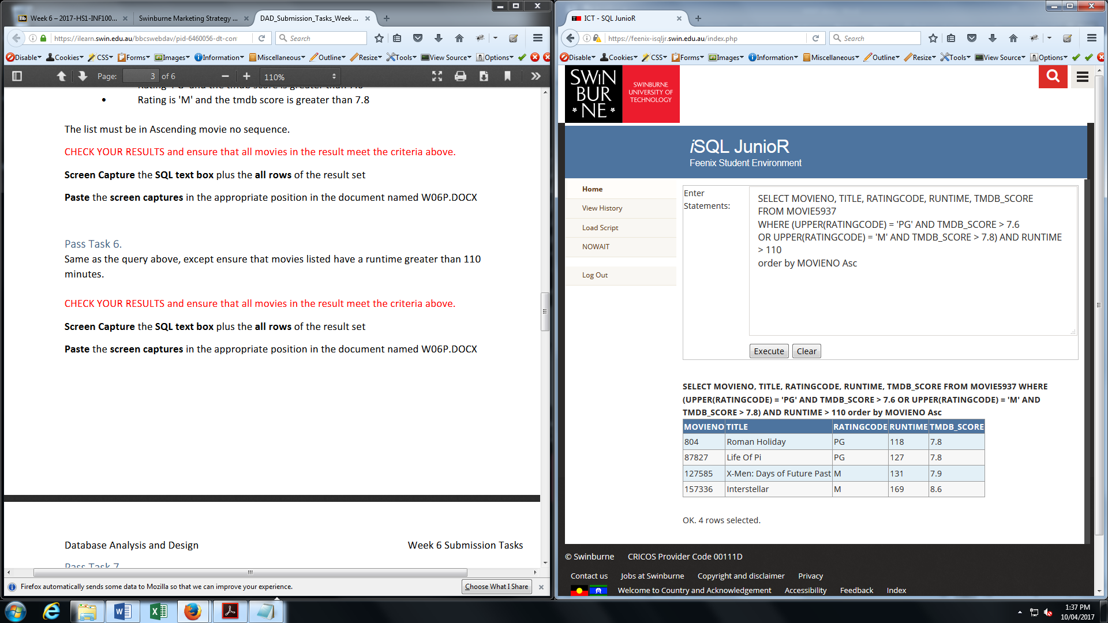========================================================

## Pass Task 7.

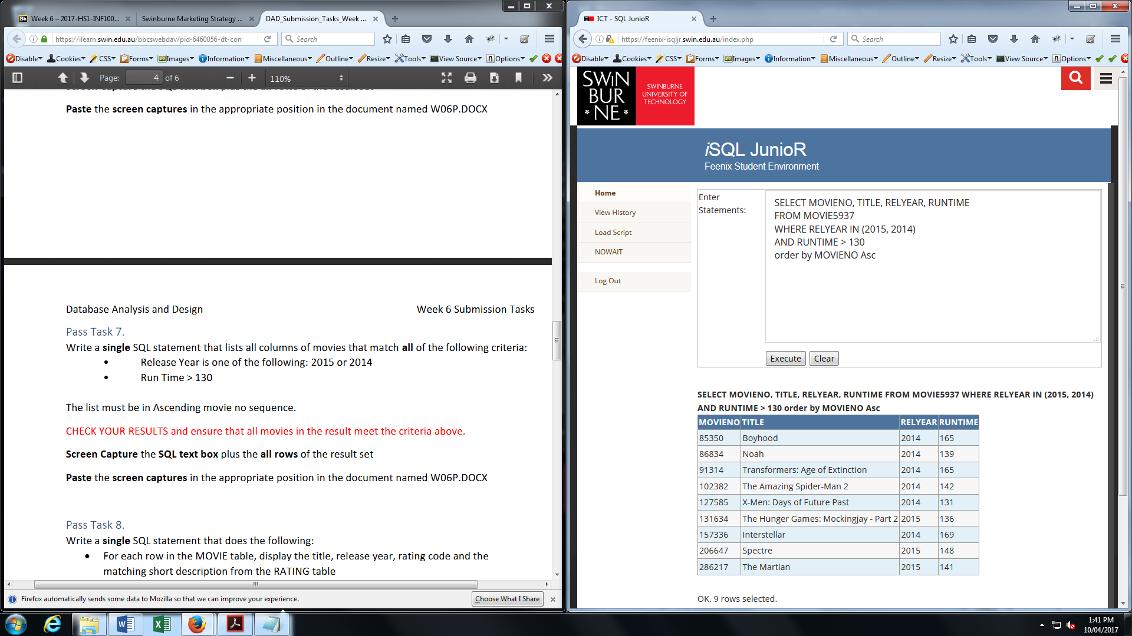========================================================

## Pass Task 8.

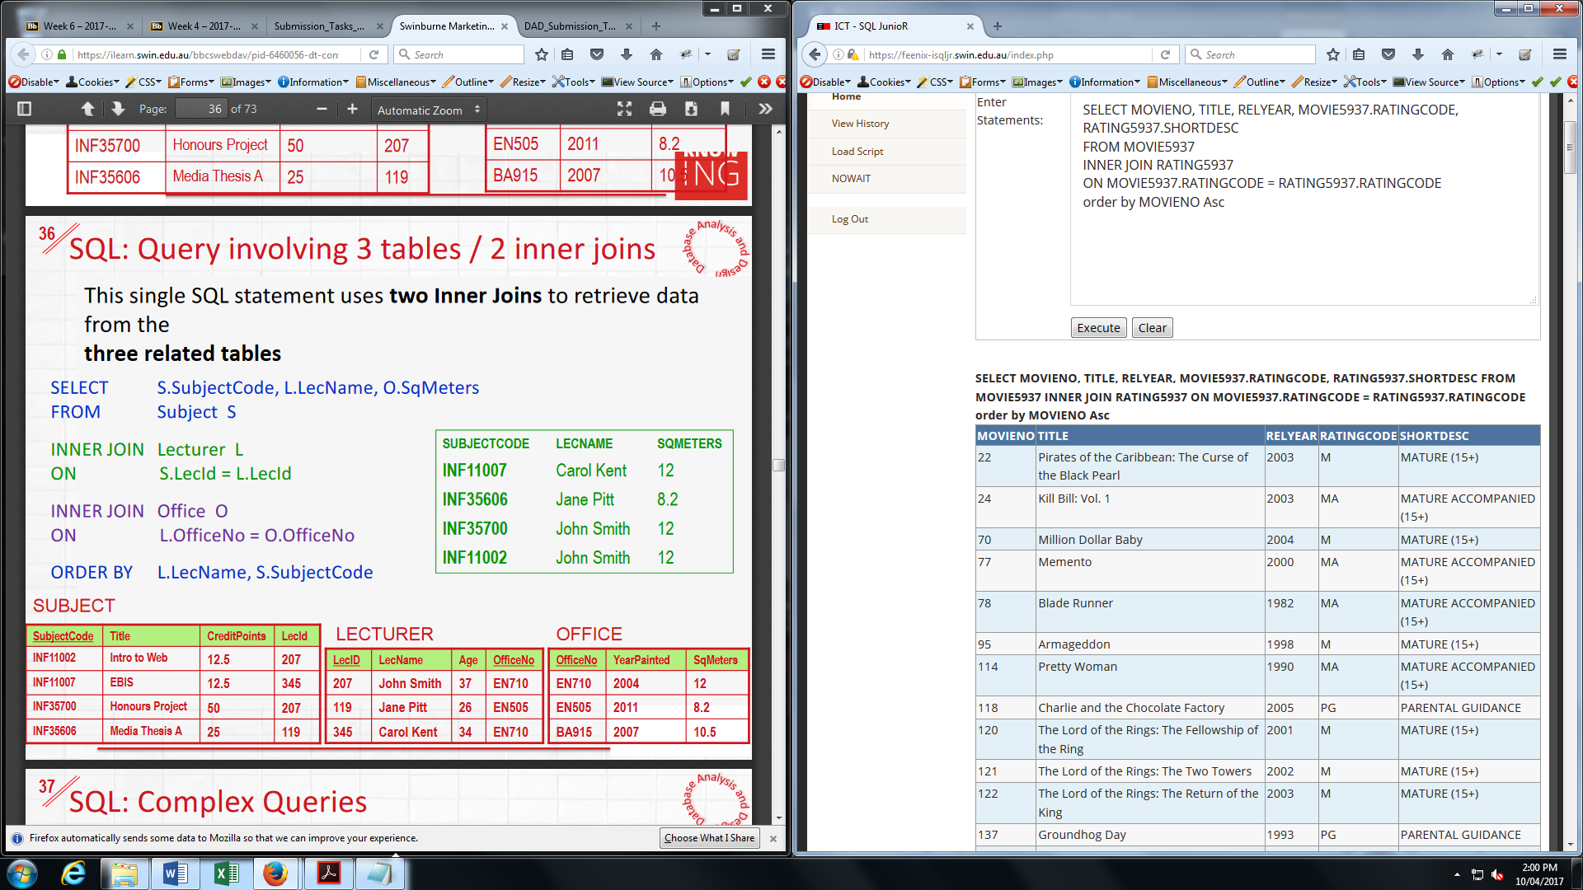========================================================

## Pass Task 9.

