DAD Week 7 **Pass** Submission Tasks

Student ID: 6835937

Student Name: Harrison Parker

## Pass Task 1.

**ERD**

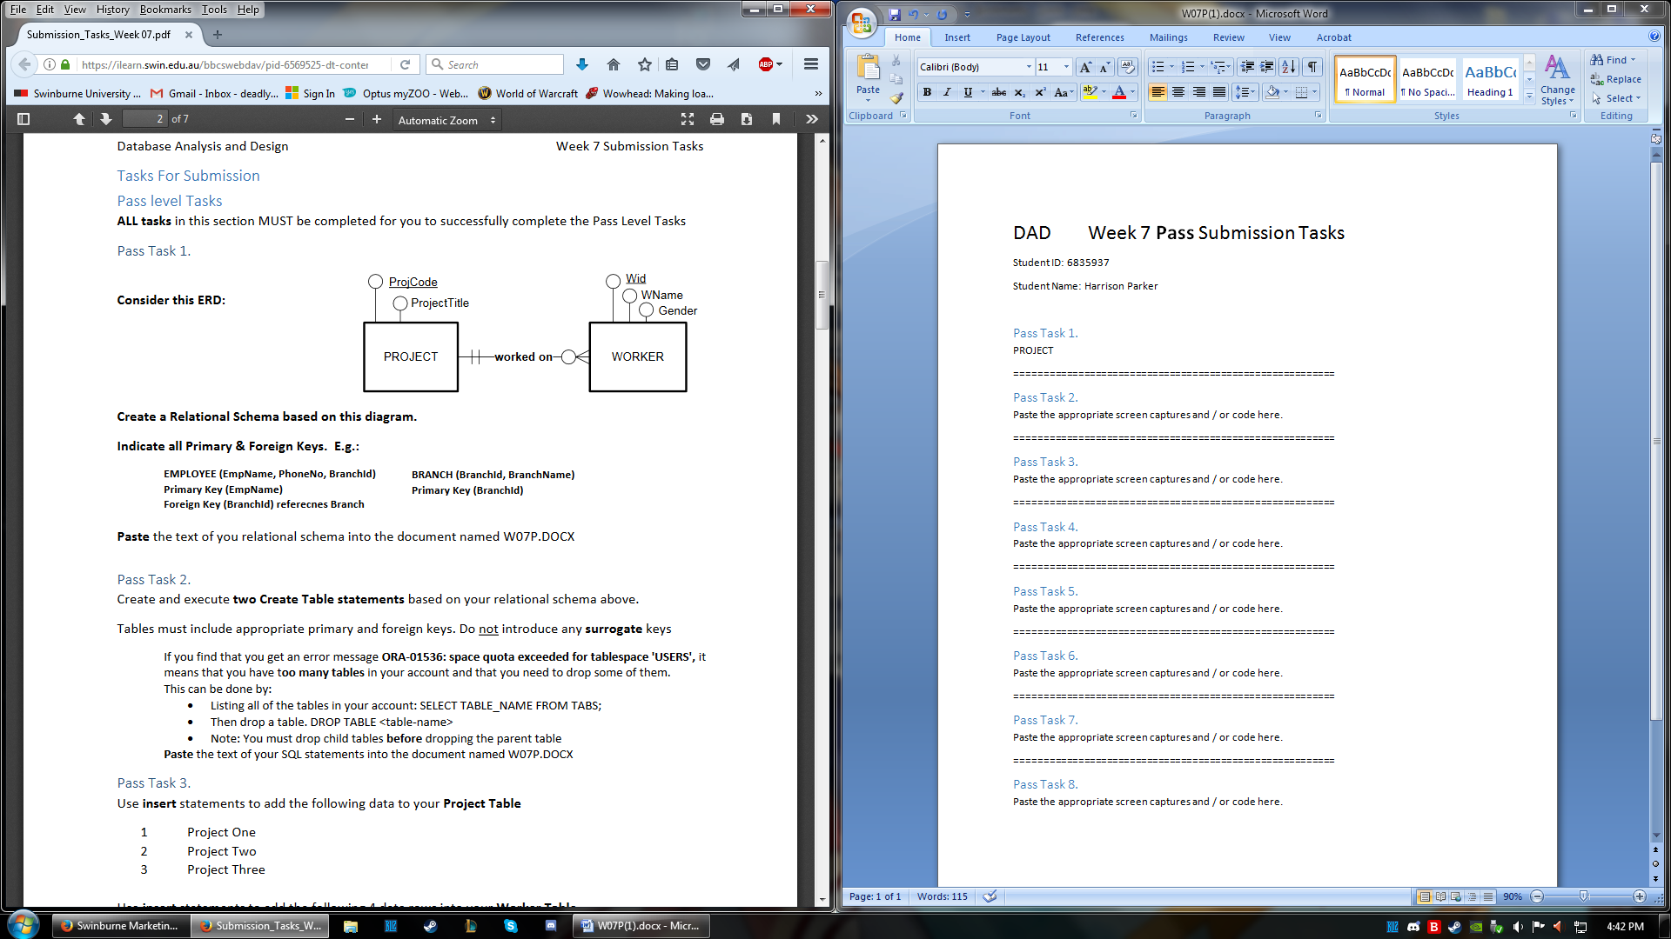

**Relational schema**

**PROJECT** (ProjCode, ProjectTitle)  
**Primary Key** (ProjCode)

**WORKER** (Wid, WName, Gender, ProjCode)  
**Primary Key** (Wid)  
**Foreign Key** (ProjCode) references to PROJECT

========================================================

## Pass Task 2.

Paste the appropriate screen captures and / or code here.

========================================================

## Pass Task 3.

Paste the appropriate screen captures and / or code here.

========================================================

## Pass Task 4.

Paste the appropriate screen captures and / or code here.

========================================================

## Pass Task 5.

Paste the appropriate screen captures and / or code here.

========================================================

## Pass Task 6.

Paste the appropriate screen captures and / or code here.

========================================================

## Pass Task 7.

Paste the appropriate screen captures and / or code here.

========================================================

## Pass Task 8.

Paste the appropriate screen captures and / or code here.