# **ubunut 16.04使用vscode调试C++**

1. vscode安装

本人使用的vscode是在安装Anaconda时顺带安装的，比较方便快捷

2. clang安装

Ubuntu16.04默认应该是没有clang的，因此要自行安装：

sudo apt-get install clang

3. vscode中安装c++环境

vscode中默认是没有C++环境的，因此需要安装拓展环境。Ctrl+p调出vscode的命令窗口，搜索ext install C++，安装重启vscode即可，我这里安装了C/C++和C/C++ Clang。

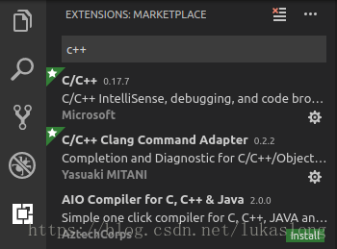

4. 建立launch.json

打开包含源文件（如main.cpp）

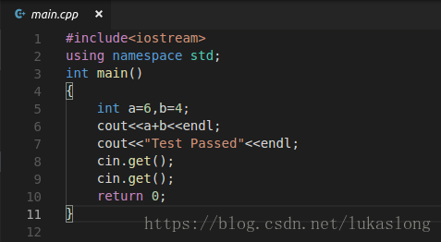

点左侧“蜘蛛”进入调试界面，上面齿轮处点击选择“C++(GDB)”，自动生成launch.json

仅需修改“program”一栏，删除前面”enter program name...”即可，保留“${workspaceFolder}/a.out”

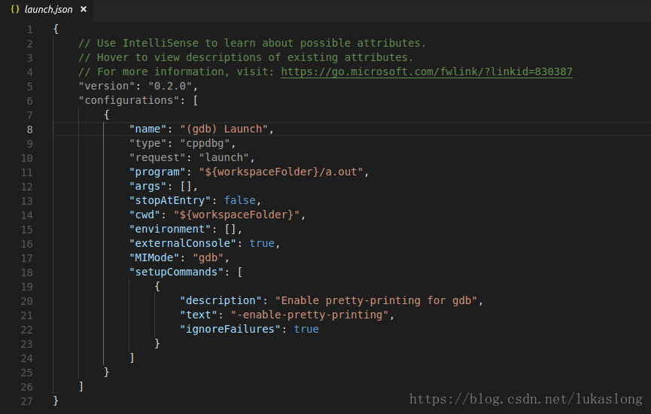

5. 建立Task.json

ctrl+p打开命令面板，然后输入>task后选择"Run Task"，自动生成task.json

修改"command"的值为"g++"，增加"args": ["-g","${workspaceRoot}/源码文件名.cpp"]

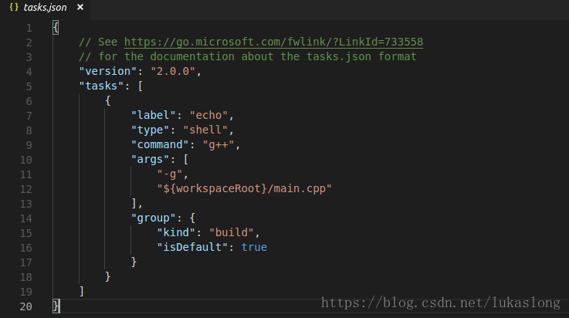

6. 按Ctrl+shift+B进行编译，按提示来即可

7. 按F5调试结果

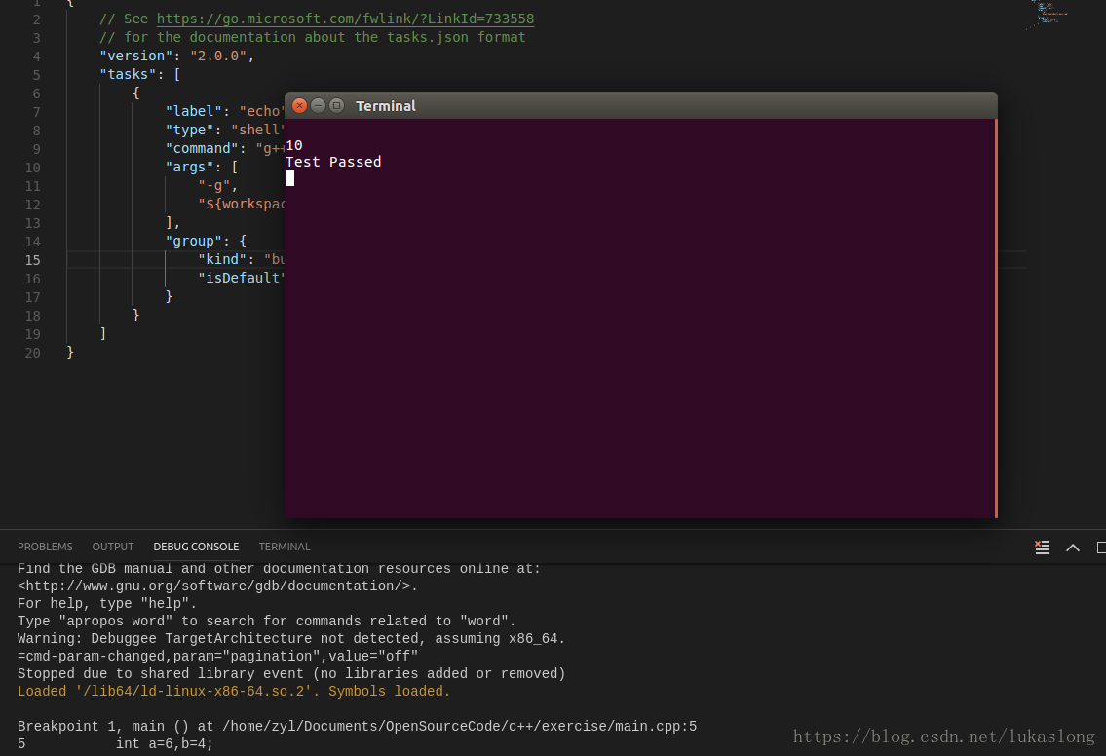

————————————————

原文链接：https://blog.csdn.net/lukaslong/article/details/81218486

launch.json

{

// Use IntelliSense to learn about possible attributes.

// Hover to view descriptions of existing attributes.

// For more information, visit: https://go.microsoft.com/fwlink/?linkid=830387

"version": "0.2.0",

"configurations": [

{

"name": "g++ - Build and debug active file",

"type": "cppdbg",

"request": "launch",

"program":"${workspaceFolder}/a.out",

"args":[],

"stopAtEntry":false,

"cwd" :"${workspaceFolder}",

"environment":[],

"externalConsole":true,

"MIMode":"gdb",

//"preLaunchTask": "g++ build active file",

"miDebuggerPath":"/usr/bin/gdb",

"setupCommands": [

{

"description": "Enable pretty - printing for gdb",

"text": "-enable-pretty-printing",

"ignoreFailures": true

}

]

}

]

}

task.json

{

// See https://go.microsoft.com/fwlink/?LinkId=733558

// for the documentation about the tasks.json format

"version": "2.0.0",

"tasks": [

{

"label": "echo",

"type": "shell",

"command": "g++",

"args": [

"-g",

"${workspaceRoot}/main.cpp"

],

"group": {

"kind": "build",

"isDefault": true

}

}

]

}