GEOG 255_Assignment 3
Rena Choi
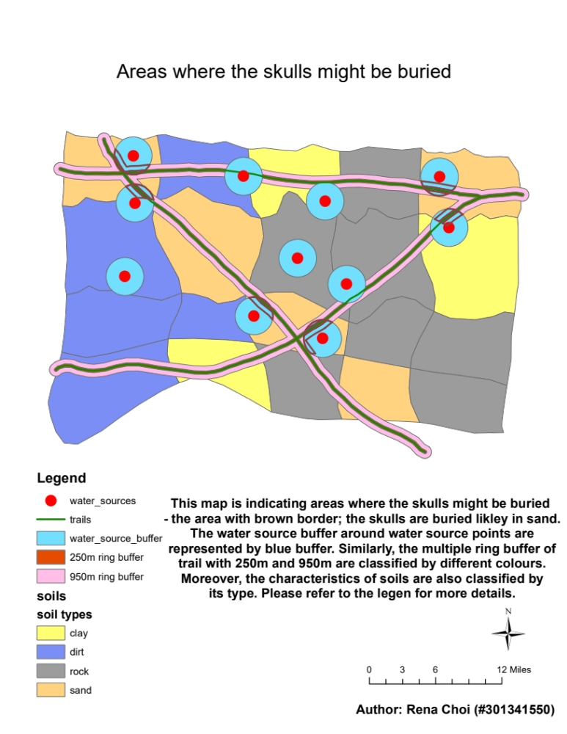
#301341550
Integration Questions

- Give two reasons why ring buffers will not accurately represent the real world?
- It reflects only distance from an input feature; if there is mountain within the buffer, it does not reflect the mountain’s height in the buffer.

- Its scale is fixed; If ring buffers are reprojected to a different coordinate system, the location and size of the original buffers will be transformed, but the shape of the buffers will not change.

- Why do researchers still use ring buffers for GIS analysis work?
- Ring buffers for GIS analysis is still used by researchers because it can create multiple buffers of different distances around an input feature at a time. Otherwise, the standard buffer must be run multiple times to make buffers of different distances around an input.

- Give two advantages that selection by location has over selection by graphic?
- The selection by graphics selects consecutive feature that intersect the selected graphic element. However, the selection by location selects features that meet certain criteria even if they are apart.

- The selection by location selects features according to your needs. For example, you can select every feature within 100m of hospital by specifying spatial selection method for target layer.

- State two ways to improve accuracy (not precision) of skulls’ location?
- Add more condition so that you can narrow down the skulls’ location; put more condition on SQL query

- Compute RMS (Root Mean Squared) error: smaller RMS error is desirable; if the RMS error is large, you can remove and add control points to adjust the error.

- Describe two ways a GIS can perform spatial analysis using multiple data layers?
- Union multiple data layers that contain distinct information so that you can do an analysis using the merged data at a time

- Clip two data layers so that you can visually carry information from both layers in one map.

