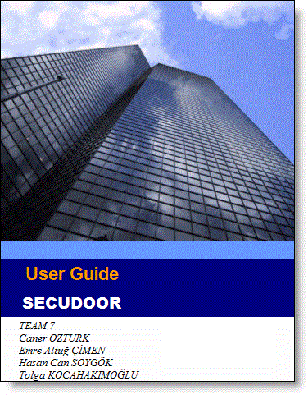

COMPONENT LIST

Secure Electronic Lock System(SELS)
-Raspberry Pi v2
-Arduino
-Fingerprint Scanner
-Camera
-Power plug(5v)

HOW TO USE IT
Fingerprint

- Connect to FingerPrint Scanner to Ardunio
- Install Ardunio application to your computer
- Run Fingerprint file to ardunio via Ardunio Application
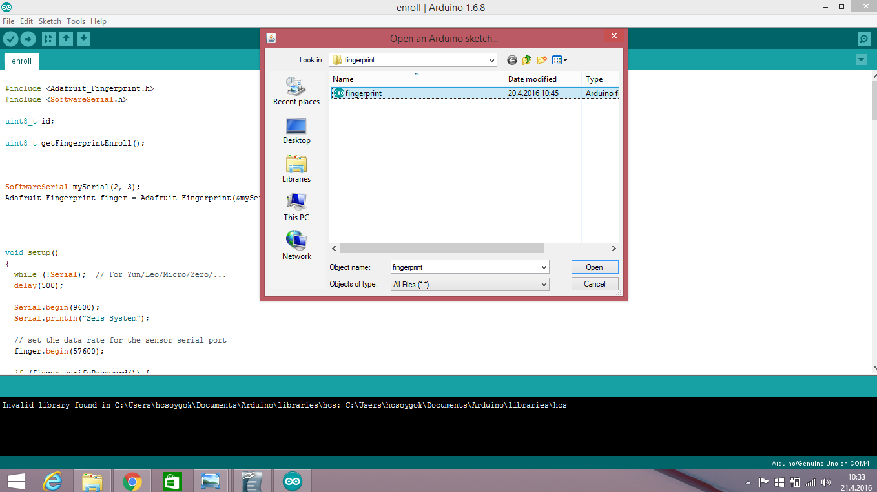

- For register run enroll file
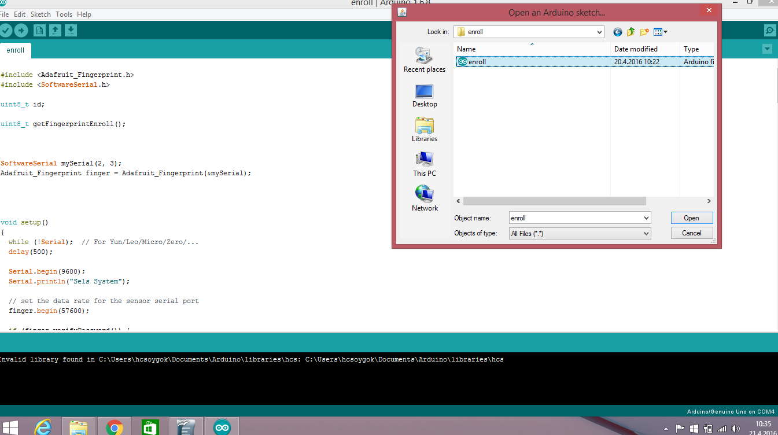

- Scan your finger and complete registration step
- For delete fingerprint image run delete file

Face Recognition

- For register
-- Run terminal (Ctrl+Alt+T)
-- Go to trainDataset Folder // cv FaceFramework/trainDataset
-- Run train.py // sudo python train.py

do not move your face during camera try to register your face

2) Recognize Face

-- Run terminal (Ctrl+Alt+T)
-- Go to apps/videofacerec Folder // cv FaceFramework/apps/videofacerec
-- Run videofacerec.py // sudo python videofacerec.py – t /home/pi/FaceFramework/trainDateset/Dataset name

