Parker Verboom – Madhulika Reddivari – Requirement 2

Our first step was to create a new Google Cloud Project. The Google Cloud Project was created under my professional gmail, parker.verboom@gmail.com.

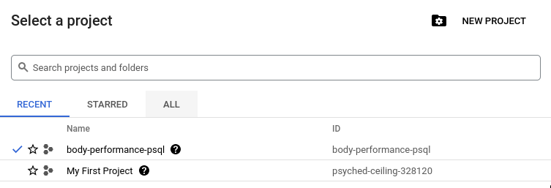

Then, We created a google bucket, uploaded our performance data from the Kaggle link to said bucket, then created a postgres SQL instance on google cloud platform.

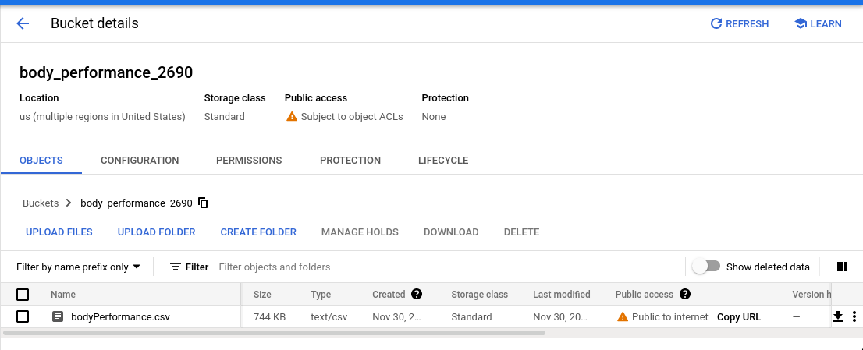

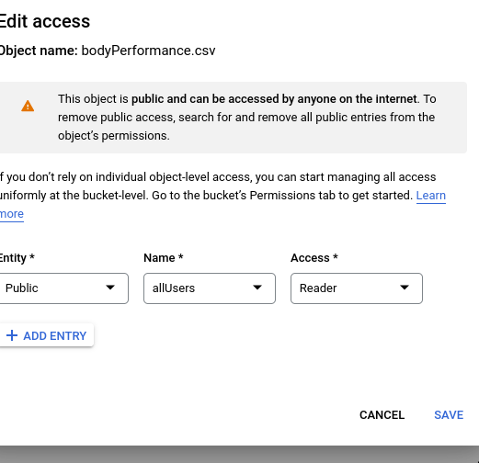

We added Public access to the file; not normally a very secure thing to do, but for the purposes of this project it made sense. The file can be found at: https://storage.googleapis.com/body_performance_2690/bodyPerformance.csv

Following the creation of the bucket, a Postgres SQL instance was created; settings were set to be fairly modest (low amount of ram, low CPU power), due to the size and type of data being hosted not demanding much more.

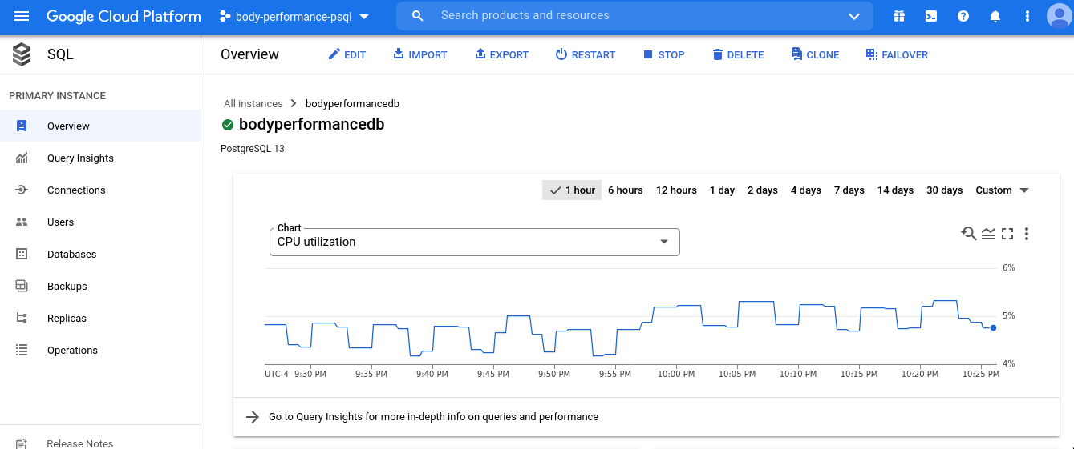

Since IP addresses provided by GCP are private by default, we added our IP Addresses to the Connections tab so we could access the server using both the psql client and pgAdmin remotely.

After getting connected, we logged into that instance with pgAdmin, and created a database called "bodyperformance";

then in pgAdmin, we created a table called "performancedata", along with a series of columns matching the headers in the .csv file. 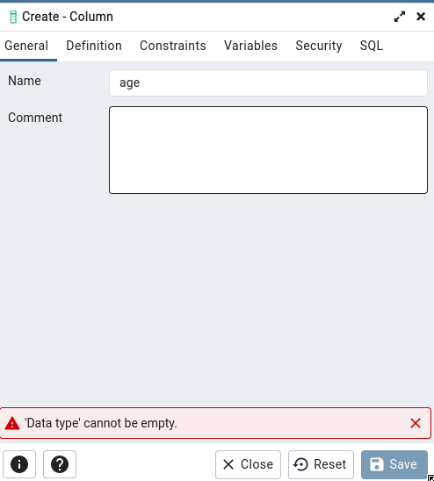

Then, we downloaded the file from our bucket, used the "Import/Export" function to import the data.

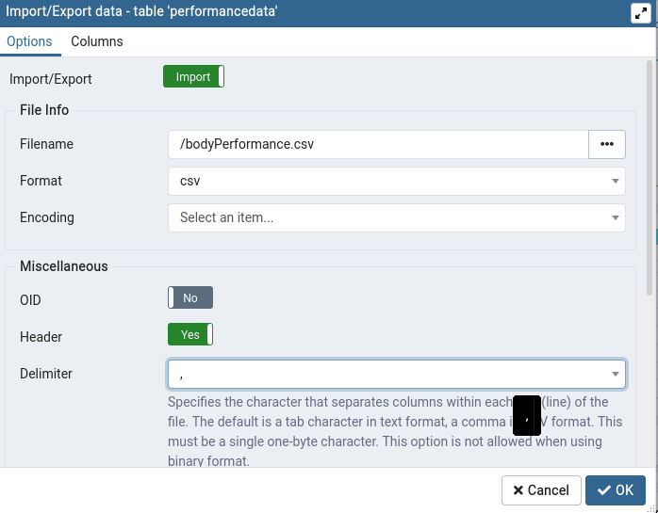

After this, we were able to run a “SELECT * FROM performancedata” query on the database, yielding the results. I ran the command from the command line:

psql "sslmode=disable dbname=bodyperformance user=postgres hostaddr=34.135.240.200"

The dbname is bodyperfomance, the user is postgres, the password is csci2690, and the tablename is performancedata

