1. 肿瘤标志物与活检结果相比较，用肿瘤标志物模型区分：

1.1癌vs非癌

Standard Wald Point 95% Wald

Parameter DF Estimate Error Chi-Square Pr > ChiSq Estimate Confidence Limits

Intercept 1 -3.4947 1.4238 6.0246 0.0141

age 1 0.0122 0.0186 0.4332 0.5104 1.012 0.976 1.050

sexc 1 0.2584 0.7032 0.1350 0.7133 1.295 0.326 5.138

smokec 1 -0.1972 0.7027 0.0787 0.7790 0.821 0.207 3.255

diasumm 1 0.1439 0.0494 8.4689 0.0036 1.155 1.048 1.272

Pro_GRP 1 0.000102 0.000308 0.1104 0.7397 1.000 0.999 1.001

SCC 1 0.1242 0.1715 0.5243 0.4690 1.132 0.809 1.585

CYFRA211 1 0.1426 0.0699 4.1582 0.0414 1.153 1.006 1.323

CEA 1 -0.00203 0.00157 1.6723 0.1960 0.998 0.995 1.001

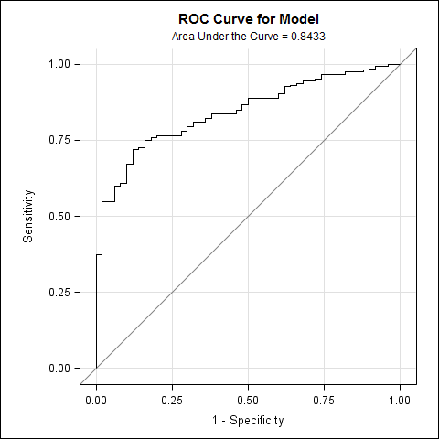

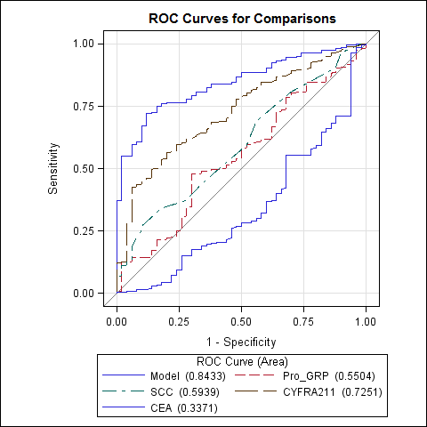

1.2区分NSCLC

Standard Wald Point **95**% Wald

Parameter DF Estimate Error Chi-Square Pr > ChiSq Estimate Confidence Limits

Intercept **1** -**1.1867** **1.1172** **1.1283** **0.2881**

age **1** **0.0315** **0.0169** **3.4787** **0.0622** **1.032** **0.998** **1.067**

sexc **1** **0.0632** **0.6449** **0.0096** **0.9220** **1.065** **0.301** **3.770**

smokec **1** -**0.2910** **0.6445** **0.2038** **0.6516** **0.748** **0.211** **2.644**

slobec **1** -**1.7430** **0.4344** **16.0997** <**.0001** **0.175** **0.075** **0.410**

diasumm **1** **0.0223** **0.00967** **5.3028** **0.0213** **1.023** **1.003** **1.042**

Pro_GRP **1** -**0.00239** **0.000715** **11.1487** **0.0008** **0.998** **0.996** **0.999**

SCC **1** **0.1982** **0.1470** **1.8185** **0.1775** **1.219** **0.914** **1.626**

CYFRA211 **1** **0.1730** **0.0594** **8.4908** **0.0036** **1.189** **1.058** **1.336**

CEA **1** -**0.00178** **0.00102** **3.0727** **0.0796** **0.998** **0.996** **1.000**

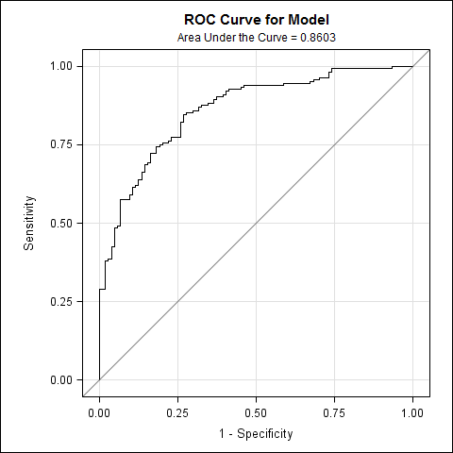

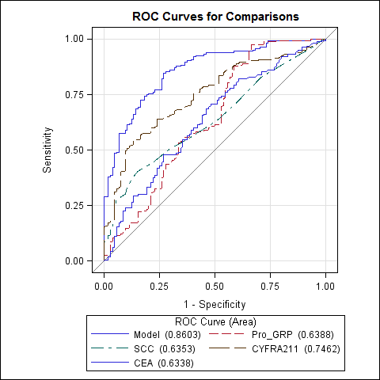

1.3区分SCLC

Standard Wald Point 95% Wald

Parameter DF Estimate Error Chi-Square Pr > ChiSq Estimate Confidence Limits

Intercept 1 -0.2728 1.9106 0.0204 0.8865

age 1 -0.0259 0.0295 0.7711 0.3799 0.974 0.920 1.032

sexc 1 -0.4151 1.7961 0.0534 0.8172 0.660 0.020 22.313

smokec 1 1.5529 1.8007 0.7437 0.3885 4.725 0.139 161.127

slobec 1 -0.8371 0.5866 2.0365 0.1536 0.433 0.137 1.367

diasumm 1 0.0340 0.0121 7.8691 0.0050 1.035 1.010 1.060

Pro_GRP 1 0.00139 0.000301 21.4566 <.0001 1.001 1.001 1.002

SCC 1 -1.3888 0.8665 2.5692 0.1090 0.249 0.046 1.363

CYFRA211 1 -0.4718 0.1958 5.8073 0.0160 0.624 0.425 0.916

CEA 1 -0.00217 0.00625 0.1208 0.7281 0.998 0.986 1.010

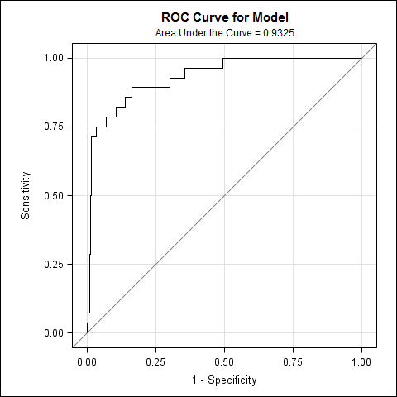

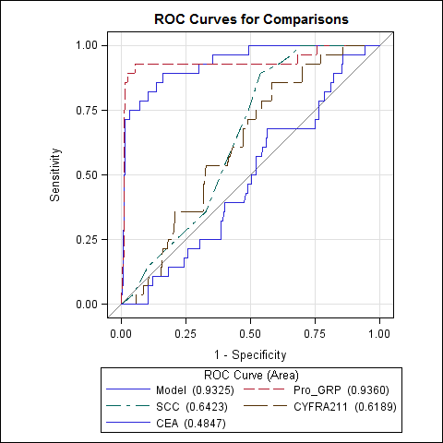

1. 肿瘤标志物与临床判断相比，用肿瘤标志物区分：Unbiopsy＋非癌vs癌

Standard Wald Point 95% Wald

Parameter DF Estimate Error Chi-Square Pr > ChiSq Estimate Confidence Limits

Intercept 1 -3.6463 0.8647 17.7804 <.0001

age 1 -0.00346 0.0120 0.0828 0.7735 0.997 0.973 1.020

sexc 1 0.2238 0.5418 0.1707 0.6795 1.251 0.433 3.617

smokec 1 -0.3887 0.5363 0.5254 0.4686 0.678 0.237 1.939

diasumm 1 0.1466 0.0262 31.4255 <.0001 1.158 1.100 1.219

Pro_GRP 1 0.000178 0.000224 0.6319 0.4267 1.000 1.000 1.001

SCC 1 0.0228 0.0531 0.1846 0.6674 1.023 0.922 1.135

CYFRA211 1 0.1027 0.0330 9.6652 0.0019 1.108 1.039 1.182

CEA 1 -0.00058 0.00109 0.2846 0.5937 0.999 0.997 1.002

