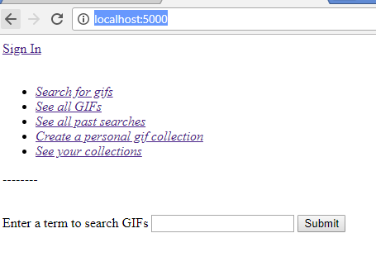

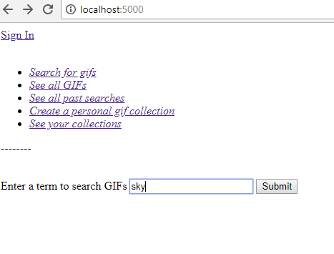 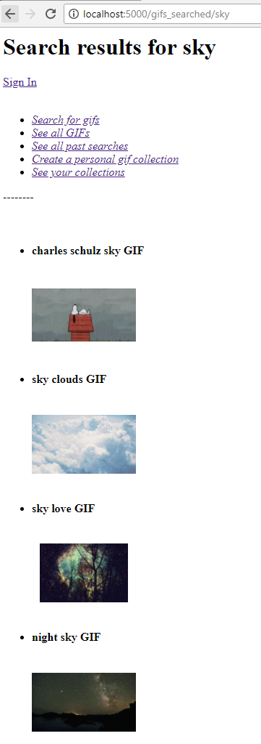

Click “See All GIFs”

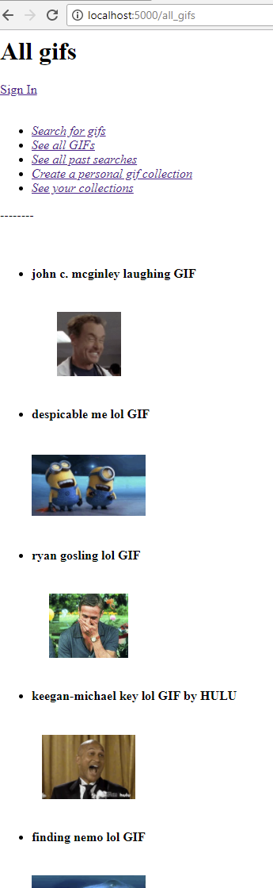

* Click [*See all past searches*](http://localhost:5000/search_terms)

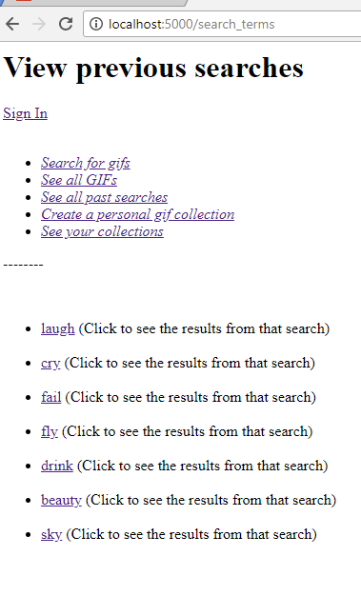

Click “*Create a personal gif collection”;* it requires you to login.

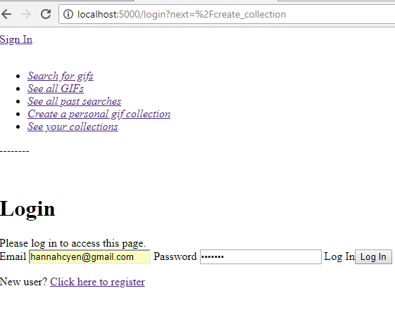

Once you type your login credentials, click log in button, you will see the form below.

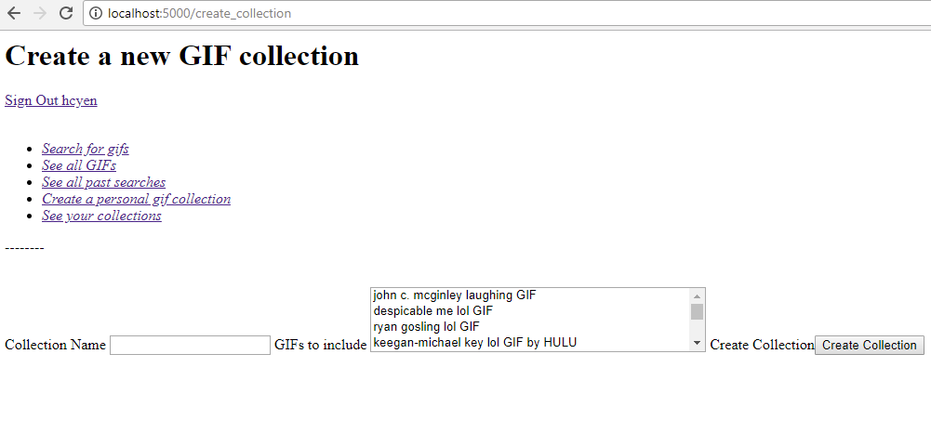

Type a collection name, and select a couple of gifs from the list, then click the Create Collection button.

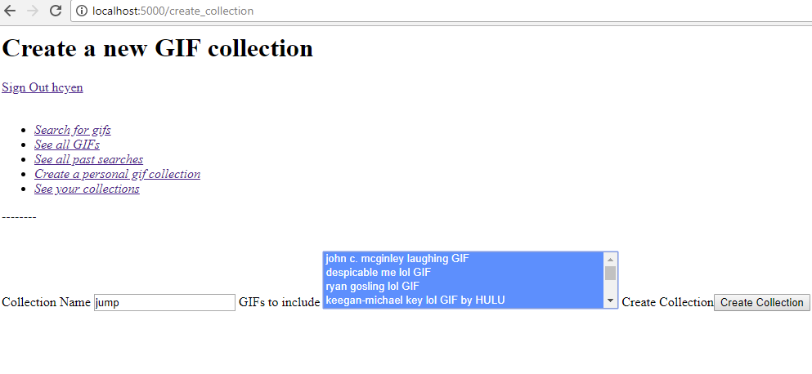

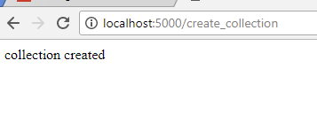

Click the back button on the browser to see the page.

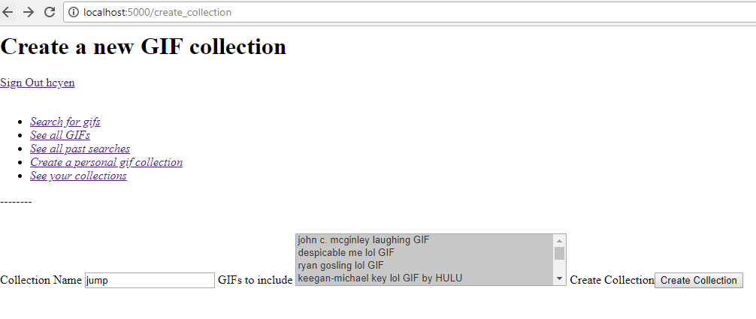

Click the “see your collections” link

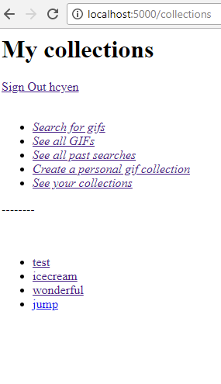

If you want to create a personal gif collection but you don’t have an account yet, you will need to do this…

If you are new user, you need to click “here to register”

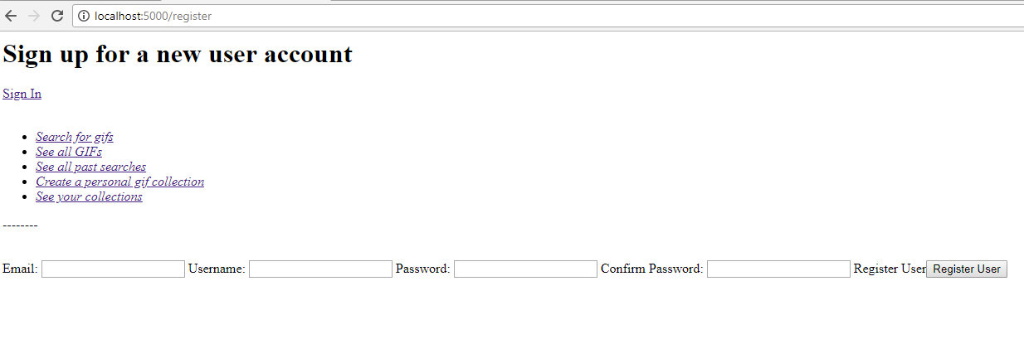

Enter the information below and then click the Register User button

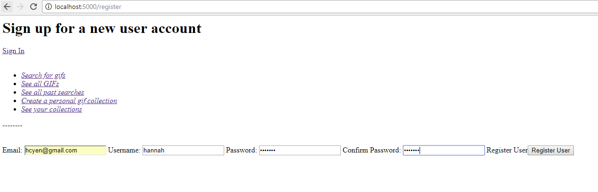

You will see the following login page and you can login.

