多元统计分析作业



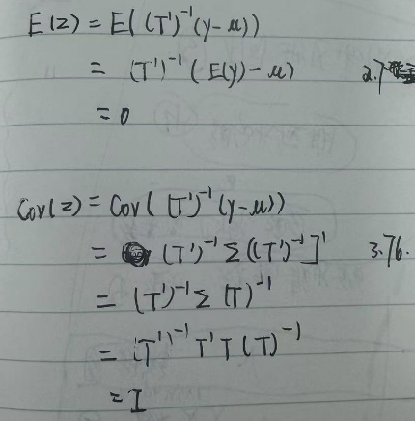



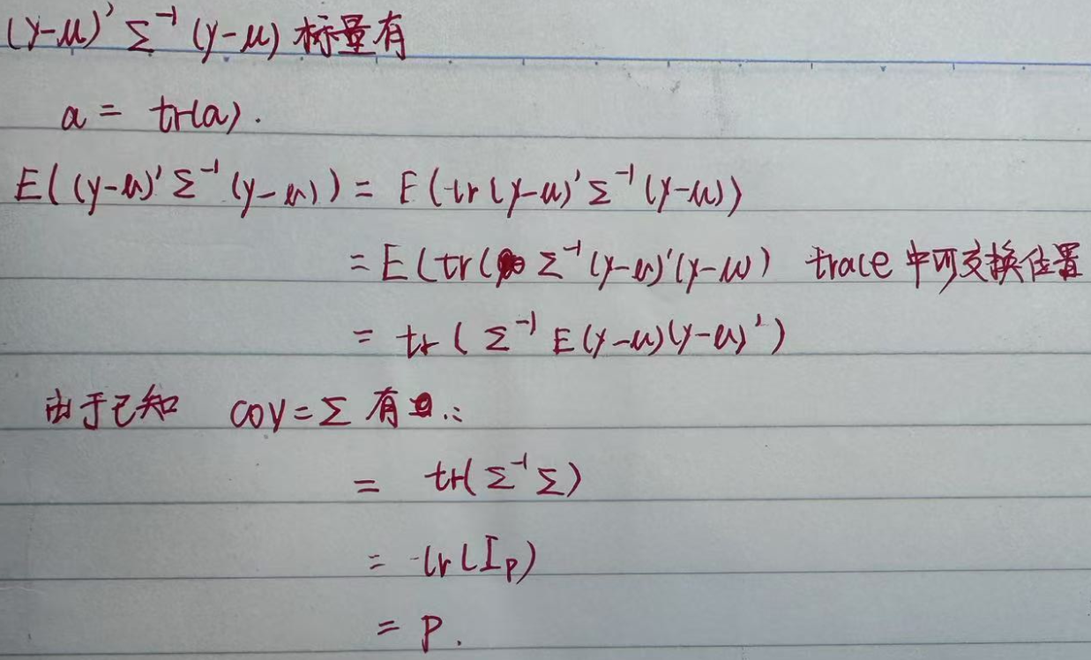

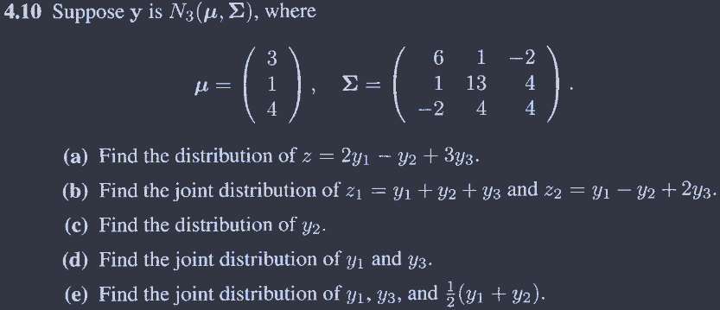

> library(data.table)

>

> # a

> mu <- c(3, 1, 4)

> sigma <- matrix(

+ c(6, 1, -2,

+ 1, 13, 4,

+ -2, 4, 4),

+ nrow = 3

+ )

>

> a <- c(2,-1,3)

>

> mu_z <- t(a)%*%mu

> mu_z

[,1]

[1,] 17

> sigma_z <- t(a)%*%sigma%*%a

> sigma_z

[,1]

[1,] 21

>

> # b

>

> A <- matrix(

+ c(1, 1, 1,

+ 1, -1, 2),

+ nrow = 3

+ )

>

> t(A)%*%mu

[,1]

[1,] 8

[2,] 10

>

> t(A)%*%sigma%*%A

[,1] [,2]

[1,] 29 -1

[2,] -1 9

>

> # c

>

> mu[2]

[1] 1

> sigma[2,2]

[1] 13

>

> # d

>

> mu[c(1,3)]

[1] 3 4

> sigma[-2,-2]

[,1] [,2]

[1,] 6 -2

[2,] -2 4

>

> #e

> A <- matrix(

+ c(1, 0, 0,

+ 0, 0, 1,

+ 0.5,0.5,0),

+ nrow = 3

+ )

>

> t(A)%*%mu

[,1]

[1,] 3

[2,] 4

[3,] 2

>

> t(A)%*%sigma%*%A

[,1] [,2] [,3]

[1,] 6.0 -2 3.50

[2,] -2.0 4 1.00

[3,] 3.5 1 5.25

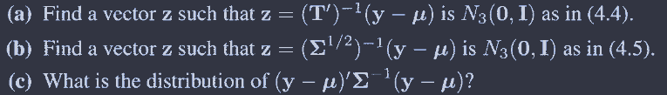

# a

mu <- c(3, 1, 4)

sigma <- matrix(c(6, 1, -2,

1, 13, 4,

-2, 4, 4), nrow = 3, byrow = TRUE)

T_upper <- chol(sigma) #Cholesky 分解

T_inv <- solve(t(T_upper))

T_inv

# 验证

t(T_upper)%*%T_upper

# 用T_iniv和矩阵 matrix(c(y-3,y-1,y-4),3,1) 相乘

# b

library(expm)

# 协方差矩阵

sigm <- matrix(c(6, 1, -2,

1, 13, 4,

-2, 4, 4), nrow = 3, byrow = TRUE)

Sigma_sqrt <- sqrtm(sigm)

Sigma_sqrt_inv <- solve(Sigma_sqrt)

# 输出结果

Sigma_sqrt_inv

# 用Sigma_sqrt_inv和矩阵 matrix(c(y-3,y-1,y-4),3,1) 相乘

# c 见96页 卡方分布

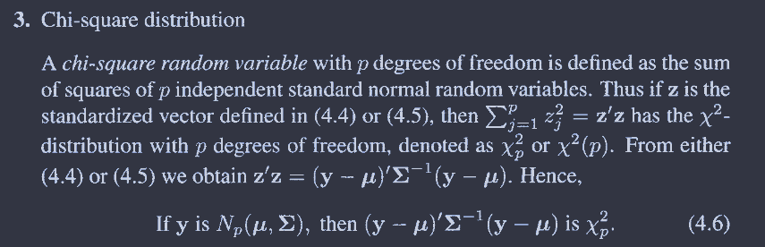

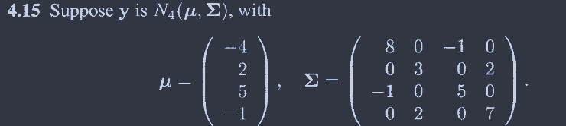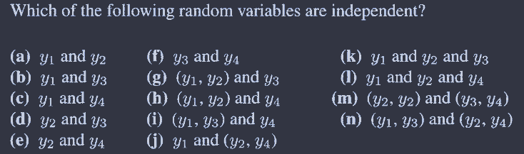

看协方差是否为0可得，独立的选项有a c d f I j

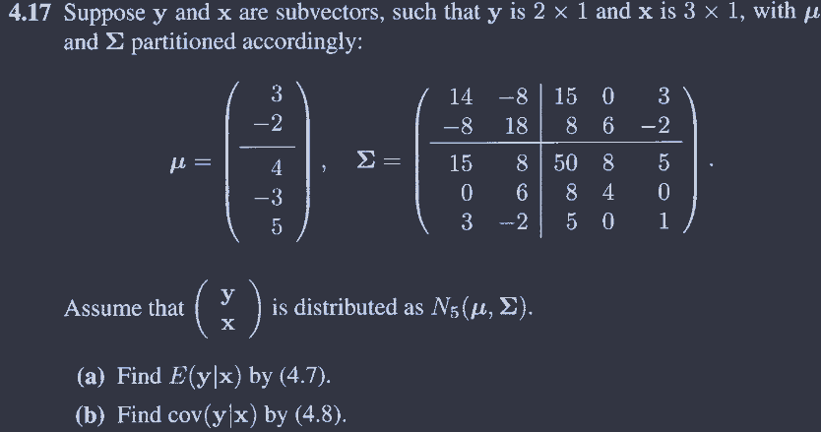

# a

matrix(c(3,-2),2) + matrix(c(15,8,0,6,3,-2),nrow = 2, ncol = 3)%*%

solve(matrix(c(50,8,5,8,4,0,5,0,1),3,3))%*%matrix(c(x1-4,x2+3,x3-5),3,1)

# b

matrix(c(14,-8,-8,18),2) - matrix(c(15,8,0,6,3,-2),nrow = 2, ncol = 3)%*%

solve(matrix(c(50,8,5,8,4,0,5,0,1),3,3))%*%matrix(c(15,0,3,8,6,-2),3,2)

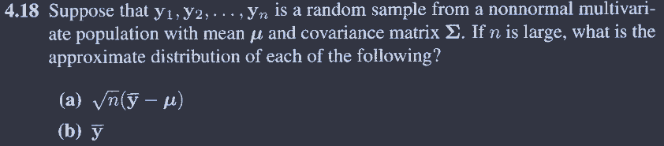

书上就是答案，反过来

