多元统计分析作业

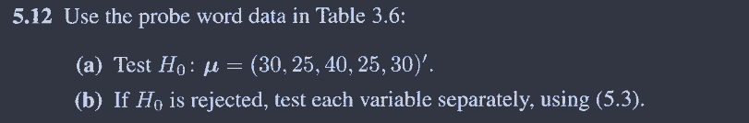

> library(data.table)

> # a

> dat <- read.table("C:/Users/hcy/Zotero/storage/MM8WF4GT/Software-Files/T3_6_PROBE.DAT") |> setDT()

> setnames(dat,colnames(dat),c("num",paste0(rep("y",5),1:5)))

>

> # H0

> mu <- c(30,25,40,25,30) |> as.matrix()

>

> sample_mu <- apply(dat[,-1],2,mean)|> as.matrix()

> sample_s <- cov(dat[,-1])

>

> T_2 <- nrow(dat)*t((sample_mu-mu))%*%solve(sample_s)%*%(sample_mu-mu)

> T_2

[,1]

[1,] 85.3327

> # 界值36.561

> # 拒绝原假设

>

> # b

> for(i in 1:5){

+ test_result <- t.test(dat[[ c(i+1)]], mu = mu[i])

+

+

+ if(test_result$p.value>0.05){

+ cat( paste0("尚不能拒绝原假设H0",'\n'))

+ }else{

+ cat( paste0(" 拒绝原假设H0",'\n'))

+ }

+ }

拒绝原假设H0

尚不能拒绝原假设H0

拒绝原假设H0

尚不能拒绝原假设H0

尚不能拒绝原假设H0



> C1 <- matrix(c(-1,1,0,0,0,

+ 0,-1,1,0,0,

+ 0,0,-1,1,0,

+ 0,0,0,-1,1),4,5,byrow = T)

>

> sample_mu <- apply(dat[,-1],2,mean)|> as.matrix()

> sample_s <- cov(dat[,-1])

>

>

>

>

> T_2 <- nrow(dat)*t(C1%*%sample_mu)%*%solve(C1%*%sample_s%*%t(C1))%*%C1%*%sample_mu

> T_2 # 界值36.561

[,1]

[1,] 30.28595

> cat("不拒绝原假设")

不拒绝原假设