计算神经科学导论：从大脑模拟到NeuroAI
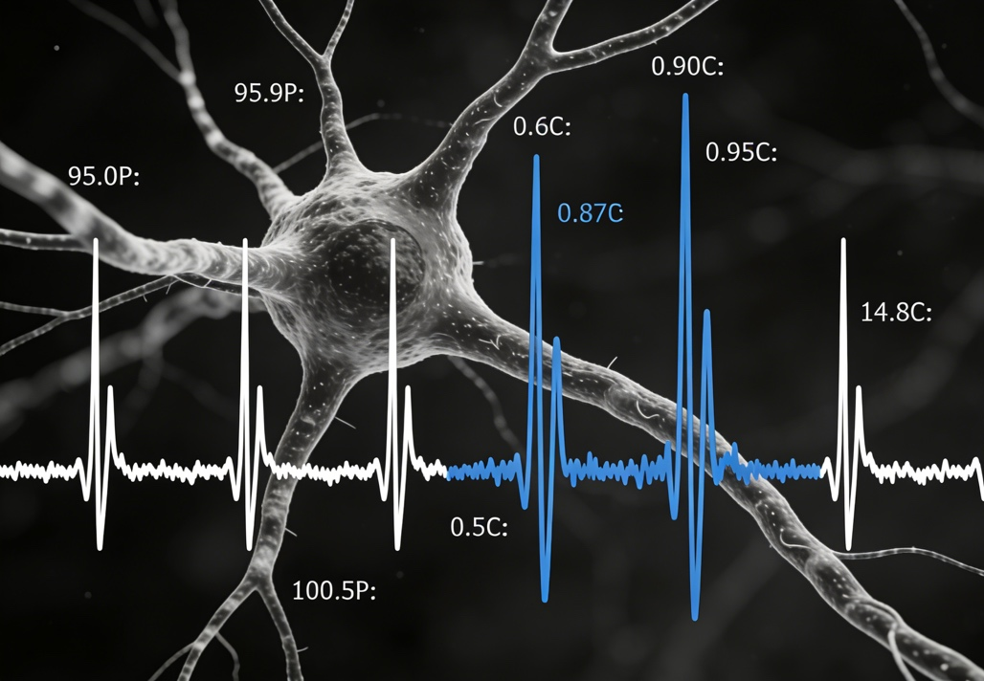
《计算神经科学导论：从大脑模拟到 NeuroAI》面向对大脑计算原理、神经系统建模以及类脑人工智能感兴趣的学生与研究者。课程从神经元与神经网络的生物基础出发，介绍电生理模型、神经编码理论、网络动力学等计算神经科学核心内容，并逐步引入大脑模拟及多尺度建模方法，帮助学生理解从单个神经元到大脑系统的计算过程。在此基础上，课程进一步探讨 NeuroAI 的最新进展，包括脑启发机器学习模型、神经形态计算、类脑网络训练机制以及大模型与神经科学融合的新趋势。通过实验、仿真与简易研究项目，学生将获得理论理解与实践能力，初步具备将脑科学知识应用于智能算法研究的能力。
Introduction to Computational Neuroscience: From Brain Simulation to NeuroAI is designed for students and researchers interested in the computational principles of the brain, neural system modeling, and brain-inspired artificial intelligence. The course begins with the biological foundations of neurons and neural circuits, covering electrophysiological models, neural coding theories, and network dynamics. Students will also learn about multiscale brain modeling and brain simulation, gaining insight into computation from single neurons to large-scale brain systems. Building on these foundations, the course explores recent advances in NeuroAI, including brain-inspired machine learning models, neuromorphic computing, training mechanisms for brain-like networks, and emerging directions that integrate large AI models with neuroscience. Through hands-on experiments, simulations, and small research projects, students will acquire both theoretical understanding and practical skills, developing the ability to apply neuroscience insights to intelligent algorithm design.

数值分析
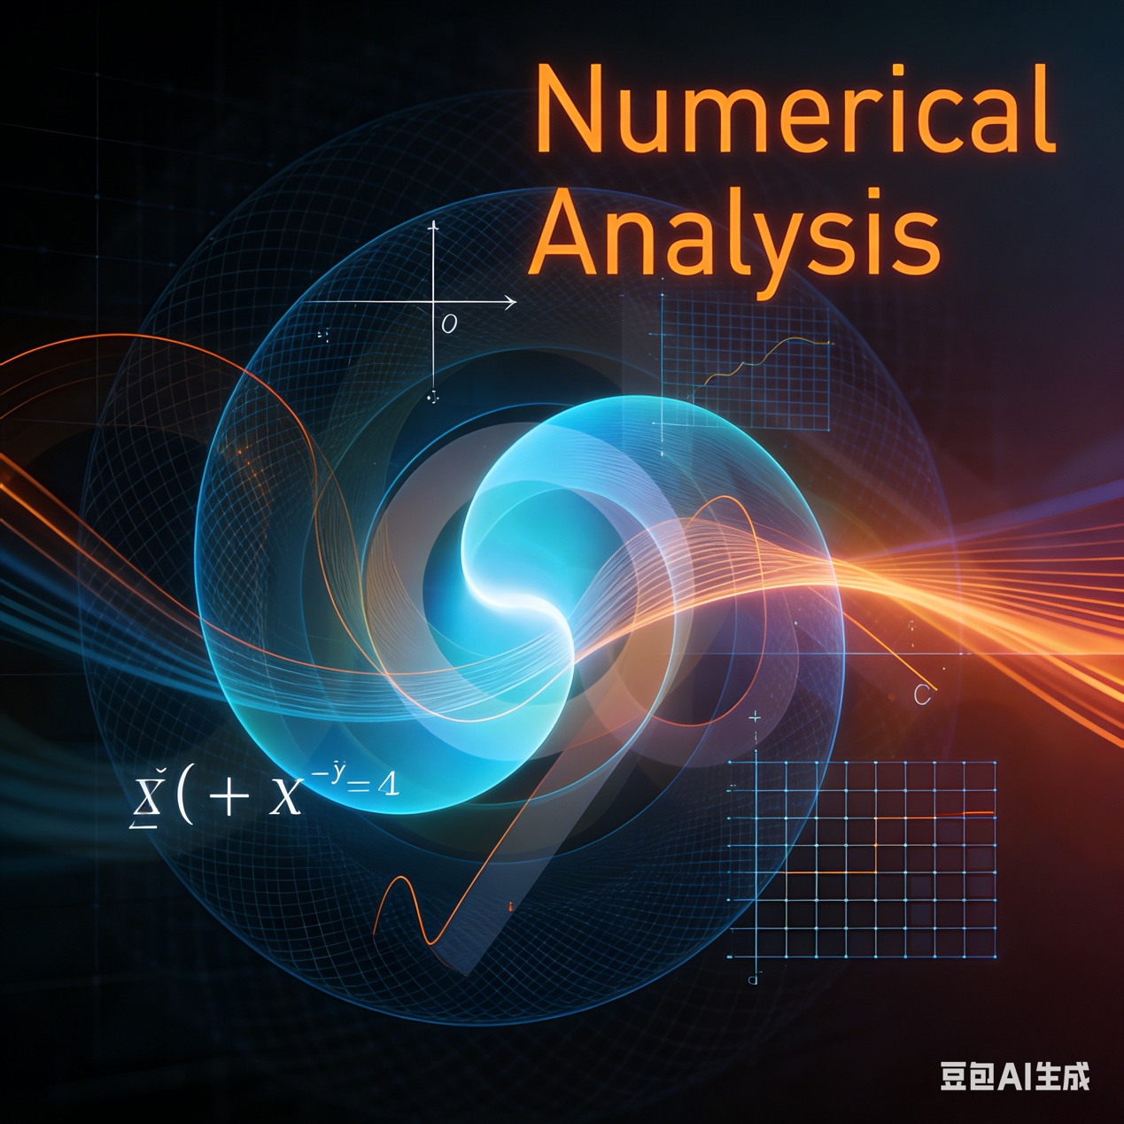
《数值分析》是一门研究利用计算方法求解数学问题的基础课程，主要关注在有限精度条件下如何设计高效、稳定且精确的算法。课程内容包括误差分析、插值与逼近、数值积分与微分、线性方程组的数值解、非线性方程求解、常微分方程数值方法、特征值问题以及优化的基本数值方法等。通过理论讲解与编程实践相结合，学生将掌握构建和分析数值算法的基本思想，理解算法稳定性、收敛性与复杂度等关键问题，并能够将数值方法应用于科学计算、工程模拟和数据分析等实际场景。课程适合数学、计算机、工程类专业学生，是后续进行科学计算和高性能计算研究的重要基础。
Numerical Analysis is a fundamental course focusing on computational techniques for solving mathematical problems under finite-precision conditions. The course covers error analysis, interpolation and approximation, numerical differentiation and integration, numerical solutions of linear and nonlinear equations, numerical methods for ordinary differential equations, eigenvalue problems, and basic numerical optimization methods. Through a combination of theoretical instruction and programming practice, students learn how to design and analyze numerical algorithms, understand key concepts such as stability, convergence, and complexity, and apply numerical methods to scientific computing, engineering simulation, and data analysis. This course is essential for students in mathematics, computer science, and engineering, serving as a foundation for advanced study in scientific and high-performance computing.

脑、认知与计算
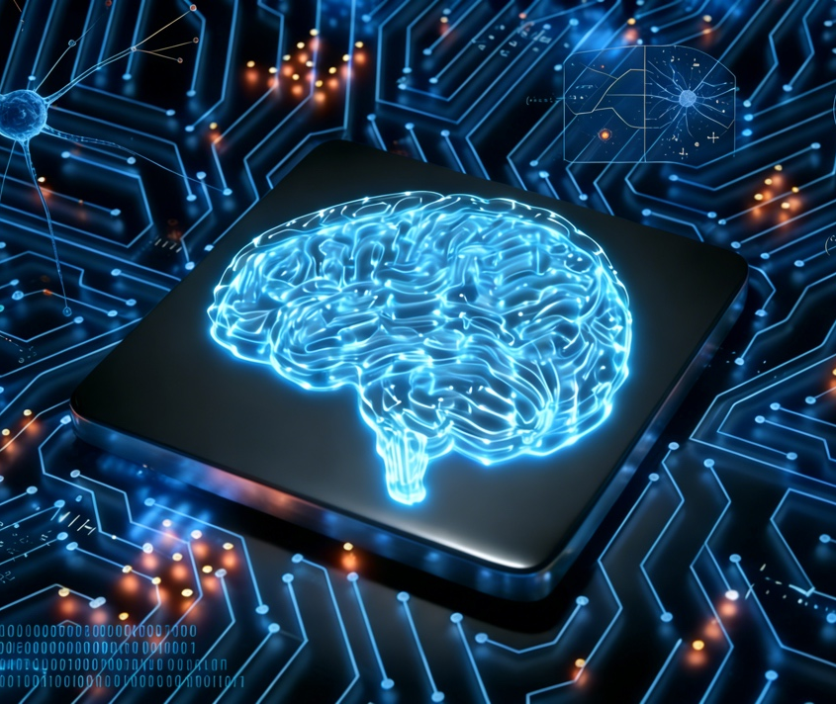
《脑、认知与计算》是一门跨学科课程，面向对脑科学、认知科学与计算方法交叉领域感兴趣的学生。课程从大脑结构与功能入手，介绍知觉、注意、记忆、学习、决策等核心认知过程的神经机制，并讨论人类智能的基本原理。 在此基础上，课程引入计算建模方法，包括神经网络模型、贝叶斯认知模型、连接主义及类脑计算框架，探讨如何利用计算方法理解认知机制，以及如何从生物和认知启发中设计新型智能算法。通过小型实验、行为研究与模型实现，学生将获得对脑、认知和计算之间关系的系统认识，具备在认知科学与人工智能交叉领域开展研究的基础能力。
Brain, Cognition, and Computation is an interdisciplinary course designed for students interested in the intersection of neuroscience, cognitive science, and computational methods. The course begins with an overview of brain structures and functions, covering the neural mechanisms underlying perception, attention, memory, learning, and decision-making, as well as the fundamental principles of human intelligence.
Building on this foundation, the course introduces computational approaches such as neural network models, Bayesian cognitive models, connectionism, and brain-inspired computational frameworks. Students learn how computational modeling helps explain cognitive processes and how biological and cognitive principles can inspire the development of intelligent algorithms. Through hands-on experiments, behavioral studies, and model implementation, students gain a systematic understanding of the relationships among the brain, cognition, and computation and develop the foundational skills needed for research in cognitive science and AI.

