前沿计算研究实践
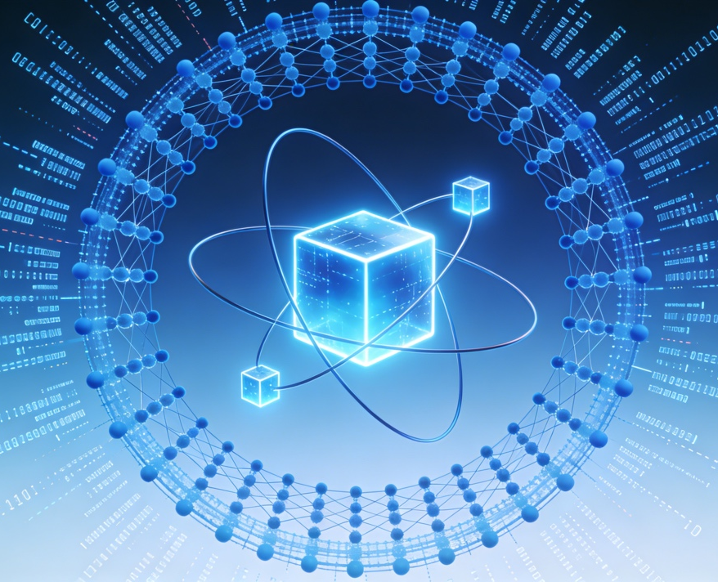
《前沿计算研究实践》面向对人工智能与计算前沿技术感兴趣的高年级本科生及研究生。课程围绕当前计算技术的最新趋势，涵盖类脑智能、机器学习、深度学习、神经形态计算、智能系统架构等领域前沿。教学方式以科研实践为核心，强调问题导向与项目驱动，引导学生理解人工智能发展的理论基础、关键技术与未来方向，并通过实验和小型研究任务获得动手能力与科研思维训练。课程目标是帮助学生理解前沿计算技术的研究方法，培养综合创新能力，逐步具备进入科研前沿领域的潜力。
Frontier Computing Research Practice is designed for advanced undergraduates and graduate students interested in cutting-edge technology in artificial intelligence and computing, the course explores emerging trends in the field, including brain-inspired intelligence, machine learning, deep learning, neuromorphic computing, and intelligent system architectures. Emphasizing research practice, the course adopts a problem-driven and project-based approach, helping students understand the theoretical foundations, key technologies, and future directions of AI. Through hands-on experiments and mini research projects, students develop practical skills and scientific research thinking. The course aims to cultivate innovation capability and prepare students to engage with leading-edge research in frontier computing.

大模型：从基础到实战
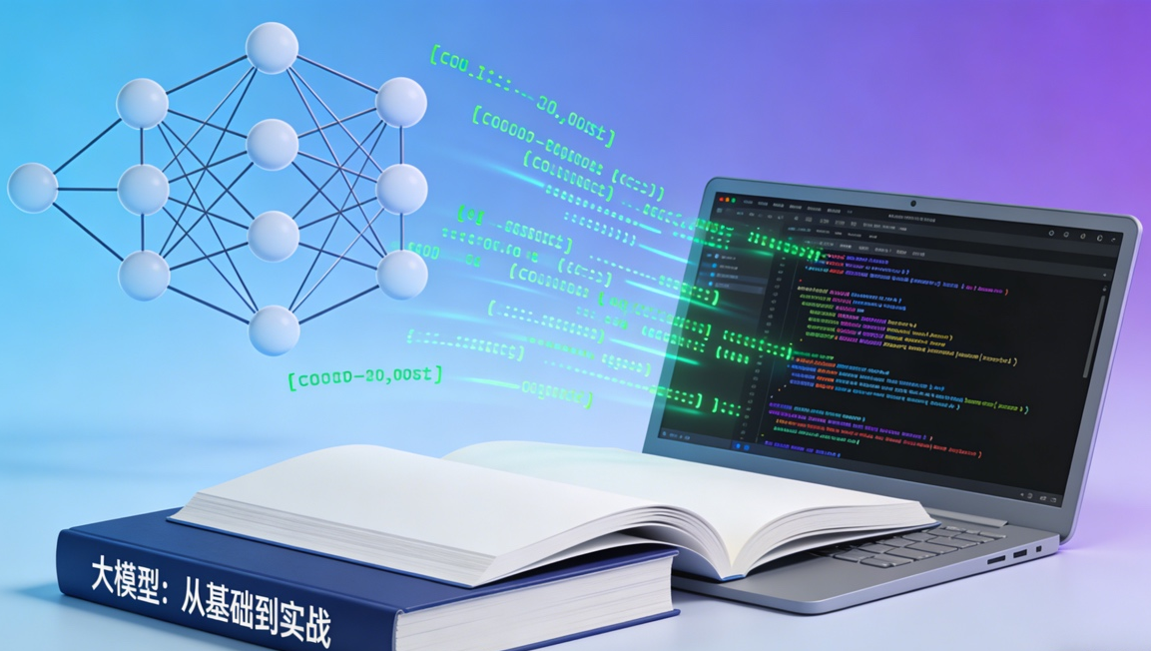
《大模型：从基础到实战》面向希望系统掌握大规模预训练模型（Large Language Models, LLMs）原理与应用的学习者。课程内容覆盖大模型的基础理论、核心算法、训练方法、推理机制及安全对齐技术，并深入讲解大模型在文本、图像、语音、多模态等领域的具体应用。
课程强调理论与实践结合，学生将通过实操完成大模型微调、数据构建、应用开发和部署优化等任务，全面理解从模型构建到真实场景落地的完整流程。本课程适合人工智能、计算机科学及相关领域的学生及开发者。
Large Language Models: From Fundamentals to Practice is designed for learners aiming to master both the theoretical foundations and practical application of large language models (LLMs). The course covers essential concepts such as model architectures, training paradigms, inference mechanisms, and safety alignment, while also exploring real-world applications in text, image, speech, and multimodal domains.
Combining theory with hands-on practice, the course guides students through fine-tuning LLMs, building datasets, developing applications, and optimizing deployment, enabling them to understand the full workflow from model construction to real-world implementation. This course is ideal for students and developers in artificial intelligence, computer science, and related fields.

数字媒体技术
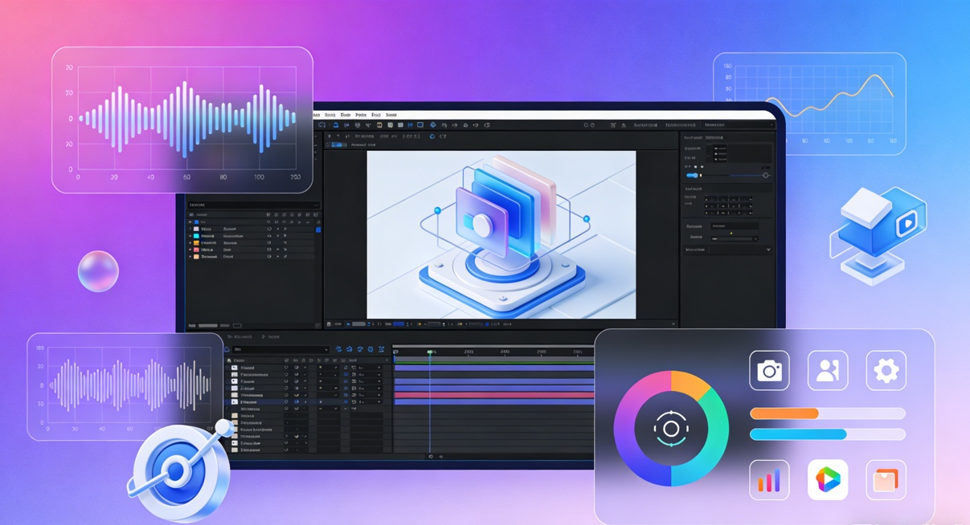
《数字媒体技术》是一门系统介绍数字内容生产、处理、呈现与交互技术的综合性课程。课程涵盖数字图像处理、音视频编码、交互设计、多媒体系统等核心领域。通过理论讲授与实践项目相结合，学生将掌握从数字媒体内容采集、编辑、压缩、传输，到可视化、交互和应用开发的完整技术链。课程强调创新应用与实际动手能力，适合从事数字媒体、计算机视觉、游戏开发、人机交互等方向的学生。本课程旨在帮助学生建立数字媒体技术的系统知识框架，并具备在新媒体、智能媒体与沉浸式应用领域开展实践与创新的能力。
Digital Media Technology is a comprehensive course that introduces the principles and applications of digital content creation, processing, presentation, and interaction. The course covers key areas such as digital image processing, audio and video coding, interaction design, and multimedia systems. By combining theoretical instruction with hands-on projects, students learn the full workflow of digital media technologies—from content acquisition, editing, compression, and transmission to visualization, interaction, and application development. The course emphasizes innovation and practical skills, making it suitable for students pursuing fields such as digital media, computer vision, game development, and human-computer interaction. The goal of the course is to provide students with a solid and systematic understanding of digital media technologies and to equip them with the ability to innovate and practice in emerging media, intelligent media, and immersive applications.

